Assessment 1
Blogging to communicate

Module code: LCBB4004
Gheorghe Laurentiu Stanescu (2124714)
Tutor’s name: Tushara Balendran
Date: 02/09/2022
1
Table of contents

Abstract 3
Introduction 3
Blog 1: Be one with nature in a hight quality! 3
Blog2: Best smartphones from Samsung! 4
Blog 3: Samsung Marketing Strategy & Marketing Mix 6
Blog 4: Why should you have a Samsung Product? 7
Blog 5: Investment for Future Growth 7
Blog 6: Samsung Galaxy S23 Release the Future 8
Conclusion 9
References: 10

2
Abstract
The assignment seeks to give students a basic understanding of marketing principles and includes a blog on Samsung in UK and globally to demonstrate the strategies the company has established to sell more of its goods.
Introduction
As one of the biggest producers of electrical goods, Samsung is a South Korean company. In addition to various consumer and commercial electronics, Samsung concentrates on making integrated systems, digital media players, semiconductors, and appliances. Presently, it dominates the technology industry and accounts for around one-fifth of all South Korean exports.
Samsung made its debut in the electronics industry in 1969, with a number of subsidiaries specifically focused on it. The first product they offered was a black and white television. In the 1970s, the company started exporting devices for home electronics. Samsung had a 50% ownership stake in Korea Semiconductor at the time, making it an important South Korean manufacturer.

Blog 1: Be one with nature in a hight quality!
We all become anxious when we are unable to visualise a scene from a movie with remarkable clarity or when an old television image becomes blurry. Samsung TVs aren't usually the most costly on the best-performing ones.
A fantastic Samsung curved screen TV gives you a wide-angle vision. These TVs aim to improve the viewing experience by mimicking the shape of your eyes and giving the impression of a panoramic picture. Additionally, it has a pleasing design that emphasises depth and contrast. A moth's eye-inspired anti-glare technology is used in Samsung's QLED TV. The primary purpose of its creation was to reduce glare and reflections on the TV screen. Because of its Nano-sized bumps and grooves, which are comparable to the moth's eye, and which enable the moth's eye to absorb enough reflected light, it is compared to the moth's eye.
Warming sound of nature!
Wall-rattling surround sound is certainly out of the question while everyone is asleep, but you still want to watch TV, especially if your TV doesn't have outstanding sound quality.
Using only the TV's sound settings will still give you excellent sound. You can obtain the greatest sound from the TV by utilising optimum sound modes and complex settings like equalisation and balance.

3
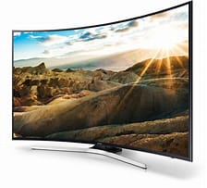
Samsung 49" KU6500 6 Series UHD Crystal Colour HDR Smart TV
(Source 49" 6 series Curved UHD 4K TV UE49KU6500UXXU | Samsung UK)

Blog2: Best smartphones from Samsung!
Undecided while looking for a smartphone?
If you're considering purchasing the best Samsung phone, you've made the right choice. These phones are renowned for their dependability, sleek software, and outstanding cameras.
Not every smartphone is as quick as we would want. The pricing, however, is a good indicator of the phone's quality even if Samsung offers a wide variety of models.
The Samsung Galaxy S22 Ultra, which combines the greatest features of the Galaxy Note and S Ultra lines into one opulent package, is the best Samsung phone available right now.
Though, with a Note-like shape, a S Pen stylus, and a slot to house it, this is more Note than S. Being able to easily sketch, edit, and take handwritten notes makes it a productivity dream. However, the Samsung Galaxy S22 Ultra also comes with the high-quality camera equipment you'd expect from the line, including an enhanced 10x optical zoom lens.
Nevertheless, this smartphone weighs 228g. 163.3 x 77.9 x 8.9 mm are the dimensions. Android 12 OS Size of screen: 6.8 inches 1440 by 3088 pixels Snapdragon 8 Gen 1 and Exynos 2200 as CPUs RAM: 12GB or 8GB 128 GB, 256 GB, 512 GB, or 1 TB 5,000 mAh battery 108MP wide-angle camera + 10MP telephoto, 3x optical + 10MP telephoto, 10x optical + 12MP on the back (ultrawide, 120-degree) 40MP front camera
Not everyone can afford a smartphone, but if you save up for a time, you can have one that is more than just a phone.

4
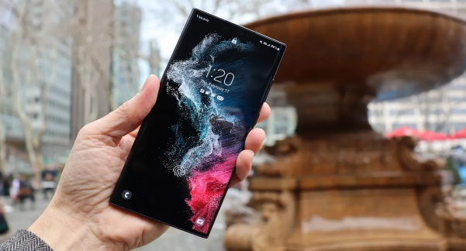
Samsung Galaxy S22 Ultra
(Source: Best Samsung phones 2022: all the top Galaxy handsets ranked | TechRadar)

Galaxy Z Fold 4

Could the foldable phone story finally be reaching its apex at this point? Samsung doesn't appear to have made any significant changes to the foldable's display or design with the Samsung Galaxy Z Fold 4. Instead, it appears to be sticking with the formula. Instead, this most recent Galaxy Z gadget adds some minor but welcome design improvements over the Z Fold 3, as well as a new processor and improved camera array.
The Z Fold 4 also includes 12MB of RAM and the Snapdragon 8 Plus Gen 1, the best mobile processor Qualcomm presently provides. This technology is not nearly as potent in terms of benchmarks as Apple's A15 Bionic, but Qualcomm is closing the gap. In our tests, the chip offered sufficient power for most everyday tasks and had extra power available for tasks that required more CPU power, such editing 8K video streams.
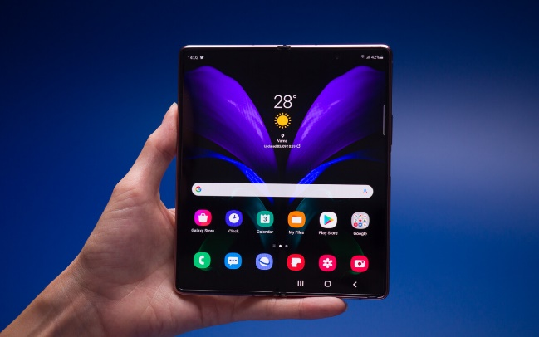

Samsung Galaxy Z Fold 4
(Source: galaxy z4 fold review - Bing images)

5
Blog 3:
Samsung Marketing Strategy & Marketing Mix

In order to analyse the brand, Samsung uses the 4Ps-based marketing mix technique (Product, Price, Place, Promotion). The placement of the brand or competing business in the market and the achievement of its business goals & objectives are both aided by Samsung's marketing strategy.
Samsung Product Strategy
To give its customers the best products, Samsung makes considerable expenditures in R&D. Samsung offers a wide range of products in many different product areas.
Samsung Price/Pricing Strategy
Understanding Samsung's pricing strategy inside its marketing mix is aided by each of them. Skimming pricing is a practise used by Samsung. For instance, when Samsung releases new products with a choice of storage capacities, the price of those things increases. However, Samsung lowers the price and easily avoids losing market share as a result when competitor firms produce smartphones with same features.

Samsung Place & Distribution Strategy
Samsung offers directly to service providers and retailers. Additionally, as a result of this strategy, the corporate sales are exclusively the responsibility of service dealers. Samsung must typically be a part of technology retailers' product lines due to the brand's global recognition. Samsung's strength lies in its distribution. Additionally, Samsung uses a single distribution firm in a certain area to distribute its goods, which is then repeated in other areas.

Samsung Promotion & Advertising Strategy
Promotion is a vital element of the company's marketing mix. For the purpose of positioning the brand and attracting potential customers, Samsung views advertising as the greatest method of marketing. Newspapers and online media are used by Samsung to advertise new goods. In order to take advantage of celebrities' vast fan bases, the company hired a number of celebrities to promote the product and act as brand ambassadors.  6

Blog 4:
Why should you have a Samsung Product?

Although Samsung is the largest firm in the world, you need keep in mind that they have been dependable and producing goods of high quality that can last longer.
In contrast to Apple, Samsung provides a variety of smartphones, from entry-level models to some very high-end models. And obviously, there are many options available for customers to pick from, which is, in my opinion, the biggest selling point for Samsung.
People today are getting more and more aware of the brands they use. Additionally, it is common for people to continue using the same brand in the years to come if they've been doing so for a while. Samsung experiences the same.
People can choose from a wide variety depending on their needs and wants. Samsung has a variety of phones available for you, from entry-level to high-end. You may always opt for the high-end Samsung smartphones if you have a lot of money to invest. If not, a cheap end phone is always ready for you. Just do a search based on your needs.
People who enjoy bright, colourful items are frequently fans of Samsung smartphones. One of the Samsung smartphones has the finest smartphone display, according to independent tests.
Despite being budget-friendly, Samsung phones have excellent cameras. Additionally, folks who enjoy snapping photos and selfies are clearly dependent on Samsung mobile devices.
After purchasing a phone, a lot might occur. In a year or two, you should change your battery to avoid cracking the screen. But don't be alarmed! Your back is always covered by Samsung. Smile. Your gadget has a guarantee from Samsung. Even if your warranty has expired, they have legitimate service centres close by that are prepared to repair your gadget as quickly as possible.

Blog 5: Investment for Future Growth

In the areas of artificial intelligence (AI), 5G, automotive electronics components, and biopharmaceuticals, with a pledge to invest KRW 25 trillion over the next three years and principally headed by Samsung Electronics, Samsung announced plans to increase investments in companies that will fuel its future growth. Samsung also unveiled a series of measures to establish itself as a key player in creating and igniting the ecosystem of creative companies for the digital economy. Using its position as a market leader in semiconductors, telecommunications, and display technology, Samsung hopes to dominate the electronics market for future automobiles, including system-on-chips for autonomous driving.
7
Together with the Korean government, Samsung will also establish and run software education facilities all around the nation, helping to develop the nation's urgently need software talent and opening up new employment possibilities.
For the next five years, the centres will offer career advisory services and teach 10,000 students and job hopefuls. Samsung will also intensify its cooperative research in the field of semiconductors and other fundamental technologies with top universities.
The scope of Samsung's "Smart Factory" programme, a project that offers intelligent improvements and automation solutions for the manufacturing facilities of small and medium-sized businesses (SMEs), will also be expanded.
.
Blog 6: Samsung Galaxy S23 Release the Future

Half a year before its anticipated release, the Samsung Galaxy S23 is already the subject of leaks and speculations; nonetheless, this is an indication of how much anticipated the Galaxy S22 replacement is by the public.
In February 2023, it's likely that the Samsung Galaxy S23 will be unveiled. With the exception of the Samsung Galaxy S21, new models in the line have regularly been introduced in February throughout the course of years, thus we say "probably" rather than "definitely" because no leaks have pointed in that direction.
What will be cost?
It could cost about the same as the Samsung Galaxy S22 in terms of pricing. Samsung could decide to do this three years in a row as it was also the launch pricing for the Galaxy S21, however the price may go up a little.

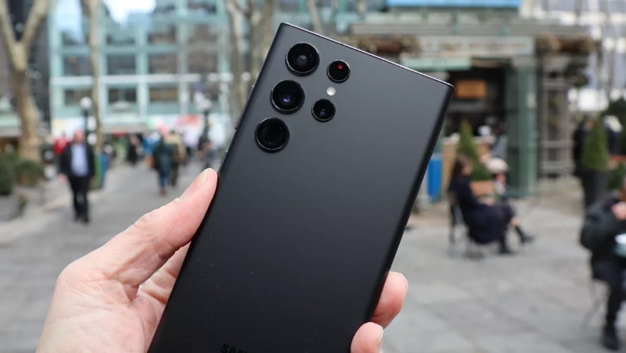
(Image credit: Future)
(Sources: Samsung Galaxy S23: what we want to see | TechRadar) 8
Beyond the rumours, we can anticipate that Samsung will initially introduce three versions in the line-up: the Galaxy S23, Galaxy S23 Plus, and Galaxy S23 Ultra, with the latter likely following the Samsung Galaxy S22 Ultra's lead by featuring a S Pen and a slot for it.
The Samsung Galaxy S23 and S23 Plus may sport the same 10MP megapixels camera as their S22 forerunners, according to information we have received on the subject of cameras. Similar to the S22 Ultra, it is possible that the Galaxy S23 Ultra will also contain a periscope camera.

Conclusion

The assignment was well-written and demonstrated the marketing strategies implemented by Samsung as a global company. Using the facts in the assignment as a starting point, consider how blog writing might advance marketing.

9

References:
< Samsung Marketing Strategy & Marketing Mix (4Ps) Access 26/08/2022/ Available at:
https://www.mbaskool.com/marketing-mix/products/16860-samsung.html>

< SPECIFICATIONS for Samsung (Access 27/08/2022) Available at:
https://www.techradar.com/news/best-samsung-phones>

< 5 Reasons why people buy Samsung phones (Access 29/08/2022) Available at:
https://www.gadgetbytenepal.com/reasons-people-buy-samsung-phones/>

<Samsung Steps Up Investment for Future Growth (Access 29/082022) Available at:
https://news.samsung.com/global/samsung-steps-up-investment-for-future-growth-takes-initiative-to-build-innovation-ecosystem#:~:text=Samsung%20announced%20plans%20to%20boost%20investments%20in%20businesses,intelligence%20%28AI%29%2C%205G%2C%20automotive%20electronics%20components%20and%20biopharmaceuticals.>

10

