Diving the depths: thalassophobia, Horror And the unease of Subnutica
How dose Subnutica evoke and explore the psychological effects of fear linked to thalassophobia through its environmental design, creatures and player intractability?
“A phobia is an overwhelming and debilitating fear of an object, place, situation, feeling or animal” (NHS)
Thalassophobia, a specific phobia that entails the instance and uncontrollable fear of the ocean and what lies beneath, for some the ocean brings images of serene waters and peaceful beaches but for others fear, fear of what waits beneath the calm surface (Cherry, 2025). Thalassophobia’s origination is from the words Thalassa the Greek word for sea or ocean and the word Phobos originating from the personification of fear from Greek mythology (Wilkin, 2019). Why do we fear the ocean? Is the inherent human fear of the unknown, of not knowing exactly what lies beneath the blue surface, is the unsettling vastness or is it something else that strikes us, throughout history stories surrounding the ocean and its capabilities to hold monstrous creatures and horrors, is that fear passed down to us? (Simons, 2023)
Why are we so drawn to the unsettling, despite the horror and unease that it can instil in us. deep diving into the psychology and subconscious of that fear, finding the reasons of why we are drawn to that horror, and discovering the motivation behind why we as humans find it so fascinating (S. Elizabeth, 2022, pp,163-164), looking into the way games and modern gaming depict thalassophobia and megalophbia, specifically looking into the way Subnutica by unknown world entertainment indirectly creates and persist that fear of the deep ocean (Cross, 2021), reviewing the subtill way that Subnutica creates fear and unease within its story and world through music, environment and atmosphere and comparing that to the psychology of thalassophobia in the real world.
The main point of this essay is to take a deeper look into Subnutica and how it effectively shows thalassophobia in its environment, dissecting the game and taking a closer look into the elements that make up the whole of Subnutica, looking into the soundtrack and how it elevates the already tense and unsettling atmosphere, looking deeper at the environments and game progression and how it makes the player go out of their comfort zone (Plafke, 2017). this then will be compared to the psychology and experiences of real-life phobias of the ocean and its inhabitants, to show the reader how closely games and fear can be linked, that games can give a person a heightened fear response due to the players own decision having and effect on the outcome (Purchese, 2024)
Depths of fear: the origins of Phobias and Thalassophobia
Phobias, the intense fear of certain objects, situations and activities, people who suffer from certain phobias work hard to avoid getting themselves in situations that include said phobias, phobias can originate from traumatic events (experiential-specific phobia) or from other sources (nonexperiential-specific phobias). Nonexperimental phobia can be caused by stimuli that trigger fear without previous experiences to that phobia, it can be ‘learnt’ through familial, genetic or environmental means, an example of this would be young children being afraid of the dark. Experimental-specific phobia originates form a traumatic event or experience, due to classical fear conditioning, were something happens if avoidance of said phobia does not happen, essentially reinforcing said fear (Garcia, 2017).
Developing the fear of deep water is linked to trauma associated with water, such as near drowning or being caught in a riptide, these are direct encounters that can fuel said phobia, another way is through observation exposure, by watching or listening to other individuals experiences with the ocean, deep water or through other medias such as YouTube of recounts of drownings, genetics can also play a role, fear passed down from a relative that the individual lived around (Hoyt, 2020). There are many legends and myths that surround deep waters, from peaceful creatures to monsters that lure and drown children, the fear of deep waters has prevailed throughout history, legends created to explain why the waters were dangerous, and to deter the young children from them, shipwrecks were explained by creatures such as the kraken or leviathans, storms attributed to angry gods, the fear and hesitance of deep water goes back to the beginning of human history (Harvey,2023).
Diving the Abyss: Thalassophobia and the fear of the unknown
The relationship between humans and the ocean is complex, for some the images of the ocean and large bodies of water can bring feelings of restoration or happiness, but to contrasted that human are air-breathing mammals that relay on our eye sight to distinguish danger, this fear of loosing sight is mainly associated with Nyctophobia (fear of the dark) but can also apply to thalassophobia is someways, especially when looking into the deep ocean (Jamieson, Singleman, Linley & Casey, 2020). Thalassophobia as well as other well-known phobias can all be narrowed down to ‘the fear of the unknown’ the lack of visual or general knowledge in an uncomfortable situation or thought, in thalassophobia case it is the no knowing of what is in the deep blue, thus leading to increased anxiety and fear of what ‘might’ be there hidden from the seeing eye (Carleton, 2016). Fear of the unknown, when it relates to thalassophobia is based on the lack of not knowing what resides in those depths, the deep ocean can be compared to a cliff, a cliff that overlooks a dark pit, the fear of something dragging us down is primal, humans have adapted to look out for danger and looking into a pit that obscures vision with no concrete knowledge of what resides in that activates that deep seated fear of the unknown (Anderson, 2023).
The fear of the ocean is also link with the way we humans function, humans are land mammals that require oxygen to survive, the deep is the complete opposite to what humans find recognisable, the deep ocean is more alien now that we don’t reside in it anymore, with unexplained creatures lurking beneath and hostile environments that we are not welcome in, the lack of knowledge surrounding what other creatures are living down there, it sets of that primal fear that a predator can emerge from the deep (Anderson, 2023). Megalophbia, the fear of large objects, creatures and or buildings, essentially the fear of feeling small when faced with objects that can dwarf a human, this type of ‘specific phobia’ can be linked to Thalassophobia, looking specifically at large ocean creatures real of otherwise calmed to exist or general underwater structures such as cliffs and craters can indue panic, large ship viewed from bellow can induce this fear especially when there is a comparison for scale (Jarrett, 2023).
Sinking Ships and Wreckage: the unease of Silence
Why do we fear shipwrecks? Submerged man-made objects such as ships, submarines and aeroplanes all fall under the phobia ‘Submechanophobia’ another ‘specific phobia’ that ties with thalassophobia. so why do we feel uncomfortable looking and preserving the image of these object under the water? It could be due to the unnaturalness of those objects and where they are, man-made objects in an otherwise ‘natural place’, the sense that they don’t belong there, or the knowledge that the craft was moving with people on board know lays motionless on the sea floor, a type of grave for something that tone held people (Risen, 2010), water possess the potential of change, ever moving and eroding objects around it, when an object is found it slowly twists and rusts until it becomes unrecognisable, leaving said object to look alien in nature as well as alien in the environment, belonging to nether world, that coupled with the lack of knowledge of the ‘how’ it got there makes the viewer increasingly unsettled, leading to the viewer assuming, was it could have been a mistake or something much more sinister, submechanophiba is not only the fear of objects submerged but also the fear of not knowing how they got there (Phelps,2020)
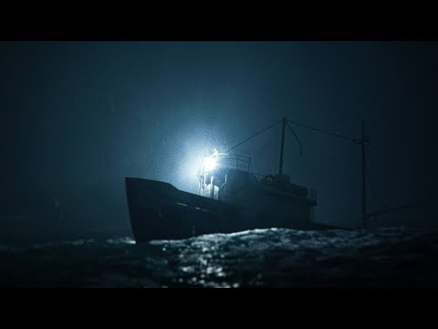
Santiago Menghini, 2024, Thalassophobia: Alone at sea

Menghini’s short film ‘thalassophobia : alone at sea’ captures the utter horror of being alone on a sinking ship, this type of isolation can also be linked to the fear of the oceans, specifically the fear of being alone out at sea and the horror that can entail, isolation in terms of horror intensifies the fear factor due to the safety net it removes, most people when put in a unsavoury situation find comfort with others, being part of a ‘group’ lessens that fear for the individuals (Foster, 2023), in terms of video games, the horror of isolation is different, especially with open world setting the feeling of isolation can be great, games don’t need to be exclusively horror to evoke the feelings of isolation.

Subnutica: Case study of thalassophobia and its depictions
Alone beneath alien waves: the narrative, exploration and intractability of Subnutica
Subnutica, a survival game based around an alien planet, planet ‘4546B’ is entirely water based, with queue biomes and intricate ecosystems, although the narrative of the game is not blatantly explanted rather shown through exploration and visual cues, the opening scene is of the player escaping a crashing space ship through and escape pod, this already explains the general goal of the game, to get off wherever we have crashed (Void0, 2020), once the player enters the water it quickly becomes clear that this environment is not something the player dominates rather it is a foreign environment that the player is learning to understand, help with understanding said environment is through the form of a AI PDA that catalogues and explains mechanics to the player, this AI helps with oxygen regulation, material gathering and environment tips, essentially acting as a cyclopaedia that is filled by interacting with said environment, this way of explaining the world is entirely up to the player rather than constantly explaining and re-explain basic features (Thirlwell, 2018).
Although Subnutica doesn’t have any key indications that split the story into ‘acts’ this distinction is designated to the players resources at each stage, act one is about surviving and gathering resources and bettering equipment, the player when starting out has limited oxygen and is at the mercy of the environment, players typically will stay in the ‘safe’ environments not searching far from the starting area, this coupled with the day night cycle will mean that the player will likely find themselves discouraged from leaving the starting pod at night due to the lack of visibility and inability to make light. Act two, exploration, were the player is insensitive to explore through radio messages from other life pods, this narrative detail gives the player a sense of hope that others from the ship crash survived, but this is slowly shown to be the opposite, with each pod found, the other survivors are shown to have died ether through audio logs or environmental story telling through the conditions of the pods, overall this act of the narrative is to explore and gather information, this point in the narrative is also were the main ‘antagonist’ is found ‘Kharaa’ an alien disease that is ravaging the alien population, that the player also comes in contact with, this sets the main goal of the game, were the player needs to find the cure to get off world (Zuker, 2021), the overall narrative of Subnutica is to find a cure to this alien disease, the inherent fear of finding that the player cannot escape said planet without curing themselves is strong, finding themselves alone on an unknown and hostile environment that is ravaged with and unknown disease that is slowly killing said player adds an additional horror and desperation for survival, not only do the players need to survive the unforgiving environment and creature but also bacteria that is directly attacking and setting a timer for an evadable death (Wedgbury, 2025).
Act three is were the player has gathered all resources and built all the items that are needed, essentially what is left is the need to solve all the mysteries that revolve around the narrative and eventually leaving said planet, at this stage the overall fear of unexplored places should be lessened due to higher levels of equipment that can negate hostile forces, with the narrative of Subnutica the player is forced to go deeper into the oceans to progress, essentially forcing the player out of their comfort zone to progress (Zuker, 2021).

Hostile Depths: The Environmental dread of Subnutica
Environments or better known as biomes in Subnutica are integral to the overall game, there are fifteen underwater biomes or seventeen if the two island are counted, ranging from heavily populated to sparce, environments in games in general can effect the player, players once immersed into a world can act the complete opposite of how they act outside of said world, preserving the virtual world as a ‘stage’ of sorts were the player can shape and warp the virtual world as they please, weather through modelling landscapes to their own desires, intern making the space ‘safe’, Subnutica offers no such shaping (Tlili, Adarkwah, Salha & Huang, 2024)
in fact the environment encourages the players to familiarize themselves with it, no maps are offered to the player making the player rely on biomes locations and landmarks to navigate, this adds a level of dread when navigating due to the chance of getting lost or tuned around leading to a posable dangerous encounter, but the familiarization with said environment instils a sense of pride for the player (Filimowicz, 2023).
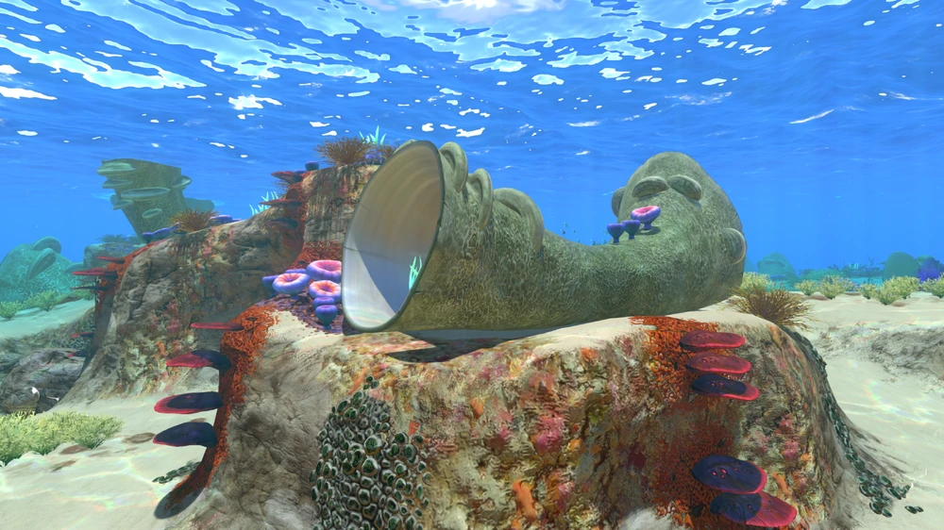
Screenshot From Subnutica, 2020, Safe Shallows
The safe shallows, the starting area of Subnutica as the name suggests is the safest area of the game, the only risk that the player can take in this biome is getting lost in its caves and running out of oxygen (Taylor, 2024) but the exploration of theses caves is integral to progression overall, Subnutica almost forces the player to engage with the environment to progress, the first real fear the player would experience in this environment would be claustrophobia, being in a limited space added to the fact that oxygen is limited with an active counter telling the player how long they have left (Heinerth, 2019),
colour is a major factor in determining the effect that a biome has on a player, the safe shallows is colourful, almost playful in nature, contrast that with the more dangerous biomes and it becomes blatantly clear that the safer biomes hold a wider variety of bright colours conditioning the player to associated colour with safety (Rmcad, 2024).
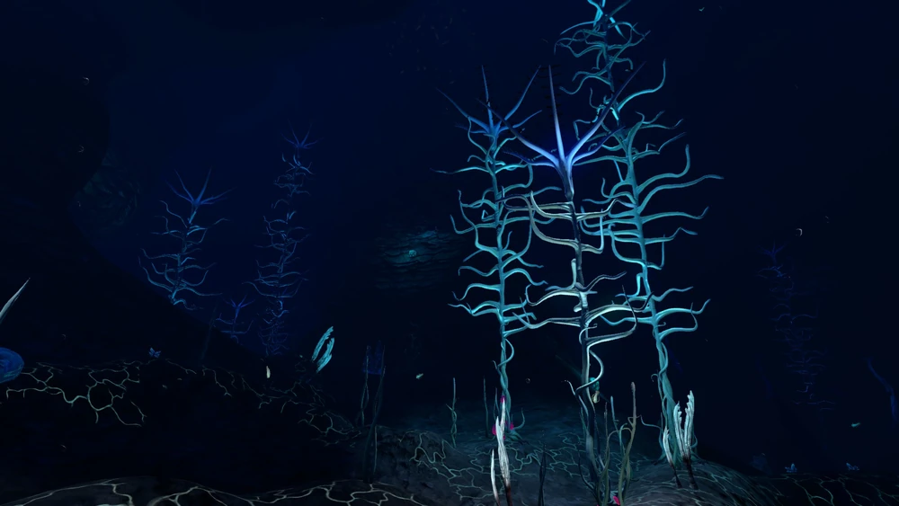
Screenshot From Subnutica, 2020, Blood Kelp Trench
“This Ecological biome matches 7 of the 9 preconditions for stimulating terror in humans” – Dialog from Subnutica
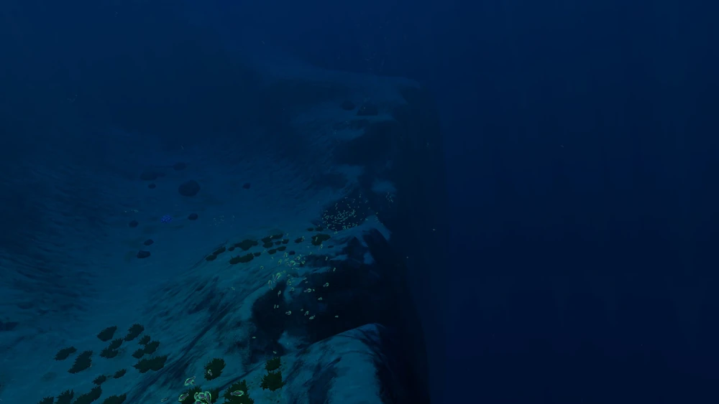
The blood kelp trench as the name suggest is a deep craves marked on the map, this area of the game is small compared to other biomes but is one that can invoke the feeling of dread, preserving this biome and or entering is a challenge in and of its self, this biome is located deep into the map meaning once preserved the player needs to actively and willingly dive deeper to find the bottom, the biome itself doesn’t have any major risks within it but the depth and low visibility make it a dread inducing experience, Subnutica again forces the player to dive deeper in the name of progression and the deeper the player goes the more strange and unnerving the environment become, the biomes become something alien and the player as an unwanted trespasser, essentially making the player feel as those they should not be there, that they don’t belong, giving way to that fear of the unknown (Evens, 2024).
Screenshot from Subnutica, 2020, Crater Edge
“Warning: Entering Ecological Dead Zone” – Subnutica Dialog
For those that have played Subnutica, the mere phrase listed above bring chills, the craters edge or ecological dead zone is essentially the end of the map, a void that surround the creator, a steep drop off into nothingness, the inherent horror of a deep pit that has no bottom, devoid of life is terror inducing, if a player is motivated enough to venture into the ecological dead zone they quickly find it only goes down, and the further it goes down the more presser is applied to the point were the player will die before reaching the bottom of the map, this for new time player with no prior knowledge becomes the prime example of the fear of the unknown, there are no visual indicators of what’s out their only the imagination of the players and the vast blueness, this area coupled with the threat of ‘leviathans’ causes the player to say very clear of entering this area, it’s a masterful way of dithering player away from the end of the map and also inducing terror for what lays beneath (Borra, 2024).
Echoes of the depths: sound, silence and music in Subnutica
When submerged into Subnutica, the music become a key element to the players perception of the environment, music or soundtracks are key to enhancing the atmosphere and immersion of said game, it can set the ‘mood’ so to speak from feeling that a place is safe to bringing tension to an already dire situation, music is integral to the player perception of the game world (Illustemagazine, 2024), Subnutica soundtrack by Simon Chylinski, consists of fifty six tracks, ranging from relatively peaceful to anxiety inducing, one track ‘abandon ship’ as the title may suggest is played when a ship is about to explode, this track is more hight octave signalling to the player that the situation is a time sensitive one, were the track eventually get more and more loud and erratic till it reaches a high point, another track that contrast this is ‘shallows’ this track is more ‘peaceful’ with an upbeat tone, in general its more playful and signals to the player that its safe (TuneTailors, 2021).
The music in Subnutica is integral to the overall experience, immersion is key to letting players experience dread and or safety in the environment, the soundtracks are all similar to one another but can be distinct when listening to them outside of the Gameworld (Mintejo, 2023), all the tracks hold and eeriness to them a subtle tension of wrongness that coupled with the visual aspect of the game can produces a strong reaction of dread, all the tracks feel alien to listen to, as those the person perceiving them is looking into something rather than being apart of it, that coupled with the distinct lack of recognition of any traditional instruments adds to the alien and futuristic atmosphere, the overall soundtrack enhances the hunting beauty of the world (Zhang & Fu, 2015). And when that music is gone the player experiences a great deal of dread, the quite can mean that there is something dangerous around them, creating and assumption of something negative happening through the lack of music.
Sound design in Subnutica can be strange, environmental sounds are dulled down due to the environment being set underwater, sounds of creatures are the most prominent in the game world, Subnutica conditions the player to associate loud sounds with danger, a distant roar or a sound that is coming closer the player immediately knows that it could be hostile, Subnutica uses sound design for the story, alien tech as its own distinct sound so that the player can associated it with story progression, the biggest difference involving sound and audio it the surface, when under the water music and sound is constant when above water it is eerily silent adding to the dread of the overall situation the player finds themselves in, almost in away the game is making the player feel uncomfortable and Alien no mater were said player is (Ng & Nesbitt, 2013), overall the sound design and soundtrack add to the uncertainty and uncomfortable of the visual world of Subnutica, without the audio inputs the overall game would not bring as much fear and dread to player, audio is integral to any game but especially one that is portraying horror in some form (Native Instruments, 2022).
Giants of the Deep: Leviathans, From Wonder to Horror
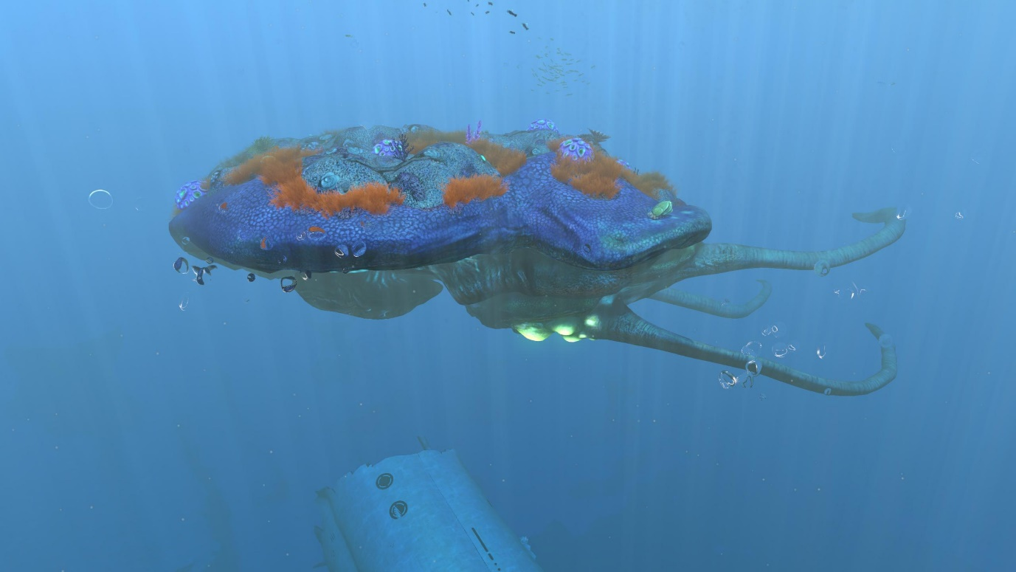
“Detecting multiple leviathan class lifeforms in the region. Are you certain whatever you’re doing is worth it” – Dialog taken for Subnutica
Screen Shot from Subnutica, Reefback Leviathan, 2016
Leviathans class creatures are entities that are massive compared to the player, while there is no precise definition on what classes a creature as a leviathan class it become obvious to the player when they encounter one, the general belief is that the creature needs to be extremely large compared to other creatures and in some cases aggressive towards the player, the first leviathan the player will encounter is the Reefback, a seventy meter passive creature that closely inhabit whale like characteristics, these leviathans are so large that they carry their own ecosystem upon their backs, the first time a player encounters them they may be warry since the player by this point has not encountered anything on the ‘massive’ scale yet, but soon the player discovers that they hold resources and are quite majestic to look at, this can give the player a sense of safety and a false expectation regarding the leviathan class (Anaya, 2025).
The reaper leviathan, the most well-known leviathan in Subnutica, it’s the first large scale aggressive creature that the player will encounter, at fifty-five meters long the reaper is on the smaller size, but it makes up by being the most notorious, with multiple spawn location littered around the map, it is the most common aggressive leviathan, and the player will have to encounter them to progress (Anaya, 2025). reaper leviathans are one of the most aggressive creatures in the game, they will actively go after the player and their various ships damaging and or outright destroying them, their appearance also solidifies this by having scares showcased around their faces to indicated that they get into conflict regularly, the means of which they attack is by using their four face mandibles to latch onto and pull pray towards their mouths, this its self is horrify since they essentially attack front facing, meaning the player must stare into the face of the leviathan while trying to escape.
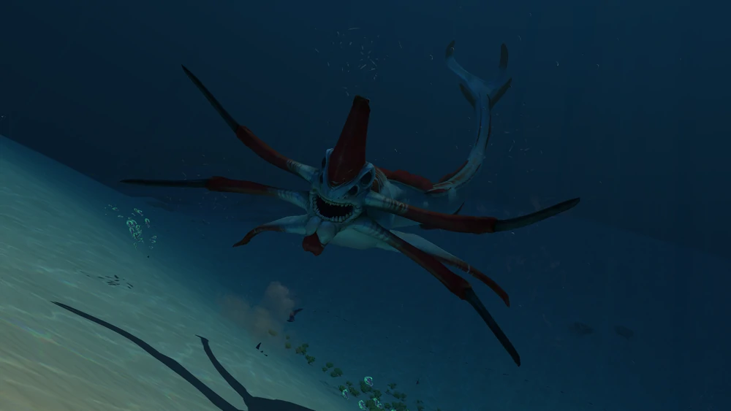
Unlike other creature in Subnutica, the reaper doesn’t have bio luminesce, meaning when in a obscured environment the reaper can attack without the player knowing from where, this add a new sense of horror since the player cannot predict or see where the threat is, add to the fact that the reaper relies on echolocation and cannot see, meaning that if the player can hear the reaper, than the reaper knowns the player is there and is actively moving towards them (The Last Bacon, 2018).
Screen Shot from Subnutica, Reaper Leviathan, 2022
Diving the Depths: Conclusion on Subnutica thalassophobia
In exploring and researching thalassophobia through both psychological theory and digital immersion based on games and other medias it clear that the fear of the oceans is more than a surface level fear, it’s a manifestation of our primal fears, whether through the fear of being hunted or feeling as those we are lower on the food chain or the unease we feel in an environment that is alien to us, its clear that thalassophobia is much more than the fear of the oceans (Anderson, 2023).
The fear of the ocean and or deep water is an off shoot of the fear of the unknown, looking into the depths and having no concreate answers of what lies beneath, it is tied to human nature and our own vulnerability about the lack of control and knowledge in an uncomfortable situation, for some it may be more pronounced for others less so, but the belief that humanity craves control over potentially dangerous situation is obvious, the water can being peace and happiness to some other it bring dread and a creeping sense of horror (Jamieson, Singleman, Linley & Casey, 2020). Many different fears compound to make thalassophobia, the fear of the dark ‘ Nyctophobia’ the fear of submerged machinery ‘Submechanophobia’ and the fear of large creatures ‘megalophbia’ these all compound under thalassophobia, being afraid of the ocean and what can lay within it, these fears shape how humans depict fear in other medias, with horror films focusing on ‘the monster’ rather than the innate horror of the ‘water’(Anderson, 2023).
Subnutica not only forces the players into existing fear but intentionally triggers them, all the listed ‘sub-category’s’ of fear are explored and felt in Subnutica, from fears of giant crashed and sinking machinery to massive aggressive creatures, Subnutica may have been created as a deep sea exploration but it ended up as an unintentional horror game that perfectly capture the unending unease that the water can create, playing into human nature and the absolute horror that can be created by the unknown, a horror game without ‘jumps capes’ instead relying on suspense, suspense that something with emerge from the depths weather monster or biome playing on that gut feeling of ‘somethings wrong here’ overall the way Subnutica feeds into fear is masterful, rather than creating it the game plays on existing fear (Evans, 2024).

Reference List
Kendra Cherry, Mse. (2025) Coping with thalassophobia (fear of the ocean), Verywell Mind. Available at: https://www.verywellmind.com/thalassophobia-fear-of-the-ocean-4692301 (Accessed: 23 April 2025).
Wilkin, E. (2019) Thalassophobia, Emma Wilkin. Available at: https://emmawilkin.com/words-of-the-week-2/2019/5/15/thalassophobia (Accessed: 23 April 2025).
Simons, A. (2023) From aquatic anxieties to oceanic oddities: Why we fear the deep blue sea, National Museum of Bermuda. Available at: https://nmb.bm/history/from-aquatic-anxieties-to-oceanic-oddities-why-we-fear-the-deep-blue-sea/ (Accessed: 23 April 2025).
Cross, • Dani (2021) How subnautica helped overcome my fear of the sea, New Game+. Available at: https://newgameplus.co.uk/2021/01/13/subnautica/ (Accessed: 23 April 2025).
S. Elizabeth (2022) The art of darkness: A Treasury of the morbid, melancholic and macabre. London: Frances Lincoln.
Plafke, J. (2017) Why ‘Subnautica’ is already one of the best survival games ever made, before it’s even released, Forbes. Available at: https://www.forbes.com/sites/jplafke/2017/03/22/why-subnautica-is-already-one-of-the-best-survival-games-ever-made-before-its-even-released/ (Accessed: 23 April 2025).
Purchese, R. (2024) The anatomy of a scare: How do games frighten you?, Eurogamer.net. Available at: https://www.eurogamer.net/the-anatomy-of-a-scare-how-do-games-frighten-you (Accessed: 23 April 2025).
Jamieson, A.J. et al. (2020) ‘Fear and loathing of the Deep Ocean: Why don’t people care about the deep sea?’, ICES Journal of Marine Science, 78(3), pp. 797–809. doi:10.1093/icesjms/fsaa234.
Anderson, W.L. (2023) Swimming in deep water: Why are we so scared?, Medium. Available at: https://medium.com/@whitneylanderson/swimming-in-deep-water-why-are-we-so-scared-8df21cf2074b (Accessed: 23 April 2025).
Hoyt, A. (2020) Thalassophobia: Do you fear the deep ocean?, HowStuffWorks. Available at: https://health.howstuffworks.com/mental-health/anxiety/thalassophobia.htm (Accessed: 23 April 2025).
Harvey, A. (2025) 55 photos that Capture the terror of thalassophobia, the fear of the sea - and what lurks within it, All That’s Interesting. Available at: https://allthatsinteresting.com/thalassophobia (Accessed: 23 April 2025).
Menghini, S., 2024. Thalassophobia: Alone at sea. [online video] Directed by Santiago Menghini. Available at: https://www.youtube.com/watch?v=SrkODSfYH1g
Foster, W. (2023) The role of isolation in horror, Medium. Available at: https://medium.com/@foster.whitney.a/psychology-in-horror-e3ef250b9232 (Accessed: 23 April 2025).
Jarrett, C. (2023) Megalophobia: Humanity’s bizarre fear of large objects, explained by a psychologist, BBC Science Focus Magazine. Available at: https://www.sciencefocus.com/the-human-body/megalophobia (Accessed: 23 April 2025).
Risen, C. (2010) What lies (horribly) beneath, The Morning News. Available at: https://themorningnews.org/article/what-lies-horribly-beneath (Accessed: 23 April 2025).
Phelps, M. (2020) The extremely specific fear you’ve never heard of, The Eagle Times. Available at: https://aghseagletimes.com/735/opinion/the-extremely-specific-fear-youve-never-heard-of/ (Accessed: 23 April 2025).
Void0 (2020) How subnautica immerses you with its compelling narrative and gorgeous world building, Void0. Available at: https://void0media.com/how-subnautica-immerses-you-with-its-compelling-narrative-and-gorgeous-world-building/ (Accessed: 23 April 2025).
Evans-Thirlwell, E. (2018) Subnautica is the open world all open worlds should learn from, Rock Paper Shotgun. Available at: https://www.rockpapershotgun.com/subnautica-is-the-open-world-all-open-worlds-should-learn-from (Accessed: 23 April 2025).
Zuker, J. (2021) Subnautica: Exploring the depths of the survival narrative, Intermittent Mechanism. Available at: https://intermittentmechanism.blog/2021/02/23/subnautica-exploring-the-depth-of-survival/ (Accessed: 23 April 2025).
Tlili, A. et al. (2024) ‘How environmental perception affects players’ in-game behaviors? towards developing games in compliance with Sustainable Development Goals’, Entertainment Computing, 50, p. 100678. doi:10.1016/j.entcom.2024.100678.
Filimowicz, M. (2024) Environment, culture & emotion, Medium. Available at: https://medium.com/narrative-and-new-media/environment-culture-emotion-7f47bcacdf9e (Accessed: 23 April 2025).
Evans, M. (2024) Game studies, Game Studies - Too Afraid to Go Deeper: Creating Pervasive Dread Through Blended Design Structures in Subnautica and Subnautica: Below Zero. Available at: https://gamestudies.org/2404/articles/evans#:~:text=Subnautica%20blends%20the%20horrific%20context,with%20more%20traditional%20horror%20design. (Accessed: 23 April 2025).
Borra, A.M. (2024) Exploring Uncharted Territory in an Adventure-Diving Game: A Framing Analysis of Subnautica’s Ecological Dead Zone, the Surrounding Online Player Discussions and User-generated Content. Available at: https://studenttheses.uu.nl/bitstream/handle/20.500.12932/46402/MA-Thesis_NMDC_A.M.Borra_6782612.pdf?sequence=1&isAllowed=y.
Heinerth, J. (2019) Exploring beyond fear, Canadian Geographic. Available at: https://canadiangeographic.ca/articles/exploring-beyond-fear/ (Accessed: 23 April 2025).
Admin (2024) The role of soundtracks in video games: How music enhances immersive gaming, Illustrate Magazine. Available at: https://illustratemagazine.com/the-role-of-soundtracks-in-video-games-how-music-enhances-immersive-gaming/ (Accessed: 23 April 2025).
Team, T. (2024) The importance of music in video games, TuneTailors. Available at: https://tunetailors.com/blogs/sound-stories/the-importance-of-music-in-video-games/?srsltid=AfmBOoo-dkoR7kPjG_gXYGBCNUWJMf2U1HUTQU3-kEmy41OO3egDr5f9 (Accessed: 23 April 2025).
Xiaoqing Fu, J.Z. (2015) ‘The influence of background music of video games on immersion’, Journal of Psychology &amp; Psychotherapy, 05(04). doi:10.4172/2161-0487.1000191.
Mintejo, D.Q. (2023) Understanding the Influence of Agency in Music on the Players’ Experiences of Games and their Emotional Responses. Available at: https://www.diva-portal.org/smash/get/diva2:1769562/FULLTEXT01.pdf.
Ng, P. and Nesbitt, K. (2013) ‘Informative sound design in video games’, Proceedings of The 9th Australasian Conference on Interactive Entertainment: Matters of Life and Death [Preprint]. doi:10.1145/2513002.2513015.
Anaya, C.J. (2025) Subnautica: All leviathans in the franchise, ranked by size, Game Rant. Available at: https://gamerant.com/subnautica-largest-leviathans/ (Accessed: 23 April 2025).
The Last Bacon,2018, Subnutica Lore: Reaper Leviathans [online Video] Available at: https://www.youtube.com/watch?v=8E3QZfu58SY

