Managing Health, Safety and Welfare in Construction
Managing Health and Safety in a Project
Lecturer: Dr Deborah Hughes
Institution: University of Wales Trinity St David

Index
Chapter 1- Introduction
Chapter 2- Construction phase plan
Chapter 3- Method statements
Chapter 4- Risk assessments
Chapter 5- Legislation
Chapter 6- References

Chapter 1
Introduction
This fictional project proposes to build a single, two storey dwelling. The client of the project is the University of Wales Trinity St David and is for the caretaker and his family. For this project, a construction phase plan, a method statement and a risk assessment is needed for the major activities that are going to take place. In this assignment I will detail each of these.
The reason why health and safety is so important in construction is because it’s the industry with the highest fatality rate. “It’s of particular importance within the construction industry because it’s the UK industry with a fatality rate four times higher than the rate across all other industries” (J.L. West, 2017)

Chapter 2
- Construction phase plan
Company name | Davies Construction
Project description | Full construction of a single, two storey detached domestic building
Client | University of Wales Trinity St David
Start date | 06/03/2020
Location | Adjacent to the new student accommodation on the SA1 site.
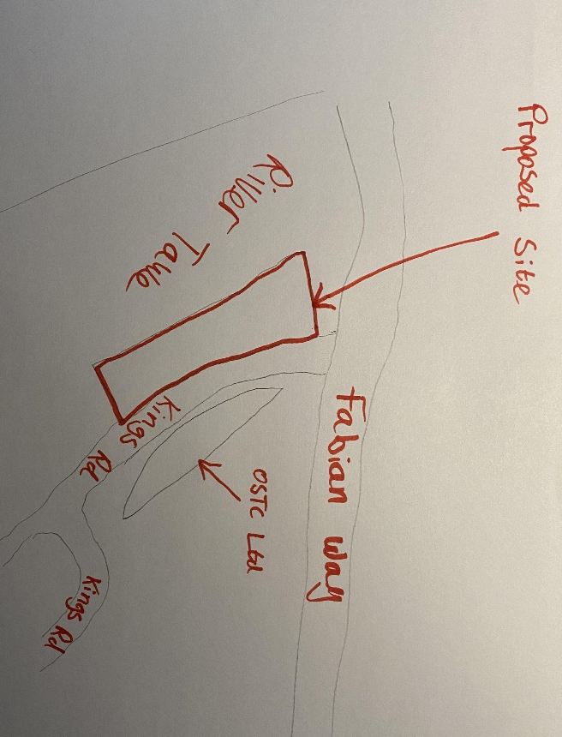
Location of site

Management
Site Rules | - Wear PPE whenever on site  - Follow Safety signs and procedures  - Report hazards and problems to site manager  - Protection for the public around the site  - Keep all facilities clean  - All personnel should have undergone safety training prior to being on site.  - Permission from the site manager must be given prior to any work taking place on site.  - No one under the influence of drugs or alcohol are permitted to be on site
Health and safety aims | Ensure the safety of workers and members of the public
Arrangements to ensure cooperation between project team members and coordination of their work | - Frequent meetings between site manager and builders  - Frequent meetings between Site manager and client  - Project programme to set out goals of the project and key dates so that all members of the project know when everything should be happening
Arrangements for involving workers | - Create a transparent and open environment for workers to communicate
Site induction | - Induction must be site specific and not broad  - Highlight risks at the site  - Site inductions are needed for frequent visitors like architects and quantity surveyors
Fire and emergency procedures | - Fire alarms  - Fire exit signs  - Frequent fire drills  - Creating a map highlighting hazardous locations

Welfare facilities
The welfare facilities are provided by the contractor in most cases but the client is actually responsible for them.
What facilities are needed on site?
- Toilets
- Washing facilities
- Changing rooms
- Eating area

Details
- The toilets be flushable toilets with running water, connected to a drainage system
- The number of toilets depends on the number of staff working on site. British standards recommends 1 toilet for every 7 persons.
- Toilets must be kept clean
- Washing facilities require, a clean supply of hot and cold water, soap, drying equipment, sufficient ventilation
- Changing rooms should have men and women rooms separately

Location of facilities

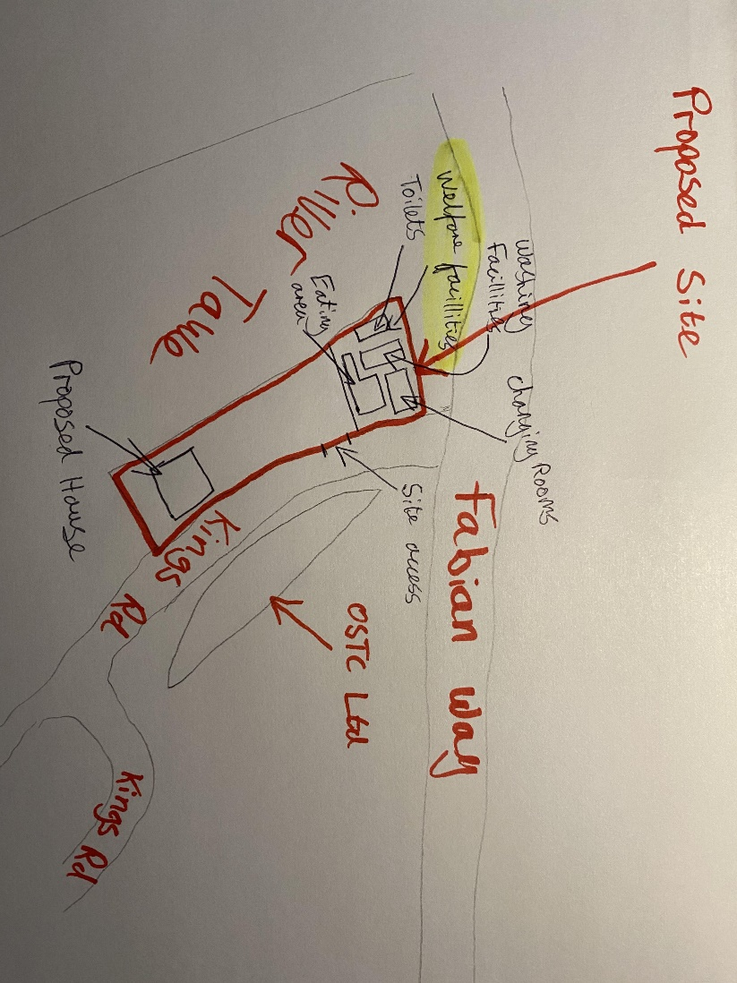
The welfare facilities will be located on the right hand side of the site at the entrance. This is close enough to the site but also gives plenty of room for the proposed building and any building material and or equipment at the left hand side of the entrance as shown on the drawing below. The toilets will be a row of portaloos and will be close to the washing facilities as recommended by HSE. (Health and Safety Executive)

Chapter 3
Method statements
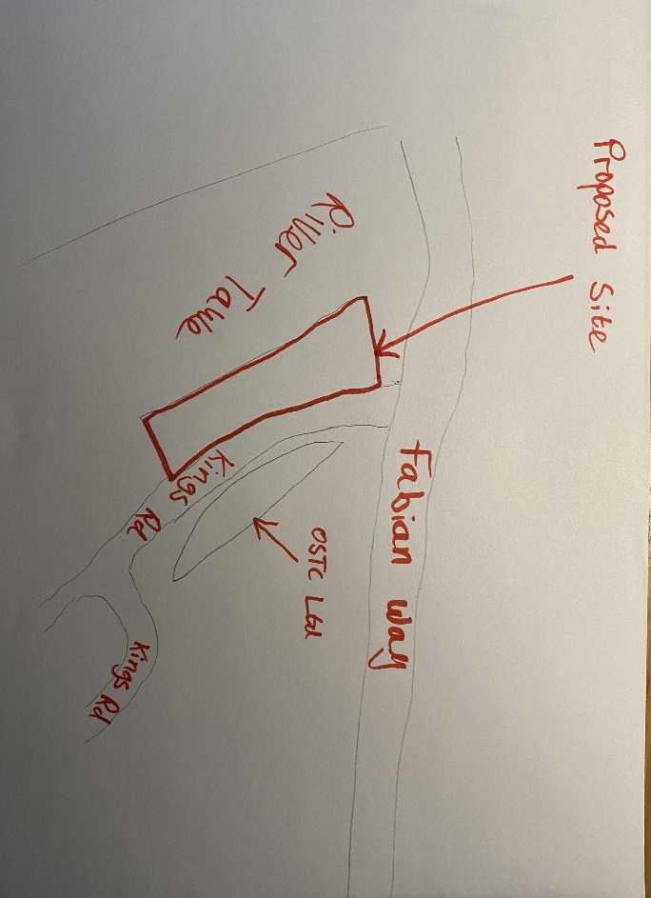
Davies Construction
Construction of a single, two story dwelling near Swansea city centre at Kings Road

Client: UWTSD
- Scaffolding
Scaffolding assists in the building of the house by supporting the workers and equipment so that work can be done higher on the house.
Anyone who has attended a CISRS scaffold investigation course is deemed to be able to assess the scaffold on whether it is acceptable or not. (Simian, 2016)
The main hazard is working from heights so there will always be a risk of falling. Barriers, stable ladders and timber beams and extra caution reduce this risk.
Control measures
- Scaffolding requires barriers around the edges so that the workers can walk and carry equipment without feeling at risk.
- Warning signs are to be put around the scaffold
- Visitors are prohibited from entering the scaffold unless the site manager has specifically said otherwise
- Workers must not attempt to lift above their threshold and anyone carrying any tools must be trained to do so

PPE
- Hard hats
- Safety boots
- Gloves
- High visibility vests
- Excavating
Excavating is used when digging out a manhole or pit to inspect the ground in the pre construction phase and is also used in the construction phase when creating room for the foundations. The foundations are said to be concrete strip foundations with a depth of 1m.
Excavations are to be assessed at least once in every day during which persons are at work there (Health and safety authority).
A hazard when excavating for a ground investigation is a trench collapse which are very dangerous when the excavation is deep enough that a worker is required to enter. A risk that is obvious when talking about any excavation is falling into it.
Control measures
- Yellow warning tape around any excavation to prevent anyone from falling into
- Supports must be put in place in order to prevent the pits from collapsing like timber walling in trenches
- Inspections of all excavations are vital after a rainstorm
- Do not work under raised loads
- Heavy equipment or vehicles should be kept away from the edge of the excavation to avoid collapse
- Complete a ground investigation where foundations are to be laid to ensure that there are no unknown underground utilities present

- Electrical
Electrical components are found frequently through houses. They are needed for lights, fridges, microwaves and many more household components.
The electricity will be installed as a distribution system. A main circuit is drawn to a distribution centre in each room which are connected to the distribution boards.
The electricity must be installed correctly to avoid any fuse blows. If done incorrectly then a fuse may blow when the homeowner moves in and it can be very dangerous when someone with a lack of knowledge tries to fix it.
Control measures
- When working with electricity the main precaution to have is an experienced electrician so that mistakes such as using faulty equipment or incorrectly wire a plug which can lead to serious injuries
“Exposure to damaged electrical tools and equipment can be very dangerous. Do not fix anything unless you are qualified to do so.” ( iAuditor)

Chapter 4
Activity to be Assessed |  |  |  |  |  |  |  |  |  |  |  |  |  |  |  |  | Assessment Number
Heavy Machinery
Persons undertaking or affected by the activity
 |  | x | Employees |  | x | Contractor |  |  | x | Public |  |  |  |  | Service User
 |  |  | Other …………………………………………………………………………………………….
Identified Hazards and Associated Risks |  |  |  |  |  |  |  |  |  |  | Likelihood |  |  |  |  |  | Severity |  |  |  |  | Risk Level
1 | Noise complaints |  |  |  |  |  |  |  |  |  | 3 |  |  |  |  |  | 1 |  |  |  |  | 3
2 | Hearing difficulty due to constant loud machinery |  |  |  |  |  |  |  |  |  | 2 |  |  |  |  |  | 4 |  |  |  |  | 8
3 | Hand arm vibration system |  |  |  |  |  |  |  |  |  | 3 |  |  |  |  |  | 4 |  |  |  |  | 12
4 | Self inflicted injuries such as crushed fingers |  |  |  |  |  |  |  |  |  | 3 |  |  |  |  |  | 3 |  |  |  |  | 9
5 | Tripping over equipment |  |  |  |  |  |  |  |  |  | 2 |  |  |  |  |  | 2 |  |  |  |  | 4
6
Existing Control Measures / Additional Control Measures Required
1 | Make suitable working hours on site
2 | Workers to wear ear defenders when necessary
3 | Mainly educationally based. Ensure that workers are holding powerful tools loosely, keep hands warm and take regular breaks from heavy use of powerful tools.
4 | Use machinery when possible but use caution when workers are needed to lift or carry heavy materials
5 | Have regular site inspections to ensure the site is always kept tidy and objects such as cables or hand tools aren’t left out
6
Reassessment of Activity Hazards |  |  |  |  |  |  |  |  |  |  | Likelihood |  |  |  |  |  | Severity |  |  |  |  | Risk Level
1 | Noise complaints |  |  |  |  |  |  |  |  |  | 2 |  |  |  |  |  | 1 |  |  |  |  | 2
2 | Hearing difficulty due to constant loud machinery |  |  |  |  |  |  |  |  |  | 1 |  |  |  |  |  | 4 |  |  |  |  | 4
3 | Hand arm vibration system |  |  |  |  |  |  |  |  |  | 2 |  |  |  |  |  | 4 |  |  |  |  | 8
4 | Self inflicted injuries such as crushed fingers |  |  |  |  |  |  |  |  |  | 2 |  |  |  |  |  | 3 |  |  |  |  | 6
5 | Tripping over equipment |  |  |  |  |  |  |  |  |  | 1 |  |  |  |  |  | 2 |  |  |  |  | 2
6
Name  Position |  |  |  |  |  |  | Signed |  |  |  |  |  |  |  |  |  | Date of Completion:
Reviews |  |  |  | Key
Review Date: |  |  |  | Likelihood |  |  |  | Severity |  |  | Severity of Injury |  | 5 | 5Y |  |  |  | 10R |  | 15 |  |  | 20 |  | 25
Reviewed by: |  |  |  | 1 very unlikely  2 unlikely  3 likely  4 very likely  5 certainty |  |  |  | 1 nuisance  2 minor  3 medical treatment  4 major  5 fatal |  |  |  |  | 4 | 4 |  |  |  | 8 |  | 12 |  |  | 16 |  | 20
Review Date : |  |  |  |  |  |  |  |  |  |  |  |  | 3 | 3 |  |  |  | 6G |  | 9 |  |  | 12 |  | 15
Reviewed by: |  |  |  |  |  |  |  |  |  |  |  |  | 2 | 2 |  |  |  | 4 |  | 6Y |  |  | 8 |  | 10Y
Review Date : |  |  |  |  |  |  |  |  |  |  |  |  | 1 | 1 |  |  |  | 2 |  | 3 |  |  | 4 |  | 5G
Reviewed by: |  |  |  |  |  |  |  |  |  |  |  |  | 0 | 1 |  |  |  | 2 |  | 3 |  |  | 4 |  | 5
Review Date : |  |  |  |  |  |  |  |  |  |  |  |  |  | Likelihood of Injury
Reviewed by: |  |  |  |  |  |  |  |  |  |  |  | Low Risk |  |  |  |  |  |  | Medium Risk |  |  |  |  | High Risk
Activity to be Assessed |  |  |  |  |  |  |  |  |  |  |  |  |  |  |  |  | Assessment Number
Working from heights
Persons undertaking or affected by the activity
 |  | x | Employees |  |  | Contractor |  |  | x | Public |  |  |  |  | Service User
 |  |  | Other …………………………………………………………………………………………….
Identified Hazards and Associated Risks |  |  |  |  |  |  |  |  |  |  | Likelihood |  |  |  |  |  | Severity |  |  |  |  | Risk Level
1 | Falling from a significant height |  |  |  |  |  |  |  |  |  | 2 |  |  |  |  |  | 5 |  |  |  |  | 10
2 | Falling objects |  |  |  |  |  |  |  |  |  | 2 |  |  |  |  |  | 4 |  |  |  |  | 8
3
4
5
6
Existing Control Measures / Additional Control Measures Required
1 | Secure Scaffolding. Avoid working from heights wherever possible such as assembling materials at ground level. Precautions such as safety nets, double guard rails and toe boards.
2 | Ensure all workers are wearing hard hats. Reduce the need for tools above ground level by assembling materials needed, on the floor and use caution when tools are needed at a hight.
3
4
5
6
Reassessment of Activity Hazards |  |  |  |  |  |  |  |  |  |  | Likelihood |  |  |  |  |  | Severity |  |  |  |  | Risk Level
1 | Falling from a significant hight |  |  |  |  |  |  |  |  |  | 1 |  |  |  |  |  | 5 |  |  |  |  | 5
2 | Falling objects |  |  |  |  |  |  |  |  |  | 1 |  |  |  |  |  | 3 |  |  |  |  | 3
3
4
5
6
Name  Position |  |  |  |  |  |  | Signed |  |  |  |  |  |  |  |  |  | Date of Completion:
Reviews |  |  |  | Key
Review Date: |  |  |  | Likelihood |  |  |  | Severity |  |  | Severity of Injury |  | 5 | 5Y |  |  |  | 10R |  | 15 |  |  | 20 |  | 25
Reviewed by: |  |  |  | 1 very unlikely  2 unlikely  3 likely  4 very likely  5 certainty |  |  |  | 1 nuisance  2 minor  3 medical treatment  4 major  5 fatal |  |  |  |  | 4 | 4 |  |  |  | 8 |  | 12 |  |  | 16 |  | 20
Review Date : |  |  |  |  |  |  |  |  |  |  |  |  | 3 | 3 |  |  |  | 6G |  | 9 |  |  | 12 |  | 15
Reviewed by: |  |  |  |  |  |  |  |  |  |  |  |  | 2 | 2 |  |  |  | 4 |  | 6Y |  |  | 8 |  | 10Y
Review Date : |  |  |  |  |  |  |  |  |  |  |  |  | 1 | 1 |  |  |  | 2 |  | 3 |  |  | 4 |  | 5G
Reviewed by: |  |  |  |  |  |  |  |  |  |  |  |  | 0 | 1 |  |  |  | 2 |  | 3 |  |  | 4 |  | 5
Review Date : |  |  |  |  |  |  |  |  |  |  |  |  |  | Likelihood of Injury
Reviewed by: |  |  |  |  |  |  |  |  |  |  |  | Low Risk |  |  |  |  |  |  | Medium Risk |  |  |  |  | High Risk
Activity to be Assessed |  |  |  |  |  |  |  |  |  |  |  |  |  |  |  |  | Assessment Number
Excavation
Persons undertaking or affected by the activity
 |  | x | Employees |  |  | Contractor |  |  | x | Public |  |  |  |  | Service User
 |  |  | Other …………………………………………………………………………………………….
Identified Hazards and Associated Risks |  |  |  |  |  |  |  |  |  |  | Likelihood |  |  |  |  |  | Severity |  |  |  |  | Risk Level
1 | Collapsing Trenches |  |  |  |  |  |  |  |  |  | 2 |  |  |  |  |  | 4 |  |  |  |  | 8
2 | Falls into excavations |  |  |  |  |  |  |  |  |  | 2 |  |  |  |  |  | 3 |  |  |  |  | 6
3 | Existing services |  |  |  |  |  |  |  |  |  | 3 |  |  |  |  |  | 2 |  |  |  |  | 9
4 | Contaminated ground |  |  |  |  |  |  |  |  |  | 2 |  |  |  |  |  | 4 |  |  |  |  | 8
5
6
Existing Control Measures / Additional Control Measures Required
1 | Timber walling to the sides of trenches to make the trench more stable. Excavation holes will be thoroughly inspected before anyone enters.
2 | Apply warning signs and tape around the excavation. Cover trenches when not being used.
3 | Any cables found shall be treated as though they were live until proven otherwise. Where there has been services identified in the desk study, only safe digging will be done,
4 | Appropriate PPE and washing facilities will be used.
5
6
Reassessment of Activity Hazards |  |  |  |  |  |  |  |  |  |  | Likelihood |  |  |  |  |  | Severity |  |  |  |  | Risk Level
1 | Collapsing Trenches |  |  |  |  |  |  |  |  |  | 1 |  |  |  |  |  | 3 |  |  |  |  | 3
2 | Falls into excavations |  |  |  |  |  |  |  |  |  | 1 |  |  |  |  |  | 3 |  |  |  |  | 3
3 | Existing services |  |  |  |  |  |  |  |  |  | 3 |  |  |  |  |  | 1 |  |  |  |  | 3
4 | Contaminated ground |  |  |  |  |  |  |  |  |  | 2 |  |  |  |  |  | 2 |  |  |  |  | 4
5
6
Name  Position |  |  |  |  |  |  | Signed |  |  |  |  |  |  |  |  |  | Date of Completion:
Reviews |  |  |  | Key
Review Date: |  |  |  | Likelihood |  |  |  | Severity |  |  | Severity of Injury |  | 5 | 5Y |  |  |  | 10R |  | 15 |  |  | 20 |  | 25
Reviewed by: |  |  |  | 1 very unlikely  2 unlikely  3 likely  4 very likely  5 certainty |  |  |  | 1 nuisance  2 minor  3 medical treatment  4 major  5 fatal |  |  |  |  | 4 | 4 |  |  |  | 8 |  | 12 |  |  | 16 |  | 20
Review Date : |  |  |  |  |  |  |  |  |  |  |  |  | 3 | 3 |  |  |  | 6G |  | 9 |  |  | 12 |  | 15
Reviewed by: |  |  |  |  |  |  |  |  |  |  |  |  | 2 | 2 |  |  |  | 4 |  | 6Y |  |  | 8 |  | 10Y
Review Date : |  |  |  |  |  |  |  |  |  |  |  |  | 1 | 1 |  |  |  | 2 |  | 3 |  |  | 4 |  | 5G
Reviewed by: |  |  |  |  |  |  |  |  |  |  |  |  | 0 | 1 |  |  |  | 2 |  | 3 |  |  | 4 |  | 5
Review Date : |  |  |  |  |  |  |  |  |  |  |  |  |  | Likelihood of Injury
Reviewed by: |  |  |  |  |  |  |  |  |  |  |  | Low Risk |  |  |  |  |  |  | Medium Risk |  |  |  |  | High Risk

Chapter 5
- Legislation
The health and safety legislation relevant to this project is the health and safety at work act 1974. This is promotes, encourages and simulates high standards of health and safety in places of work.
The construction design and management regulations are very relevant for this particular project. The CDM regulations say that it is the responsibility of the commercial clients to make sure welfare facilities are provided. It states in schedule 2 that toilets must be provided, they must be adequately lit and ventilated and that there must be separate facilities for men and women, all which are present in this project. This duty is shared with the principal contractor.
The domestic client, in this case the caretaker and his family do not have any duties as they are usually transferred to the contractor. However if the caretaker can choose to carry out the duties having had a written agreement with principal designer.
Any foreseeable risks is also the responsibility of the designer. This includes making sure a desk study is done on the area so that there are no unforeseen existing services in the ground when it comes to excavating as discussed in the method statements and the risk assessments.
As discussed in the construction phase plan, there will be a site induction and frequent catch up meetings. These are the responsibilities of the principal contractors.
It is the contractor’s responsibility to provide a construction phase plan similar to what is shown in this assignment.
In many of the risk assessments it shown that a lot of difference can be made when caution is used on site. This is why, according to the CDM regulations it is the responsibility of the workers to take care of their own and others health and safety. Such as when tools are being used at hight.
With this being a fairly small construction project, it would be acceptable as far as signage goes to have one encompassing single health and safety sign at the entrance. (Display Signs)
Manual handling is also frequently talked about through this assignment. That’s why The Manual Handling Operations Regulations are relevant to this project. This regulation talks about the use of PPE. PPE has been mentioned when talking about walking on or around scaffolding., using heavy machinery and when in trenches.

Chapter 6
References
J.L. West (2017)- Building Education -Why health and safety is so important in construction
Health and Safety Executive
(2016)- Simian- Scaffolding Inspection Legal requirements
iAuditor- 7 common electrical hazards in the workplace
Display Signs- What signs are needed for a building site?

