Name: DAVE MAULIK B
Student number: 2106684

Coerce: MSC in Automotive
Sub: Hybrid Powertrain and Control
Sub cord: ACEA7007
Assignment Title: Series Hybrid Vehicle CW2

INDEX
- Abstrca.........................................................................................
- Introduction.................................................................................
- The design layout for hybrid powertrain.....................................
- Engine..........................................................................................
- Genrator......................................................................................
- Battery........................................................................................
- Contoller.....................................................................................
- Motor.........................................................................................
- Costing........................................................................................
- Comparision of hybrid buggy final costing …....................
- Conclusion.........................................................................
- Refrence............................................................................

ABSTRCA
In this file we can see that constraction of hybrid buggy and we can use hybrid powertrain and there different parts which is use in hybrid powertain. After that we can see that varios type of graph in that and in end of we cant count as over all costing. When we convert normal car to hybrid powertrain, we have lost of benefit firt and main benift is we can save money with this powertarin ,then it is help to improove engine life and vehicle as well. We can save reduce enivorment polution.morover with help of this powertrin we can give batter power to the engine. This we can use different confriguration such as hevy duty truck oprated over urbun and higwaydriving cycles and light duty vehicles. These result will quantify the heavy dependence of fuel economy benefits associated with different types of driving cycles.
INTRODUCTION
In this assigment A typical hybrid electric buggy powertrain has two power sources: an engine, generator, and planetary gear set, and a motor, battery and controler . The carrier gear is connected to the engine, the sun gear is connected to the generator, and the ring gear is connected to the motor in the planetary gear set. Through gear reductions, the motor is also linked to buggy wheel. The engine speed is decoupled from the vehicle speed in this planetary gear design, allowing for greater engine efficiency.
The power split hybrid powertrain technology gives the control system designer more control over the engine's functioning, as well as the opportunity to enhance fuel economy if done correctly. However, there are additional requirements that must be met that are not present in traditional powertrain systems.
High-voltage battery power and other new restrictions are the most significant.
voltage. Exceeding the power and voltage limitations can shorten battery life and harm electronics the electrical power electronics in addition, the sensitivity of the vehicle response to noise sources such as the engine
In a power split vehicle, torque imbalances are different. in comparison to a traditional car A substantial amount control problem that was addressed in order to determine the desired operating point for the powertrain
fuel efficiency, performance, and other car characteristics drivability, the battery, and the high-voltage bus are all met the power and voltage limitations are satisfied, and Issues with robustness have been addressed.
Our solution relied on a power-based control system to manage and coordinate drivetrain activities in order to meet the driver's needs while balancing energy flow to and from different power units (such as the motor, generator, engine, and battery). The control system determined the appropriate traction torque using this method by regulating the wheel power, battery power, and engine power optimally. Detailed tests were conceived, scheduled, and executed to ensure that the design met the criteria under a variety of operating situations.
The problem that the control system was built to solve, the new battery power control requirements that were established, the design of the controls, the verification tests, and the test results are all described in this document.

THE DESIGN OF LAYOUT FOR HYBRID POWERTRAIN
The transmission gear, the torque converter clutch state, and the intended engine torque are the three factors that must be determined. The mechanism has two degrees of freedom for a certain wheel torque and speed. (This system would only have one degree of freedom if there were no torque converter.) The control system in this situation could look like this.
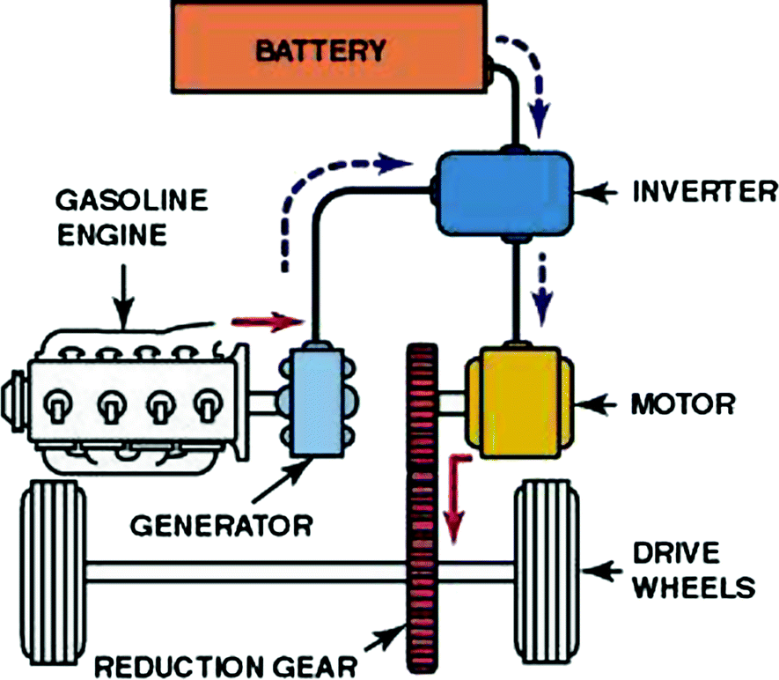.

- Determine the wheel torque demanded by the driver (using the accelerator pedal input).
- Determine the appropriate gear and torque converter clutch condition (either using the driver's input or a set of scheduling tables).
- Determine the engine torque required to meet the demands of the driver.
Last, we discuss about different HEV parts use in buggy

- ENGINE
In this buggy we have 300 cc engine fitted in there. its maximum speed around 30 mph, in this buggy power split the robustness of the above control system to mismatches in engine torque. In this buggy engine produce 22(Nm) the engine give power to generator.
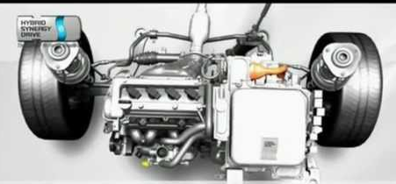
FIG: 1 HYBRID ENGINE
Need to determine the engine torque command engine speed and wheel torque command. The Driver power request determination subsystem oversees determining the desired driver demand and vehicle speed for power requests. The wen torque command is determined by the wheel torque determination subsystem based on the driver power request. The Engine power command determination subsystem also calculates total engine power to match driver power requests and the power required to maintain high-voltage (HV) battery state of charge (SOC). Finally, the Engine speed and torque commands determination subsystem calculates the engine speed and torque instructions in the most efficient manner possible.

- GENERATOR
We have various type of option in generator, but we can select 12V-48V 130mm 2kW/3kW lightweight pancake.

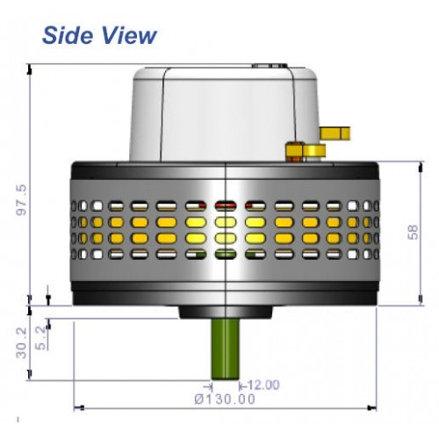
FIG:2 GENRATOR DIMENTION LAYOUT
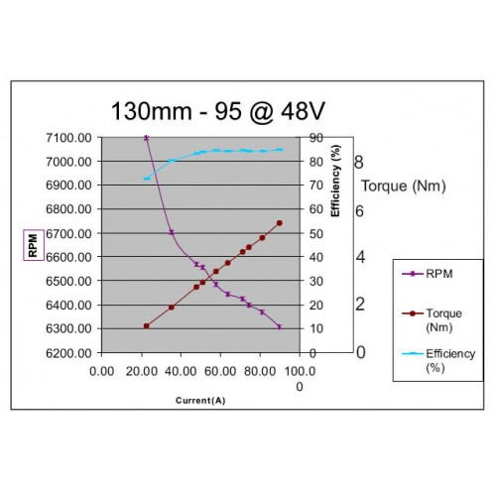
The generator take power threw to engine and supply to controller in some new car car starts with the electric mother. The HEV can use the electrical machine to behave a generator and there by produce electrical energy which can be stored used later.
In this graph we can see that (RPM), TORQUE(Nm)and efficiency of generator.
Generators produce RPM around 7100.00 which is maximum, and sufficient for buggy. Torque rate all so good, And 90%efficiency by 48V generator. However, we need to add reduction gear to control power.
It is located between engine and generator. So, engine properly transfer their power in proper way to generator. Generator is very light wight vehicle application. It is having high power to wight ratio, high efficiencies well.

- BATTERY
One of the important parts in hybrid buggy is battery pack with help of battery we can save fuel as well as improve our buggy performance.

For our buggy we need 48V battery, so we take 24v battery and connect 2 batteries to gather in service and make battery pack.
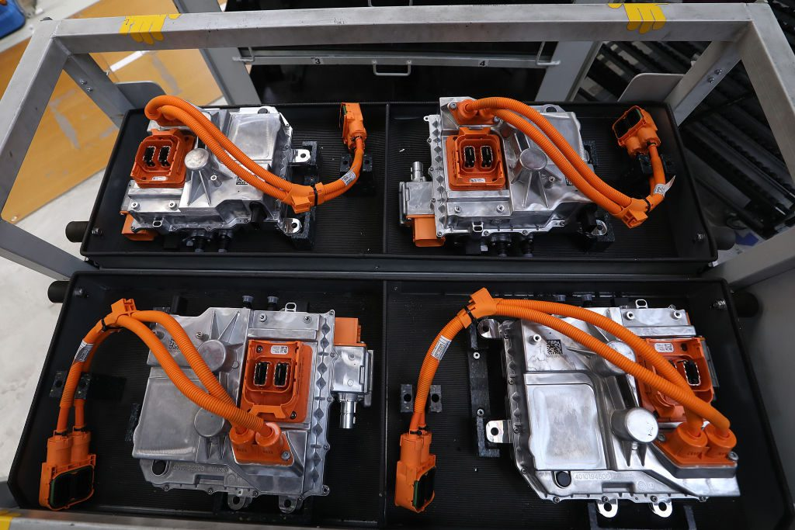
FIG:3 SERICE BATTERY
Hybrid vehicles combine electric car and regular car technology. A hybrid car, like a regular vehicle, uses a 48-volt lead-acid battery and gasoline while simultaneously drawing energy from an electric battery. The vehicle can easily switch between power sources without the driver even realising it. Provide long storage life with few limiting conditions.

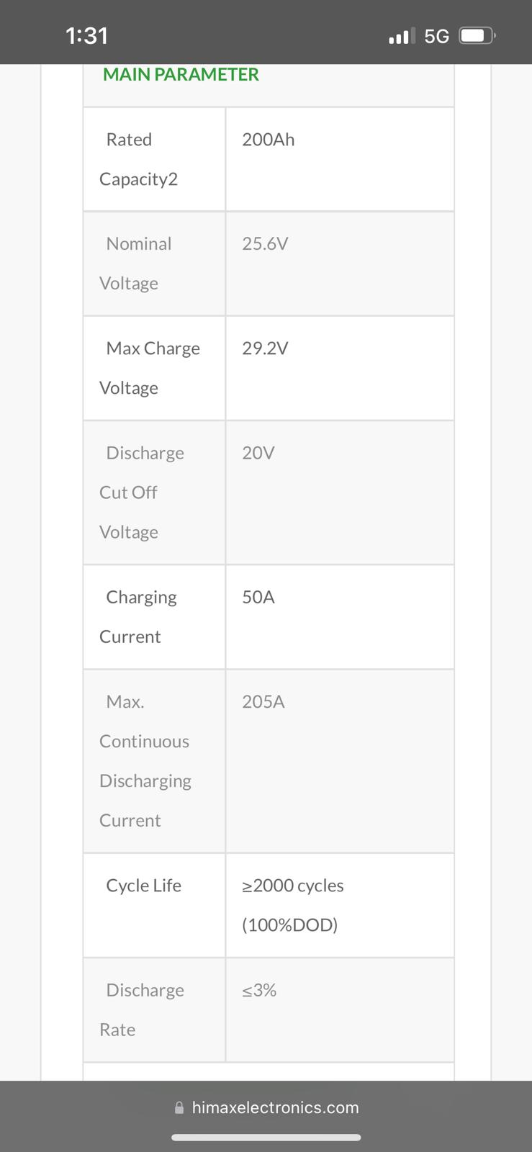
The battery has very good capacity to save power it has 150 Ah capacity; it has two-year battery warranty and 24V each.
Regenerative braking is a method of recharging the electric battery. The electric battery is recharged by the energy created when the driver presses on the brake pedal. The ability of a hybrid car to switch between electric and gas power is crucial to its excellent energy efficiency. Hybrid automobiles are 20 to 35 percent more fuel efficient than typical vehicles since they run on gas only part of the time. This also lowers the vehicle's emissions, making a hybrid automobile more environmentally friendly.
FIG:4 BATTERY INFORMATION TABLE
In this chart we can see that all information like battery has 200Ah
Max charging voltage around 29.2V and cut off rate has 20V. battery has life around >2000 cycles.

CHARGING DISCHARGING GRAPH OF BATTERY
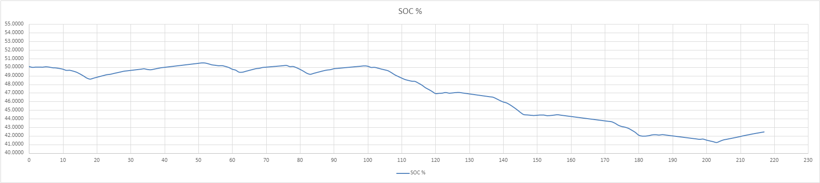
In this chart we can see that charging and discharging rate of battery in starting battery charged in proper way however period of time graph going down because in this part buggy need more torque to run engine. With help of this chart, we can see that battery condition at each point.

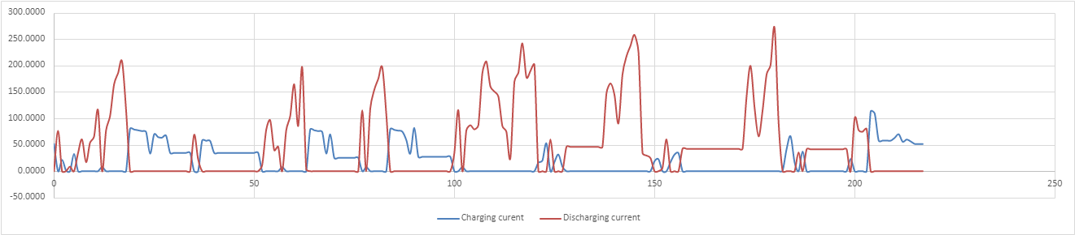

In this chart we can see that battery charging and discharging rate. Charging rate is low compeer to discharging chart. After starting distance buggy has on different stage so in discharging also going to fluctuate as well after starting distance battery graph went the highest.

- Controller

The block diagram of the IPM motor system is shown in Fig. A motor, sensor systems, an inverter, and an Electric Control Unit make up the majority of the IPM motor system (ECU).
A stator wound with coils and a rotating rotor inside the stator make up the basic framework of a motor system. A transmission transmits the rotating movement to an axle shaft.
The rotating direction and rotor position determine the electrical energization phase. Electromagnetic attraction is formed when electric current is applied to the coils in proportion to the applied current intensity.
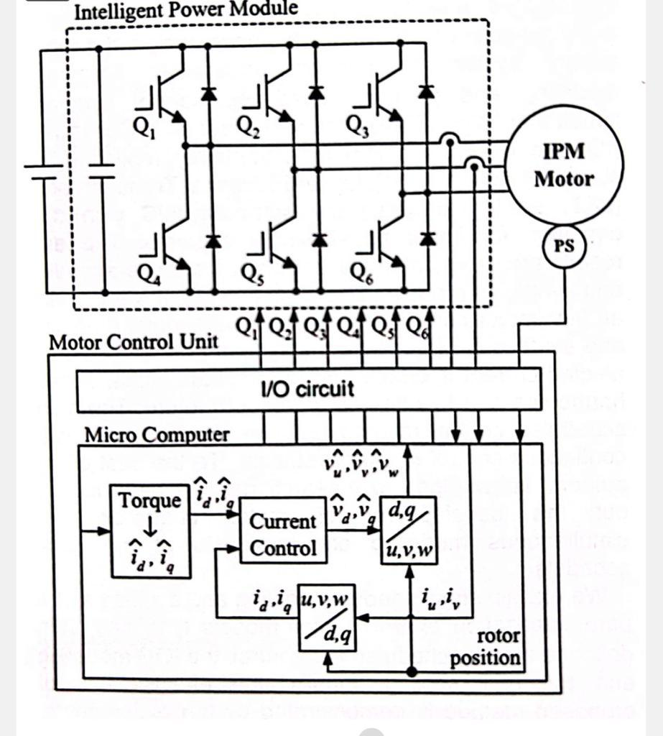
The magnetic circuit design in this system is optimised via FEM analysis. Sensor systems transmit numerous signals to the ECU, including rotation position, coil current, and motor temperature. A Motor Control Unit (MCU) and a Vehicle Control Unit (VCU) are two sections of the ECU (VCU).
FIG :5 CONTROLLER LAY OUT
The VCU uses an acceleration signal to determine the motor's intended torque. The target torque is delivered to the motor MCU via CAN connection.
Based on the goal torque for the motor and the signals sent by each sensor, the MCU-integrated microcontroller controls the current value and phase sent to the motor coils.
For each phase, the inverter has two IGBTs (Isolated Gate Bipolar Transistor) and two diodes, with the IGBTs being controlled by the current controller.

- Motor
In hybrid buggy we can use 12V-48V 130mm 2kW/3kW lightweight pancake PM motor

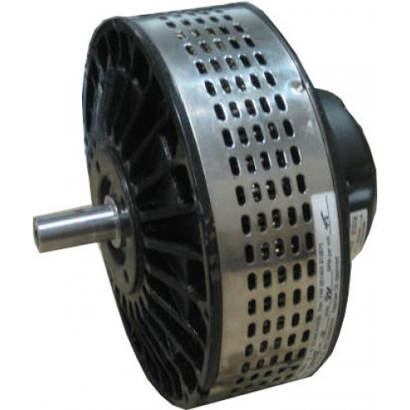
FIG 6: MOTOR
In buggy is fitted between controller and gearbox, controller give power to motor, and motor transfer their power to gearbox, motor has 85% efficiency, so motor consumed around 15% power. 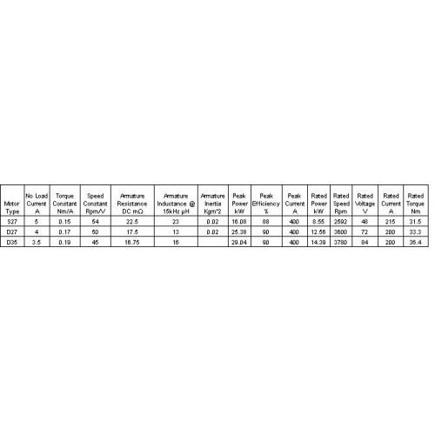

We selected this motor for various resion first this this motor provides sufficient volte which is totally appropriate for our buggy. Secondly this motor is provided good torque which is mentioned in table it is light wight as well. Other details in performance table of in this chart motor.

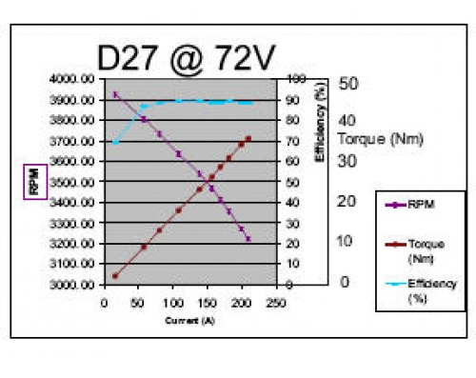
In this graph we can see that RPM, torque and efficiency. Rated power highest voltage outputs range between 8.5kW to 14 kW* and peak instantaneous short duration outputs from 16kW to 29kW*
these motor has high power to wight ratio and wight has around 11kg, it has high efficiency simple electronic control interchangeable shaft, integral commutator and rugged construction moreover it has sped roughly proportion to voltage.

- COSTING
Parts costing
Motor cost =£500
Generator cost around =£450
Controller cost around= £200
And battery cost around = £800
So total cost of part is around £1950.

Battery costing
First, we going battery charging rate in one lap, Sin one lap our battery charged around 6 to 7% so when our buggy complete 15.5lap then battery charged 100%.
so, we consider that 15.5*1.5which is total distance of lap, so all to gather is 23km buggy travel in fully charged battery. In one lap we need 0.22Kw power Frome motor into the battery. So, with fully charged battery we can travel around 12 to 15lap.
After that with help of charging distance and discharging distance we can count one cycle which is we consider around 37km = one cycle. Our battery has a 2000> life cycle.
After that we can count total battery life *total distance in one cycle, so we can get 74000 total battery lifestyles.

Fuel costing
We can say that in pure IC engine buggy par lap engine consumed around 0.10liter fuel. Moreover, after converting with hybrid engine buggy consumed around 0.06.% par lap so we can save around 0.04% in one lap. So, in 74000 we can save fuel around 18500liter in that km.
In fully petrol car for 74000km we need 4933.3liter petrol to run buggy. And now a days we can consider fuel price around £ 1.6. so total cost around £11840
- Comparison of hybrid buggy Final costing
Total fuel cost in IC engine = £ 11840
We can save fuel with hybrid system = £ 4200
Hybrid parts costing = £1950.
So, finale we can save £2250 in one battery cycle.

CONCLUSION
Hybrid Cars consume no energy while idle and utilise less energy than gasoline engines at low speeds. At lower speeds, no pollution is produced, allowing the vehicle to keep its long-term advantage. The car uses an electric motor until it reaches cruising speed, and then it uses an internal combustion engine. They get better gas mileage than regular cars. Noise pollution and CO2 emissions are significantly decreased. However, they are more expensive and more complicated to build than ordinary cars.
REFRENCE
- https://www.everything-ev.com/12V-72V-8.5kW-14kW-PM-Motor
- https://himaxelectronics.com/product-item/25-6v-200ah-lifepo4-battery-pack/hr
- https://himaxelectronics.com/product-item/25-6v-200ah-lifepo4-battery-pack/
- Book: sae global mobility

