Scott Jones
1803767@student.uwtsd.ac.uk
Wireless networks and simulation
Design and Evaluation of Wireless Sensor Networks

Introduction 2
Research of Modulation Schemes 2
Research 2
Simulation or Test Bed? 3
Wireless Sensor Network Design and Evaluation 4
Research 4
Wireless Networks and Communication Systems 4
Internet of Things 4
Security Imaging Technology 4
Design and Implementation 5
Basic Design 5
Lights Design 6
Advanced Design 7
Smart Cities and Monitoring 8
Conclusion 9
References 10

Introduction
The first section of this report will discuss modulation schemes / techniques. It will go in depth about a specific technique chosen, why it was chosen and the advantages and disadvantages of said technique. The chosen modulation technique will need to match the one used in the design for the second section. Each modulation has its own advantages and disadvantages, the one which would be best for the next section will need to be chosen.
The second section of this report will show the design and implementation of a wireless monitoring system in two different situations. These situations will be mentioned just before the design. The design will show a detailed layout of what each case would look like, as well as justifying why certain parts have been strategically placed in order to provide the best protection and signal throughout the area covered. There will also be a short research section which mainly covers different types of security technology that could be used to protect areas where crime happens quite often. All this technology must tie in and be able to function with the layout of the wireless networks. This means that the sensors need to be placed in such a way that everywhere that needs to be covered and be able to access the internet. On a large scale, you can’t use cables because there are too many issues.
Both situations are located on the Caribbean islands. The first situation will be a system for a farm in order to prevent thieves from stealing / damaging the livestock and crops. Anti-theft measures need to be put in place to prevent this from happening. The second situation is for general theft in major cities / towns, especially targeting the use of security on public transport.

Research of Modulation Schemes

Research
There are many different types of modulation techniques. Each have their own pros and cons, and it is important to use the one that is best for your situation. Modulation has quite a simple function. It is the process of converting data into radio waves by adding information to an electronic signal [1]. There are multiple benefits of modulation, the main advantage being that it makes multiplexing possible. Multiplexing combines multiple communication signals so they can traverse an otherwise single signal communication medium simultaneously [2].
Quadrature Phase Shift Keying (QPSK) is one of these modulation techniques. In QPSK, two bits are modulated at once, whereas Binary PSK (BPSK) only modulates one at a time. Modulating two bits are once allows the signal to carry twice as much information (compared to BPSK) whilst still using the same bandwidth. Another advantage is that QPSK has great noise immunity. Noise is a generic word, meaning voltage or current that is usually low amplitude and always undesirable [3]. Obviously, noise immunity is great because it drowns out any currents that are not wanted, this improves the overall quality of the signal. There is also a lower chance of error compared to BPSK (Binary Phase Key Shifting). For eh same rate of error, the bandwidth needed for QPSK is half that needed by BPSK.
A disadvantage of using QPSK over BPSK is that more power is needed in order to transmit two bits instead of one. This makes it less power efficient. Also, QPSK is much more complex compared to BPSK.

QPSK is the main method for modulation used in modems, satellites and various other communication systems. An article written by Lee Teschler talks about the fundamentals QPSK modulation. “The concept of quadrature phase key shifting arises from the idea that there can be more than two states of phase shifting” [4]. This is where quadrature phase key shifting gets its name. It is also called “4-PSK” that corresponds to the four phases involved. A digital signal is used to alternate between 2 signals with the same frequency, which in turn will generate a phase-modulated waveform. Multiplying this modulated waveform by a sine wave with equal frequency would generate two component waveforms [4]. In quadrature phase key shifting, the carrier undergoes four changes in each phase, each of the phases can represent two binary bits of data compared to one in Binary Phase Key Shifting.
The four phases involved are determined to be 45 degrees, 135 degrees, 225 degrees and 315 degrees. There needs to be a 90-degree separation between each phases since there are four phases to fit into a 360-degree space. Another article by Robert Keim states that it makes sense to use the four phases (45, 135, 225 and 215) since they are easily generated using I/Q modulation techniques [5].

Simulation or Test Bed?
When it comes to research methods, simulation is widely used in the industry. There are other methods, such as testbeds. These methods will be compared. A very generic definition of a testbed is any device used for testing something. A great advantage of simulation is that it is a flexible method. High flexibility aids in answering a wide range of research questions [6]. Another good advantage of using simulation over other methods such as test bed, is that you can create and run the simulations with little to no data. Although, if you want to check the integrity of the data, you will need other data sources to compare to. If you didn’t compare, there is no way you can be confident that the data is accurate and represents what it is supposed to.
A research paper by U. M. Colesanti, C. Crociani & A. Viteletti (see reference [7]) goes in-depth about using simulations and test beds in a wireless sensor network. The paper talks about how a test bed can strongly constraint a network due to the cost of running the equipment on a testbed, and that using simulation is the ‘most practical tool to obtain a feedback on the performance of a new solution’.

Wireless Sensor Network Design and Evaluation

Research

Wireless Networks and Communication Systems
Wireless Communication Systems are essential for every day communication over the internet. Computer systems transfer data back and forth to be able to execute specific programs. There are multiple different types of wireless communication systems.
Satellites are one of the most popular communication method. Satellites provide worldwide coverage and have multiple advantages especially for rural areas. This systems offers a variety of wireless services, including GPS, Broadcasting and Internet [8]. Satellites are very affordable for rural areas. If you think about the cost of deploying either fibre optic or copper cables from the plant to customers, it would be very high for people in sparsely populated areas [9].
A big disadvantage of using satellite communication is that it needs a direct line of site with the receivers. This may cause some noise interference with the signal. This is the main reason why satellites are less reliable and usually slower than broadband or fibre connections.
It is useful having a communication system that uses low energy, that has a wide range. LoRa (standing for Long Range) is one of these systems. This radio modulation technique can reach up to 30 miles away from a LoRa based station. If a company wants to have access to LoRa, they need to purchase LoRa-capable chips so that the devices can connect to the LoRaWAN network [10].

Internet of Things
In basic terms, the Internet of Things (IoT) is made by devices that are connected via the internet. IoT allows devices on a private network to communicate with one another, these devices can range from smart toasters to fitness collars for dogs [11].
Security may be an issue with IoT, some sensors are collecting very sensitive data. There could be flaws in any software and hardware. Some of these devices are unable to be patched, which means they are permanently at risk [12].
Internet of Things plays a massive part in Smart Cities. Cities are already collecting massive amounts of data every single day through security cameras and sensors. Connecting all the networks in a city would allow for a greater intelligence on how the city functions. This can be monitored, and appropriate actions could take place to improve an environment.
A great example of this is the use of smart sensors for parking and traffic in Kansas City. This provides real-time visualisation of data collected by these sensors, so the residents in this area have an easy time navigating themselves through the city.

Security Imaging Technology
A full body scanner is basically a device that shows what somebody is carrying on their person, this is used for security purposes. It allows for body scanning without any physical contact. These scanners are found all over the world, primarily in Airports to stop the illegal trafficking of prohibited items.

Design and Implementation
The task is to design a wireless monitoring system for a farm in the Caribbean. The goal of this system is to prevent criminals from scrutinising the farm in anyway. Several designs have been made to show the basics of this farm.

Basic Design
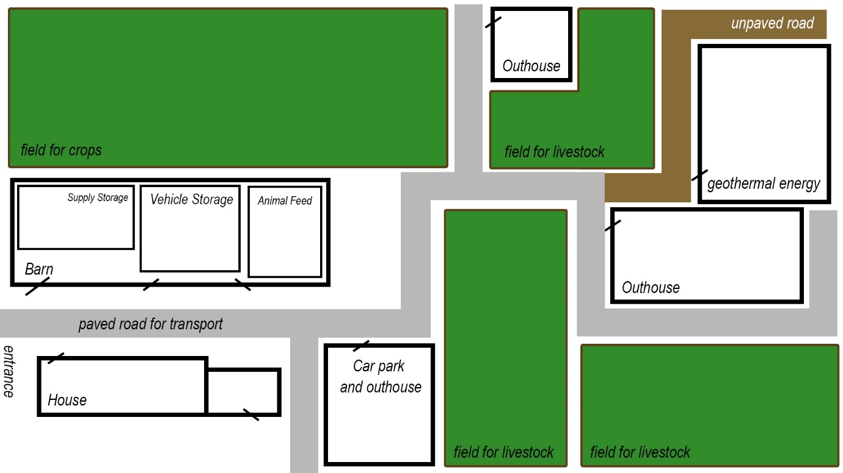
This is the barebones of the design without any of the security methods shown on it. The farm is a rectangular shape farm with outhouses scattered throughout. The main purpose of these outhouses is to put the animals in at night time. The outhouses also carry a signal from the main router in the house across the farm to all the sensors and devices throughout the farm. The black border surrounding the picture shows the fence which would be coated with anti-climbing paint. This paint is a non-toxic method used for security in mainly places, often found on train station fences. If somebodies’ hand or clothes touch this paint, it will stain and be difficult to remove. This can be rather expensive to paint the entire high fence this colour, so it would just be put on top to stop people from climbing. This paint can be a decider if someone is accused of climbing somewhere that they shouldn’t.
The small geothermal energy plant in the top right corner of the image would be the main power source for the farm. Geothermal energy uses heat sources stored within the earth to generate power. Usually geothermal energy plants are large, yet it is possible to have a small one. An article written by Alexander Richter shows just how small one of these plants can be (see reference [13]). Obviously, they produce less energy than large plants, but this shouldn’t be a problem since it only needs to supply power to the farm. The Caribbean islands are ideally located to harvest geothermal energy [14]. The farm has one main entrance, which will be covered. So, if an intruder wants to get into the farm, they would need to go over/through the fence. For the next design it will show the light setup of the farm.

Lights Design
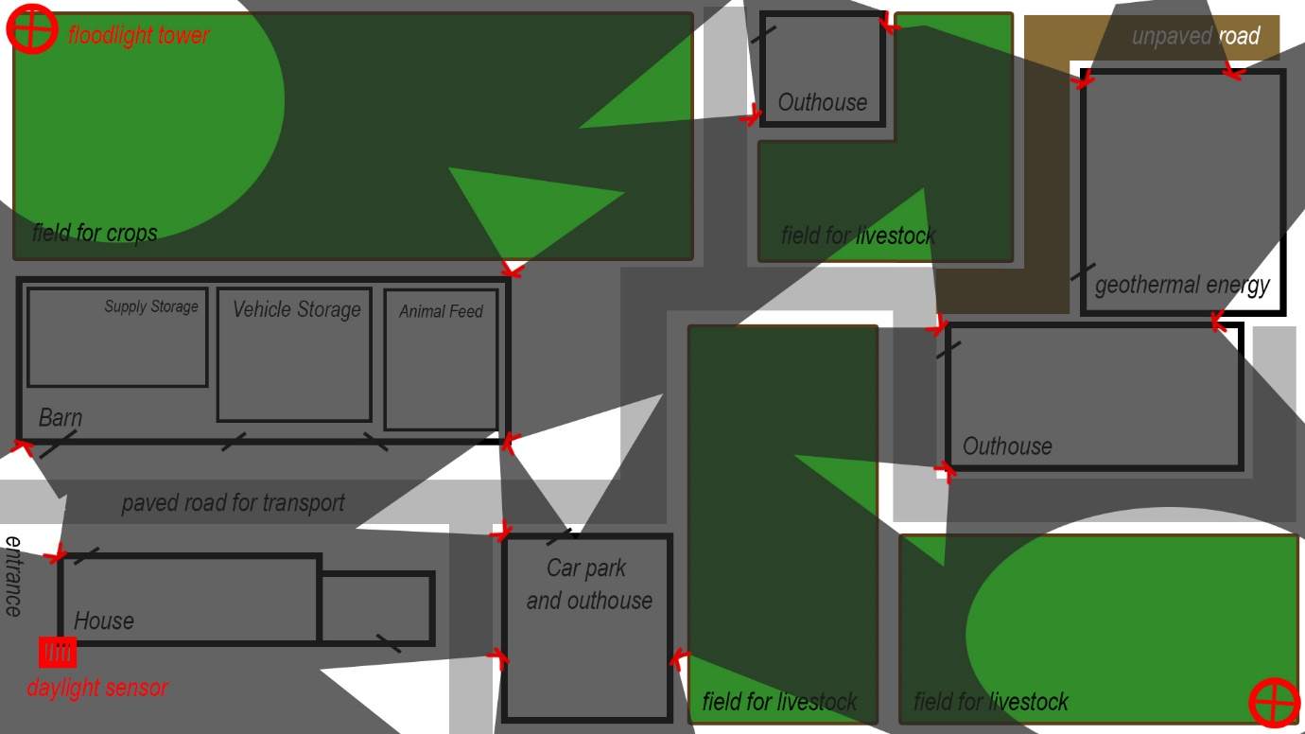
The specification says that most of the farms are raided at night. These lights would be controlled by a daylight sensor that is located on top of the house. This sensor would distinguish between day and night, and when it gets to the time of day where the sun goes down it will automatically activate all the lights across the farm. The point of these lights is to cover most of the farm that would be most vulnerable, for example the corners. The above pictures show the areas that would be covered with the lights the rest has been blacked out to simulate the darkness.
The floodlights in two of the corners would supply a 360-degree illumination, they act as floodlights so they would be significantly bigger and brighter than the other lights. These floodlights would require a lot of power, which is a downside to the lighting. The money is saved through the geothermal energy. These lights are over the fields, they would-be put-on top of poles that are secured into the ground.

Advanced Design
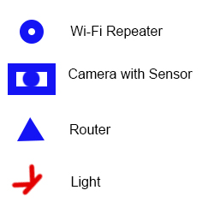
Key
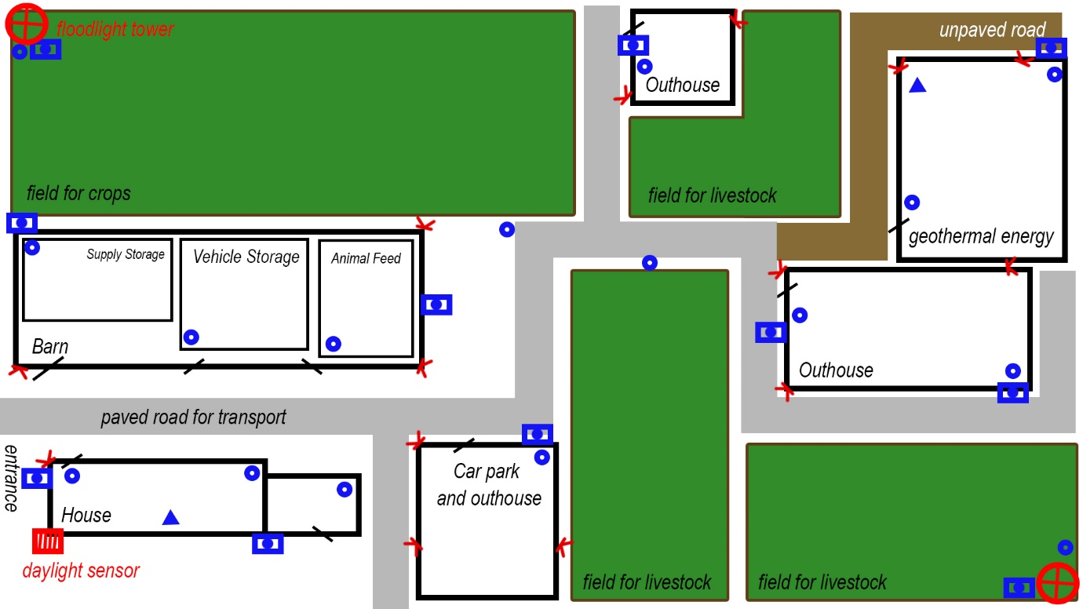
This is the design including the cameras, routers and repeaters. There is a key above the image to show which icon is which. The main router is in the house, so the house has the strongest connection since this is where the owners would be living. There will obviously be a difference in internet speed the further away you are from the router. Since repeaters are being used, with every repeater the speed and performance decreases. It is possible to connect a repeater to a repeater, but the performance would drop significantly. That is why there is a second router in the power plant. This is so there is a moderate internet performance throughout the farm.
There is also sensor activated cameras which will only start recorded when the sensors pick up movement. This is to reduce the power and storage that the cameras use. If all the cameras were recording 24/7, there would be an absurd amount of storage needed for all the footage. This network would also be linked directly to a police station so any footage gathered would be sent directly to the station after being reviewed by the owner of the farm. If the footage wasn’t reviewed, the police station could get spammed with unnecessary footage.

Smart Cities and Monitoring
Smart cities all over the world are growing bigger and better as new technology emerges. It is important to make sure everything is constantly being monitored with little to no downtime. The second situation talks about robbery and theft in major towns and cities, targeting civilian commuters specifically since these are the most effected.
On a city-wide scale, any method of security that is introduced will be very expensive since it would need to be all around the city. There are measures that could be put in place to try and stop people from carrying concealed weapons. A few months ago, in London, UK, a new technology was developed specifically for finding concealed weapons being carried by people. These smart cameras measures body heat, and they can pick up any objects on a person that is blocking their body heat in any way. Police or law enforcement officers can be trained to detect such weapons and act accordingly [15]. It could be made public that these cameras will be placed around the city, including on buses, trains and their appropriate stations. If the funding is available, these cameras could be implemented everywhere on a small scale. There should also be a heavy penalty / charge to anybody carrying such a weapon, this would reduce the number of people carrying.
It may be thought, what would a bus drive do exactly if somebody was carrying a knife or a gun? If there was a silent alarm installed on every bus (like there is in every bank) which monitors the next stop on route, the bus driver can press the alarm if somebody with a concealed weapon enters the bus. There would then be a police officer waiting at the next bus stope to take appropriate action towards the carrier. The silent alarm would not make the carrier away that the police will be waiting for them.

Conclusion
This report talked about wireless communication methods and monitoring systems. IT is important to keep up to date on the latest wireless technologies.
The first section talks about wireless communication and research methods. This part discussed the differences, advantages and disadvantages of some of the main methods.
The second section of the report talks about to specific cases in the Caribbean Islands. Satellites are no longer the go-to method in most places, yet on the rural farm it may have been the only option depending on how remote the farm was. There may no be any cellular coverage in that area, which means there would be no chance for copper or fibre optic cabled connection. The satellite connection would only need one receiver which isn’t obstructed in any way to be able to carry a connection throughout the farm’s devices. This included a design of the farms. The second scenario was robbery and theft in a city. Security Monitoring systems would need to be implemented, along with heavy penalties for any corresponding crimes, to try and reduce the impact that this is having on people’s daily lives.

References

[1] | M. Rouse, “modulation,” TechTarget, October 2018. [Online]. Available: https://searchnetworking.techtarget.com/definition/modulation. [Accessed 28 April 2020].
[2] | J. M. Stewart, “What Is Multiplexing?,” Global Knowledge, 22 August 2013. [Online]. Available: https://www.globalknowledge.com/us-en/resources/resource-library/articles/what-is-multiplexing/. [Accessed 28 April 2020].
[3] | R. Keim, “What Is Electrical Noise and Where Does It Come From?,” All About Circuits, 21 June 2018. [Online]. Available: https://www.allaboutcircuits.com/technical-articles/electrical-noise-what-causes-noise-in-electrical-circuits/. [Accessed 2 May 2020].
[4] | L. Teschler, “QPSK Modulation and generating Signals,” Test and Measurement tips, 4 April 2017. [Online]. Available: https://www.testandmeasurementtips.com/basics-qpsk-modulation-display-qpsk-signals/. [Accessed 2 May 2020].
[5] | R. Keim, “Understanding Quadrature Phase Shift Keying (QPSK) Modulation,” All About Circuits, 17 August 2016. [Online]. Available: https://www.allaboutcircuits.com/technical-articles/quadrature-phase-shift-keying-qpsk-modulation/. [Accessed 2 May 2020].
[6] | D. Duzevik, “Advantages and Disadvantages,” Concentric, 3 February 2017. [Online]. Available: https://concentricmarket.com/blog/advantages-and-disadvantages-of-simulation. [Accessed 4 May 2020].
[7] | C. C. A. V. Ugo Maria Colesanti, “On the Accuracy of Omnet++ in the Wireless Sensornetworks Domain: Simulation vs. Testbed,” in Proceedings of the 4th ACM Workshop on Performance Evaluation of Wireless Ad Hoc, Sensor,and Ubiquitous Network, New York, Association for Computing Machinery, 2007, pp. 25-31.
[8] | Anusha, “Wireless Communication: Introduction, Types and Applications,” Electronics Hub, 8 June 2017. [Online]. Available: https://www.electronicshub.org/wireless-communication-introduction-types-applications/. [Accessed 4 May 2020].
[9] | M. Marius, “SATELLITE COMMUNICATION: PROS AND CONS,” ICT Pulse, 28 September 2016. [Online]. Available: https://www.ict-pulse.com/2016/09/satellite-communication-pros-cons/. [Accessed 4 May 2020].
[10] | C. Atwell, “Everything You Need to Know about LoRa and the IoT,” DesignNews, 9 May 2019. [Online]. Available: https://www.designnews.com/electronics-test/everything-you-need-know-about-lora-and-iot/16320406960771. [Accessed 4 May 2020].
[11] | M. Burgess, “What is the Internet of Things? WIRED explains,” WIRED, 16 February 2018. [Online]. Available: https://www.wired.co.uk/article/internet-of-things-what-is-explained-iot. [Accessed 4 May 2020].
[12] | S. Ranger, “The Internet of Things explained. What the IoT is, and where it's going next.,” ZDNet, 2 February 2020. [Online]. Available: https://www.zdnet.com/article/what-is-the-internet-of-things-everything-you-need-to-know-about-the-iot-right-now/. [Accessed 4 May 2020].
[13] | A. Richter, “MiniGeo – a small-scale, off-grid geothermal power plant for remote areas,” ThinkGeoenergy, 24 May 2016. [Online]. Available: https://www.thinkgeoenergy.com/minigeo-a-small-scale-off-grid-geothermal-power-plant-for-remote-areas/. [Accessed 4 May 2020].
[14] | M. Pandika, “The Caribbean goes geothermal,” USA Today, 25 August 2014. [Online]. Available: https://eu.usatoday.com/story/news/nation/2014/08/25/ozy-caribbean-geothermal/14559687/. [Accessed 4 May 2020].
[15] | Home Office, UK, “New technology to detect knives in public places,” GOV.uk, 16 September 2019. [Online]. Available: https://www.gov.uk/government/news/new-technology-to-detect-knives-in-public-places. [Accessed 5 May 2020].

marking criteria and Student FEEDBACK

This section details the assessment criteria. The extent to which these are demonstrated by you determines your mark. The marks available for each criterion are shown. Lecturers will use the space provided to comment on the achievement of the task(s), including those areas in which you have performed well and areas that would benefit from development/improvement.

Common Assessment Criteria Applied (Assignment 1) | Marks available | Marks  awarded
1. Engagement with Literature Skills
Extent of research and/or own reading, selection of credible sources, application of appropriate referencing conventions.
You have discuss key concepts, appropriately summarised your research content and use the appropriate referencing convention. However, most of your sources are company articles and website. You need to engage with academic peer review article to make your work credible. Websites require careful consideration. (Grade mark: 66.67%) | 15 | 10
2. Knowledge and Understanding Skills
Extent of knowledge and understanding of concepts and underlying principles associated with the discipline.
You have demonstrated knowledge and understanding. However, see comment above which is lacking in this report. You have not used the IEEE report formatting. (Grade mark: 66.67%) | 15 | 10
3. Cognitive and Intellectual Skills
Analysis, evaluation and synthesis; logic, argument and judgement; analytical reflection; organisation of ideas and evidence
You have reviewed and justified the chosen modulation technique (BPSK). A Simulink model wasn’t explained or discussed. You were required to do a Simulink creation of a modulation technique. Task 1 was not completed due to the missing Simulink creation of a modulation technique. This was covered in the tutorial by Paul along with e.g. of QPSK and QAM 64, along with SNR and aWGN. These were carried out in tutorial by students along with excel line graph. You have discuss relevant solutions for the case study, evaluating solutions for farmers and the increase crime robbery in the city. Your conclusion can be improved and summarised more of the key areas of your report. (Grade mark: 60.00%) | 30 | 18
4. Practical Application Skills
Deployment of methods, materials, tools and techniques; application of concepts; formulation of innovative and creative solutions to solve problems.
You have discuss application of the methods, tools and sensors you would design in the practical development. Your design of the physical implementation was well labelled and explained which include the cameras, routers and repeaters, sensors, light, etc. It's a pity, these design could not be simulated. Good job. (Grade mark: 77.14%) | 35 | 27
5. Transferable Skills for Life and Professional Practice
Attributes in professional practice: individual and collaborative working; deployment of appropriate media; presentation and organisation.
Your work could do with formatting alignment. There are some grammatical errors, Some sentences could be written much clearer; engaging with peer review articles will improve your writing style. (Grade mark: 60.00%) | 5 | 3

Assignment Mark (Assessment marks are subject to ratification at the Exam Board. These comments and marks are to give feedback on module work and are for guidance only until they are confirmed. ) | Late Submission Penalties (tick if appropriate) |  | 68%
 | Up to four weeks late |  | 68%
 | First Attempt? |  | 68%

