ADPA 5002

Changemakers: Creativity and Value Creation

Student number: 2103390

Submission deadline: 20th January 2023

Table of contents
Introduction | p.3
Method | p.6
-Design | p.6
-Participants | p.6
-Procedures | p.6
-Materials | p.6
Results and discussion | p.7
References | p.10
Appendices | p.12
-Appendix 1: Questionnaire to international students | p.12
-Appendix 2: Questionnaire to UK students | p.14
-Appendix 3: Responses to question 2 | p.15
-Appendix 4: Responses to question 6 | p.16
-Appendix 5: Responses to question 3 | p.17

Project Proposal: On campus donation room
Introduction
As a result of international travel restrictions, international students must leave behind items that could have benefited their studies as well as their day-to-day life.

According to Bolton and Lewis (2022, p.1), “584,100 overseas students” came to study in a UK university in 2021/22. However, travelling overseas comes with limitations. Items including kitchenware, specifically, knives and scissors, may be seen as weapons, meaning these items cannot be travelled with in their hand luggage, as well as their hold luggage in some cases (Gov.uk, 2021). Additionally, tableware like plates can be heavy to transport, so students may also avoid travelling with these items.

With an increase in the cost of living, students may find difficulty in purchasing items essential for their study and beneficial for their daily lives. In response to a study completed by Study International (2022, p.1), “69% of applicants” expressed that the cost of living in the UK was such a concern that it was a leading factor in preventing them from wanting to study here. Therefore, with an on-campus donation room made accessible to international students, they can access items they want or require at no cost to themselves.

With limited transport made available up to the university, it can also be difficult to transport items to accommodation. Buses from Carmarthen bus station to the university run on an hourly basis and stop after 6pm (Traveline Cymru, 2022). As a result of this, international students may find difficulty in transporting recently bought items to campus, specifically as a result of timetabled teaching/learning sessions leaving little room for students to make this journey during the week. An on-campus donation room will relieve that stress as they can access what they need via the donation room.

In our day to day lives, we produce large amounts of waste which can be harmful to the environment, therefore donating to the donation room can be a sustainable solution, helping towards reducing waste. According to Lancen (2022), donating can reduce the overall amount of waste we produce. She explains that local charities accept many things now, including large furniture and electronics, making it accessible for all to do. Romano (2022, p.1) reinforces this by stating donating “can reduce waste in a landfill by almost 10%”. However, Kealty (2021) reminds us that if donated items are deemed unfit for trading, they can add to landfill. This suggests that donating is not always the best option for some items, and it can benefit the environment more if we safely recycle items that cannot be rehomed. Therefore, it is important to ensure to check the safety and function of items to be certain students can make effective use of what they are borrowing. It will be the responsibility of the donation room staff to make sure this happens by contacting the appropriate department within the university to have all donated electrical appliances tested via portable appliance testing (PAT) before they are made available to students. It has also been found that students who use second-hand items are more environmentally aware than those who do not shop second-hand (Yan, 2015).

A main concern was being able to recruit enough students to operate the donation room. A general overview was gathered of whether students are likely to volunteer for the greater good of others. Ellison and Kerr (2014, p.4) state that “78 per cent of students” who do voluntary work reflected that they do it for the benefit of others. They continue by stating that one of the main reasons for volunteering was that students felt it was an opportunity to develop new skills. Therefore, in theory, it is likely that at least a few students will volunteer to staff the donation room.

Through exploring the possibilities of making the donation room a reality, it became apparent that the donation room may be slow to start, potentially as a result of a lack of donations. The Guardian (2012) clarifies that 16% of people under the age of 30 donated to charities in the year 2010. A more recent study from Clark (2022) shows that 50% of people aged 16 to 24 donate to charities frequently. However, the same study indicates that this percentage is decreasing by an average of 5% every year. Knowing this, there will be a need to ensure that the marketing of the donation room is clear and accessible to students who do wish to donate.

Primary research was conducted via questionnaires developed with carefully thought-out questions to ensure that the relevant information was received to progress with this study. Although this project is aimed at international students, it also wanted to gauge the attitudes and opinions of students from the UK. Secondary research was then conducted to compare the responses with current literature; this was done from both the international and UK student questionnaires, to help evaluate whether there would be a clear demand for a donation room, in other words, if there was a market for it.
The responses from the questionnaires revealed that both the international and UK students would appreciate having a donation room on campus. Therefore, the aim is to explore the possibilities and potential obstacles associated with achieving this. The Students’ Union (SU) was contacted as a starting point to present the idea and gain feedback from them, to see if they would be able to support the necessary arrangements to move forward with the idea.

The overall objective is to enable international students to be able to settle at university and eliminate the stress that comes with the practicalities of moving to campus. Although this project is still early in the planning stage, it would be good to be able to set this up and, over time, make it accessible to all students at the university.

Method
Design
Questionnaires were designed to ascertain whether it was felt that there was a need for a donation room on campus to help international students to obtain resources they were not able to bring with them due to flight restrictions. The questionnaires had 9 questions for UK students with an emphasis on whether they would be happy to donate to the donation room and volunteer to run it. The questionnaires sent to the international students had 11 questions, with an emphasis on whether they would use the donation room, what items they would not be able to bring with them, and what they would find useful to be able to obtain from the donation room.
Participants
32 UK students and 20 international students participated in the research.
Procedures
2 separate questionnaires were distributed to UK students via social media (WhatsApp), and international students via e-mail.
Participants were asked to respond to the questionnaire within 3 weeks.
Materials
Questionnaire 1 (refer to appendix 1)
Questionnaire 2 (refer to appendix 2)

Results and discussion
During the research several key themes were noted.

In terms of exploring which personal and practical items were restricted during travel, it was found that kitchenware was the most recurring theme in the responses from the international students. International students were asked if there were any items they forgot or were unable to travel with. 85% of respondents replied with items relating to kitchenware, 30% of which specifically stated “knives” as an item in their responses. This is supported in existing research which stated travel restrictions prevent students from travelling with items they need, for example knives and scissors (Gov.uk, 2021). Due to this, students must purchase these items when they arrive in the UK.

When asked, if they would be happy to borrow second-hand or unused items, 75% of international students responded “yes” (see appendix 3). As students elaborated on this response, 35% suggested that they prefer second-hand items as it is “good for environment”, indicating that students are keen to take steps in reducing the amount of waste we produce. The existing research suggests that using recycled items can significantly reduce landfill (Romano, 2022) and that students are prepared to make use of second-hand items provided they are deemed safe to use. As participant 1 stated, “As long as items are clean and safe I can’t see why it should be a problem”, otherwise they may end up in landfill (Kealty, 2021). Research also showed that environmental awareness is present in those who do shop second hand (Yan, 2015).

With the main concern being that there would not be enough student volunteers to operate the donation room, students were asked in the survey if this was something they would be prepared to do. With 63% of respondents replying “yes” (see appendix 4), it was reassuring that the donation room would have the support it needs to be put into effect. Prior research indicates that many students who volunteer do it to help people who need it, as well as to build on existing abilities whilst learning new skills (Ellison and Kerr, 2014, p.4).

After concerns about the donation room receiving a beneficial amount of donations from students, students on Carmarthen campus were asked via questionnaire if they would be willing to donate items to the donation room. With 94% responding “yes” and 6% responding with “maybe” (see appendix 5), knowing that we would have plenty of donations to the room was very encouraging. This percentage exceeds average percentages found in online research, as in previous studies, it was found that only 50% of people under 24 in the previous year donated to a charity (Clark 2022). The same research also indicates that the percentage of donations by people under 24 has decreased by 24% since 2013.

The strengths of the donation room are that it can be accessed by students at no cost to them. Moreover, in comparison to local shops, the donation room will be located on-campus, making it accessible to students living in university accommodation. The donation room is also a sustainable form of recycling, helping to reduce landfill. Not only can international students access items they need, reducing stress, but student volunteers can also develop new transferrable skills to further excel in future employment.

There are some challenges, one of which being that the donation room may be slow to start due to a lack of donations. To overcome this, marketing the donation room via posters and social media would allow us to reach more students, raising awareness of the donation room. Furthermore, whilst electrical items are sent away for PAT testing, it can cause delays for students who may need a particular electrical item. Moreover, there would be a need for the university to agree to provide, for example, health and safety, fire safety training, as well as taking responsibility for any waste produced to ensure safe disposal, and this may take extra time due to rules the university has to follow.

Future amendments, or additions to the idea of a donation room could include the following: firstly, organising meetings with international students to fully understand their issues or concerns about transporting their belongings onto campus; secondly, setting up a scheme to ensure student volunteers gain recognition for their work via a certificate stating the hours they have spent helping international students and volunteering to run the donation room; and finally, making the donation room available to all students rather than only international students, in order to support UK students who could also benefit from the service.

References
Bolton, P. and Lewis, J. (2022) International Students in UK Higher Education. Available at: https://commonslibrary.parliament.uk/research-briefings/cbp-7976/#:~:text=Overseas%20student%20numbers%20In%202020%2F21%2C%20there%20were%20605%2C100,students%20by%202030%20was%20met%2010%20years%20early (Accessed: 2 January 2023).
Clark, D. (2021) Charitable Giving England 2020, by Age. Available at: https://www.statista.com/statistics/292936/giving-to-charity-in-england-by-age/ (Accessed: 4 January 2023).
Ellison, F. and Kerr, H. (2014) The Student Volunteering Landscape. Available at: http://s3.amazonaws.com/student-volunteering-week-production/attachments/resources/pdfs/47/original/The_Student_Volunteering_Landscape.pdf?1392977996 (Accessed: 5 January 2023).
Gov.uk (2021) Hand Luggage Restrictions at UK Airports. Available at: https://www.gov.uk/hand-luggage-restrictions/personal-items (Accessed: 2 January 2023).
Kealty, C. (2021) Our Clothing Donations May Cause More Harm than Good. Available at: https://www.ncronline.org/news/opinion/our-clothing-donations-may-cause-more-harm-good (Accessed: 15 December 2022).
Lancen, L. (2022) 6 Ways to Reduce Waste in the Community. Available at: https://www.climateofourfuture.org/ways-to-reduce-waste-in-the-community/#:~:text=Disposing%20of%20used%20items%20creates%20a%20lot%20of (Accessed: 15 December 2022).
Romano (2022) 7 Reasons Why Reducing Waste to Landfill Is Important. Available at: https://planetrenewed.com/7-reasons-why-reducing-waste-to-landfill-is-important/#:~:text=Donating%20items%20to%20a%20new%20family%2C%20donation%20centers%2C (Accessed: 15 December 2022).
Study International (2022) Is the Cost of Living in the UK Too Expensive for International students? Available at: https://www.studyinternational.com/news/cost-of-living-in-the-uk/ (Accessed: 2 January 2023).
The Guardian (2012) Charitable Giving - How Does It Differ by age? Available at: https://www.theguardian.com/news/datablog/2012/sep/25/charitable-giving-generation-gap-age (Accessed: 4 January 2023).
Traveline Cymru (2022) Journey Planner. Available at: https://www.traveline.cymru/journey-planner-results/?search=1&typeaheadFromName=Carmarthen+Bus+Station+%2C+Carmarthenshire&typeaheadFromLat=51.8557&typeaheadFromLng=-4.3085&typeaheadToName=UWTSD+Carmarthen+Campus+%2C+Carmarthenshire&typeaheadToLat=51.8584&typeaheadToLng=-4.3287&maxWalkDistanceMetres=800&from=Carmarthen+Bus+Station+%2C+Carmarthenshire&to=UWTSD+Carmarthen+Campus+%2C+Carmarthenshire&time=08%3A45&date=1674000000&timeMode=LeaveAfter&maxChanges=999&walkSpeed=4&maxWalkDistanceMetresRestricted= (Accessed: 5 January 2023).
Yan, R-N. (2015) Second-hand Clothing Shopping among College students: The Role of Psychographic Characteristics. Available at: https://www.researchgate.net/publication/276083185_Second-hand_clothing_shopping_among_college_students_The_role_of_psychographic_characteristics (Accessed: 5 January 2023).

Appendices
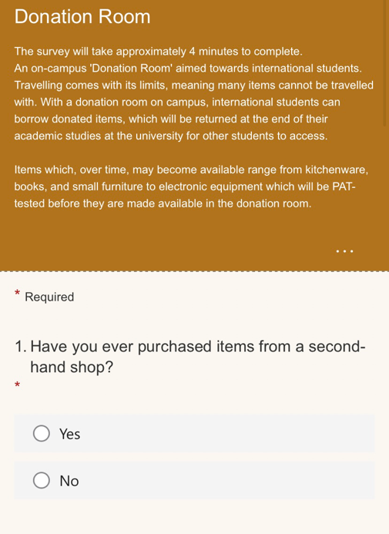
Appendix 1 – Questionnaire to International students
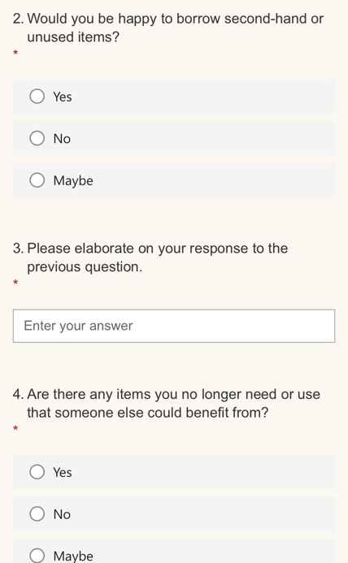

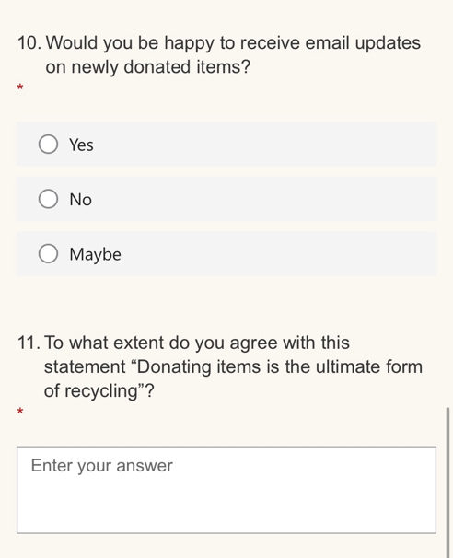
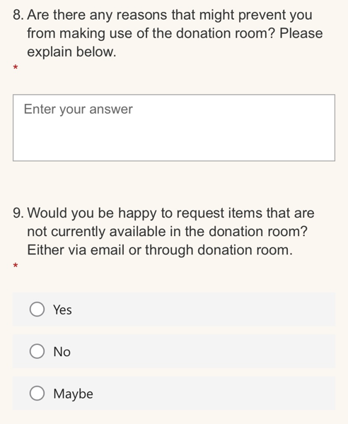
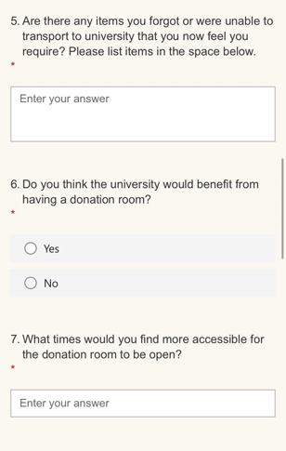
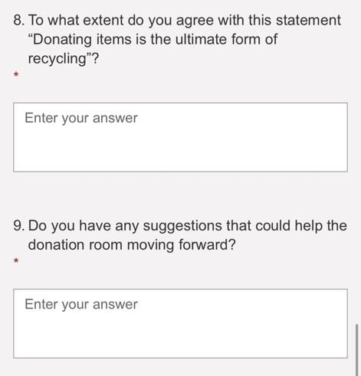
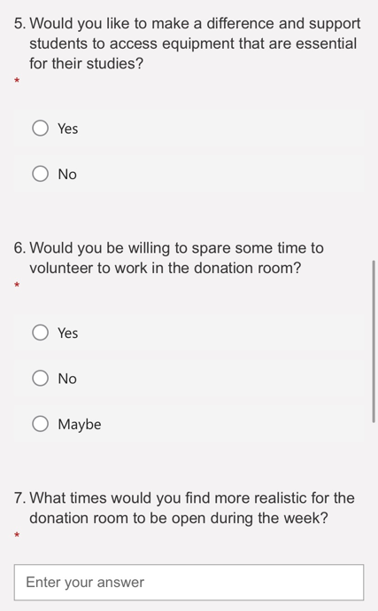
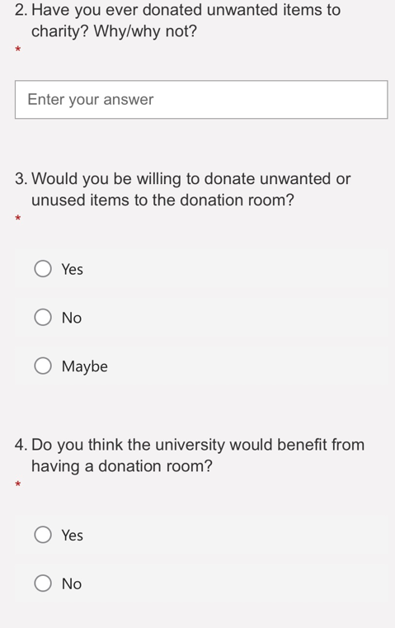
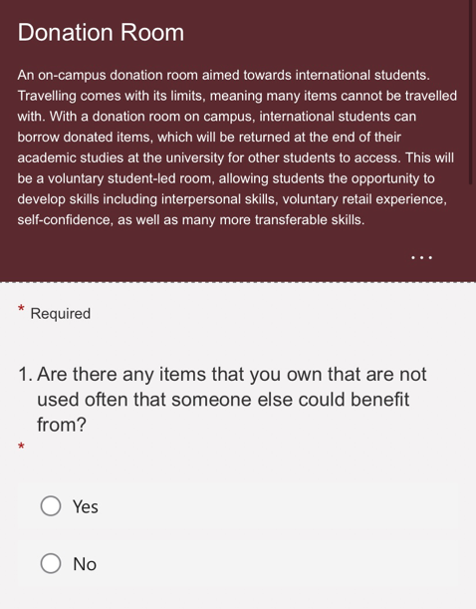
Appendix 2 – Questionnaire to students

Appendix 3 – Response to question 2
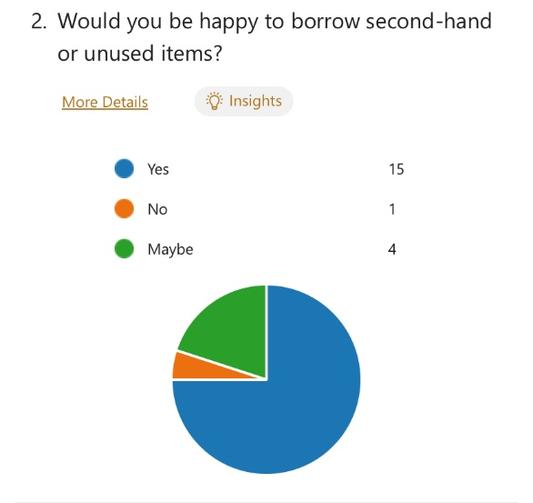

Appendix 4 – Response to question 6
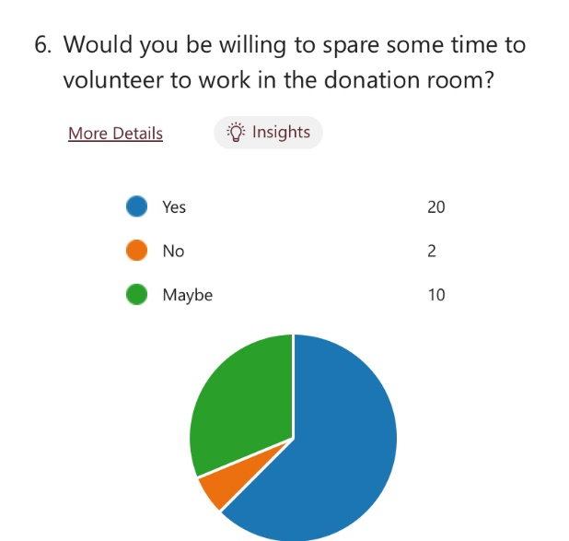

Appendix 5 – Response to question 3


