


Gareth Jones
Micros Peripherals and Interfaces (L4)

ACDA4004
Contents
Introduction 5
PIC16F84A circuit 5
Components used 6
PIC considerations 9
PIC data 9
Programming the Pic 9
Ports 10
Pins 10
ALU 10
W Register 11
How ALU and the W Register work together 11
Register file map 11
Watchdog timer 11
Fuses 11
Binary 12
Hexadecimal 12
Displaying hexadecimal characters on a seven-segment display 12
Coding questions 12
Code set up 12
(Definitions) 13
(Variables) 13
(Reset and interrupt vectors) 13
1. Modify “Count.asm” 0 to F in hexadecimal numbers in 0.2 second increments. 14
2. Two buttons, it displays "L" or “r” the 7 segment LED display 16
16
3. LED segments to light all on or all off 17
18
4. Display5 count up to 9 and back down to 0 18
5. Make piezo sounder produce a tone while one of the buttons is pressed 21
Summary 22
References 23
Appendices 24

Figure Table
Figure 1 PIC16F84A circuit 5
Figure 2, Original circuit provided 6
Figure 3, LED display 6
Figure 4, Display configuration [1] 7
Figure 5, Truth table 7
Figure 6, 5V regulator with capacitors 7
Figure 7, Transistor and buzzer 7
Figure 8, Buttons with pull up resistors 8
Figure 9, Crystal and capacitors 8
Figure 10, PIC, 8
Figure 11, Block diagram on PIC [4] 9
Figure 12, Pin location 10
Figure 13, Register file map 11
Figure 14, Binary for 1-F 12
Figure 15, Code set up 13
Figure 16, End of each code 14
Figure 17, flow chart 0-f display 14
Figure 18, Code for question 1 (1) 15
Figure 19, Code for question 1 (2) 16
Figure 20, Flow chart for "L" or "R" button press 16
Figure 21, code for question 2 17
Figure 22, Flow chart for all LED's on/off 17
Figure 23, Code for question 3 18
Figure 24, Flow chart, question 4 19
Figure 25, Question 4 (1) 19
Figure 26, Question 4 (2) 20
Figure 27, Question 4 (3) 20
Figure 28, Question 4 (4) 21
Figure 29, Flow chart for question 5 21
Figure 30, Question 5 code 22

Introduction

This report includes a simulated circuit from the “count” project, originally designed for the HND/BEng PIC16F84 board assignment using Proteus. The PIC16F84A microcontroller is part of the PIC16 family and is typically used in simpler embedded systems. In this project, the microcontroller drives the circuit and interfaces with a seven-segment display through its General-Purpose Input/Output (GPIO) pins. The report will provide detailed explanations of the components and their functions, supported by external research. Later, it will include examples of the assembly code used, illustrating how these components interact within the circuit. The code will be annotated, and flowcharts will be provided to outline the coding process.

PIC16F84A circuit
The circuit shown in Figure 1, is built off the original circuit shown in Figure 2. It has an 8-bit microcontroller from Microchip which is the central controller reading button inputs and controlling outputs to the LED display and buzzer. There are seven 220Ω resistors in series to limit current flow through each segment of the LED display. Two buttons with 10K pull up resistors
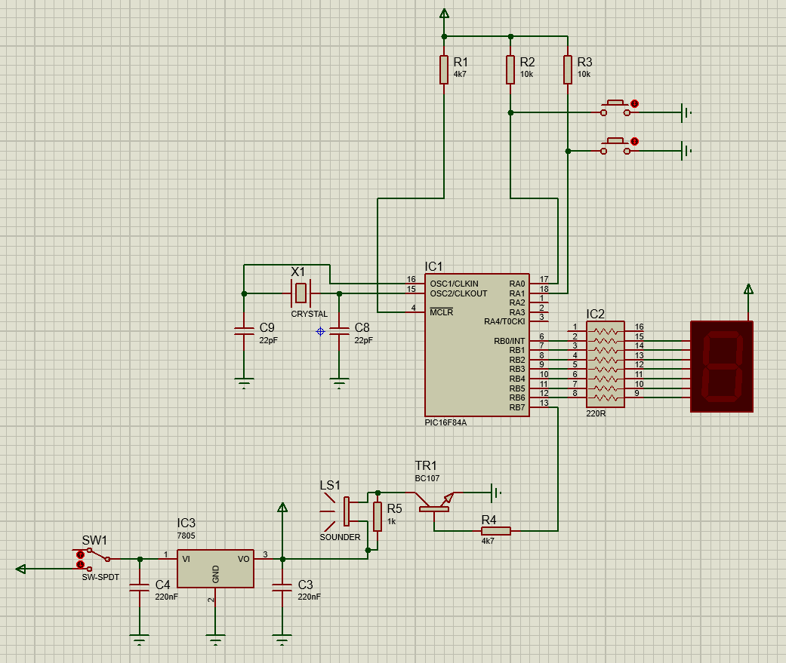
Figure 1 PIC16F84A circuit
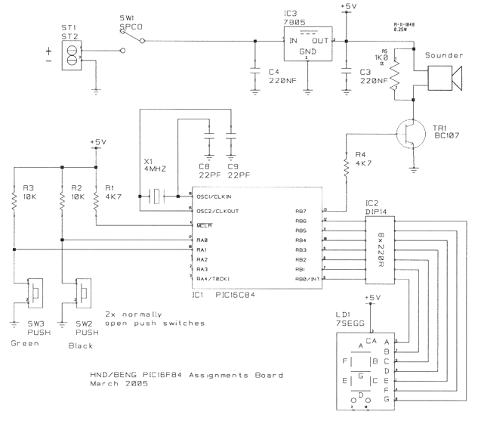
Figure 2, Original circuit provided

Components used
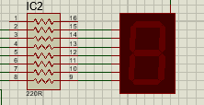
LED seven segment display – This simple display consists of seven segments all of which can be turned on and off individually, when combined they can produce numbers and letters [1] . seven segment displays can also be arrayed next to each other to create multi-digit displays, Display configuration show in Figure 5 [1]. When coding later in the report it becomes apparent how important it is to know which segment lights up. Also shown in Figure 3, LED is the seven 220Ω resistors. Each one connected to each segment to reduce the chance of burn out, seen in Figure 4. The common anode needs 5V which goes through a 220Ω resistor, one for each segment. Resistor 1 is not used as we don’t need the decimal point on this occasion. The LED display is sinking current into the PIC. If a segment needs to be on the logic is 0 as it is +5V from the common anode not the PIC, the PIC is grounding the LED. Truth tables can be used to help work out which segment will illuminate. See Figure 5.
Figure 3, LED display
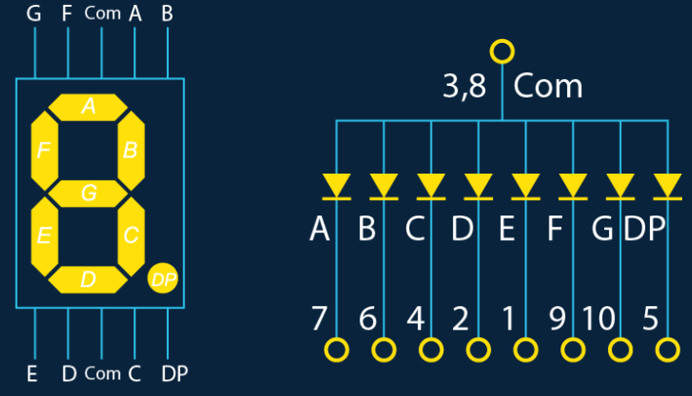
Figure 4, Display configuration [1]
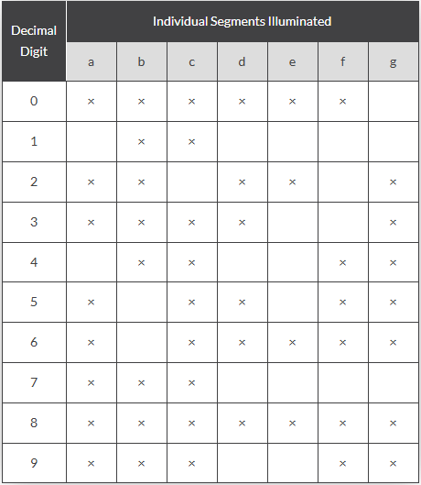
Figure 5, Truth table
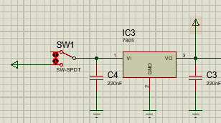
5V Fixed 1A positive power supply regulator (7805) - This component is a 5V regulator meaning it restricts the output voltage to 5V on various ranges of input voltages. This will add safety to the circuit and protect against voltage fluctuations, as seen in Figure 6. In this circuit capacitors are added to help with smoothing and stop the output voltage from oscillating, by charging and discharging. Pin 2 is the ground, Pin 1 and 3 are connected to 220nF capacitors. One downfall from using the 7805 regulator is it can produce a lot of heat.
Figure 6, 5V regulator with capacitors

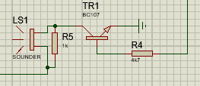
Silicon NPN low power bipolar transistor (BC107) – Seen in Figure 5. This is a semi conductive device, the function of this is to amplify or switch the signal. A primary use of these NPN (Negative-Positive-Negative) transistors are in amplification circuits. They are used to amplify a weak signal into a larger output signal. In this circuit it is used along with the sounder see Figure 1. This transistor is connected through port B, which is also connected to a sound buzzer. The transistor flexing sends a pulse to the buzzer. To do this the pin needs to go on and off over and over to make a sound.
Figure 7, Transistor and buzzer

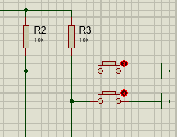
Button – The buttons used in this circuit are push buttons that don’t latch when pressed. These buttons, have been added to the circuit with 10K pull up resistors, see Figure 8. Adding these resistors ensures that when the button isn’t pressed it remains on logic 1. The buttons are grounded so when the button is pressed the current on the one side is able to flow to the other, however when the button is released the circuit is broken and the button is floating. As the voltage is intermittent it needs to be connected to ground to ensure 0V is read. [2] Having 10K resistors means less current which results in less impact when shorted to ground, too much resistance causes noise on the line. When working out resistance values for LED’s the equation used was Ohms law seen in Equation 1.
Figure 8, Buttons with pull up resistors
$$V=IR$$
Equation 1, Ohms law

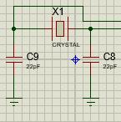
Crystal – A crystal is a two-pin device, with a wafer of quartz crystal or ceramic inside with electrodes connected to it. [3] The waves produced are square and tend to be very accurate. The crystal oscillator along with the 22pF capacitors will produce an external clock used to help keep track of time and can stabilise frequencies, see Figure 9. It works by a changing the shape of the quartz under an electronic field, known as piezoelectricity. When creating a circuit, you can pick from an external oscillator or an internal one built into the Pic. When using proteus it is important to note that the crystal may behave differently than in a real-world scenario. Crystals can also be used in walkie talkies, but their functionality changes slightly in that they are used the crystal stabilise the frequency appose to creating a sound.
Figure 9, Crystal and capacitors

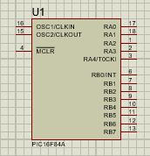
PIC16F84A – The PIC seen in Figure 9, is made by Microchip and belongs to the mid-range family of the PICmicro microcontroller devices, [4] A block diagram of the chip internals is shown in Figure 11[4] [4]. The memory contains 1k words which means it can translate 1024 instructions. The RAM (Read Only Memory) contains 68 bytes and EEPROM (Electrically Erasable Programmable Read-Only Memory) is 64 bytes. This Pic has 13 0/1 pins which are configurable on a pin to pin basis. Proteus can supply 5V but when creating this circuit in a practical sense a power supply would need to be added. As per the data sheet [4] the sink/source Max Per Pin is 25mA before the pins or device get damaged.
Figure 10, PIC,
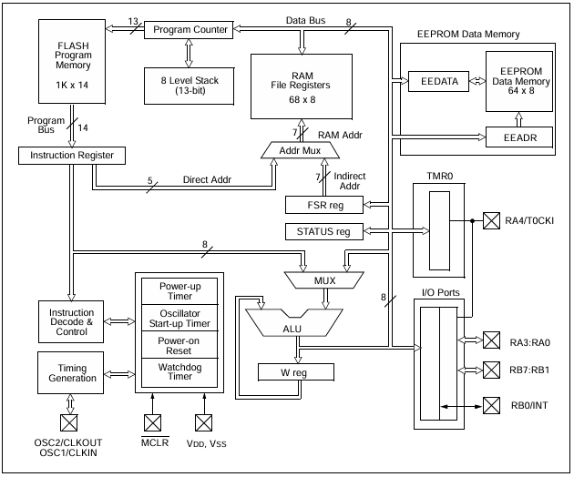
Figure 11, Block diagram on PIC [4]

PIC considerations
When choosing the right PIC microcontroller, keep in mind the performance you require, budget and understand the design of your circuit.
Consider the following:
- ‘F’ and ‘C’ type variants: most are ‘f’ types, but some are ‘C’ types which mean you can only flash them once.
- Oscillators and speed: If the PIC has an internal oscillator. 4MHz is a common speed. For reading buttons, multiplexing displays or turning LED’s or motors on or off, is plenty. [5]
- Compiler: Many compilers are available, be sure to pick one that is compatible with the langue being used.

PIC data
The PIC used in this circuit is the PIC16F84A. It is an 18-pin Enhanced FLASH/EEPROM, 8-bit Microcontroller.
- 18pin: refers to the number of pins the PIC has.
- EEPROM: (Electrically Erasable Programmable Read-Only Memory) allows for data to be written erased and rewritten electronically.
- 8-bit: Processes data in 8-bits (1 byte) this is what this PIC can handle in one operation
- 68 bytes of RAM: This is a relatively small amount, suitable for smaller projects.

Programming the Pic
Programming the PIC16F84A involves writing a code, the code language for this Pic is assembly and carried out on proteus. Programming this PIC can also be done in MPLAB along side a suitable complier like ‘MPLAB XC8’. MPLAB is a programme developed by the same company who developed the PIC. [6]

Ports
Port A has five available ports. Port B has seven available ports. This PIC has two banks, A is for inputs or outputs B is to manipulate the data.
Bank 0 contains the lower 128 registers (addresses 0x00 to 0x7F).
Bank 1 contains the upper 128 registers (addresses 0x80 to 0xFF).
To switch between Bank 0 and Bank 1, the RP0 bit in the STATUS register is used:
RP0 = 0: The microcontroller is in Bank 0.
RP0 = 1: The microcontroller is in Bank 1.

Pins
Pins are used to attached power, ground, inputs and outputs and communications. See Figure 12 for pin locations.
- RA0, RA1, RA2, RA3 and RA4, these are assigned to port A and can be configured as inputs or outputs.
- RB0-RB7 are assigned to port B and have multiple options. These can be used as inputs or outputs or used as an interrupt. For example, putting the chip to sleep via an external interrupt.
- MCLR, Master/Memory Clear Reset. Is used when starting the device, resetting it means you know where you are starting from. The bar over the top means pulse ‘LOW’ to clear. No bar means pulse ‘HIGH’ to clear.
- OSC is the oscillator.
- VDD is +5V (note: not in proteus)
- VSS is -5V (note: not in proteus)
The Pins on this PIC have a default state of high/true, when buttons are not pressed. When the button is pressed it goes to logic 0 state. They are inverted.
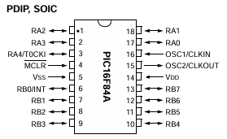
Figure 12, Pin location

ALU
The Arithmetic Logic Unit (ALU) is an internal digital circuit that operates in binary data. It performs two categories of operation logical operations (AND, OR, NOT etc) and arithmetic operations like addition and subtraction.

W Register
The W Register (Working register) is a single 8 bit register that is a temporary storage area for data being processed by the microcontroller. You can put any value that you wish, once assigned, you can add to it or move it but if you assign another value it will be overwritten.
In this Pic the destination designator specifies where the result of the operation is to be placed, if ‘d’ is ‘0’ it is placed in the W resister, if ‘1’ it is placed in the specified file register. [4]
Using interrupts with the W register can cause issues as it may move the value inputted before the interrupt and fail to return to it.

How ALU and the W Register work together
Data is loaded into the W register using instructions like MOVLW (Move literal to W register). When the ALU receives one operation from the W register and one from another memory location, The ALU will take the W register contents and perform the operation to give the result back to the port called upon. The result will either be stored in the W register or the A file register.

Register file map
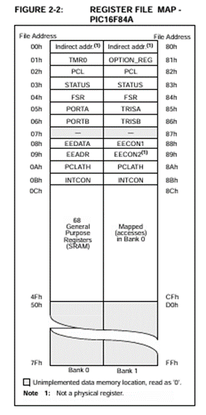
The PIC16F84A has a reasonably simple file register map, seen in Figure 13. The file map refers to the organisation of internal RAM, where the special function registers and general-purpose registers are located. There are two banks on this PIC 0 and 1. To call a bank use the RP0 bit, (RP0 = 0 is for bank 0, RP0 = 1 is for bank 1). You can change between banks by clearing the RP0 bit in the STATUS register. The status register is used for controlling the program flow and interacting with the microcontroller operations.

Figure 13, Register file map

Watchdog timer
A watchdog timer is a failsafe for a programme that will continuously run. A watchdog timer is there to reset a programme that may have got stuck in a loop. Inside the PIC there is a resistor/capacitor network working as an internal clock. When it starts it will be at 00 and go up in one increment until it reaches FF before it returns to 00. Note that these times are irrespective of an external clock frequency. It is important to know if the watch dog timer is running, glitches could cause an error. When active you can add a clear watch dog command.

Fuses
The fuses (fuse bits) built into the PIC are not to be confused with fuses you’d use on a breadboard. These are however electronic switches that are ‘blown’ by the programmer. [7] They are used for control settings such as clock speed. If you want the watchdog timer, these fusses need to be ‘blown’ for the watchdog timer to work. To do this a couple of lines can be written at the beginning of the programme, which will enable certain fuses.

Binary
The PIC16F84A works with an 8-bit data meaning each register holds an 8-bit binary value. 00000000 to 11111111 in binary. As binary numbers are only 1’s and 0’s they need more digits to represent large values. The length of a binary number describes how many bits it is made of. Four bits are 1 nibble, eight bits are a byte. In Figure 14 you see an example later used in the code of the binary structure to enable the seven segment LED display to go from 1 to F.
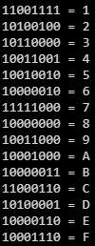
Figure 14, Binary for 1-F

Hexadecimal
The PIC16F84A works with an 8-bit data, meaning each register holds an 8-bit binary value. 00000000 to 11111111 in binary or 0x00 to 0xFF in Hexadecimal. Hexadecimal are base-16, like decimal numbers are 0-9 for the tenth value. Numbers 11 to 15 are represented by letters. Each four bits can be converted to its hexadecimal equivalent.

Displaying hexadecimal characters on a seven-segment display

To display the hexadecimal characters of 0-F on the seven segments display each segment will light up individually depending on which value is being called to display. To do this each hexadecimal digit will need to be called to its corresponding 7-bit binary pattern. This binary pattern will need to be send to the appropriate GPIO pins. See figure Figure 14 for the correct binary pattern for the 1-F.

Coding questions

Below are flow charts and annotated code for Section 3 of the assignment.

Code set up
Below is how most of the code is set up before you start getting into the loops, which is more specific code. See Figure 14. The end of each code is also Identical in that it used the same count, loadN and decN. See Figure 15. Assembly code language is used to programme the PIC.

(Definitions)
First calling upon the main.asm source file and including the p16f84a.inc register definition file.
portB = Defining/naming value (something later will use the value)
trisb = (tri state) input or output pins (direction register)
status = Status register = 8 bits
RP0 = bit 5 of status register
RP1 = 6 of status register

(Variables)
count = set counter 0 to 255
nCount = pause routine inner loop counter
mCount = pause routine outer loop counter

(Reset and interrupt vectors)
RST = Jump to named label “goto start” Before loop must be set up.
goto = Go back to start of code
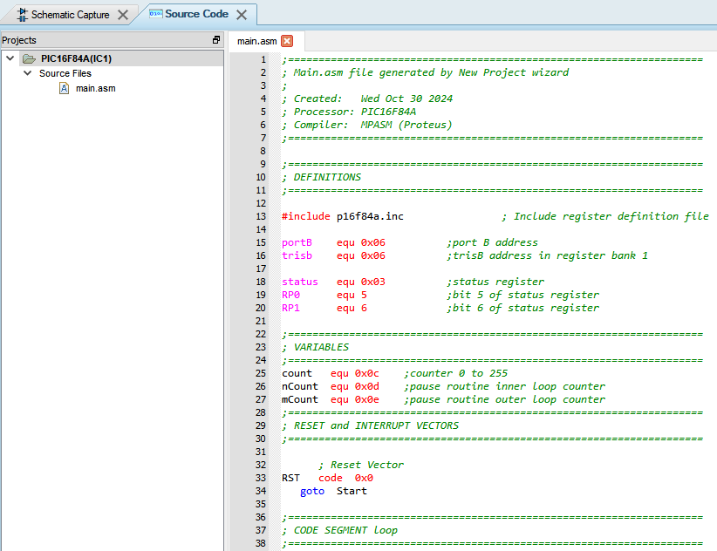
Figure 15, Code set up

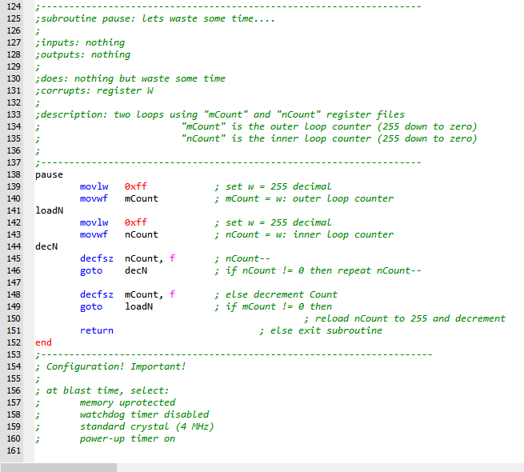
Figure 16, End of each code

Modify “Count.asm” 0 to F in hexadecimal numbers in 0.2 second increments.

Note that the start and end of the code are shown in Figure 15 and Figure 16.
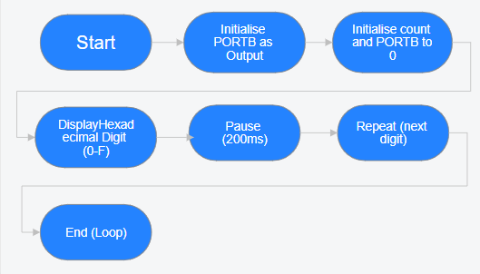
Figure 17, flow chart 0-f display
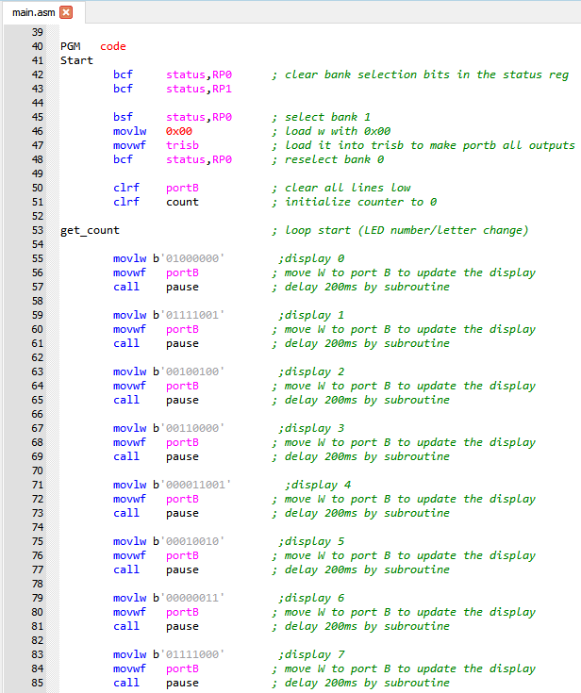
Figure 18, Code for question 1 (1)
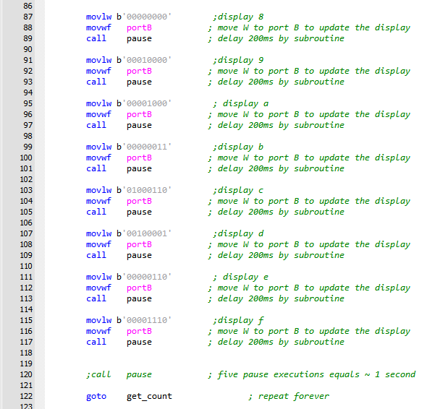
Figure 19, Code for question 1 (2)

Two buttons, it displays "L" or “r” the 7 segment LED display

Note that the start and end of the code are shown in Figure 15 and Figure 16.

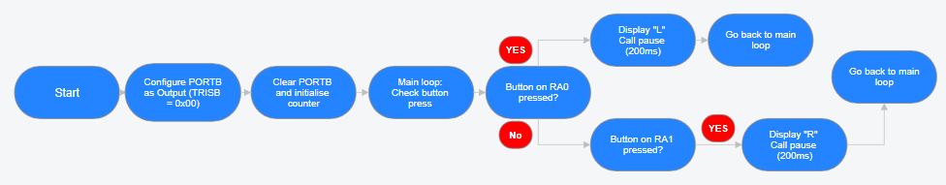
Figure 20, Flow chart for "L" or "R" button press

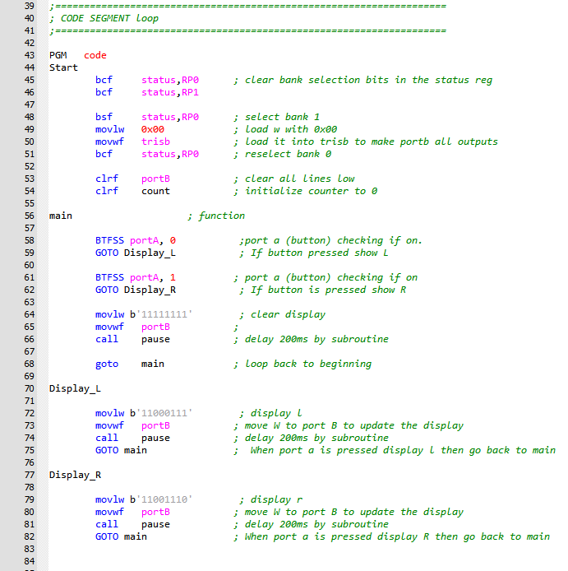
Figure 21, code for question 2

LED segments to light all on or all off

Note that the start and end of the code are shown in Figure 15 and Figure 16.

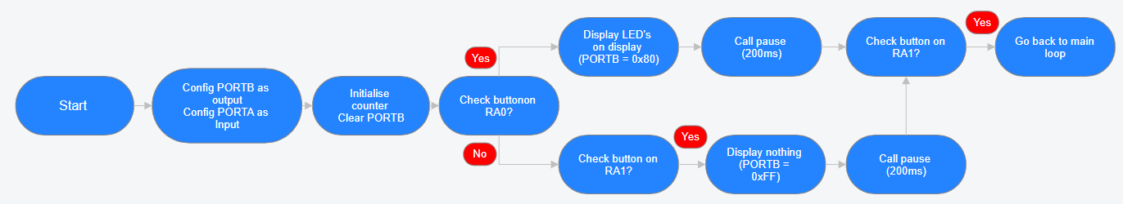

Figure 22, Flow chart for all LED's on/off

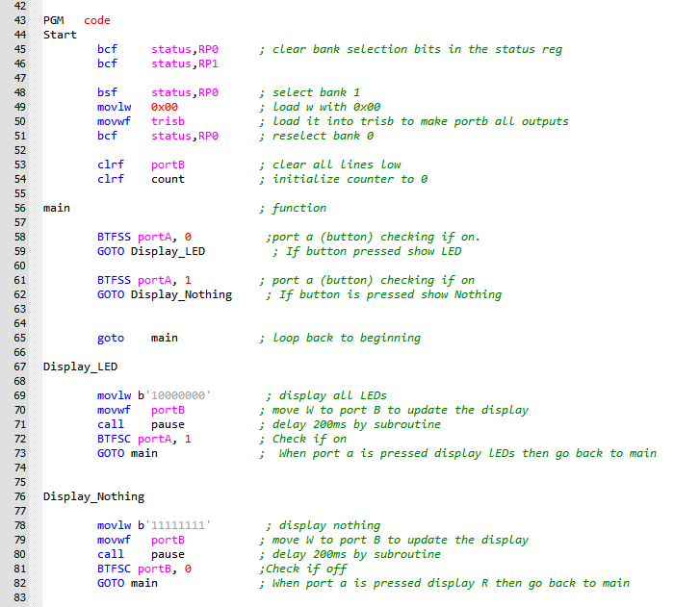
Figure 23, Code for question 3

Display5 count up to 9 and back down to 0

The start-up for question four is different to the other questions. The outputs where set as variables, so only a word was needed as appose to the binary pattern to clean up the code and make it easier to read. The variables where made from the hexadecimal conversion from the binary pattern needed to represent the number outputting on the LCD display.

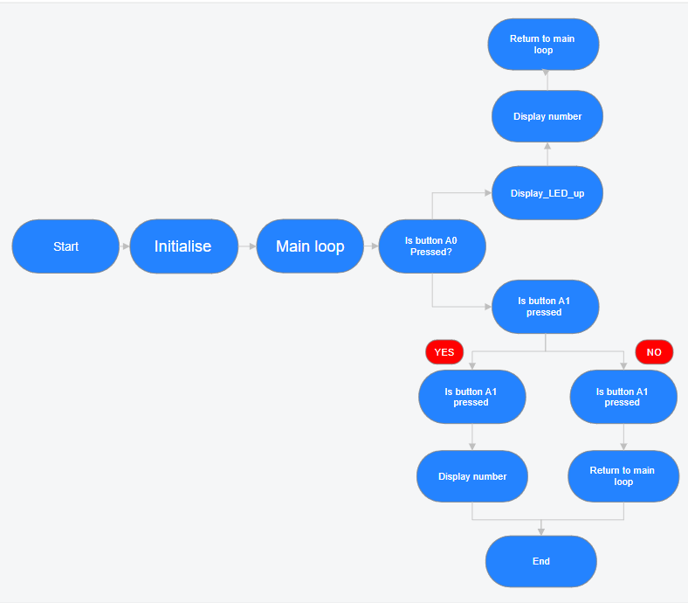
Figure 24, Flow chart, question 4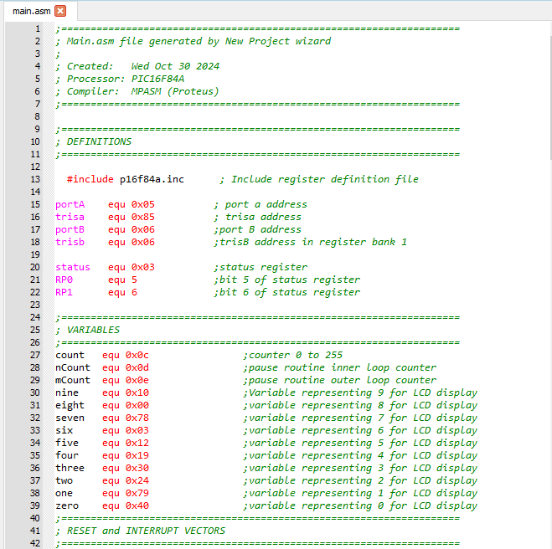
Figure 25, Question 4 (1)
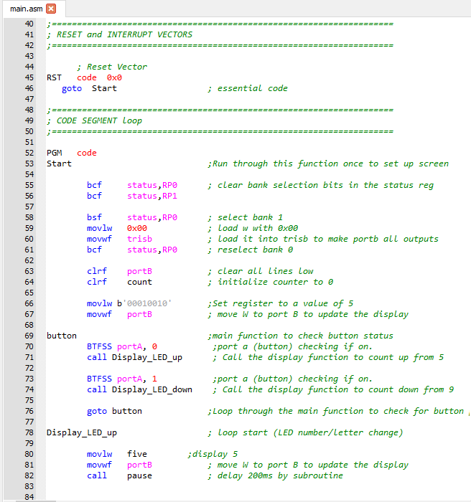
Figure 26, Question 4 (2)
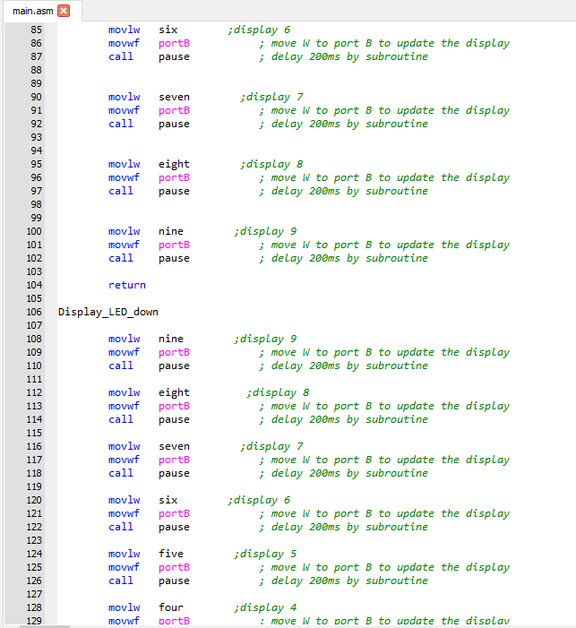
Figure 27, Question 4 (3)
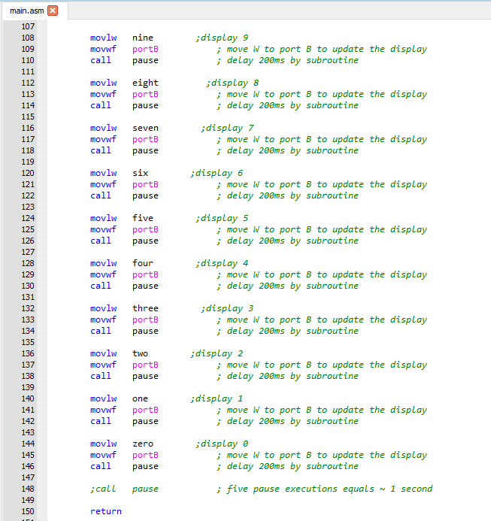
Figure 28, Question 4 (4)

Make piezo sounder produce a tone while one of the buttons is pressed

Note that the start and end of the code are shown in Figure 15 and Figure 16.

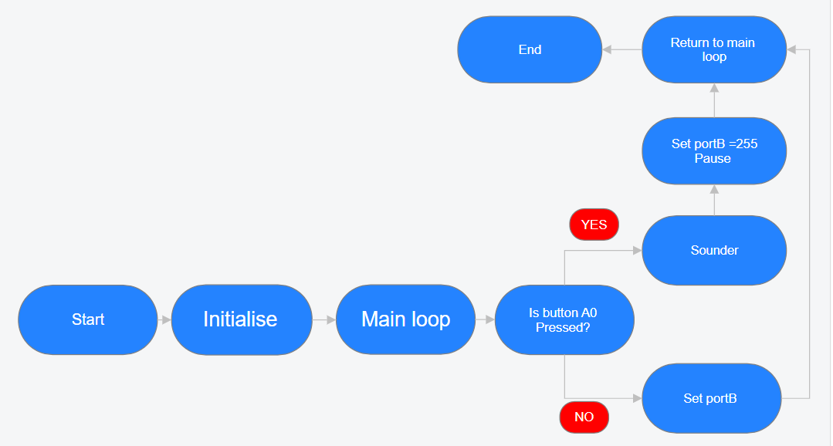
Figure 29, Flow chart for question 5
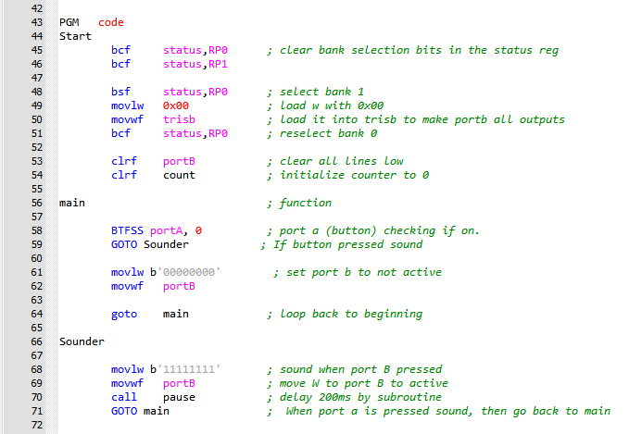
Figure 30, Question 5 code

Summary

This report has shown the “count” project, which utilizes a seven-segment LED display and a simulated circuit developed in Proteus using the PIC16F84A microcontroller. It features screenshots of the circuit and provides an explanation of each component and their interactions. To understand these components further, additional research was conducted, included diagrams and information from external sources. The report also details the method for displaying hexadecimal characters (0-F) on the seven-segment display, highlighting the corresponding binary representations that activate specific segments. Finally, the report includes flowcharts and annotated assembly language code, with annotations clarifying the purpose of each instruction and its role in the overall functionality of the program. This section shows the significance of clear logic and structured programming.

References

[1] | Proteus, “Proteus,” lab centre , 2024. [Online]. Available: https://www.labcenter.com/blog/sim-7seg-displays/. [Accessed 04 November 2024].
[2] | creative technology lab, “How to connect a push button or switch,” Creative technology lab , [Online]. Available: https://lab.arts.ac.uk/books/physical-computing/page/how-to-connect-a-push-button-or-switch#:~:text=When%20the%20button%20is%20pressed,ensure%20the%20Arduino%20reads%200V.. [Accessed 05 November 2024].
[3] | “Crystal oscillator,” Wikipedia, 26 October 2024. [Online]. Available: https://en.wikipedia.org/wiki/Crystal_oscillator#:~:text=Crystal%20is%20the%20common%20term,circuits%2C%20such%20as%20crystal%20filters.. [Accessed 04 November 2024].
[4] | Microchip, PIC16F84A Data sheet, Microchip technology inc, 2001.
[5] | Dan, “PIC Microchip Guide, Tools and Tips,” Electro-dan : Electronics and Computing, July 2022. [Online]. Available: https://electro-dan.co.uk/electronics/PIC_guide.aspx. [Accessed 05 November 2024].
[6] | Microchip, MPLAB, Arizona: Microchip technology inc.
[7] | mstracy, PIC programming in assembly.

Appendices


