COMPONENT 1: MOCK INTERVIEW

Programme of study: CertHE Business Skills for the Workplace
Module: LCLM4005 Employability and Career Development
Assessment: Component 1 – Mock interview
Student name: Rukhshanda Hafeez
Student ID: 2525298
Lecturer: Dian Mayasari
Submission date: 19/10/2026
University of Wales Trinity Saint David (UWTSD)

https://www.wmjobs.co.uk/job/279018/send-higher-level-teaching-assistant-hlta-/
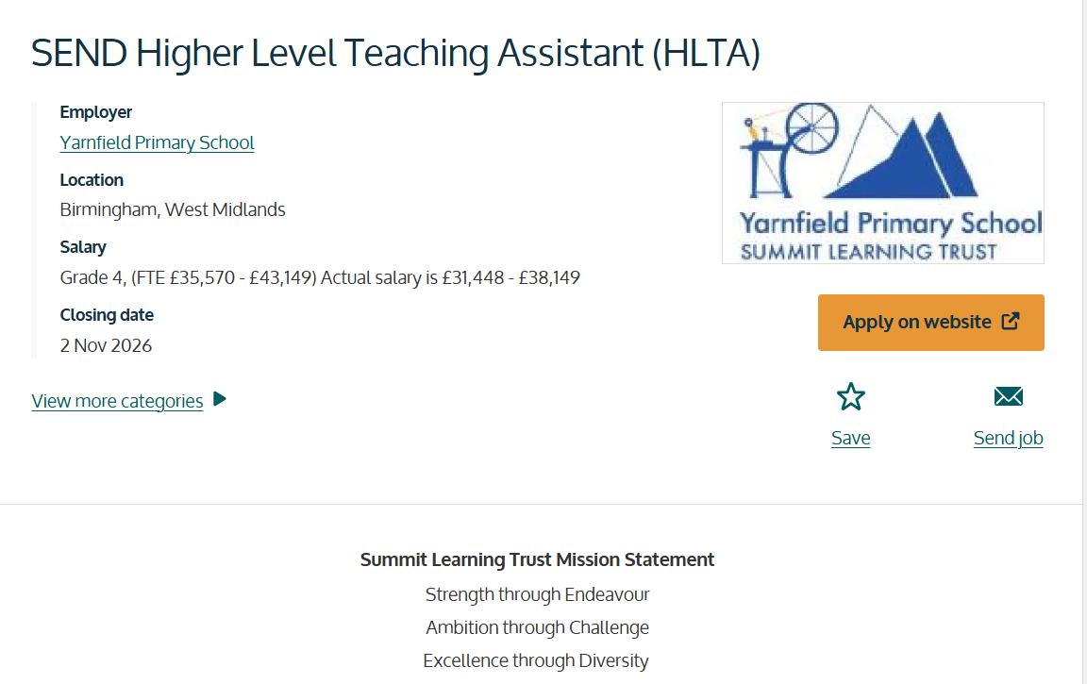
Job description:
We are seeking an enthusiastic, dedicated and highly motivated SEND Higher Level Teaching Assistant (HLTA) to join our growing Enhanced Provision. This is an exciting opportunity for an experienced practitioner to play a key role in supporting pupils with a range of additional needs and to help shape inclusive practice across our school. This role will be based in our enhanced provision to support our high-needs SEND pupils.
As our SEND HLTA, you will work alongside the SENDCO and wider staff team to deliver exceptional support for pupils with SEND. You will lead targeted interventions, support teaching and learning, monitor pupil progress and contribute to the development of high-quality provision that enables every child to thrive.
The role provides opportunities to:
- Lead learning activities, interventions and small group teaching.
- Support pupils with a range of SEND, including communication and interaction, cognition and learning, sensory and physical, and social, emotional and mental health needs.
- Contribute to EHCP reviews and annual review processes.
- Work closely with families and external professionals.
- Support and mentor Teaching Assistants within the Enhanced Provision.
- Help develop and promote inclusive practice across the school.
- Make a genuine difference to children's academic, social and emotional development every day.
PERSON SPECIFICATION:
We Are Looking For Someone Who:
- Has HLTA status or significant experience working within a SEND environment.
- Has strong knowledge of SEND and inclusive teaching practices.
- Can build positive relationships with pupils, families and professionals.
- Is confident leading interventions and supporting learning across the curriculum.
- Has excellent communication, organisational and teamwork skills.
- Is passionate about helping children achieve their full potential.
- Can remain calm, adaptable and solution-focused when supporting pupils with complex needs.
- Shares our commitment to high expectations, inclusion and safeguarding.

CV
RUKHSHANDA HAFEEZ
Birmingham
B33 8SY
07365238136 msajid642@yahoo.com

PROFESSIONAL PROFILE
I am a qualified teaching assistant with the experience of working more than three schools in Birmingham. I also had the several years of lunchtime supervisor experience. I also had practical experience in helping the small groups of pupils to develop their numeracy skills through the practical small-group activities, also teaching them about addition and subtraction using the counting blocks. I am aware of the commitment towards the inclusive learning, well-being, safeguarding and building positive relationship with children. I am applying to get the more in-depth knowledge of SEND higher level teaching assistant role.

RELEVANT SKILLS
- Practical learning and small-group numeracy support using resources.
- Patience and the adaptability to support the pupils with different educational needs.
- Maintain the positive communication with pupils, teachers and school colleagues
- Maintaining pupil supervision, well being and safe school environment for the pupils from different backgrounds.
- Following the safeguarding, teamwork and organization according to school policies.
- IT skills, including Microsoft Office and Excel

EMPLOYMENT EXPERIENCE
Waverley Primary School — Lunchtime Supervisor
January 2022 – April 2026
- Supervised pupils during lunchtime, helping maintain a safe, positive and inclusive school environment.
- Supported children with daily routines, positive behaviour and respectful interactions.
- Worked with school staff to respond to pupils’ needs and concerns.
Hodge Hill Primary School — Lunchtime Supervisor
January 2021 – January 2022
- Supported pupils’ safety, wellbeing and behaviour during lunch periods.
- Communicated with staff and helped maintain a welcoming environment.
Oasis Till December / Stechford Primary School — Teaching Assistant
October 2019 – March 2020
- Assisted classroom learning activities and supported pupils under teacher direction.
- Used practical resources, including counting blocks, in small-group addition and subtraction activities.
Oasis Academy Hobmoor — Teaching Assistant
September 2018 – June 2019
- Supported teaching and learning in a primary school setting.
- Helped pupils engage with classroom activities and follow routines.
Vicar-un-Nisa Noon Girls Higher Secondary Institute — Physics Teacher September 2009 – March 2010
- Taught intermediate-level physics and explained subject concepts to learners.

EDUCATION AND QUALIFICATIONS
NCFE CACHE Level 3 Certificate in Supporting Teaching and Learning — University College Birmingham (2019–2020)
level 2 functional skills maths
level 2 functional skills English
COVER LETTER
Rukhshanda Hafeez
Birmingham B33
07365 238136
msajid642@yahoo.com
19 October 2026
Recruitment Panel
Yarnfield Primary School
Summit Learning Trust
Birmingham
Dear Recruitment Panel,
I am writing to apply for the SEND Higher Level Teaching Assistant position at Yarnfield Primary School. I hold an NCFE CACHE Level 3 Certificate in Supporting Teaching and Learning and have experience working in primary schools as both a Teaching Assistant and Lunchtime Supervisor. I am keen to use this experience to support pupils in your Enhanced Provision and continue developing my SEND practice.
In my Teaching Assistant roles at Oasis Academy Hobmoor and Stechford Primary School, I supported pupils with classroom activities and learning. One example was working with a small group using counting blocks to practise addition and subtraction. Using practical equipment helped make the tasks more accessible and gave pupils a way to explore their answers. This experience strengthened my interest in adapting activities to suit individual learning needs.
My work as a Lunchtime Supervisor at Waverley Primary School and Hodge Hill Primary School also developed my ability to build positive relationships with children, maintain a safe and supportive environment, respond calmly to different situations and work closely with other school staff. I understand the importance of safeguarding, patience, consistency and helping every pupil feel included.
I am particularly interested in the opportunity to work alongside the SENDCO and wider team, contribute to targeted interventions and help monitor pupils’ progress. I would welcome the chance to develop my knowledge of Education, Health and Care Plans (EHCPs), annual reviews and the needs of pupils within an Enhanced Provision. I am also motivated by Summit Learning Trust’s commitment to ambition, excellence and diversity.
I believe my school experience, teaching qualification, practical approach to learning and commitment to children’s wellbeing would allow me to make a positive contribution. I would appreciate the opportunity to discuss my application and how I could support your pupils and staff.
Thank you for considering my application.
Yours faithfully,
Rukhshanda Hafeez

