

Student Name: PRAJAPATI JIGARKUMAR YOGESBHAI

Student ID:2430810

Module Name: International Marketing: Principles and Practices

Module Code: LCMB7026

Lecturer’s Name: Tushara Balendran

Work Count: 5460

Term 2

Table of Content
1. Introduction 7
2. Company Overview 7
2.1 Mercedes-Benz 7
2.2 Vision and Mission 8
2.3 Mercedes-Benz in the United Kingdom 8
2.4 Mercedes-Benz in India 9
3. Macro Environment 9
3.1 Definition of PESTEL Analysis 9
3.2 PESTEL Analysis 10
3.2.1 Political 10
3.2.2 Economic 11
3.2.3 Social 13
3.2.4 Technological 13
3.2.5 Legal 15
3.2.6 Environmental 17
3.3 Similarities and Differences in PESTEL 18
3.4 Cultural Analysis 20
3.4.1 United Kingdom 20
3.4.2 India 21
3.4.3 Advantages and Disadvantages of Hofstede’s Model 21
4. Comparison of Mercedes-Benz’s STP Strategies in the UK and India 22
4.1 Segmentation Strategies 22
4.2 Targeting Strategies 24
4.3 Positioning Strategies 25
4.4 Comparative Summary of STP 27
5. Comparison of Marketing Mix Strategies in the UK and India 28
5.1 Product 29
UK 29
India 29
5.2 Price 30
UK 30
India 30
5.3 Place 31
UK 31
India 31
5.4 Promotion 32
UK 33
India 33
5.5 People 34
UK 34
India 34
5.6 Process 34
UK 34
India 34
5.7 Physical Evidence 35
UK 35
India 36
5.8 Similarities and Differences in 7Ps 36
6. Ansoff Matrix: Mercedes-Benz India Brand Directional Development Strategy 37
7. Ethical Issues and Unethical issues in Mercedes-Benz’s Marketing Mix: UK 39
Ethical Issue 1 – Sustainability Promotion 39
Ethical Issue 2 – Customer Transparency and Safety 40
Unethical Issue 1 – Greenwashing Risk 40
Unethical Issue 2 – Data Privacy Concerns 41
8. Recommendations 42
9. Conclusion 43
10. Reflective Account Using Gibbs Reflective Cycle 43
10.1 Description 44
10.2 Feelings 45
10.3 Evaluation 46
10.4 Analysis 47
10.5 Conclusion 47
10.6 Action Plan 48
11. References 50

List of Tables
Table 1: Comparative PESTEL Analysis of the United Kingdom and India 19
Table 2: Advantages and Disadvantages of Hofstede’s Model 21
Table 3: Comparative Summary of STP 28
Table 4: Similarities and Differences in 7Ps 36
Table 5: Application of Ansoff Growth Strategies in Mercedes-Benz India 38
Table 6: Evaluation of Assignment - Strengths and Challenges 46
Table 7: Action Plan 48

List of Figures
Figure 1: Mercedes-Benz Logo 7
Figure 2:Mercedes-Benz Mission and Vision 8
Figure 3: PESTEL Analysis Framework 10
Figure 4: Brexit Impact on UK Automotive Trade 11
Figure 5: Evolution of India’s EV Policy Timeline 11
Figure 6:UK Inflation Trend 12
Figure 7: Growth of India Luxury Car Market 13
Figure 8: Regional Distribution of EV Charging Infrastructure in the UK 14
Figure 9: EV Charging Infrastructure in the United Kingdom 15
Figure 10: Growth in UK Zero Emission Vehicle Registrations 16
Figure 11: India Automobile Tax Structure Before and After GST 17
Figure 12: Hofstede Cultural Dimensions Comparison 20
Figure 13: Environmental Concern Levels in the UK 22
Figure 14: Luxury Lifestyle and Status Symbol of Mercedes-Benz Ownership in India 23
Figure 15: Mercedes-Benz MBUX Digital User Experience System 24
Figure 16: Mercedes-Benz SUV Lineup in India 25
Figure 17: Perceptual Map of Automotive Brands Based on Price and Quality 26
Figure 18: Mercedes-Benz MANUFAKTUR Customisation and Luxury Personalisation 27
Figure 19: Mercedes-Benz Electric Vehicle Product Portfolio (EQ Models Lineup) 29
Figure 20: Mercedes-Benz MANUFAKTUR Personalisation Options 30
Figure 21: Mercedes-Benz Online Sales Promotions and Financing Offers (UK) 31
Figure 22: Mercedes-Benz Premium Showroom Experience in Chennai 32
Figure 23: Mercedes-Benz Sustainability-Focused Promotional Campaign 33
Figure 24: Mercedes-Benz Luxury Launch Event Promotion Strategy 33
Figure 25: Mercedes-Benz Modern Luxury Showroom Design 35
Figure 26: Ansoff Matrix 37
Figure 27: Greenwashing in Automotive Sustainability Advertising 39
Figure 28: Automotive Cybersecurity Threats in Connected Vehicles 41

1. Introduction
This report evaluates the international marketing mix of Mercedes-Benz, in two major markets: United Kingdom and India. The report is aimed at comparing the capacity of the company to adjust its marketing strategies in the various economic, cultural, and competitive environments. The analysis starts with a comparison of the macroenvironment in both countries based on the PESTEL framework with special focus on social and cultural differences. Then it analyses the company segmentation, targeting and positioning strategies (STP) and then compares the 7Ps marketing mix in detail. The report further analyzes the directional development strategy of the brand in one of the selected markets and also talks about ethical concerns regarding its marketing activities. Lastly, practical advice is given on how to enhance the future global marketing strategies. The presented analysis outlines the importance of global brands striking the right balance between standardisation and adaption in order to thrive in different international markets.
Gibbs Reflective Cycle Self-reflection teaches a person to critically analyze their experience in a systematic way by breaking the process down into descriptive, feelings, evaluation, analysis, conclusion and action plan. It facilitates lifelong learning and growth both personally and professionally by recognizing the lessons learnt and improvement to be made in future (Gibbs, 1988).

2. Company Overview

2.1 Mercedes-Benz

Figure 1: Mercedes-Benz Logo
Source: Wikimedia Commons
One of the most powerful and innovative premium car manufacturers in the world is Mercedes-Benz, with its focus on performance, luxury, and innovation. The brand was invented in Germany during the late 19th century and is a well-known pioneer of the modern car manufacturing industry. In the long run, it has spread all over the world and currently sells a varied portfolio of vehicles namely sedan cars, SUVs, electric vehicles (EVs) and high-performance cars. Advanced engineering, safety and technological innovation are prioritized by the company and this has enhanced its position in the luxury car market across the world (Mercedes-Benz, 2026a).

2.2 Vision and Mission
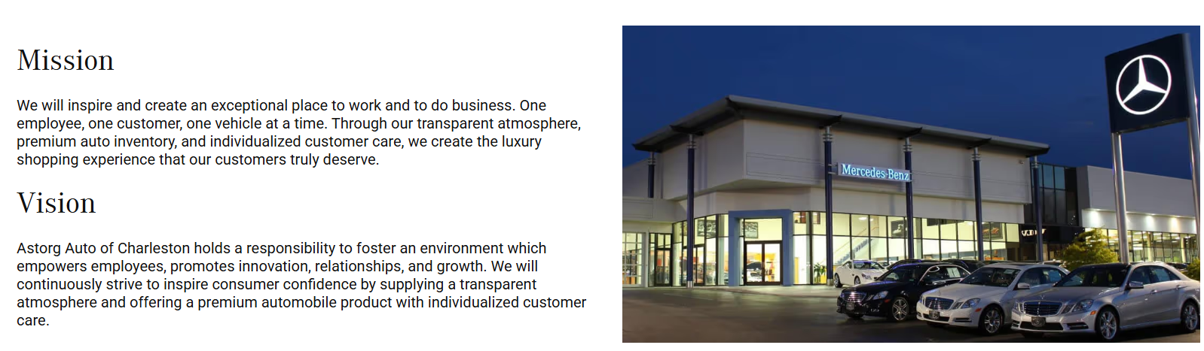
Figure 2:Mercedes-Benz Mission and Vision
Source: Mercedes-Benz Mission and Vision Page
Mercedes-Benz is determined to be the future of mobility by integrating luxury and sustainability with innovation. It has a vision of becoming an electric mobility, digital transformation, and customer experience leader. The company is also dedicated to cutting down on carbon emissions and ensuring full electric vehicle portfolios as part of its long-term sustainability agenda. It aims at supplying vehicles of high quality that are comfortable, safe, and technologically advanced in addition to high brand value and customer satisfaction (Mercedes-Benz, 2026b).

2.3 Mercedes-Benz in the United Kingdom
Mercedes-Benz is very popular in the high-end market in the United Kingdom. The company has a large chain of dealerships and service centres, which sell new and certified used vehicles. UK market is competitive and well established with a great demand of electric and hybrid cars. Mercedes-Benz has reacted by diversifying its EVs and concentrating on online retailing and customer experience. The brand has a good reputation of quality, innovation and luxury to the UK consumers (Mercedes-Benz Media UK, 2026).

2.4 Mercedes-Benz in India
Mercedes-Benz is a luxury car market leader in India. The company started its operations in India in 1990s and has since then spread its operations with local assembly and extensive dealership network in major cities. The Indian market is expanding at an alarming rate because of the growth in incomes and the need to acquire high quality cars. Mercedes-Benz India specializes in luxury models of high end, SUVs and electric vehicles and has plans to launch several new models of EV in order to consolidate its market. Exclusivity and customisation are also aspects of the brand that focus on high-income consumers, like its MANUFAKTUR customisation programme, to gain the attention of high-income buyers (Fortune India, 2025; Mercedes-Benz India, 2026).

3. Macro Environment

3.1 Definition of PESTEL Analysis
PESTEL analysis is a strategic analysis tool that is applied when analyzing external macroenvironment within which a business operates. It analyses six major factors, which include political, economic, social, technological, legal and environmental factors. These are the factors that affect the business decision and the opportunity and risks in the market. In the case of international organizations such as Mercedes-Benz, PESTEL analysis is significant to comprehend variations across nations and to effectively market in different markets.
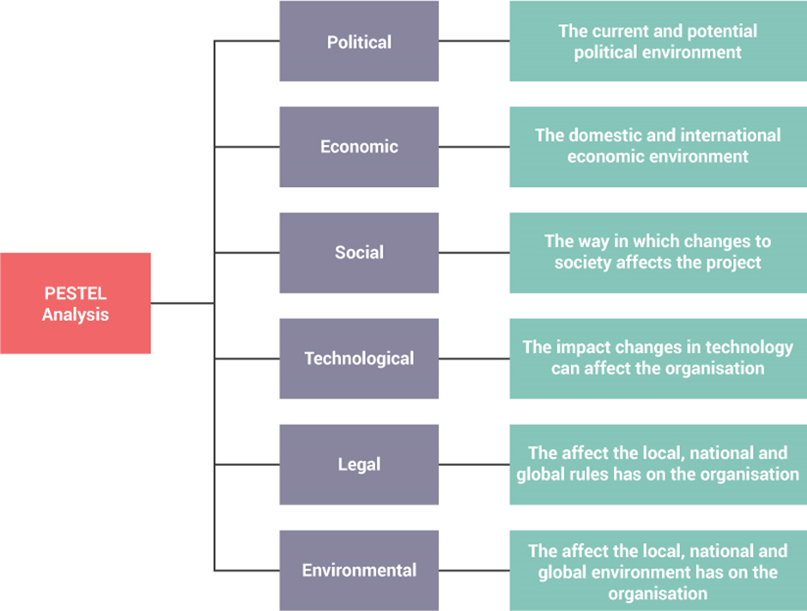
Figure 3: PESTEL Analysis Framework
Source: Adapted from EdrawMax (2021)

3.2 PESTEL Analysis

3.2.1 Political
- United Kingdom: Both Favourable and Unfavourable
- India: Favourable
The political environment in the United Kingdom is quite stable, although Brexit has posed a problem to the automotive industry. Carmakers have been subjected to trade barriers and supply chain disruptions, which have added complexity and cost to their operations (CLEPA, 2025). Moreover, the government policies are very favorable towards electric cars with incentives and regulations that control pollution.
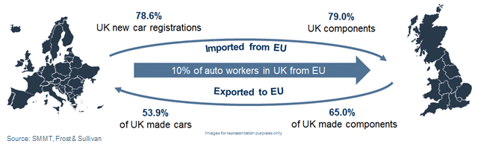
Figure 4: Brexit Impact on UK Automotive Trade
Source: Adapted from SMMT and Frost & Sullivan
The Indian political environment is favourable to the automotive industry particularly with the move by the government to promote manufacturing via the make in India program and policies that promote local manufacturing. Policy frameworks and incentives are also encouraging the government to embrace electric mobility and this opens a growth opportunity to luxury EV brands (Dutta et al., 2025).
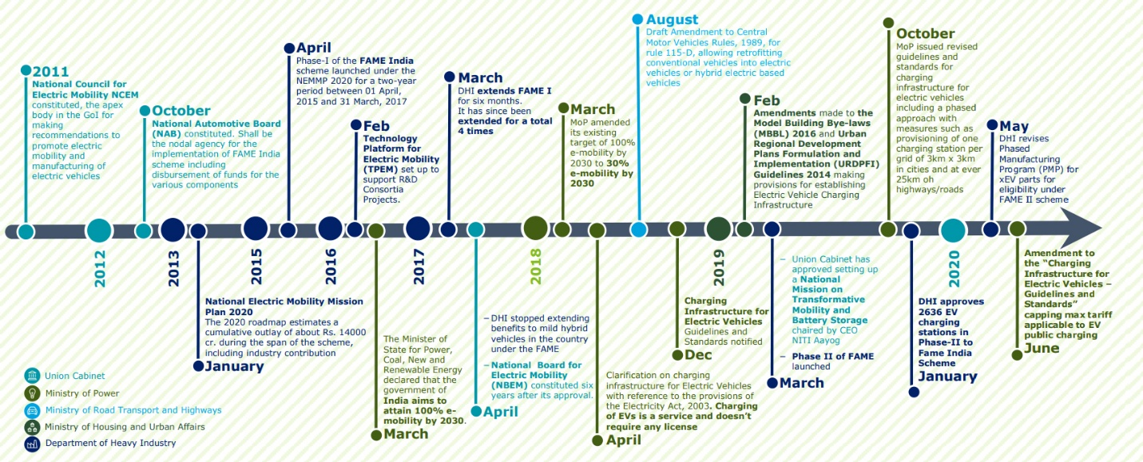
Figure 5: Evolution of India’s EV Policy Timeline
Source: Adapted from Government of India EV Policy Timeline

3.2.2 Economic
- United Kingdom: Both Favourable and Unfavourable
- India: Favourable
The UK economy has moderate growth with an increase in inflation and cost-of-living pressure which diminishes overall consumer spending. Nevertheless, the luxury car market is not as volatile since the consumer with high income is not price-sensitive. Good financial services, leasing facilities, and established credit facilities are also good contributors to the premium cars demand (OECD, 2025).
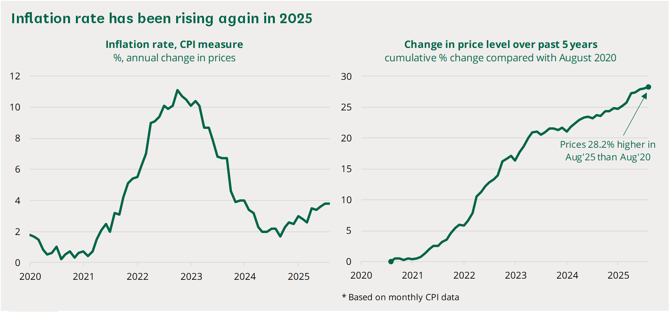
Figure 6:UK Inflation Trend
Source: Adapted from Office for National Statistics
India, however, is showing good economic growth and increase in disposable income of affluent customers. This has resulted in high demand of luxury products such as luxury cars. Research indicates that an increase in GDP is correlated with the growth of the luxury market (Zhu, 2025). Consequently, India has a better growth prospect than the UK which is a mature market.
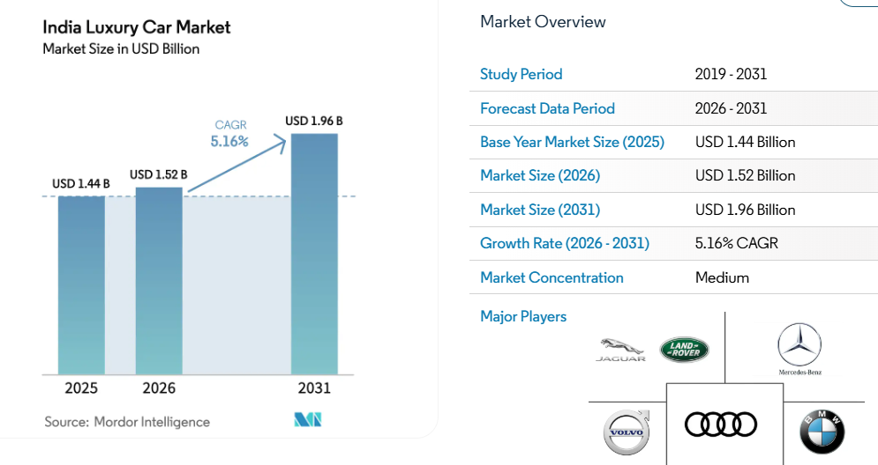
Figure 7: Growth of India Luxury Car Market
Source: Adapted from Mordor Intelligence

3.2.3 Social
- United Kingdom: Favourable
- India: Favourable
Consumers in the UK are very conscious about sustainability and environmental concerns. Electric vehicles and hybrid vehicles are in demand. Technology, safety and convenience are also important attributes that customers consider when buying cars (Agoro et al., 2025).
In India, the social factors vary. Luxury cars have been regarded as status, success and prestige. Brand image and social recognition have a greater impact on the decision-making process of the consumer (Gaur and Verma, 2025). There is also growing demand in Tier 2 and Tier 3 cities as a result of increasing wealth and urbanisation (SME Futures, 2025).

3.2.4 Technological
- United Kingdom: Favourable
- India: Both Favourable and Unfavourable
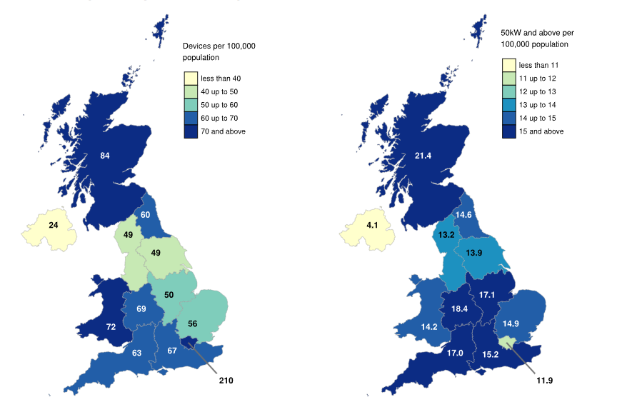
Figure 8: Regional Distribution of EV Charging Infrastructure in the UK
Source: Adapted from Zapmap (2025) and UK Department for Transport statistics
The UK is well-developed technologically with a digital retail platform and extensive EV charging networks. This helps the use of electric and connected cars. The further improvement in automotive technology and the governmental support of EV infrastructure contribute to the readiness and competitiveness of the market (Mishra et al., 2025).
India is also making strides in terms of technology, particularly in the areas of digitalisation and EV development. The infrastructure like charging stations are however still in development. The automotive industry is being encouraged by government policies to embrace new technologies and innovate (Mishra et al., 2025).
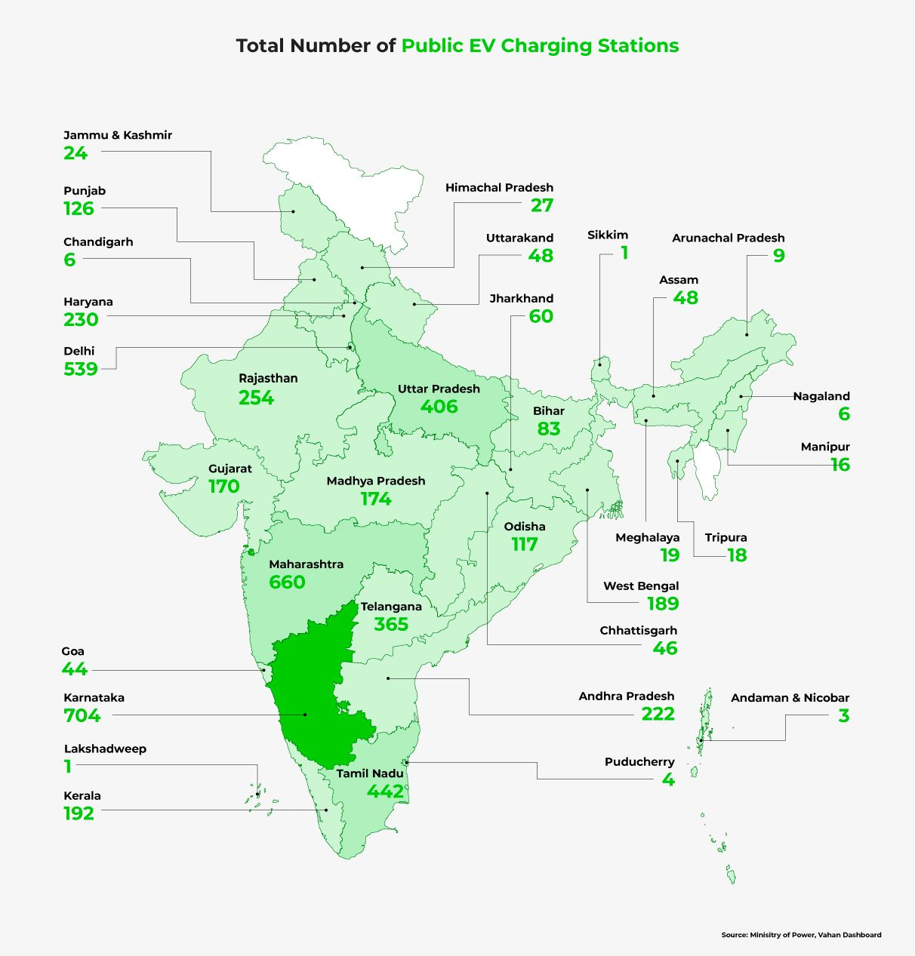
Figure 9: EV Charging Infrastructure in the United Kingdom
Source: Adapted from Department for Transport

3.2.5 Legal
- United Kingdom: Both Favourable and Unfavourable
- India: Both Favourable and Unfavourable
There are rigorous laws in the UK concerning emissions, safety and consumer protection. Some of the policies that have been instituted by the government include the Zero Emission Vehicle (ZEV) policy that mandate manufacturers to sell more EVs (UK Government, 2026; Alatawneh et al., 2025). These laws raise the cost compliance, but it also leads to innovation.
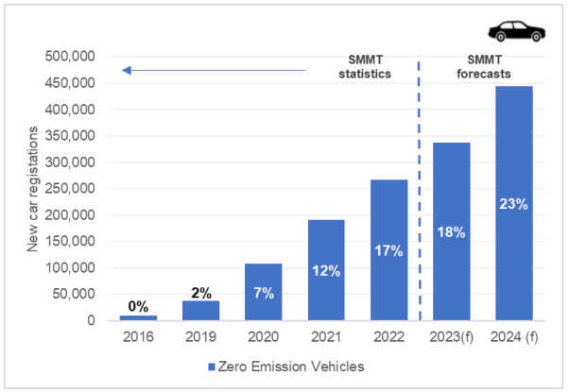
Figure 10: Growth in UK Zero Emission Vehicle Registrations
Source: Adapted from UK Government
There are also stringent regulations in India, especially regarding import duties, taxation and local manufacturing requirements. The luxury cars become costly due to the high import tax hence influencing firms to assemble the cars locally. Regulation and policies are changing to promote EV adoption and sustainability (Dutta et al. 2025).
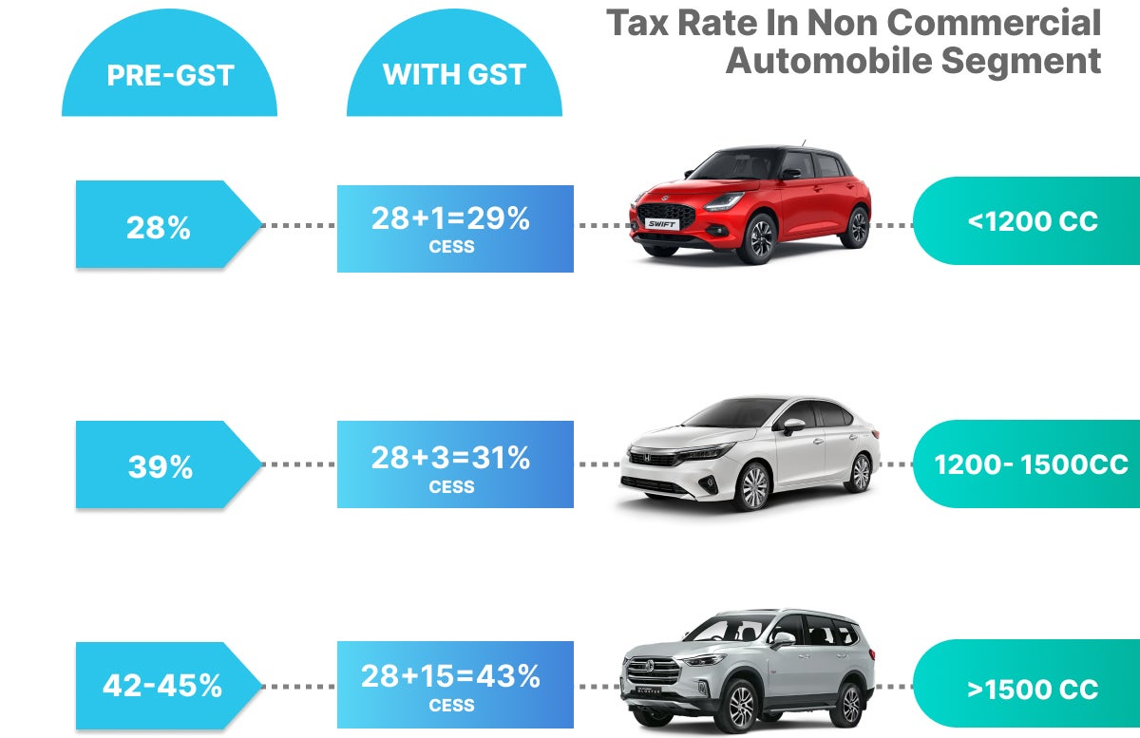
Figure 11: India Automobile Tax Structure Before and After GST
Source: Adapted from ClearTax (2026) and Government of India GST data

3.2.6 Environmental
- United Kingdom: Favourable
- India: Favourable
UK is highly environmental conscious and companies are under strict pressure to lower the amounts of emissions and to be environmentally friendly. Eco-friendly cars and in particular electric vehicles are becoming a popular choice among consumers. Net-zero goals are also supported by the government policies, promoting the use of more ecological means of transportation and enhancing the transition to low-emission mobility in the automotive industry (Achillas et al., 2024).
In India pollution and climate change are rising issue of environmental concern. Policies and incentives to support the use of electric cars and green mobility exist in the government. In turn, Mercedes-Benz increases its range of EVs and invests in sustainable technologies to correspond to the environmentally friendly intentions and market expectations (Achillas et al., 2024).

3.3 Similarities and Differences in PESTEL
Factor | UK | India | Similarities | Differences
Political | The UK has a stable political system, but Brexit has created trade barriers and supply chain challenges for the automotive sector. | India has supportive government policies such as “Make in India” that encourage local manufacturing and foreign investment. | Both countries support the transition toward electric vehicles through government initiatives and policies. | The UK faces post-Brexit trade disruptions, while India provides a more growth-oriented and investment-friendly environment.
Economic | The UK economy is mature with slow growth and inflation pressures affecting consumer spending. | India has a fast-growing economy with rising disposable income and increasing luxury demand. | Both markets have established demand for luxury automobiles. | India offers higher growth potential, while the UK is a stable but saturated market.
Social | Consumers are sustainability-conscious and prefer environmentally friendly vehicles. | Consumers are influenced by status, prestige, and brand image when purchasing luxury cars. | Brand value plays an important role in both markets. | UK consumers focus on eco-conscious choices, while Indian consumers emphasise social status.
Technological | The UK has advanced EV infrastructure and digital automotive systems. | India is developing EV infrastructure but still faces limitations. | Both countries are moving toward EV adoption and digital innovation. | The UK is technologically more advanced compared to India.
Legal | Strict regulations on emissions, safety, and EV adoption increase compliance requirements. | High import duties and evolving laws influence pricing and localisation strategies. | Legal frameworks affect business operations in both markets. | The UK focuses more on environmental regulation, while India emphasises taxation and localisation.
Environmental | Strong pressure for sustainability and strict net-zero targets influence business strategies. | Environmental awareness is increasing due to pollution and climate concerns. | Both countries are promoting green mobility and sustainability. | The UK has more advanced sustainability practices, while India is still developing in this area.
Table 1: Comparative PESTEL Analysis of the United Kingdom and India
Source: Author

3.4 Cultural Analysis
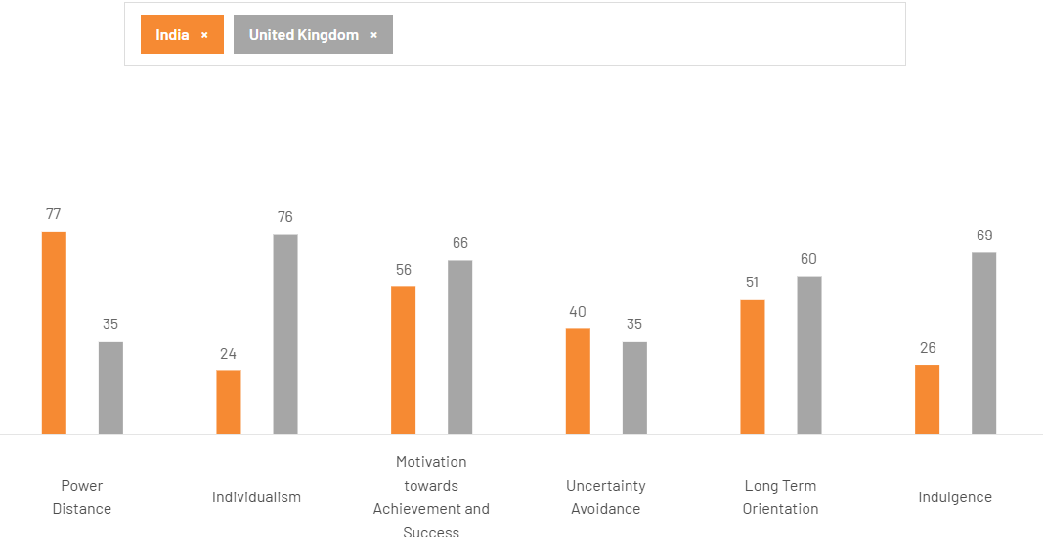
Figure 12: Hofstede Cultural Dimensions Comparison
Source: Adapted from Hofstede Insights

3.4.1 United Kingdom
The culture of the United Kingdom is more inclined towards individualism, innovation and efficiency. Consumers are also likely to make individual buying choices and value their personal preferences over the group influence. When buying a car, consumers are concerned about the quality of the products, their performance, safety, and superior technology (Rodrigues et al., 2023). Sustainability is also gaining momentum, with more and more electric vehicles and environmental solutions being in demand (Agoro et al., 2025). The use of functional advantages like reliability, fuel efficiency, and technological advancement in most instances drives luxury car consumers in the UK instead of primarily social status (Al-Issa et al., 2025). Also, transparency, responsibility in the production process, and brand responsibility are significant factors that will influence perceptions and consumer loyalty (Luo et al., 2026).

3.4.2 India
Comparatively, India is a more collectivist society in which social relations and group influence greatly influence the consumer behaviour. The family members, peers, and societal expectations tend to affect buying choices (Chatterjee et al., 2021). Car ownership in the luxury automobile industry is directly related to social status, prestige and success. Luxury brands are regarded as the representation of success and promotion to a higher level among consumers (Gaur et al., 2025). Brand image, reputation, and exclusivity are thus crucial elements affecting purchasing decisions (Nunes, 2024). Moreover, the cultural values place an emphasis on respect towards hierarchy and social recognition, which in turn makes the premium products even more valuable. Consequently, Indian marketing practices tend to put an emphasis on the aspirational lifestyle and emotionalism.

3.4.3 Advantages and Disadvantages of Hofstede’s Model
Advantages | Disadvantages
Provides a structured way to compare cultures across countries | May oversimplify complex cultural differences
Helps businesses adapt marketing strategies internationally | Based on limited data and may not reflect current changes
Useful for understanding consumer behaviour patterns | Ignores regional and individual differences within countries
Widely used in international business research | Cultural values may change over time
Supports cross-cultural communication and management | May reflect Western bias in interpretation
Table 2: Advantages and Disadvantages of Hofstede’s Model
The macroenvironment analysis indicates that both markets have opportunities available but the UK is a mature and regulated market as compared to India which is a fast-growing and a highly dynamic market.

4. Comparison of Mercedes-Benz’s STP Strategies in the UK and India

4.1 Segmentation Strategies
In the United Kingdom and India, Mercedes-Benz employs a multi-level segmentation scheme which depends on geographic, demographic, psychographic and behavioural segments.
The geographic segmentation in the UK is based on urban and suburban regions where the premium cars are in high demand. The demand to cities like London, Manchester and Birmingham are high because of the increased income and well-developed infrastructure. The demographic of the brand is the high-income professionals, executives and business users who can afford the expensive cars.
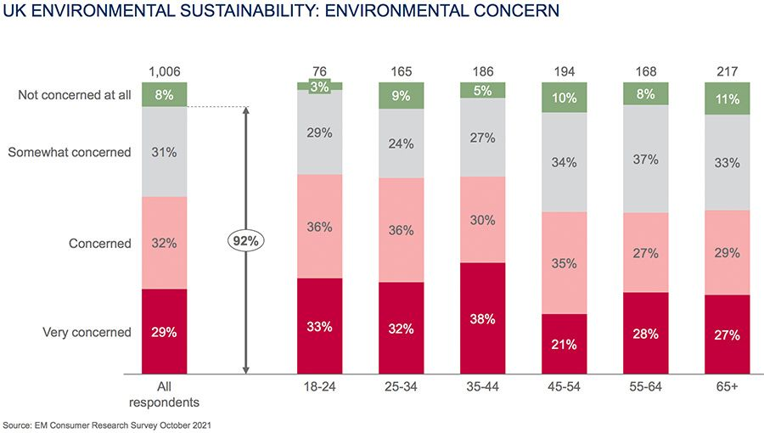
Figure 13: Environmental Concern Levels in the UK
Source: Adapted from EM Consumer Research Survey (2021)
Psychographically, the UK consumers attach importance to quality, innovations and environmental sustainability. Electric vehicles and high-tech technologies are of interest to many customers. On the behavioural front, the UK customers value leasing, upgrades, and financing plans, particularly in the high-end car category (Rodrigues et al., 2023).
Segmentation in India is concentrated on the urban metropolitan cities like Mumbai, Delhi, and Bangalore, though it is also spreading to Tier 2 cities and Tier 3 cities. The brand demographics are high net worths (HNWIs), business people, and business executives. Indian consumers have status, luxury, and social recognition as their psychographic motivators.
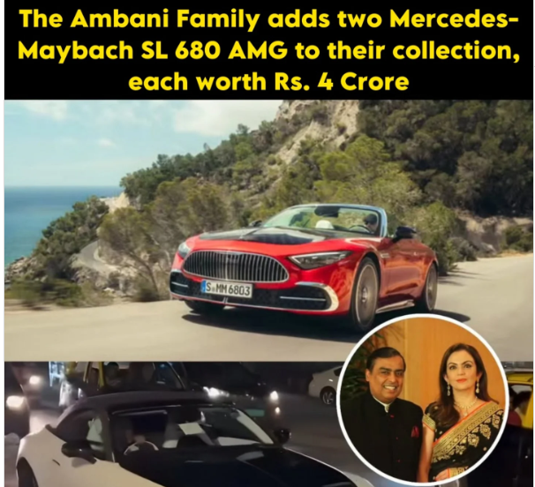
Figure 14: Luxury Lifestyle and Status Symbol of Mercedes-Benz Ownership in India
Source: Adapted from social media representation
Luxury cars are regarded as a symbol of prestige and success. On the behavioural front, customers display great brand loyalty and are driven by customised experiences and quality services. The expansion of the luxury automobile market in smaller cities indicates that the segmentation is growing outside of the traditional centres (Gaur et al., 2025; SME Futures, 2025).

4.2 Targeting Strategies
Mercedes-Benz has a differentiated targeting strategy in the UK. It appeals to various markets including business people, environmentally conscious consumers, and car lovers. The business has a broad range of products such as electric vehicles (EQ models), SUVs and executive sedans to suit various customer demands. It is tailored towards customers who attach importance to performance, sustainability and technological excellence (Rodrigues et al., 2023; Al-Issa et al., 2025).
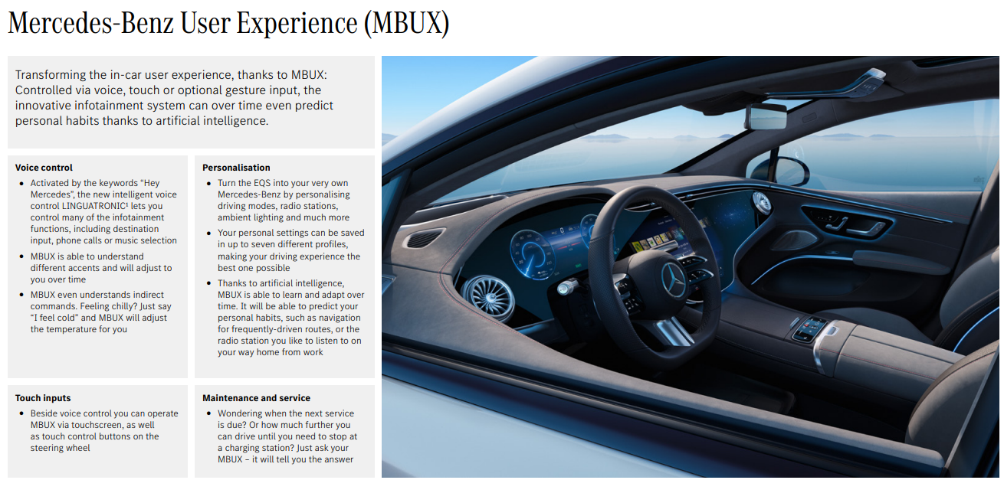
Figure 15: Mercedes-Benz MBUX Digital User Experience System
Source: Mercedes-Benz Group AG (2025)
In India, the targeting technique is more selective and narrower. The company primarily focuses on the high-end clients, such as business executives, celebrities, and high-income professionals. These consumers want exclusivity, comfort and good brand image. The younger rich customers are also a target of this company as they like luxury SUVs and techno-savvy cars. The company is also focusing on the environmentally conscious consumers who are in high income brackets with the launch of new EV models (Fortune India, 2025).
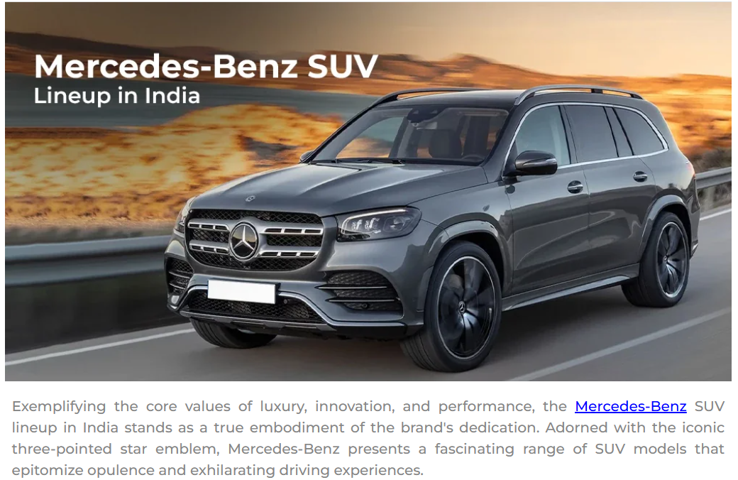
Figure 16: Mercedes-Benz SUV Lineup in India
Source: Adapted from CarLelo (2026)

4.3 Positioning Strategies
Mercedes-Benz adheres to a global positioning theory which is grounded on luxury, innovation, and performance (Barakati et al., 2024; Rodrigues et al., 2023). Nonetheless, there is some adjustment in positioning in both markets.
The brand is positioned as a technologically advanced and a high-end automotive firm in the UK. It focuses on innovation, safety as well as sustainability (Braidy et al., 2025). Its positioning is based on electric vehicles and digital features (Achillas et al., 2024). The UK consumers perceive Mercedes-Benz as a brand that is engineering, reliable, and modern in terms of mobility solutions (Al-Issa et al., 2025). The brand is in strong competition with other upscale brands like BMW and Audi (McKinsey & Company, 2025).
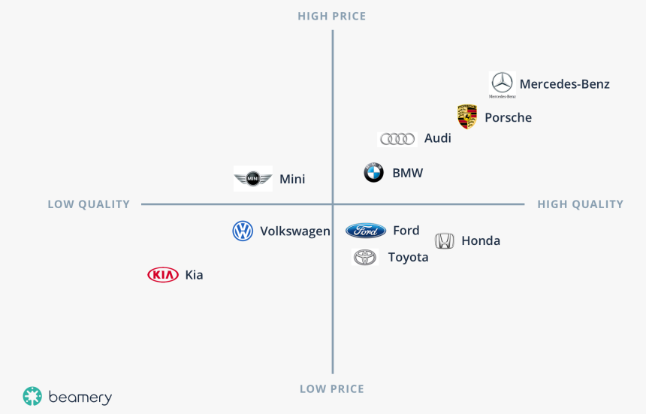
Figure 17: Perceptual Map of Automotive Brands Based on Price and Quality
Source: Adapted from Perceptual Map Concept
The brand is more aligned as a status brand in India. Emotional and social value is a larger factor but luxury and innovation is still significant. Having a Mercedes-Benz car is regarded as an indicator of success and status (Lestari, 2026). The exclusivity is also emphasised by the company in the form of high-end services such as a customised design or high-end product line including MANUFAKTUR (Mercedes-Benz India, 2026).
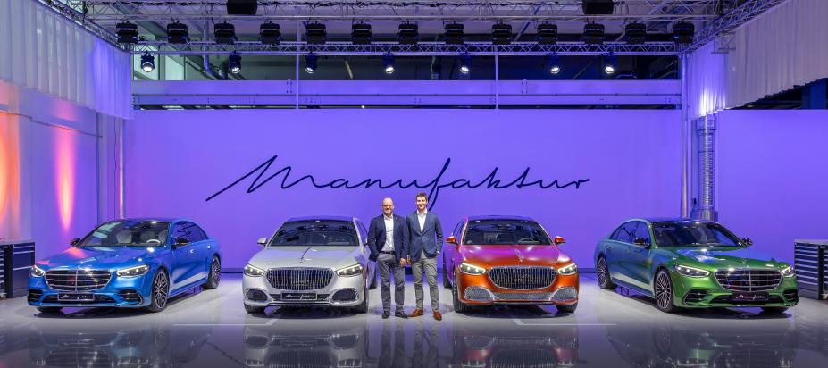
Figure 18: Mercedes-Benz MANUFAKTUR Customisation and Luxury Personalisation
Source: Mercedes-Benz Group (2026)
One of the determinants of customer choice in the luxury car market is the brand image, and effective positioning will enable Mercedes-Benz to retain its competitive edge (Nunes, 2024).

4.4 Comparative Summary of STP
STP Element | Similarities | United Kingdom | India
Segmentation | Uses geographic, demographic, psychographic, and behavioural segmentation | Focus on urban high-income professionals and sustainability-conscious consumers | Focus on HNWIs, entrepreneurs, and expanding demand in Tier 2 cities
Targeting | Targets premium and high-income customers in both markets | Differentiated targeting across EV users, executives, and luxury buyers | Selective targeting of affluent and status-driven consumers
Positioning | Positioned as a global luxury and innovative brand | Focus on technology, sustainability, and performance | Focus on prestige, exclusivity, and social status
Table 3: Comparative Summary of STP
Source: Author

5. Comparison of Marketing Mix Strategies in the UK and India
One of the important frameworks used to analyse how a company creates and delivers value to its customers using product, price, place and promotion and in service situations, people, process and physical evidence are also incorporated. The marketing mix in international marketing assists firms to adjust their strategies to various cultural, economic and competitive situations in every country. In the case of a global luxury brand like Mercedes-Benz, the 7Ps play a crucial role in the brand consistency and, at the same time, addressing the needs and market conditions of local customers in the United Kingdom and India (Rodrigues et al., 2023; Amro et al., 2025; McKinsey and Company, 2025).
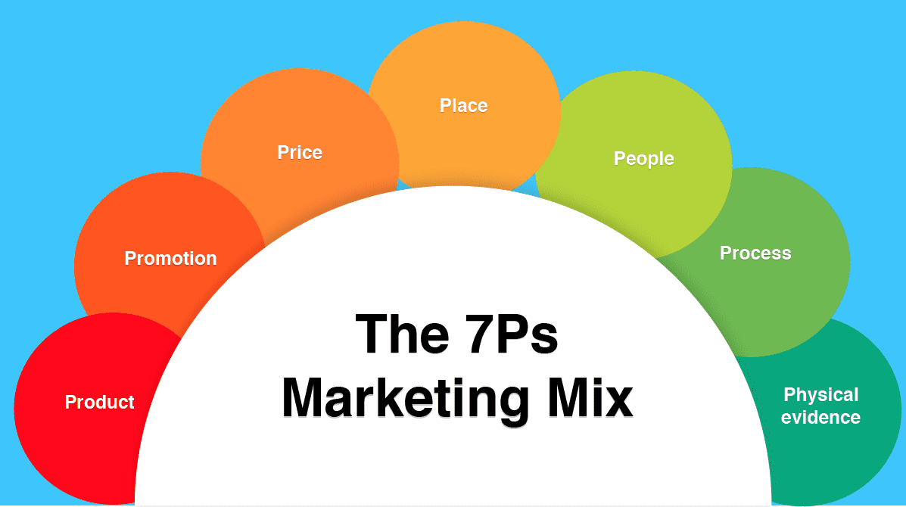

5.1 Product
Mercedes-Benz sells a big variety of luxury motor vehicles such as sedans, SUV, as well as electric cars in the United Kingdom as well as in India.
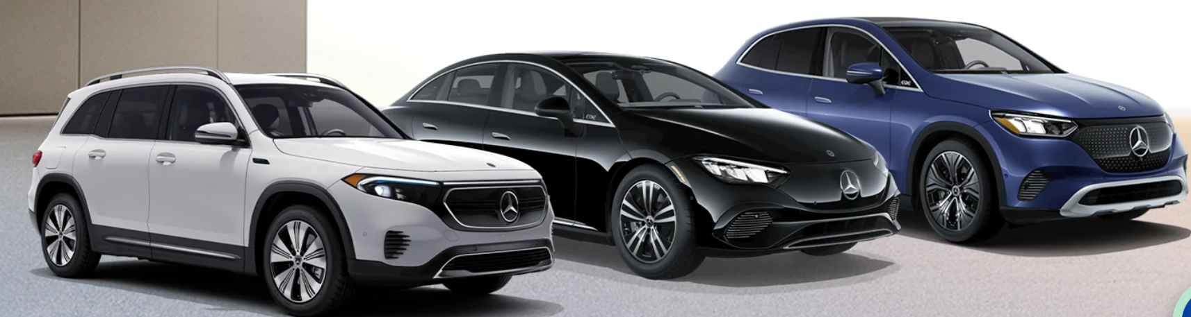
Figure 19: Mercedes-Benz Electric Vehicle Product Portfolio (EQ Models Lineup)
Source: Adapted from Mercedes-Benz Official Website

UK
In the UK the product approach is heavily based on innovation and sustainability. The company has a complete line-up of electric EQ models, hybrid, and high-performance AMG models. The UK consumers seek high tech, safety and environmentally conscious products, and this has resulted in a robust growth in EV products (Achillas et al., 2024).

India
India is more selective in its product strategy and is tailored to the local demand. The company deals with luxury sedans and SUVs which are very popular in the market. Electric cars are also getting more and more attention, and several EV models are going to be introduced to seize the demand in the future (Fortune India, 2025). Moreover, the customisation services, like MANUFAKTUR, increase the exclusivity of products (Mercedes-Benz India, 2026).
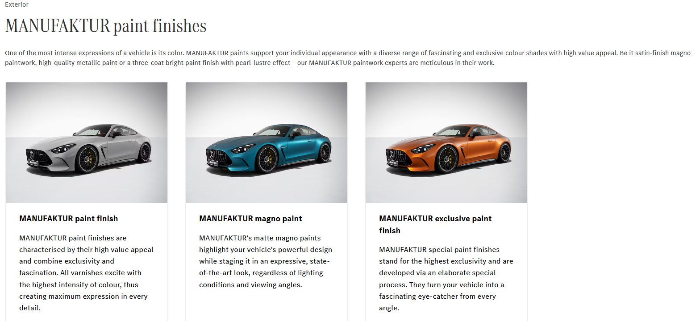
Figure 20: Mercedes-Benz MANUFAKTUR Personalisation Options
Source: Mercedes-Benz Official Website (2026)

5.2 Price

UK
Mercedes-Benz in the UK adheres to a premium pricing approach, although it applies flexible pricing like leasing and financing. This renders luxury cars to be more affordable to work people and businesspeople. The competition, innovation and customer expectations play a role in pricing that influences a mature market (Rodrigues et al., 2023; McKinsey & Company, 2025).

India
In India, the cost is a lot more with the duties and taxes on imports. The locally assemblies are placed as luxurious products too. The company uses a premium-plus pricing strategy, which aims at the high-end consumers that are not price sensitive. The perception of price is a significant part of the customer experience and brand value (Amro et al., 2025).

5.3 Place

UK
Merccedes-Benz has a wide distribution network in the United Kingdom with dealerships in key cities and thus good market coverage. Digital platforms are also incorporated into the company, which enables customers to design cars, reserve test drives, and make purchases online. This is an omni-channel model that enhances customer accessibility and convenience (Rodrigues et al., 2023).
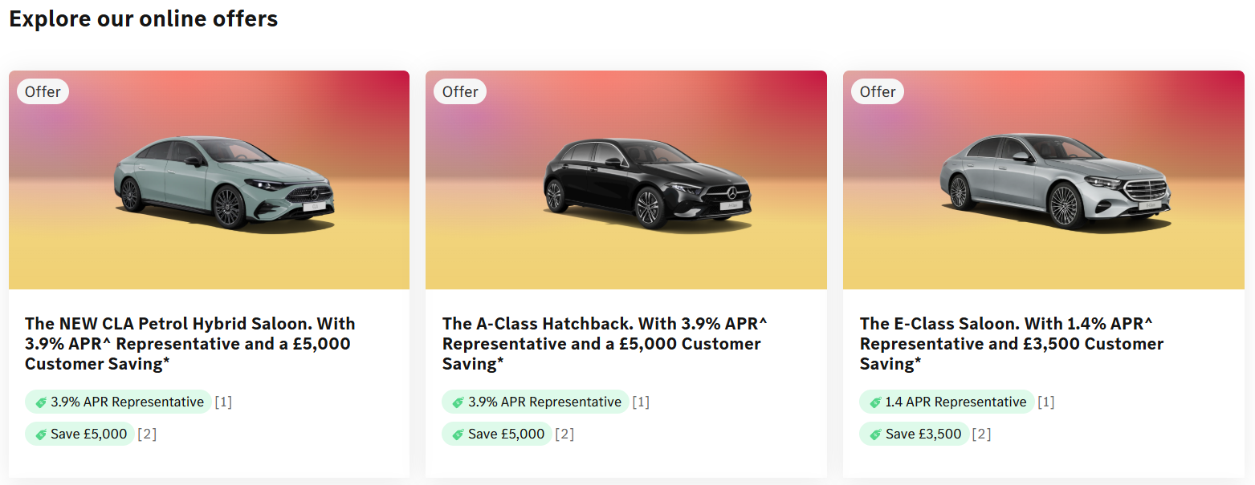
Figure 21: Mercedes-Benz Online Sales Promotions and Financing Offers (UK)
Source: Explore Mercedes-Benz Online Offers

India
In India, distribution is less dispersed and rather concentrated in metropolitan cities like Delhi, Mumbai and Bangalore. Nonetheless, there is a trend towards entering Tier 2 cities as a result of the growing luxury car demand. The brand image and the high-end customer experience are supported with the help of premium showrooms and exclusive retail environments (SME Futures, 2025; Gaur et al., 2025).
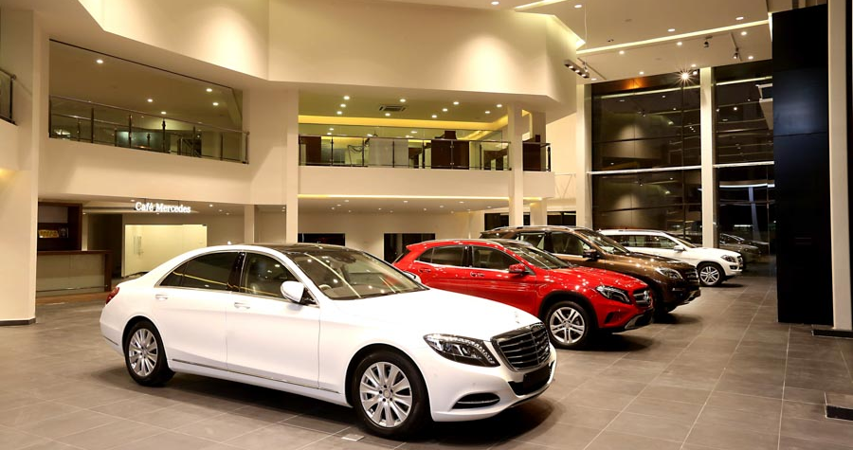
Figure 22: Mercedes-Benz Premium Showroom Experience in Chennai
Source: Adapted from Mercedes-Benz Dealership Showroom

5.4 Promotion
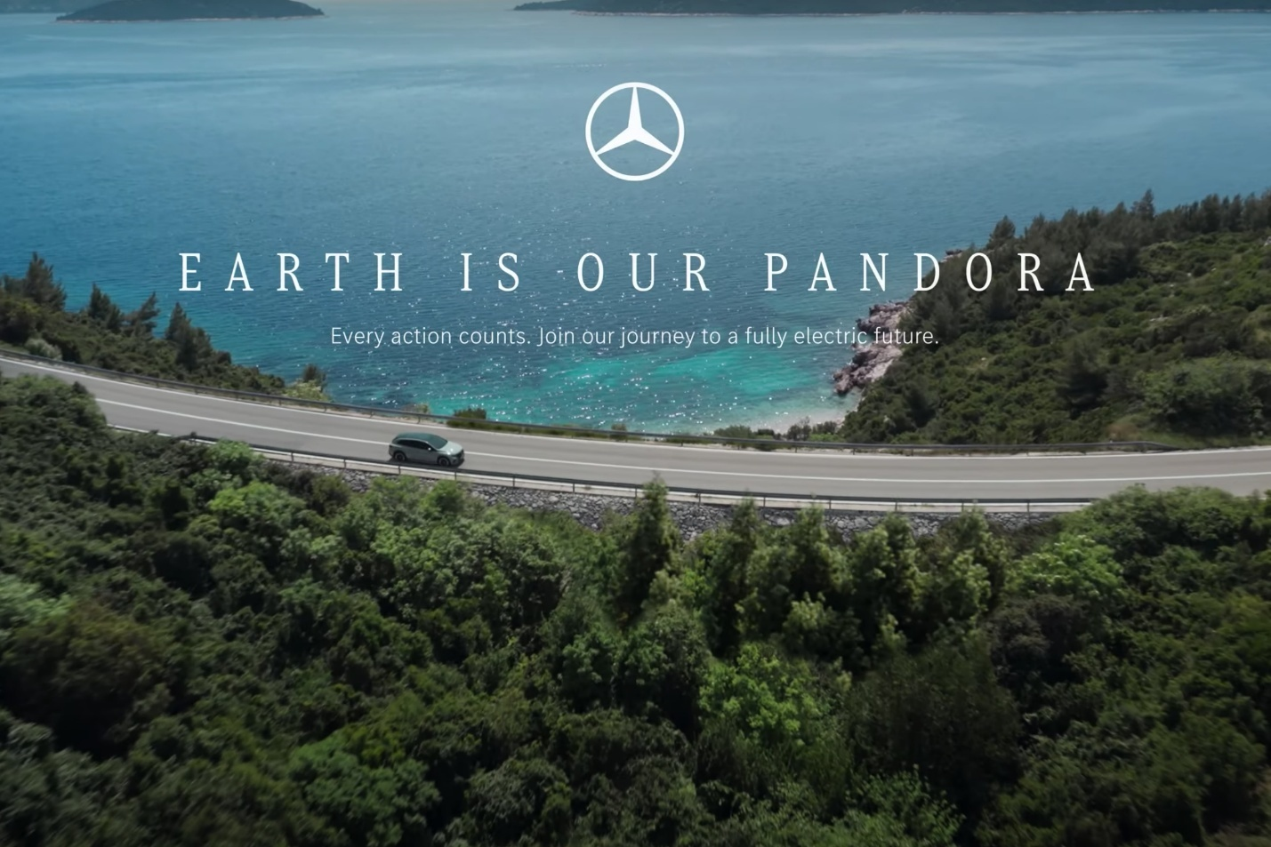
Figure 23: Mercedes-Benz Sustainability-Focused Promotional Campaign
Source: Adapted from Mercedes-Benz “Earth is Our Pandora” Campaign

UK
In the UK, the promotional methods of Mercedes-Benz focus on digitalisation, innovation, and sustainability. Electric mobility, advanced technology and performance are emphasized in marketing campaigns to appeal to environmentally conscious and technologically-minded consumers. Social media platforms and experiential marketing are also employed as the brand tries to interface with customers (Rodrigues et al., 2023).

India
Promotion is more luxurious, lifestyle-oriented and status-oriented in India. Mercedes-Benz employs the use of celebrities, high-end events, online campaigns to attract wealthy consumers. The most important factors are emotional storytelling and aspirational messaging as the brand image is a major determinant of purchase decisions (Thongmak, 2025; Gaur et al., 2025).

Figure 24: Mercedes-Benz Luxury Launch Event Promotion Strategy
Source: Adapted from Mercedes-Benz India Promotional Event

5.5 People

UK
In the United Kingdom and India, workers are very vital in achieving a high quality of customer experience in Mercedes-Benz. The employees in the UK are well trained to deliver professional and efficient services with great focus on product knowledge, customer satisfaction, and efficient interactions. This is in line with customer expectations in a mature and service-based market (Rodrigues et al., 2023).

India
Customer service in India is more personal and relationship-focused. The sales representatives are geared towards the development of long-term relationships and the provision of individualised experiences in response to customer needs. To preserve brand prestige and increase customer loyalty, high-quality service is necessary (Amro et al., 2025).

5.6 Process

UK
The process of purchasing Mercedes-Benz in the United Kingdom is extremely computerised. Customers have an opportunity to design vehicles on internet, book test drives and make purchases using online stores. The services of after sales are effective and smooth and increase the total satisfaction and convenience of customers (Rodrigues et al., 2023).

India
In India, there is a mixed digital and physical buying process. Before customers make a purchase, they tend to visit show rooms and have a personalised relationship with them. Nevertheless, online tools are gaining prominence in the customer experience. Effective service processes aid in the enhancement of consumer satisfaction, involvement, and brand loyalty in the long run (Amro et al., 2025).

5.7 Physical Evidence
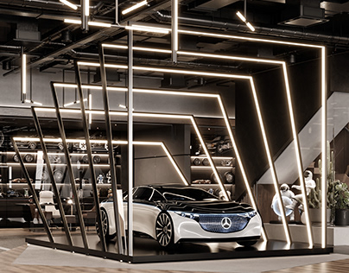
Figure 25: Mercedes-Benz Modern Luxury Showroom Design
Source: Adapted from Mercedes-Benz

UK
Modern showrooms, high-quality interiors, and high-tech interfaces are the physical evidence in the United Kingdom, which is an expression of the global brand name of Mercedes-Benz. Its dealerships are upheld by similar store design and high-quality visual display, which contributes to the image of a technologically advanced luxury brand (Rodrigues et al., 2023).

India
Physical evidence in India is oriented towards getting a unique, personalised luxury experience. Showrooms are characterised by luxurious interiors, classy designs, and personalized service zones. Prestige and attention to detail are emphasized in this environment and are valuable to consumers who attribute prestige brands to status and social acceptance (Gaur et al., 2025).

5.8 Similarities and Differences in 7Ps
7Ps Element | Similarities | United Kingdom | India
Product | Premium vehicles and innovation focus | Strong EV and hybrid portfolio | Focus on SUVs, sedans, and selective EVs
Price | Premium pricing strategy | Flexible financing and leasing | High prices due to taxes and import duties
Place | Dealership networks and digital channels | Wide and accessible network | Metro-focused with growing Tier 2 expansion
Promotion | Digital marketing and branding | Focus on sustainability and innovation | Focus on luxury, lifestyle, and status
People | Skilled workforce delivering premium service | Professional and efficient service | Highly personalised customer experience
Process | Structured purchase and service systems | Highly digitalised process | Mix of digital and personal interaction
Physical Evidence | Strong brand identity and premium environments | Modern showrooms and digital presence | Luxury showrooms with personalised experience
Table 4: Similarities and Differences in 7Ps
Source: Author

6. Ansoff Matrix: Mercedes-Benz India Brand Directional Development Strategy
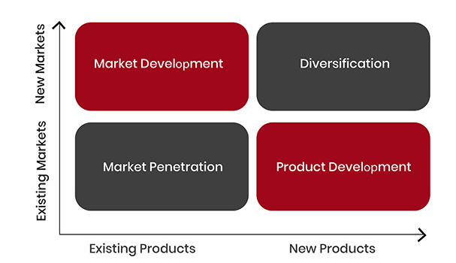
Figure 26: Ansoff Matrix
Source: Adapted from Ansoff Product–Market Growth Matrix
The Ansoff Matrix is a strategic tool used to identify growth opportunities based on existing and new products and markets. For Mercedes-Benz in India, the framework highlights how the company can expand in a fast-growing luxury automobile market.
Strategy | Application to Mercedes-Benz India
Market Penetration | Mercedes-Benz focuses on increasing its market share within the existing luxury segment in India. The company strengthens customer engagement through improved after-sales services, premium showroom experiences, and flexible financing options. Expanding dealership networks into Tier 2 and Tier 3 cities helps improve accessibility and brand visibility. Rising demand in these cities supports deeper market penetration and increases overall sales performance (SME Futures, 2025).
Product Development | The company actively introduces new models to meet changing consumer preferences. A key focus is on electric vehicles (EVs) and luxury SUVs, which are increasingly popular among Indian consumers. Mercedes-Benz plans to launch multiple EV models, showing strong commitment to innovation and sustainability. In addition, premium customisation services such as MANUFAKTUR enhance product differentiation and allow customers to personalise vehicles, increasing perceived value and exclusivity (Fortune India, 2025; Mercedes-Benz India, 2026).
Market Development | Mercedes-Benz is expanding into new geographic markets within India, especially emerging urban areas. Growth in disposable income and increasing aspiration for luxury products in smaller cities create new opportunities. The company is targeting these regions to reach new customer segments and strengthen its market presence beyond major metropolitan areas (Gaur et al., 2025).
Diversification | Diversification is relatively limited but developing. The company is exploring digital mobility services and electric mobility ecosystems. This includes investment in EV infrastructure, charging networks, and digital platforms to improve the overall customer experience. These initiatives support long-term growth and align with global sustainability trends (Achillas et al., 2024).
Table 5: Application of Ansoff Growth Strategies in Mercedes-Benz India
Source: Author

7. Ethical Issues and Unethical issues in Mercedes-Benz’s Marketing Mix: UK

Ethical Issue 1 – Sustainability Promotion
In UK, the marketing mix of Mercedes-Benz has ethical issues mainly concerning environmental impact and transparency. Though the company boasts of electric vehicles and sustainability, there is the fear of greenwashing where marketing messages can overemphasise on the environmental advantage whilst production processes continue to emit emissions (Dudziak et al., 2025). As an illustration, EVs do not emit emissions at the tailpipe, yet there are environmental effects in the battery production and supply chains.
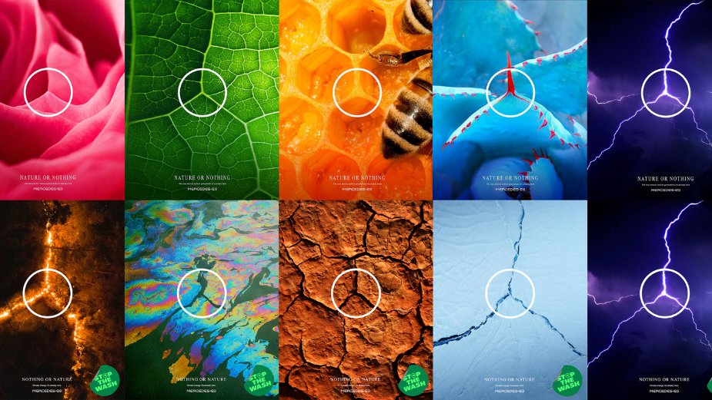
Figure 27: Greenwashing in Automotive Sustainability Advertising
Source: Adapted from Mercedes-Benz “Nature or Nothing” Campaign
The other ethical concern is the issue of privacy of data. Connected technologies that are employed in modern vehicles gather information about the customers. Although the features enhance user-friendliness, they create issues regarding information privacy and misuse of data (Mili, 2026).

Ethical Issue 2 – Customer Transparency and Safety
In its advertising, Mercedes-Benz emphasizes innovation in safety, product quality, and more driver-support system. Customer trust is achieved by giving transparent information on the safety features of the vehicle and enabling customers make informed buying choices. Ethical relations between the brand and the consumer are reinforced by honest communication (Rodrigues et al., 2023).

Unethical Issue 1 – Greenwashing Risk
Greenwashing could occur with Mercedes-Benz sustainability marketing if its environmental advantages are overemphasised. While EVs eliminate tailpipe emissions, there are still environmental impacts from battery production and supply. Overemphasising positives could deceive eco-conscious consumers in the UK (Dudziak et al., 2025).

Unethical Issue 2 – Data Privacy Concerns
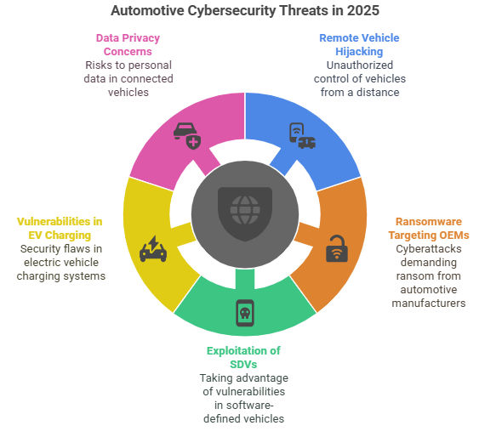
Figure 28: Automotive Cybersecurity Threats in Connected Vehicles
Source: Adapted from Automotive Cybersecurity Industry Reports
Ethical consideration is also on pricing. High pricing can reduce the access and encourage social disparities, in particular, luxury cars as sustainable options. Thus, although Mercedes-Benz is an innovative and sustainable company, it is not ethical in terms of environmental claims, data utilization, and social responsibility (Dudziak et al., 2025; Mili, 2026).

8. Recommendations
- Strengthen electric vehicle (EV) strategy in both markets
Mercedes-Benz needs to keep on increasing its EV portfolio both in the United Kingdom and India. This will facilitate regulatory compliance and sustainability in the UK. Following the trend of expanding EV options and investing in charging infrastructure in India can assist in capturing the future demand and contribute to government efforts (Dutta et al., 2025).
- Enhance localisation strategy in India
The company would need to make more in the country and localise the products to the Indian tastes that include SUV and tailor-made luxury. This will lower the cost, enhance competitiveness, and address the consumer expectations of the local consumers better (Gaur et al., 2025).
- Improve digital customer experience
Mercedes-Benz must put more resources into online platforms like online vehicle configuration, virtual showroom, and AI-based customer interaction. This will make the process more convenient and interactive, particularly among younger and tech-conscious customers (Rodrigues et al., 2023).
- Strengthen sustainability and transparency
The company should not only effectively report its sustainability activities but also mitigate the chances of greenwashing by making clear cut information on the emissions and production processes (Dudziak et al., 2025).
- Expand presence in emerging markets within India
Expanding the number of dealerships in Tier 2 and Tier 3 cities will assist the company in accessing new customer groups and aid future growth in the long term (SME Futures, 2025).

9. Conclusion
In this section, it is evident that Mercedes-Benz has a powerful global marketing approach yet is flexible to local market environments in the United Kingdom and India. UK market is concerned with sustainability and innovation with India market being concerned with status and luxury. The varying economic, cultural and regulatory environment affects marketing preferences. In general, a successful implementation of adaptive processes and ongoing innovation are the keys to success in foreign markets in the long run.

10. Reflective Account Using Gibbs Reflective Cycle
The Reflective Cycle by Gibbs is one of the most popular models that assist people to learn by experience in a logical 6-step procedure: description, feelings, evaluation, analysis, conclusion, and action plan. The framework, first established by Graham Gibbs in the year 1988, promotes the critical thinking process by viewing an experience in both negative and positive ways. It is widely used in education, business, healthcare, and professional development to enhance performance in the future. Adhering to each step, students will be able to define their strong points, areas of weakness, and viable improvements. Reflective Cycle, created by Gibbs was applied in this assignment to examine the learning process and acquire the skills of future academic and professional activity (Gibbs, 1988).


10.1 Description
This reflection report is an assessment of the procedure undertaken in conducting the research, analysis and writing of the report on the international marketing mix of Mercedes-Benz in the United Kingdom and India. Some of the major marketing frameworks that were to be applied in the assignment included PESTEL analysis, STP strategies, 7Ps marketing mix, and the Ansoff Matrix. In order to prepare the report, I collected academic journals, company reports, and industry reports. I paid attention to the recent statistics, particularly since 20252026, to make the analysis timely and up-to-date.
This included the process of identifying the appropriate sources, examining the differences between the two markets, and reporting results in a tabular format. Tables were also used to compare data in an easy manner. Using the theoretical models assisted me in structuring the material and making the report have a logical flow. Generally, the assignment included not only theoretical knowledge but also practical skills in marketing concepts across the borders.

10.2 Feelings

When starting the assignment, I was confident in marketing frameworks like STP and the 7Ps since I had previously learned these concepts. Nevertheless, I also was unsure about how to apply them to a real company in two countries. It was difficult to find steady and updated information about the UK and India, causing a certain degree of stress at the beginning.
My further advancement led me to feel more skilled in information analysis and applying theory to practical cases. The analogy of the two countries was quite interesting to me as the people have brought the differences in culture and economy to determine the way in which marketing strategies are impacted. This enhanced my interest and involvement in the task.
At the conclusion of the assignment, I was more convinced in my research and analytical abilities. I also was quite satisfied with my skill to organize a comprehensive report and use theoretical knowledge in the practice.

10.3 Evaluation
Strengths | Challenges
Use of structured frameworks (PESTEL, STP, 7Ps) improved organisation and clarity | Difficulty in finding accurate and up-to-date data for specific areas
Effective comparison between UK and India enhanced understanding of international markets | Limited access to internal company information (e.g., pricing, processes)
Use of tables and comparisons improved presentation and readability | Maintaining consistency in referencing
Inclusion of recent and relevant data made analysis realistic | Avoiding repetition across sections
Improved critical thinking and analytical skills | Managing time for extensive research
Table 6: Evaluation of Assignment - Strengths and Challenges
Source: Author
Overall, the assignment was a valuable learning experience. One of the main strengths was the use of structured frameworks, which helped organise the analysis clearly. For example, the PESTEL framework allowed me to compare macroenvironmental factors effectively, while the 7Ps helped in analysing the marketing strategies in detail. Tables and comparisons also improved the clarity of the report.
The use of updated and current data was another strength as it made the analysis more realistic. The emphasis on the developed (UK) and developing (India) markets gave a wider insight into the international marketing strategies.
Nevertheless, it did not go without difficulties. To locate the correct and updated data on certain regions like pricing strategies and internal processes of the company, a lot of research had been conducted. The other challenge was to be consistent in referencing and avoiding repetition. Regardless of such difficulties, the process assisted in enhancing my critical thinking and researching abilities.

10.4 Analysis
This assignment made me realize that international marketing entails standardizing the world and localizing it as well. As an example, Mercedes-Benz has a powerful global brand image, yet it modulates marketing mix according to the conditions in the local markets. During the UK, sustainability and technological innovation are the priorities, whereas in India, the priorities are luxury and social status.
The application of models like STP and the 7Ps demonstrated how businesses would divide markets, focus on particular targeted customers, and position their products in such a manner. It also emphasised the need to know the consumer behaviour in various cultural environments. As an example, status and brand image are more important to Indian consumers whereas functionality and sustainability are more significant to UK consumers (Nunes, 2024; Gaur and Verma, 2025).
Another important aspect of the assignment that enhanced my learning skills was the ability to relate theory to practice. I was taught that economic conditions, government policies as well as cultural differences are key determinants of marketing strategies. This knowledge will be relevant in further study and practice in the field of international business.

10.5 Conclusion
This reflective procedure helped me to understand more effectively how to tackle complicated academic assignments. I have been taught about the need to integrate both theoretical and practical information in order to come up with a meaningful analysis. It also helped me to learn how to organise the information and display it in a systematic manner with headings and tables, which is a part of the assignment.
I also understood that it is crucial to use credible and up-to-date sources to back arguments. Among the lessons was that time management is critical as research and analysis take a lot of time and effort. On the whole, this experience has improved my research, analytical and academic writing abilities.

10.6 Action Plan
Aspect | Action | Timeline | Method | Expected Outcome
Research Skills | Identify key sources early | Week 1 | Use academic journals and reports | Better quality data
Time Management | Create a structured schedule | Weekly | Use planner or Gantt chart | Timely completion
Critical Analysis | Improve linking of theory and practice | Ongoing | Apply frameworks consistently | Deeper analysis
Referencing | Organise citations properly | Throughout | Use reference tools | Accurate referencing
Writing Skills | Improve clarity and structure | Ongoing | Practice academic writing | Clear and logical reports
Reflective Practice | Use Gibbs cycle regularly | After each task | Self-evaluation | Continuous improvement
Table 7: Action Plan
Source: Author
The action plan is aimed to increase the main academic and professional skills. It also involves improving research quality, in terms of time management, critical analysis, and proper referencing. The continuing training of academic writing and self-assessment with the help of the Gibbs model will help to communicate and comprehend better, developing personally and professionally.

11. References
Achillas, C. and Iosifidou, P. (2024) ‘Shifting towards electric vehicles: A case study of Mercedes-Benz from the perspective of cross-functional teams and workforce transformation’, World Electric Vehicle Journal, 15, p. 325. Available at: https://doi.org/10.3390/wevj15070325 (Accessed: 1 March 2026).
Agoro, H. and Solomon, D. (2025) ‘Consumer attitudes toward electric vehicles’, Journal Article. (Accessed: 2 March 2026).
Al-Issa, N., Abiad, M., Kallach, L. and Alakoum, A. (2025) ‘The new luxury equation: consumer values and market preferences’, Cogent Social Sciences, 11. Available at: https://doi.org/10.1080/23311886.2025.2518444 (Accessed: 3 March 2026).
Alatawneh, A. and Torok, A. (2025) ‘Projecting AV sales in the EU-27 and UK: Insights from Euro emission standards and historical trends’, Transport Policy, 163, pp. 91–101. Available at: https://doi.org/10.1016/j.tranpol.2025.01.009 (Accessed: 4 March 2026).
Amro, A., Rehman, A.U. and Ali, A. (2025) ‘Service quality and price perception as catalysts for customer engagement and experience in automotive aftersales’, Cogent Business & Management, 12(1). Available at: https://doi.org/10.1080/23311975.2025.2514939 (Accessed: 5 March 2026).
Barakati, P., Bertini, F., Corsi, E., Gabbrielli, M. and Montesi, D. (2024) ‘Luxury car data analysis: A literature review’, Data, 9, p. 48. Available at: https://doi.org/10.3390/data9040048 (Accessed: 6 March 2026).
Braidy, A., Pokharel, S. and ElMekkawy, T. (2025) ‘Research perspectives on innovation in the automotive sector’, Sustainability, 17, p. 2795. Available at: https://doi.org/10.3390/su17072795 (Accessed: 7 March 2026).
Chatterjee, S., Chaudhuri, R., Vrontis, D. and Thrassou, A. (2021) ‘The influence of online customer reviews on customers’ purchase intentions: A cross-cultural study from India and the UK’, International Journal of Organizational Analysis. Available at: https://doi.org/10.1108/IJOA-02-2021-2627 (Accessed: 8 March 2026).
CLEPA (2025) Position paper on Brexit. Available at: https://www.clepa.eu/wp-content/uploads/2025/03/CLEPA-Position-Paper-on-Brexit.pdf (Accessed: 9 March 2026).
Dudziak, A., Juściński, S., Droździel, P. and Słowik, T. (2025) ‘The phenomenon of greenwashing in the automotive industry and its perception among market users’, Sustainability, 17, p. 11123. Available at: https://doi.org/10.3390/su172411123 (Accessed: 10 March 2026).
Dutta, A. and Padmanaban, S. (2025) ‘Shaping India’s EV future: A policy framework inspired by global best practices’, Academia Green Energy, 2. Available at: https://doi.org/10.20935/AcadEnergy7683 (Accessed: 11 March 2026).
Fortune India (2025) ‘Mercedes-Benz India to expand top-end EV push with 12 new launches this year’. Available at: https://www.fortuneindia.com/auto/mercedes-benz-india-to-expand-top-end-ev-push-with-12-new-launches-this-year/132106 (Accessed: 12 March 2026).
Gaur, S. and Verma, M. (2025) ‘Luxury consumption in India: Consumer behavior, market trends, and future prospects’, Stallion Journal for Multidisciplinary Associated Research Studies, pp. 87–91. Available at: https://doi.org/10.55544/sjmars.icmri.15 (Accessed: 13 March 2026).
Lestari, A. (2026) ‘The effect of luxury brand and brand experience on customer loyalty’, Jurnal Manajemen Motivasi, 22, pp. 910–926. Available at: https://doi.org/10.29406/jmm.v22i1.8610 (Accessed: 14 March 2026).
Luo, Y., Bazi, S., Ul-Durar, S., De Sisto, M. and Damij, N. (2026) ‘Can sustainable technology features of products stimulate market performance?’, Journal of Business Research, 208, 116079. Available at: https://doi.org/10.1016/j.jbusres.2026.116079 (Accessed: 15 March 2026).

