Understanding and Engaging in the Customer Experience
Aphie Mongombe (1604236)
Lecturer: DR Rexon Nting

Contents
Introduction 1
Task-1: Critically analyzes the factors that impact on organization’s ability to maximize customer value. 2
Customer and customer value 2
How customer value can be weighted? 3
How Tesco Plc. delivers value to its customers? 3
Ranges of factors that impact on organization’s ability to maximize customer value? 5
Task-2: Critical understanding of organizational quality processes and its effectiveness in meeting customer requirements. 10
Quality processes of Tesco Plc. and effectiveness in meeting customer requirements 10
Purpose of using quality management process 11
Steps involves in quality management process of Tesco Plc. 13
Sample of quality management plan (Tesco Plc.) 16
Assessment of the effectiveness of quality processes 18
Conclusion 19
References 20

Introduction
A customer engages in transaction whenever he/she found the positive result of customer value. When the perceived benefit exceed the bearing cost, customer enjoys value. In this study, the author will cover a number of aspects relating understanding and engaging in the customers. The author will define the terms customers and customer value. The author will shows process of measuring customer value and present the ways how Tesco Plc. delivers value to its customers. The author will analyze the ranges of factors impact on organization’s ability to maximize customer value. The author will touch the gaps appears in service offering and provides logical solution to close these gaps. And lastly the author will focus on Tesco Plc.’s quality processes and its effectiveness in meeting customer expectations.

Task-1: Critically analyzes the factors that impact on organization’s ability to maximize customer value.

Customer and customer value
Customers is the considered the integral part of whole business process. A business is not only producing required products and services. Finding the right customer group is another important fact. A business without customer cannot be survived and competed. Customers and their preferences influence the way companies in every single industry and determine the growth and expansion (Flint and Woodruff, 2014). That’s why it is challenging of managing effective interactions with customer and providing them value not only offering products but also through interactions, relationships and constant connection.

The wide practice of worldwide business has proved it that, customers are the biggest asset of an organization without which survival is impossible. The challenging fact is that, customers are in permanent change, becomes more demanding as the days ahead and got more profiled (Flint and Woodruff, 2014). So organization has nothing but concentrate and focus on its customers if wants to survive in the competition. For the sake of our analysis, we can divide the customer group into two different segments. These are external customers and internal customers.
Image: Customer Value
Source: Gumasta et al, 2012
External customers include outside the organization, business customers, suppliers, partners, end consumers. On the other hand, internal customers are organization, various departments and fellow employees. Whether it is internal or external customer, satisfaction and retaining of customer depends on customer value (Gumasta et al, 2012). Where customers is not satisfied with the values receive from connected organization, they normally tends break the relationship.

How customer value can be weighted?
Now the question arises, how customer value can be weighted? The customer value usually weighted against the customer values assigned for similar products and services that can be able to provide similar types of benefit. One thing important to note that, customer usually purchase or choose the items with the highest customer value among the alternatives (Khajvand et al, 2011).

How Tesco Plc. delivers value to its customers?
Now we will learn how Tesco Plc. delivers value to its customer. Tesco Plc. usually follows three important directions whenever it engages with customer transactions:
Offer best cost: Tesco Plc. does business in the retail industry. Retain industry is full of competition as entry of new business or individual is free and there is no one to stop the flow of entrance. So competition lies mainly on, who can offer the best products with the cheapest cost? And customer value increases only when customer can have products and services with least cost (Frow et al, 2014).

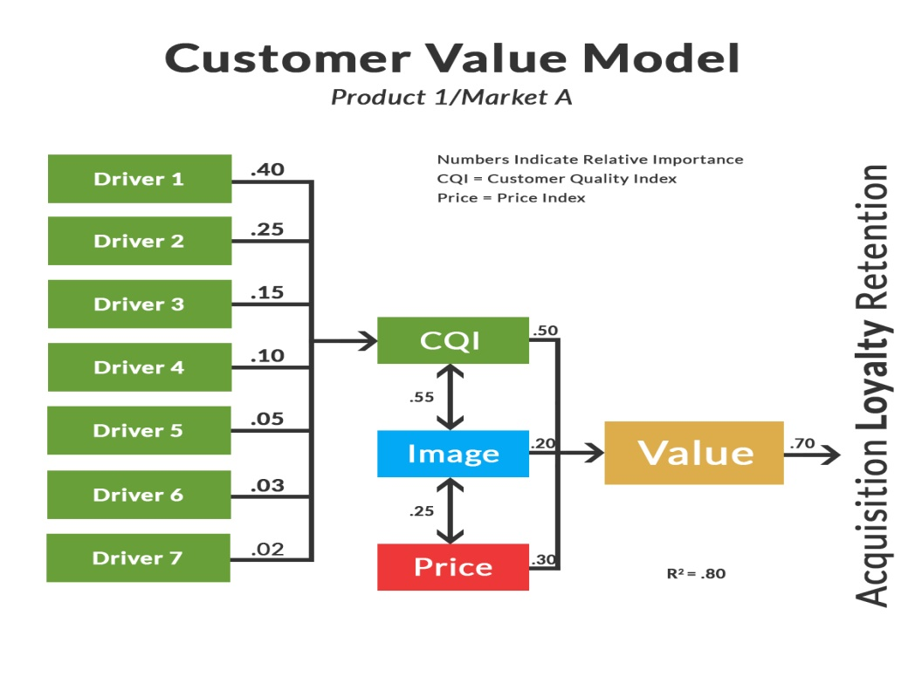

Image: Customer Value Model
Source: Frow et al, 2014
Offer best products: Tesco Plc. believes that, it is not products and services that customer actually buys. It is value what customers wants to perceived. Best products; the terms identify the products with required standards and qualities. Because companies that provide best quality products in the market, it increase its customer value (Frow et al, 2014). Say for example, Tesco Plc. offers foods and occasional items, which may costs higher compare to the competitors, but it provides highest value that is not possible to perceive by this price from other competitors.
Service performance: Service performance considered an important part which cannot be ignored. Offering quality and customer value is not enough, how employees will behave and engage in transaction with customer also define the customer value. Tesco Plc. believes that, customer is the root cause of their expansion and growth and that’s why they should be treated with best treats.

Ranges of factors that impact on organization’s ability to maximize customer value?
When a customer is valued, he/she might be satisfied. Satisfaction arises when customer can realize that the organization with they involved has provided the best value than other organization in the market. Tesco Plc. has identified a number of factors that impact on its ability to maximize its customer value perceived:
Financial stability: Customer value increases when organization can provide products with cheapest cost than the other competitors. And reducing the production costs depend on certain factors like raw materials, technology, employees’ skills and experiences, and organizational mechanism which works as comparative advantage (Garrido and Padilla, 2011). Tesco Plc. believes that, when an organization has its financial stability it can produces products with best mechanism which decreases the unit cost.
Technological advancement: It is technology which offers cost and time effective production. What is not possible by mankind can be possible by technological advancement (Hung et al, 2010). Say for example, Tesco Plc. uses machine technology to produces food items, in this total process there is no touch of human kind. So machine technology work relentlessly and flaws appears little.
Standard and quality measurement: It has been said earlier that, customer actually purchase value not the products. And it is standard and quality that satisfy the customers. Tesco Plc. monitors the standard and quality of all its products from the very basic stage (Hung et al, 2010). To maximize the customer value , although Tesco focuses on reducing price and cost of production. It does not compromise with product quality and standard.
Customer relationship measurement: Keeping connection with customer not only keeps them connected rather valuable feedback and suggestion can be archived. Tesco Plc. delivers good customer service using a number of ways. This includes constantly making improvement through hiring the right people, developing the right tools, training and motivation programs (Hassan, 2012).

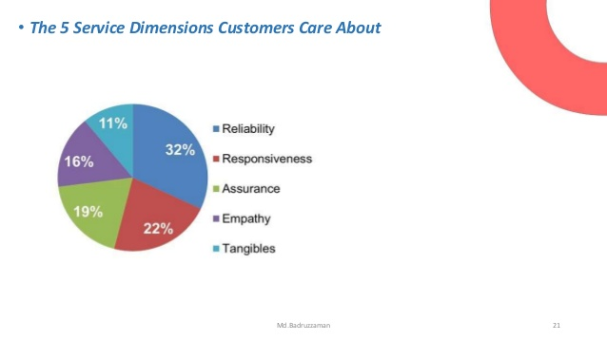
So far we have discussed how Tesco Plc. delivers the customer value and its organizational factors that impact on its ability to maximize its customer value perceived. From a theoretical basis, now we will evaluate how customer value can be measured.
Image: Customer value measurement
Source: Mukerjee, 2013
Reliability: To measure customer value, the first evaluative factor is the organization’s ability to perform the promised service dependably and accurately. Customer feel valued by purchasing the products only when they realize that, organization provided product as promised, careful about handling customer obligations, performs in the right and promised and maintaining error-free records (Mukerjee, 2013).
Assurance: Assurance implies the requiredknowledge and courtesy of employees and their ability to inspire trust and confidence. Customer feels valued in terms of assurance when employees can able to install confidence in customer’s mind, makes customer feel safe in transactions, shows constant courteous and ability to answer customer requirements (Mukerjee, 2013).
Tangibles:In terms of tangibility, it requires physical facilities, equipment, and appearance of personnel before the customers. Customer feels satisfied and valued in terms of tangibility when organization able to uses modern equipment, can show visualize appealing facilities and professional appearance and can attach visually appealing materials associated with the service (Day and Moorman, 2013).
Empathy:Being empathetic is also a matter of valuing customer. Empathy includes caring, individualized attention the firm provides its customers. In terms of Tesco Plc. empathetic behaviors includes giving individualized attention, deals customer with caring fashion, understanding of customer needs and requirements and offering services at customer-convenient business hours.
Responsiveness: And lastly responsiveness includes willingness to help customers and provide prompt service. Customers realized that they are valued when employees can make customers informed, provide prompt services, have a customer help attitude and readiness for any service required by customers (Day and Moorman, 2013).
It can be concluded that, customer not only evaluate value by considering the benefits perceived and cost had to bear, rather all these five factor’s positivity increase customer value and also their negative appearances decreases customer value.

To provide the best values to the customer, sometimes some failures made it complex for organization retain its customer. These failures are called gaps. Closing the gaps and focusing more on five factors discussed can ensure the customer values and can able to keep customer satisfied. Better identifying the gaps and following systematic approach to close the gaps can recover the customer value realization.
The gaps experienced by the Tesco Plc. in its whole life of business are customer service expectation and service perceived, perceptions of service quality specifications and management service perceptions, customer preferred service design and standard vs company focused design, external communication and service delivery and customer expectation and customer perception.
Closing the gaps appears when delivering the products and services considered one of the integral remedy of experiencing customer the best value. To close these gaps, management of Tesco usually follows these options:
Learn what customer expects: Deep understanding the customer expectation is considered the basic requirement of fulfilling customer’s value. Because when it is unknown for organization to what actually its customer wants, it actually breaks the line of accurate performance (Hill and Alexander, 2017). Tesco Plc. in this case focus on certain factors like improving communication with front line employees and staff, focus on customer feedback and suggestions, and turn all the information and sights into action.
Establish right and accurate service quality standards: Customer usually focus on organizational standard and quality. It is quality and standard which lead the brand loyalty. Monitoring and using best technology and management approach to measure the quality can be solution and understanding customer preferred features is another option (Marshall, 2013). To keep standard accurate, measuring performance and regular feedback must be continued with that rewarding for best performance can motivate the employees.
Ensure service performance meets standards: Engagement and performing while customer stay before is important for creating a best value. Behaving with customer in an empathetic way, attitudes must be showed that employees are ready for any requirements. In this approach, clarify the role of parties engage customer transaction is important, training employees in several activities like time management, coordination and team working, and how to work for shared goals (Marshall, 2013). On the other hand, managing conflict in the groups and rewarding culture for best performance required to maintain.
Ensure delivery matches promised made: Keeping promised made before is another factor that customer keeps in mind most. That’s why organization should be aware about its promises made and seeing whether the promises are satisfied or not. In this regards, advertising and promotional activities must be conducted on reality basis, visualizing the real customers, real products and real situation and focusing on internal marketing program (Frow et al, 2011). Gaining communication between different wings like sales, operations and customers and meeting the standards in multi-site operations.

Task-2: Critical understanding of organizational quality processes and its effectiveness in meeting customer requirements.
In retail market, number of entrance and substitutes are knows no bound. Competition and keeping customer satisfied being in such complex business environment depended on certain factors. These factors not only make customer satisfied but not create a distinct identity of the provider. Quality and accurate standards of products and services are among the most integral facts.
As number of the competitors are high in retail market, customers tend to differentiate good provider based on service quality and service performance (Reinartz et al, 2011). Highest quality and standards with the cheapest expenses increase the customer value. In this quality measurement process, keeping quality assured depends on good raw materials, technological advancement, skilled and experienced workforce and quality monitoring approach.

Quality processes of Tesco Plc. and effectiveness in meeting customer requirements
Quality process tends to work for ensuring the quality of products and services within an organization. And quality process also termed as quality management process. Quality management process can be defined as the set of procedures which are followed to ensure that deliverable products are ‘fit for purpose’ (Goetsch and Davis, 2014). The initial task of quality management process begins with setting quality targets. Quality targets works as the roadmap which then guides the total steps.
In Tesco Plc. quality ensure through deep monitoring and employing skilled and experienced employees in quality management team. Tesco Plc. believes that quality management process can improve the quality of products and services. Quality management process assists to produces deliverable products and ensures the desired quality demanded by customer group (Goetsch and Davis, 2014).

Purpose of using quality management process
Tesco Plc. uses quality process/ quality management process to ensure four different purposes. These purposes include:
Quality assurance: Although sometimes quality assurance and quality control are used interchangeably, these have different meaning. First of all, quality assurance is defined as all the planned and systematic activities implemented within the quality system which can be visualized to provide a deep confidence that a particular product or service will able to meet the requirements demanded by the customers (Alli, 2016). The activity of quality assurance tends to centralize within the quality system. In this part, organization typically set target, define quality volume and fix the range of quality comparing with market competitors.
Quality control: Whereas quality assurance is systematic plan and set of procedure how quality management requirements can be organized and utilize, quality control is directly related with action of total plans. Quality control is the set of operational techniques and activities used to fulfill the requirements of for quality (Bergman and Klefsjö, 2010). Although both quality assurance and control are part of quality management, quality control actually focuses on fulfilling quality requirements and termed as applied version of quality assurance plans and technique.
Quality improvement: Quality improvement can be termed as the third stage of total quality management process. In this stage, all the limitations and flaws are detected and final solutions are given by the specialist (Ryan, 2011). Quality improvement follows four steps and ensures the accurate solution. These are plan, do, check and act. Initially planning for where improvement required, then implement the plans and check the progress by continuous monitoring.

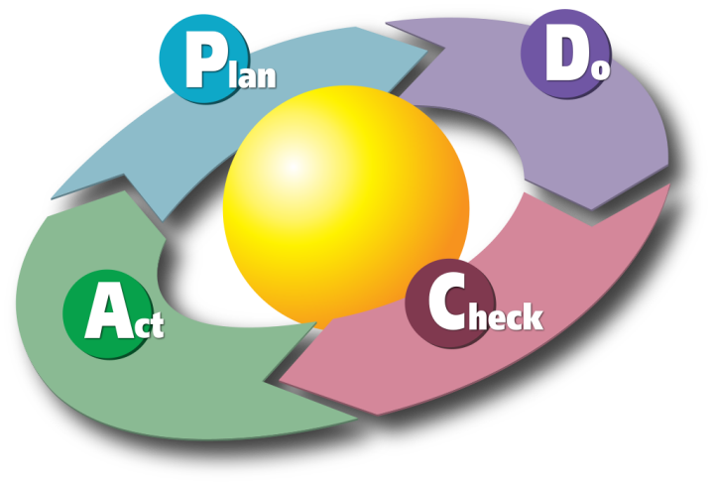

Image: Quality improvement
Source: Lindsay and Evans, 2010
Quality management: Quality management is the total and overall plan and technique. Quality management ensures that an organization, product or service is consistent. Quality management involves with activities ranges from quality planning, assuring, control and improvement at the end (Lindsay and Evans, 2010). In Tesco Plc. quality management includes all activities of the overall management function which aims to determine the quality policy, objectives, and responsibilities of distinct groups.

Steps involves in quality management process of Tesco Plc.
Quality management is set of activities aims only to ensure the quality and standard that desired by the targeted customer not what organization wants. A total quality management process lead the organization to set quality targets, defines how quality targets can be achieved, force to take actions, detect quality issues and improvement and last reports all the progress and limitations.
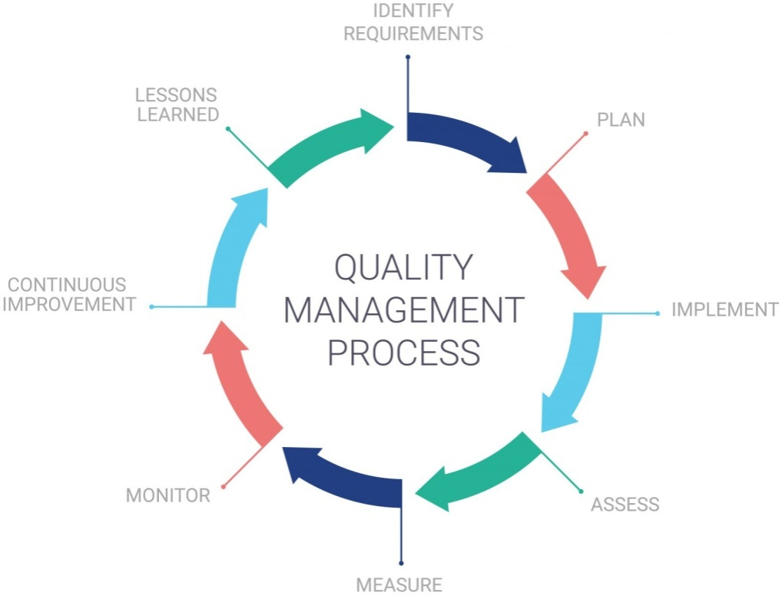

Image: Quality management process
Source: Ross, 2017
Identify requirements: The very step of quality management process is identifying the requirements, demands or desires. It is not the organization who will define the requirements, rather it is the customers who actually basic source of requirements (Ross, 2017). Customer feedback, organizational research and information from frontline employees can help in this regard.

Planning: When primarily information is collected, organization can able to plan for the next few steps. When the date of requirements is on hand, organization plans for how quality can be ensured, what requirements are required, what will be time-frame, who will lead the team, funds, and technology and logistics requirements? (Krajewski et al, 2010) Planning must be taken in a participative mode where all the employees of production department should be aggregated. Plan then act as the guideline and most importantly monitoring and evaluation process must be included in planning step.
Implementation: This step is the most critical. In this step, all the plans and techniques are executed. Careful planning , employing skilled and experienced workers, proper using of required materials, providing necessary funds and tech supports must be ensured. Implementation is the visual version of the total plan. Success of implementation depends on planning and execution.
Assess: Assessment of whether in the implementation steps, all the activities and task are done based on planning is another fact to be noted. The purpose of assessment is to ensure that, plans and techniques are must execute in the implementation step (Turner, 2014). If any deviation is seen, immediate steps must be taken.
Measure: Measuring the performance of employees and employed techniques is another prudential impact factors. Employees also have performance guidance, measuring whether they are meeting their performance standard or not. Measurement of careful diagnosis that raw materials are perfect to meet the requirements, techniques and plans are doing well and employees are putting their best are main target of measurement step (Turner, 2014).
Monitor: Monitoring the current progress and providing the immediate feedback where it is required. Monitoring in Tesco Plc. follows three steps. These are setting standards, measuring performance and taking corrective actions. From the very basic step of ensuring quality, monitoring to ensure that every step is going ahead and still okay to meet the required demands are key decisions in this step.

Continuous improvement: Actually there is not real boundary of improvement. It should be up to possible by putting utmost effort. In this step, improvement should be based on what customer suggested, given feedback, further modification or adding new features and follow of current trends can be the source of improvements (Diabat and Govindan, 2011).
Lessons learned: In every action, whether the action is appeared to as success or failure, there is a learning. Learning can be how to again accomplish this task more easily; learning can be how cost can be minimized in further accomplishment and so on. Most important thing is utilizing the lessons in the next actions so that same problems cannot be seen again.

Sample of quality management plan (Tesco Plc.)
 | Quality Planning | Quality control | Quality assurance | Quality improvement
 | Plan | Do | Act | Check
What is done | Defining what will be quality and how it will be measured | Monitoring whether specific product is meeting the quality and standard criteria. | Assesses measurement of quality is appropriate through evaluating overall performance regular basis | Continues to increase the effectiveness and efficiency by regular check and immediate solutions.
When it is done | Project planning steps  Processes  - Develop PMP  - Project scopes and defining of customer requirements  - Developing team  - Schedule arrangement  - Estimation of required resources  - Delivery acquisition strategy | Implementation and control steps  Processes  - Planning implementation and control  - Lessons learned | Implementation and control steps  Processes  - Project execution and control | Implementation, control and planning phase  Processes  - Changes in management  - Development PMP

Plan
- Identify customer required quality objectives
- Assisting customer to express their expectation in objectives
- Maintain professional standard which must include legal, environmental, economic, life and health issues (Hoang et al, 2010).
- Keep balance of needs and wants of both customer and stakeholder in planning of cost, schedule and standards
- Procedure plans which must include quality assurance, quality control and total quality management
- And lastly considers the potentials threats or risks that may encounter and ready contingency plans

Do
- Continue accomplishment of tasks based on approved PMP and defined standards
- Project development plan must be communicated, meet on a regular basis and able to adapt the changes (Hoang et al, 2010).
- Required changes and modification must be brought out if required

Check
- Ensure regular technical review, management oversight and verify to be ensure that performance meeting standards
- Regular assessment and monitoring of progress must be ensured and performance will assessed against standards (Hoang et al, 2010).
- Share findings with the entire project participant to facilitate continuous improvement.

Act
- Take continuously corrective actions to fix the systematic cause of any non-conformance, deficiency, and other unwanted effects.
- Keep quality control document which may include revisions of quality management plan, alternation and control procedures and adjustments to resource allocation in the total accomplishment time (Hoang et al, 2010).

Assessment of the effectiveness of quality processes
It is quality which defines the standards of any product and service. A product with intense quality is seems the best product in the market if it exceed the quality limit of other substitutes. And quality of any product and service depends on the mechanism follows by organization; which is called quality process (Wang et al, 2012). Quality process is the steps that organization goes through or follows to make product quality-full.
Now if we see the quality process of Tesco Plc. and assess how it works we can easily find out how much effective the quality process used by Tesco Plc. It is seven steps process which ensure the complete quality of products that offers by the company (Trkman, 2010). These steps begin with identifying the requirements. That’s the very basic things that should be on every quality process. Identifying the requirements or quality standards that demand by the targeted customer is very important information; otherwise foundation of quality will be violated.
Then the other steps are planning, implementation of planning, assessment, measurement, monitoring, continuous improvement and lastly keeping in mind the lessons learned. This process is the total and complete quality management process, we can see only if we look at the steps that appear. After knowing the information what will be quality standards, management starts to plan and then collect required resource to implement the plans. From the very early of quality process, every single process goes through complex assessment and measurement so that any flaws or deficiency can detect.
Monitoring and continuous improvement are another two important steps of total quality process. Monitoring to assess the progress or finding out deficiency is the action must be continued if organization wants to have quality products. Monitoring detects the lacking and seeks to provide immediate responses. And in every step, there should be an intension to improve tasks with efficiency so that both time and cost can be saved (Khanna et al, 2011).

Conclusion
Whatever the products or services organization offers, customer actually perceives values through quality and standards. When quality and standard of customers is met, customer feels that they are valued. After completing this study, the author has learned about customer and customer value along with the mechanism of weighting customer value. The author has learned the factors those have potential impact on an organization’s ability to maximize its customer perceived value. The author has learned the gaps encountered when service is offers and the remedial factors to close these gaps at the ends. And lastly the author has learned about Tesco Plc.’s quality processes it follows and effectiveness of meeting customer requirements.

References
- Alli, I., (2016). Food quality assurance: principles and practices. CRC Press
- Bergman, B., and Klefsjo, B., (2010). Quality from customer needs to customer satisfaction. Studentlitteratur AB
- Day, G and Moorman, C., (2013). Regaining customer relevance: the outside-in turnaround. Strategy and Leadership, 41 (4), pp.17-23
- Diabet, A. and Govindan, K., (2011). An analysis of the driver affecting implementation of green supply chain management. Resources, Conservation and Recycling, 55 (6), pp. 659-667.
- Fint, D.J and Woodruff, R.B., (2014). Marketing’s service-dominant logic and customer value. In The service-Dominanat Logic of marketing (pp.201-213). Routledge
- Frow, P., Mrcoll-Kennedy, J.R, Hilton, T., Davidson, A., Payne, A. and Brozovic, D., (2014). Value propositions; A service ecosystems prospective. Marketing Theory, 14 (3),pp.327-351
- Frow, P., Payne, A., Wilkinson, I.F and Young, L., (2011). Customer management and CRM: addressing the dark side. Journal of Services Marketing, 25( 2), pp.79-89.
- Garrindo-Moreno, A. and Pandilla-Melendez, A. (2011). Analyzing the impact of knowledge management on CRM sources: The mediating effects of organizational factors. International Journal of Information Management, 31(5), pp. 437-444
- Goetsch, D.L and Davis, S.B., (2014). Quality management for organizational excellence. Upper Saddle River, NJ: Pearson.
- Gumasta, K., Chan, F.T and Tiwari, M.K., (2012). An incorporated inventory transport system with two types of customers for multiple perishable goods. International Journal of Production Economics, 139 (2), pp.678-686
- Hassan, A., (2012). The value proposition concept in marketing: How customers perceive the value delivered by firms-A study of customer perspective on supermarket in Southampton in the United Kingdom. International Journal of Marketing Studies, 4(3), p.48
- Hill, N. and Alexander, J., (2017). The handbook of customer satisfaction and loyalty measurement. Routledge.
- Hoang, D.T., Igel, B., and Laosirihongthong, T., (2010). Total quality management (TQM) strategy and organizational characteristics: Evidence from a recent WTO member. Total quality managment, 21 (9), pp.931-951
- Hung, S.Y., Hung, W.H., Tsai, C.A and Jiang, S.C., (2010). Critical factors of hospital adoption on CRM system: Organizational and information system perspective. Decision Support Systems, 48 (4), pp.592-603
- Khajvand, M., Zolfaghar, K., Ashoori, S. and Alizadeh, S., (2011). Estimating customer lifetime value based on RFM analysis of customer purchase behavior; Case study. Procedia Computer Science,3,pp.57-63
- Khanna, H.K., Sharma, D.D. and Laroiya, S.C., (2011). Identifying and ranking critical success factors for implementation of total quality management in the Indian manufacturing industry using TOPSIS. Asian Journal on Quality, 12(1), pp.124-138.
- Krajewski, L.J., Ritzman, L.P., and Malhotra, M.K., (2010). Operational Management: processes and supply chains. Upper Saddle River, New Jersey: Pearson.
- Lindsay, W.M and Evans, J.R., (2010). The management and control of quality. South-Western Cengage Learning.
- Marshall, K., (2013). Rethinking teacher supervision and evaluation: How to work smart, build collaboration, and close the achievement gap. John Wiley & Sons.
- Mukerjee, K., (2013). Customer-oriented organizations; a framework for innovation. Journal of Business Strategy, 34 (3), pp.49-56
- Reinartz, W., Dellaert, B., Krafft, M., Kumar, V. and Varadarajan, R., (2011). Retailing innovations in a globalizing retail market environment. Journal of Retailing, 87, pp.S53-S66
- Ross, J.E., (2017). Total quality management: Text, cases, and readings. Routledge.
- Ryan, T.P., (2011). Statistical methods for quality improvement. John Wiley & Sons.
- Trkman, P., (2010). The critical success factors of business process management. International journal of information management, 30(2), pp.125-134.
- Turner, J.R., (2014). Handbook of project-based management (Vol.92). New York, NY: MrGraw-hill.
- Wang, C.H., Chen, K.Y. and Chen, S.C., (2012). Total quality management, market orientation and hotel performance: The moderating effects of external environmental factors. International Journal of Hospitality Management, 31(1), pp.119-129.

