To What Degree did the Developments in Tank Design in the World Wars Influence Modern Tactics?

  - Cameron Lane- OME Apprentice


  - Abstract
Since their introduction to the battlefield at Flers-Courcellette in 1916, tanks have cemented their role in combat. The design of tanks has evolved considerably since then, fixing the initial flaws, improving armour and armaments, and changing how they are used on the battlefield. This paper will look into what degree the key developments in tank design during the World Wars impacts the way tanks fight on the modern battlefield, looking at the role of mobility, armour and armaments. This is then contrasted with developments post the World Wars, looking at the role of fire control, airpower and production constraints. This is concluded with an evaluation of what degree World War and post war developments are responsible for the way tanks fight on the modern battlefield.

Table of Contents
1 Not war but ‘savage butchery’ [1] 2
2 The Development of the Tank in the World Wars 2
2.1 Mobility 2
2.2 Armour 2
2.3 Armaments 4
3 Post War Developments 5
3.1 Fire Control 5
3.2 Air Power 6
3.3 Cost 7
4 Conclusions 7
5 Bibliography 9

Table of Figures
Figure 1 - Cross sectional view of the upper glacis of Tiger II [24] 3
Figure 2- Cross section of Abrams upper glacis [13] 4
Figure 3- Cutaway of Western APFSD Round [25] 5
Figure 4- Showcasing the stabiliser of tanks with a beer [27] 6

Not war but ‘savage butchery’ [1]
Canadian troops reported German troops abandoning trenches, “terrified at the approach of the tank” [2], while New Zealanders reported tanks “breathing death and destruction” [3], instilling “fear of a kind hitherto unknown into those of the enemy who encountered it” [3]. “Not war but ‘savage butchery’” was the remarks by German soldiers that faced them at the battle of Flers-Courcellete, the first introduction of tanks to the battlefield [1]. Despite the less than stellar strategic results, those that fought against and beside them had clear views on the role that tanks had on the battlefield that day. Since then, tanks have gone through evolution time and again to confirm their place on the battlefield, from the mud of the Somme to the snow of the Eastern Front and the deserts of the Middle East. This paper seeks to outline what developments have had the greatest impact on the way that tanks fight on the modern battlefield, by comparing World War developments with post-war.

The Development of the Tank in the World Wars
While there are countless developments in the design of tanks during the World Wars, 3 key categories have been chosen to be looked at, mobility, armour, and armaments. These are in many ways the key drivers in the design of tanks, with other developments such as radios, material sciences and projectile design building upon the work of these categories.

Mobility
One of the key criticisms of early tanks during the First World War was their mobility and reliability. At Flers-Courcellete, only 2 of the 6 tanks assigned to the 2nd Canadian Division reached the front line [4]. Between the underpowered engines and battlefields torn up by years of trenches and artillery, these early tanks suffered heavily. Reliability was improved in the Mark IV tanks, using a more powerful engine, however they still suffered in the mud. The First World War did however show the potential that the mobility of tanks had. During the Hundred Days Offensive, mobility was used to great effect. ‘Musical Box’ a Whippet tank at the Battle of Amiens, broke through the German front line on a rampage lasting 10 hours, interrupting logistics and destroying artillery batteries in the process [5].
Improvements had been made in the mobility of tanks by the Second World War, however results varied. While the T-34 was known for being reliable across the varied conditions of the eastern front, German tanks faced the same issues as tanks in the First World War. Breakdowns when steering in certain ways or climbing hills plagued the Panther, with British testing on 5 vehicles halted due to “the unreliability of the steering mechanism, and the tendency of the engine to catch fire” [6].
The recognition on the importance of mobility post war is clear, however. With few exceptions, the performance of modern tanks far outstrips that of any tank in the World Wars. Capable of dealing with the tropical climates of Vietnam, to the deserts of the middle east, and ford rivers if needed, mobility has had a significant impact on tank tactics as highlighted by the tanks usage in Desert Storm, spearheading the ground offensive across 4 days.

Armour
Designed to break the deadlock of the trenches, World War 1 tanks were armoured against rifle and machine gun fire, up to 12mm thick in places. In this role, they were largely successful, requiring Germany to introduce firstly the K bullet and later the Tankgewehr rifle for anti-tank roles. Artillery remained a significant threat to tanks throughout the war, with shrapnel able to penetrate armour, and direct hits destroying tanks entirely. Combined with the poor mobility, the slow moving, or worse broken down, tanks were highly vulnerable to artillery, resulting in the loss of many.
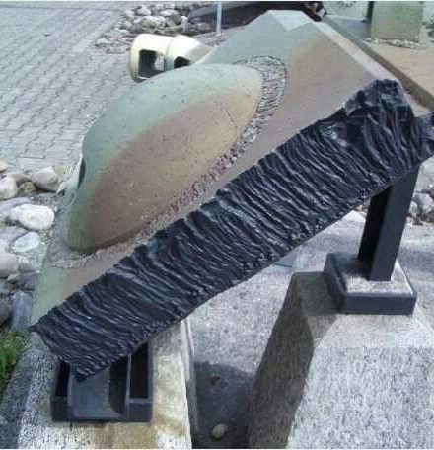
Figure 1 - Cross sectional view of the upper glacis of Tiger II [24]
Shown above in Figure 1, is the front plate from a Tiger II, a 150mm plate sloped at 40 degrees. The growth in armour during WW2 that led to this was in response to the growth in threats faced. Machine guns as the main armament of tanks were replaced by increasingly larger cannons, from the 30mm on Panzer III, all the way up to the 152mm on the ISU-152. Alongside this is the increase in threats faced from the air, from infantry portable weapons and from anti-tank guns. As a result, tank armour grew. Initially this was through thicker plates, such as on the Tiger I, armour then started to be angled, as seen on the T-34, and add on armour was fitted, such as the side-skirts on late model Panzer IVs.
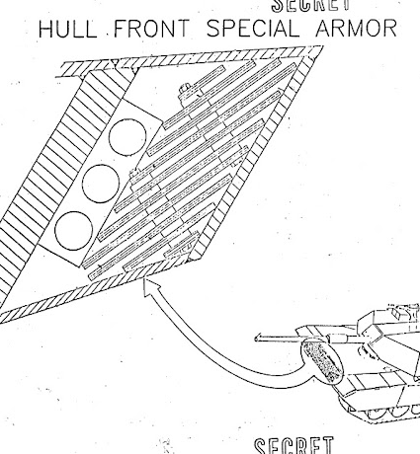
Figure 2- Cross section of Abrams upper glacis [13]
Modern tanks feature numerous technologies to increase the effective armour of the tank beyond the developments of WW2. Figure 2 shows a cross section of the upper glacis of an Abrams, incorporating layers of different armour plates and materials to increase overall protection [7]. Composites and ceramics are commonly used, as on the T-64, with Abrams armour incorporating depleted uranium [8] [9]. Additionally, modern tanks may have reactive armour fitted, designed to be triggered by a projectile impacting the armour, to push a ‘flyer’ plate out to disrupt a shaped charge jet or kinetic penetrator [10]. Finally, as an additional layer of defence, tanks may include active protections systems, to jam sensors, conceal the tank, or intercept incoming projectiles.
All these measures are implemented in order to allow the tank to continue to operate in much the same manner as it did in the Second World War. While not being hit in the first place remains best, these layers of protection allow tanks continue to operate on the frontlines, providing fire support whilst working in conjunction with infantry in a combined arms approach, with the tank able to be fired upon and withdraw from combat if needed.

Armaments
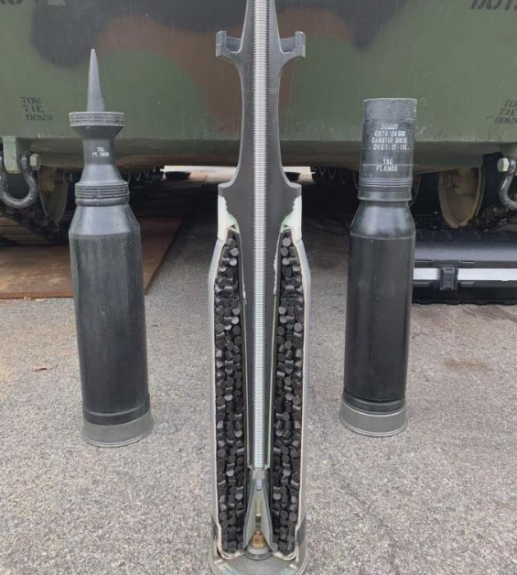
As mentioned above, the armaments on tanks only grew across the World Wars. The first tanks were designed with the trenches of the Western Front in mind, tasked with crossing no mans land, crossing trenches and defeating the infantry inside. For this role, machine guns were ideal. By the Second World War however, improvements had been made. Tanks were increasing armed with small calibre cannons. WW2 saw an arms race in tanks guns, as each nation fitted more powerful guns to defeat the increasingly thick armour on newer tanks. This saw the increase from the 20mm autocannons from Panzer II tanks at the start of the war, to ISU-152 mounting a 152mm gun, the impact of which would shatter welds on German tanks, even if it failed to penetrate.
Figure 3- Cutaway of Western APFSD Round [25]
While WW1 and early WW2 tanks were focused around supporting infantry, by the end of WW2 there was a significant emphasis on tanks being armed for anti-tank roles. This was seen in the up-arming of Shermans with 17-pounders and the use of 88mm guns in German tanks. The reference threat for modern tank design has remained a hostile tank, armoured to withstand incoming fire, and a gun capable of defeating enemy armour. While the race for higher calibre guns has largely halted, with Russia and China standardising around the 125mm gun, and the West the 120mm, improvements have continued to be made. The key to this has largely been in advancements to ammunition design. For all countries the primary anti-tank ammunition remains armour piercing fin stabilised discard sabot (APFSDS), seen in Figure 3. These rounds are designed to focus the energy of the cannon on a smaller projectile, accelerating it to extreme speeds to penetrate armour, up to a metre of solid steel on modern rounds. Improvements in guns have been implemented in support of these rounds. Western 120mm guns have move from L/44 (5.3m) to L/55 (6.6m), to enable higher velocities and increased pressures, alongside more powerful propellants, including those incorporating high explosives such as RDX [11]. This has a corresponding impact on the gun though, with barrel life falling as low as 200 rounds [11]. Combined these developments help to maintain the tank’s role as laid out at the end of WW2, an independent unit on the battlefield, capable support infantry, destroy fortifications and engage hostile armour as required.

Post War Developments

Fire Control
Crucial to the success of armaments on modern tanks is the improvements made to fire control systems. While limited numbers of night vision systems saw use on German Panther tanks in WW2, it was during the Cold War that this technology matured, as showcased during the First Gulf War. During the Battle of Norfolk, an Iraqi counterattack was launched at 0300 hours, which encountered the British 1st Armoured Division. After 90 minutes of fighting in the dark, over 50 Iraqi tanks and armoured vehicles from the 52nd Armoured Division were destroyed, for the loss of no allied tanks [12]. The following evening, the remnants of this division was engaged, and by dawn on the 26th February had been destroyed. Elsewhere on 25th, night fighting by the British 7th Armoured Brigade saw the destruction of the 48th Division [12]. As was stated to congress by a US officer, “We owned the night” [13].
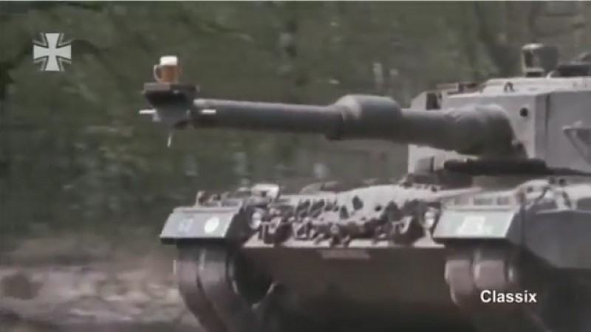
The advancements in fire control were not just limited to night fighting, however. During daytime operations, “quick - firing M1 crews dispatched T-55s before they could fire off a round”, while a Challenger 1 was responsible for the longest tank-on-tank kill until Ukraine, at 5,100 metres [12, 14]. These systems allowed for the acquisition of targets at greatly increased ranges, greater communication between commander and gunner in passing information about identified targets, and quicker firing once a target had been acquired. This was compounded by the stabiliser system fitted to tanks to keeping the gun stable during manoeuvring. This allowed for the gun to be pre-aimed once a target was acquired, reducing the time needed for stopping to fire, or even to allow for firing on the move. Showcasing the ability of the stabilisers, a stein of beer was placed on the barrel of a German Leopard 2, and driven through a forest, without spilling a drop, seen in Figure 4.
Figure 4- Showcasing the stabiliser of tanks with a beer [27]
Advancements in fire control are by no means responsible solely for the tactics used by modern tanks. However, they take the key elements of the tank, the mobility, the armour and the gun, and allow it to be used in a far more effective manner than during the World Wars. It has allowed for more mobile fighting, longer ranges, greater accuracy, and night fighting, all of which has been worked into the tactics used in modern combat.

Air Power
While air power was a factor in both the First and Second World Wars, it has been in the post was period that the effectiveness against tanks has grown significantly. During the Second World War, close air support (CAS) was done using unguided rockets, bombs and machine gun fire. This required the attacking aircraft to be low, slow, and fly directly at or over the target, leaving them vulnerable to interception or anti-aircraft fire. Communication between air and ground forces was also limited or non-existent. A US friendly fire incident by aircraft left “nearly every vehicle and anti-tank weapon was destroyed or damaged” [15]. While CAS in WW2 had its successes, interdicting supply routes and supporting ground operations, it also had its limitations.
By the late 1950s, this situation had changed significantly. Following the introduction of jet aircraft, and the difficulties of CAS in Korea, precision guided weapons had begun to be introduced, such as the AGM-12 Bullpup. While early weapons were limited, the performance only grew. By the First Gulf War, air power played a crucial role in ground operations. In total, A-10 aircraft flying in a CAS role flew the fourth highest number of sorties of the conflict, behind the F-16s, which also flew CAS missions, cargo flights and refuelling flights [16]. They were responsible for employing 5,013 AGM-65 Maverick anti-tank missiles, with helicopters firing an additional 2,876 Hellfires against ground targets [16]. Attrition because of air attack varied by unit, ranging from below 10% in rear units, to almost 100% in frontline units [16]. Republican Guard tank divisions, the most well-equipped units in the Iraqi army, faced 25% attrition of tanks prior to the ground offensive [16]. It is clear that with developments in air power, the tank is far move vulnerable than ever before, able to be engaged from beyond line of sight. Tanks operating in an offensive role require either air superiority, or need air defence systems following them up, while tanks on the defensive are forced to remain within their air defence ‘bubble’.
The use of drones in Ukraine could be said to be an evolution of the threat of air power to tanks. Building upon the threat of beyond line-of-sight strikes from aircraft, drones are being employed in a similar manner, striking logistics, staging areas and frontline units. This use of drones has in many ways had an even greater impact on the tactical usage of tanks. While air defences were able to offer some protection against CAS, forcing the aircraft to be risked launching the strike, FPV drones are harder to locate, harder to target, and the pilots harder to find. Over 80% of Russian casualties in Ukraine are now being caused by drones, with 819,737 Russian targets hit in 2025 [17]. This is forcing tanks into a more supportive role reminiscent of assault guns, firing in either a direct fire or using modern fire control system for indirect fire, targeting fortifications to support infantry offensives [18]. This is particularly effective when combined with drone spotting, allowing for a Ukrainian tank to destroy a Russian tank at a range of 10.6km, over double the distance recorded by a Challenger 1 in the First Gulf War [19].

Cost
Finally, the cost and availability of tanks need to be considered when examining the tactics. The Panzer IV was one of the most widely used tanks by Germany in WW2. Just under 9,000 were produced in 5 years, at a cost of 103,462 Reichmarks each for the base model [20], approximately $500,000 in modern dollars. During the Battle for Normandy, 750 Panzer IVs saw combat, with 95% destroyed [21]. No country saw tanks as expendable, with damaged tanks repaired and recovered, however it was expected that there would be losses. By comparison, the M1A2 SepV3, is set to cost $29.8 million per tank, upgrading at a rate of 30 vehicles per year, severely more limited than during WW2 [22]. Meanwhile in Ukraine, Russia has been forced to pull mothballed tanks from storage to replace combat losses, including T-54s first introduced in 1948, due to limited production capacity [23] [24]. This highlights how tanks have moved from being a valuable, but replaceable, part of an army’s composition, to a highly expensive resource with a limited capacity for repair or replacement. This has corresponding impact on the tactical usage of tanks, in a more conservative manner, with greater support in combat, and for recovery and maintenance to put damaged tanks back into service.

Conclusions
While the roots of modern tank tactics can be traced down through the developments in tank design during the World Wars, which lead to the current iteration of mobility, armour, and armaments, post-war developments have had a far greater impact on how tanks are used on the modern battlefield. The evolution in tank design during the World Wars was considerable. The handful of Mark 1 tanks used at Flers-Courcellete bear little resemblance to the battlefields of the Second World War, with Kursk involving thousands of tanks across the battle. The thin vulnerable armour of the First World war was replaced with thick sloped plating, requiring larger weapons to penetrate. Combat had moved from dozens of metres, to over a kilometre at times, with tanks facing far greater threats from infantry, the air, and other tanks than during WW1.
Yet it is the developments post-WW2 that have had the greatest impact on the way tanks fight on the modern battlefield. Apart from the introduction of modern fire control systems, allowing for engagement at increasingly distant targets, at night and in all weather conditions, the use of tanks has been reactionary to developments around them. Airpower requires tanks to operate within friendly air defences, limiting the potential exploitation of a breakthrough. Drones further restrict this, with tanks facing attacks before reaching the front line, pushing them into a fire support role alongside infantry. This role is further encouraged by the cost and production constraints of modern tanks, to maximise recovery and repair from behind friendly lines.

Bibliography

[1] | D. E. Macintyre, Duncan Eberts Macintyre Fonds: Volume 1, N.A: Library and Archives Canada, 1919.
[2] | D. Fraser, The Journal of Private Fraser, 1914-1918, Victoria: Sono Nis Press, 1985.
[3] | A. E. Byrne, Official History of the Otago Regiment, N.Z.E.F. in the Great War 1914-1918, Dunedin: J. Wilkie & Company, 2021.
[4] | A. McEwen, “"“A useful accessory to the infantry, but nothing more”: Tanks at the Battle of Flers-Courcelette, September 1916.",” Canadian Military History, vol. 20, no. 4, 2011.
[5] | L. Smith, “A Whippet called Musical Box,” Degawny History Group, [Online]. Available: https://www.deganwyhistory.co.uk/a-whippet-called-musical-box/.
[6] | “Post War British Report on Panther,” Tank and AFV News, 13 09 2015. [Online]. Available: https://tankandafvnews.com/2015/11/13/from-the-vault-post-war-british-report-on-panther-reliability/.
[7] | Department of the Army, “Special Armour Security Classification Guide,” Department of the Army, Warren, 1988.
[8] | A. Tarasenko, “Balls of Soviet Tanks,” Tank Archives, 25 04 2022. [Online]. Available: https://www.tankarchives.com/2022/04/balls-of-soviet-tanks.html.
[9] | Department of the Army, “Proposed Finding of No Significant Impact (FONSI) for the M1 Abrams Main Battle Tank Heavy Armor System,” U.S. Army Program Executive Office, Ground Combat & Support Systems, Warren, 1998.
[10] | C. H. K. Yap, “The Impact of Armour on the Design, Utilization and Survivability of Ground Vehicles,” Naval Postgraduate School, Monterey, 2012.
[11] | C. Woodley, R. Critchley and D. Wallington, “QinetiQ Studies on Wear and Erosion in Gun Barrels,” QinetiQ, Sevenoaks, 2003.
[12] | S. A. Bourque, Jayhawk! The VII Corps in the Persian Gulf War, Washington D.C.: Department of the Army, 2002.
[13] | C-SPAN, U.S. Military Reform After Oper. Desert Storm, Washington D.C.: C-SPAN, 1991.
[14] | A. Macalpine, “World’s Longest Recorded Tank Kill—Challenger Legacy Powers Ukraine’s Battlefront,” United24 Media, 03 07 2025. [Online]. Available: https://united24media.com/war-in-ukraine/worlds-longest-recorded-tank-kill-challenger-legacy-powers-ukraines-battlefront-3169.
[15] | P. C. Gallogly, “THE EVOLUTION OF INTEGRATED CLOSE AIR SUPPORT: WORLD WAR II, KOREA AND THE FUTURE OF AIR-GROUND COMBINED ARMS SYNERGY,” SCHOOL OF ADVANCED AIR AND SPACE STUDIES , Montgomery, 2011.
[16] | T. A. Keaney and E. A. Cohen, “Gulf War Air Power Survey,” United States Air Force, 1993.
[17] | V. Zelenskyy, Twitter post by Zelenskyy, Online: Online, 2026.
[18] | M. Bazovský, “Future of the Russian tank forces,” Adapt Institute, 09 03 2026. [Online]. Available: https://www.adaptinstitute.org/future-of-the-russian-tank-forces/09/03/2026/.
[19] | D. Hambling, “How A Ukrainian Gunner Scored A Record-Breaking Tank-To-Tank Kill From 6 Miles Away,” Forbes, 01 09 2022. [Online]. Available: https://www.forbes.com/sites/davidhambling/2022/09/01/how-ukrainian-gunner-scored-a-record-breaking-tank-to-tank-kill-from-six-miles-away/.
[20] | A. Frankson and N. Zetterling, Kursk 1943: A Statistical Analysis, London: Frank Cass, 2000.
[21] | G. Forty, The Reich's Last Gamble : the Ardennes Offensive, December 1944, London: Cassell, 2000.
[22] | Department of War, “Department of War Fiscal Year (FY) 2027 Budget Estimates,” Army Financial Management & Comptroller, 2026.
[23] | C. Snow, “Medium,” 04 02 2026. [Online]. Available: https://medium.com/@snowythefirst/osint-analysis-shows-russia-is-losing-the-war-of-attrition-at-current-depletion-rates-salvageable-a4d57e7a1b35. [Accessed 2026].
[24] | V. Litnarovych, “United24 Media,” 01 11 2025. [Online]. Available: https://united24media.com/latest-news/from-7342-to-92-satellite-analysis-shows-russias-depot-armor-is-nearly-spent-12298.
[25] | N.A., Profile of what 150mm of frontal armor on a German Mk VI Tiger tank looked like, N.A.: Reddit, 2016.
[26] | N.A, “Cutaway 120mm M829A4 APFSDS-T SABOT,” 2022. [Online]. Available: https://www.reddit.com/r/MilitaryPorn/comments/v4ms6i/cutaway_120mm_m829a4_apfsdst_sabot_480x640/.
[27] | Bundeswehr, When a German Leopard 2 tank carried a beer without spilling a drop, BFBS Forces News, 1986.

