Aisha Begum
2321254
BMHP5015
COMPONENT 1
PORTFOLIO

Task1

Personal branding is fundamentally about how I convey my values, behaviour, and reputation to others, and in the field of policing, this is especially vital. Trust, integrity, and professionalism are the cornerstones that determine the effectiveness and respect an officer command. I aspire for my personal brand to reflect a dependable individual who remains calm under pressure and genuinely cares for others. When colleagues and employers think of me, I want them to envision someone reliable, approachable, and dedicated to doing what is right.

I am proud of the problem-solving skills and proactive initiative I am recognized for, yet I acknowledge that there is always room for growth. I am committed to enhancing my communication and confidence, particularly in engaging with people from diverse backgrounds. By seeking out volunteering opportunities and shadowing experienced police officers, I aim to deepen my understanding of the role's realities (College of Policing, 2023).
Additionally, I plan to focus on continuous learning, physical fitness, and emotional resilience to equip myself for the demands of policing. Ultimately, my goal is to cultivate a powerful professional image anchored in honesty, respect, and accountability. By developing my personal brand in this manner, I will position myself as a competent, compassionate, and respected police officer, ready to make a meaningful impact in the community (Montoya, 2020).

Task2

COMMUNITY
(Local leaders, volunteers, schools, faith groups, community hubs)

SOCIAL = ME (center) ----CAREER (friends, hobby groups, confidante,
Peers, fitness activities buddies, neighbours. training providers,
Colleagues/co-
workers,
recruiters.

SUPPORT
Family, partner, friends, GP/counsellors, support workers (PCSO's), charities/organizations (MIND).

Supporting Rationale
My current network can be characterized as hybrid, effectively blending both closed and open elements. I have cultivated strong, trusted connections within my immediate support system—comprising family, close friends, and colleagues—providing me with a solid foundation and vital emotional support. Concurrently, I have established open links with professional mentors, community members, and training providers, which offer valuable exposure to new opportunities and diverse perspectives. This strategic balance not only keeps me grounded but also propels my professional growth within the policing field (Seibert, Kraimer and Liden, 2001).

Nevertheless, I recognize key areas where my social capital could be strengthened. While my bonding ties are robust, they predominantly consist of individuals with similar backgrounds and experiences. To foster greater growth, I must actively diversify my close network by engaging with colleagues and peers from various departments and communities. Regarding bridging ties, my connections currently extend only slightly beyond my immediate social and professional circles. By participating in networking events, volunteering, and immersing myself in community engagement, I can enhance this aspect of my network.

Moreover, my linking ties—which are connections with individuals in higher positions or different organizations—remain underdeveloped. To address this, I am committed to seeking out mentorship opportunities, attending targeted professional development sessions, and maintaining ongoing communication with police leadership. These efforts will not only enhance my career trajectory but also elevate my visibility within the field (Woolcock, 2001).

Task3

Digital Inclusion in Healthcare
In today's fast-paced world, technology is revolutionizing the way we access health and social care services. From booking GP appointments online to using apps that monitor medication and long-term conditions, digital tools are reshaping the landscape of care delivery. However, we face a pressing challenge: not everyone has equal access to these transformative digital opportunities. This brings us to the critical issue of digital inclusion.
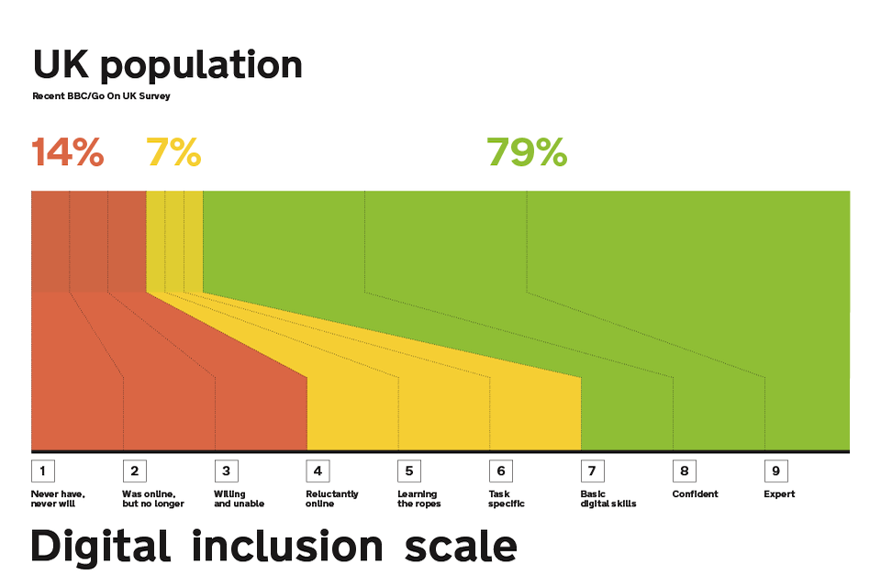
(Knight, 2018).

Digital inclusion is about ensuring that every individual—regardless of age, income, disability, or background—can effectively use and benefit from digital technologies. In the realm of health and social care, this is far more than a matter of convenience; it is a question of fairness, independence, and improved health outcomes. According to NHS Digital (2023), approximately one in five adults in the UK lack essential digital skills, severely limiting their ability to access vital online services.

For professionals in the sector, this situation presents both a challenge and a powerful opportunity. By championing digital inclusion, we can empower individuals to gain confidence with technology, provide accessible alternatives when necessary, and advocate for user-friendly designs in healthcare systems. It is essential to approach this with patience and understanding, recognizing that digital barriers often reinforce existing inequalities.

To create a more equitable future, we must
- Unite professionals, policymakers, and communities—toward closing the digital divide. By promoting training initiatives, offering accessible resources, and actively listening to the experiences of service users, we can build a more inclusive, connected system. Together, we can ensure that everyone has the opportunity to thrive in the digital era of health and care.
Conclusion and Call to Action
Digital inclusion is not just an important issue; it is essential for achieving equitable health and social care. Ensuring that all patients have the necessary skills, access, and confidence to utilize digital tools is critical for delivering personalized and effective care. As healthcare professionals, we hold a pivotal role in this transformation. By acknowledging barriers, providing support in the use of digital tools, and actively advocating for accessible systems and policies, we can significantly enhance patient experiences and outcomes.

Let’s commit to integrating digital inclusion into our daily practices. Evaluate your service or department: Are your digital resources truly accessible to everyone? Could your patients benefit from tailored guidance or alternative options? Additionally, engaging with local community initiatives or pursuing professional training on digital skills can initiate meaningful change. Together, we can bridge the digital divide and ensure that everyone receives the high-quality care they deserve.
References
- NHS Digital (2023) Digital inclusion and health inequalities. Available at: https://digital.nhs.uk/ (Accessed: 2 November 2025)
- Age UK (2022) Digital inclusion in later life. Available at: https://www.ageuk.org.uk/

Task4
Quiz
- What is the primary goal of the NHS Equality, Diversity, and Inclusion Improvement Plan?
(Answer in one or two sentences.)

The main objective of the NHS Equality, Diversity, and Inclusion Improvement Plan is to ensure that all staff and patients are treated fairly and equitably. This plan aims to promote an inclusive culture that values diversity while addressing discrimination and health inequalities throughout the NHS.

- How does the NHS EDI Improvement Plan propose to tackle the gender pay gap?
(Answer in one to two sentences.)
The NHS EDI Improvement Plan aims to address the gender pay gap through several key measures. These include ensuring transparent reporting of salaries and career progression, promoting fair recruitment and promotion practices, supporting flexible working arrangements, and tackling structural barriers that hinder women's advancement in their careers.

- What is meant by the term ‘intersectionality’ as used in the NHS EDI Improvement Plan?
(Answer in one to two sentences.)
The NHS EDI Improvement Plan emphasizes intersectionality, which highlights how various aspects of identity—such as race, gender, disability, and age—interact to shape unique experiences of discrimination and disadvantage. It asserts that understanding inequality requires recognizing these interconnected identities, not just single characteristics.

- Why is it important for the NHS to create a psychologically safe work environment?
(Answer in one to two sentences.)
It is important for the NHS to create a psychologically safe work environment so that staff feel able to speak up, share concerns, and contribute ideas without fear of blame or discrimination, which supports wellbeing, teamwork, and high-quality patient care.

- How does the NHS EDI Improvement Plan suggest improving the experience of internationally recruited staff?
(Answer in one to two sentences.
The NHS EDI Improvement Plan aims to enhance the experience of internationally recruited staff by providing better support for their integration, overcoming barriers to career progression, and ensuring access to fair treatment, mentoring, and development opportunities.

- What role does leadership play in advancing EDI objectives according to the NHS Improvement Plan?
(Answer in one to two sentences.)

The NHS EDI Improvement Plan highlights the essential role of leadership in advancing equality, diversity, and inclusion (EDI) objectives. Leaders are responsible for setting the tone, modeling inclusive behaviors, holding teams accountable, and implementing policies and practices that promote EDI throughout the organization.

- Identify one way the NHS EDI Improvement Plan aims to reduce health inequalities within the workforce.
(Answer in one to two sentences.)

The NHS EDI Improvement Plan aims to reduce health inequalities in the workforce by monitoring and addressing disparities in career progression, pay, and training access for underrepresented or disadvantaged staff groups.

- Why does the NHS EDI Improvement Plan emphasize the importance of collecting and analyzing data on protected characteristics?
(Answer in one to two sentences.)

The NHS EDI Improvement Plan highlights the importance of collecting and analyzing data on protected characteristics. This data helps identify disparities, monitor progress, and guide targeted actions that promote equality, diversity, and inclusion within the workforce. By using an evidence-based approach, the plan ensures that interventions are both effective and fair.

- Explain how flexible working policies can contribute to equality and inclusion in the NHS workforce.
(Answer in one to two sentences.)

Flexible working policies play a vital role in promoting equality and inclusion within the NHS workforce. They help staff balance their work and personal responsibilities, support individuals with caring duties or disabilities, and ensure that career opportunities are available to a diverse range of employees.

- What is one strategy mentioned in the NHS EDI Improvement Plan to combat bullying and harassment in the workplace?
(Answer in one to two sentences.)
One strategy outlined in the NHS EDI Improvement Plan to address bullying and harassment is the establishment of clear reporting processes and strong policies, along with training and support for staff, to ensure that incidents are dealt with promptly and fairly.

Task5

Dear Younger Me,
I recognize that you’re navigating a challenging time right now, feeling overwhelmed and uncertain about how to tackle the obstacles ahead. As I reflect on this, I want to emphasize that cultivating emotional intelligence and resilience could have profoundly transformed how you approached those moments.

Emotional intelligence is about more than just understanding your own feelings; it’s about recognizing how they influence your actions and being attuned to the feelings of others. In the past, you may have reacted impulsively or allowed stress to dominate, making situations more difficult than necessary. By taking the time to pause, reflect, and acknowledge your emotions, you could have responded with greater calmness and made decisions that served you better.

Resilience is equally vital—it's your ability to recover from setbacks and persist in the face of adversity. During tough times, it's easy to feel as though challenges are insurmountable. However, by nurturing resilience through self-care, seeking support, and focusing on what you can control, you would have tapped into an inner strength that often goes unnoticed.

Keep in mind that both emotional intelligence and resilience are skills that can be developed. By practicing self-awareness, empathy, and effective coping strategies, you’ll not only manage stress more effectively but also enhance your well-being and build deeper, more meaningful relationships. Each challenge you encounter is a powerful opportunity to strengthen these vital attributes, and they will serve you well throughout your life.

Be gentle with yourself; you are far stronger and more capable than you realize.

With unwavering support,
Me

Task6

Task7

As the manager of a care home, I am committed to implementing a digital care recording system that will replace traditional paper-based documentation. This transformative change is designed to significantly enhance accuracy, improve efficiency, and facilitate real-time communication among our team, ultimately elevating the quality of care we provide to our residents.

To drive this change effectively, I will employ Lewin’s Change Model (1951), which consists of three crucial stages: unfreezing, changing, and refreezing. In the unfreezing phase, I will clearly articulate the compelling reasons for this transition, highlighting how digital systems can drastically reduce errors and save valuable time. During the changing phase, our staff will receive comprehensive hands-on training to enhance their digital literacy and instil confidence in using the new system. Finally, in the refreezing stage, we will embed the digital system into our daily routines, supported by regular feedback sessions and ongoing refresher training.

Key skills that will drive this initiative include strong leadership, effective communication, targeted training, and adept problem-solving. I will harness active listening and empathy to address any staff concerns, ensuring that everyone feels valued and supported throughout this transition. To build competence and mitigate resistance, we will provide technical training and establish a peer mentoring system.

We may encounter potential barriers such as staff resistance, varying levels of IT proficiency, and limited resources. However, I will strategically involve staff early in the decision-making process, offer continuous technical support, and implement a phased rollout to allow ample time for adjustment.

By fostering a culture of collaboration and promoting a positive attitude towards this change, we will not only modernize our care delivery but also enhance our record-keeping processes and strengthen compliance with regulatory standards. Together, we can create a more effective and responsive care environment that benefits both our staff and the residents we serve (NHS Digital, 2023; Lewin, 1951).

Reflection using Gibb’s Reflective Cycle model

Description:
During this module, I delved into critical topics such as emotional intelligence, resilience, personal branding, and professional development. These themes prompted profound reflection on my strengths and areas for growth, particularly in communication, self-awareness, and adaptability within the health and social care setting.

Feelings:
At first, I felt uncertain about my capacity to engage in critical self-reflection regarding my practice. However, as I immersed myself in the learning materials and activities, my confidence grew. I began to recognize the significant impact my behaviours and attitudes have on others in professional contexts.

Evaluation:
This experience has proven invaluable, as it has illuminated my tendency to prioritize task completion over emotional engagement. By learning about emotional intelligence, I have come to understand the vital role of empathy and active listening in cultivating strong, effective relationships with colleagues and service users.

Analysis:
I have discovered that enhancing my resilience and self-awareness is essential for effectively managing stress and responding positively to challenges. Gaining insights into professional networking and personal branding has equipped me with the tools necessary to position myself advantageously for future employment opportunities.

Conclusion:
In summary, this module has reinforced my understanding that personal growth is a continuous journey rooted in reflection, feedback, and a commitment to self-improvement.

Action Plan:
Looking ahead, I am committed to regularly integrating reflective practices into my routine, actively seeking feedback from peers, and further honing my communication and leadership skills. This proactive approach will prepare me for a successful career in the health and social care or policing sectors (Gibbs, 1988; Schön, 1983).

Reference list
College of Policing (2023) Competency and values framework for policing. Available at: https://www.college.police.uk/ (Accessed: 2 November 2025).
Gibbs, G. (1988) Learning by Doing: A Guide to Teaching and Learning Methods. Oxford: Oxford Polytechnic.
Knight, M. (2018). A data literacy scale? | ONS Digital. [online] Ons.gov.uk. Available at: https://digitalblog.ons.gov.uk/2018/04/05/a-data-literacy-scale/ [Accessed 2 Nov. 2025].
Lewin, K. (1951) Field Theory in Social Science: Selected Theoretical Papers. New York: Harper & Row.
Montoya, P. (2020) The brand called you: Personal branding for success in life and business. New York: McGraw-Hill
NHS Digital (2023) Digital inclusion and health inequalities. Available at: https://digital.nhs.uk/ (Accessed: 2 November 2025)
NHS Digital (2023) Digital Transformation in Adult Social Care. Available at: https://digital.nhs.uk (Accessed: 4 November 2025).
Schön, D. A. (1983) The Reflective Practitioner: How Professionals Think in Action. New York: Basic Books.
Seibert, S.E., Kraimer, M.L. and Liden, R.C. (2001) ‘A social capital theory of career success’, Academy of Management Journal, 44(2), pp. 219–237.
Woolcock, M. (2001) ‘The place of social capital in understanding social and economic outcomes’, Canadian Journal of Policy Research, 2(1), pp. 11–17.

