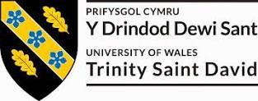
Mohammed Abdul Farhan(P147765)

Civil Engineering & Environmental Management BSc (Hons)

Assignment 1

Contract Practice & Procedures
M5X01878

Procurement Problems

Summary
Report recommending the different procurement routes available for the 4 proposed projects

Content Page

Brief & question and answer 1……page 13

Brief & question and answer 2……page 14

Brief & question and answer 3……page 15

Brief & question and answer 4……page 16

References and bibliography……page 17

This brief written report will outline the various procurement routes that are best suitable for each case study given. The choice of the procurement method will be backed up with why it was chosen and what other alternative methods there are but why they aren’t as effective for the case study’s.

Scenario 1

Answer

Correct procurement route and contract for this Doctor’s surgery would be Major Project Construction (MP). The procurement Route would be design and Build due to the work, you can carry it out in various ways and it can be used by both private and public employers. The contractor’s main occupation would be to carry out both the work and design to a completed standard.
The employer’s set tasks have been issued and provided to the contractor. The contract is focused highly on bigger construction project where major work is involved. The employer finds contractors who are well skilled with the correct experience and can take the full risks than any other contracts. The responsibility falls to the contractor as well as finishing the build, there is no full self-responsibility for the employer or developer. In other circumstances the contractor takes the risks which can occur when producing and finishing the design from the beginning.
The contract sets out the work to be done in steps and using a lump sum contract, which the contractor takes on a certain amount of work and gets a sum which is agreed by both parties. With this type of contract there’s an alternative agreement which is given, so that the architect or main designer that initially paired to work with the employer can undergo to communicate and design but full responsibility under the main contractor.
Scenario 2

Answer

For this Tesco build, the suitable procurement route to take would be a design and build process as the time here is important and can be fast track, overlap design and construction. Tesco have their own specialist contracts. Build and design is a single point of responsibility which in this scenario is the contractor and build responsibility.
The standards building contract with quantities would be considered as an appropriate contract. In this case, client to work for this professional contract, is due to give a tender stage numerous amount of drawings and bill or quantities, this is to show what is to be used for the main build and exactly how the client would like the end product to be like, the quality and quantity is important. The employer will hold the responsibility for the bill of quantities, accuracy and detail. If there are any alterations that need to be made to the build after the contractor has fully accepted, this should be all totalled to the contract sum. Within this contract there should be detailed rules and regulations of the employer and contractor, the authority and duties of the architect/ contract administrator and the quantity surveyor, and the administrative approach appropriate to any problems that may arise with projects which are this complex.
The time for this build is vital and therefore the completion set date that the contract will say there can not be any extra time for any sort of delays,
which can apply and is the control of the contractor.

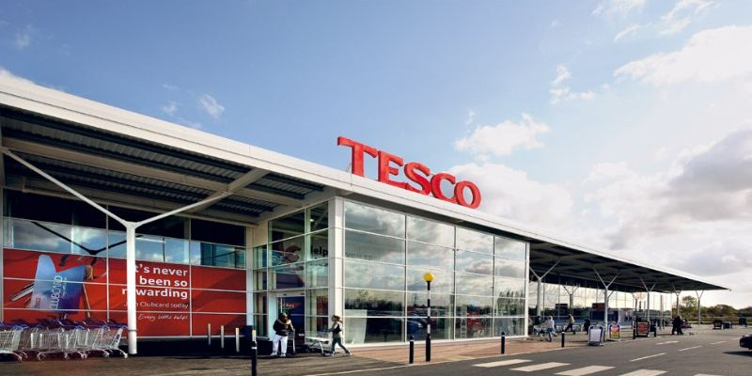

Scenario 3

Answer

The best choice of contract and procurement route for this scenario would be Major Project Construction for the contract and Management building contract for the route to be undertaken. Undergoing big scale projects, they enable an early start in the construction site, the works and design on behalf of the employer needs to be done, however if the full design is not prepared before the construction work begins, the employers are legalised to give the main management contractor with set drawings and a full specification, additionally, the management contractor is to approve of the conditions. There is no work to be done by the management, this meaning construction work, however they are entitled to charge a project fee. They employ workers to do the labour construction work which need to be completed. It issued by private employers and local authority
For this contract is would be ideal for the creation of a new hotel and retail units as it is designed for large projects where major work is involved such as foundation elements etc. to the completed project.
Contractors that are liable have to accept that the contractors have a huge amount of necessary experience in the building industry and therefore able to take a better risk that can occur under other contracts. The procurement route would be design and build for the proposal, the main client has no responsibility linked with the contractor.
The payment method would be lump sum with monthly payments which depend on the pricing file, inevitable once the work has been finished the contractor is paid the settlement figure that is said in the contract at the beginning.

Scenario 4

Answer

The correct procurement route to take for this build would be Traditional or Conventional- Lump sum. The work for this Theatre is simple, the employer would designed the work, but they would need to give drawings and a specification sheet outlining would needs to be included, this would include work schedules along with the quality and quantity of the final work piece.
To administer the condition would be in the hands of the Architect/ Contract Administrator. This route is used by the private and local authority employers. The type of contract is Minor Works Building Contract (MW). Payment would be based on a lump sum contract, where contractor will provide a full completed set of work and will be paid the agreed sum as stated in the contract. It is very important to make sure that all parties are known for the obligations and liabilities and that all risks are being accepted by the parties for when something arises. With this type of contract there are no bill required due to it, not being longer than 12 months and the responsibility of volunteers the project is nothing to be to extremely difficult, but simple design and fitting a new updated facility to give a better viewing of the theatre.
The contract can give drawings and a brief specification to the volunteer client, with this they can get a work schedules to give them the quantity of the work and what sort of quality is to be expected, not a long of work needed, fairly simple and low amount of work, like new interior and new access path for the disabled people to feel more secure.

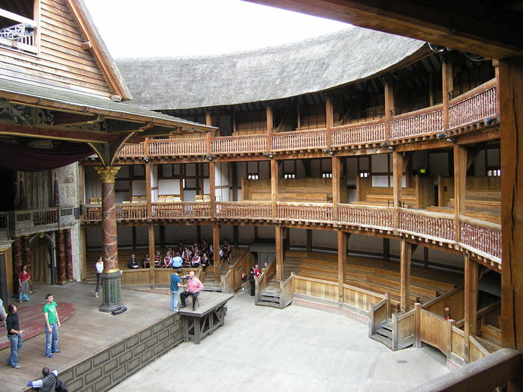

References and bibliography

http://www.theatrestrust.org.uk/discover-theatres/theatre-faqs/172-how-has-the-design-of-theatre-buildings-changed-over-time - scenario 4 image to represent theatre build

Procurement route and contract decided by using the following website

https://www.jctltd.co.uk/docs/Deciding-on-the-appropriate-JCT-contract-2016.pdf

Limited, T. J. C. T., 2018. Design and Build Contract (DB). [Online]
Available at: https://www.jctltd.co.uk/product/design-and-build-contract - used for Scenario 2

Limited, T. J. C. T., 2018. Minor Works Building Contract (MW). [Online]
Available at: https://www.jctltd.co.uk/product/minor-works-building-contract - used for scenario 4

Limited, T. J. C. T., 2017. Major Project Construction Contract. [Online]
Available at: https://corporate.jctltd.co.uk/products/major-project-construction-contract/ - used for scenario 1 and 3

