10/13/2025
University of Wales Trinity Saint David
London campus
E-Portfolio Link:
Module Name: Learning In the Digital Era
Module Code: ACCA 4025

Student Name: Semra Ozturk
Student ID: 2510165
Group: 2

Lecturer’s Name: Koushik Modak

LDE Assignment 1
E-Portfolio
Table of Contents
Introduction 2
Main Body 2
Task 1: Essential Academic and Employment Skills for the future career Path 2
Task 1 (a): Report on Essential Academic and Employment Skills 2
Task 1 (b): Evaluation of Task 1 (a) based on Similarity report 2
Task 2: Collaborative Mind Map and Individual Poster 2
Mind Map (Collaborative) 2
Poster (Individual) 2
Task 3: Virtual Collaboration and RefWorks 2
Report on Virtual Collaboration 2
Step-by-step process of using RefWorks with visuals 2
Task 4: E-Portfolio Creation and Evaluation 2
Task 4 (a): E-Portfolio Creation 2
Task 4 (b): Illustrative Review of E-Portfolio tool Selection 2
Conclusion 2
References 2
Task 1 References: 2
Task 3 References: 2

Introduction

Main Body

Task 1: Essential Academic and Employment Skills for the future career Path

Task 1 (a): Report on Essential Academic and Employment Skills

Task 1 (b): Evaluation of Task 1 (a) based on Similarity report

Task 2: Collaborative Mind Map and Individual Poster

Mind Map (Collaborative)

Poster (Individual)

Task 3: Virtual Collaboration and RefWorks

Report on Virtual Collaboration

Step-by-step process of using RefWorks with visuals

Task 4: E-Portfolio Creation and Evaluation

Task 4 (a): E-Portfolio Creation

Task 4 (b): Illustrative Review of E-Portfolio tool Selection

Conclusion

References

Task 1 References:

Task 3 References:
Essential Skills for Study and Employment (Data Analyst Focus)
In a competitive business today, it is paramount to have a combination of both academic and professional skills in order to achieve success especially when one would like to embark the career of Data Analyst. Data Analysts work on raw data and find or build the desired information from it. Data analytics is the fuel of the business intelligence nowadays. All the business decisions are now backed with strong data analytics. Now business processes are design in a way to store things to make in format [1].
Critical thinking is one of the most useful skills that enable analysts to evaluate problems rationally and determine trends and create strategic solutions. The interpretation skills in analytical data analysis are also important since the business decisions are becoming data-oriented. The ability to use such tools like Excel, Power BI, Tableau, and SQL are useful in collecting, organizing, and analyzing complex data to come to conclusions. With that Python and R for data analytics programming language help the visualise billion of rows in dataset [2].
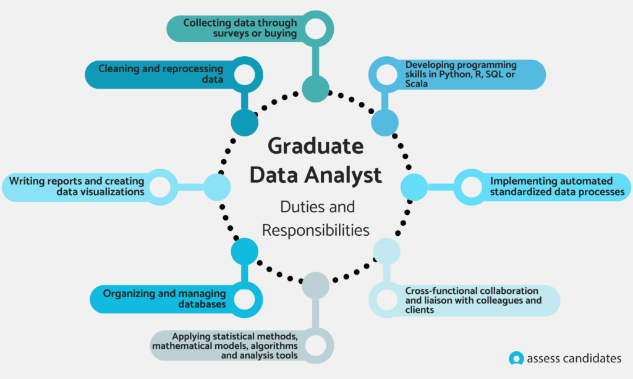

Image 1: assessscandidates.com [3].

Data visualisation and communication skills would allow the analysts to make technical concepts lucrative to non-technical stakeholders in a way that makes everybody aware of the business purpose. These skills also encourage group work and support in the establishment of strong interdepartmental relationships. The skills of making decisions and solving problems will also be fundamental in the assessment of the business problems and the adoption of effective solutions which can contribute to the desire value. Moreover, changeability and time management aid Data Analysts become need in quickly changing, fast business environments where priorities and needs can be extremely moving [4].
Acquiring these fundamental capabilities in the course of the studies eases one towards the employment by enhancing the capabilities. Now universities offer data courses at entry level programs. These things encourage me to become a proficient Data Analyst in my selected field because I will be able to perform efficient data analysis, convey knowledge to others, and formulate business decision that will eventually result in organizational development and prosperity [5].

References

Task 1 References:

[1] | K.Eremenko, Confident Data Skills: How to Work with Data and Future-proof Your Career, London, 2020.
[2] | R. Sikdar, Data Analytics-An Emerging Skills Gap, vol. 10, pp. 1-13, 2022.
[3] | A.Arshad, “"Hiring Graduate Data Analyst: Why you should adopt these pre-employment assessment," Assess Candidates,” 2025.
[4] | E.Stevens, What is Data Analytics?A Complete Guide for Beginners, 2023.
[5] | “L.E. Education,” How data skills Can Expand your career.

.

