
Llanferian PFF FLow Meter project

May 27, 2022
University of Wales Trinity Saint David

Executive Summary

Llanfarian wastewater treatment works has been picked out amongst several sites to be installed with a new Magflow flowmeter. These sites have all had reports that they are functioning over capacity and they are being switched to storm too often. When a site is under storm conditions this means that most of the water that is submitted into the works is being pumped either into storage tanks or into a nearby water network such as a river or the sea. By installing flow meters within these sites, it gives Welsh water an accurate reading of the incoming flows coming into the specific site. Whitland Engineering has been tasked with installing the flowmeter within Llanfarian and the pipework surrounding it. Research was carried out to come to the best design proposal to issue to Welsh Water, after research it came to light that the site required a pass forward flow rate of 5.7 litres per second to be sustainable. For this reason, it was concluded by Whitland Engineering that a weirbox was needed to control the flows accurately within the site. Using a large diameter pipe Whitland Engineering created an adjustable weirbox in order for the site operators to accurately adjust flows going through the site.
The weirbox was placed after the flowmeter, for the flowmeter to be fully submerged. If the flowmeter is not fully submerged the whole time it will cause damage to the unit. This is only one of the constraints a flowmeter presents to pipework. Another constraint that was carefully considered by Whitland Engineering is to not to implement any turbulence into the pipework which impedes the flowmeter from being accurate. For this reason, Whitland Engineering implemented long radius elbows to guide the flows through the flowmeter, as opposed to sharp bends that may introduce turbulence into the pipework. Introducing long radius elbows also solves the issue of air within the pipework which is the final constraint that goes hand in hand with flow meters. If air can pass through the pipework, it disturbs the electromagnetic waves that read the flow going through the flowmeter.
A detailed project plan Gantt chart was made to guide the project and to conclude the project. Also, extensive planning and fabrication the project was installed with very little problems and was a success in what the project set out to achieve (5.7 litres per second). An error within the fabrication of the weirbox was the main issue that occurred which affected the adjustability of the weirplate. The issue resulted in the correct flow to be passed through the site but in the long term it could be an issue if the site demands a larger flow rate. If this issue does occur Whitland Engineering has set out to replace the weirplate and rework the box. Apart from this issue Welsh Water has commended Whitland Engineering with a successful project and perfect flows passing through the site.

Table of Contents
Executive Summary 1
Introduction 3
Initial Design Intent 4
Reasoning Behind the Project 5
Research 6
Project Scan 7
Project Plan 8
Flow Calculations 9
The Design 9
Site Excavation 13
Installation 14
Conclusion 15
Bibliography 17
Appendix 18

Introduction

This report contains information about the solution for Llanfarian wastewater treatment works. PFF is a Welsh water scheme to deliver Flow meter units to specific sites within Wales which require monitoring. The aim for the scheme is to function alongside event duration monitoring for storm flows into storm tanks within water treatment works. The need of the project is to install flow and storm event monitors and to provide reporting and analysis capability at Llanfarian as identified by Welsh Water. This will prevent more frequent, higher strength and longer duration discharges to receiving waters form last in line overflows, storm tanks of other storm overflows that control PFF to Welsh Water treatment works. It will allow receiving waters to respond to rainfall events to provide additional dilution.

Initial Design Intent
A sub-contracting firm called Hornbill carried out an event duration monitoring survey on the 10th of November 2015 and sketched flows through the site and arrangement of the unscreened and screened storm storage tanks. The site features two flow meters that are already installed, but the flow meter Welsh Water require is one that can be calibrated. To calibrate a flow meter 500 milometers straight pipework is required to clamp on a clamp on flow meter. One flow meter is on the flow to full treatment line to the Humus Tank, another is on the humus return-line, and another is on the bio-filter recirculation line. Morgan Sindall, another sub-contracting firm carried out a PFF preliminary site survey on eighth of January 2021, which suggested the option of adding a new PFF flowmeter on inlet screen FFT discharge pipe. The report did not cover PFF flow rates of the requirement for flow control. A detailed pre-construction PFF site survey was carried out by Whitland Engineering and Morgan Sindall on twenty second of November 2021, to check the site, water levels, site dimensions, cable ducting, potential construction access and constraints for any new structures adjacent to the inlet screen.
Historically, the PFF control at Llanfarian was achieved using a fixed orifice plate in the discharge pipe from the inlet screen channel. This orifice plate flow control method was superseded by a knife gate valve, which has been subsequently identified by Welsh Water Operations as being unsuitable. During 2021, the Llanfarian water treatment works scheme scope of works was expanded by Welsh Water to include the provision of a PFF control to achieve a forward flow rate of 5.7 litres per second.
The proposed measurement solution is to install a new approved flowmeter chamber on the inlet screen fast forward flow discharge pipe. Dependant on the result of trial excavations of the existing discharge pipeline route, there may be an opportunity to reduce the overall length of new buried pipework for the installation of the new flowmeter chamber. The proposed PFF flow control method is to use a weir plate within a weir-box. This is to be installed in the FFT line, just downstream of the proposed PFF flowmeter chamber. When the new FFT flowmeter is being commissioned, the weir plate height can be fine-tuned and set to achieve the required FFT before storm spill commences at the upstream inlet screen storm weir.
This PFF monitoring solution would utilise an in-line Siemens Diameter 125 wastewater electromagnetic flowmeter connected to a remote transmitter in the site kiosk. At this wastewater treatment works, humus returns flows appear to be returned downstream of the proposed new PFF monitoring location. Returns flow rate data has not been supplied for this wastewater treatment works and further analysis of the process returns flow rates at this wastewater treatment works is currently not within the scope of this design report

Reasoning Behind the Project
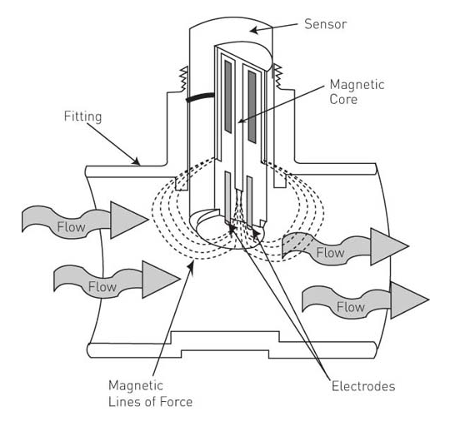
Within Welsh water there are several sites that demand work to them for them to meet current regulations. All over Wales there are sites that can switch to storm event prematurely, this is when flows are too great for the site and the flows are pumped elsewhere. A storm event is only designed to occur once the rain fall is so great it dilutes all the wastewater to acceptable level to be pumped into a nearby river. This method should only be used if there is no other option. Often waste water treatment works are unmanned and work through level sensors and weir plates. These level sensors and weir plates dictate where the flows get directed. A weir plate is simply a metal plate set at a certain height. Once water reaches the top of the plate the water will begin to spill over the top of the weir plate into either an overflow storm tank or elsewhere within the tank. A level sensor uses a laser to shine down from the top of a tank to know what the water level is within the tank. Once the water reaches a certain level within the tank or the chamber the level sensor will trigger a pump or a valve to open to deal with the rising water level.
Figure 1 Flow Meter Diagram

Figure 1 Flow Meter Diagram
Due to this reason Welsh Water have chosen to install flow meters on selected sites that they have worked out to be storming more than necessary. Once the flow meters are installed data will be generated and logged to make sure that investment is given to the sites that are not functioning to meet demands. Flow meters use electromagnetic wave lengths as seen in figure 1. These magnetic wave lengths measure the flow rate coming through that specific pipe. These Magflow Flowmeters are perfect for wastewater as there is no physical equipment that is protruding into the pipe. If a sensor was protruding into the pipe, it may be a cause of ragging or build up. This is where solid materials get caught on something within the pipe and create a blockage. In this project an in line Magmeter will be used which uses high purity Alumina ceramic detection tubes which allows for the meter to take precise flow measurements in a wide range of applications. These flow meters can range from half an inch to 16 inches in diameter.
Flow meters demand a certain amount of straight undisrupted pipework to take an accurate reading of the flow. These are constraints that are applied within the design, if there are any turbulence within the flow it will deem the flow meter not accurate and not fit for purpose. Therefore, within the project a long straight piece of pipe can be seen to make sure the flowmeter is verified for intended use. The flow meter also cannot have any air passing through the pipe as the electromagnetic waves read the flow incorrectly. To recap there are three main constraints that drive the project and how it is undertaken:
- Minimal turbulence within the pipe from sharp turns in the pipework and change of diameter in pipework.
- Pipework needs to be aerated to make sure minimal air passes through the flow meter to gather accurate results.
- Flow meter must always remain submerged to make sure the unit does not become damaged overtime.

Research
A large amount of research was carried out in the first week of carrying out the project plan. Several subjects were covered including flow meters, weir plates, underground pipework and 3D scanning. Most of the knowledge was taken from time served engineers within Whitland Engineering who have been carrying out projects within the water industry for 25 years. Within LARRARTE, F. and PIERRE, F. (2012) writes a journal detailing the effect of wastewater within an electromagnetic flow meter. The journal includes experiments proving that electromagnetic flow meters are ideal to measure flows within wastewater pipework as there is no probe within the pipe flow to catch on any solid material that is passing through the liquid. The flowmeters will be able to gather accurate flowrates for wastewater. The only time the tests were inconclusive was when the transducer was damaged. This is providing the pipework has been aerated and any high bubble concentration is reduced before the flow meter.
Bagheri, & Heidarpour, M. (2009) Writes an article including information concerning rectangular weir plates in which Whitland Engineering are interested in using. The article states that sharp-crested weir plates are the simplest form of over-flow spillway that is commonly used to determine the flow rate in hydraulic laboratories, industry and irrigation systems. The article also states the uses of these plate offers the opportunity to provide accurate flow rates for a system depending on the head height of the previous spill point. If the head height is matched with the previous spill point the weir plate that is downstream will spill instead of the previous spill point. This is what Whitland Engineering require to succeed when working on the new pipework network. The previous spill point within this current project is the screen before the flow meter. Within the screen there is a weir plate of its own that bypasses the pipework and spills into a storm outlet directly linked into the nearby river. This is a bypass that is should only be used when the site is at risk of flooding and should not be used under nominal flows.
In a report by Tuck, (2006) it goes into detail concerning a wastewater treatment works that has been revamped in recent years. The site has implemented a range of cutting-edge techniques and machinery to treat wastewater effectively. This is by using air to promote biological removal of ammoniacal-nitrogen. Using aeration, the site has improved the clarity of its water and its upkeep of equipment with a small investment. The flow meters that will be installed within the PFF scheme will dictate to Welsh Water which sites need investment and modernisation.
In an article submitted by Anspach, C. (2018) it details the importance of flowmeters within the water industry. The article includes information about the growing demand for water which is providing a newfound strain on the water industry. Flow meters are a key factor within the water industry for several reasons such as water storage, transmission to wastewater treatment, leak detection and pump management, all of which cannot be carried out without flow meter technology. Anspach, C. (2018) goes onto mention that electromagnetic flow meters and control valves play a vital role in keeping wastewater emissions within limits.

Project Scan

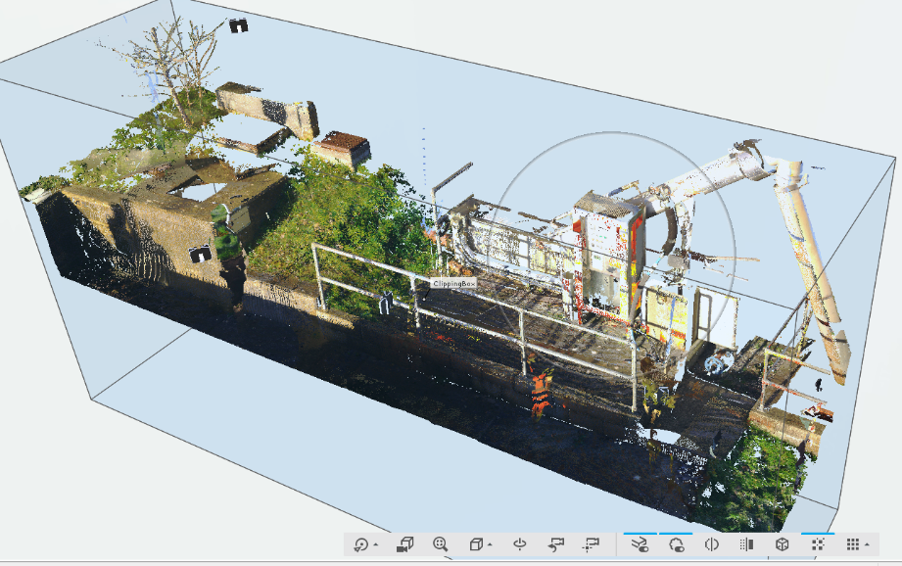
On the Twenty second of November 2021 Whitland Engineering and Morgan Sindall conducted a site survey of Llanfarian wastewater treatment works. Within this survey the project scope was discussed. While on site, the plan for the project was marked out on site using estimated measurements. Once site photos and layout were confirmed, a 3D scan of the site was taken using a FARO 3D scanner in order to take measurements down to a tolerance of 0.15mm. In order to gather as much information as possible, twelve scans were taken around the place of work. Using the 3D scan data this can be then converted into CAD and can be modelled around the scan. In Figure 2 the full site layout can be seen, this software makes 3D CAD much easier to navigate for several reason. By using 3D scanning software, it deems manual measurement taking using a measuring tape unnecessary. Also, this can then be converted into 3D CAD parts and assemblies can be clearly seen on how they fit within the site. This software is vital because the pipework Whitland engineering will be connecting onto is existing and the chamber that the pipe work is discharging into is also existing. The software was also used to mark up any civil groundwork that may be disturbed by the project for example the screen slab and the path around the screen that would need to be taken up before the install date.
Figure 2 Initial 3D Scan of site

Project Plan
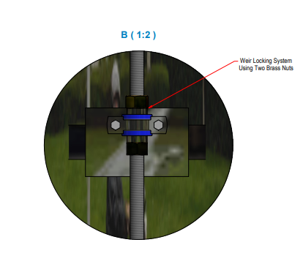
After carrying out a 3D scan a project meeting was conducted within Whitland engineering to discuss the project at hand. The meeting was attended by the design engineer, project engineer and managing director. Within this meeting a verity of different options was discussed in order to carry out the project in the best possible way. Discussions includes how to simplify the design to minimise cost of materials, also on how to accurately set the flows to a certain amount. As stated in the design proposal Whitland Engineering will need to achieve a flow rate of 5.57 litres per second in order to consider the project a success. From the discussion it was decided that the best option would be the use of a weir box. With a weir box the site will have the freedom to set the flows within the adjustment of the weir plate. The weir plate will be fabricated with a locking system on a threaded bar as seen on figure 3. The site operator will adjust the plate using the two brass nuts on either side of the one-inch spacer. If they require larger flows, they would be able to loosen the top nut and be able to drop the plate to the desired height. Once the flow is correct the nuts can be locked into place to avoid the plate dropping even further.
Figure 3 Weir Plate Locking Mechanism
After the decision was made to fabricate a weir box, a discussion was then undertaken to find the most cost-effective way of fabricating the assembly. Normally within Whitland Engineering, weir boxes were fabricated using stainless steel sheets and fabricating them into a 3D box and using the same concept of a weir. After discussions with the managing director the idea was put forward to use 500-millimetre diameter pipe section as the weir box body. By using a section of pipework, it makes material cost far cheaper and time fabricating the assembly is halved. Once the team was happy with the design plan revision one started to take shape. Once revision one had been designed more meetings took place to discuss the design before being sent to the client.
Once all details were confirmed a project Gantt chart was created, this was updated weekly to keep up with client demand. All steps of the project were identified and estimates of the time the sections would take were set. As can be seen in appendix 5 the Gantt chart provided the project with a step-by-step plan and any new steps were added to the chart to conclude the project after installation.

Flow Calculations
The Llanfarian project is unique in what Whitland Engineering has dealt with before as there is a complicated pipework system before the new pipework. The whole system that Whitland Engineering will be working on needs to be looked at as anything that is installed may have a knock-on effect on what in already installed downstream of the project. Within this specific project the pipework being installed is directly below an existing screen set up on site. The screen discharge has two options in the path the flows take, either through the pipework to manhole three or through the overflow storm network. The overflow it set on a weir plate; the flows will only pass over the weir plate if the site is at risk of flooding. For this reason, the new weir box that will be installed by Whitland Engineering will need to consider the head height of the pipework when backing up flows. As can be seen in appendix 7 the head height has been considered using a spreadsheet set up to calculate head heights within a pipework network.
Using the 3D scan taken in Llanfarian and a level survey taken by Morgan Sindall Whitland were able to set a datum for the site levels. Using the datum that was set at 10.000 which was the top of the concrete of manhole three, Whitland Engineering were able to create a detailed flow plan for the site. As can be seen within appendix 7 the levels are set accurately to show the head height within the site. Using these levels, the height of the weirplate that was being installed could be deduced to make sure that the height of the plate was not going to flood the site.

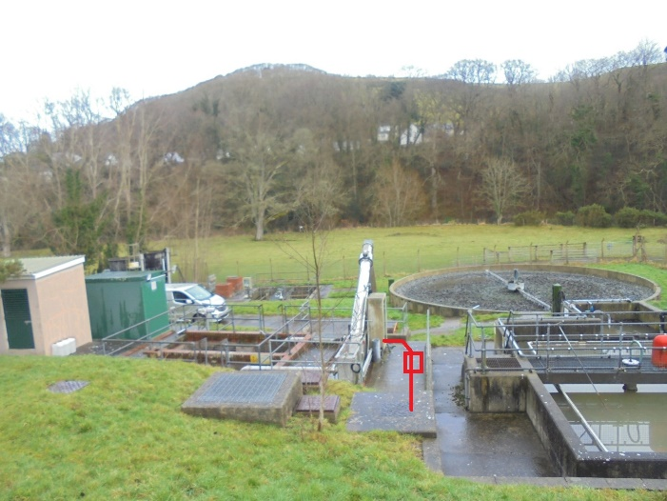
The Design
Once the project planning phase was complete the design of the project was able to take place. At this point the 3D scan taken in the site visit was exported into the 3D CAD software and the 3D models of the pipework for the project could be placed into the assembly. Using the 3D scan the designer on the project can set up grounded points where the pipework starts and the pipework ends. In this application the pipework starts off a knife gate valve straight off the 4mm screen in the waste treatment works. For some background information a screen in a waste treatment works takes most of the solid material out of the water and ejects the solid material into a nearby skip to be disposed of. This prevents blocked pipes within the works and is the first step of treating the water to the point where it can be safely deposited into either the sea or a nearby river.
Figure 4 Site Photo Layout Plan

Figure 4 Site Photo Layout Plan
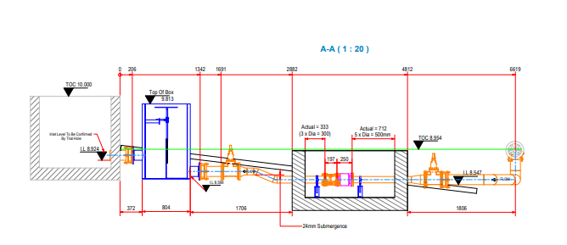
As seen in figure 4 as plan view of the project sent by Morgan Sindall, this is a clear view of what need to be undertaken within the project. The photo however does not include the weir box at this point as revision one of the projects was not issued to the client. Before the realisation that the project needed flow control it was a simple case of adding straight pieces of pipework through a flow meter and into the existing chamber.
Figure 5 Revision 1 section view

Figure 5 Revision 1 section view
In the included snapshots of the revision one in figure five and six the project can clearly be seen. As stated above the project starting point is from the existing knife gate valve and leads into the existing chamber. In figure 5 it shows also new isolation being added into the pipework by adding two new gate valves. This is so the operator can isolate both sides of the flowmeter and drain the pipework, this is for maintenance or replacement in the future.
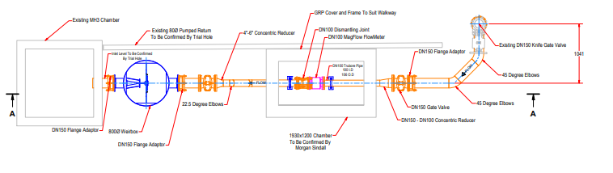
Figure 4 Revision 1 Plan View

Figure 4 Revision 1 Plan View

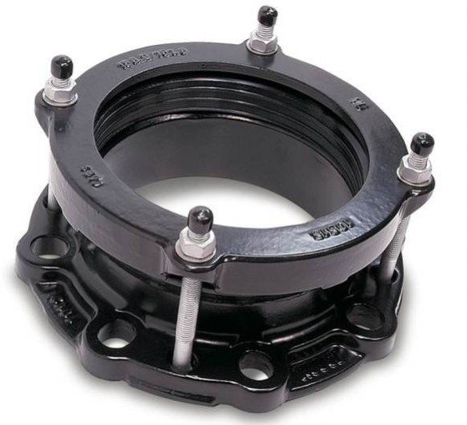
As seen in figure 5 all gate valves used are linked to the pipework using a flange adaptor on one side of the unit. Flange adaptors are used on most of the pipework installed by Whitland Engineering and pipework installed by other contractors. The reason for the use of flange adaptors is purely for the fact that it gives the install team a vast amount of flexibility when installing the project. The reason for this is due to that a flange adaptor works by being bolted on a flange and then the other side has a rubber seal that seals on the pipework and no fixings are required as seen on figure 7. The flange adaptors have a range of pipe sizes that they can be used on, for example the flange adaptors that will be used on this project are 152-168 millimetres and our pipework is stainless steel 162 outer diameter. That gives the install team 6 millimetres of adjustment, also four degrees of angular adjustment. Flange adaptors also act as rockers for the pipework also, this means it gives the pipework space to move slightly. Pipework will always expand and contract depending on the conditions, by adding rocker pipes it counter acts cracking of pipes as the pipes are not static.
In figure 5 a small vertical bend can be seen after the flow meter chamber, this to keep the flow meter fully submerged. Flow meters cannot function if they are not fully submerged, if the pipe is partly full it can cause damage to the unit and would result in the project failing. The weir box would keep the flow meter full submerged but if an operator was to remove the weir plate for cleaning it would result in the pipe being partly full.
Figure 5 Flange Adaptor

Figure 5 Flange Adaptor
In the screenshot of the drawing in Figure 5 a concentric reducer can be seen. This is from the original diameter pipe of 150 millimetres to a reduced diameter of 125 millimetres. This was to ensure that the pipe maintained a full capacity, by reducing the diameter of the pipe it means that it takes less water to fill. It also has a hidden benefit of cost due to less materials used and the smaller the diameter of the pipe it means flanges and fittings cost less. The main cost for the client is the flowmeter, which is provided by the client. The difference between a 150-diameter flowmeter and a 125 flowmeter was £230.
The locking system for the weirplate was looked at extensively by Whitland Engineering to create the most ergonomic design for operators on site. It was decided by Whitland Engineering that a simple threaded bar handle between two brass nuts. As seen in figure 3 the brass nuts lock against a small length of one inch pipe on both sides. It was decided to use brass nuts due to that brass is self-lubricating and has a far less likelihood of ceasing and not being able to move.
With projects that require a wastewater treatment works the large amount of time spent on the project is within the design section of the project. This is because the client would rather get the project 100% correct and all issues that could go wrong, spoken about before the install date. For this reason, the project generated a total of five revisions due to changes made by the client. There were also issues such as new ground works discovered that adapted the design also.
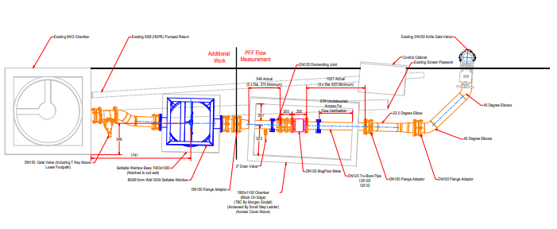
The design process was thought to take four weeks of design, the design process took a total of eight weeks. As stated above there was numerous customer demands that lead the design process to overrun. After several changes to suit customer requests and Welsh water legislation a construction drawing was released to the customer. As can be seen in figure 8 and 9 there was several changes compared to revision one. Some of the most prominent changes is the last connection into the chamber which was set at an angle to suit the existing pipe entering the chamber. Originally it was thought this pipe was straight and was easy to connect onto, but after trial holes took place, it was discovered that this pipe was set at a 9-degree angle under the screen slab. This meant a bespoke pipe had to be made to suit this connection for the project to be a success. After talks with the fabrication manger it was decided that the connection was possible to fabricate and was then able to be issued to be fabricated. Another change that can be seen is that the weir box was moved closer to the flow meter chamber. The reason for this was that the operator could use the ground level that was being set as a step to see into the weir box. This was also so the operator could clean the weir box if it was blocked up or very dirty, without a view into the box it would present problems such as burst pipes and flooding due to blockages. The handle for the weir box also needed to be accessible for the operator for them to alter the flow rates going through the site.
Figure 6 Revision 5 Plan View
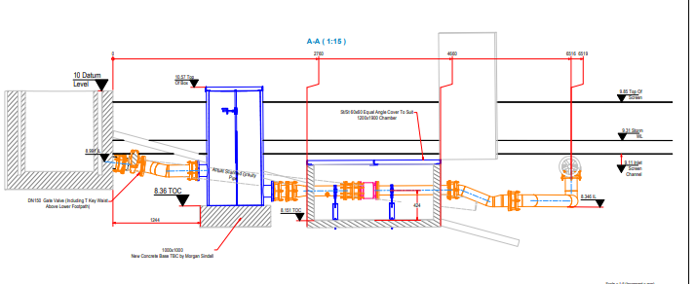
Figure 8 Revision 5 Section View

Site Excavation
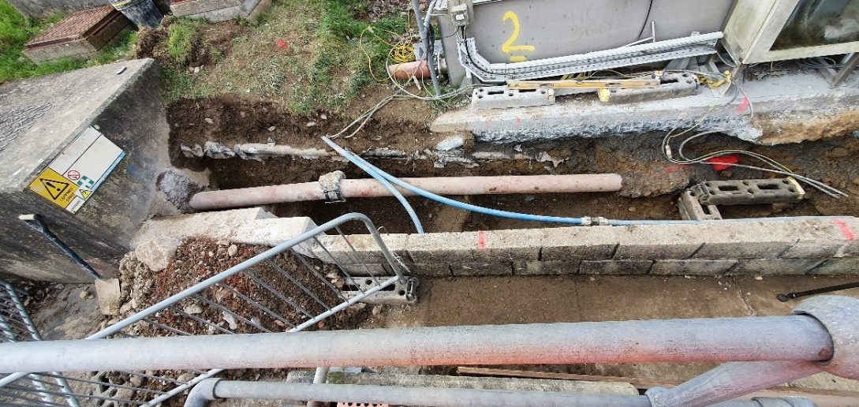
Two weeks before the project was set to be installed Morgan Sindall began excavating the site to install the new pipe network. When the site was fully excavated Morgan Sindall uncovered some unforeseen pipework that was in line with the new pipework layout. This caused Morgan Sindall to request a further 3D scan to make sure that Whitland Engineering pipework was not clashing with any existing pipework. The main problem that presented itself was two plastic air relief pipes that were crossing where the weir box was being placed. This can be seen in figure 10. Two weeks before the install date the site was 3D scanned for a second time, the scan presented a few problems that were covered within the design section of this report. As can be seen in appendix 2,3 and 4 there was clear clash points where the pipework runs through the proposed new weir box. A teams meeting was set up to discuss the issue, it was decided within the meeting that the existing plastic pipework could be rerouted around the weir box. This meant the design could go ahead as planned. The angled pipe was also discussed, it was decided that with the unique spool that was being made was fit for purpose as it was between two flange adaptors. The flange adaptors would give Whitland Engineering a higher margin for error due to the amount of flexibility the adaptors provide.
Figure 9 Excavated Site Photo

Installation
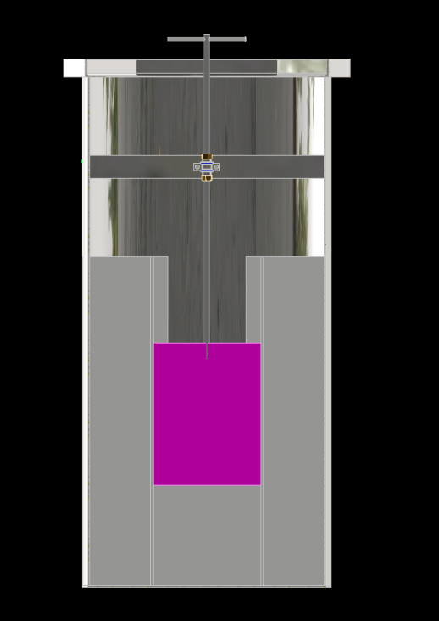
On the week of installation all plans were in place for pipework to be installed within the week. This was achieved but there were some issues that occurred due to fabrication error. Once all pipes had been installed and the final connection was made the calibration of the weir box was the last activity to cover. Once the box was fixed into place and the pipework was connected to the box the project manager set out on setting the weir plate to meet the correct flow of 5.7 litres a second. As can be seen in figure 11 the pink plate is the weir plate that controls the rate of flow. It was designed to have a wide margin of adjustment for the operator to decide the best flow for the site using the threaded bar handle and the over sized weir place. As can be seen in appendix 6 the weir box was made with a solid bottom which effects the amount of adjustability that the plate has. Within the design it was made so if needed, the weir plate could rest of the bottom of the tank. It was also included on the fabrication drawing to have the stainless-steel guide rails lead down to the bottom of tank. Due to fabrication error the weir plate was only able to be adjusted 40 millimetres.
Figure 10 3D Model of weir box
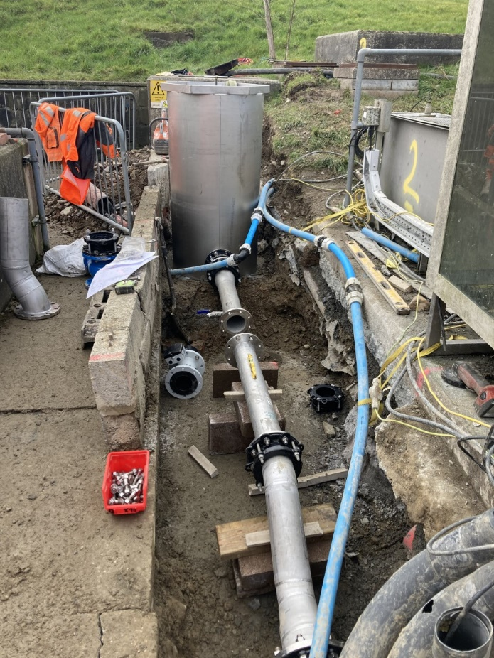
The installation was able to be completed as the weir plate was able to achieve the flow rate of 5.7 litres a second but in the long term it could cause issues if the demand for the site is increased. If the demand for the site increased the weir plate would not be able to pass the point where the guide rails end.
Figure 11 shows a photo of the project being installed once the existing pipework was removed. The method of installing consisted of placing the pipework on blocks before civils could back fill where the pipework would be.
Figure 11 Installation of the project

Conclusion

In conclusion the project was a success, the pipework all fit into place and the flowmeter was installed as intended. The existing plastic pipework was rerouted around the installed weir box using compression fittings and elbows. The planning of the project contributed to a smooth install and a well-rounded design that the client was pleased with. The pipework was tested using a strap on flowmeter to make sure that the flow meter Whitland Engineering installed was functioning. The results were forwarded to Whitland Engineering as a success of 5.7 litres a second and the most accurate PFF project reading thus far, this was out of 43 PFF projects that were installed before Llanfarian. The fact that the weir plate was fabricated wrong demands research, Whitland Engineering were very lucky that the box still served its purpose. If the plate was any shorter it would have demanded the box to be recalled back to Whitland Engineering and reworked. If this occurred, it would have been a massive cost to keep the wastewater treatment works on stop and the cost of transport and materials.
After a project review meeting after the install date, it was decided that in future the project manger on the specific project needs to inspect the physical fabricated parts before they go to site. If parts are inspected as they get to site, it gives no margin for error. If the parts are inspected as they are completed in fabrication it gives Whitland Engineering the opportunity to rework the part before the install date if an error has occurred.
After fabrication and installation, within the project review meeting it was mentioned by the fabrication manager that the threaded bar presents risk in the long term. It was explained stainless is hard but brittle, by using threaded bar it presents an issue when pulled passed a fixed small length of pipe, there is a chance the thread could be damaged easily. Derman, A. (2019) states that when stainless steel threads are used it causes “galling”. Galling is when stainless steel loses it oxide layer on its surface, under high contact forces the oxide can be deformed, broken, or removed on part of the component, this exposes the bare metal. When two of the same bare metal come into contact it causes them to cold weld together or fuse together. This means that the thread would be nearly impossible to function and would need to be cut off. If a similar project is undertaken within Whitland Engineering it was decided that a non-threaded solid bar will be used, this will work in the same way but instead of the brass nuts and the small pipe clip fixing the locking pipe, the pipe clip will fix onto the solid bar. To adjust the weirplate it will be a simple case of loosening the pipe clip and then pulling the bar up and then retightening. This would solve the problem that may occur over a long period of time.
In a report by Almasi, A. (2021) it shows details of wastewater pipework. It shows in the report many different rules of carrying out wastewater pipework, one of these rules are keeping the number of flange connections to a minimum. This is due to that any flange connection could be a point of leakage, every connection demands upkeep from operations within Welsh Water. The project installed had several flange connections that were connecting flange adaptors and different spools for ease of manoeuvrability and ease of manual handling. If the project was under extreme pressure and being pumped, more consideration would be taken on the number of connections being implemented into the pipework. Within this project the flow is gravity fed and is functioning under a pressure of 5 bar which is minimal.
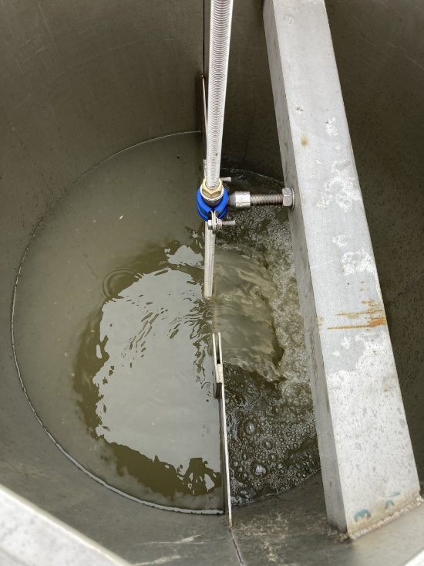
Solorio, J. (2018) states in a report that CPVC is the most cost effective and the most resistant pipework that should be used when dealing with wastewater. It states that CPVC has superior mechanical strength and reduces installation time as the pipework is very light. This was certainly a possibility when designing the pipework for this project but there are some draw backs working with plastic pipework. Colonel, R. (2010) states that stainless steel is by far superior compared to any other material when dealing with wastewater. The report states that stainless is ideal for wastewater due to its hardness. The pipe not only is resistant to corrosion if treated correctly, but it is also wear resistant. With wastewater there are many solid objects that pass through the pipework which would wear down a CPVC pipe overtime. Air within a pipe will also wear down a CPVC pipe overtime. This would not be a problem with stainless as pipework that was installed in the 1940s is still going strong to this day. Tuthill, A. (1999) also supports that stainless steel is ideal for wastewater treatment works. Therefore, stainless steel was used within this project.
Figure 12 Water passing through Weirbox
After contact with Welsh Water, it has concluded that the weir plate was a welcome addition into the works. The operator within the site has mentioned to Whitland Engineering that the weirplate is not only acting as a flow control it is also acting as a second screen. Herschy. (1995) found the same outcome when using rectangular cascade weirs. He states that because the water needs to travel over an obstacle any floating solids will be trapped on the inlet of side of the weir. Due to Whitland Engineering installing the weirbox with an easily removable cover it means that the operator can clean any solid objects out before it gets further down in the treatment works. As can be seen in figure 12 which shows the weirbox in operation.
As can be seen in figure 13 and 14 it shows the completed project which has had groundwork remade around the weir box and the flow meter. Figure 14 shows the flow meter chamber once the electrics had been installed in the chamber. Whitland Engineering is very pleased on how this project turned out and how professional the final product looks. This project opens doors for the company all around Wales to install flow meters.
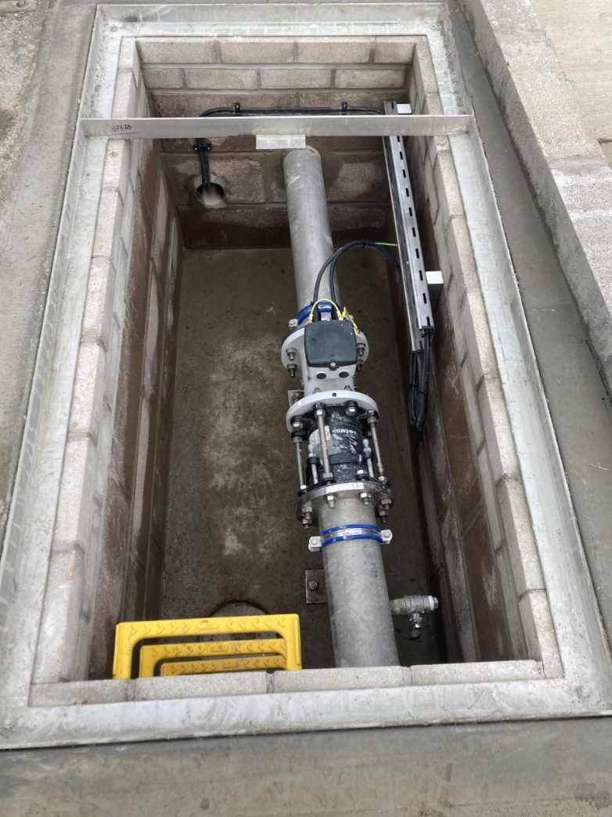
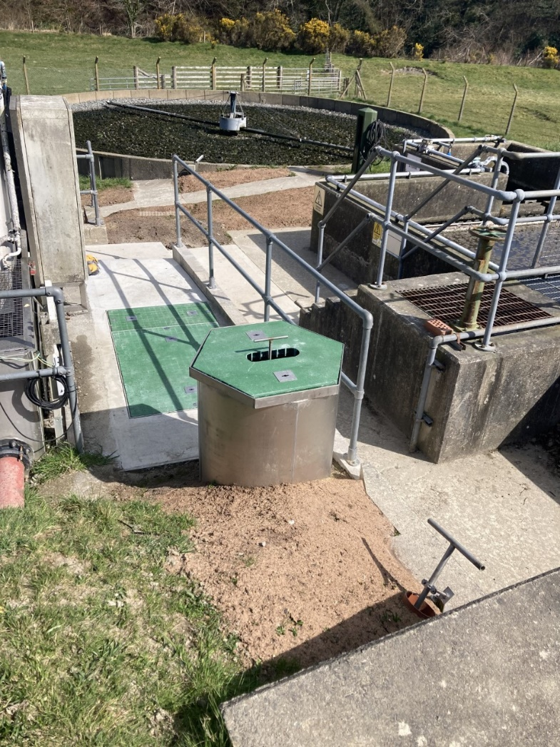
Figure 13 Completed Project
Figure 14 Completed Flow meter Chamber

Bibliography
- LARRARTE, F. and PIERRE, F., 2012. Attenuation of an ultrasonic beam by suspended particles and range of acoustic flow meters in sewer networks. Water Science and Technology, 65(3), pp. 478-483.
- Bagheri, & Heidarpour, M. (2009). Flow over rectangular sharp-crested weirs. Irrigation Science, 28(2), 173–179. https://doi.org/10.1007/s00271-009-0172-1
- Tuck, S. (2006). Welsh Water use PPM waste water monitors to control treatment. [online] Pollution & Process Monitoring. Available at: http://www.pollution-ppm.co.uk/installations-11-welsh-water.asp [Accessed 25 May 2022].
- Anspach, C. (2018). How Flow Measurement Technology Can Save Water. [online] Pumps and Systems Magazine. Available at: https://www.pumpsandsystems.com/how-flow-measurement-technology-can-save-water [Accessed 25 May 2022].
- Almasi, A. (2021). Piping for water and wastewater treatment systems. [online] Water Technology. Available at: https://www.watertechonline.com/wastewater/article/14210705/piping-for-water-and-wastewater-treatment-systems [Accessed 27 May 2022].
- Tuthill, A. (1999). Stainless Steel in miniclipal waste water treatment plants. Stainless Steel in miniclipal waste water treatment plants.
- Colonel, R. (2010). Stainless Steel in Sewage Treatment Plants A Clean Solution for Pure Water. [online] Available at: https://www.worldstainless.org/Files/issf/non-image-files/PDF/ISSF_Stainless_steel_in_sewage_treatment_plants.pdf [Accessed 27 May 2022].
- Solorio, J. (2018). Why Use CPVC in Wastewater Treatment Plants? [online] www.corzan.com. Available at: https://www.corzan.com/blog/why-use-cpvc-in-wastewater-treatment-plants [Accessed 27 May 2022].
- Herschy. (1995). General purpose flow measurement equations for flumes and thin plate weirs. Flow Measurement and Instrumentation, 6(4), 283–293. https://doi.org/10.1016/0955-5986(95)00016-X
- Derman, A. (2019). Galling is serious…but there are solutions. [online] Stainless Steel World.net. Available at: https://stainless-steel-world.net/galling-is-seriousbut-there-are-solutions/ [Accessed 27 May 2022].

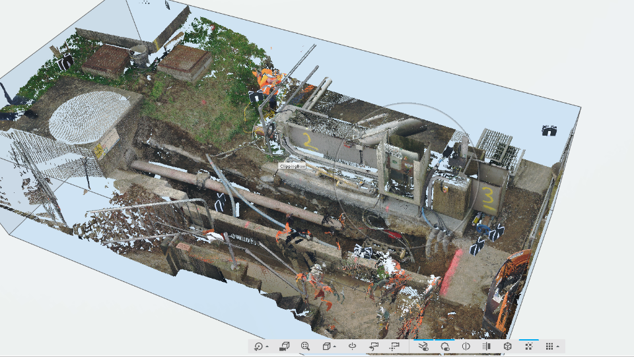
Appendix

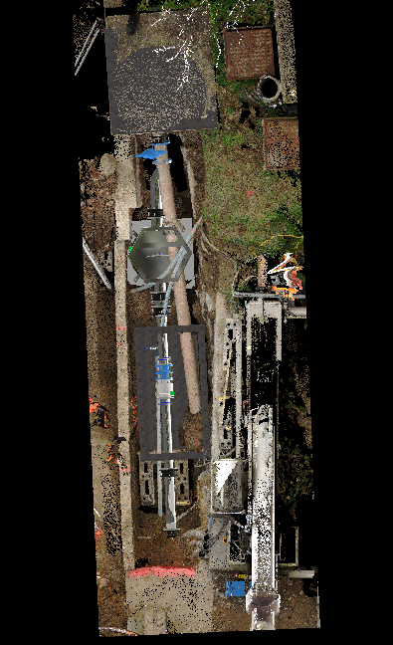
Appendix 1 3D Scan of excavated site

Appendix 2 3D CAD Model with excavated site scan
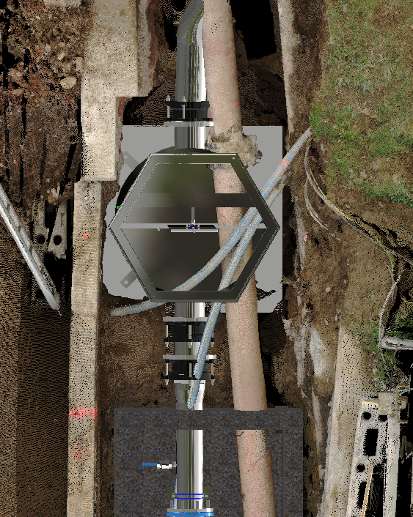

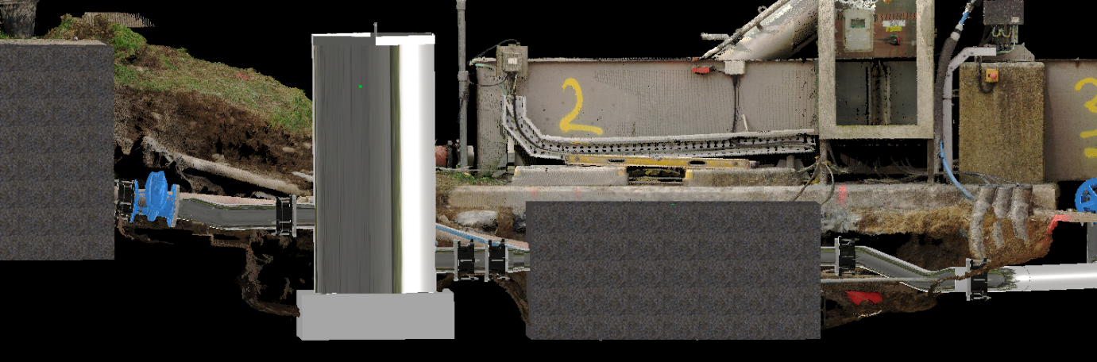
Appendix 4 3D CAD Model with excavated site scan (Pipe angle issue)

Appendix 3 3D CAD Model with excavated site scan (Existing Pipe Issue)

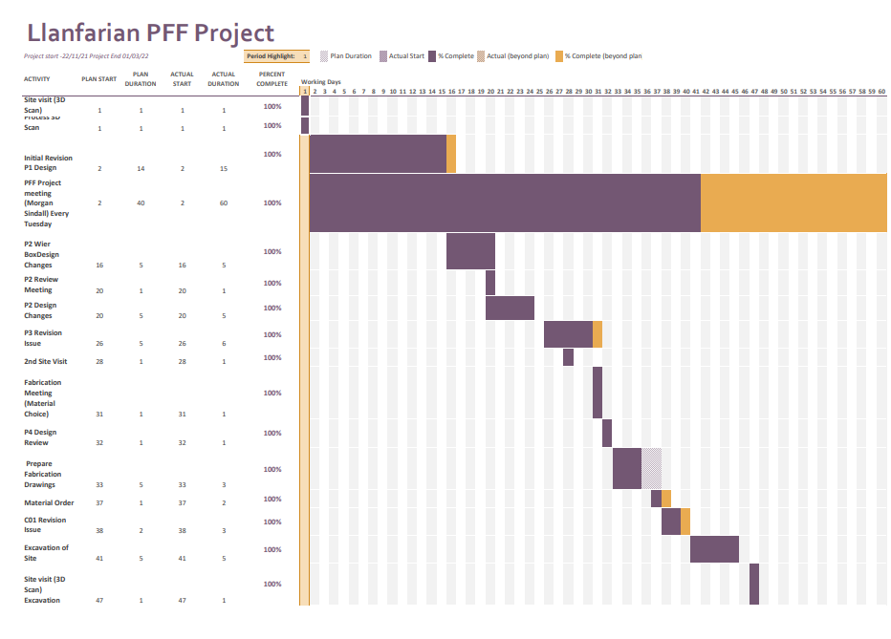
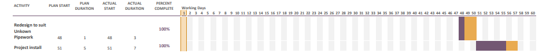
Appendix 5 3D Project Gantt Chart

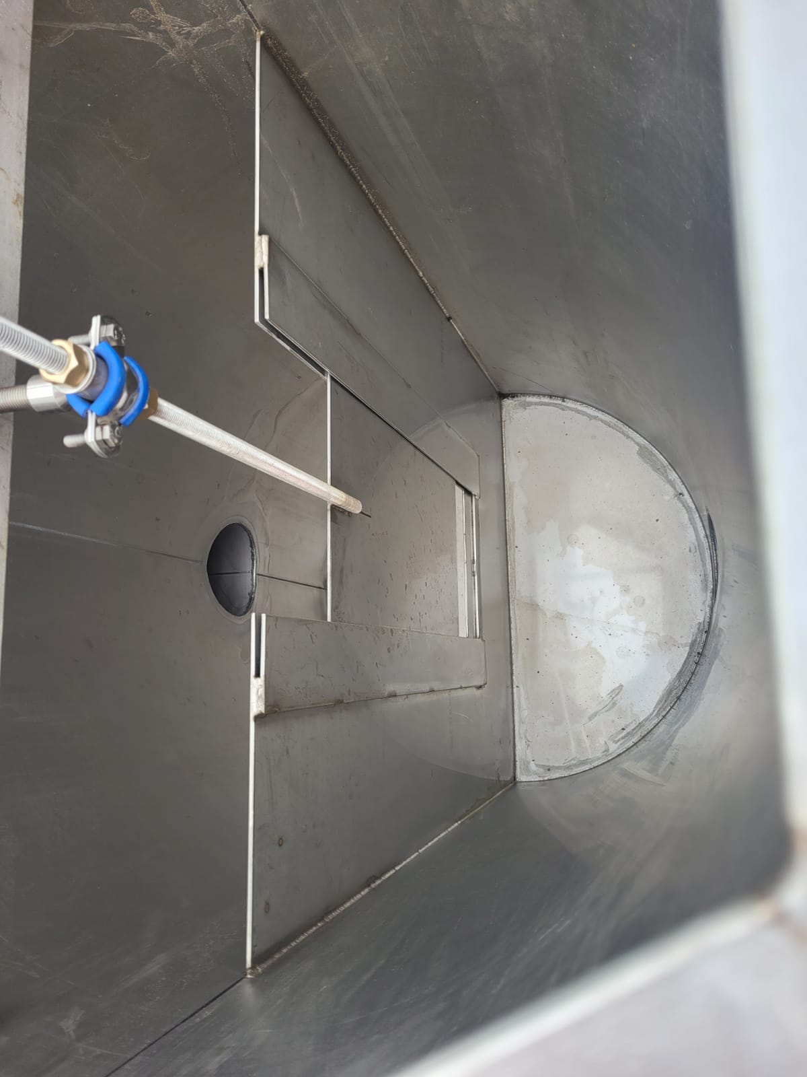
Appendix 6 Photo taken of fabricated weir box

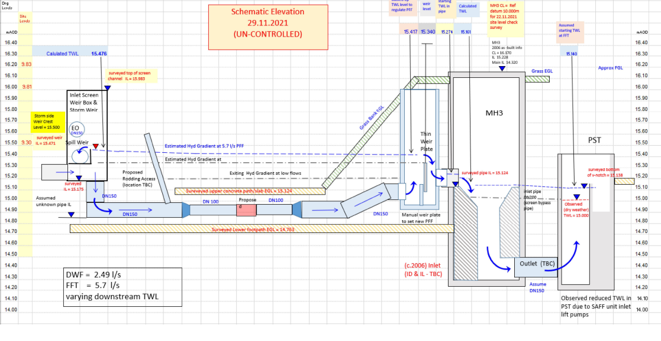

Appendix 7 Flow calculations within Llanfarian Project

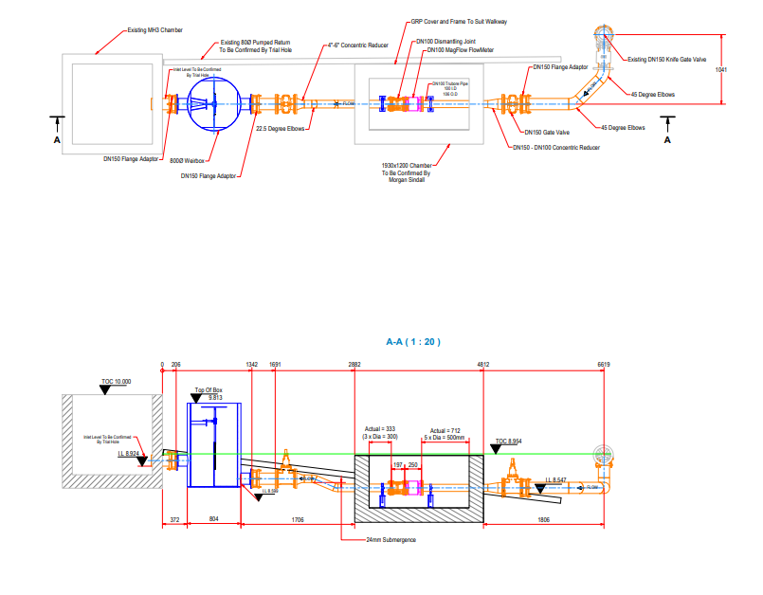
Appendix 8 P01 drawing revision

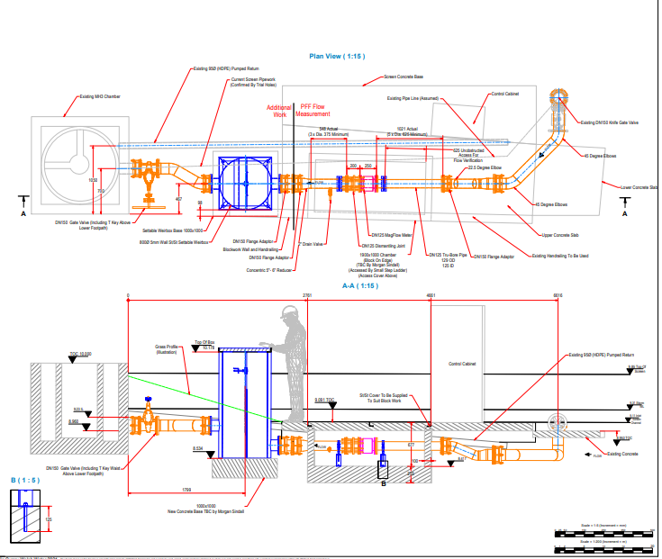
Appendix 9 C01 drawing revision

