Digital Business – Assignment 2

Report

Module Code: BMSP6002
Module Tutor: Dr Roisin Mullins

Lauren Emily Price
Student Number: 1807244

CONTENTS
1.0 EXECUTIVE SUMMARY 2
2.0 INTRODUCTION 2
3.0 AIRBNB LANDSCAPE 3
4.0 BUSINESS MODEL 3
4.1 BUSINESS MODEL CANVAS 4
4.2 THE NINE BUILDING BLOCKS 5
4.3 AIRBNB BUSINESS MODEL CANVAS 6
5.0 STRATEGY FORMULATION FRAMEWORK 6
5.1 THE GRAND STRATEGY MATRIX 7
6.0 KEY TOOLS/SYSTEMS 9
6.1 THE PLATFORM 9
6.2 CUSTOMER RELATIONSHIP MANAGEMENT (CRM) 9
6.3 SUPPLY CHAIN MANAGEMENT (SCM) 9
6.4 ENTERPRISE RESOURCE PLANNING (ERP) 10
7.0 CONCLUSION 10
8.0 REFERENCES 12

EXECUTIVE SUMMARY
This report critically examines Airbnb as an example of the sharing economy through the analysis of the financial landscape, the creation and evaluation of the business model canvas, the Strategic Formulation Framework (SFF) in particular, the Grand Strategy Matrix (GSM) and the use of information tools and systems such as the platform, CRM, SCM and ERP. The report will also examine how these systems support the key processes and functions of the business operations and activities.

INTRODUCTION
Founded in 2008 in San Francisco, Airbnb has gained unprecedented popularity as the world’s leading peer-to-peer digital, online sharing economy platform, acting as a social marketplace and travel community for both hosts and travellers looking to rent holiday accommodation. (Airbnb, 2021).
Airbnb was introduced to the market through the sharing economy. This platform has stimulated substantial public interest due to the impact it has on the social and economic system and as a result, companies such as Airbnb are gaining competitive advantage over more traditional market competitors. (Cheng, 2016). The availability of the internet, social networking platforms, mobile technology and location-based services are fueling the growth seen in the sharing economy and there is great benefit to individuals who are now able to capitalise via this platform on resources lying idle or underutilised. (Wu et al., 2012).
Airbnb focuses on a collaborative consumption approach, where idle and underutilised accommodation spaces are offered by hosts to provide travellers with unique, one-of-a-kind, authentic experiences all over the world. Through collaborative consumption, Airbnb facilitate the temporary access and non-ownership of accommodation space already owned by its hosts as well as its use of Web 2.0 and an online, digital platform which allows meaningful engagement and transactions to take place between its users. (Belk, 2014). Airbnb’s peer-to-peer online marketplace business model has facilitated the creation of a communicative platform, which allows engagement between its hosts, travellers and the company itself.
The rapid trajectory in popularity and growth of the sharing economy is attributed to obtaining higher levels of value distribution within the supply chain and is directly linked to social and economic conditions. (Gansky, 2010). The rise in popularity of the sharing economy has seen Airbnb grow from just two hosts to over 4 million, across 100,000 cities in almost every country across the globe. (Airbnb, 2021).
This report will attempt to critically examine Airbnb as an example of the sharing economy and through the use of academic sources, drawing on relevant theory and terminology, will analyse the financial landscape of Airbnb, the creation and evaluation of the business model canvas in relation to Airbnb, the strategic formulation framework (SFF) in particular where Airbnb sits within the Grand Strategy Matrix (GSM) and how this benefits strategic thinking and the use of information systems and how these support the business activities of Airbnb.

AIRBNB LANDSCAPE
Airbnb is an excellent example of one of the most popular and successful digital, e-commerce businesses which trade via collaborative consumption, on a peer-to-peer platform through the sharing economy. (Dolnicar, 2017).
Airbnb’s ever-growing popularity and success have been apparent through their worldwide revenue trajectory which has seen a steady increase over three years with revenue figures recorded of 2.56 billion USD in 2017, 3.65 billion USD in 2018 and 4.81 billion USD in 2019. (Statista, 2021). Although, in 2020 Airbnb saw a drop in worldwide revenue to 2.52 billion USD, this was primarily as a result of the COVID-19 pandemic and the effect that this had on the travel and tourism industry all over the world. Many countries imposed stay at home/lockdown orders to restrict the movement of people and travel bans with the closing of international borders in order to prevent and/or reduce the spread of the virus across the globe. (Narayan et al., 2021). The United Nations World Tourism Organization announced that following the outbreak of the COVID-19 pandemic, the travel and tourism industry has been one of the worst affected in terms of both travel demand and supply. (UNWTO, 2020). It is no surprise therefore that Airbnb suffered a substantial drop in bookings through the platform. Unlike other sharing economy, e-commerce businesses such as Uber, who was able to diversify its activities in terms of carrying out deliveries instead of transporting people, Airbnb had been unable to do this, which makes them and their business model extremely vulnerable and leaves them in an exposed position in terms of gaining revenue to stay afloat. (Neate, 2020).
However, in December 2020 Airbnb made its initial public offering (IPO) debut and saw shares in the company almost double when they began trading on the Nasdaq stock exchange. (Feiner, 2020). This bold move will prove to be extremely lucrative in terms of securing further fortune for its founders and will enable staff to sell off up to 15% of their shares prior to the normal ‘lock-up period’. (Rushe, 2020). By releasing shares on the stock market, Airbnb are attempting to acquire shareholders, to secure investment and increase their market capitalisation which garnishes them with fluid income that they can invest. By engaging with the marketplace in this way and taking investment from shareholders, Airbnb is illustrating its intention to use the investment internally to grow various aspects of the business through this generated separate income stream.

BUSINESS MODEL
Timmers (1998) describes a business model as ‘An architecture for the product, service and information flows, including a description of the various business actors and their roles; and a description of the potential benefits for the various business actors; and a description of the sources of revenues’. (Timmers, 1998). This is supported by Osterwalder and Pigneur (2010) who liken a business model to that of a blueprint for strategy implementation, and define it as the way an organisation creates, delivers and captures value. (Osterwalder & Pigneur, 2010). To obtain competitive advantage, a company must be able to state clearly what its value proposition is. In terms of Osterwalder & Pigneur’s (2010) theory, they believed that a business model is defined through the ‘Nine Basic Building Blocks’ that highlight the logic in terms of how a business aims to make money. These nine blocks encompass customers, offer, infrastructure, and financial viability and are considered the four main areas of focus within business. (Ibid).
Airbnb’s business model is peer to peer as the business itself has created an intermediary, meaning that is it the model within the platform allows the exchange between the buyer and the seller to take place. Its business model activities facilitating this is the intermediary model and the marketplace model.
The nine building blocks used by Osterwalder and Pigneur (2010) to develop the Business Model Canvas (BMC), are a concept which allows a business to describe and manipulate their business models in order to create, develop and implement strategic alternatives. (Ibid). These nine building blocks will be applied to Airbnb to further determine their business model activities and assess areas for strategy implementation.

BUSINESS MODEL CANVAS
In terms of digital business, the BMC is a visual modelling tool, utilised by companies to assist in the creation and design of their business models through nine building blocks. The BMC is an emergent process. As strategies evolve and respond to changes within the internal and external environment so too does the organisation’s business model. (Fritscher & Pigneur, 2014). This modelling tool is used to identify the mini models that are to be included within the main business model and by undertaking the BMC, an organisation can identify weaknesses and use strategic tools to convert these into opportunities. Essentially, the BMC develops business strategy by drawing out and examining its initial business model. Casadesus-Masanell and Enric Ricart (2010) believe that strategy refers to the business model an organisation chooses through which it will compete within the marketplace and the tactics that the organisation choses to employ refer to the choices available by virtue of the business model it currently undertakes. (Casadesus-Masanell and Enric Ricart, 2010).
The Nine Building Blocks are described in detail below and have been discussed in relation to Airbnb.

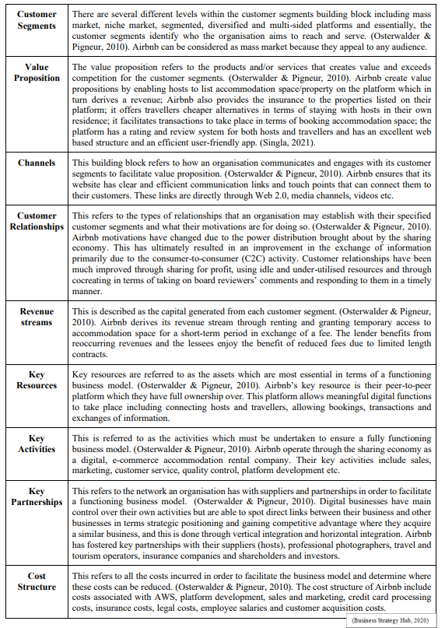
THE NINE BUILDING BLOCKS

AIRBNB BUSINESS MODEL CANVAS
Figure 1.0 illustrates the Business Model Canvas for Airbnb, which has been carried out in relation to their current business activities and operations based on their business model and the nine building blocks.
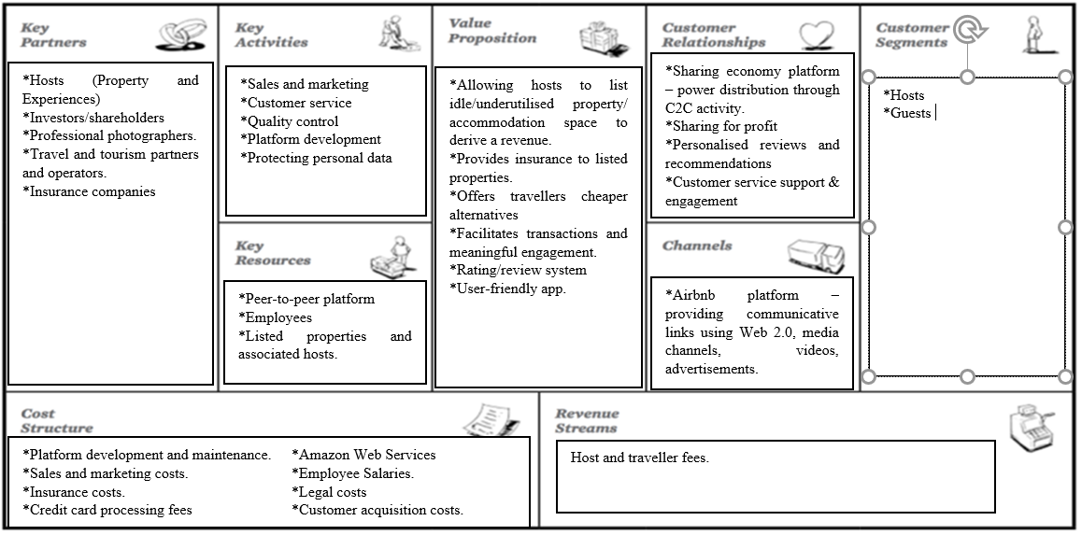
Figure 1.0

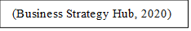

STRATEGY FORMULATION FRAMEWORK
Devised by Fred David, the Strategy Formulation Framework (SFF) (Figure 2.0) is a structured tool which is illustrated through three specific stages that an organisation should follow in terms of its key strategic decision making.
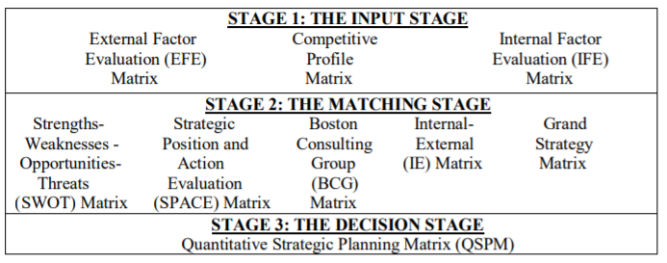
Figure 2.0

(Torlak & Şanal, 2007).
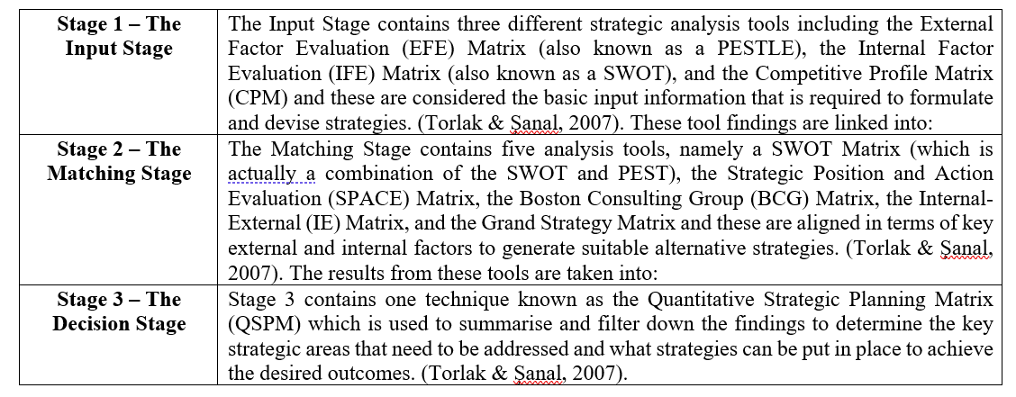

The SFF contains a quantitative scoring system which is split into ‘weighting’ and ‘rating’ and each factor is given a particular score based on its priority level over others. To determine the priority, the weight is multiplied by the rating to obtain a value that can be added up. Unlike strategic analysis tools used in traditional business, in digital business the SFF can easily capture live information on a more regular basis by way of quantitative scales which can be fed back into the organisation for more efficient fact-based strategic decision making. (David, 2011). A value can be applied based on internal knowledge of what the company is attempting to achieve and by utilising the various strategic tools with their individual quantitative values, it is much easier to establish areas that may have been overlooked and areas that may need prioritisation. (Ibid).
The SFF allows the application of quantitative values to establish a comprehensive summary in terms of clear strategic decision making. It is noted however that this tool is extremely beneficial to larger organisations but is far too detailed to apply to smaller organisations. (David, 2011).

THE GRAND STRATEGY MATRIX
The Grand Strategy Matrix is contained within Stage 2, The Matching Stage of the SFF and is an extremely useful strategic tool to determine where an organisation resides in terms of market growth vs competitive position. (David, 2011).
Figure 3.0 illustrates The Grand Strategy Matrix which has been completed in relation to Airbnb.

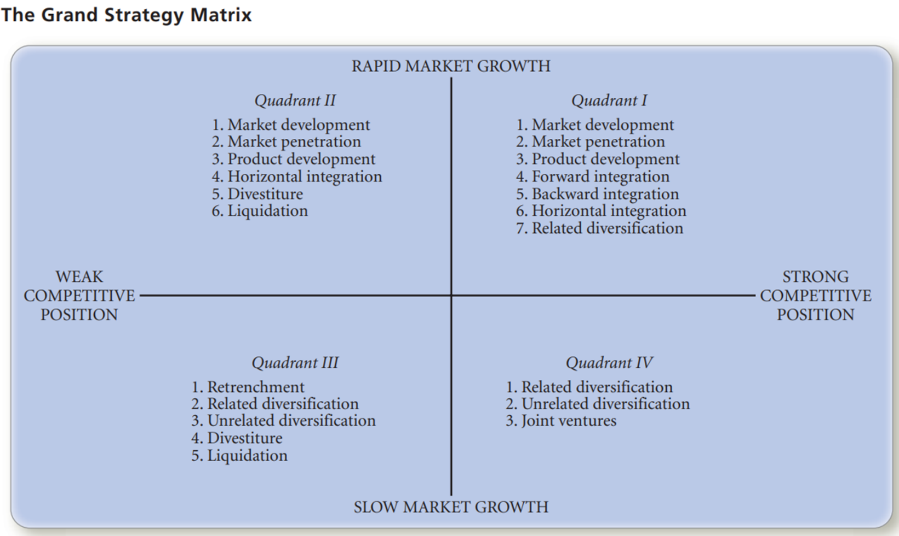
(Figure 3.0)



(David, 2011).
Airbnb’s positioning on the matrix is defined by its strong competitive position and rapid market growth. Research suggests that Airbnb have shown growth in terms of product development and related diversification to their platform with their ‘experiences’ element of the business which has created a completely new avenue and added further incentives for travellers and hosts to utilise the platform. (Airbnb, 2021).
Airbnb have also successfully penetrated the hospitality market through the sharing economy and have significantly disrupted the hotel industry by providing travellers with more choice, offering them unique, one-of-a-kind experiences. (Li & Tabari, 2019). Though 2020 saw a drop in revenue as a result of the Covid-19 pandemic, it is likely that when stay at home restrictions and travel bans are relaxed, more people will likely look for self-catering accommodation through Airbnb because of being able to stay within their bubble and prevent the spread of infection.
Their intention to grow and build on current strategies is also visible through their recent IPO debut and through the investment from shareholders, Airbnb are intending to use this investment to further develop the business internally, creating a stronger competitive position through fluid income streams.

KEY TOOLS/SYSTEMS
Digital/e-commerce businesses, such as Airbnb rely on technologies that enable the processes and functions of the organisation and essentially there are four key tools/systems which are essential to their activities.

THE PLATFORM
Airbnb have what is known as a multi-sided platform because it allows the information exchange and the transfer of funds between one side and another which is directly mediated by technology. The platform used by Airbnb allows the supplier (host) to exchange information with the customer (traveller) facilitating multi-sided engagement. The technology that Airbnb use, runs on Amazon Web Services. (AWS, 2021). AWS provide Airbnb with platform services for a fee which allows them full access to cloud services. (Ibid). The platform allows the connection between all the parties from different sides of the market to connect the buyers and sellers.

CUSTOMER RELATIONSHIP MANAGEMENT (CRM)
CRM is described as an ‘enabling technology for organizations to foster closer relationships with their customers’. (Rababah et al., 2011). The system enables an organisation to build sustainable relationships in terms of customer knowledge and satisfaction. (Ibid). Airbnb use a CRM system to capture information about their customers via the use of Web 2.0 social media technologies. (Akshay, 2014). Airbnb capture internal and external customer discussions in their unstructured formats through tools such as Facebook, Twitter, media posts, reviews etc. via push and pull technology. Their CRM system contains libraries and formulas that have the relevant algorithms to negotiate the coding which allows them to pull the information into a database where it can be analysed to search for patterns within the discussions and pinpoint how best to respond to the customer, address their requirements and determine their level of happiness, thus building stronger consumer relationships.
This can be considered as the sell side implementation of these activities. The goal of Airbnb is to convince their customers that they are adding value to their purchase by creating partnerships between the suppliers (hosts) and the customers (travellers). The reviews garnished from previous customers are the means by which they determine how well this connection has been made and this information is pulled in the CRM for analysis. Airbnb then pull this information back into their ERP for separate analysis.

SUPPLY CHAIN MANAGEMENT (SCM)
Dave Chaffey (2007) defines SCM as the optimisation and coordination of all supply operations and activities of a particular organisation from its suppliers and/or partners to its customers and states that supply chain is associated with material and information flows. (Chaffey, 2007). These operations can be split into three categories of either Upstream Supply Chain activities (where transactions take place between an organisation and its suppliers and intermediaries which is considered equivalent to buy-side e-commerce), Internal Supply Chains (where internal processes for transforming inputs into outputs takes place) and Downstream Supply Chain activities (where transactions take place between an organisation and its customers and intermediaries which is considered equivalent to sell-side e-commerce). (Ibid).
Airbnb have databases to hold information about their suppliers (hosts) and the system standardises all relevant information so that they connect and coordinate transactions between the supplier and the customer. The system in place on the platform in Airbnb’s case, would be the booking system and this can be considered as the inventory; this is where information is contained regarding all suppliers and customers and is housed on the SCM system. Airbnb must ensure they have enough choice of suppliers to match the needs of the customers.

ENTERPRISE RESOURCE PLANNING (ERP)
Shehab and Spedding (2004) define ERP as an integrated business management system that comprises comprehensive software, applications and tools used by organisations to manage all business functions including finance and accounting, sales and marketing, HR, SCM, CRM etc. (Shehab & Spedding, 2004).
Airbnb’s ERP system connects all the functional areas of the organisation into one software system that sits on the platform. Airbnb previously would have had separate databases such as inventory, invoices, SCM and CRM etc., therefore the ERP software captures all the internal and external information relating to each database into one system so that all parts of the business have access to it in real time.
The ERP system is also connected to the SCM system and the CRM system, this allows a much more fluid conversation between the decisions recorded internally and how they are capturing new information from the customers. All the information is fed across the system in the ERP.

CONCLUSION
Airbnb is an extremely successful peer-to-peer digital, online sharing economy business with a clear focus on collaborative consumption and non-ownership through the rental of accommodation space on short term contracts. Their key objectives focus primarily on creating value between their suppliers (hosts) and their customers (travellers) and this is done through their efficient peer-to-peer platform, where all meaningful transactions and engagement take place. Airbnb have a highly successful business model and by utilising strategic and analytic tools such as the Strategy Formulation Framework (SFF) they are rewarded the foresight to see areas of weakness as opportunities to develop and grow. This is noted when, through diversification, Airbnb began offering their ‘experiences’ and again in 2020 when they saw a poor year of revenue growth primarily as a result of the COVID-19 pandemic, yet, through strategy implementation, were able to see an opportunity and made their initial public offering (IPO) which saw shares in the company almost double when they began trading on the Nasdaq stock exchange. Airbnb rely on the use key digital systems and mediated technologies which enable processes and functions essential to their business operations and activities such as the use of the platform, CRM, SCM and ERP. It is through these systems that Airbnb can carry out and facilitate all essential functions in terms of their business model, the reason they are continually attracting and maintaining such high levels of both hosts and travellers and why they are currently the leading peer-to-peer accommodation network in almost every country around the globe. (Dolnicar, 2017).

REFERENCES
Airbnb. (2021). About Us. Available at: https://news.airbnb.com/about-us/ (Accessed on: 25th February 2021).
Airbnb. (2021). One-of-a-kind activities hosted by experts. Available at: https://www.airbnb.co.uk/s/experiences?gclid=EAIaIQobChMIkY-41ZmF7wIVwoBQBh0fkQNmEAAYASAAEgI67PD_BwE&c=.pi0.pk113255333253_481546261611_c_303480525523&af=&_set_bev_on_new_domain=1614261760_MDcxNWE4MGNkMzhh (Accessed on: 25th February 2021).
Akshay, D. (2014). CUSTOMER RELATIONSHIP MANAGEMENT – AIRBNB. Available at: https://daveakshay.wordpress.com/2014/10/30/customer-relationship-management/ (Accessed on: 3rd March 2021).
Amazon Web Services. (2021). Airbnb Case Study. Available at: https://aws.amazon.com/solutions/case-studies/airbnb-case-study/ (Accessed on: 3rd March 2021).
Belk, R. (2014). You are what you can access: Sharing and collaborative consumption online. Available at: https://www.sciencedirect.com/science/article/pii/S0148296313003366 (Accessed on: 25th February 2021).
Business Strategy Hub. (2020). Airbnb Business Model | How does Airbnb make money?. Available at: https://bstrategyhub.com/airbnb-business-model-how-does-airbnb-make-money/ (Accessed on: 1st March 2021).
Casadesus-Masanell, R., & Enric Ricart, J. (2010). From Strategy to Business Models and onto Tactics. Available at: https://www.sciencedirect.com/science/article/pii/S0024630110000051 (Accessed on: 2nd March 2021).
Cheng, M. (2016). Sharing economy: A review and agenda for future research. Available at: https://www.sciencedirect.com/science/article/pii/S0278431916300743?via%3Dihub (Accessed on: 25th February 2021).
Dave Chaffey. (2007). E-Business & E-Commerce Management. (3rd ed.). Pearson Education Limited. Available at: https://books.google.co.uk/books?hl=en&lr=&id=EOjG84UvrHMC&oi=fnd&pg=PR13&dq=dave+chaffey+definition+of+supply+chain+management&ots=XaAJicUIyw&sig=kjnwpqGohst4r4JffD2K-sjbmTU#v=onepage&q=supply%20chain%20management&f=false (Accessed on: 3rd March 2021).
David, F. R. (2011). Strategic Management: Concepts and Cases. Prentice Hall. 13th edition.
Dolnicar, S. (2017). Peer-To-Peer Accommodation Networks: Pushing the boundaries. Goodfellow Publishers Limited. Available at: https://library.oapen.org/bitstream/id/8c26ef66-8bbd-4aa2-ad44-e0e47d3bcc9e/640674.pdf (Accessed on: 26th February 2021).
Feiner, L. (2020). Airbnb skyrockets 112% in public market debut, giving it a market cap of $86.5 billion. Available at: https://www.cnbc.com/2020/12/10/airbnb-ipo-abnb-starts-trading-on-the-nasdaq.html (Accessed on: 1st March 2021).
Fritscher, B., & Pigneur, Y. (2014). Visualizing Business Model Evolution with the Business Model Canvas: Concept and Tool. Available at: https://ieeexplore.ieee.org/abstract/document/6904149/authors#authors (Accessed on: 1st March 2021).
Gansky, L. (2010). Why the Future of Business is Sharing. Available at: https://books.google.co.uk/books?hl=en&lr=&id=3Guci5d1RaAC&oi=fnd&pg=PT7&ots=iQydG_89hP&sig=235A1aCwpq6RSdYmSYczOcrap9M&redir_esc=y#v=onepage&q&f=false (Accessed on: 25th February 2021).
Li, L., & Tabari, S. (2019). Impact of Airbnb on customers' behaviour in the UK hotel Industry. Available at: https://shura.shu.ac.uk/23916/7/Tabari_Impact_of_airbnb_%28VoR%29.pdf (Accessed on: 3rd March 2021).
Narayan, P., Phan, D., Liu, G. (2021). COVID-19 lockdowns, stimulus packages, travel bans, and stock returns. Available at: https://www.sciencedirect.com/science/article/pii/S154461232030934X (Accessed on: 26th February 2021).
Neate, R. (2020). How the Covid-19 crisis locked Airbnb out of its own homes. Available at: https://www.theguardian.com/technology/2020/apr/04/how-the-covid-19-crisis-locked-airbnb-out-of-its-own-homes (Accessed on: 26th February 2021).
Osterwalder, A., & Pigneur, Y. (2010). Business Model Generation. Available at: https://r2.vlereader.com/Reader?ean=9780470901038# (Accessed on: 1st March 2021).
Rababah, K., Mohd, H., Ibrahim, H. (2011). Customer Relationship Management (CRM) Processes from Theory to Practice: The Pre-implementation Plan of CRM System. Available at: https://d1wqtxts1xzle7.cloudfront.net/31400708/process.pdf?1371363905=&response-content-disposition=inline%3B+filename%3DProcess.pdf&Expires=1614776386&Signature=gTEXJapXrSQQPJwmxSkhP7DM2qYJZqgebhsbMSzmgNBdlW-p0cw7YzIt6K-oGjd06CNEwQKgLYUVjuukzmKsJfbkkRoAZg6W6oWwSdR~~Tt2yA-tLvGd9C6o-DaW5oCenxlWCdRk43eim3iZ7Y~gt3jTeCU-MZCidWxfILtNrGXpPKw89y6LSRXcq7Nua9m33IUqATE89CwcldsV79QDS37XtZrq8-BkH9UTOqq~lE9c1sYwKrOe-P33sx334NFYjF3sSlZejbxg6DUGqyKgl8GIjIjBez8CVJ62jTeCCh6Gx~6R6K2OjwAkwZiCCFLXfuASoYIZAXvTBOOtYLnXfg__&Key-Pair-Id=APKAJLOHF5GGSLRBV4ZA (Accessed on: 3rd March 2021).
Rushe, D. (2020). Airbnb soars to near $100bn valuation as shares more than double in IPO. Available at: https://www.theguardian.com/technology/2020/dec/10/airbnb-ipo-wall-street-share-sale (Accessed on: 1st March 2021).
Shehab, E., & Spedding, T. (2004). Enterprise resource planning - An integrative review. Available at: file:///C:/Users/laure/Downloads/vseoERP-BPMJ-2004-1570100401_nov.pdf (Accessed on: 3rd March 2021).
Singla, S. (2021). How Airbnb Works | Insights into Business & Revenue Model. Available at: https://jungleworks.com/airbnb-business-model-revenue-insights/ (Accessed on: 1st March 2021).
Statista. (2021). Revenue of Airbnb worldwide from 2017 to 2020. Available at: https://www.statista.com/statistics/1193134/airbnb-revenue-worldwide/ (Accessed on: 26th February 2021).
Timmers, P. (1998). Business Models for Electronic Markets. Available at: https://peoi.net/Courses/Coursesen/emarket/Resources/Business%20Models%20for%20Electronic%20Markets.pdf (Accessed on: 1st March 2021).
Torlak, N., & Şanal, M. (2007). DAVID’S STRATEGY FORMULATION FRAMEWORK IN ACTION: THE EXAMPLE OF TURKISH AIRLINES ON DOMESTIC AIR TRANSPORTATION. Available at: file:///C:/Users/laure/Downloads/Strategic%20Formulation%20Frmaework%20Paper%20-%20Turkish%20Airlines%20implement%20Strategic%20formulation%20framework.pdf (Accessed on: 2nd March 2021).
UNWTO. (2020). WORLD TOURISM ORGANIZATION UNDERSCORES TOURISM’S IMPORTANCE FOR COVID-19 RECOVERY IN AUDIENCE WITH THE KING OF SPAIN. Available at: https://www.unwto.org/news/unwto-underscores-tourisms-importance-for-covid-19-recovery-in-meeting-with-the-king-of-spain (Accessed on: 26th February 2021).
Wu, S., Lee, F., Reynard, J. (2012). Airbnb. Available at: http://www.econ.ucla.edu/sboard/teaching/tech/Airbnb.pdf (Accessed on: 1st March 2021).

