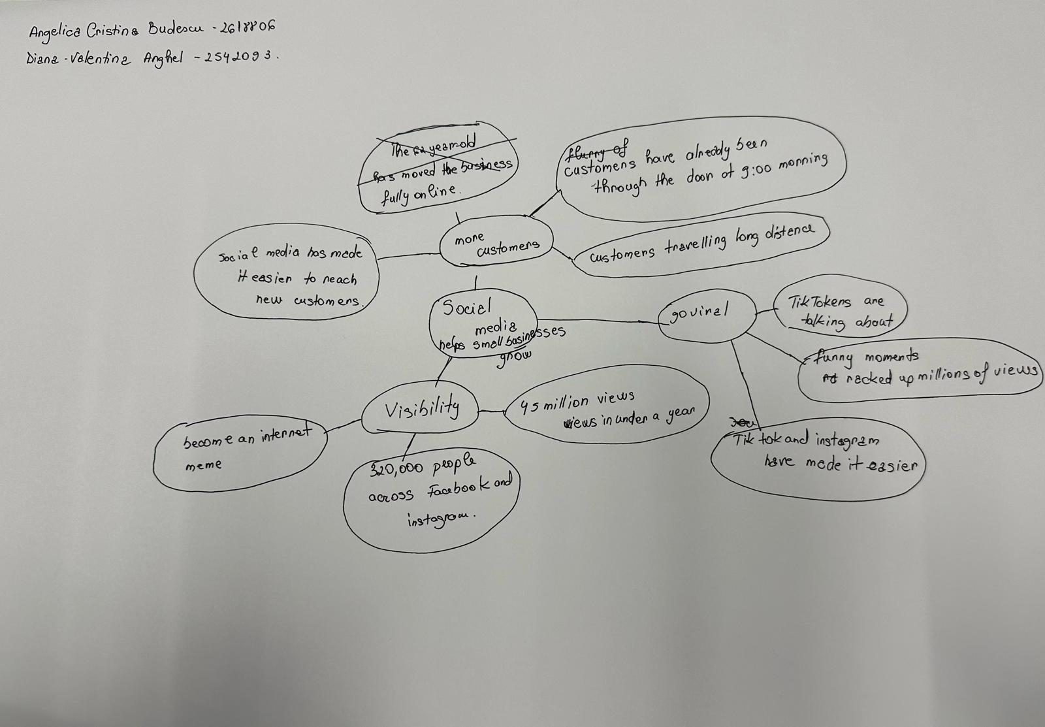NAME : BUDESCU ANGELICA CRISTINA
STUDENT ID NUMBER : 2618806

QUESTION A:
-WHAT IS THE MAIN IDEA OF THE ALL TEXT ?
ANSWER :
-THE MAIN IDEA OF THE TEXT IS THAT SOCIAL MEDIA HELPS SMALL BUSINESSES BECOME POPULAR AND ATRACT MORE CUSTOMERS.
QUESTION B :
-WHAT IS ONE KEY POINT THAT SUPORTS THE MAIN IDEA AND WICH SPECIFIC EXAMPLE FROM THE TEXT SHOWS THIS ?
ASNWER:
-ONE KEY POINT IS THAT VIRAL VIDEOS CAN MAKE A BUSINESS POPULAR. MY NOTES MENTION A VIDEO THAT RECIVED 45MILION VIEWS IN LESS THAN A YEAR.
QUESTION C :
-WHAT IS A DIFFERENT KEY POINT THAT SUPPORTS THE MAIN IDEA AND WICH SPECIFIC EXAMPLE FROM THE TEXT SHOWS THIS ?
ANSWER:
-SOCIAL MEDIA INCREASES BUSINESS VISIBILITY . KRYSTALLS BOUTIQUE BECAME POPULAR BECAUSE ITS FUNNY VIDEOS RECIVED MILLIONS OF VIEWS .
QUESTION D :
-WICH PART OF THE TEXT DO YOU THINK IS MOST IMPORTANT AMD WHY ?
REFLECION
-ANSWER:
I THINK THE MOST IMPORTANT PART IS THAT SOCIAL MEDIA CAN CHANGE A SMALL BUSNIESS. I WAS SURPRISED THAT PEOPLE TRAVELED 3 HOURS JUST TO TRY A CHICKEN BURGER .
QUESTION E :
-WHAT DID YOU FIND DIFFICULT IIN THIS ASSESSMENT (INCLUDING IN CLASS COMPONENT ) , AND WHY WAS IT DIFFICULT ?
ANSWER:
-I THINK THE MOST DIFFICULT THING FOR ME WAS THE LANGUAGE BARRIER , AND I COULDN’T EXPRESS MY SELF HOW I WISHED TOO.
QUESTION F :
-WHAT HELPED YOU WITH THIS DIFFICULTY, AND HOW DID IT HELPED YOU ?
AMSWER :
-THE MIND MAP READING THE TEXT CAREFULLY AND DISCUSSING THE EXAMPLES IN CLASS HELPED ME . THEY HELPED ME ORGANISE MY IDEAS AND UNDERSTAND HOW SOCIAL MEDIA CAN HELP SMALL BUSINESSES GROW.

