

THE IMPACT OF INTEGRATED MARKETING COMMUNICATIONS AND DIGITAL MARKETING ON CONSUMER BEHAVIOUR IN THE HOTEL INDUSTRY: AN ANALYSIS OF HOTEL INDUSTRIES IN THE UK

Student Name: Ahammed Azharudeen Master house
Student ID:2229990
Submission date:12/10/2024

Master’s Degrees by Examination and Dissertation
Declaration Form.

I, Ahammed Azharudeen Master House, declare that this dissertation has been composed by myself, that the work contained herein is entirely my own except where explicitly stated otherwise in the text, and that this work has not been submitted for any other degree or qualification, in whole or in part, except as specified.

Signature: Ahammed Azharudeen Master house ………………………………............................

Date: 12/10/2024 ………………………………............................

Acknowledgement
I feel thankful for my classmates' and teachers' help and advice in putting this research project together. Additionally, I would like to express my sincere gratitude to everyone who has assisted me in finding pertinent articles and scholarly journals. I am also grateful for the help that the team leader provided. I received help from the department head in choosing the best study topic. In addition, I would like to thank my academic collaborators for helping me acquire the practical knowledge necessary to complete this project effectively.

Abstract
The following research topic has been presented based on investigating the impact of integrated marketing communication (IMC) and digital marketing (DM) on shoppers purchasing habits, specifically in the hotel industry in the UK. For the past decade, digital marketing has grown dramatically, influencing total business and brand advertising. As a result, studying the effect of IMC has been a useful part in comprehending its role in affecting consumer behaviour. Aside from that, the prominence of the study is clear in terms of encouraging business advertising professionals to examine IMC strategies to better improve their advertising while stressing consumer behaviour.
The current study has concentrated on the adoption of primary quantitative methodologies for data collection and interpretation. In this domain, the researcher used positivism philosophy, a logical technique, and a strategy for quantitative study to gather data through the primary quantitative method with a survey. In this respect, a cross-sectional time horizon is selected for the purpose of collecting data from 51 participants who have been selected through purposive methods of sampling. In this regard, 16 survey questionnaires have been developed which have been distributed among 51 participants regarding the impact of IMC and DM on the behaviour of shoppers within the hotel sector of the UK. However, the data collected through the survey have been analysed via percentage analysis while following the ethical guidelines related to data protection to safeguard research information.
Findings indicate that the usage of the internet and other online platforms, along with the quick advancement of technology, has changed the behaviour of guests in the British hotel business. Consequently, it is now essential for UK hoteliers to prioritise DM and IMC in order to grab customers' attention and change their behaviour. In conclusion, UK hotels' DM and IMC initiatives have the power to favourably influence guests' behavioural intentions. Considering the overall finding, UK hotels are recommended to emphasize improving transfer NC across organisational operations emphasising personalized offering, established content management teams, and others.

Table of Contents
Chapter 1: Introduction 10
1.1 Background 10
1.2 Problem Statement 10
1.3 Rationale 11
1.4 Research aim 13
1.5 Research objectives 13
1.6 Research Questions 13
1.7 Hypothesis 13
1.8 Dissertation structure 14
Chapter 2: Literature Review 16
2.1 Introduction 16
2.2 Concepts and significant aspect of key terms 16
2.3 Analytical assessment of IMC's impact on consumer behavior in the UK hotel industry 17
2.4 Analysis of how DM tactics affect customer preferences and booking behaviours in the UK hotel industry 18
2.5 Compare and contrast traditional marketing methods versus digital marketing 19
2.6 Examination of how customers view the legitimacy and dependability of marketing materials from UK hotels 20
2.7 Literature gap 22
2.8 Theoretical understandings 22
2.8.1 IMC 22
2.8.2 Digital Marketing 24
2.8.3 Consumer behaviour 26
Chapter 3: Methodology 30
3.1 Introduction 30
3.2 Research Onion 30
3.3 Research philosophy 31
3.4 Research approach 32
3.5 Research strategies 32
3.6 Type of Investigation 33
3.7 Choices 34
3.8 Time Horizons 35
3.9 Data Collection and Analysis 35
3.10 Sampling 36
3.11 Data Collection Method 36
3.12 Analysis of Data 37
3.13 Research Ethics 38
Chapter 4: Data Analysis 39
4.1 Introduction 39
4.2 Primary quantitative analysis 39
RQ1. What components of integrated marketing communications are most effectively used by UK hotels to influence consumer behaviour? 39
RQ2. How do digital marketing techniques impact consumer preferences and booking behaviours in the UK hotel industry? 43
RQ3. What is the comparative effectiveness of traditional marketing methods versus digital marketing for UK hotels? 45
RQ4. How do consumers perceive the authenticity and trustworthiness of marketing communications from UK hotels? 49
Chapter 5: Discussion 53
5.1 Introduction 53
5.2 Discussion 53
Chapter 6: Conclusion and recommendations 57
6.1 Summary 57
6.2 Linking with Objectives 57
6.3 Revisiting the research questions 58
6.4 Recommendations 59
6.5 Future scope 60
Reference list 62
Appendices 73
Appendix 1: Survey questionnaire 73
Appendix 2: Final Google form 81
Appendix 3: Responses 83
Response 1 83
Response 2 83
Response 3 84
Response 4 84
Response 5 85

List of figures
Figure 1.1: Number of social media and internet users globally 11
Figure 1.2: Dissertation structure 14
Figure 2.1: IMC Approach 22
Figure 2.2: Aristotle's Model of Communication 23
Figure 2.3: Social Exchange Theory 24
Figure 2.4: RACE Model 25
Figure 2.5: Maslow’s Hierarchy of Needs model 26
Figure 2.6: Model of consumer decision-making process 27
Figure 2.7: Three-stage model of perception 28
Figure 3.1: Research Onion 30
Figure 4.1: Perception of consumers on IMC strategy 40
Figure 4.2: Aspects of IMC strategy specifically preferable for consumers 41
Figure 4.3: Type of content preferred on digital platform by consumers 42
Figure 4.4: Influence of targeted online advertisement on customers hotel consideration 43
Figure 4.5: Impacts of hotels’ reputation of online platforms on customers references and booking consideration 44
Figure 4.6: Impacts of hotels’ digital effort brand perception 45
Figure 4.7: Consideration of relevant online marketing channels 46
Figure 4.8: Effectiveness of hotel’s digital presence 47
Figure 4.9: Satisfaction regarding interaction and engagement levels of UK hotels 48
Figure 4.10: Frequency of visiting hotels 49
Figure 4.11: Frequency of using online platforms to search hotels before booking 50
Figure 4.12: Influence of personalised marketing on booking decisions 51
Figure 4.13: Consideration online reviews before selecting hotels 52

List of Abbreviations
DM: Digital Marketing
IMC: Integrated Marketing Communication
SM: Social Media
AMC: Aristotle's Model of Communication
SEO: Search Engine Optimization
SET: Social Exchange Theory
RACE: Reach, Act, Convert, and Engage

Glossary
Terms | Definition
IMC | IMC is the process of coordinating all communication media namely advertisement, public relations, direct marketing, sales promotion, and digital media to influence customers
DM | DM may be defined as the process of marketing goods or services using internet commonly through social media, search engines, e-mail, or the web
SM | SM promote amenities through pictures and videos, which is very influential to consumers’ decision-making processes
SEO | SEO procedure for increasing the volume and the standard of search engine visitors to a website

Chapter 1: Introduction

1.1 Background
Integrated marketing communication’s digital marketing, PR, advertising, and other tactics are utilised to establish brand identity and increase brand visibility. By enhancing brand loyalty and competitiveness, it can also boost customer involvement through pricing and profitability (Aminullah and Kristiyono, 2021). Nowadays, the hospitality business in the UK (United Kingdom), as a sub-sector of the hospitality sector, has seen substantial changes, aided by advances in the use of DM (Digital Marketing) and IMC (Integrated Marketing Communication). It is observed that the rivalry in the industry is increasing, thus it is critical for hotels to comprehend the impacts of different marketing techniques on customers' purchasing patterns. Adding to this, web marketing, which includes all web-based media and technology is one of the most effective tools for reaching and communicating with customers (Kumar and Singh, 2020). It may guarantee that a firm and its brand are communicated to consumers consistently (Aminullah and Kristiyono, 2021).
Besides this, integrated marketing communication is committed to changing the behaviour of its target demographics by utilising all the communication tools available to the hospitality sector (Porcu et al. 2019). Rapid digital transformation is occurring in the hotel business, which is expected to be worth £24.7 billion in 2023 (Statista, 2024). This change calls for a better knowledge regarding the way IMC and advertisements through digital means affect customer behavior in this dynamic environment. Eventually, it will become clear that IMC, which is comparable to the marketing communication mix, uses numerous advertising and communication instruments to guarantee a consistent brand message. Combining digital marketing with integrated marketing communication enhances the likelihood of reaching customers with a consistent brand message and persuading them to act in a way that leads to the desired behavior (Rehman et al. 2022).

1.2 Problem Statement
The study’s problem statement foresees how IMC and DM would influence clients’ behaviour in the hotels of the UK. The study defends the efficacy of IMC in the British hospitality sector while highlighting the many facets of DM and IMC in the country. Furthermore, it also takes into consideration the requirement to prevent the negative effects of digital marketing in the UK hotel industry. For this reason, the study's problem statement has also provided insight into the problematic circumstances related to the investigation and avoidance of problems encountered during the utilisation of digital marketing and marketing communications in the UK. In addition to that, this can help in determining the extent to which digital marketing communications will increase or decrease revenue and profitability. In the process, it will also offer the UK hotel sector insightful knowledge and advice that they may employ to improve their digital marketing strategies and increase return on investment.

1.3 Rationale
The hotel sector, influencing and shaping consumer behaviour is always one of the prime concerns of organisations. This is because by understanding clients' behavioural intentions and shaping them, businesses can efficiently elevate their business activities including marketing, customer service, and others to improve client experience (Hossain et al. 2023). Furthermore, improved client experience is effective in terms of boosting their loyalty and influencing their repeat purchasing intentions, which is beneficial for organisations in guaranteeing sales growth and competitiveness. Clients’ expectations have been increased regarding having a seamless experience, while connecting with hotels (Svendsen, 2024). In this regard, there is a growing focus of businesses in the hotel industry on IMC and digital marketing to elevate clients’ experience.
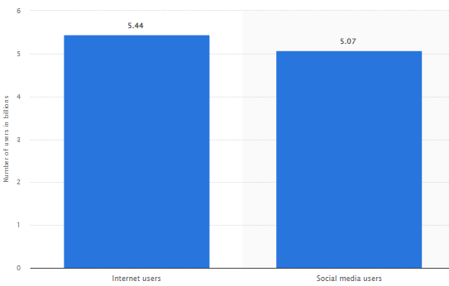

Figure 1.1: Number of social media and internet users globally
(Source: Petrosyan, 2024)
This is because due to the growing use of the internet and SM (social media) online platforms among customers, it has become easier for organisations to communicate with them by using digital channels. For evidence, the number of internet and online platforms’ users around the world is currently an estimated 5.44 billion and 5.07 billion respectively (Petrosyan, 2024). Considering the growing usage of the Internet and online platforms, organisations in the hotel industry emphasize integrating digital marketing, which allows them to connect and communicate with potential clients by utilising the Internet and various online communication channels (Mahmutović, 2021). Through digital marketing, it is possible for them to effectively engage with customers and promote their service offerings, which further can influence individuals' behaviour.
Aside from that, it is a notable fact that IMC is one of the efficient marketing techniques in the present hotel industry environment, which allows businesses to deliver their unified messages across a variety of marketing channels (Jusuf, 2024). As businesses nowadays emphasise using various marketing channels, including digital and traditional channels, they can deliver unified messages through the integration of IMC. In the UK, there are approximately 9876 hotels, which is the reason for extreme competitive rivalry in this sector (IBISWorld, 2024). Thus, through digital marketing and IMC, they can ensure their competitiveness. Most UK travellers use online booking services to make hotel reservations. Comprehending how IMC, DM, and clients’ behaviour interact has been essential to the sectors’ competitiveness and success going forward.
A trend towards streamlining goods and services through the use of hospitality services, including online meal delivery, is being driven by digitalisation. In order to better service customers and suppliers, half of the world's hospitality businesses listed new technology as a major priority (Statista, 2024). 84% of these businesses' leaders had firsthand experience with digital transformation (Statista, 2024). Most UK travellers use online booking systems to make hotel reservations. Comprehending how IMC, DM, and client behaviour is essential to the industry's competitiveness and success going forward. In this context, this study has been attentive to evaluating the significance of incorporating IMC into digital marketing procedures within the hotel sector of the UK. As a result of this, it has been noted that one important component of DM in the UK hotel sector is integrated marketing communication. This research focuses on marketing strategies that are relevant to the UK hotel sector and have a significant impact on clients' understanding and company performance. Regarding this, this study will also reveal the IMC and digital marketing tactics that UK hotels may use to expand customer traffic and keep competitive advantages in the technological era.

1.4 Research aim
This research’s aim is to investigate both IMC and DM’s impact on clients’ behaviour in the UK’s hotel industry. More broadly, this study aims to answer the following research question that focuses on how effective IMC and DM are when applied to UK hotels, and what effect this has on consumers. Thus, the purpose of this study is to evaluate two techniques of marketing communication to determine how well they impact consumers' decisions, preferences, and loyalty.

1.5 Research objectives
The following are the objectives of the current study:
- To explore the role of IMC in influencing consumer behaviour in the UK hotel industry.
- To analyse the digital marketing techniques’ influence on consumer preferences and behaviours while booking in the UK hotel sector.
- To compare the effectiveness of traditional marketing methods versus digital marketing in the context of the UK hotel industry.
- To explore consumer perceptions of the authenticity and trustworthiness of marketing communications from UK hotels.

1.6 Research Questions
1. What components of integrated marketing communications are most effectively used by UK hotels to influence consumer behaviour?
2. How do digital marketing techniques impact consumer preferences and booking behaviours in the UK hotel industry?
3. What is the comparative effectiveness of traditional marketing methods versus digital marketing for UK hotels?
4. How do consumers perceive the authenticity and trustworthiness of marketing communications from UK hotels?

1.7 Hypothesis
H0: Digital marketing communications have a favourable influence on sales and profitability.
H1: Digital marketing communications negatively impact revenue and profitability.

1.8 Dissertation structure
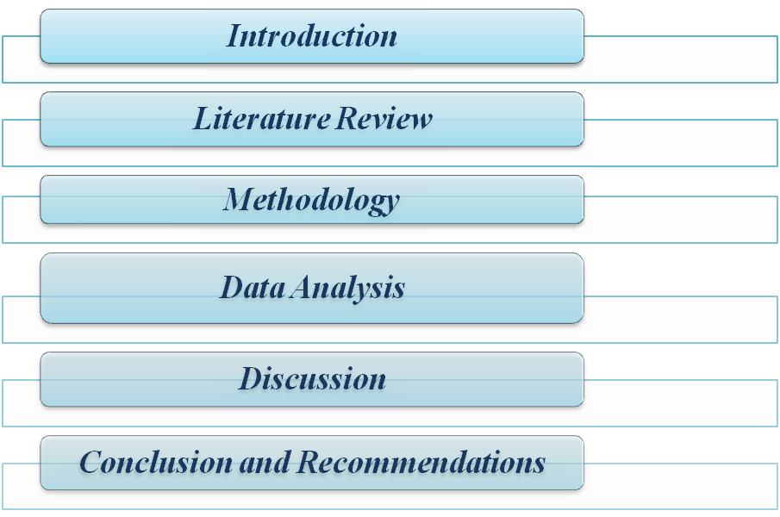

Figure 1.2: Dissertation structure
(Source: Self-created)
The complete research will be divided into 5 particular chapters, as depicted in Figure 2.1.
Chapter 1: Introduction
The initial chapter has been attentive to clearly illuminating the aim and objectives of the research, aside from providing a well-defined rationale for researching the present topic.
Chapter 2: Literature Review
Critical perspectives of scholars regarding the effectiveness of DM and IMC in shaping clients’ behaviour in the hotel industry of the UK will be added by carrying out a critical literature review.
Chapter 3: Methodology
The chosen methods will be declared, along with providing justifications for their selection in the research.
Chapter 4: Data Analysis
The fourth chapter will emphasise the interpretation and elucidation of collected data in order to address this study’s questions.
Chapter 5: Discussion
This chapter will focus on outcomes gained from the previous chapter with a high alignment of literature points of view along with research questions and theories.
Chapter 6: Conclusion and Recommendation
The sixth chapter of the study will include concluding remarks considering observations made throughout the research.

Chapter 2: Literature Review

2.1 Introduction
The current section of the literature study will analyse previous studies and publications that address the effects of DM and IMC on customer behaviour in the hotel sector. Hereby, the chapter critically analyses three different factors within this chapter, such as IMC, DM, as well as consumer behaviour within the UK hotel arena. Besides, in order to bolster the overall study results, the researcher will also concentrate on creating a theoretical underpinning section. Additionally, the researcher will create a literature gap analysis to pinpoint any significant gaps for further analysis.

2.2 Concepts and significant aspect of key terms
The modern hotel sector in the UK has highlighted the importance of IMC and DM in shaping consumer behaviour. Following the study of Fitri and Herdiansyah (2021), in order to influence consumers, IMC combines media, public relations, sales promotion, advertising, and direct marketing. Hence, the importance of IMC is centred on the idea that consumers are subjected to a consistent experience, which enforces the brand’s message. Similarly, Luck et al. (2020) also stated that IMC is an approach that helps in leveraging marketing initiatives, increasing brand association, and increasing overall consumer interaction as each communication integrates with the others to form a more coherent and powerful message to the consumers.
Contrary to that, Peter and Dalla Vecchia (2021) argued that DM may be understood as the procedure of marketing goods using internet commonly through social media, search engines, e-mail, or the web. Hence, it is evident that some of the common approaches of digital marketing are content marketing, SEO, pay-per-click and influencer marketing. Thus, the importance of DM comes from the fact that it is global, measurable, and targeted based on consumers’ flow of traffic and their demographic characteristics.
Under the study of White et al. (2019), it is evident that buyer behaviour involves considering the way consumers choose, plan, sustain, and end their product purchases and consumption. It includes psychological, social, and cultural components that are relevant to these decisions. Hereby, organisational management may learn a great deal from the behaviour of their customers, especially as it helps them develop marketing strategies that work for target audiences (Fader, 2020). Consumer behaviour is an increased strategic awareness that may be applied to positioning, communication, channelling, and product planning. Comparably, there are ethical dilemmas as organisational management influences customers' choices by designing clickbait advertisements or taking advantage of their vulnerabilities. Thus, understanding customers is essential for organisational success, however accomplishing should not infringe on their right to privacy or self-determination.

2.3 Analytical assessment of IMC's impact on consumer behavior in the UK hotel industry
As per the study of Fitri and Herdiansyah (2021), it can be stated that IMC is a strategic tool that effectively directs consumer behaviour through the provision of harmonised, compelling, and timely communication to the consumer. This is important in formulating brand experience since it is critical to inform the consumer’s experiences, perceptions, and tendencies. Besides, customer behaviour is significantly influenced by IMC and digital marketing techniques. IMC boosts customer commitment and the brand experience by preserving the same message across various media and locations. It includes the marketing process by guaranteeing that communication is efficiently organised to enhance and amplify the marketing process.
Contrary to that, Fitri and Herdiansyah (2021) stated that another advantage of IMC is that the organisational management can achieve cohesion in various media used to pass messages across targeted groups of customers within the market. It is useful in establishing agreement to brand image and its value proposition, minimising confusion to consumers and thereby creating credibility. For instance, organisational management within the UK hotel industry engages in IMC to make sure that any promotional campaign of online ads and social media posts depict the same brand image of quality and value for enhancing consumer commitment (Ibrahim et al. 2021). Eventually, IMC targets consumers using some outlets at different consumer stages of the buying process. By adopting different strategies that include advertisement, marketing, social media, and PR the IMC makes it possible for the brand to continue being seen and needed thus affecting the behaviour of the clients. Whereas, Rehman et al. (2022) stated that IMC is an approach to communication that strategically coordinates the realisation of communicated goals, hence, brands can communicate to different segments of their audiences and make the communications more meaningful and effective. These types of messages are more appealing to consumers hence they trigger high engagement and eventual conversion. Moreover, it is evident that research and analytical findings implemented by organisational management make it possible to target their IMC strategies to meet the audiences’ needs for the right information, in the appropriate place at the proper time (Luck et al. 2020). Therefore, it can be evident that IMC is certainly one of the prominent strategies for suggesting modifications to consumer behaviour.

2.4 Analysis of how DM tactics affect customer preferences and booking behaviours in the UK hotel industry
DM strategies largely have impacted consumers’ perceptions and buying patterns in the hotel sectors in the UK. As per the study of Ibrahim (2021), SM advertising, material mailing, and SEO (Search engine optimization) play a prominent role in consumers’ perception and selection of hotels. Regarding this, Foris et al. (2020) highlighted that with the popularisation of personalised advertisements and offers based on the history of the browser's activities, it became easier for UK hotels to capture certain categories of customers, increasing their attendance level and reservations. In the same way, Mohammad et al. (2024) stated that SM channels such as Instagram and Facebook enable hotels to promote amenities through pictures and videos, which is very influential to consumers’ decision-making processes. Similarly, by the study of Amagsila et al. (2022), reviews, and especially influencers, have shifted the trust perception among UK consumers in the hotel industry. Reviews and influencers’ opinions are one of the main criteria for making a decision. Likewise, Balsiger et al. (2023) identified that the utilisation of DM has introduced intense rivalry amongst the hotels in the UK since even a rather small hotel can give tough competition to some well-framed brand image hotel chains because of the right marketing strategies. However, Wynn and Lam (2023) argued that the cost of building and sustaining a proper digital strategy can become expensive for small hotels, paradoxically detrimentally increasing the gap between the budget and luxury accommodations. Hotels may more effectively target a certain demographic and boost brand awareness and conversion by utilising strategies like SEO and social media advertisement. The veracity of the marketing messaging and the legitimacy and authenticity of customer views are emphasised. Therefore, Amoako et al. (2023) mentioned that as much as new digital marketing strategies have introduced drastic changes to consumers’ experiences and their decision-making processes in the UK hotel, their implementation comes with some drawbacks regarding consumer trust, privacy, and competition in the market.

2.5 Compare and contrast traditional marketing methods versus digital marketing
Traditional marketing and DM are two strategies for how companies can communicate with customers and sell goods and services, and both show some advantages and some disadvantages.
Cost-effectiveness and Reach
In terms of cost and coverage, a major difference can be observed between the traditional and digital marketing methods. Online marketing communications, also known as IMC, are a series of processes used to convey information to customers across the internet and be cheaper, relative to traditional marketing communication (Rehman et al. 2022). Rabindranath and Singh (2024) stated that the traditional way includes television, radio, newspapers, and billboards, where one may be forced to spend a large sum of money to market at prime time or circulate most circulated newspapers. However, Banyeva et al. (2023) acknowledged that in the framework of the UK hotel sector, additional kinds of advertising, like email, social networking, and search engine optimization, are often seen to enhance relatively lower costs by the possibility of reaching out to a larger market. Balsiger et al. (2023) noted that this is in contrast with conventional marketing techniques, which may be less widespread worldwide, but through digital marketing, UK hotels can sell to consumers worldwide with the help of precise targeting, thus increasing coverage without necessarily increasing the cost too much.
Audience Targeting and Engagement
Digital marketing is the best way of advertising, especially for the UK hotel industry, because it has advantages in segmenting and personalising the targeted audiences using analytical data. Sakas et al. (2022) described that this capability allows marketers to post different content that fits the preferences of separate customers, and such campaigns tend to have elevated interaction levels. However, Hegner et al. (2021) argued that for the hotel industry of the UK, traditional marketing is not as accurate in terms of targeting customers, as it involves a general approach with limited brand-customer communication. Moreover, Mishra and Amin (2020) explained that though techniques like TV ads or print campaigns can target many people, there is no way to establish a two-way conversation with the audience right away, as it happens with digital platforms where brand engagement in the form of comments, messages, likes, or reactions is possible on the spot.
Measurement and Analytics
Another factor is the difference in their ability to measure the effectiveness of the activities that they undertake. As per the views of Agrawal et al. (2020), DM has tight controllable metrics, which include click-through rate, conversion rate and other real-time metrics to help marketers make changes on the fly. In contradiction, Rajesh et al. (2022) highlighted that traditional marketing channels are less capable for the hotel industry of giving a precise account of the impact of a marketing campaign since viewership or readership figures offer a rudimentary understanding of consumers’ engagement levels. According to Rajesh et al. (2022), this is often an issue for the UK hotel industry since the real-time data to analyse the effects of traditional campaigns is often difficult to read in terms of sales or brand appeal.
Credibility and Consumer Trust
However, despite the benefits of digital marketing that have been described, traditional marketing is still perceived by consumers as something more credible in the UK hotel sector. As found in the study by Powell (2021), traditional advertisements, which include print media and television commercials, are deemed to be more credible because of the tangibility and longevity of large media firms. Contrarily, Di Domenico et al. (2021) pointed out that digital marketing, though useful, is occasionally faced with credibility crises attributed to fake advertisements, sham reviews, and data privacy.

2.6 Examination of how customers view the legitimacy and dependability of marketing materials from UK hotels
As it comes to influencing consumers' final selections based on marketing material that UK hotels provide, the veracity and authenticity of the information analysed are crucial factors. Marketing communications have complete responsibility for the way consumers evaluate the hotel's value, quality and dependability and the way this affects potential customers' decisions. Following the study of Taheri et al. (2020), it can be denoted that sincerity in marketing refers to communications that are truthful and honest as well as honest to organisational management within the hotel sector. These results suggest that consumers perceive UK hotels that have implemented a transparent communication strategy as genuine, particularly when it comes to the availability and calibre of the goods and services they provide, including the portrayal of room conditions. For instance, as a hotel advertises that it is eco-friendly, customers would want assurances that this is reflected in its operations, like the utilization of environmentally friendly products or the lack of energy waste (Gupta et al. 2019).
In that context, Rossanty et al. (2019) stated that a decent package that is being offered differs from the ones consumers may obtain on the market, which leads to favourable remarks against the hotel. Additionally, organisational management discovered that individuals saw UK hotels as being more genuine as they chose to include user-generated information, such as reviews and SM testimonials, as reliable proof. Hotels demonstrate their commitment to their guests and ideals as they interact with them and respond to their remarks in public (Xiang et al. 2022). Moreover, organisational management gains credibility as customers believe that the hotel's marketing materials are truthful and accurate. Thus, UK hotel organisational managements that employ clearer, less confusing advertising messaging than their rivals win over more patrons.
H0: Digital marketing communications have a favourable influence on sales and profitability
Digital marketing creates opportunities for organisational management to get in touch with their customers, create brand awareness and even generate conversions quicker than the customary marketing models (Fitri and Herdiansyah, 2021). It has been seen that in today’s world, consumers are heavily dependent on digital channels and hence the importance of digital marketing cannot be underestimated. Therefore, it provides the organisational management with the ability to efficiently market the services or products among a particular targeted group of customers within the market in different parts of the group with the help of social media platforms. Thereby, while reaching out to a diverse customer base, digital marketing communications help improve organisational sales and profitability.
H1: Digital marketing communications negatively impact revenue and profitability
However, the shift that has occurred towards the implementation of DM has not had its benefits completely positive. On that ground, Jones (2021) denoted that e-mail blasting and web banner advertisements may flood the market with commercials, putting off consumers’ interest possibly forever. Comparably, Kronemann et al. (2023) argued that at the same time, the personalisation that is supposed to deliver a personalised experience may pose a concern regarding data privacy among UK consumers, as they might feel that a high level of their data is being collected. Apart from that, Beck et al. (2024) depicted that the authenticity of such reviews is nowadays increasingly controversial, especially when there are signs such as fake or paid reviewers. This scepticism may help negatively influence consumers’ buying behaviour since they may consider the marketing strategies as deceptive. Thus, these various factors can hinder consumer trust and loyalty while negatively impacting business profitability.

2.7 Literature gap
Despite the suitable outcome regarding the research topic, there has also been a potential gap within the literature review section. Although there has been a brief acknowledgement regarding the impact of techniques of advertisement within digital platforms on clients' preferences and behaviour within the industry of hospitality, the review of literature sources has a potential gap in terms of highlighting the barriers that could be confronted by the UK hotel sector in representations of implementing those strategies. Moreover, it also lacks in providing protein understanding regarding the strategy's impact towards organisational performance within the UK hotel sector.

2.8 Theoretical understandings

2.8.1 IMC
Integrated Marketing Communications Approach
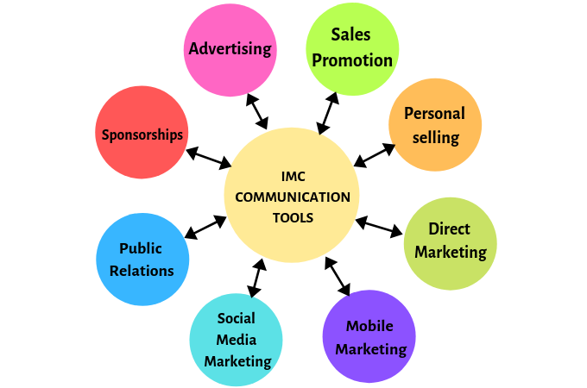

Figure 2.1: IMC Approach
(Source: Schultz, 2020)
The Integrated Marketing Communication (IMC) approach reveals the process that tends to unify a brand's message to ensure high consistency across different media. However, Blakeman (2023) pointed out the importance of implementing IMC approaches to effectively reach the targeted audience within the market. Supporting this, Schultz, (2020) indicated IMC approaches to be strategies that assist organisations regarding tactics and communication to be used within different channels of marketing which in turn, assist in engaging customers and ensuring a loyal customer base. In consideration of the figure above, it can be expressed that the hotel industry within the UK can implement different IMC approaches such as sales promotion, mobile transaction, social media commerce, Public Relations, direct trade, and many others to influence customers' behaviour accordingly.
Advantages and disadvantages of the IMC approach
Advantages of this theory include effective targeting of more demographics while creating high understanding of the brand in the market. It also obliges in building a faithful base of shoppers and creating efficiencies within the channels of communication. Following this, lowering the cost of promotion is also an advantage of this theory. On the other hand, difficulty in regards to tailoring of the targeted audience, improper management of negative reviews and difficulty in terms of measuring the impact and assuming the website traffic is its disadvantages.
Aristotle's Model of Communication
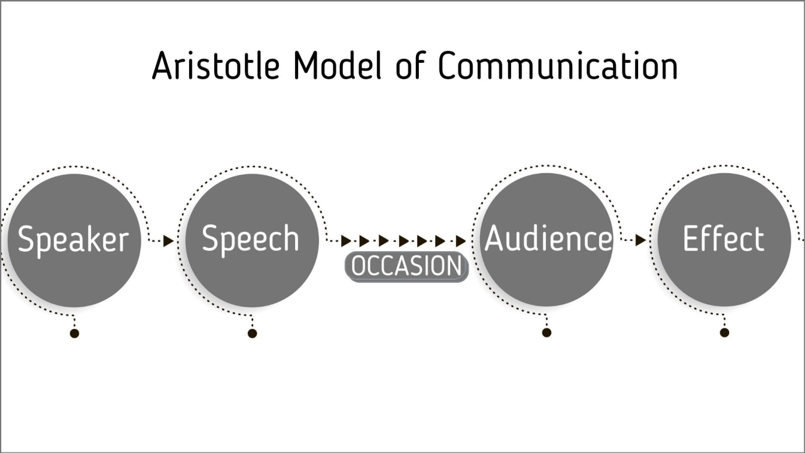

Figure 2.2: Aristotle's Model of Communication
(Source: Sütterlin and Yu, 2021)
Aristotle's model of communication (AMC) mainly emphasises the fact that the art of efficient persuasion alongside persuasive discourse seems to be influencing the notion of communication. Following this theoretical point of view, Trenholm (2020) indicated the importance of rhetoric within the area of communication that seems to involve argumentation and different languages regarding a specific matter. This in turn is efficient in shaping the attitudes, actions, and beliefs of audiences in the market. As can be observed from the figure above and stated by Sütterlin and Yu (2021), this theory is concerned with the development of speech in accordance to different audiences based on different occasions which in turn can analyse decisions of consumer purchasing.
Advantages and disadvantages of Aristotle Model of Communication
Emphasis on the area of persuasion along with a high focus on maintaining ethical communication and maintaining emotional appeal and logical argumentation are advantages of this model. Moreover, ensuring creativity and flexibility while developing a holistic understanding also seems to be an advantage in this area. Contrary to this, the expressed procedures seem to be limiting interactivity while providing variation within contextual and cultural areas which seems to be a disadvantage along with limitations in terms of gaining feedback and negligence towards non-verbal communication (Sütterlin and Yu, 2021).
Compare and contrast
However, Mancino (2020) argued that IMC and AMC seem to be focusing on different areas of communication. Compared to AMC, IMC is focused on the channels of communication while AMC is focused on speech developed by the company to influence consumer behaviour. Upon comparing both models of communication, it can be articulated that the hotel industry within the domain of the UK needs to select relevant channels of communication and develop relevant speeches that will target different audiences based on selected occasions. As a whole, IMC reveals positive alongside negative influences on the purchase behaviour of consumers based on the messages conveyed by the companies.

2.8.2 Digital Marketing
Social exchange theory
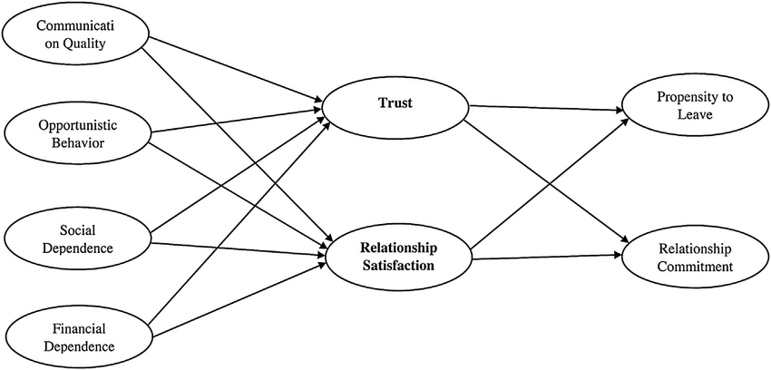

Figure 2.3: Social Exchange Theory
(Source: Thomas and Gupta, 2021)
The social exchange theory (SET) reviews the fact that people seem to be weighing benefits and costs in terms of social relationships for minimising costs and maximising benefits. According to Thomas and Gupta (2021), SET emphasises the area of trust and relationship satisfaction within digital marketing to exploit the purchasing conduct of shoppers. Based on the figure above, communication quality along with opportunistic conduct, social dependence and financial dependence seems to be influencing relationship satisfaction and trust among customers. Supporting this, Meira and Hancer (2021) highlighted the importance of trust and relationship satisfaction in developing customers' intention either to be committed towards the organisation or leave the organisation. Henceforth, digital marketing approaches enforced by the UK hotel sector need to be effective in developing trust and relationship commitment to influence consumer behaviour.
Advantages and disadvantages of social exchange theory
This model is highly simple in terms of understanding general assumptions and it maintains cost and relationship areas within the marketing techniques further proving to be its advantages along with ensuring a balanced proportional between the client and the company. On the other hand, it is often viewed as a mathematical model and is complex in certain areas. However, it can be generalised for interpreting interactions with humans and consists of doubt regarding the accuracy of the outcome further stating its disadvantages.
RACE model
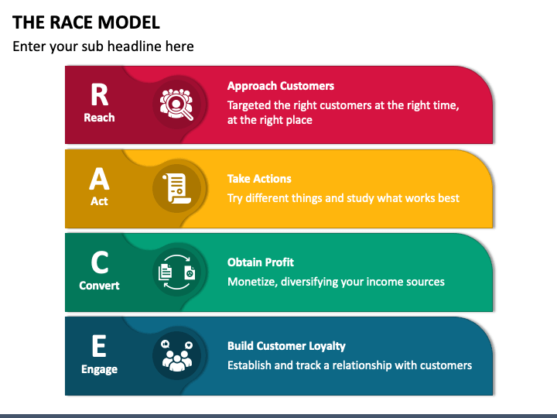

Figure 2.4: RACE Model
(Source: Poole et al. 2021)
The RACE (Reach, Act, Convert and Engage) model is a strategy related to digital marketing that assists organisations in administering different activities related to marketing areas and improving the experiences of customers. However, Poole et al. (2021) pointed out the significance of the RACE framework in terms of reaching customers most effectively and further providing relevant outcomes. As per the figure above, the Framework consist of four stages such as reaching the target audience, taking relevant actions, converting income sources to obtain profit and engaging customers to build a loyal base of customers. Contrasting this view, Akter et al. (2022) argued regarding the complexity of the framework in terms of managing different stages within the customer journeys. Henceforth, this framework is effective in shaping a proper digital advertising strategy for the UK hotel industry.
Advantages and disadvantages of RACE model
The framework provides the advantage of being customer-centric while is action-oriented and ensures the enactment of digital marketing through the relevant channels of communication. It also assists in the area of goal-setting to improve processes of business further stating the advantages of this model. However, the framework is time-consuming and challenges can be faced in terms of understanding the customer's demand and interaction with a business. Moreover, complexity in managing different communication channels can also be observed further reflecting its disadvantages.
Compare and contrast
After analysing both models of digital marketing, high feasibility can be observed of both theories to be enforced within the process of digital advertising in the UK Hotel Sector. It is because Poole et al. (2021) mentioned SET focuses on the significance of generating trust and relationships between the company and the customers while the RACE model emphasises the Framework development which can be adopted by organisations to promote organisational offerings digitally. Henceforth, adopting a suitable strategy of digital marketing can be effective in influencing the customer behaviour of the UK hotel sector positively.

2.8.3 Consumer behaviour
Maslow’s hierarchy of Needs model
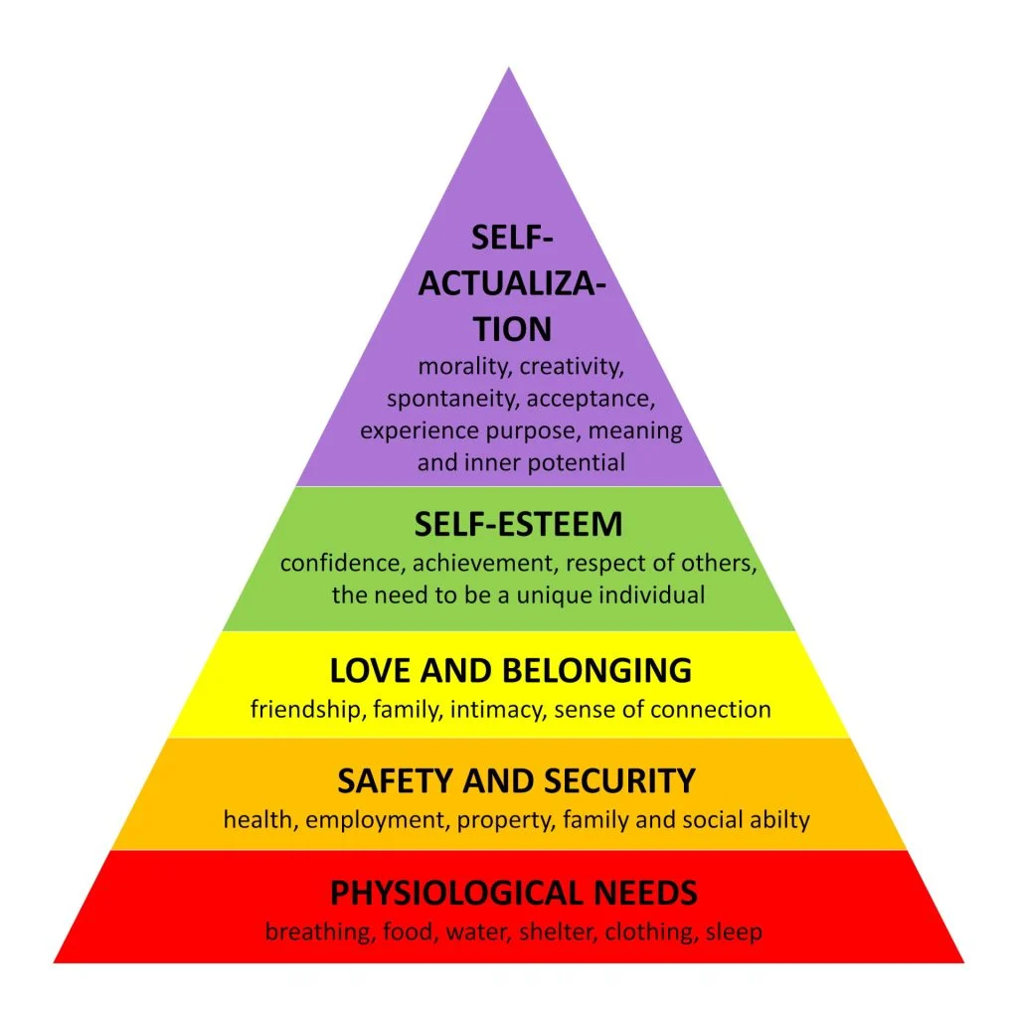

Figure 2.5: Maslow’s Hierarchy of Needs model
(Source: Dar and Sakthivel, 2022)
Maslow’s Hierarchy of Needs is a model that helps in comprehending the influence of consumer behaviour based on their needs. As per Dar and Sakthivel (2022), Maslow’s theory reveals five basic needs of humans that seem to be motivating them such as psychological conditions, self-esteem needs, self-actualisation requirements, love and belonging needs and safety needs. This reveals the importance of generating high satisfaction from customers by meeting the five basic needs to influence their purchasing behaviour positively.
Advantages and disadvantages of Maslow’s hierarchy of Needs model
Individualist approach to motivating customers or employees is the current advantage while ensuring meeting basic 5 needs and relevant satisfaction and maintaining relevant relationships. However, difficulty in understanding and measuring employees' behaviour in certain areas and chances of revealing the wrong interpretation of human needs are the disadvantages of this model (Hong et al. 2020).
Model of consumer decision-making process
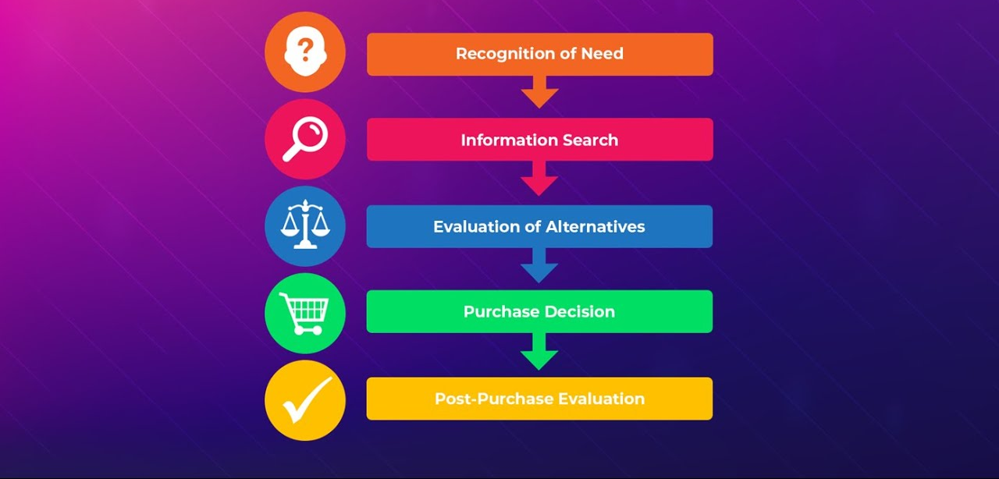

Figure 2.6: Model of consumer decision-making process
(Source: Mishra et al. 2021)
The model of consumer decision-making assists marketers in terms of understanding the process through which buyers make decisions at the time of their purchase. According to the figure above and the ideas of Mishra et al. (2021), the model of buyer decision-making reveals five basic steps such as need recognition, searching for relevant data, searching for relevant alternatives, making the actual decision to buy, and evaluating the product and services after the purchase. These areas are analysed to be followed by the customers in terms of selecting relevant hotels in the UK.
Advantages and disadvantages of Model of consumer decision-making Process
Effective understanding of consumer behaviour along with proper market segments, predictive actions of consumers and understanding of the customer base are advantages of this model. Besides, oversimplification of the process can be a disadvantage along with challenges related to cultural variation and rational making of decisions as per consumer trends.
Three-stage model of perception
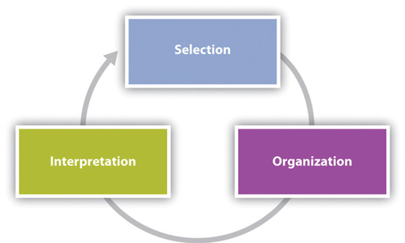

Figure 2.7: Three-stage model of perception
(Source: Jiao et al. 2020)
Customers' decisions related to purchase can be evaluated through the three phases of the perception model. According to Jiao et al. (2020), customer mainly deals with the selection of different stimuli based on their needs and demands further organising the information to make relevant sense. The third stage of consumer behaviour as per the model is an interpretation of the stimuli based on their desires, thereby, relating to the purchase of products and services.
Advantages and disadvantages of Three-stage model of perception
Benefits organisations to understand consumer behaviour and relevant analysis of customers' demand are its advantages. Apart from that, time-consuming to interpret consumer demand and the chances of making wrong assumptions are considered to be the disadvantages of this theory.
Compare and contrast
Comparing and contrasting all three models related to consumer decision-making, it can be evaluated that organisation needs to be highly focused on market trends and previous purchasing behaviour to analyse consumer purchasing decisions in the current scenario (Dar and Sakthivel, 2022). However, relevant initiatives of the UK Hotel Sector to analyse previous market trends and consumer purchasing behaviour can be efficient in increasing sales and profit margins accordingly.

Chapter 3: Methodology

3.1 Introduction
The division on procedure mainly deals with detailing various procedures that have been employed by the researcher for the pursuit of the current research. In consideration of this, different layers of research onion will be considered to structure this section which in turn will deliver a detailed analysis concerning the philosophies, approaches, strategies, and different techniques that have been utilised by the recent investigator to gain suitable research data. Apart from that, techniques of analysis will also be stated to gain suitable research outcomes while ethical considerations will also be evaluated that have been ensured to mitigate possible barriers in this area. However, this section will allow videos to analyse the overall trustworthiness and facts of the current study.

3.2 Research Onion
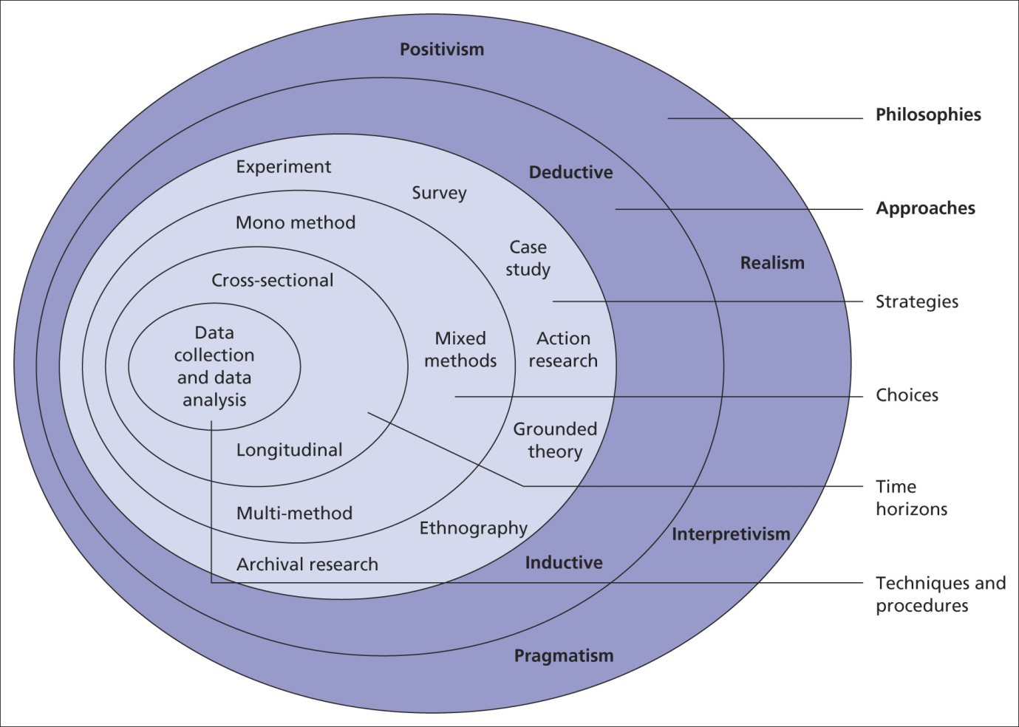

Figure 3.1: Research Onion
(Source: Saunders et al. 2022)
The research onion as indicated in the figure was designed in 2007 by Saunders et al. (2022). This is a technique that describes stages which assist an experimenter in terms of conceiving a productive methodology. As the name suggests, this framework seems to consist of different layers similar to an onion which depicts different stages of research. The first stage as illustrated above, deals with evaluating research philosophies while the second stage deals with evaluating research approaches and the third stage indicates deciding on research strategies. Apart from that, the fourth stage seems to indicate the choices of the researcher in order to carry out an investigation in terms of selecting single method, mixed methods, or multi-method. However, as the time horizon is highly essential for any research, therefore, the next stage of research onion deals with deciding the time zone of the research while the preceding stages deal with analysing the data assemblage and examination methods (Mardiana, 2020).

3.3 Research philosophy
Philosophy within investigation deals with different principles that concern different areas that deal with the conduction of the research. As per Mathotaarachchi and Thilakarathna (2021), the philosophy of study refers to different beliefs in consideration of the character of a specific reality that is being examined within research. Upon considering various research philosophies, the contemporary researcher has selected the positivism philosophy for the conduction of the present examination. In the idea of Alharahsheh and Pius (2020), positivism philosophy mainly deals with testing examination questions and finding relevant explanations that can be measured for the purpose of acceptance of the research outcome. However, it is highly shaped by factual areas and also deals with objectivism which makes the researcher highly aware of different social phenomena related to the issue.
As a result of this, through the enactment of the positivism philosophy, the current research has been effective in analysing different aspects related to the IMC and DM and their influence on consumer conduct within the hotels of the UK. Apart from that, Mbanaso et al. (2023) indicated the fact that positivism philosophy is also shaped by the area of realism that further assists in finding the underlined cause of the concerned matter. Overall, the positivism philosophy has been positively beneficial for the current researcher in order to structure the information collection based on the research questions further testing different areas to depict its reliability and validity. Moreover, the information gained by the researcher through the positivism area has been effective in measuring the outcome and supporting it with relevant explanations. Henceforth, the preference of the positivism philosophy for the current investigation is highly justifiable.

3.4 Research approach
The second phase of the research onion deals with the preference for a research approach that indicates a procedure for the intention of data accumulation and examination. Concerning the current subject area. The current investigator has selected a deductive approach. In the thought of Proudfoot (2023), the deductive approach mainly aims at finding answers to the queries of research that have been created at the beginning of the investigation. The notion of the deductive approach is highly similar to that of the positivism philosophy further depicting the suitability of adopting this approach for the current investigation. Similar to the notion of positivism philosophy, Niaz et al. (2023) indicated the fact that the deductive approach also deals with finding a suitable answer to the research question by testing different knowledgeable areas. However, the deductive approach also deals with using existing theory for the purpose of testing different areas and this approach does not necessarily deal with the generation of new concepts. Henceforth, this approach has been effective in understanding the consequence of IMC and DM on patron’s conduct within the hotel sector of the UK.

3.5 Research strategies
Selecting a relevant strategy for the analysis is supposed to be highly efficacious in terms of generating viable outcomes. Linking with the stages of the research onion, the current experimenter has implemented a survey technique for the existing study. As opined by Akesson et al. (2022), the survey is considered to be one of the effective strategies of research that tends to allow researchers to accumulate real-time data from different populations. It is considered to be highly effective in accumulating a huge sample size in order to gain relevant responses, which is highly suitable to react to the research questions. However, the researcher emphasised the selection of a survey strategy for the current research as it is highly linked with the deductive approaches of investigation. Similar to the area of detective approach, the survey also deals with finding suitable solutions to the research question in the form of questionnaires from different populations in the market. As a result of this, Ikegwu et al. (2022) indicated the significance of survey strategy in terms of accumulating reliable and rich sources of data which can improve the credibility of the current outcome. Henceforth, the preference of a survey method for the existing research is highly stands to estimate the perception of different populations in the need regarding the impact of the DM and IMC on their purchase behaviour.

3.6 Type of Investigation
There are mainly two types of investigation that are being taken by different researchers in the current area such as primary research and secondary analysis. In the thought of Brick et al. (2020), primary research is analysed to be a methodology that is being used by different investigators in terms of collecting information directly from the concerned area rather than being dependent on the knowledge that has been assembled by previous experimenters in the same field.
In order to be specific, primary research mainly deals with information directly collected for a specific cause further providing real-time data for the purpose of analysing specific situations. Relating to this area, Akesson et al. (2022) indicated the advantages of primary research in terms of collecting real-time and up-to-date knowledge from the targeted population. Apart from that, this method also processes the benefit of gaining unique information in accordance with research questions and objectives further generating quick results and increasing research credibility.
Contrary to this, Taherdoost (2021) argued the disadvantages of primary research in terms of misleading, biased and inaccurate results. As primary data are collected from different populations in the market whether it be employees, customers, managers, or others, therefore, responses gained from participants possess the chances of biased information. In certain areas, the collected responses can often be misleading, thereby, creating hardship in terms of rendering suitable outcomes. On the other hand, Jain (2021) highlighted the difficulty of collecting primary research and indicating it to be highly expensive and time-consuming for the objective of conducting any research. This is because primary research mainly consists of observation, surveys or interviews which depend on the availability of the participants alongside time consumed for collecting responses and others which may be impactful for completing the research in the targeted time frame. Currently, it will be conducted via survey. On the other hand, Baldwin et al. (2022) indicated secondary research to be a method where researchers are involved in collecting previous information accumulated by previous researchers in the field and is conducted via the literature review.
This is also considered to be cost-effective as compared to primary research and intends to save a lot of time by collecting data that are already available within secondary databases. Most importantly, the advantage of using secondary research can be highlighted from the area of its thorough understanding and wide source of information related to the cause. Contrary to this, Neale (2020) argued regarding the sources' quality in terms of secondary research, thereby, contributing to its disadvantages. Most importantly, data generated from secondary sources also seems to be highly generic further limiting the chances of being specific in regard to research question and objective. However, upon comparing the primary and secondary examination, it can be commented that both types of investigation seem to have certain flaws and positive areas which may be suited for different research purposes. Though implementation of primary research seems to be consuming high cost and time but it provides the researcher with the aptitude of collecting specified data that can influence research outcomes positively, thereby, justifying the adoption of the primary method in the current examination.

3.7 Choices
The main method used for this research was primary quantitative, which was considered the highly appropriate to examine how IMCs and DM influenced consumer behaviour in the UK hotel industry (Adams and McGuire, 2022). This helped the researcher collect fresh, specific, and relevant data from customers themselves which was based on primary research helping in building up-to-date information for the study. Unlike secondary research, which is based on past data sets and may not be actual or relevant in context to what actually happening today within the hospitality industry. The secondary data may be out of date and thus not relevant for this research which further reduces its usefulness to the research. This study was focused on understanding customer responses and perceptions of marketing strategies, which was collected directly through primary research (Rana et al. 2021).
Furthermore, using quantitative research as the mono-method, rather than a mixed method was used. This was selected as this approach offered a directed method of obtaining numerical data and is conducive to statistical analysis which has been a major advantage of using this method (Rana et al. 2021). This was more efficient than data collection done through mixed-method, which would have required both quantitative and qualitative research methods that would have made the study time-consuming. This researcher decided to employ mono-method because of another advantage which is its clarity, consistency as well and simplicity of analysis which was ultimately achieved (Adams and McGuire, 2022). This also helped in a reduction in the amount of human and time resources required for collection of data and analysis; again, supporting the mono method over selecting a mixed-method approach. Mono-method research, though useful in restricting the complexity of data and analyses for policy or practice decisions, cannot replace qualitative methods to provide the richness of insights needed to complement quantitative data which is one of its major disadvantages. Depending on a single technique may produce one-sided or weak outcomes that undermine the validation and robustness of the studies Adams and McGuire, 2022.

3.8 Time Horizons
The research founded on the basis of a cross-sectional, which has been the most convenient time horizon for assessing IMC and DM from consumer perspective in hotel industry in UK. The cross-sectional method means that customers were only surveyed at one time point (Rana et al. 2021). The selection of this approach was done, in order to have a database of the behavior consumer they presently accept and act through marketing motion. One of the advantages with cross-sectional studies is they are generally less expensive and time-consuming than longitudinal methods, which involve testing changes over a longer period. This research in particular aimed to achieve and evaluation of the short-term effects of marketing communications and digital strategies; thus, a cross-sectional design was suitable (Adams and McGuire, 2022). It offered key insights into the success of existing strategies in a way that long-term data collection would lead to difficult, complex answers. Longitudinal studies might be useful for tracking changes over time, but would not fit the use case of this study. This study aimed to detect consumer behaviour at a particular point, as such a cross-sectional time horizon was more effective. The primary advantages of this method were the simplicity, cost-effectiveness and quickness with which responses could be generated made sure the captured data was demonstrated in current market practices within hotels.

3.9 Data Collection and Analysis
Data was collected using a survey to efficiently reach as many participants as possible and collect quantitative data. In this case, what the survey provided was responses from hotel customers on perceptions of marketing strategies by which systematically gathered was data. This was especially useful for getting a quantification of the behavioural and attitudinal consumer data (Rana et al. 2021). By means of quantitative techniques, the survey responses were analysed. Approaching in this manner the researcher was able to observe actionable trends and patterns of correlation that exist between data sets, making it possible to give concise summaries on how integrated marketing communications or digital marketing is impacting each other. The utilisation of surveys and quantitative analysis contributed to the attainment of rigorous, empirical results that addressed the research objectives.

3.10 Sampling
The research used a purposive sampling method with 51 UK respondents as the target sample size to ensure the data was relevant of this study. This type of sampling was able to hone in on people who had stayed at hotels and received marketing communications and digital strategies (Dolnicar, 2020). This focused selection of purposive sampling provided greater insights into how these strategies affected consumer behaviour from the less directed to the more directed. This was preferable to simple random sampling, as the researcher might have received responses from people with no practical experience in the hotel industry (Adams and McGuire, 2022).
A sample size of 51 survey participants was taken with the aim of making a detailed interpretation from people who have practical knowledge about hotels and marketing plan. The data was collected for a few weeks from UK respondents. While the sample varied by age and gender, almost all described troubling situations. The researcher familiarised with the 51 respondents which was facilitated by the need for engagement with customers who had relevant experience; working as a hotel receptionist. It served as an extra level of control for who was completing the survey to make sure the correct audience were entering the survey.
Moreover, using simple random sampling would have possibly included members who were not even aware of the marketing strategies being researched, and that possibility could have made a bias. Purposive sampling also ensured that the sample was made up of persons able to provide useful and relevant insights. It can be stated that it was an effective and focused way to collect data, which directly related to the research questions they sought answers to and helped to make findings more reliable. Yet there were disadvantages to this method just as advantages like; Purposive sampling can lead to researcher bias; the selection of participants is subject and may be skewed or not represent the larger population at large. Generalizability is limited in purposive sampling because the sample size is generally small and subject specific.

3.11 Data Collection Method
The data collection was done by employing a questionnaire that was given to the respondents on their insights and experiences with regard to hotel marketing by using closed-ended questions The survey was intended to capture comprehensive but efficient and systematic data relating to the themes (Dehalwar and Sharma, 2024). These questions were specifically designed to cover all the essential features of consumer behaviour and also covered areas related to Integrated Marketing Communications and digital marketing. Demographic information questions, such as age, gender and job title also worked to break out the types of data collected into groups and patterns within questions between them. This gave some good feedback on how consumers engage with the marketing from hotels, in terms of what factors they considered and any other details which resulted in their queries.
The data on how marketing channels and their online impacts along with the effectiveness of IMC strategies followed by personalised marketing provided insight into consumer preference while making purchase decisions. The researcher developed 16 closed-ended questions using google forms to maintain clarity and assist quantitative analysis which was key for the study, as this allowed us to measure responses and examine common trends (Adams and McGuire, 2022). The design also facilitated easy comparison of responses and efficient data management. The questionnaire used the simple closed-ended format along with a few demographic questions to reduce ambiguity and obtain reliable and consistent data that was directly relevant to the aims of our research. Each respondent was given 20-25 mins to complete the questionnaire. The method helped in collecting the data faster and it became easy to analyse the impact of DM along with IMC methods on consumer behavioural aspects in the Hotel industry of UK.

3.12 Analysis of Data
Percentage analysis and descriptive statistics were put to use to analyse the data in this research, which was extracted from survey data. The method facilitated with neat and easy study of the accumulated data (Taherdoost, 2022). The answers to most questions could be broken down into decided-upon categories, and percentage analysis was used to identify how many respondents fit into each category for a particular question allowing the researcher to immediately see the trends of opinion or preference. Descriptive statistics was computed to offer an overview of the data. It also uses a relatively simple, easily interpretable simplification compared to more complex empirical methods.
This was a useful technique for data analysis of quantitative variables that did not require doing anything other than simple statistics. The simple percentage analysis and descriptive statistics have been aided buy the use of MS Excel which contained the data from the survey and have allowed a succinct summary of the results in comparison to previous methods, making it practical (Mohajan, 2020). This method was quite effective as the researcher wanted to bring out trends and insights embedded in a dataset rather than describe cause-and-effect relationships or make forward-looking predictions. These easy-to-use measures expedited an efficient analysis while being consistent with the research objectives of evaluating marketing exposures on consumer behaviour without burdening unneeded complexity.

3.13 Research Ethics
All ethical guidelines were followed and as a result, the participants in this photograph are not identified by name. No personal data was recorded and all responses were anonymised to protect the identity of any individual. The data was saved securely in encrypted systems so no unauthorized person could access it. This step kept the participant's information secure and it stayed within these four walls only. The work followed all ethical guidelines of the university which ensured confidentiality, and respect for human dignity through their safety and well-being (Adams and McGuire, 2022). There was an obvious effort to prevent being biased or profiting from the data. Results were utilized only for educational ends and not profited from or distributed commercially. This prevented people from taking part unknowingly, or being coerced into the study; and introduced transparency about how the data would be used before volunteers had made a decision. All participants in this study gave permission for the data to be collected which is consistent with ethical guidelines that assure the integrity of research.

Chapter 4: Data Analysis

4.1 Introduction
This chapter focuses on interpreting the obtained data from the survey questions, which investigates how IMC and DM campaigns influence behaviour of consumer in the UK hotel sector. The results are based on responses from a pool of participants with different demographics such as age, gender, or place of work. Most respondents were 25–34 years old (74.51%), followed by those aged 18–24 (15.69%) and lower figures for other age groups. Only 3.92% of people from this group were under 18, and 1.96% for 35-44, 45–54 and 55–64 years old respectively.
Regarding gender, more than half (64.70%) of the respondents were male, with 29.40% being female and 5.90% choosing not to disclose their gender. In terms of what they are doing now, more than half worked full-time (54.90%), 11.76% part-time, 7.84% self-employed and 9.80% unemployed. A total of 13.73% were students and the others belonging to other professional categories had a prevalence of 5.88%. This chapter offers a thorough analysis of the responses and will further explore how these demographic variables are likely to affect consumer behavior in UK hotels integrated marketing communication as well as Digital Marketing strategies.

4.2 Primary quantitative analysis

RQ1. What components of integrated marketing communications are most effectively used by UK hotels to influence consumer behaviour?
Q9. How do you perceive the efficacy of IMC strategies used by hotels in the UK?
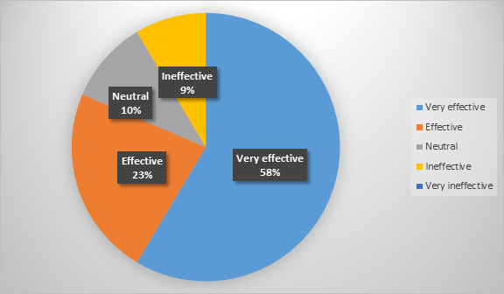

Figure 4.1: Perception of consumers on IMC strategy
(Source: Survey)
Based on the analysed aspect in the above sections, it has been identified that there are significantly different benefits and advantages of IMC strategies that are considered by hotels impacting the betterment of customer service and customer attraction. In this regard, it has been identified that referring to the aspect of consumer perception towards the consideration of IMC strategies among 51 respondents, the maximum number of individuals stated the IMC strategy to be effective 58%. On the other hand, it is regarded that 23% stated effective, 10% stated neutral, and only 9% stated ineffective. In this concern, it can be understood that the IMC strategy is mostly preferred by consumers, which can impact the betterment of UK hotels in terms of improving their communication with consumers while influencing them to perceive their services.
Q10. Which aspect of UK hotels’ IMC strategy do you consider most persuasive?
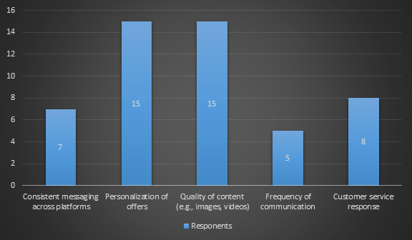

Figure 4.2: Aspects of IMC strategy specifically preferable for consumers
(Source: Survey)
IMC strategy has been noted to be mostly prominent in terms of improving the consistent messaging aspects, personalisation, and quality content of UK hotels. Regarding this, it is identified that UK hotels focus on numerous different aspects in terms of improving their IMC strategy. For evidence, consistent messaging across the platform, personalisation, quality of content, frequency of communication, and customer service response has been noted to be the prominent aspect the UK hotels consider. Among them, the maximum number of individuals rooted in personalisation of offers and quality of content with 30% where the majority of 15 respondents responded to these aspects. Besides this, customer service response, consistent messaging across platforms, and frequency of communications were identified to be the least perceived aspects with 16% 14% and 10% respectively. Regarding this, only 8 individuals rooted for customer service response, 7 of 51 respondents stated consistent messaging across the platform is perceived among them and only 5 of them noted their likeability towards frequency of communication.
Q15. What type of content do you mostly prefer on digital platforms of hotels?
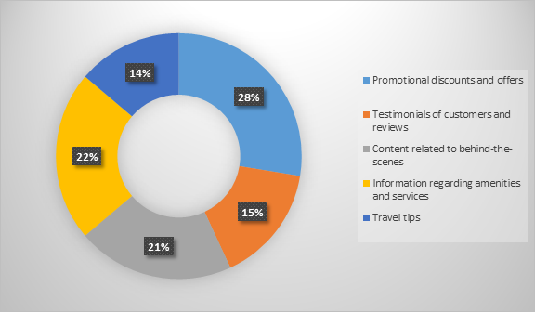

Figure 4.3: Type of content preferred on digital platform by consumers
(Source: Survey)
Connecting to the digital platform considered by UK hotels and the contents consumer prefers, it has been identified that different aspects are considered by consumers that significantly influence their behaviour towards the booking. For evidence, it has been identified that among 51 respondents, 28% of individuals stated that promotional discounts and offers are the most influential content they mostly prefer on the digital platforms of hotels. Besides this, content related to behind-the-scenes, information regarding amenities and services along with testimonials of customers and travel tips is followed by their preferences with 21%, 22%, 15%, and 14% respectively.
In terms of identifying and addressing the components that are specifically used by UK hotels to influence consumer intention through IMC strategy, UK hotels are specifically focused on personalisation, quality content, and customer service aspects that are effectively influencing the consumer behaviour of respected targeted customer’s segments. Regarding this, content through digital platforms is required to be improved with promotional discounts and offers along with information regarding the services, which are prominent in terms of consumer preferences. Therefore, these significant aspects have been considered to be the most prominent aspects that are the components of IMC strategy by UK hotels with significant addresses RQ1.

RQ2. How do digital marketing techniques impact consumer preferences and booking behaviours in the UK hotel industry?
Q8. Have you ever got influenced to consider hotels because of a targeted online advertisement?
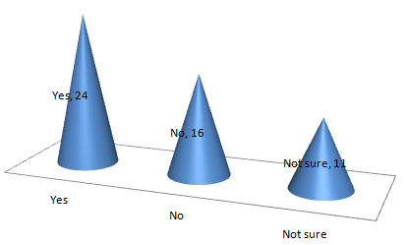

Figure 4.4: Influence of targeted online advertisement on customers hotel consideration
(Source: Survey)
By considering the second research question, respondents during the survey were asked about the impacts of targeted digital advertising of UK hotels on their purchasing behaviour. Consequently, the survey revealed that approximately 47% of the total respondents have got impacted by targeted digital advertising of hotels in the UK. However, 31% of respondents disagreed in this regard, which reflects they have never got influenced by targeted online advertising initiatives of hotels, while choosing head hotels. Moreover, about 22% of respondents were not sure about the influence of online advertisement initiatives of UK hotels on their hotel selection.
Considering the survey results, it is notable that most clients of the British hotel sector prefer to consider hotels by getting influenced by their targeted advertisements. However, it cannot be ignored that a considerable number of individuals are not sure and the number of disagreements in this regard is also notable. Comparing the overall responses, it is acknowledged that digital marketing techniques of UK hotels can play a conclusive role in influencing individuals' behaviour of hotel selection.
Q13. To what extent does hotels’ reputation on social media platforms impact your booking decision?
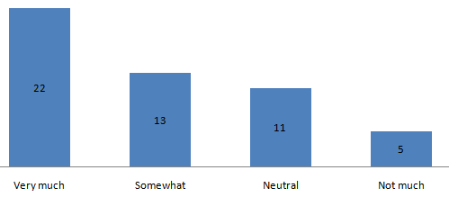

Figure 4.5: Impacts of hotels’ reputation of online platforms on customers references and booking consideration
(Source: Survey)
Based on the survey outcomes, 43% of those who participated said they agreed that the reputation of hotels on online sites has a very much impact on their booking decisions. Additionally, 25% of participants agreed that the reputation of hotels on online platforms somewhat influences their booking preferences. In contrast, only 10% of participants pointed out that the reputation of hotels on online platforms has not much impact on their booking decisions. However, in this regard, 22% of responses were neutral. Overall, while critically contrasting all the results to this particular survey question, it is notable that the reputation of UK hotels on online platforms takes a constructive part in altering the booking decisions of individuals to some extent. Considering this idea, it is understood that the digital marketing techniques of hotels that help them to improve their reputation on online platforms can assist them in positively altering the booking behaviour and preferences of customers.
Q16. Do you think that a hotel's digital effort to advertise affects the prevalent perception of the brand?
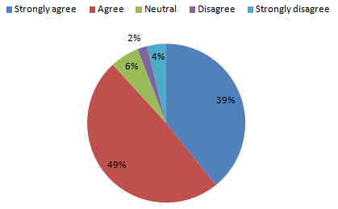

Figure 4.6: Impacts of hotels’ digital effort brand perception
(Source: Survey)
Considering the survey results, digital advertising efforts are observed to be critical in terms of influencing their prevalent perception of brands. This is because the maximum participants, which is approximately 49%, concur that the digital advertising efforts of hotels can alter their prevalent brand perception. Furthermore, 39% of participants have also exchanged strong agreement regarding this. Conversely, aside from 6% of neutral responses, only 2% of respondents disagreed and this remark was strongly disagreed with by 4% of respondents. Therefore, a comparison of all responses to this particular question clearly points out that the digital efforts of hotels in the UK can have a notable effect on their prevalent brand perception.
Overall, online advertisement and the reputation of hotel brands on online platforms are influential on brand perception, customers preferences and hotel selection behaviour. Therefore, digital marketing techniques of UK hotels are influential on customers' preferences.

RQ3. What is the comparative effectiveness of traditional marketing methods versus digital marketing for UK hotels?
The third question of the present analysis mainly ensures the analysis of the efficacy of traditional techniques of marketing versus digital procedures of marketing. However, certain survey questions can be aligned with the current question of research in order to derive suitable consequences for the sake of the successful execution of the current research.
Q6. Which online marketing channels do you consider most relevant when looking for hotels?
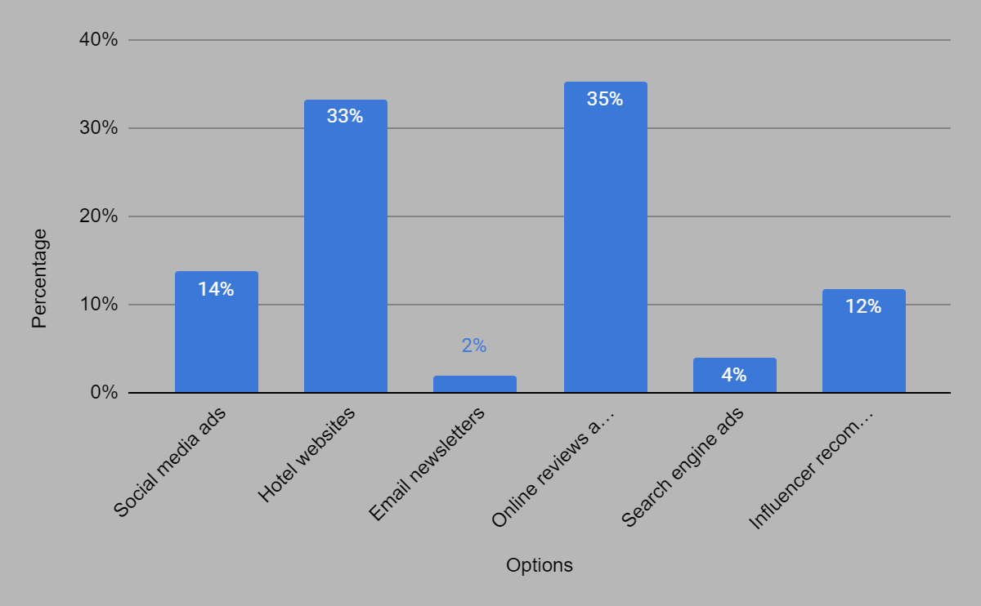

Figure 4.7: Consideration of relevant online marketing channels
(Source: Survey)
Focusing on question 6, it can be observed that different online challenges of marketing are considered by customers in terms of searching for relevant hotels. From the replies gained, it can be concluded that 14% of the overall participants are highly dependent on advertisements within social media sites to search for relevant hotels. Apart from that, hotels' websites, online reviews from clients seem to play an integral role in regard to shaping the customer buying intention or customer decision-making process. Apart from that some of the customers are also influenced by influencer recommendations in terms of selecting any hotels for their stick. Similarly to this, email newspapers and advertisements within search engines seem to also have minimal contribution towards the influence of customers' decisions regarding selecting a hotel.
Based on the existing answers, it can be regarded that most of the consumers are favourably dependent on digital methods of marketing that are being adopted by hotels within the UK. In this respect, social media sites along with the website of the hotel and online reviews and feedback from customers seem to be effective digital marketing techniques adopted by the hotels within the domain of the UK in order to draw customers and influence the process related to making choices. Henceforth, digital marketing methods are considered to be admiringly effective for UK hotels as analogised to traditional ways of commerce in the current scenario.
Q7. How pivotal is a hotel's digital presence in your purchasing decision-making process?
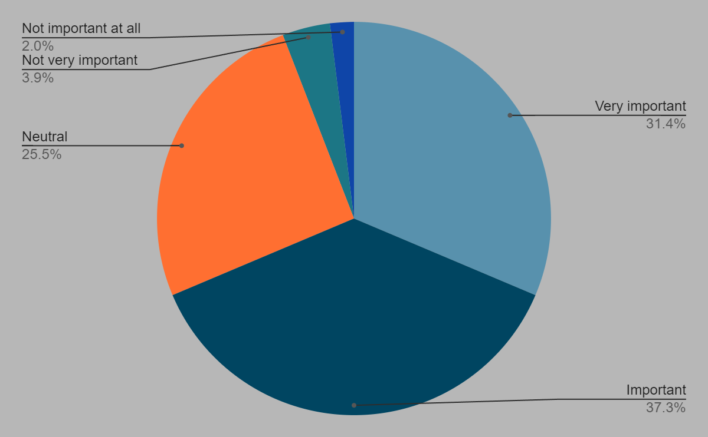

Figure 4.8: Effectiveness of hotel’s digital presence
(Source: Survey)
In order to evaluate the 4th question of the current study, the 7th question of the survey mainly ensures analysis of the importance of digital presence within hotels in representations of controlling the purchasing decision-making of the buyers in the market. Based on the replies gained from the survey, it can be interpreted that the majority of the participants that is 37.3% seem to consider the digital presence of hotels to be favourably noteworthy in regard to controlling the buying conduct of consumers in the market. Similarly, 31.4% which indicates the second majority of survey respondents, conformed to the fact that the digital presence of hotels is considered to be very substantial in terms of controlling the purchase determinations of customers. However, 25.5% of survey participants indicated neutral responses while 5.9% of the survey respondents did not consider the presence of digital platforms of the Hotel to be important for influencing the purchase area of customers. In respect to this, it can be evaluated that the digital marketing method adopted by UK hotels at considered to be effective as corresponds to traditional procedures of marketing in terms of enhancing customer awareness and drawing customers by influencing their purchase decision regarding hotel stay in a positive way.
Q14. How satisfied are you with the level of interaction and engagement UK hotels have with their clients on digital platforms?
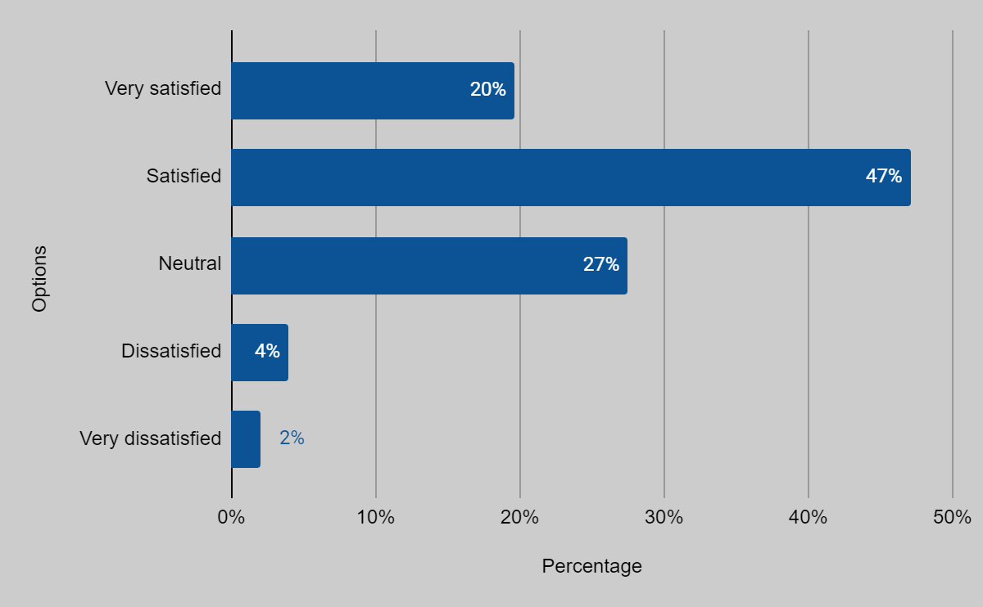

Figure 4.9: Satisfaction regarding interaction and engagement levels of UK hotels
(Source: Survey)
The 14th question of the current research seems to be measuring the effectiveness of engagement and interactions facilitated by UK hotels in regard to satisfying consumers through platforms within digital areas. From the reactions acquired, it can be examined that the majority of the customers that is 67% seem to be satisfied by the level of engagement and interaction facilitated by UK hotels through digital platforms which in turn influences their purchase decision positively. However, 27% of neutral responses were gained in this area while 4% and 2% of survey participants indicated dissatisfaction and very dissatisfaction regarding the engagement and level of interaction facilitated by the UK hotels within digital platforms. Considering the majority of responses, it can thereby be expressed that digital marketing methods embraced by the UK Hotel Sector seem to be positively influencing customer interaction and engagement and are effective as compared to the traditional ones.

RQ4. How do consumers perceive the authenticity and trustworthiness of marketing communications from UK hotels?
Q4. How often do you visit hotels?
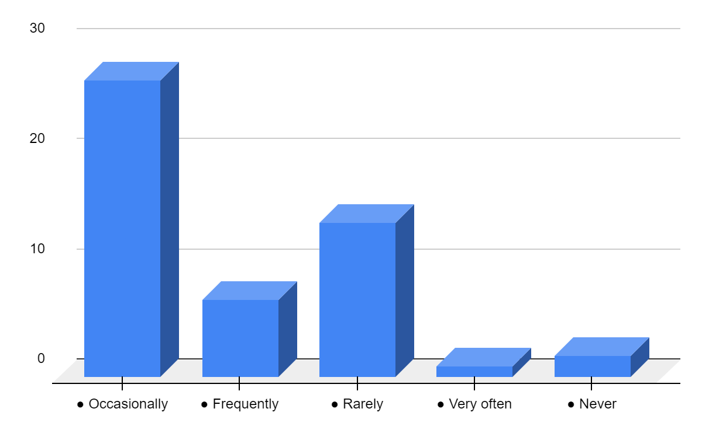

Figure 4.10: Frequency of visiting hotels
(Source: Survey)
The Responses to this question give an idea about how often participants are checking into hotels. Most respondents (54.90%) state that they visit hotels every once in a while, which means the average Brit engages with the hotel industry to some degree throughout their life. Nearly a third of those questioned hardly visit hotels (27.45%), highlighting a relatively large cohort within the sample having limited contact with the industry. Another much smaller percentage (11.76%) admit to frequenting hotels with great frequency. While a mere 1.96% of respondents reported frequented hotels often, which essentially equates to a handful of highly frequent guests.
On the other hand, 3.92% said that they never visited hotels making this a small cohort with no physical experience of hotels. More than seven 70% were occasional or rare visitors, indicating this is not a field that engages most people enough for them to keep up with the latest hotel news. As such, this study has the potential to inform both IMC and DM strategies within hotels, in which case they may consider ways to increase guests' level of frequency by converting infrequent or rare guests to a more frequent visits, as well as understanding better the segments that could host frequent and very frequent visitors. However, it can be articulated that IMC alongside digital methods of marketing seems to be influencing positively the shopping conduct of consumers within the hotel industry.
Q5. How often do you use online platforms to search hotels before booking?
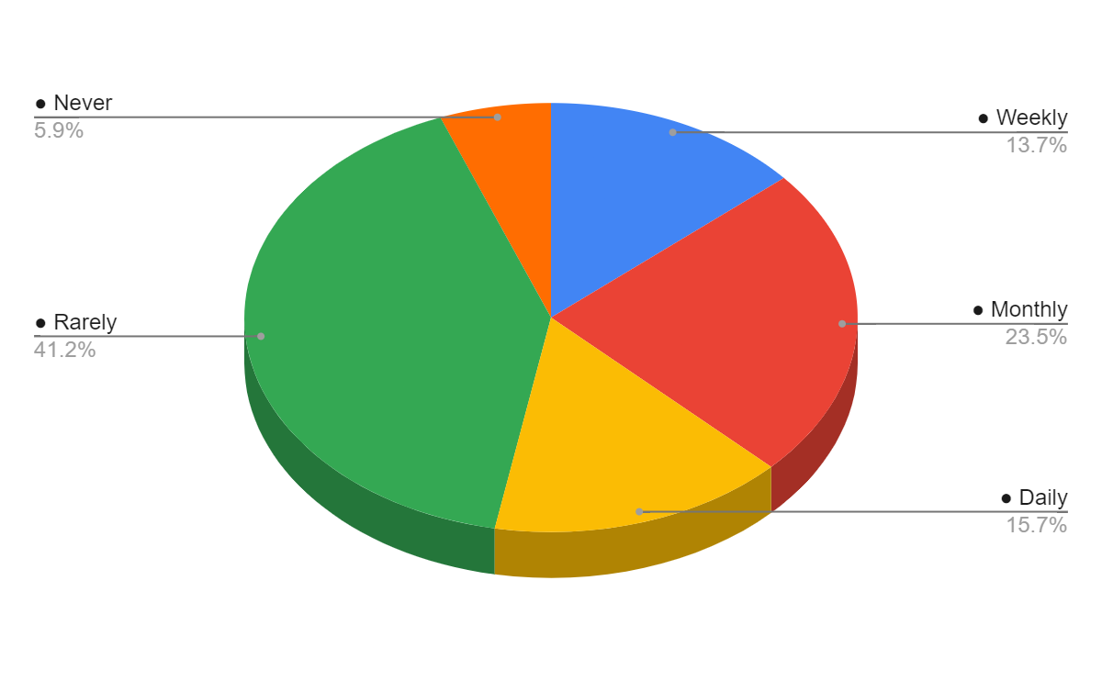

Figure 4.11: Frequency of using online platforms to search hotels before booking
(Source: Survey)
The responses to that question reflect some telling trends in how travellers are using digital tools when they shop for hotels. Additionally, 43.14% of these respondents stated they seldom use online platforms for searching hotels. Most stated that although many users do use online tools, no instance is popular enough to be a routine matter for more than a few users. In parallel, another 19.61% used it monthly, a moderate usage figure that seems subjective to this subcategory of the sample. Moreover, 15.69% of them use these platforms on a daily basis which means these people are very active and regular users while doing hotel research online.
Daily users aside, 11.76% of survey participants use online platforms every week, implying an ongoing albeit somewhat less frequent usage. Additionally, 9.80% of the respondents reported never using online websites to identify and look for hotels, which is a small part of the sample that prefers not to use any kind of digital tool in such context. This data shows a mix of usage patterns and most lean towards infrequent or moderate use of online platforms. It aims at maintaining transparency and providing different facilities that satisfy customers and attract them, thereby, enhancing the profit margin of the sector accordingly.With infrequent and one-off users, for example, Hotels can concentrate on engagement and offer experiences to regular daily and weekly which are already steeply dependent on the internet for hotel booking decisions.
Q11. How does personalised marketing influence your booking decisions?
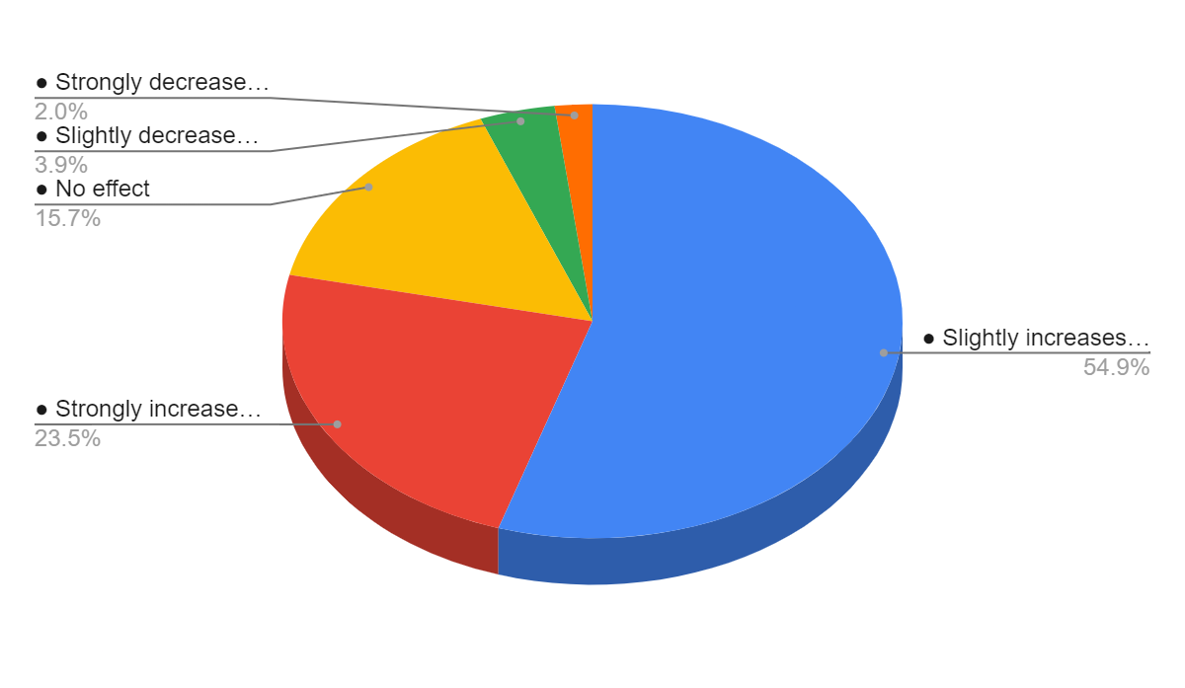

Figure 4.12: Influence of personalised marketing on booking decisions
(Source: Survey)
Responses to what role personalized marketing plays in their booking decisions offer a look into tailored marketing strategies and how they affect consumer behaviour. However, 52.94% of respondents stated that this type of marketing only slightly raises the proclivity to book and it is therefore unlikely to have the potential impact. In total, 23.53% of respondents singled out personalised marketing as boosting their chances of booking outright, indicating that a substantial part of the market is particularly receptive to tailored offers and messaging. Yet 13.73% of respondents revealed that personalised marketing has no impact on them and for others, these strategies have an inconsequential effect on their decisions in any case.
Similarly, only 3.92% of participants said that personalised marketing somewhat reduces their chance to book and 1.96% strongly reduces the likelihood they will book, so it seems a very small number of people perceive personalisation negatively or even intrusively. Generally, these data reveal a positive impact of personalisation in most respondents as more than 75% jointly report being more likely to purchase due to personalised marketing materials.
Q12. How often do you consider online reviews before selecting hotels?
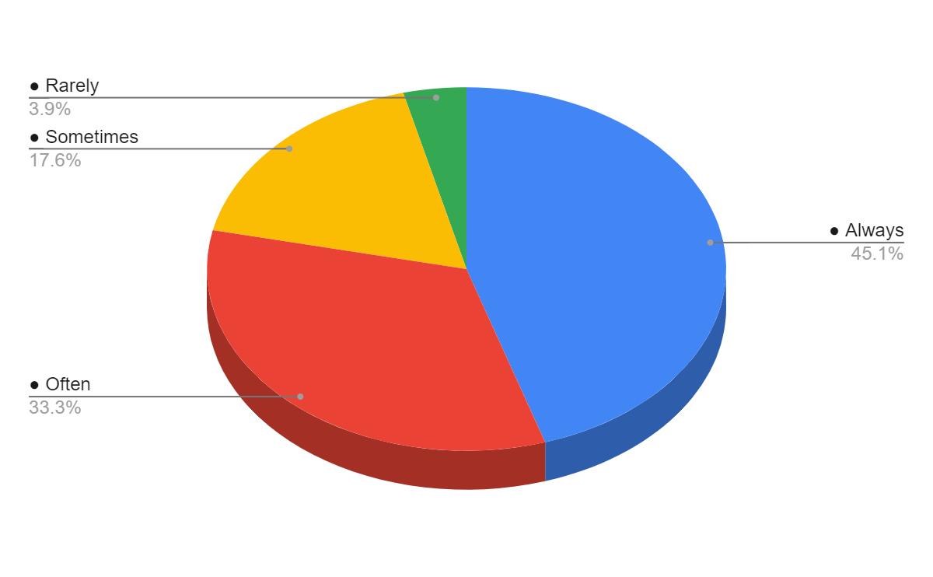

Figure 4.13: Consideration online reviews before selecting hotels
(Source: Survey)
The responses to the question show just how much of a factor online reviews are to consumers making decisions. A large proportion (45.10%) admit to always or often using online reviews when selecting hotels, underlining the clear impact customer feedback has on booking decisions. In addition, 31.37% of the respondents said that they frequently rely on reviews, motivating the value of reviews in depicting consumer attitudes and choices as well. Combined, these two segments comprise a large majority of consumers who consider online reviews to be an important part of choosing their hotel. Just 3.92% indicated they rarely look at online reviews, and none ever ignore them. The data is indicative of the widespread dependence on online reviews, as most respondents consult them frequently when considering a hotel.

Chapter 5: Discussion

5.1 Introduction
Considering the above-noted findings as well as observations made through critically reviewing literature, the present chapter has been attentive to have a critical discussion. Throughout the chapter, critical discussion will be conducted to reflect on the way research questions have been achieved. Moreover, the way theories have helped in the overall evaluation will also be reflected in this chapter. Furthermore, the chapter will address the constraints that have impacted the study's overall conclusions and results.

5.2 Discussion
The study has been presented based on undertaking the IMC and DM impact on customer behaviour specifically considering the analysis of the UK fooding and lodging busniess. Regarding this, significantly different research questions have been presented, such as RQ1 specifically referring to understanding the components of IMC that are specifically employed by UK hotels to sway customer behaviour. Connecting with the literature perspective of Fitri and Herdiansyah (2021), it has been effectively met through numerous different understandings of consumer perception through surveys towards the IMC strategy of UK hotels and the significant digital platforms and content for hotel booking. Moreover, RQ2 significantly focuses on analysing digital marketing techniques that prominently impact consumer booking behaviour, which is addressed through understanding insights of consumers towards the digital efforts of hotels. Regarding this, aligning the survey responses with the literature findings of Foris et al. (2020), SM platforms have been considered to be the most prominent context that impacts the booking decisions of consumers.
Apart from this, RQ3 significantly focuses on having an analysis of digital and traditional marketing strategies' efficacy for UK hotels. Regarding this, the following aspect has been while understanding the preferability of consumers' online marketing tools that are specifically relevant to them and impact their purchasing decision-making process. Besides this, interrelating with the literature of Sakas et al. (2022), the degree of customer happiness has been undertaken through the survey responses, which reflect the context of engagement and interaction with UK hotels that is relevant in terms of showcasing the growing context of the contrast between traditional and DM. Moreover, the final RQ4 refers to the consumer perception towards trustworthiness and authenticity of marketing communication through IMC strategy of UK hotels. This has been prominently mitigated in the survey responses in terms of identifying instances of personalised marketing influencing booking decisions along with the prominence of online reviews. Specifically, in comparison to the literature perspective of Taheri et al. (2020) sincerity in marketing and communication has been noted to be the most prominent aspects consumers focus on in terms of influencing their booking approach.
Hence, based on the study scenario and collected evidence the entire research work has answered all the research questions while testing the “H0: Digital marketing communications have a favourable influence on sales and profitability”.
The use of effective theoretical frameworks has played a profound role in elevating the study outcomes. The IMC approach and AMC theory reflect that emphasising effectively communicating with customers is a critical aspect for organisations to ensure success. Specifically, AMC theory highlighted the essentiality of emotional appeal of organisational communication with clients’, which is beneficial to be considered in the digital marketing efforts of businesses (Sütterlin and Yu, 2021). Moreover, the theoretic idea of IMC approach reflects the essentiality of unified brand messages across various online platforms and emphasising targeted marketing (Schultz, 2020). Regarding this, it is evident that the findings of this research have been consistent with these theoretical understandings, as findings clearly emphasised the significance of effectively communicating with consumers through digital advertising or other IMC initiatives.
Aside from that, while concerning digital marketing the SET and the RACE model have been taken into account. The theoretical idea of SET is noted to emphasise “trust” and “relationship satisfaction” (Thomas and Gupta, 2021). Likewise, the observations made by interpreting survey responses it is notable that IMC and digital marketing activities of UK hotels emphasise improving their brand perception among customers and relationship with them. These aspects further not only boost customer trust but also influence their hotel selection decisions. Besides, the RACE model clearly reflected the necessity for organisations in this sector to not only efficiently reach their target audience but also emphasise obtaining profit by increasing conversion rate through trust building (Poole et al. 2021). In consistency with the SET and RACE model, the research findings also revealed the essentiality for British hotels to maintain positive relationships with their customers and boost trust as well as loyalty among them. In support of this, survey findings also revealed that digital advertisements and other digital marketing efforts of hotels in the UK have been positively altering clients' perceptions toward hotel brands as well as the selection of hotels.
Besides, as this research has a considerable focus on clients’ behaviour in the British hotel sector, “Maslow’s hierarchy of Needs model”, the “model of the consumer decision-making process”, and the “three-stage model of perception model” have been considered. The “hierarchy of needs model” reveals the needs of individuals, which pointed out that businesses must emphasise the needs of individuals while they want to influence individuals’ behaviour (Dar and Sakthivel, 2022). Regarding this, observations made through the survey responses illustrated that organisations in the hotel sector must emphasise individuals' psychological needs and need for love and belonging. Moreover, in consistency with the consumer decision-making process model, findings revealed that customers consider online platforms for searching hotels and evaluating alternatives, making decisions regarding hotel booking. Besides, the three-stage model of perception reveals that customers' decision or selection of hotels is strongly based on their needs and demands (Jiao et al. 2020). For example, customers in this sector want organisations to have consistent brand messaging in various platforms, personalized offers, and frequency of communication as well as service response, which can boost their sense of connection with brands.
However, from the responses gained through the survey along with areas of the literature review and the reports of the hotels of the UK, no unexpected results have been found that needed additional justification or explanation. It is because Peter and Dalla Vecchia (2021) indicated IMC and marketing methods through digital platforms to be effective in creating awareness of the services provided by the hotels. It also assists in building quick connections between the customer and the organisation, thereby, building relevant bonds that ensure a loyal base of clients in the market. Most importantly, IMC is also considered to be a cost-effective approach that influences consumers' behaviour in a positive way, thereby ensuring high profitability to the overall industry in terms of gaining clients, enhancing sales, and acquiring high profits. In respect to this, it can further be mentioned that outcomes that have been gained in the current study are backed up by theoretical areas and logical instances, thus, improving the reliability of the derived output. Most importantly, the utilisation of real-time information also enhances the scope of success, thereby, driving relevant outcome based on the experience of clients of the hotel industry in the United Kingdom, both now and in the future.
The research includes critical findings related to the influence of IMC and digital marketing on behaviour intention of clients in the British hotel industry. However, this research has limitations such as the consideration of a limited sample size and the UK market only. While considering the regional limitation, it can be stated that the consideration of the UK market only has made the study focused on a single market. This further has prevented it from having a critical comparison of the influence of digital marketing and IMC on customer preferences between the UK and other markets. However, it is evident that a critical comparison of the influence of IMC initiatives of hotels of different markets and their influence on consumer behaviour has influenced the study outcome positively.
Aside from that, the fact cannot be ignored that as this research needs to be completed within a limited time span, it has been considered a very limited or small sample size, which has added a limitation in terms of integrating findings. Pointedly, having a considerably big sample size could have enhanced the study outcomes by providing more critical perspectives of customers. Moreover, considering the perspectives of industry professionals like marketing managers of UK hotels could have elevated the study findings to a great extent. These limitations have affected research results.

Chapter 6: Conclusion and recommendations

6.1 Summary
In this digitalised scenario of the hotel industry, in marketing, IMC and digital efforts of hoteliers have been positively assisting them in gaining desired outcomes of marketing functionalities. The overall finding of the study has pointed out that client behaviour in the hotel industry of Britain has been altered by rapid technological changes and the use of the internet as well as various online platforms. Pointedly, customers in this particular market are observed to emphasise searching for hotel properties on online sites and consider reviews or comments of clients, before making purchasing decisions. This indicates that emphasising online marketing and IMC has become imperative for UK hoteliers to draw the attention of clients and alter their behavioural intentions. Correspondingly, theoretical implications of the IMC approach and AMC have highlighted that businesses in this sector are required to effectively communicate with their clients through targeted marketing or promotional initiatives for shaping their behaviour intentions, which is beneficial for their sales growth.
However, findings from the survey result have made it clear that emphasizing boosting trust among clients is a pivotal factor for organisations, which must be stressed by hoteliers while they emphasize IMC. In support of this, the understanding of the SET and RACE model clearly illuminated that organisations must always take action through their marketing initiatives to build a positive relationship with their clients that emphasizes trust building. Moreover, it is also a notable fact that nowadays customers' expectations from hotels have been changing rapidly. In particular, customers expect organisations to be more focused on providing them with personalised service offerings, quality content in promotional activities, frequent communication with them and responding to their queries quickly. This also indicates the power of IMC and online marketing initiatives in the present corporate settings of the UK hotel industry. Overall, it is concluded that both DM and IMC efforts of UK hotels have the ability to positively impact clients' behavioural intentions.

6.2 Linking with Objectives
From the contemporary research, it can be regarded that four objectives have been developed that created a guideline for the conduction of the overall study. From the first research objective, “To explore the role of IMC in influencing consumer behaviour in the UK hotel industry” discussions within the Literature Review and survey conclude the fact that IMC plays an influential role in influencing the behaviour of customers positively by maintaining transparency regarding the services provided by the hotels of the UK that in turn encourages the behaviour of purchasing thereby developing trust among customers and maintaining a loyal base of customers in the market. Besides, the second objective is “To analyse the digital marketing techniques’ influence on consumer preferences and behaviours while booking in the UK hotel sector” and results gained from the survey and the literature review denoted the fact that digital advertising tactics appear to be influencing consumer choices and scheduling behaviour based on reviews left by previous users on the website.
Apart from that, the third objective is, “To compare the effectiveness of traditional marketing methods versus digital marketing in the context of the UK hotel industry” and the fourth objective, “To explore consumer perceptions of the authenticity and trustworthiness of marketing communications from UK hotels”. Summarising the survey result and literature review, it can be stated that Methods of digital advertising are thought to be more successful than conventional ones, and clients primarily look for genuineness and trustworthiness from UK resorts they book through social media platforms. This reveals the success of the current investigation further enhancing outcome credibility.

6.3 Revisiting the research questions
What components of integrated marketing communications are most effectively used by UK hotels to influence consumer behaviour?
While revisiting the first research question, it can be stated that different components of IMC are used by UK hotels for the pursuit of exploiting the conduct of consumers. This mainly includes advertisement within social media sites along with individual selling, direct marketing, promotion of sales, Public Relations (PR) and many others (Luck et al. 2020).
How do digital marketing techniques impact consumer preferences and booking behaviours in the UK hotel industry?
Upon visiting the second question of investigation, it can be revealed that techniques of digital marketing seem to be influencing the preferences of customers alongside booking behaviours by the feedback of other customers within online sites (Peter and Dalla Vecchia, 2021). It mainly assists in analysing the positive sides and services that are being offered by UK hotels further influencing the booking behaviour and consumer preferences accordingly.
What is the comparative effectiveness of traditional marketing methods versus digital marketing for UK hotels?
In an effort to revisit the third question of investigation, it has been evaluated that digital methods of marketing are considered to be more effective as compared to traditional ones. It is because digital methods for marketing assist customers to engage with the hotel further providing the hotels with the feasibility of maintaining transparency for gaining customers' trust and operating successfully.
How do consumers perceive the authenticity and trustworthiness of marketing communications from UK hotels?
In an endeavour to answer the 4th question of the investigation, it can be expressed that customers mainly demand trustworthiness and authenticity from the UK hotels which are being acquired from social media sites. Customers mainly check reviews on online portals of the UK hotels, thereby, deciding on the areas of staying within the hotel (Taheri et al. 2020).

6.4 Recommendations
Connecting to the identified aspects in terms of reflecting on the IMC strategy of the hotel industry impacting consumer behaviour and digital marketing significant sets of recommendations have been presented below that can prominently impact the betterment of the IMC strategy of hotels.
Transparency across organisational operation
Consumer trust has been identified to be the prominent area that is hindering the entire IMC strategy of the hotel business in the UK because consumers specifically maintain a stronger relationship with brands who are emphasising a transparent approach while maintaining authenticity. In this context, transparency has been noted to be integral factor for consumers in terms of improving relationships that can impact organisational churn rates, increasing customer loyalty, and revenue. Regarding this, in terms of improving transparency across UK hotels, the organisations are required to establish a policy of transparency that can positively impact the consumer's motivation towards making a connection with the brand.
Emphasising personalised offers
Personalisation has been identified to be a significant aspect that impacts improving client loyalty and brand visibility. In this context, it is suggested that UK hotels should focus on analysing their data for opportunities and insights while brainstorming ideas that can impact coming up with effective options for offers. This can significantly target the segmented individuals while improving their experience. Additionally, through the support of this recommendation, UK hotels can prominently repeat purchases and increase sales while improving customer loyalty, and satisfaction, and enhancing engagement, which can impact on the better consumer reviews on the websites while gaining a competitive advantage.
Establishing a content management team
Content management has been noted to be mostly last by consumers in terms of undertaking the IMC strategy of UK hotels. In this context, through the support of consistent branding, customisation, and improving analytics of business, UK hotels can significantly improve their content management. Moreover, establishing a team for content management would be a better option for the organisation that can help the business beyond major content while creating, improving, optimising, and delivering content to the right audience through the right channels, which can facilitate impactful experiences digitally. Additionally, effective content management would allow a business to develop user-friendly websites, which support the community effectively.
Creating an informative website
Creating an informative website is necessary in terms of improving an IMC strategy that can target adequate consumer segments while influencing their behaviour and purchasing aspects. In this regard, UK hotels are required to plan features and purpose of their website while emphasising designing templates, themes, colours, images, layouts, and navigations that suits the website's information. Websites can significantly increase sales and traffic, which can improve online presence management while building credibility, visibility, and brand awareness. This can exchange information adequately with targeted consumers while advertising the products and services the brands are offering while showcasing a growth opportunity and expanding customer reach. Currently, digital marketing has been extensively increasing, which is allowing businesses to generate leads with convenience. This allows consumers to have easy access to business information along with a company’s branding.

6.5 Future scope
As technological instances are increasingly adopted by different businesses for the purpose of integrating automation and enhancing operational efficiencies, therefore, the current research seems to have a high scope to assist businesses in the future. It is because the present study focuses on the impact of IMC along site DM on the behaviour of customers within the hotel sector. In this respect, awareness regarding DM and IMC can be ensured through this study further providing future scope for different hotels to integrate AI facilities by analysing its importance. Most importantly, the current research also serves high scope of generating awareness regarding the challenges and issues that are being faced by the hotel sector in terms of implementing DM and IMC. As a result of this, the significant impact due to the implementation of DM and IMC can be reviewed by the hotel sector, thereby, adding to the future scope of generating relevant awareness regarding the positive and negative areas of technology implementations within the marketing and communication areas. Nonetheless, strategies required for the mitigation of barriers related to the implementation of IMC and DM are also discussed in this study. This reveals another scope for the hotel sector in the future to deal with effective strategies that could enhance their technological operation.

Reference list
Adams, K. A., and McGuire, E. K. (2022). Research methods, statistics, and applications. Sage Publications. https://books.google.com/books?hl=enandlr=andid=enNYEAAAQBAJandoi=fndandpg=PT20anddq=primary+research+methodsandots=je4dfmoj5Eandsig=EMLy8TJmyuWnSkRHAoq9C94K_jE
Agrawal, N., Najafi-Asadolahi, S. and Smith, S.A., (2020). Optimization of operational decisions in digital advertising: A literature review (pp. 99-146). Springer International Publishing. https://is.muni.cz/th/isq90/DP_final.pdf
Akesson, B., Nasri, M., Nelissen, G., Altmeyer, S. and Davis, R.I., (2022). A comprehensive survey of industry practice in real-time systems. Real-Time Systems, 58(3), pp.358-398. https://link.springer.com/content/pdf/10.1007/s11241-021-09376-1.pdf
Akter, S., Dwivedi, Y.K., Sajib, S., Biswas, K., Bandara, R.J. and Michael, K., (2022). Algorithmic bias in machine learning-based marketing models. Journal of Business Research, 144, pp.201-216. https://www.sciencedirect.com/science/article/pii/S0148296322000959
Alharahsheh, H.H. and Pius, A., (2020). A review of key paradigms: Positivism VS interpretivism. Global Academic Journal of Humanities and Social Sciences, 2(3), pp.39-43. https://gajrc.com/media/articles/GAJHSS_23_39-43_VMGJbOK.pdf
Amagsila, F., Cadavis, E.M., Callueng, J.P. and Manio, J.R., (2022). The impact of influencer marketing on consumers’ brand perception of travel applications. Journal of Business and Management Studies, 4(2), pp.241-255. https://www.al-kindipublisher.com/index.php/jbms/article/download/3180/2777
Aminullah JR, R.X. and Kristiyono, J., (2021). Internet Marketing Strategy Demandailing Café in Building a Digital Brand on Instagram. Communicare: Journal of Communication Studies, 8(2), pp.165-178. https://journal.lspr.edu/index.php/communicare/article/download/312/155
Amoako, G.K., Doe, J.K. and Neequaye, E.K., (2023). Online innovation and repurchase intentions in hotels: the mediating effect of customer experience. International Hospitality Review, 37(1), pp.28-47. https://www.emerald.com/insight/content/doi/10.1108/IHR-02-2021-0008/full/html
Baldwin, J.R., Pingault, J.B., Schoeler, T., Sallis, H.M. and Munafò, M.R., (2022). Protecting against researcher bias in secondary data analysis: challenges and potential solutions. European Journal of Epidemiology, 37(1), pp.1-10. https://link.springer.com/content/pdf/10.1007/s10654-021-00839-0.pdf
Balsiger, P., Jammet, T., Cianferoni, N. and Surdez, M., (2023). Coping with digital market re-organization: How the hotel industry strategically responds to digital platform power. Competition & Change, 27(1), pp.163-183. https://journals.sagepub.com/doi/pdf/10.1177/10245294211055612
Banyeva, I., Lebedieva, N., Parfinenko, T., Velychko, O., Petrova, O. and Peresichna, S., (2023). Digital Tools of Marketing Strategies in Hotel Branding. Journal of Information Technology Management, 15(1), pp.62-88. https://jitm.ut.ac.ir/article_90726_685c759b58e19850dfab7780c2d89c31.pdf
Beck, B.B., Wuyts, S. and Jap, S., (2024). Guardians of trust: How review platforms can fight fakery and build consumer trust. Journal of Marketing Research, 61(4), pp.682-699. https://www.ftc.gov/system/files/ftc_gov/pdf/r311003presentationbeckwuytsjap20240213.pdf
Blakeman, R., (2023). Integrated marketing communication: creative strategy from idea to implementation. Rowman & Littlefield. https://thuvienso.hoasen.edu.vn/bitstream/handle/123456789/12524/Contents.pdf?sequence=1&isAllowed=y
Brick, T.R., Mundie, J., Weaver, J., Fraleigh, R. and Oravecz, Z., (2020). Low-burden mobile monitoring, intervention, and real-time analysis using the wear-it framework: example and usability study. JMIR formative research, 4(6), p.e16072. https://formative.jmir.org/2020/6/e16072/
Dar, S.A. and Sakthivel, P., (2022). Maslow’s Hierarchy of Needs Is still Relevant in the 21st Century. Journal of Learning and Educational Policy, 2(5), pp.1-9. https://www.researchgate.net/profile/Showkat-Dar-13/publication/368327434_Maslow's_Hierarchy_of_Needs_Is_still_Relevant_in_the_21st_Century/links/640887240d98a97717ec841e/Maslows-Hierarchy-of-Needs-Is-still-Relevant-in-the-21st-Century.pdf?origin=journalDetail&_tp=eyJwYWdlIjoiam91cm5hbERldGFpbCJ9
Dehalwar, K., and Sharma, S. N. (2024). Exploring the Distinctions between Quantitative and Qualitative Research Methods. Think India Journal, 27(1), 7-15. https://www.thinkindiaquarterly.org/index.php/think-india/article/download/20451/15223
Di Domenico, G., Sit, J., Ishizaka, A. and Nunan, D., (2021). Fake news, social media and marketing: A systematic review. Journal of Business Research, 124, pp.329-341. https://orca.cardiff.ac.uk/id/eprint/150514/1/Fake_News_Social_Media_and_Marketing.pdf
Dolnicar, S. (2020). Why quantitative papers based on primary data get desk-rejected by Annals of Tourism Research. Annals of Tourism Research, 83, 102981. https://www.ncbi.nlm.nih.gov/pmc/articles/PMC7365648/
Fader, P., (2020). Customer centricity: Focus on the right customers for strategic advantage. University of Pennsylvania Press. https://executiveeducation.wharton.upenn.edu/wp-content/uploads/2019/01/Customer-Centricity-Excerpt-2019.pdf
Fitri, U.D. and Herdiansyah, H., (2021). The Influence of IMC Implementation on the Brand Awareness of BLANJA. com. Jurnal Komunikasi Global, 10(1), pp.120-136. https://jurnal.usk.ac.id/JKG/article/download/20156/14199
Foris, D., Tecau, A.S., Hartescu, M. and Foris, T., (2020). Relevance of the features regarding the performance of booking websites. Tourism Economics, 26(6), pp.1021-1041. https://www.academia.edu/download/108802947/135481661984579020231212-1-a15ndx.pdf
Gupta, A., Dash, S. and Mishra, A., (2019). All that glitters is not green: Creating trustworthy ecofriendly services at green hotels. Tourism Management, 70, pp.155-169. https://www.academia.edu/download/93692086/j.tourman.2018.08.01520221105-1-ct98m6.pdf
Hegner, S.M., Lotze, C. and Beldad, A.D., (2021). Emoticons are not for everyone: The role of congruence between hotel brand positioning strategies and communication style in enhancing customers’ brand attitude and booking intention. Tourism and Hospitality Research, 21(3), pp.317-329. https://research.utwente.nl/files/266764632/Hegner_2021_Emoticons_are_not_for_everyone_the_.pdf
Hossain, M.S., Sambasivan, M., Abuelhassan, A.E. and Khalifa, G.S.A., (2023). Factors influencing customer citizenship behaviour in the hospitality industry. Annals of Leisure Research, 26(1), pp.65-88. https://www.academia.edu/download/108874239/11745398.2020.185030220231213-1-hyg0aw.pdf
IBISWorld, (2024). Hotels in the UK - Number of Businesses. [Online]. Available at: https://www.ibisworld.com/united-kingdom/number-of-businesses/hotels/3375/#:~:text=There%20are%209%2C876%20Hotels%20businesses,five%20years%20between%202018%20%2D%202023 [Accessed on 14 August 2024]
Ibrahim, B., (2021). The nexus between social media marketing activities and brand loyalty in hotel facebook pages: A multi-group analysis of hotel ratings. Tourism: An International Interdisciplinary Journal, 69(2), pp.228-245. https://hrcak.srce.hr/file/376970
Ibrahim, Y., Abbas, T.M. and Kamal, M.A., (2021). The impact of online communities-based social customer relationship management (S-CRM) on customer loyalty and brand image on hotels. Journal of Association of Arab Universities for Tourism and Hospitality, 21(2), pp.206-232. https://journals.ekb.eg/article_184932_5b050b661d904153457bbc0d09454f73.pdf
Ikegwu, A.C., Nweke, H.F., Anikwe, C.V., Alo, U.R. and Okonkwo, O.R., (2022). Big data analytics for data-driven industry: a review of data sources, tools, challenges, solutions, and research directions. Cluster Computing, 25(5), pp.3343-3387. https://www.academia.edu/download/115565302/Ikegwu_et_al_2022_Big_data_analytics_for_data_driven_industry_a_review_of.pdf
Jain, N., (2021). Survey versus interviews: Comparing data collection tools for exploratory research. The Qualitative Report, 26(2), pp.541-554. https://www.sciencedirect.com/science/article/pii/S1551714421000264
Jiao, W., Chen, H. and Yuan, Y., (2020). Understanding users’ dynamic behavior in a free trial of IT services: A three-stage model. Information & Management, 57(6), p.103238. https://www.sciencedirect.com/science/article/pii/S0378720618304075
Jones, W., (2021). Email Marketing. Editora Bibliomundi. https://www.elissatalley.com/s/EmailMarketingCliffNotes.pdf
Jusuf, D.I., (2024). Integrated Marketing: A Powerful Strategy for Increasing Brand Awareness. Best Journal of Administration and Management, 2(3), pp.104-109. https://internationalpublisher.id/journal/index.php/Bejam/article/download/149/159
Kronemann, B., Kizgin, H., Rana, N. and K. Dwivedi, Y., (2023). How AI encourages consumers to share their secrets? The role of anthropomorphism, personalisation, and privacy concerns and avenues for future research. Spanish Journal of Marketing-ESIC, 27(1), pp.3-19. https://www.emerald.com/insight/content/doi/10.1108/SJME-10-2022-0213/full/html
Kumar, P. and Singh, G., (2020). Using social media and digital marketing tools and techniques for developing brand equity with connected consumers. In Handbook of research on innovations in technology and marketing for the connected consumer (pp. 336-355). IGI Global. https://www.researchgate.net/profile/Pawan-Kumar-161/publication/361080712_Using_Social_Media_and_Digital_Marketing_Tools_and_Techniques_for_Developing_Brand_Equity_With_Connected_Consumers/links/6624a7da43f8df018d1e5609/Using-Social-Media-and-Digital-Marketing-Tools-and-Techniques-for-Developing-Brand-Equity-With-Connected-Consumers.pdf
Luck, E., Barker, N., Sassenberg, A.M., Chitty, B., Shimp, T.A. and Andrews, J.C., (2020). Integrated marketing communications. Cengage AU. https://books.google.com/books?hl=en&lr=&id=sdsBEAAAQBAJ&oi=fnd&pg=PR11&dq=IMC+is+an+approach+that+helps+in+leveraging+the+marketing+initiatives,+increasing+the+brand+association+and+increasing+integrates+with+the+others+to+form+a+more+coherent+and+powerful+message+to+the+consumers+in+UK+hotels&ots=te6Lf6kEU_&sig=0U4a-0WKA2d9WhtYAk1dIsOI6KA
Luck, E., Barker, N., Sassenberg, A.M., Chitty, B., Shimp, T.A. and Andrews, J.C., (2020). Integrated marketing communications. Cengage AU. https://books.google.com/books?hl=en&lr=&id=sdsBEAAAQBAJ&oi=fnd&pg=PR11&dq=organisational+management+makes+it+possible+to+target+their+IMC+strategies+to+meet+the+audience%27s%E2%80%99+needs+for+the+right+information,+in+the+right+place+at+the+right+time&ots=te6Lf6lASY&sig=4UDeQp659W-kM2d7nkINIsQdOls
Mahmutović, K., (2021). Development and validation of the scale for measuring digital marketing orientation in the hotel industry. EKONOMSKI VJESNIK/ECONVIEWS: REVIEW OF CONTEMPORARY BUSINESS, ENTREPRENEURSHIP AND ECONOMIC ISSUES, 34(1), pp.115-129. https://hrcak.srce.hr/ojs/index.php/ekonomski-vjesnik/article/download/12945/9385
Mancino, S., (2020). Doing philosophy and rhetoric historically: A review of the philosophy of communication. Communication Research Trends, 39(2), pp.5-26. https://search.proquest.com/openview/240d21cac70e54852d7ab9c0b092fef1/1?pq-origsite=gscholar&cbl=1576344
Mardiana, S., (2020). Modifying research onion for information systems research. Solid State Technology, 63(4), pp.5304-5313. https://www.researchgate.net/profile/Siti-Mardiana/publication/359542575_Modifying_Research_Onion_for_Information_Systems_Research/links/62432dc07931cc7ccf033406/Modifying-Research-Onion-for-Information-Systems-Research.pdf
Mathotaarachchi, K.P. and Thilakarathna, K.A.A.N., (2021). Philosophy of approaches in social sciences: A review of positivism, phenomenology and critical social sciences in qualitative research. Technium Soc. Sci. J., 20, p.944. https://techniumscience.com/index.php/socialsciences/article/download/3559/1362
Mbanaso, U.M., Abrahams, L. and Okafor, K.C., (2023). Research philosophy, design and methodology. In Research Techniques for Computer Science, Information Systems and Cybersecurity (pp. 81-113). Cham: Springer Nature Switzerland. https://link.springer.com/chapter/10.1007/978-3-031-30031-8_6
Meira, J.V.D.S. and Hancer, M., (2021). Using the social exchange theory to explore the employee-organization relationship in the hospitality industry. International Journal of Contemporary Hospitality Management, 33(2), pp.670-692. https://www.emerald.com/insight/content/doi/10.1108/IJCHM-06-2020-0538/full/html
Mishra, R. and Amin, S., (2020). COMPARATIVE EVALUATION OF THE DIGITAL MARKETING PROCESS TO IMPROVE REVENUE AND CONVERSION RATES THROUGH REAL-TIME INTERACTIONS WITH SPECIFIC AUDIENCES. International Journal of Management (IJM), 11(4). https://www.researchgate.net/profile/Shahid-Amin-10/publication/365126324_COMPARATIVE_EVALUATION_OF_THE_DIGITAL_MARKETING_PROCESS_TO_IMPROVE_REVENUE_AND_CONVERSION_RATES_THROUGH_REAL-TIME_INTERACTIONS_WITH_SPECIFIC_AUDIENCES/links/63654c49431b1f53006d6d64/COMPARATIVE-EVALUATION-OF-THE-DIGITAL-MARKETING-PROCESS-TO-IMPROVE-REVENUE-AND-CONVERSION-RATES-THROUGH-REAL-TIME-INTERACTIONS-WITH-SPECIFIC-AUDIENCES.pdf
Mishra, R., Singh, R.K. and Koles, B., (2021). Consumer decision‐making in Omnichannel retailing: Literature review and future research agenda. International Journal of Consumer Studies, 45(2), pp.147-174. https://onlinelibrary.wiley.com/doi/abs/10.1111/ijcs.12617
Mohajan, H. K. (2020). Quantitative research: A successful investigation in natural and social sciences. Journal of Economic Development, Environment and People, 9(4), 50-79. https://mpra.ub.uni-muenchen.de/105149/1/MPRA_paper_105149.pdf
Mohammad, A.A., Elshaer, I.A., Azazz, A.M., Kooli, C., Algezawy, M. and Fayyad, S., (2024). The Influence of Social Commerce Dynamics on Sustainable Hotel Brand Image, Customer Engagement, and Booking Intentions. Sustainability, 16(14), p.6050. https://www.mdpi.com/2071-1050/16/14/6050
Neale, B., (2020). Qualitative longitudinal research: Research methods. Bloomsbury Publishing. https://books.google.com/books?hl=en&lr=&id=N5EFEAAAQBAJ&oi=fnd&pg=PR3&dq=secondary+research+to+be+a+method+where+researchers+are+involved+in+collecting+previous+information+accumulated+by+previous+researchers+in+the+field&ots=OVB33uJFGB&sig=Adta6Wog722dgx5K_YO2H4owH2w
Niaz, S., Salam, T. and Nazir, S., (2023). Statistical Methods in Computer Science: A Comparative Review of Inductive and Deductive Approaches. VAWKUM Transactions on Computer Sciences, 11(1), pp.204-216. https://www.vfast.org/journals/index.php/VTCS/article/download/1407/1208
Peter, M.K. and Dalla Vecchia, M., (2021). The digital marketing toolkit: a literature review for the identification of digital marketing channels and platforms. New trends in business information systems and technology: Digital innovation and digital business transformation, pp.251-265. https://www.researchgate.net/profile/Marc-Peter/publication/342784263_The_Digital_Marketing_Toolkit_A_Literature_Review_for_the_Identification_of_Digital_Marketing_Channels_and_Platforms/links/64059fbc0cf1030a56777e0c/The-Digital-Marketing-Toolkit-A-Literature-Review-for-the-Identification-of-Digital-Marketing-Channels-and-Platforms.pdf
Petrosyan, A., (2024). Number of internet and social media users worldwide as of April 2024. [Online]. Available at: https://www.statista.com/statistics/617136/digital-population-worldwide/ [Accessed on 14 August 2024]
Poole, S.M., Grier, S.A., Thomas, K.D., Sobande, F., Ekpo, A.E., Torres, L.T., Addington, L.A., Weekes-Laidlow, M. and Henderson, G.R., (2021). Operationalizing critical race theory in the marketplace. Journal of Public Policy & Marketing, 40(2), pp.126-142. https://epublications.marquette.edu/cgi/viewcontent.cgi?article=1572&context=comm_fac
Porcu, L., del Barrio-García, S., Alcántara-Pilar, J.M. and Crespo-Almendros, E., (2019). Analyzing the influence of firm-wide integrated marketing communication on market performance in the hospitality industry. International Journal of Hospitality Management, 80, pp.13-24. https://digibug.ugr.es/bitstream/handle/10481/86425/Post%20print%20Porcu%20et%20al%202019.pdf?sequence=1
Powell, H., (2021). The advertising revolution: Past, present and future. In Innovations in Magazine Publishing (pp. 103-126). Routledge. https://openresearch.lsbu.ac.uk/download/70c724f546f07787846cb59adfb1a2b55a7b3f6382ed728f27f0ad9de1774535/1428841/Powell%20magazine%20advertising%20chapter.pdf
Proudfoot, K., (2023). Inductive/deductive hybrid thematic analysis in mixed methods research. Journal of mixed methods research, 17(3), pp.308-326. https://journals.sagepub.com/doi/pdf/10.1177/15586898221126816
Rabindranath, M. and Singh, A.K., (2024). Types of Advertising. In Advertising Management: Concepts, Theories, Research and Trends (pp. 39-78). Singapore: Springer Nature Singapore. https://link.springer.com/chapter/10.1007/978-981-99-8657-6_2
Rajesh, S., Abd Algani, Y.M., Al Ansari, M.S., Balachander, B., Raj, R., Muda, I., Bala, B.K. and Balaji, S., (2022). Detection of features from the internet of things customer attitudes in the hotel industry using a deep neural network model. Measurement: Sensors, 22, p.100384. https://www.sciencedirect.com/science/article/pii/S2665917422000186
Rana, J., Gutierrez, P. L., and Oldroyd, J. C. (2021). Quantitative Methods. Global Encyclopedia of Public Administration, Public Policy, and Governance, 1-6. https://www.researchgate.net/profile/Juwel-Rana/publication/352356475_Quantitative_Methods/links/62a622eea3fe3e3df8725b28/Quantitative-Methods.pdf
Rehman, S.U., Gulzar, R. and Aslam, W., (2022). Developing the integrated marketing communication (imc) through social media (sm): the modern marketing communication approach. Sage Open, 12(2), p.21582440221099936. https://journals.sagepub.com/doi/pdf/10.1177/21582440221099936
Rehman, S.U., Gulzar, R. and Aslam, W., (2022). Developing the integrated marketing communication (imc) through social media (sm): the modern marketing communication approach. Sage Open, 12(2), p.21582440221099936. https://journals.sagepub.com/doi/pdf/10.1177/21582440221099936
Rehman, S.U., Gulzar, R. and Aslam, W., (2022). Developing the integrated marketing communication (imc) through social media (sm): the modern marketing communication approach. Sage Open, 12(2), p.21582440221099936. https://journals.sagepub.com/doi/pdf/10.1177/21582440221099936
Rossanty, Y., Nasution, M.D.T.P. and Irawan, I., (2019). Communication and customer relations strategy in improving hotel guests’ satisfaction in Samosir tourism area, North Sumatra, Indonesia. International Journal of Management (IJM), 10(6). https://www.academia.edu/download/61702671/IJM_10_06_009_120200107-43601-4r64eu.pdf
Rowles, D., (2022). Digital branding: a complete step-by-step guide to strategy, tactics, tools and measurement. Kogan Page Publishers. https://www.durnell.co.uk/uploads/newsletters/Business_Sales-and-Marketing-2021_catalogue.pdf
Sakas, D.P., Reklitis, D.P., Terzi, M.C. and Vassilakis, C., (2022). Multichannel digital marketing optimizations through big data analytics in the tourism and hospitality industry. Journal of Theoretical and Applied Electronic Commerce Research, 17(4), pp.1383-1408. https://www.mdpi.com/0718-1876/17/4/70
Saunders, M. N. K., Lewis, P., and Thornhill, A. (2022). Research methods for business students (Eighth edition.). Pearson. https://www.pearson.com/nl/en_NL/higher-education/subject-catalogue/business-and-management/Research-methods-for-business-students-8e-saunders.html
Schultz, D.E., (2020). From advertising to integrated marketing communications. In A reader in marketing communications (pp. 10-40). Routledge. https://www.taylorfrancis.com/chapters/edit/10.4324/9781003060420-2/advertising-integrated-marketing-communications-schultz
Statista, (2024). Digitalization of hospitality worldwide - statistics & facts. https://www.statista.com/topics/8339/digitalization-of-the-hospitality-industry/ [Accessed on 14 August 2024]
Statista, (2024). Market size of the hotel industry in the United Kingdom from 2013 to 2023, with a forecast for 2024. https://www.statista.com/statistics/1364712/hotel-industry-market-size-uk/#:~:text=In%202023%2C%20the%20market%20size,around%20400%20million%20British%20pounds. [Accessed on 14 August 2024]
Sütterlin, C. and Yu, X., (2021). Aristotle's dream: Evolutionary and neural aspects of aesthetic communication in the arts. PsyCh Journal, 10(2), pp.224-243. https://onlinelibrary.wiley.com/doi/pdfdirect/10.1002/pchj.416
Svendsen, K., (2024). Addressing Rising Customer Expectations In Hospitality. https://www.forbes.com/councils/forbesbusinesscouncil/2024/02/15/addressing-rising-customer-expectations-in-hospitality/ [Accessed on 14 August 2024]
Taherdoost, H. (2022). What are different research approaches? Comprehensive Review of Qualitative, quantitative, and mixed method research, their applications, types, and limitations. Journal of Management Science and Engineering Research, 5(1), 53-63. https://hal.science/hal-03741840/file/What%20Are%20Different%20Research%20Approaches%20Comprehensive%20Review%20of%20Qualitative%2C%20Quantitative%2C%20and%20Mixed%20Method%20Research%2C%20Their%20Applications%2C%20Types%2C%20and%20Limitations.pdf
Taherdoost, H., (2021). Data collection methods and tools for research; a step-by-step guide to choose data collection technique for academic and business research projects. International Journal of Academic Research in Management (IJARM), 10(1), pp.10-38. https://hal.science/hal-03741847/document
Taheri, B., Gannon, M.J. and Kesgin, M., (2020). Visitors’ perceived trust in sincere, authentic, and memorable heritage experiences. The Service Industries Journal, 40(9-10), pp.705-725. https://napier-repository.worktribe.com/preview/1958475/Visitors%20perceived%20trust%20in%20sincere...AAM.pdf
Thomas, A. and Gupta, V., (2021). Social capital theory, social exchange theory, social cognitive theory, financial literacy, and the role of knowledge sharing as a moderator in enhancing financial well-being: from bibliometric analysis to a conceptual framework model. Frontiers in Psychology, 12, p.664638. https://www.frontiersin.org/articles/10.3389/fpsyg.2021.664638/pdf
Trenholm, S., (2020). Thinking through communication: An introduction to the study of human communication. Routledge. https://www.taylorfrancis.com/books/mono/10.4324/9781003016366/thinking-communication-sarah-trenholm
White, K., Habib, R. and Hardisty, D.J., (2019). How to SHIFT consumer behaviors to be more sustainable: A literature review and guiding framework. Journal of marketing, 83(3), pp.22-49. https://journals.sagepub.com/doi/full/10.1177/0022242919825649
Wynn, M. and Lam, C., (2023). Digitalisation and IT strategy in the hospitality industry. Systems, 11(10), p.501. https://www.mdpi.com/2079-8954/11/10/501
Xiang, K., Huang, W.J., Gao, F. and Lai, Q., (2022). COVID-19 prevention in hotels: Ritualized host-guest interactions. Annals of Tourism Research, 93, p.103376. https://www.ncbi.nlm.nih.gov/pmc/articles/PMC8853753/
Hong, S.R., Hullman, J. and Bertini, E., (2020). Human factors in model interpretability: Industry practices, challenges, and needs. Proceedings of the ACM on Human-Computer Interaction, 4(CSCW1), pp.1-26. https://dl.acm.org/doi/abs/10.1145/3392878

Appendices

Appendix 1: Survey questionnaire
Q1. What is your age group?
Options | Number of total respondents | Number of responses | Percentage
Under 18 | 51 | 2 | 3.92%
18-24 | 51 | 9 | 15.69%
25-34 | 51 | 38 | 74.51%
35-44 | 51 | 1 | 1.96%
45-54 | 51 | 1 | 1.96%
55-64 | 51 | 1 | 1.96%
65 and over | 51 | 0 | 0.00%

Q2. What is your gender?

Options | Number of total respondents | Number of responses | Percentage
Male | 51 | 34 | 64.7%
Female | 51 | 13 | 29.4%
Prefer not to say | 51 | 2 | 5.9%

Q3. What is your current profession?

Options | Number of total respondents | Number of responses | Percentage
Student | 51 | 7 | 13.73%
Employed full-time | 51 | 28 | 54.9%
Employed part-time | 51 | 6 | 11.76%
Self-employed | 51 | 4 | 7.84%
Unemployed | 51 | 5 | 9.80%
Retired | 51 | 0 | 0%
Other (please specify) | 51 | 3 | 5.88%

Q4. How often do you visit hotels?

Options | Number of total respondents | Number of responses | Percentage
Never | 51 | 2 | 3.92%
Rarely | 51 | 14 | 27.45%
Occasionally | 51 | 28 | 54.90%
Frequently | 51 | 6 | 11.76%
Very often | 51 | 1 | 1.96%

Q5. How often do you use online platforms to search hotels before booking?

Options | Number of total respondents | Number of responses | Percentage
Daily | 51 | 8 | 15.69%
Weekly | 51 | 6 | 11.76%
Monthly | 51 | 10 | 19.61%
Rarely | 51 | 22 | 43.14%
Never | 51 | 5 | 9.80%

Q6. Which online marketing channels do you consider most relevant when looking for hotels?
Options | Number of total respondents | Number of responses | Percentage
Social media ads | 51 | 7 | 14%
Hotel websites | 51 | 17 | 33%
Email newsletters | 51 | 1 | 2%
Online reviews and ratings | 51 | 18 | 35%
Search engine ads | 51 | 2 | 4%
Influencer recommendations | 51 | 6 | 12%

Q7. How pivotal is a hotel's digital presence in your purchasing decision-making process?
Options | Number of total respondents | Number of responses | Percentage
Very important | 51 | 16 | 31%
Important | 51 | 19 | 37%
Neutral | 51 | 13 | 25%
Not very important | 51 | 2 | 4%
Not important at all | 51 | 1 | 2%

Q8. Have you ever got influenced to consider hotels because of a targeted online advertisement?
Options | Number of total respondents | Number of responses | percentage
Yes | 51 | 24 | 47%
No | 51 | 16 | 31%
Not sure | 51 | 11 | 22%

Q9. How do you perceive the efficacy of IMC (integrated marketing communications) strategies used by hotels in the UK?
Options | Numbers of total respondents | Number of responses | percentage
Very effective | 51 | 9 | 58%
Effective | 51 | 21 | 23%
Neutral | 51 | 18 | 10%
Ineffective | 51 | 2 | 9%
Very ineffective | 51 | - | -

Q10. Which aspect of UK hotels’ IMC strategy do you consider most persuasive?

Options | Numbers of total respondents | Number of responses | percentage
Consistent messaging across platforms | 51 | 7 | 14%
Personalization of offers | 51 | 15 | 30%
Quality of content (e.g., images, videos) | 51 | 15 | 30%
Frequency of communication | 51 | 5 | 10%
Customer service response | 51 | 8 | 16%

Q11. How does personalised marketing influence your booking decisions?

Options | Number of total respondents | Number of responses | Percentage
Strongly increases likelihood | 51 | 12 | 23.53%
Slightly increases likelihood | 51 | 27 | 52.94%
No effect | 51 | 7 | 13.73%
Slightly decreases likelihood | 51 | 2 | 3.92%
Strongly decreases likelihood | 51 | 1 | 1.96%

Q12. How often do you consider online reviews before selecting hotels?

Options | Number of total respondents | Number of responses | Percentage
Always | 51 | 23 | 45.10%
Often | 51 | 16 | 31.37
Sometimes | 51 | 9 | 17.65%
Rarely | 51 | 2 | 3.92%
Never | 51 | 1 | 1.96%

Q13. To what extent does hotels’ reputation on social media platforms impact your booking decision?
Options | Number of total respondents | Number of responses | percentage
Very much | 51 | 22 | 43%
Somewhat | 51 | 13 | 25%
Neutral | 51 | 11 | 22%
Not much | 51 | 5 | 10%

Q14. How satisfied are you with the level of interaction and engagement UK hotels have with their clients on digital platforms?
Options | Number of total respondents | Number of responses | Percentage
Very satisfied | 51 | 10 | 20%
Satisfied | 51 | 24 | 47%
Neutral | 51 | 14 | 27%
Dissatisfied | 51 | 2 | 4%
Very dissatisfied | 51 | 1 | 2%

Q15. What type of content do you mostly prefer on digital platforms of hotels?

Options | Numbers of total respondents | Number of responses | percentage
Promotional discounts and offers | 51 | 16 | 28%
Testimonials of customers and reviews | 51 | 9 | 15%
Content related to behind-the-scenes | 51 | 12 | 21%
Information regarding amenities and services | 51 | 13 | 22%
Travel tips | 51 | 2 | 14%

Q16. Do you think that a hotel's digital effort to advertise affects the prevalent perception of the brand?
Options | Numbers of total respondents | Number of responses | percentage
Strongly agree | 51 | 20 | 39%
Agree | 51 | 25 | 49%
Neutral | 51 | 3 | 6%
Disagree | 51 | 1 | 2%
Strongly disagree | 51 | 2 | 4%

Appendix 2: Final Google form
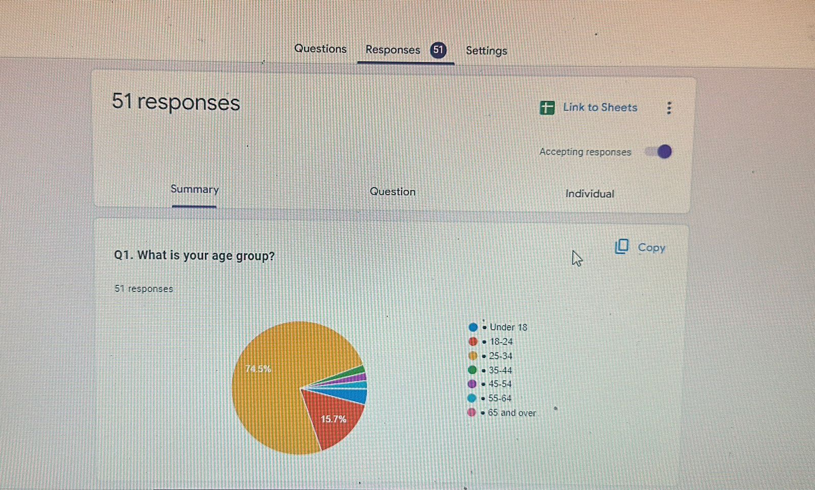
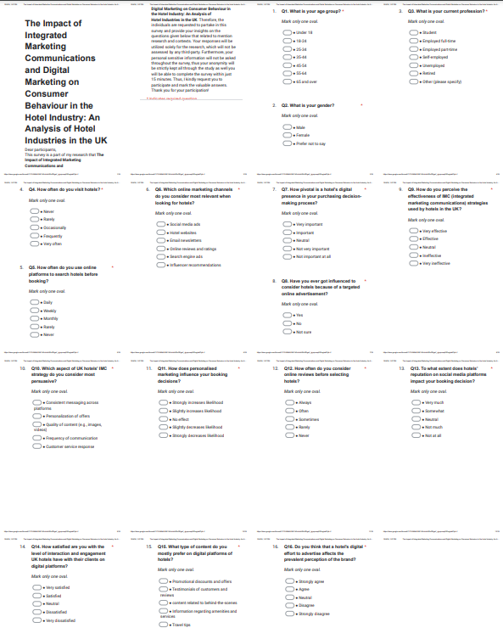

Appendix 3: Responses

Response 1
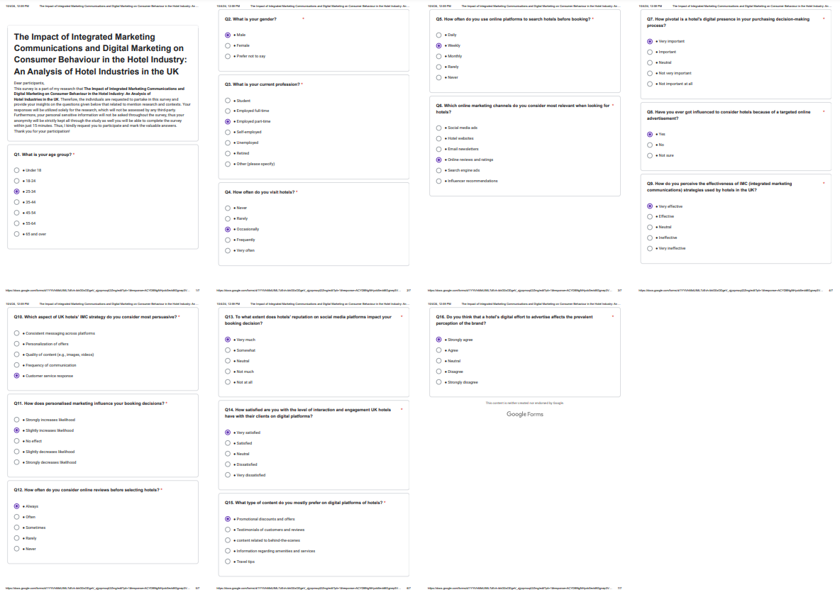

Response 2
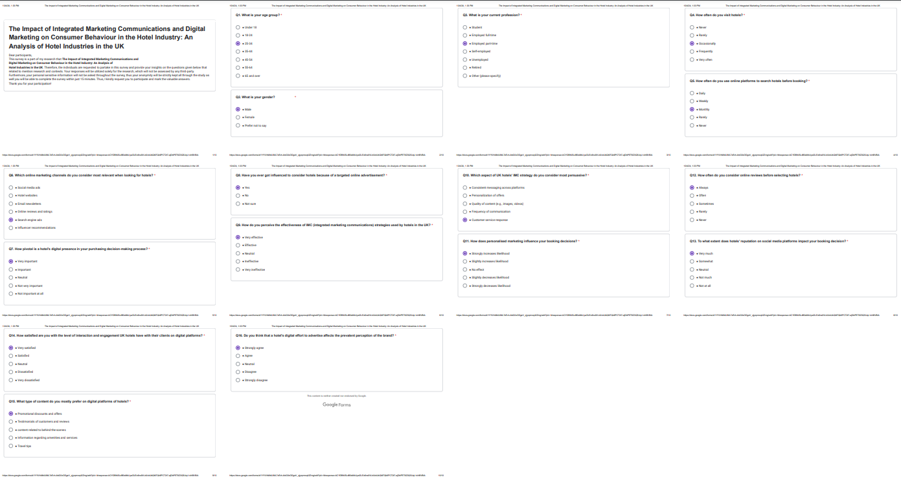

Response 3
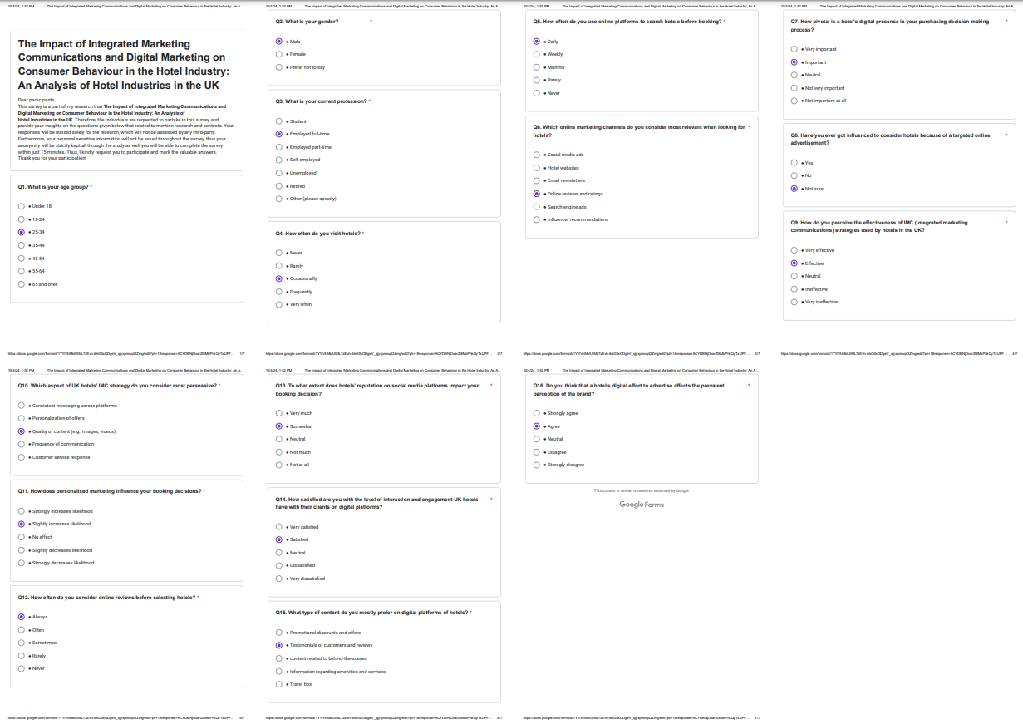

Response 4
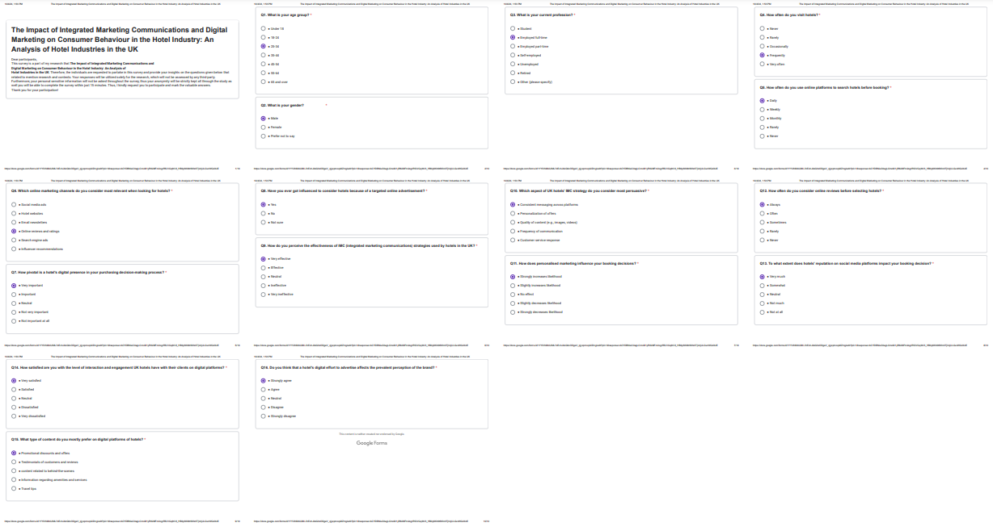

Response 5


