Field and Lab Skills in Relation to River Flooding 07/02/2022
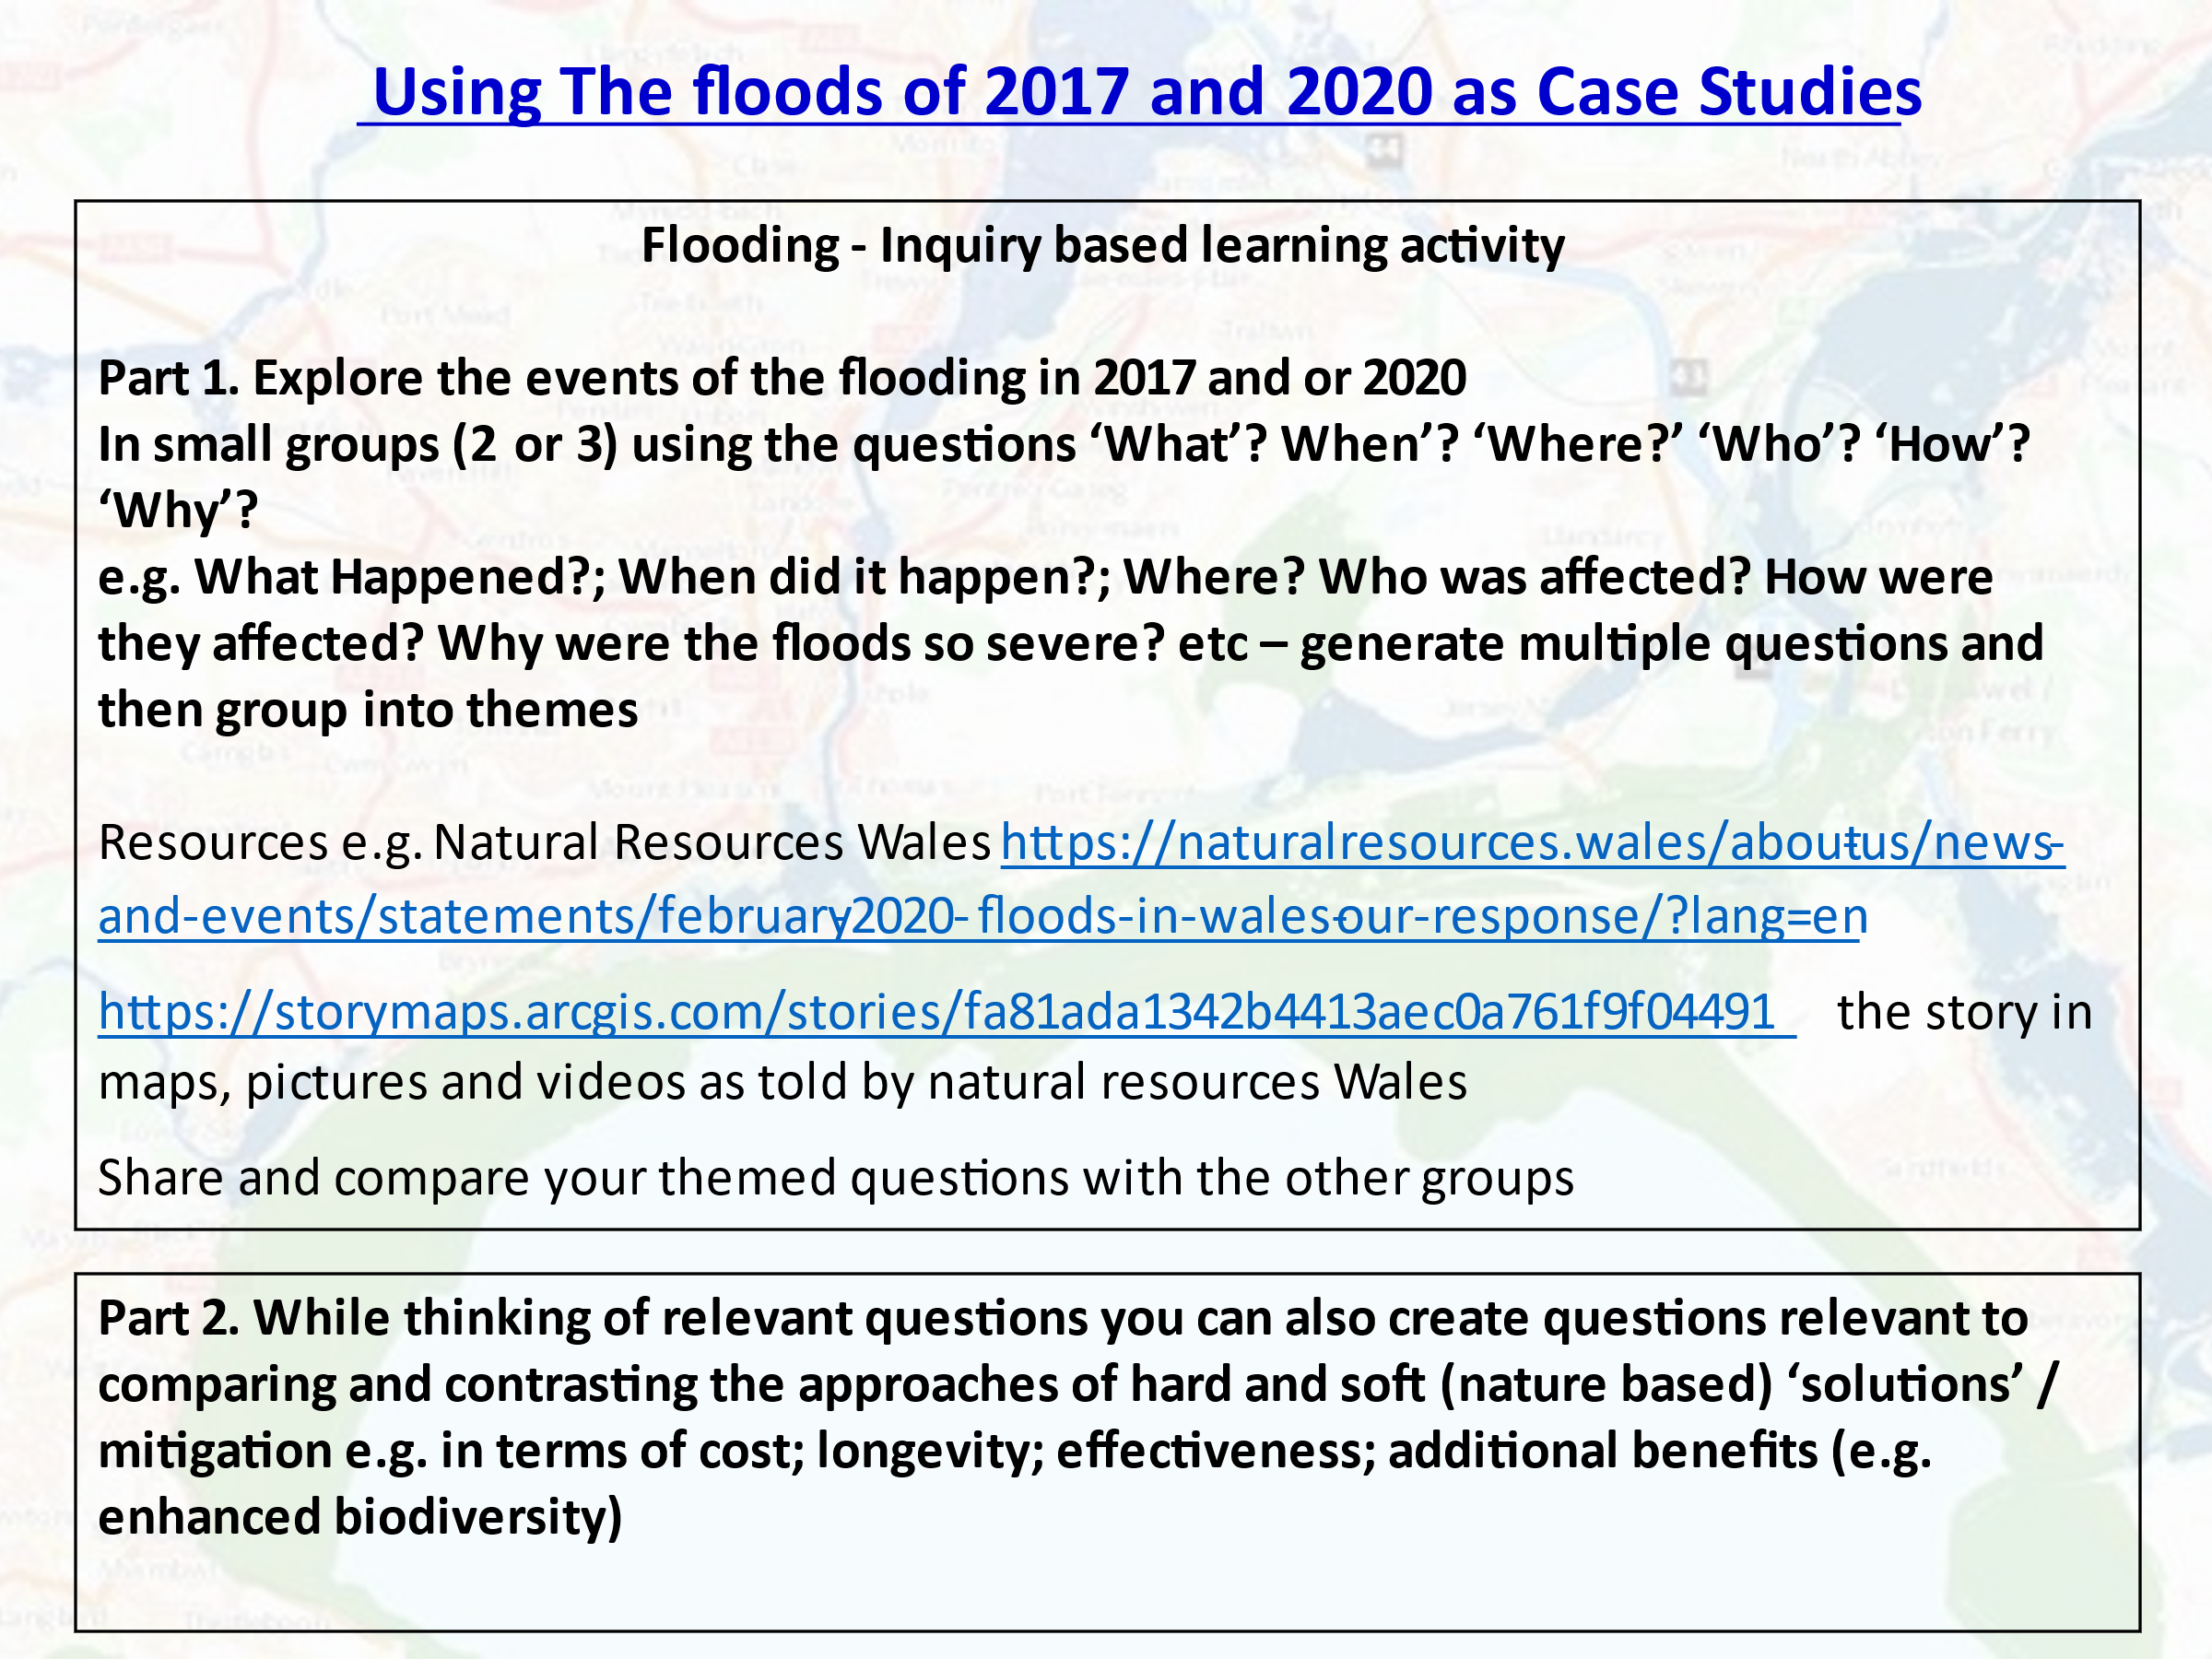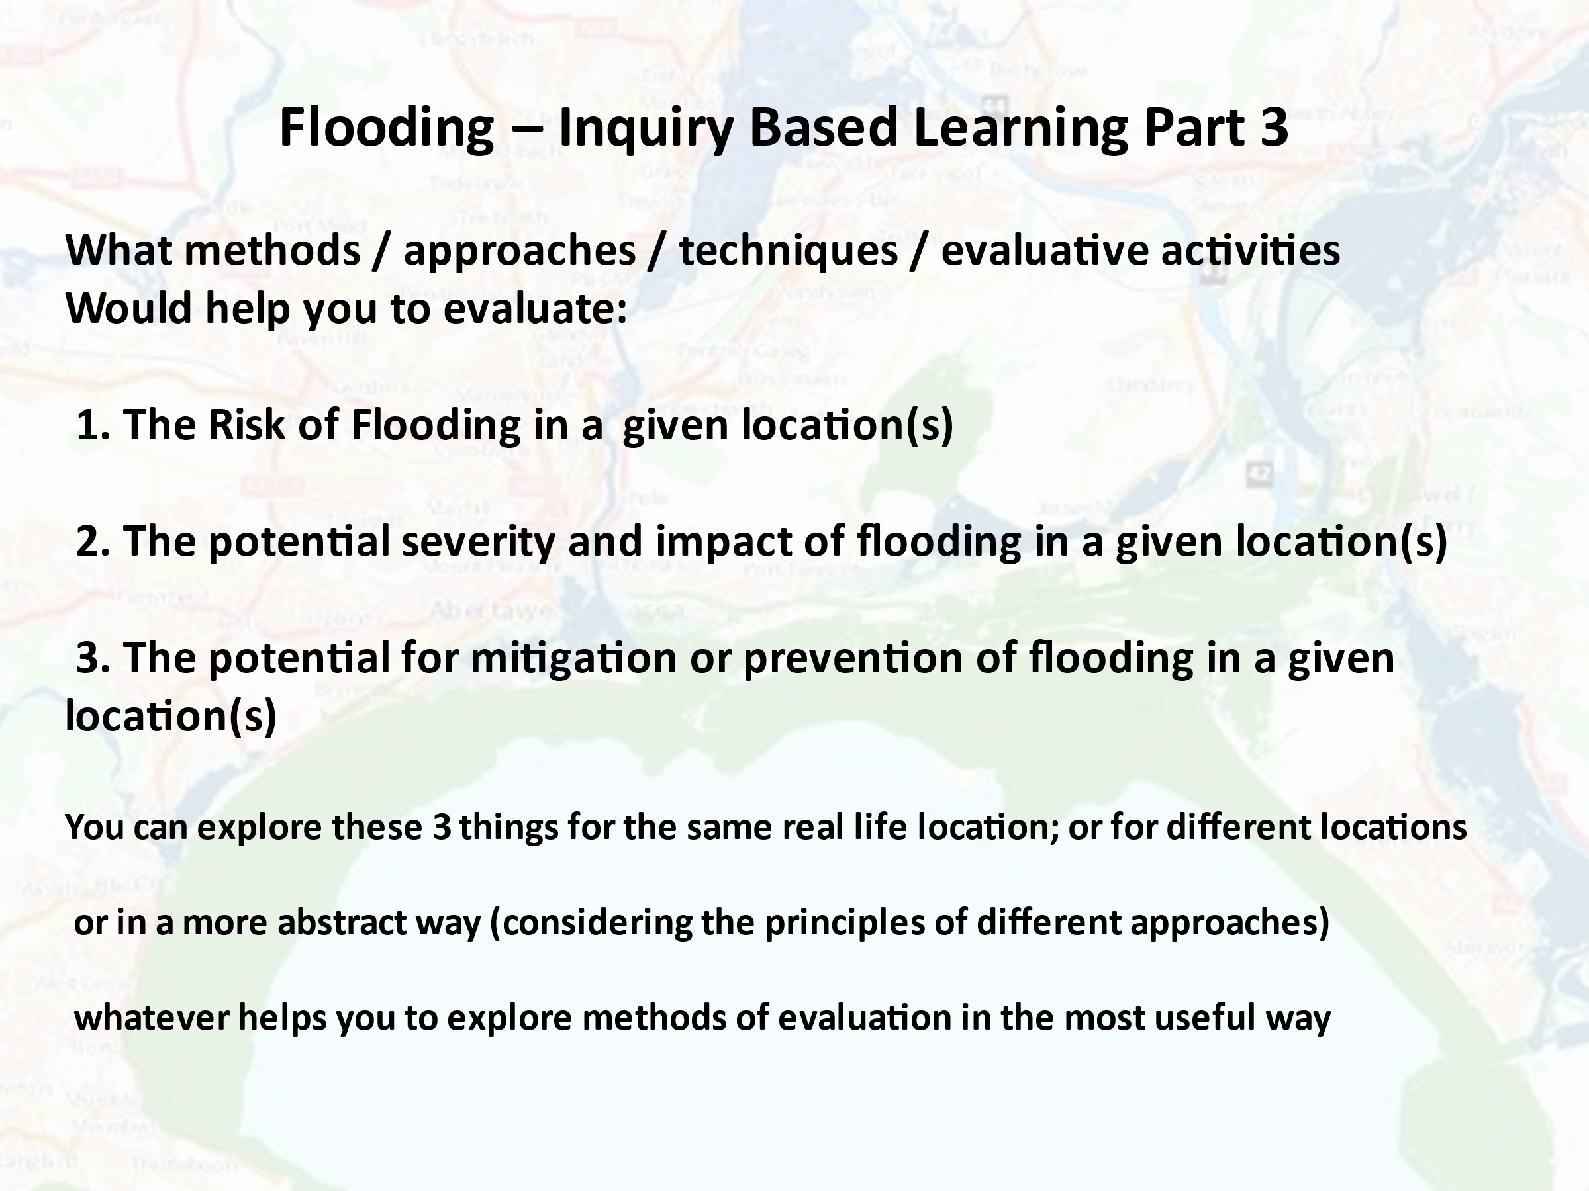
Suggested Categories that might help shape your Exploration of Evaluative Methods
Causes of Flooding e.g. changes to weather patterns; characteristics of land / land use
River / Flood Management e.g. river course management / land use / type & frequency of management
Risk and Vulnerability e.g. habitation / human use mapping; historical records; risk perception
Impact of Flooding e.g. cost of flooding incidents; people’s experiences

