
Aquatic Life Quality Monitoring System
By Jordan Thomas

April 2021
UWTSD
Supervisor: Dr Gary Jones
Second Marker: TBC

Project submitted as part of the requirements for the award of BEng (Hons) Electrical & Electronic Engineering

Contents
Table of figures 4
Aquatic Life Quality Monitoring System 6
Declaration form 6
Abstract 6
Chapter 1 - Introduction 7
1.1 Problem 7
1.2 Solution 8
1.3 Proposal 8
1.4 Planning – Gantt Chart 9
Chapter 2 - Research & Literature Review 10
2.1 What is dissolved oxygen 10
2.1.1 Desired Oxygen Levels 10
2.1.2 Methods Used to Improve Dissolved Oxygen Levels 10
2.1.3 Photosynthesis 10
2.2 Aeration 10
2.2.1 Surface Aeration 11
2.2.2 Compressed Air Diffusers 11
2.3 Fish Kill 11
2.4 Turbidity 11
2.4.1 Measuring Turbidity 11
2.4.2 Effect of high Turbidity 11
2.5 pH 11
2.6 Temperature 12
Chapter 3 - Research 13
3.1 Auto Aerator Unit 13
3.2 Aqua - Control One 13
3.3 hIOTron's Remote Pont Monitoring System 14
3.4 Comparison Table 15
3.5 Final Selection Criteria 16
3.5.1. Dissolved Oxygen 16
3.5.2 Turbidity 16
3.5.3 pH 16
3.5.4 Temperature 16
3.5.4 PLC 16
3.5.5 HMI 16
3.5.6 Enclosure 16
3.5.7 Floating Device 16
3.5.9 Enclosure Alarm 16
3.6 Dissolved Oxygen Levels (Sensor) 17
3.7Turbidity 20
3.8 PH Level Probe 21
3.9 Sunlight 22
3.10 Water Temperature 24
3.11 PLC 27
3.12 LED lights 29
3.13 Floating device 31
3.13 Case 32
3.14 Final Component Review 33
Chapter 4 Design & Implementation 34
4.1 Sensor Bench Tests 34
4.1.1 Turbidity Test 34
4.1.2 pH Test 35
4.1.3 Temperature Test 36
4.2 Flow Chart 39
4.3 Block Diagram 40
4.4 0 - 10v Signal Generator 40
4.5 Relay Circuit 41
4.6 Schematic Diagram 41
4.7 PLC Software 42
4.8 HMI Design 50
4.9 Final Layout 51
Chapter 5 Analysis & Evaluation 56
5.1 Bill Of Materials 56
5.2 Potential Cost Saving 56
5.3 Final Gantt Chart 57
5.4 Next Step 57
Chapter 6 Conclusion & Improvements 58
6.1 Dissolved Oxygen 58
6.2 Depth of Probes 58
6.3 Turbidity Sensor 58
6.4 Additional Probes & Improved Quality 58
6.5 Battery 58
6.6 Remote Driven 59
6.7 App 59
Chapter 7 Personal Reflection 60
Chapter 8 Bibliography 61
Bibliography 61

Table of figures
Figure 1 - Auto Aerator Unit 13
Figure 2 - Aqua Control One 14
Figure 3 - hIOTron 14
Figure 4 - DO 17
Figure 5 - DO 1 18
Figure 6 - DO 2 18
Figure 7 - DO 3 18
Figure 8 - DO Data Sheet 19
Figure 9 - Turbidity 1 20
Figure 10 - Turbidity 2 20
Figure 11 - Turbidity 3 20
Figure 12 - pH 1 21
Figure 13 - pH 2 21
Figure 14 - pH 3 21
Figure 15 - pH Data Sheet 21
Figure 16 - Sunlight 1 22
Figure 17 - Sunlight 2 22
Figure 18 - Sunlight 3 22
Figure 19 - Sunlight 4 22
Figure 20 - Sunlight 5 22
Figure 21 - Sunlight 6 22
Figure 22 - Sunlight Data Sheet 23
Figure 23 - Temp 1 24
Figure 24 - Temp 2 24
Figure 25 - Temp3 24
Figure 26 - Temp 4 25
Figure 27 - Temp 5 25
Figure 28 - Temp 6 25
Figure 29 - Temp Data Sheet 26
Figure 30 - PLC 1 27
Figure 31 - PLC 2 27
Figure 32 - PLC 3 27
Figure 33 - Data Sheet 28
Figure 34 - LED 1 29
Figure 35 - LED 2 29
Figure 36 - LED 3 29
Figure 37 - LED Data Sheet 30
Figure 38 - Floating 1 31
Figure 39 - Floating 2 31
Figure 40 - Floating 3 31
Figure 41 - Case 1 32
Figure 42 - Case 2 32
Figure 43 - Case 3 32
Figure 44 - Case Data Sheet 33
Figure 45 - Turbidity Circuit Diagram 34
Figure 46 - Turbidity Test 1..................................................................................................................34
Figure 47 Turbidity Test 2 34
Figure 48 - Turbidity Test 4 35
Figure 49 - pH Test 1............................................................................................................................ 35
Figure 50 - pH Test 2 35
Figure 51 - pH Test 3 36
Figure 52 - LM35 Connection .............................................................................................................36
Figure 53 - LM35 Circuit Diagram 36
Figure 54 - LM35 Test 1 .......................................................................................................................37
Figure 55 - LM35 Test 2 37
Figure 56 - LM35 Modified .................................................................................................................37
Figure 57 - LM35 Test 3 37
Figure 58 - LM35 Test 4........................................................................................................................38
Figure 59 - LM35 Test 5 38
Figure 60 - LM35 Test 6 .......................................................................................................................38
Figure 61 - LM35 Test 7 38
Figure 62 - System Flow Chart 39
Figure 63 - System Block Diagram 40
Figure 64 - Signal Generator 40
Figure 65 - Non-Latching Relay............................................................................................................41
Figure 66 - Relay Circuit Diagram 41
Figure 67 - Schematic Diagram 41
Figure 68 - Network 1 42
Figure 69 - Network 2 42
Figure 70 - Network 3 43
Figure 71 - Network 4 43
Figure 72 - Network 5 44
Figure 73 - Network 6 44
Figure 74 - Network 7 45
Figure 75 - Network 8 45
Figure 76 - Network 9 46
Figure 77 - Network 10 46
Figure 78 - Network 11 47
Figure 79 - Network 12 47
Figure 80 - Network 13 48
Figure 81 - Network 14 49
Figure 82 - HMI Root Screen 50
Figure 83 - HMI Data Screen 50
Figure 84 - Final Build 51
Figure 85 - Door Panel Inside 52
Figure 86 - Panel Door Front 52
Figure 87 - Electrical Enclosure 53
Figure 88 - LM35..................................................................................................................................53
Figure 89 - LM35 Waterproof 53
Figure 90 - pH probe 54
Figure 91 - Sensor Rig 2 .......................................................................................................................54
Figure 92 - Sensor Rig 54
Figure 93 - Sensor Rig 3 55
Figure 94 - Bill of Materials 56
Figure 95 -Final Gantt Chart 57

Aquatic Life Quality Monitoring System

Declaration form
I Jordan Thomas declare that the project "Aquatic Life Quality Monitoring System" submitted to the University of Wales Trinity St David, is original work with the supervision of Dr Gary Jones. The project work submitted is partial fulfilment towards the requirements of BEng (Hons) Electrical & Electronic Engineering. This work not been submitted or accepted as part of any other submissions.

Abstract
The aim of this project is to design a water quality monitoring system that is capable of measuring the key parameters, Dissolved Oxygen, pH, Temperature and Turbidity. Research will be carried out to highlight the relationship and importance of the 4 key parameters. Following this the required sensors and equipment will be compared and the best suited will be used for the final build. A PLC software will be used to collect the data and control the lake aerator as and when required. The unit will go through a range of testing with all results and findings analysed. Flow charts, Block diagrams, Schematic diagrams and potential cost savings will all be included within the project scope. By the end of the project a fully functioning Aquatic life quality monitoring system will be capable of being installed in a live environment.

Chapter 1 - Introduction
The project will be based on a water quality monitoring system that will measure and display the oxygen levels and other key variables of a fishing lake. Just like humans, fish need oxygen to survive. Consistent oxygen levels are vitally important for the well being and growth of fish in both fish farms and fishing lakes. Water molecules do contain oxygen atoms however, it is dissolved oxygen that aquatic life requires to survive. Oxygen enters water such as lakes after it dissolves from the atmosphere, this is known as dissolved oxygen. The level of dissolved oxygen is used as a key indication of the water quality.
According to a government report, recreational angling contributed £1.4bn into the economy in 2018. Coarse fishing was found to be the most popular activity with an estimated 19 million days of fishing. The report also found that "a clean and attractive environment was more highly valued by anglers than the size and abundance of fish" [1]
Fast moving water naturally contains higher levels of oxygen than lake water because “the mixing of surface waters by wind and waves increases the rate at which oxygen from the air can be dissolved or absorbed into the water” [2]
Stagnant water such as fish farms or lakes contain less oxygen than fast moving water due to a number of factors. Oxygen is transferred through surface diffusion and the lake water will have a reduced surface area due to the lack of movement or water transfer. Also as organic matter decays in the water, the bacteria will start to consume oxygen from within the water.
Weather conditions can also play a part in the level of dissolved oxygen in the water. During winter when the temperature is cooler, the oxygen levels are naturally higher than during the summer months when the weather is much warmer. As the temperature rises there is less oxygen available to the fish. Aquatic life also desires higher levels of oxygen during the warmer weather.

1.1 Problem

The normal oxygen content of water in a fishing lake or fish farm is hardly enough for all forms of aquatic life to survive. Furthermore, low oxygen levels will negatively impact the wellbeing and growth of the fish. This situation will often leave fish gasping for oxygen at the surface. In extreme cases a fish kill could occur which would mean a large percentage of the fish dying.
Many factors can affect the oxygen levels of the lake. At some point during the algae life cycle it will die, when this happens it will strip up to 100% of the oxygen from the water, potentially killing all the fish. [3] Even slightly lower levels of oxygen can affect the fish as lower oxygen levels makes it more difficult for carp to digest food.
It is also important to know the oxygen levels before feeding. If the oxygen is already low then the fish will eat less which will mean lots of waste. If this happens then it will contribute to the decline in dissolved oxygen. It is also important, particularly in fish farms, that the fish are feeding as expected.
Another issue with oxygen levels in lakes is that the oxygen level reduces as it gets deeper. Deep lakes get very litter water transfer or wind to increase the surface area. This will mean the fish avoid these areas where possible, effectively reducing the size of the lake.

1.2 Solution
When you consider the value of large carp, there is clearly a need to maintain the oxygen levels.
A common method of improving the oxygen levels involves using an aerator. Surface aerators are a relatively simple design that involves and electric motor and a paddle wheel. The wheel sits on a floating device and is partly submerged in the water. As the wheel turns it breaks up the water and splashes it into the air. The water will then re-enter the lake with a much higher oxygen level. The other benefit is that it will cause the water in the lake to circulate, meaning the improved oxygen levels will reach more areas of the lake.
The oxygen levels need to be monitored, waiting for physical signs of low oxygen will mean the levels have already been too low for too long. Therefore relying on human judgement as to when the oxygen levels need improving could be very costly.
The design proposal will incorporate aeration methods already used with a monitoring system. The system will involve sensors that monitor the temperature, water turbidity, dissolved oxygen levels and more. This data will be used to determine when and for how long the aerator needs to be running. This will allow the increase the oxygen levels as they begin to drop meaning the fish benefit from a consistent oxygen level.
A basic system will rely of human judgement as to when the levels need to be increased. This system will also provide energy cost savings as it will indicate when the aerator can be switched off. This will be a great improvement to the current guess work of switching it on for a set amount of time.

1.3 Proposal
My proposal is to design a low cost monitoring system that will constantly keep the oxygen levels safe. This will incorporate methods already used to increase oxygen levels, such as aerators, but without the human judgment.
The project will include a monitoring system to determine when and for how long the aerator will need to be running in order to get the desired oxygen levels. This will prevent any potentially fatal mistakes happening and provide great energy savings as an alternative to running the aerators 24/7. The monitoring system will include the following:
- Mobile, waterproof and durable casing which is capable of being moved to multiple locations around the fishery.
- Pre start up warning for any anglers nearby.
- Measure oxygen levels in the lake
- Ambient temperature
- Water temperature
- Turbidity
- Wind speed
- Sun light strength and duration
- HMI interface for visual representation of the oxygen levels.

The monitoring system will be affordable and aimed at small to medium sized family owned fisheries. It will be proactive by using a range of instruments to gather data. When the set criteria is met, the PLC program will turn on the aerator for the required length of time. A HMI screen will be used as a real time visual display of the data being collected.

1.4 Planning – Gantt Chart
The Gantt chart below lays out the initial major tasks for the project. Tasks will be added to the chart as the project develops. A colour code system will also be in place to record if the test has been completed on time or not. This will be key to keeping the project on track.
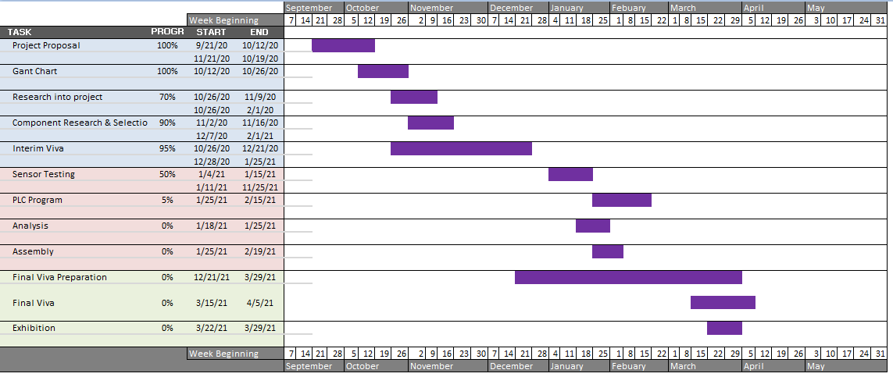

Chapter 2 - Research & Literature Review

2.1 What is dissolved oxygen
Dissolved oxygen levels will be the main consideration when measuring the water quality of the lake. It is a common opinion that "Dissolved oxygen is one of the most critical parameters of concern with any kind of aquaculture operation" [4]
Water (H2O) contains an oxygen atom however, it is dissolved oxygen (DO) that is required for aquatic life to survive. Molecular oxygen (O2) is known as free oxygen and it is this form of oxygen that diffuses into the water to produce DO. Dissolved oxygen is a key parameter when investigating water quality as the levels of DO available will have a huge impact of all forms of aquatic life. [5]
The main source of dissolved oxygen is provided by photosynthesis and diffusion. Approximately 1 to 5 mg/L will diffuse naturally through surface water. In addition approximately 5 to 20mg/L will be produced through photosynthesis, however respiration should also be considered to determine the net gain. Photosynthesis - respiration = 0 to 5mg/L of dissolved oxygen daily gain for organic matter such as plankton [4]

2.1.1 Desired Oxygen Levels
If the dissolved oxygen levels are too low then it will negatively affect the fish. 4mg/l is generally considered a healthy amount of dissolved oxygen within the water for fish to live, eat and grow as normal. If the level drops to 3.5mg/l then the fish will reduce feeding. At 3mg/l the fish will stop feeding altogether. For the short term it isn't a big concern however, if the fish aren't feeding then it reduce the enjoyment that the fishermen have. Carp are known to be able to survive in tough conditions such as 1mg/l, although the fish will be gasping at the surface whenever the level drops below 1.5mg/l. [6]
In a study of the effects of dissolved oxygen and fish size carried out by Abdel-Tawwab it was found that "DO levels adversely affected fish growth and feed utilization" [7]
Growth of fish and feeding rates are vitally important for fishing lakes which makes maintaining the desired oxygen levels all the more important.

2.1.2 Methods Used to Improve Dissolved Oxygen Levels
As previously mentioned, the mixing of surface waters by wind and waves increases the speed that oxygen can be absorbed into the water. These conditions need to simulated as it is highly unlikely waves will be found in a lake or pond. This can be done by a range on mechanical equipment that will splash the water or pump air into the water. Dissolved oxygen levels will also increase as a result of photosynthesis.

2.1.3 Photosynthesis
Photosynthesis is a process where plants and organic matter use light energy from the sun into chemical energy. This energy such as glucose is used as nutrients by the organic material, however there are by-products produced such as oxygen. Algae and submerged plants that live in the lake or pond will increase the dissolved oxygen levels during the day through photosynthesis. It's important to control the amount of organic material within the lake as too much oxygen can also be dangerous. [8]

2.2 Aeration
Aeration is a term used for the process where air is circulated through, mixed with or dissolved in a liquid or substance. [9] It is a method used in many different industries for various reasons. This is a method uses by fisheries to maintain consistent oxygen levels, it is used by sports clubs to improve the quality of grass and it is used by utility companies to remove carbon dioxide.

2.2.1 Surface Aeration
A surface aeration system is used to improve the amount of dissolved oxygen in ponds or lakes. There are a range of devices which work with the same principle in mind. Surface fountains or floating paddle wheels are often used to splash water out of the lake and into the air to increase the surface area and allow oxygen to enter. These also help with circulating water around the lake. Surface aerators are most effective at improving oxygen levels in the top half of a lake. [10]

2.2.2 Compressed Air Diffusers
This method of aeration can be 3 – 5 times more effective but will come at a cost. Pipe work is laid along the lake bed with areas that dissipate small oxygen bubbles which will then work their way to the surface. The air is fed from an on land compressor or air supply. This method provides an increase of oxygen and circulation to the deeper levels where surface aerators could not reach. [11]

2.3 Fish Kill
Fish kill or fish die-off is the term used to describe a situation where a large percentage of fish die in a lake or waterbody. There are a number of factors that could be responsible such as reduced oxygen levels, algae boom, a persistent rise in water temperature and overpopulation. This event has the ability to wipe out a fish farm or fishing lake due to the value of the stock. A fish kill is more likely to happen during the summer months due to the warmer weather, although oxygen depletions can happen at any time. [12]

2.4 Turbidity
Turbidity is a term used to describe the clearness of water. Turbidity is a measurement of how many particles are within a water sample. Lower particles will indicate that the water is clear whilst a higher amount will indicate the opposite. Materials that can cause a higher turbidity reading include clay, silt, plankton, algae and other organisms.

2.4.1 Measuring Turbidity
A high concentration of particles will affect how well light can penetrate the water. For this reason many turbidity sensors work by measuring how much light is scattered when shined through a water sample. [13]

2.4.2 Effect of high Turbidity
Turbidity and dissolved oxygen are inversely related. A high turbidity reading will mean the dissolved oxygen levels in a number of ways. These particles will prevent sunlight from reaching plants below the surface which will decrease the rate of photosynthesis. The result of this will be less oxygen produced by the plants. High turbidity readings will also mean an increase in water temperature as the suspended particles will absorb more heat from the sunlight. This heat will then transfer to the water and decrease the dissolved oxygen available. [14]

2.5 pH
pH is the measurement of free hydrogen and hydroxyl ions in a sample of water. The result is used to determine how acidic or alkaline water is on a scale between 0 - 14. This is an important consideration for water quality as different forms of aquatic life can only survive within set limits. Bacteria can survive between 1 - 13, plants such as algae can survive between 6.5 - 12.5 and more critically fish such as carp can survive between 6 - 9.5. Values outside of this range can heavily impact behaviour and survival rates. [15]
Carbon dioxide is a common factor in reducing the ph value therefore pH can be used as an indicator to the amount of carbon dioxide within the water.

2.6 Temperature
Temperature is also an important parameter for water quality as high temperatures directly reduce the amount of dissolved oxygen in water. This happens due to the solubility of oxygen at different temperatures. Table 9-1, page 152 of 'Limnology - Lake and Rive Ecosystems' states that the maximum solubility of oxygen at 0°C is 14.621 mg/L however, the maximum at 30°C is reduced to 7.558 mg/L. [16] Not only is there less oxygen available but requirements of the fish also increase during higher temperatures. This can create a critical situation.

Chapter 3 - Research

3.1 Auto Aerator Unit
http://www.aquacultureequipment.co.uk/index.php/products?page=shop.product_details&flypage=flypage.tpl&product_id=17&category_id=3
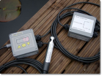 [17]
Figure 1 - Auto Aerator Unit
The Auto Aerator Unit DO1020 is a cost effective system capable of maintaining consistent Dissolved oxygen levels in lakes or ponds. The unit will determine when the aeration system is required. The unit can either be attached to an aerator or can be located in a control room to be used with multiple aerators. Up to 64 units can be connected to a 2 wire bus for locations with multiple lakes. Due to the compact size the system can also be used in transportation tanks. When the lower limit is triggered it will activate the power switch. This will stay active until the upper limit is reached. [17]

3.2 Aqua - Control One
http://simon-moore.com/aerators-aquaculture/control-systems/
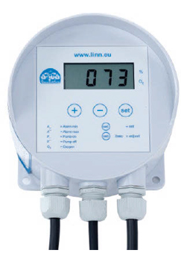 [18]
Figure 2 - Aqua Control One
The Auto Control One is a reliable low cost device that can be used to control dissolved oxygen levels. The splash-proof enclosure can be easily mounted in any position and can control equipment supplied with either 230V or 400V. This system involves a optical dissolved oxygen probe, visual display of ponds, a switching cabinet and an oxygen enrichment system. As this is a low cost device it relies only on the feedback given by the dissolved oxygen probe to activate the oxygen enrichment system. A plc module gives a real time display of the oxygen levels and also has the ability to set warning alarms. [18]

3.3 hIOTron's Remote Pont Monitoring System
https://www.hiotron.com/smart-pond-monitoring-system/
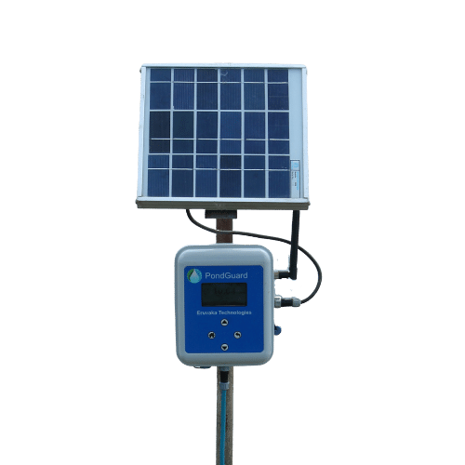
Figure 3 - hIOTron
This smart pond monitoring system has been designed to reduce the risks associated with aquaculture farming [19]. This system requires a 5v/12v supply although it is equipped with batter that is capable of providing 15-20 days of power. Solar technology is also used to recharge the batteries allowing the system to keep running in the event of a power failure. The system has cloud connectivity through a built in GNSS module. Dissolved oxygen, PH & temperature are the main consideration for this system. Real time data monitoring with mobile app that has 2 way communication. In built storage in case of power failure. [19]

3.4 Comparison Table
Name | DO1020 | Aqua-Control One | hIOTron
Picture |  | 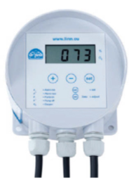
Power Supply | 230 VAC or 12/24 VDC | 230v | 5/12Vdc
Intended Market | Professional | Budget | Professional Fish Farm
Battery | No | No | Yes - 2700MAH Backup
Temperature Probe | Yes - RTD | Yes - PT100 | Yes
Ambient Temp Range | -10 to +40°C | - | 1 to 60
Current | 24A@240V or 16A@24VDC | -
Sensor | Single sensor | Single sensor | PH & DO
Material | Galvanic (Maintenance free) | Dryden Oxygen Probe
DO2 Range | 0 to 40mg/l |  | 0 to 100mg/l
DO2 Accuracy | +/- 0.2mg/l | 0.01mg/l | 0.05mg/l
Automatic Aerator start | Yes | Yes | No - Data feedback only
Application | Single PH or 3 PH | Single PH or 3 PH | -
Mounting | Wall / Pole | Wall /Pole
LED Screen | Yes | Yes | Management platform available on desktop and app.
Data logger | Yes – RS485 Port | No | Yes
Over Voltage Protection |  | Yes | Yes
Warnings | Yes – Minimum and Maximum. | Yes - Limits to be set by user. | Yes - Limits to be set by user.
Web Link | http://www.aquacultureequipment.co.uk/index.php/products?page=shop.product_details&flypage=flypage.tpl&product_id=17&category_id=3 | http://simon-moore.com/backend/wp-content/uploads/2019/05/Control-Systems-Aqua-Control-One.pdf | https://www.hiotron.com/smart-pond-monitoring-system/

The 3 chosen systems offer a range of monitoring techniques for various budgets. The main consideration or all is the dissolved oxygen levels. For 'Control One' and 'Auto Aerator Unit' the dissolved oxygen levels are used to determine if the aerator should be running and both have the capability to control the aerator . They both also feedback real time data to a display screen/control room. The 'hIOTron' is a remote monitoring system which measure a wider range of parameters. Due to the solar and battery set up this unit has the ability to measure in any location.
A combination of ideas from the 3 units will be used for this project.

3.5 Final Selection Criteria
After completing the research section a final specification for the design has been completed. The research has outlined the most important sensors required for the monitoring unit.

3.5.1. Dissolved Oxygen
Following the research section it is clear that Dissolved Oxygen level is the most important factor for water quality monitoring. For this reason a Dissolved oxygen Sensor will be included. 0 - 24v

3.5.2 Turbidity
For this application the senor will be used to gauge how much algae is in the water and the general clearness of the water. A high reading will be interoperated as excess algae in the lake. This warning will alert the operator too add a solution which will kill the algae. 0 - 24v

3.5.3 pH
The third item will be a pH probe. It is also clear from the research of important the correct levels are for aquatic life. 0 - 14 range

3.5.4 Temperature
A temperature probe will be required to monitor water temperature. The probe will need to be either water proof or be adaptable to become waterproof. It would be better suited if the probe is capable of being submerged at a distance below the surface to give a more accurate reading of the water temperature. Sunlight brightness could also be recorded. 0 - 24v

3.5.4 PLC
A Programmable Logic Computer (PLC) will be used to automatically switch the aerator on/off when required. Ladder logic will be used to create a program that will interoperate data received from the sensors. Limits will then be set and used to trigger alarms.

3.5.5 HMI
A Human-Machine Interface (HMI) screen will be used as a remote visual display for all data and alarms. The screen will also have a manual override to turn the aerator on or off in an emergency.

3.5.6 Enclosure
An electrical enclosure will be used to house all items except the sensors. This enclosure will need a high IP rating to protect against poor weather conditions. The enclosure will be mounted on a poll near the lake.

3.5.7 Floating Device
The floating device will provide a platform to secure all 4 probes/sensors and allow them to be submerged in the water. The leads of the probes/sensors would be extended and connected to the PLC housed within the enclosure.

3.5.8 LED pilot lights
There will be 3 panel mount pilot LED's fitted to the door of the enclosure. These will provide a visual display representation of how the system is running for anyone near the lake.

3.5.9 Enclosure Alarm
A buzzer or alarm will also be fitted to the door of the enclosure. This will be activated in the DO levels drop to a critical level.

3.6 Dissolved Oxygen Levels (Sensor)
The most common methods used for measuring DO are optical and electrochemical. Electrochemical can be split into sub-categories with the 2 most popular being polarographic & galvanic.
Optical sensors work by looking at the relationship between oxygen and luminescent dyes whilst a blue light is present. When oxygen interacts with the luminescent dye a it reduces the intensity and lifetime. The photodetector within the sensor will be used to measure the intensity and lifetime of the returned luminescent, therefore the DO concentration can be determined by the amount of returned luminescence. A higher luminescence will mean a lower amount of DO.
Electrochemical sensors have two sub categories that are polarographic and galvanic. Both work in a similar way where the sensor contains a electrolyte solution which contains both an anode & cathode. A semi-permeable membrane is then used to separate the electrodes from the sample liquid. The sample liquid will penetrate the membrane and pass over the cathode. As this happens any oxygen will be consumed which creates an electrical current. The current will be determined by the concentration of oxygen. The main difference between polarographic and galvanic is the material used for the electrodes. Galvanic can self-polarize which reduces the warm-up time. [20]
Name | Optical | Polarographic | Galvanic
Picture | 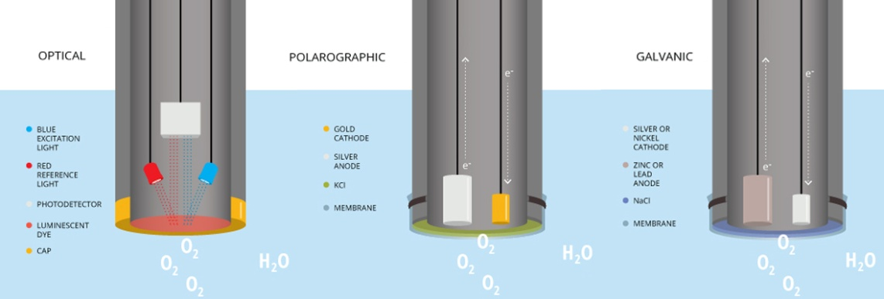  Figure 4 - DO
Results time | 2 - 4 times longer | Quick | Quick
Maintenance | Low | High | High
Advantage | Higher accuracy, not effected by gasses, good for long term monitoring | Very cost effective, fast response time | No warm-up time, Low Cost, fast response time.
Disadvantage | Higher power requirements, | Warm-up time required, frequent maintenance, performance degrades. Not best suited for still water. | Need to replace anode metal - frequent maintenance. Not best suited for still water.
Web Link | https://www.nexsens.com/blog/blog-measure-dissolved-oxygen.htm

The optical sensor will be best suited for the long term intended use on the monitoring system due to its low maintenance requirements and high reliability. The response time can be slightly slower than the other technologies however that will have a minimal effect on long term monitoring.

Name | Orion RDO Opyical | Mettler Toledo 605 Optical | RDO PRO-X Optical
Picture | 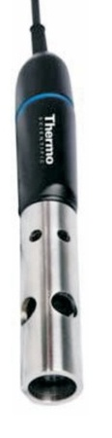  Figure 5 - DO 1 | 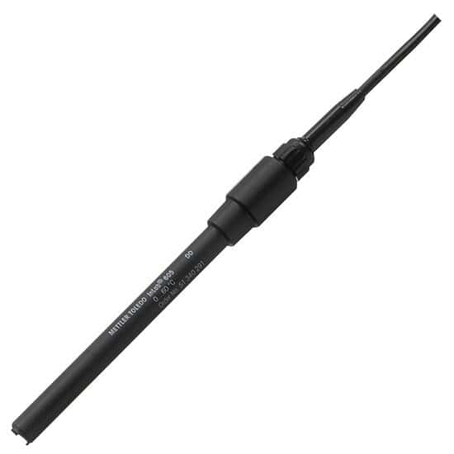  Figure 6 - DO 2 | 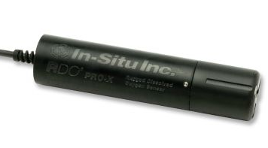  Figure 7 - DO 3
Price | £713.37 | £1,118.14 | £1,230.00
Range | 0 to 20 mg/L | 0 to 200%, 0 to 20mg/L | 0 to 60 mg/L
Accuracy | - | - | <0.1mg/L
Response Time | - | - | <60 sec @25°C
Temperature Range | 0°C to 50°C | 0°C to 60°C | 0°C to 50°C
Diameter | - | 12mm | 46.99mm
Working Voltage | - | - | 8 to 36 VDC
Cable Length | 6M | 10M | 10M Standard, Up to 4,000M
IP Rating | IP 68 Waterproof | Robust IP67 | IP 67
Web Link | https://www.thermofisher.com/order/catalog/product/087010MD#/087010MD | https://www.coleparmer.co.uk/i/mettler-toledo-605-dissolved-oxygen-probe-with-ism-10-m-cable/3590302?PubID=UY&persist=true&ip=no | https://in-situ.com/uk/rdo-pro-x-dissolved-oxygen-probe

The selected optical is a fantastic piece of equipment and meets all of the requirements. The sensor is highly accurate, has the desired working voltage and the long cable length allows for readings to be taken at different locations. These sensors are particularly expensive has it has proved difficult to source a probe within budget. A final decision will be made after a budget review when all components have been selected

Data Sheet:
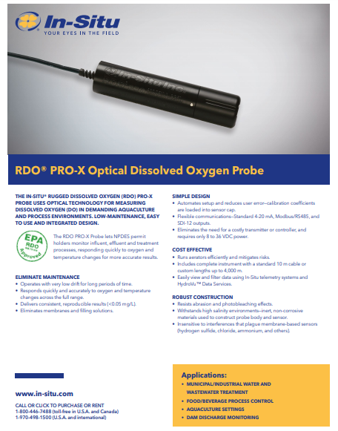
Figure 8 - DO Data Sheet

3.7Turbidity
Name | Fdit | GE Measurement & Control | Optisens Tur 2000
Picture | 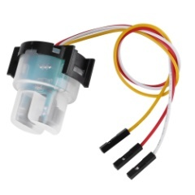  Figure 9 - Turbidity 1 | 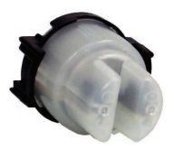  Figure 10 - Turbidity 2 | 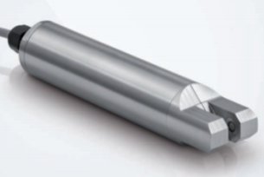  Figure 11 - Turbidity 3
Part Number | Zunateniurgh1cse | TSD-10 | Optisens TSS 2000
Intended Market | Budget | Dishwasher & Washing machines | Professional
Working Voltage | DC5V | Dc 5V | 24vDC
Working Current | 30mA(Max) | 30mA Max | -
Response Time | <500mS | - | <1Second
Operating Temperature | -30°C - 80°c | -10°C - 90°C | 0 to 70°C
Connection | 3-wire | 3 Pin | 3-wire
Waterproof housing? | Yes | Partly | Yes - Stainless Steel
Price | £15.89 | Unavailable for sale in Europe | Unknown ££££
Other | TSS | Nephelometer with correction | IP 68
Dimensions |  |  | 205.5 x 40O/D  1.5kg
Website | https://www.amazon.co.uk/gp/product/B088TPC4QG/ref=ppx_yo_dt_b_asin_title_o01_s02?ie=UTF8&psc=1 | https://www.amphenol-sensors.com/en/thermometrics/turbidity/2958-tsd-10 | https://cdn.krohne.com/dlc/TD_OPTISENS-TSS-2000_en_180710_4006310501_R01.pdf

The sensor will use a diode and phototransistor to measure how many particles block the light. The chosen sensor is an entry alternative that will serve purpose during the prototype testing whilst helping to stay within budget. This sensor has a simple 3 wire connection and a desired analogue voltage output. If the prototype is successful the Optisens sensor could be a future upgrade.
No data sheet available.

3.8 PH Level Probe
Name | DO1020 | PH Electrode LE407 | PH Electrode Probe
Picture | 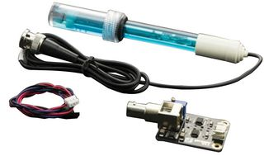  Figure 12 - pH 1 | 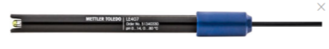  Figure 13 - pH 2 | 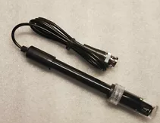  Figure 14 - pH 3
Price | £27 | £72.20 | £7.99
PH Range | 0-14PH | 0-14 PH | 0-14 PH
Cable length | - | 100cm | 80cm
Operating Temp | 0-60 | 0-80 | 0-60
Durability | Ok | Very Good | Ok
Connector | BNC Plug | BNC Plug | BNC Plug
Accuracy | +/- 0.1PH |  | 0.2PH
Module | Arduino | N/A | N/A
Length | - | 12cm | 12cm
Availability | Very Good | Good | Good
Web Link | https://uk.farnell.com/dfrobot/sen0161/analog-ph-sensor-meter-kit-arduino/dp/2946120?gclid=EAIaIQobChMI1qDn75a_7QIVGbvVCh2IEQRPEAQYAyABEgI8n_D_BwE&gross_price=true&mckv=sEj6d4SxJ_dc|pcrid|483687683215|kword||match||plid||slid||product|2946120|pgrid|112844087463|ptaid|pla-301371186909| | https://www.mt.com/gb/en/home/products/Laboratory_Analytics_Browse/pH-meter/sensor/lightedition-sensor/pH-Sensor-LE407.html?SE=GOOGLE-Shopping&cmp=sea_02554126&Campaign=MT_ANA_EN_UK_Shopping&Adgroup=ANA%20products&bookedkeyword=&matchtype=&adtext=266043130549&placement=&network=g&kclid=_k_EAIaIQobChMI_dnC6oTV7QIVh7HtCh0Xxg80EAQYBCABEgIx8_D_BwE_k_&gclid=EAIaIQobChMI_dnC6oTV7QIVh7HtCh0Xxg80EAQYBCABEgIx8_D_BwE | https://www.ebay.co.uk/itm/PH-Electrode-Probe-BNC-Connector-Aquarium-PH-Controller-Meter-Tester-Sensor-EA/383824205980?hash=item595db4989c:g:3fYAAOSwLAtfmixb

The main difference from the pH comparison table is the cost. The LE407 is a more sophisticated model and the increased durability would make an ideal improvement later in development. The budget pH electrode probe meets the criteria set out for the prototype and is selected to help meet the budget.
Data Sheet: (Limited)
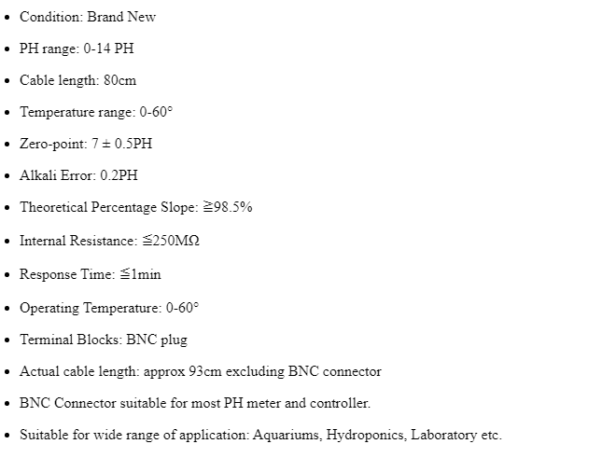
Figure 15 - pH Data Sheet

3.9 Sunlight
Below is the comparison of electronic devises that will be used to measure the light intensity.
Name | Photodiode |  |  | Phototransistor | Light Depended Resistor
Picture | 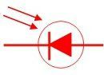  Figure 16 - Sunlight 1 |  | 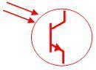  Figure 17 - Sunlight 2 |  | 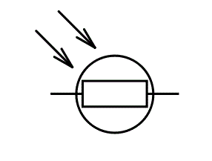  Figure 18 - Sunlight 3
Response Time | Very Fast |  |  | Slow | Fast
Durability | Good |  |  |  | Very Good
Advantage | Commonly used for precision laboratory equipment. Low Cost |  |  | Good sensitivity.  Cheap. | Better suited for harsh environments. Excels in situations where the light intensity varies. Low Cost
Disadvantage | Can only give 2 values - on or off. |  |  | Temperature sensitive
Web Link | https://circuitglobe.com/difference-between-photodiode-and-phototransistor.html#:~:text=One%20of%20the%20major%20difference,conversion%20of%20light%20into%20current. | https://circuitglobe.com/difference-between-photodiode-and-phototransistor.html#:~:text=One%20of%20the%20major%20difference,conversion%20of%20light%20into%20current. |  |  | https://www.electrical4u.com/light-dependent-resistor-ldr-working-principle-of-ldr/
A light dependent resistor has been selected for use on the prototype due to its high durability and ability to function in harsh environments. The devise also does particularly well in situations where the light intensity varies.
Name | Luna Optoelectrics Norps-12 | Luna Optoelectrics NSL-19M51 | Silonex to-18 Photocells
Picture | 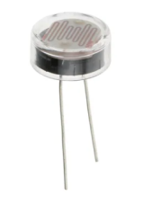  Figure 19 - Sunlight 4 | 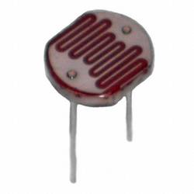  Figure 20 - Sunlight 5 | 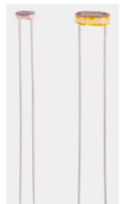  Figure 21 - Sunlight 6
Mounting | Through hole | Through hole | Through Hole
Rise Time | 45mS | 45mS | -
Pins | 2 | 2 | 2
Temperature Range |  | -60°C to 75°C
Material | Cds | Cds | cds
Power | 250mW (20.8mA @12v) | 50mW (4mA @12v) | 250mW
Voltage Rating | 250 V Max | 100 V Max | 250 V Max
Price | £2.44 | £0.676 | £0.98
Range | 5.4 kΩ - 12.6kΩ | 20 kΩ - 100 kΩ | 170 Ω - 2kΩ
Web link | https://uk.rs-online.com/web/p/ldr-light-dependent-resistors/9146714/ | https://uk.rs-online.com/web/p/ldr-light-dependent-resistors/9146710/ | https://uk.rs-online.com/web/p/ldr-light-dependent-resistors/4661974/
A comparison of 3 LDR's was carried out and it was found that the 3 devices performed very similarly. Due to this a selection was made on the price and availability, furthermore this item was included in small breadboard kit which was also required.
Data Sheet:
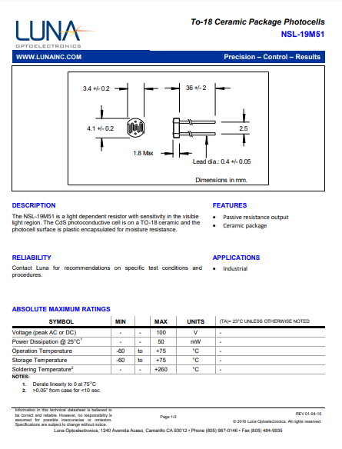
Figure 22 - Sunlight Data Sheet

3.10 Water Temperature

Name | LM35 |  | Thermistor | Thermocouple
Picture | 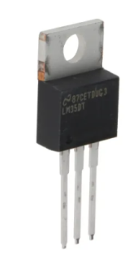  Figure 23 - Temp 1 | 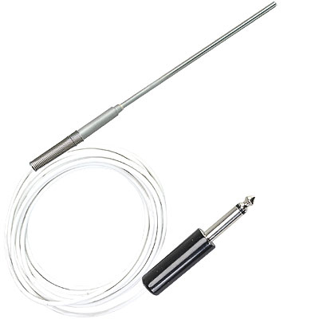  Figure 24 - Temp 2 |  | 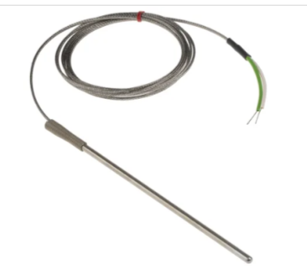  Figure 25 - Temp3
Accuracy | Excellent | Good |  | Good
Price | £ | ££ |  | ££
Advantage | Wide Temperature range.  Simple to use.  Proportional voltage analogue output | Good long term stability  Can be immersed |  | Fast response time  Best Temperature range
Disadvantage | Will need to be adapted for waterproof | Smaller temp range than other options. |  | High system costs
Web Link | https://uk.rs-online.com/web/p/temperature-humidity-sensor-ics/5359458/ | https://www.omega.co.uk/googlebase/product.html?pn=ON-403-PP&gclid=EAIaIQobChMIgMDn7pCM7gIVVrvVCh0hHw52EAQYBCABEgKmXPD_BwE |  | https://uk.rs-online.com/web/p/thermocouples/7621128/?cm_mmc=UK-PLA-DS3A-_-google-_-CSS_UK_EN_Automation_%26_Control_Gear_Whoop-_-Thermocouples_Whoop+(2)-_-7621128&matchtype=&aud-827186183886:pla-341118988070&gclid=EAIaIQobChMIloGfz5GM7gIVQ7TtCh2E2AmUEAQYBSABEgKkkfD_BwE&gclsrc=aw.ds

The proportional analogue voltage output that will not need to be amplified is a big advantage for this selection. The sensor will not be waterproof bit undergo a simple modification onto an extension pole with a plastic wrapping. The LM35 is also very cheap and readily available.

Name | Texas LM35 DT/NOPB | Texas LM35CAZ/NOPB | Texas LM35DZ/LFT1
Picture | Figure 26 - Temp 4 | 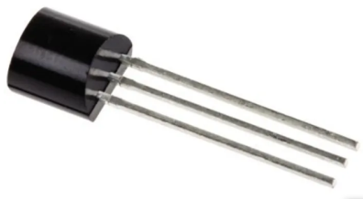  Figure 27 - Temp 5 | 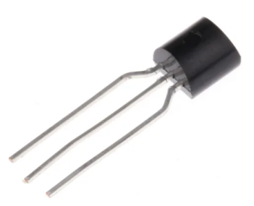  Figure 28 - Temp 6
Part Number | LM35DT/OPB | LM35CAZ/NOPB | LM35DZ/LFT1
Temp Range | 0 to 100 | -40 to 110 | 0 to 100
Sensor Gain | 10mV/C | 10mV/C | 10mV/C
Output Type | Voltage | Voltage | Voltage
Supply Voltage | 4 to 30v | 4 to 30v | 4 to 30v
Pin | 3 | 3 | 3
Mounting | Through Hole | Through Hole | Through Hole
Accuracy | 0.6C | 0.2 | 2C
Price | £2.398 | £2.628 | £0.848
Min Order | 5 | 1800 | 10
Dimensions | 10.16x8.8x4.7mm | 5.2x5.2x4.19 | 5.21x4.19x5.34mm
Website | https://uk.rs-online.com/web/p/temperature-humidity-sensor-ics/5359458/ | https://uk.rs-online.com/web/p/temperature-humidity-sensor-ics/1218696/ | https://uk.rs-online.com/web/p/temperature-humidity-sensor-ics/8115595/

As shown in the above comparison table, all 3 models are very similar. The final decision was based on cost, availability and the additional fixing hole on the LM35 DT/NOPB. This sensor will be supplied with a 12vdc supply and give a analogue output.

Data Sheet:
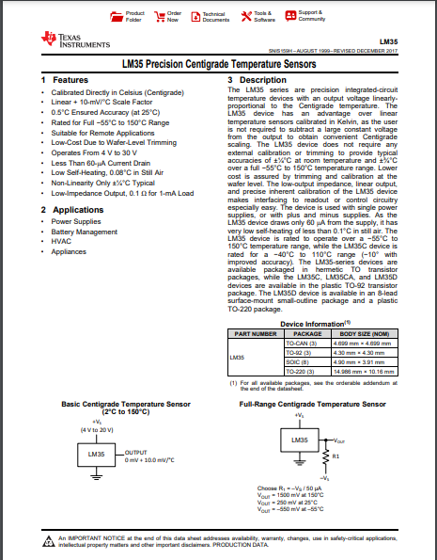
Figure 29 - Temp Data Sheet

3.11 PLC

Name | Siemens S7-1200 | Allen Bradley Micr0 810 | ABB AC500-eC0
Picture | 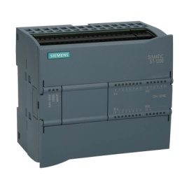  Figure 30 - PLC 1 | 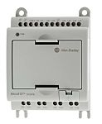  Figure 31 - PLC 2 | 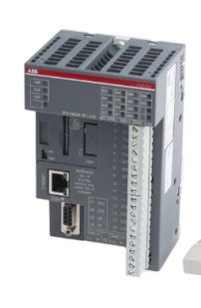  Figure 32 - PLC 3
Model | CPU 1214C DC/DC/DC | 2080-LC10-12QWB | AC500-eCO
Supply Voltage Range | 20.4 to 28.8V DC | 20.4 to 26.4 VDC | -
Analogue Inputs | 2 x 0 to 10V  (Extension Module Available) | 4 | 0
Digital Inputs | 14 x 24V DC | 4 | 8
Outputs | Digital 10 x 24V DC | 4 | 6
Program Memory | 100kB | 4kB | 128kB
Interfaces | Ethernet RJ45 | - | Ethernet, RJ45, RS485
Switching Frequency | 100kHz | - | -
Resolution | 10 bit | 10 bit | -
Mounting | DIN-rail (35mm) | Din Rail | Din Rail
Dimensions | 110 x 100 x 75mm | 91 x 75 x 59mm | 74 x 82 x 148mm
Price | £297.45 | £85.20 | £628.85
Previous Experience? | Yes | No | No
Website | https://www.automation24.co.uk/siemens-cpu-1214c-6es7214-1ag40-0xb0 | https://uk.rs-online.com/web/p/plcs-programmable-logic-controllers/7508602/ | https://uk.rs-online.com/web/p/plcs-programmable-logic-controllers/7631002/
The above table compares 3 selected plc units. The PLC will be a highly important component for the water quality management system. The Siemens S7-1200 will be used for the prototype due to a superior number inputs and outputs. Another advantage is the previous experience which could aid the software design. This PLC is available free issue from UWTSD.

Data Sheet:
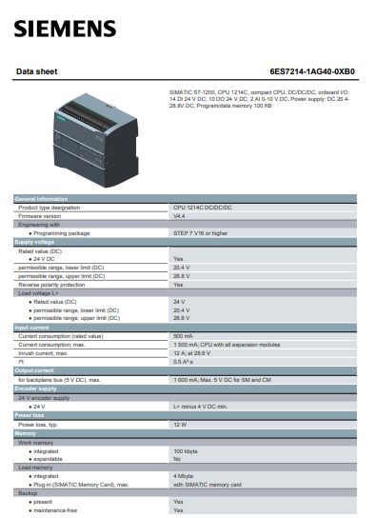
Figure 33 - Data Sheet

3.12 LED lights
Name | Panel Mount Green | Panel Mount Red | Panel Mount White
Picture | 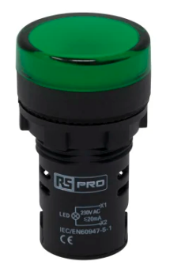  Figure 34 - LED 1 | 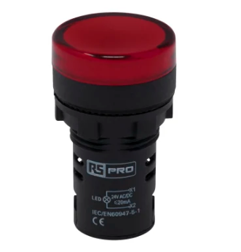  Figure 35 - LED 2 | 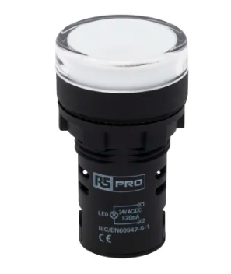  Figure 36 - LED 3
Stock Number | 763-7949 | 763-7909 | 763-7905
Supply Voltage | 24v | 24v | 24v
Colour | Green | Red | White
Cut Out Diameter | 22mm | 22mm | 22mm
Mounting Type | Panel Mount | Panel Mount | Panel Mount
IP | IP65 | IP65 | IP65
Website | https://uk.rs-online.com/web/p/pilot-light-complete-units/7637918/ | https://uk.rs-online.com/web/p/pilot-light-complete-units/7637909/ | https://uk.rs-online.com/web/p/pilot-light-complete-units/7637905/

The panel mount LED's are required for the enclosure. Different colours will be required to indicate different events and as a result all 3 will be selected. The 24v supply voltage means they can be easily powered from the plc outputs.

Data Sheet:
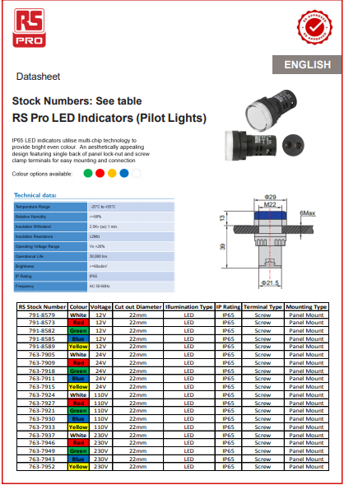
Figure 37 - LED Data Sheet

3.13 Floating device
Material | Polystyrene | Aqua Marina Island Air Platform | E-Domodel Floating Undercarriage
Picture | 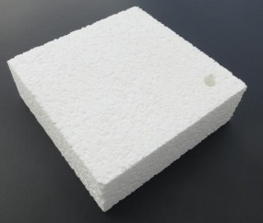  Figure 38 - Floating 1 |   Figure 39 - Floating 2 | 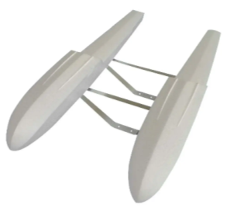  Figure 40 - Floating 3
Cost | Low | High | Low/Medium
Adaptability | High | Low | Medium
Size | Varies | Large | small
Durability | Low | Very High | High
Weight Capacity | Medium | Very High | Medium
Transportable | High | Low | Medium
Website | https://www.wickes.co.uk/Kay-Metzeler-General-Purpose-Polystyrene-EPS70---2400mm-x-600mm-x-25mm/p/210801 | https://www.sailboats.co.uk/aqua-marina-island-air-platform?gclid=EAIaIQobChMIsdCo8onJ7QIV2u3tCh0_fQNPEAQYAiABEgIjJPD_BwE | https://uk.banggood.com/E-Domodel-Floating-Undercarriage-for-1000mm-10-15-Sizes-Seaplane-EPO-Water-Landing-Gear-Amphibious-Float-Pontoon-Buoy-Kit-for-RC-Airplane-Aircraft-p-1582256.html?utm_source=googleshopping&utm_medium=cpc_organic&gmcCountry=GB&utm_content=minha&utm_campaign=minha-gbg-en-pc&currency=GBP&cur_warehouse=CN&createTmp=1&utm_source=googleshopping&utm_medium=cpc_bgcs&utm_content=sxxx&utm_campaign=ssc-gbg-toys-rcdro-ve-newcustom-80-1118&gclid=EAIaIQobChMIsdCo8onJ7QIV2u3tCh0_fQNPEAQYBSABEgLUHPD_BwE

Initially polystyrene will be used due to the low cost and adaptability. The polystyrene sheet can be easily shaped as required and through holes can be drilled for probes. If there is a buoyancy issue then more sheets can be added to increase the thickness. The durability is lower than other options however, if the prototype is successful then this will be a future improvement.

3.13 Case
Name | Schneider | Schneider | Hylec
Picture | 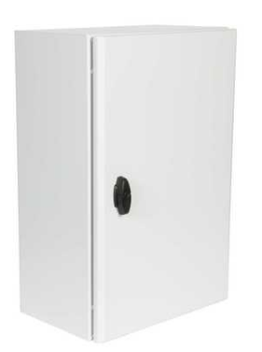  Figure 41 - Case 1 | 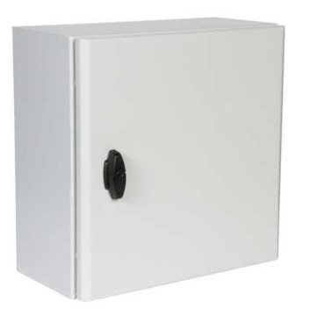  Figure 42 - Case 2 | 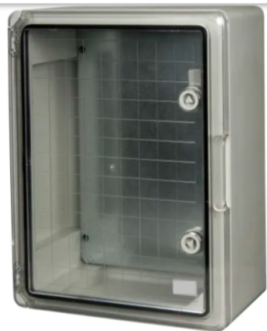  Figure 43 - Case 3
Part Code | NSYS3D6425 | NSYS3D4420 | DED018
Dimensions | 600 x 400 x 250 | 400 x 400 x 200 | 600 x 400 x 200
Material | Steel | Steel | ABS
IP | 66 | 66 | -
Mounting Plate? | Additional | Additional | Yes
Colour | Grey 7035 | Grey 7035 | Grey 7035
Lock | Yes | Yes | Yes
Weight | 11.6Kg | 6.5Kg | -
Door | Steel | Steel | Transparent
Price | £95.94 | £70.14 | £109.56
Website | https://www.cef.co.uk/catalogue/products/1867512-600mmx400mmx250mm-sheet-steel-enclosure-ip66?gclid=EAIaIQobChMIv5-mrNy17wIVkd_tCh24wQpaEAQYAyABEgIVkfD_BwE&gclsrc=aw.ds | https://www.cef.co.uk/catalogue/products/1867485-400mmx400mmx200mm-sheet-steel-enclosure-ip66?gclid=EAIaIQobChMIwICMpd-17wIVTtPtCh0PiglTEAQYDiABEgLhKvD_BwE&gclsrc=aw.ds | https://www.electricaldirect.co.uk/product/hylec-transparent-door-enclosure-ip65-600x400x200mm-248464?vat=1&pr=1&gclid=EAIaIQobChMI5_ufq-C17wIVCurtCh3qcgYQEAQYAiABEgKEs_D_BwE

An Electrical Enclosure be required to house all the key electrical components near the lake. The 3 selected options were all very similar, therefore the final decision was taken after a draft layout drawing was complete. It was estimated that the 400 x 400 enclosure would be suitable. This was also the cheapest option.

Data Sheet:
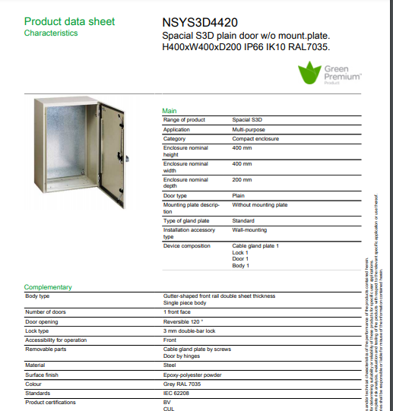
Figure 44 - Case Data Sheet

3.14 Final Component Review
The dissolved oxygen sensors proved difficult to source within budget. A selection has been carried out to determine the most suitable available however, due to the high cost of the sensors a 0 - 10v voltage signal generator will be used to simulate the sensor. If the prototype is successful then additional funding will available.
After reviewing all chosen components it was noted that the system will be dependent on 5 analogue inputs. The chosen PLC (Siemens S7-1200) has 2 as standard and an additional 2 available through the analogue extension module. As a result a decision was taken to source the analogue extension and remove the LDR from the prototype.
On Further review and as a result of unforeseen covid-19 related circumstances the analogue extension module was not available free issue from UWTSD as expected. After some design and discussion a final decision was taken to use relay circuit. This was the most cost effective method and would allow the project to continue. The relay circuit will connect to all 4 sensors with only 2 in use at any one time. When the coil is energised the connection will change from the first 2 sensors to the second 2 sensors. The PLC software will be designed to include this relay operation. Further designs will be displayed later in the report.

Chapter 4 Design & Implementation

4.1 Sensor Bench Tests

4.1.1 Turbidity Test
A basic trial was carried out with the chosen turbidity sensor to help determine if it will be suitable for the application. The clear water will simulate perfect conditions & the thick gravy will simulate worst possible readings. A site visit will be carried out to help determine the alarm limits.
Figure 45 shows the connection used during the bench tests.
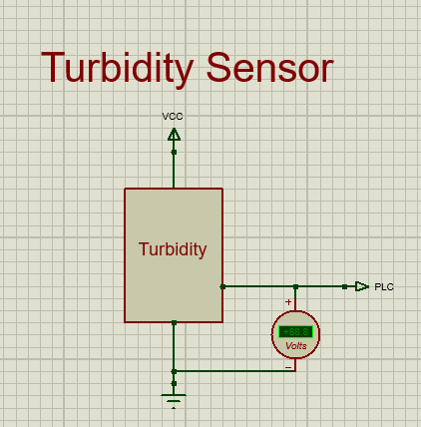
Figure 45 - Turbidity Circuit Diagram
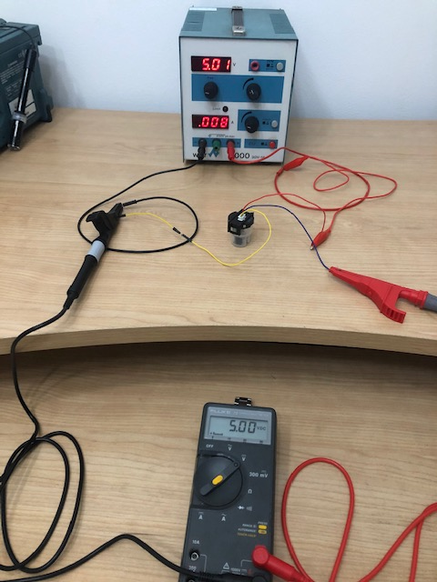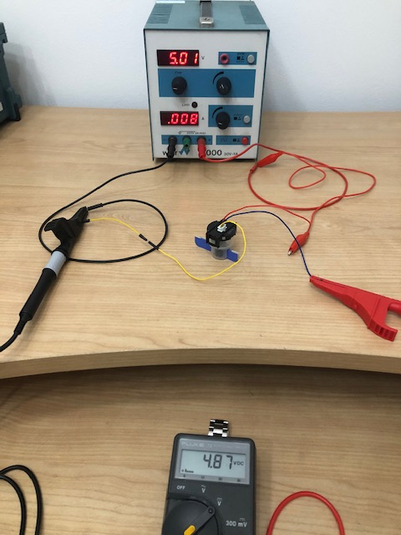
Figure 46 - Turbidity Test 1 Figure 47 Turbidity Test 2
Test conditions | 5V Supply -  Clear Water | 5V Supply -  Thick Gravy
Reading | 5V | 4.87
After reviewing the results a decision was made to repeat the tests to investigate if room light was contributing to the light received by the receiver. Figure 48 shows the turbidity sensor completely wrapped in PVC tape to block the emitter, receiver and external light.
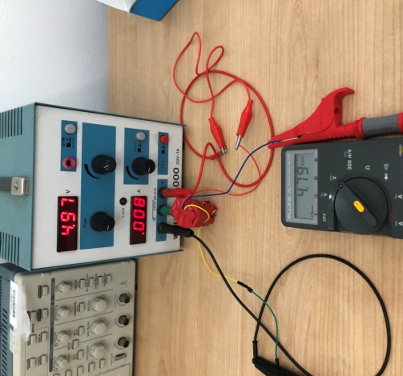
Figure 48 - Turbidity Test 4
Test conditions | 5V Supply -  Clear Water | 5V Supply -  Thick Gravy | 5v Supply - PVC tape
Reading  (v) | 5 | 4.87 | 4.79

4.1.2 pH Test
The images below show the test results for the pH sensor trial. The purpose of this trail is to determine the output readings from the sensor. This information will then be used when designing the PLC software. The trial involved pH buffer solution in a small amount of demineralised water. The output for this probe is mV and no supply voltage is required.
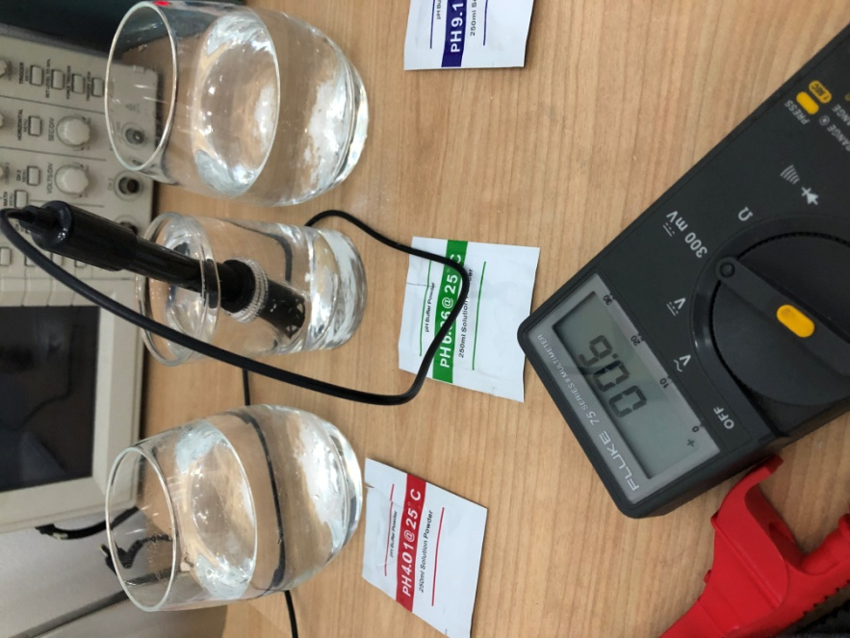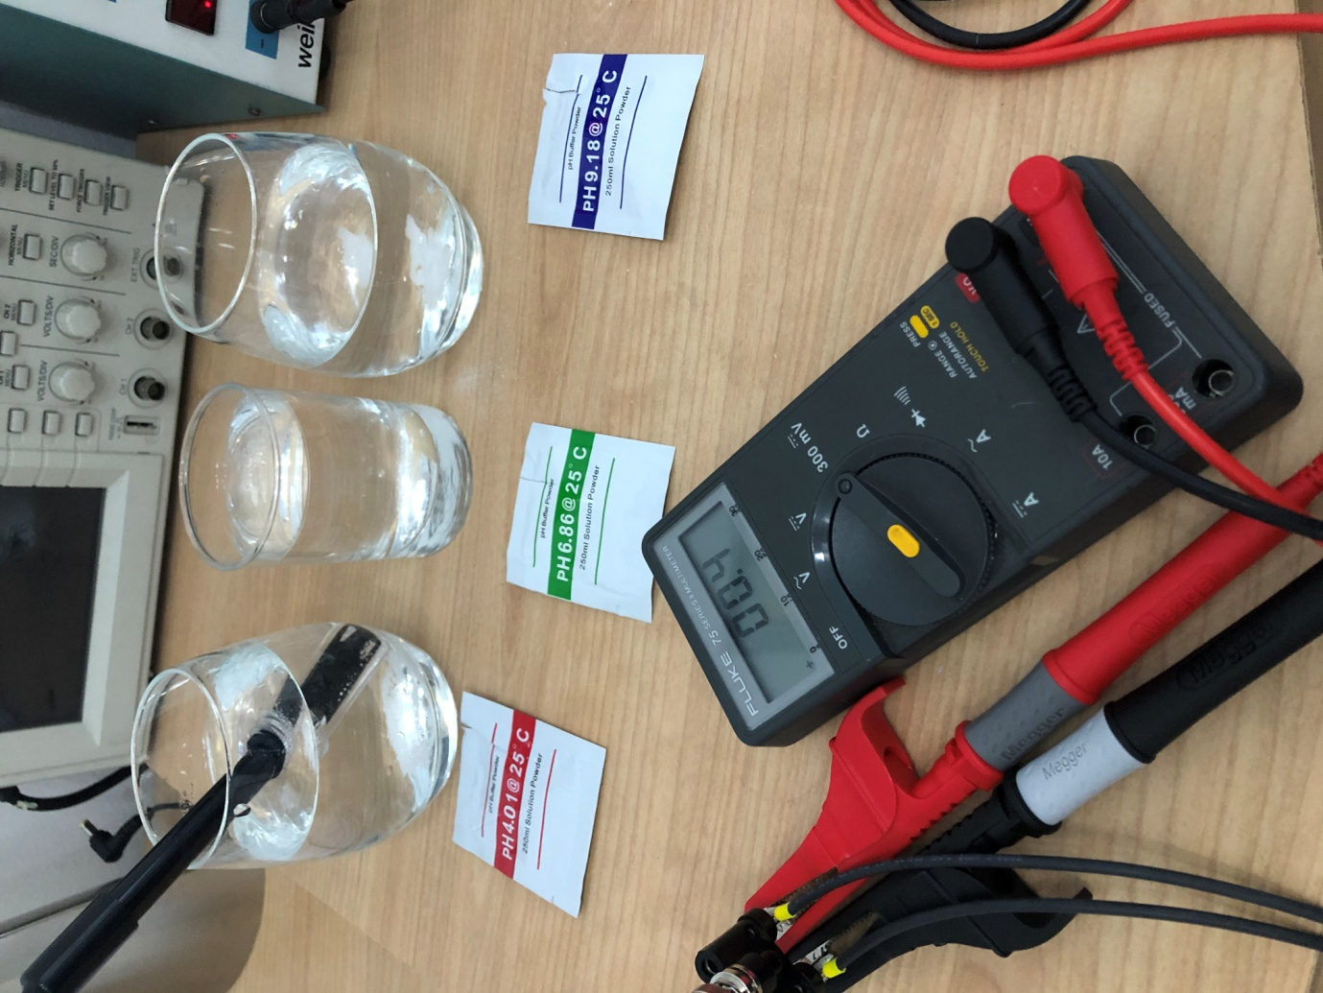
Figure 49 - pH Test 1 Figure 50 - pH Test 2
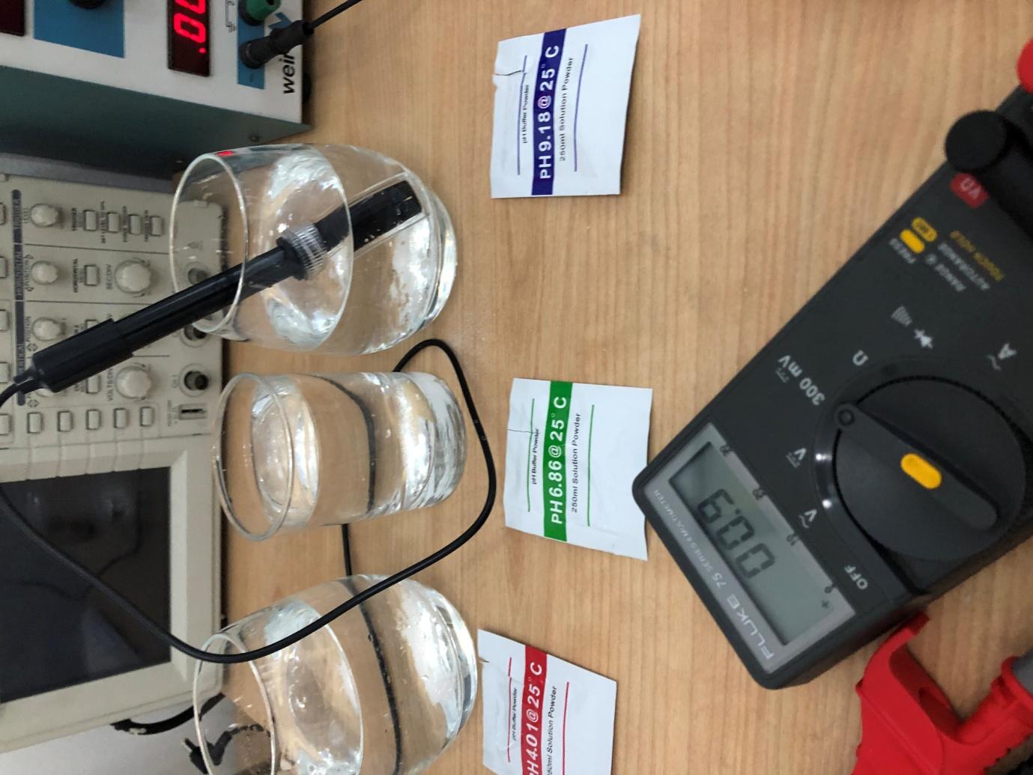
Figure 51 - pH Test 3
Figure 49 shows the probe inserted in water with a pH 6.86 solution. Output reading of 0.6mV. Figure 50 shows the probe inserted in water with a pH 4.01 solution. Output reading of 0.4mV. Figure 51 shows the probe inserted in water with a pH 9.18 solution. Output reading of 0.9mV.
All results are as expected and the sensor will be used for the final build.

4.1.3 Temperature Test
Tests were carried out to determine the accuracy and performance of the LM35 sensor and a PT100 resistor was used to compare the readings. The PT 100 has a resistance of 100 Ω at 0.00°C and will increase by 0.05 Ω for every 0.1°C. The LM 35 output is linear and a reading of 100mV would indicate a temperature of 10°C. The selected LM35 temperature sensor has a simple 3 pin connection with a 5v supply. Below is the connection used for all tests. A voltmeter was placed across ground and Vout.
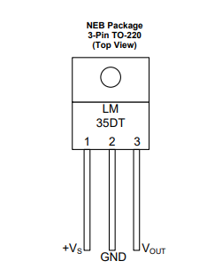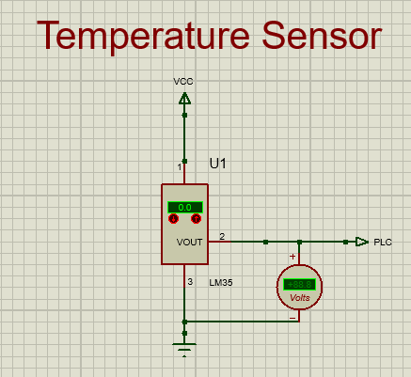
Figure 52 - LM35 Connection Figure 53 - LM35 Circuit Diagram

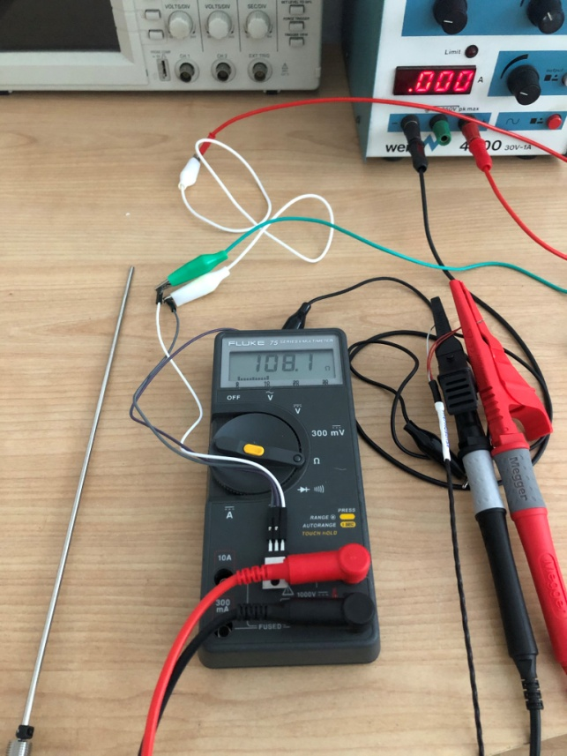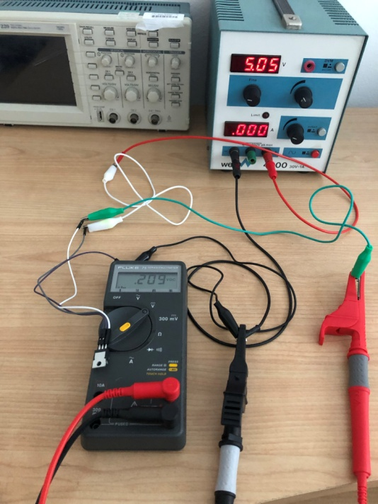
Figure 54 - LM35 Test 1 Figure 55 - LM35 Test 2
Figure 54 shows a resistance reading of 108.1Ω which converts to 20.8°C. Figure 55 shows a reading on 209mV which converts to 20.9°C. These results prove the lm35 functions as expected.
The next step is to check if the sensor can function in water as required for the monitoring system. To prove the principle a simple sandwich bag was used for waterproofing. Figure 56 below shows the sensor in the bag ready for water tests. Figure 57 shows the setup used with the sensor submerged in water.
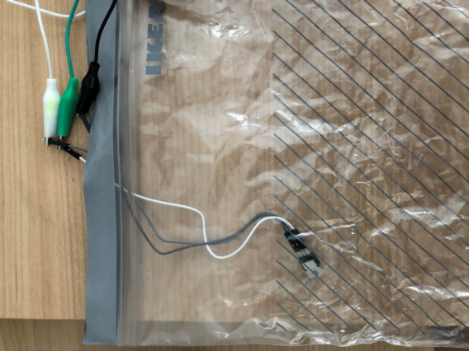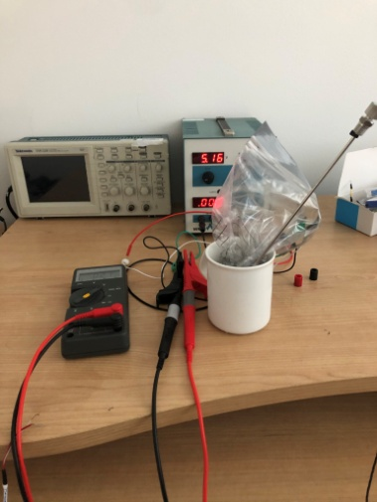
Figure 56 - LM35 Modified Figure 57 - LM35 Test 3
The below images show the low temperature tests carried out which involved ice and water. Both sensors were given 60 seconds to react to the temperature. Figure 58 shows a resistance of 101.3Ω which converts to 3.3°C. Figure 59 shows a reading of 33mV which converts to 3.3°C.
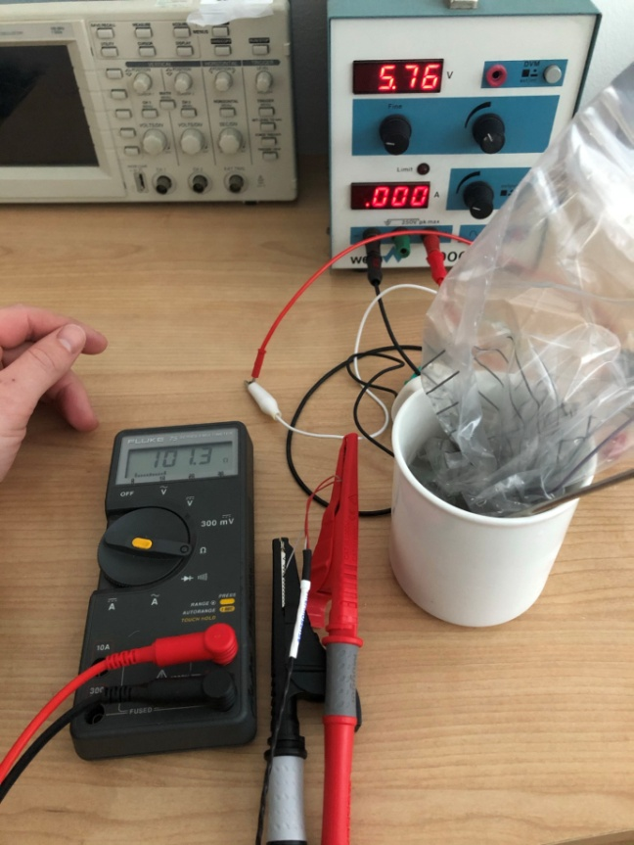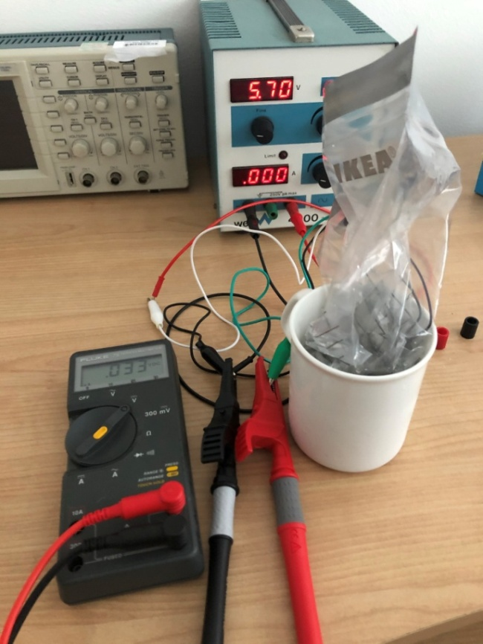
Figure 58 - LM35 Test 4 Figure 59 - LM35 Test 5
Next was a high temperature test with the with the same method as previous. This time boiling water was used after being allowed to cool to give a more realistic test. figure 60 shows a resistance of 120.6Ω which converts to 53.1°C. Figure 61 shows a reading of 517mV which converts to 51.7°C.
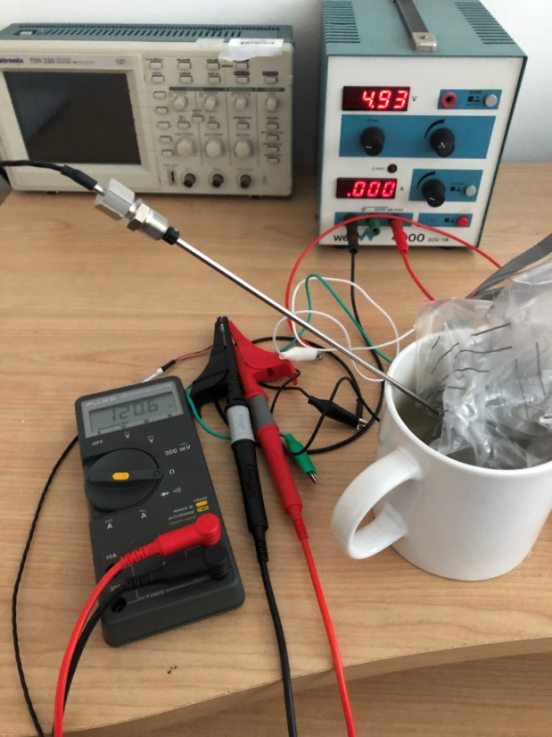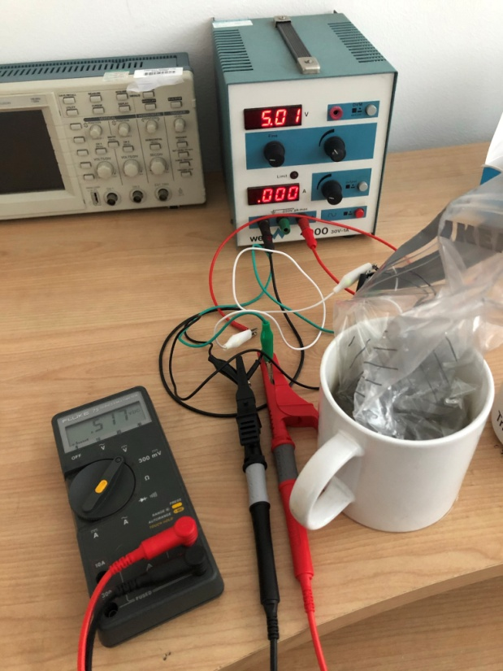
Figure 60 - LM35 Test 6 Figure 61 - LM35 Test 7

Temperature | PT 100 | °C | LM35 | °C
Ambient | 108.1Ω | 20.8 | 209mV | 20.9
Low | 101.3Ω | 3.3 | 33mV | 3.3
High | 120.6Ω | 53.1 | 517mV | 51.7

The final results are shown above. There is a small difference in results for the high temperature test however this is partly due to a delay when changing the connection of the multi-meter. The main purpose of the tests was to determine if the sensor could function correctly whilst submerged. The tests have proved successful and the LM35 will be used for the final build. A more durable method of waterproofing will be used for the final design.

4.2 Flow Chart
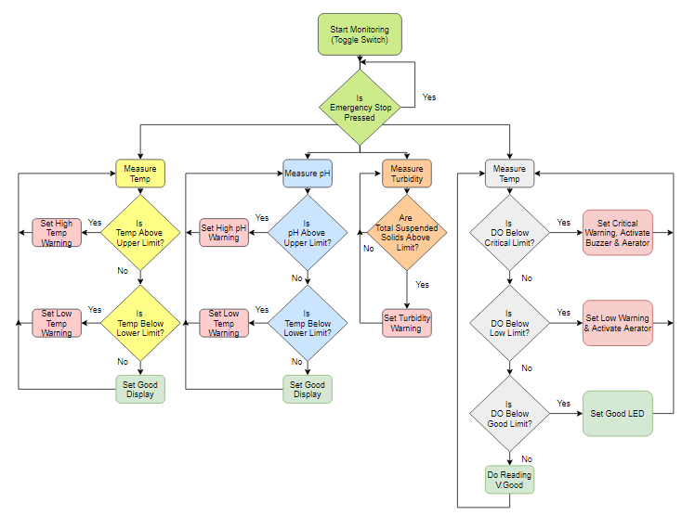
Figure 62 - System Flow Chart

4.3 Block Diagram
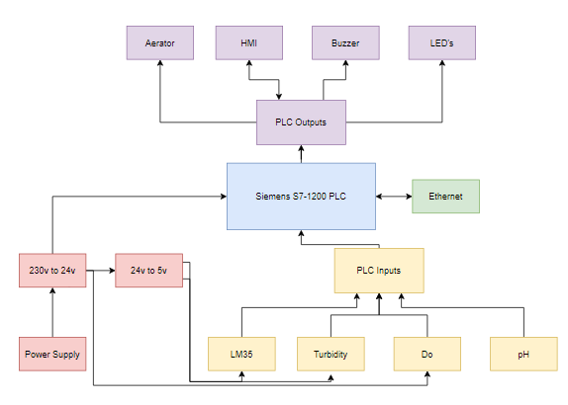
Figure 63 - System Block Diagram

4.4 0 - 10v Signal Generator
Figure 64 is the 0-10v voltage signal generator which has substituted the Dissolved Oxygen sensor for the prototype. This module will have a 24v supply with an adjustable 0 to 10v output which will feed into the PLC input. This can be adjusted to simulate the dissolved oxygen sensor.
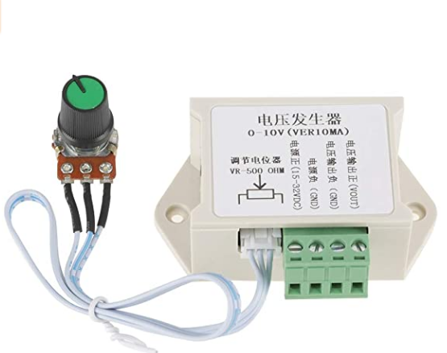
Figure 64 - Signal Generator

4.5 Relay Circuit
As discussed previously in the report a relay circuit will need to be designed as an alternative to the unavailable analogue module. A non-latching replay will be used to act as a switch. The relay will stay in the normally closed position when there is no power supplied. When the coil is energised the magnetic force will switch to the normally open position. When the supply is cut the relay will return to the normally closed position. This sequence will continue if the coil is energised and de-energised.
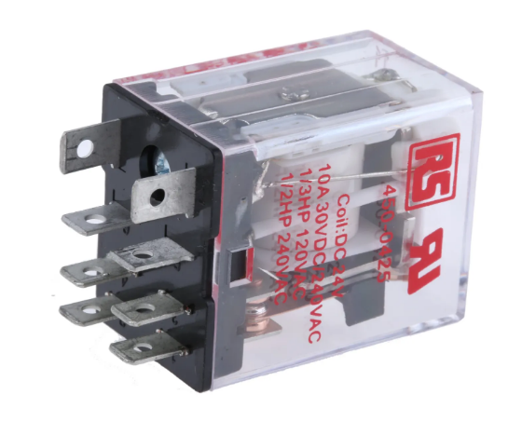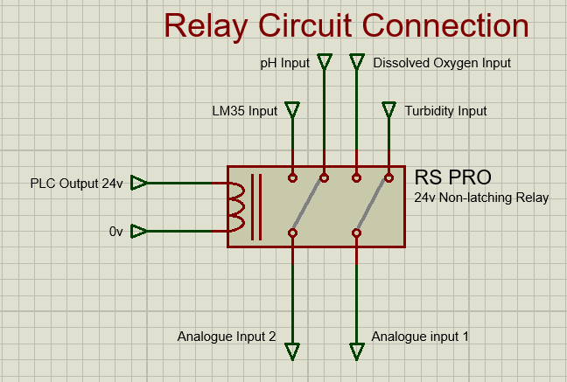
Figure 65 - Non-Latching Relay Figure 66 - Relay Circuit Diagram
Figure 66 shows the relay connection. The 4 input sensors will be permanently to the relay. The output from the relay will be change as the coil is energised and de-energised.

4.6 Schematic Diagram

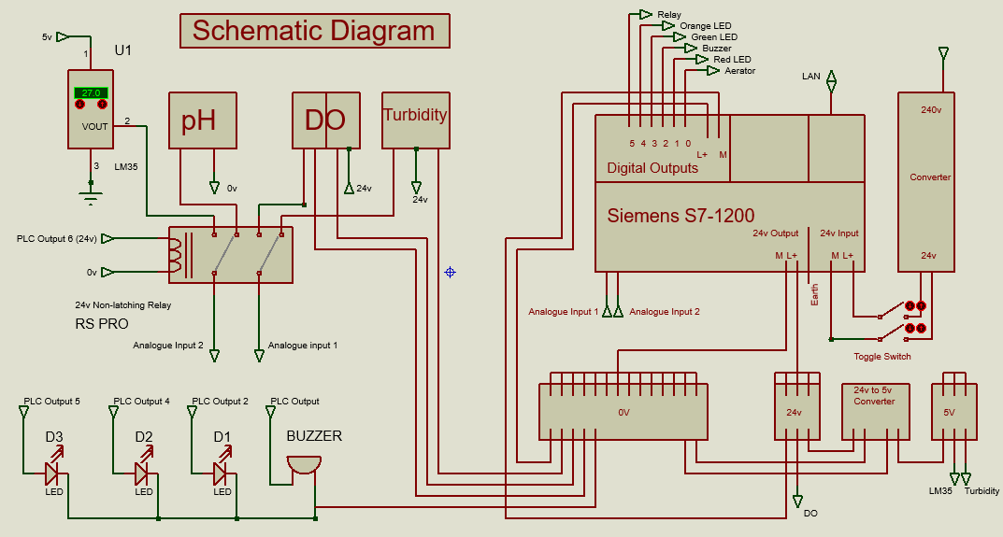
Figure 67 - Schematic Diagram

4.7 PLC Software
Figure 68 shows network 1. When the power is on the green light will stay on. Only the emergency stop will turn the running light off.
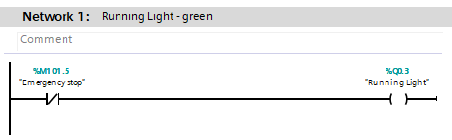
Figure 68 - Network 1
Figure 69 shows network 2. The warning light will activate if any of the set criteria is met including p.H low or high, Temperature low or high, DO low & turbidity high. Again if the emergency stop is pressed then the LED will switch off.
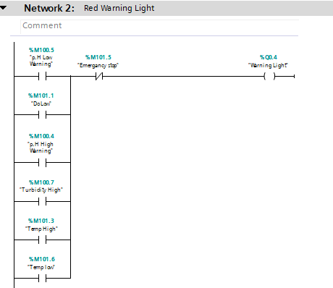
Figure 69 - Network 2

Figure 70 shows network 3 and the aerator operation. If the DO is low then the aerator will activate as the oxygen levels would have dropped below the safe level. If the turbidity is high, temperature is high and the DO is good then the aerator will turn on. Te reason for this is these conditions would suggest that the amount of DO is likely to decrease. There is also a manual aerator on control available for the operator.
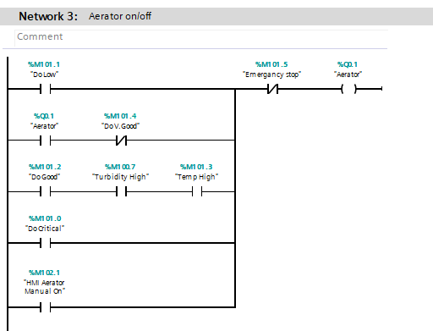
Figure 70 - Network 3
Figure 71 shows network 4. When the aerator is on it will activate the orange LED. This LED will also be on the enclosure and warn anyone nearby.
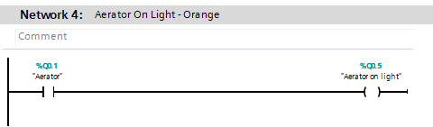
Figure 71 - Network 4

Figure 72 shows network 5. This is the warning buzzer operation and will only be active if the DO levels reach the critical limit. This will notify staff members that action is required immediately.
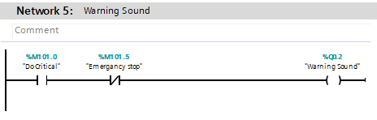
Figure 72 - Network 5
Figure 73 shows network 6. This network produces a 'actual' DO value which will be used to set the warning limits. The integer input from the sensor is converted to a real value by the conversion function block. The division is then carried out as there are 32767 steps for the analogue input. This produces the DO actual value with will be used to set limits and as a visual on the HMI. This process is used on all 4 sensor inputs.
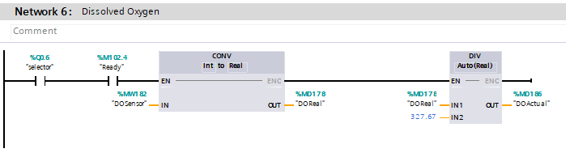
Figure 73 - Network 6

Figure 74 shows network 7. This network sets the warning limits for the Dissolved Oxygen levels. <2 will be categorised as critical. <4 will be as low. Greater than 4 but Lower than 6 be described as good. and readings > 6 will be categorised as Very Good. The Last run is for a HMI visual to signal that the DO is good.
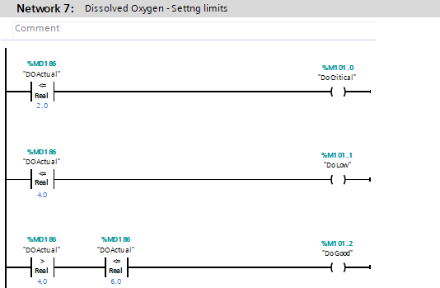
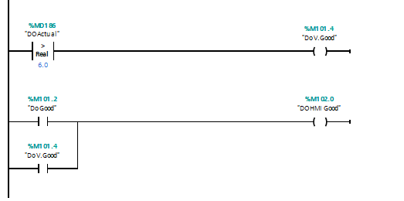
Figure 74 - Network 7
Figure 75 shows network 8. This again converts the input from the LM35 sensor into a real 'actual temp' output which will be used to set the temperature limits.
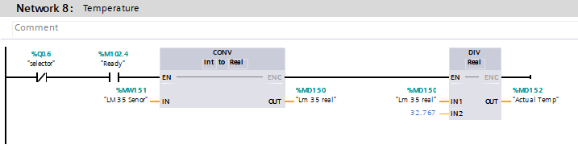
Figure 75 - Network 8
Figure 76 shows the temperature limits. The temperatures have been split into 3 categories of Low, Good & high. These outputs will be used on the HMI display and for the aerator operation.
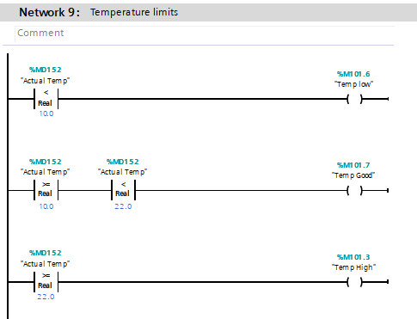
Figure 76 - Network 9
Figure 77 shows network 10 which is the turbidity input conditioning. This network works similar to network where an Int is converted to a real and then divided to create an actual value.
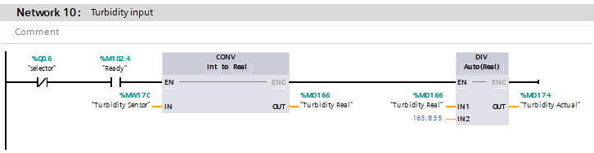
Figure 77 - Network 10

Figure 78 shows network 11 which is the turbidity limits. A value of 7 is used but this can be adjusted if required after completing site tests.
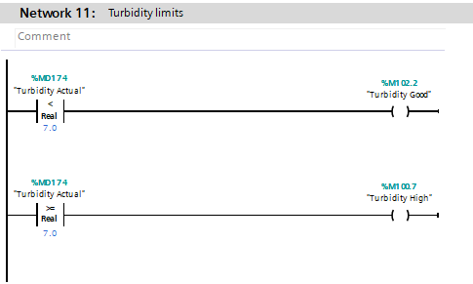
Figure 78 - Network 11
Figure 79 is network 12. This again conditions the pH input. The value used to divide on this occasion is 234.5.
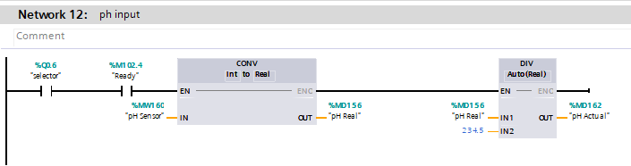
Figure 79 - Network 12

Figure 80 is network 13. This network contains the pH sensor limits. These has been set after reviewing the research carried out. 'Low' and 'high' will activate the LEDS on the panel.
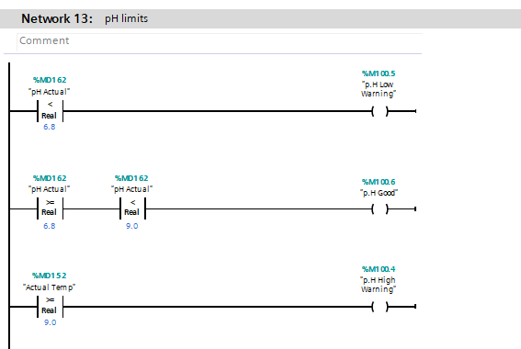
Figure 80 - Network 13

Figure 81 contains the relay circuit software which was created as a solution to the analogue input problem. The key output here is 'selector' which appears on each sensor conditioning network. When this output is 'set' the PLC will receive information from the LM35 sensor and DO sensor. When the output is 'not-set' the PLC will receive information from the turbidity and pH sensors. A combination of timers and a counter will flick the output sensor on and off. Currently the time delay is set for 2 seconds. This can be adjusted if required after field tests.
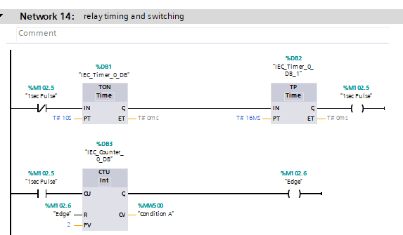
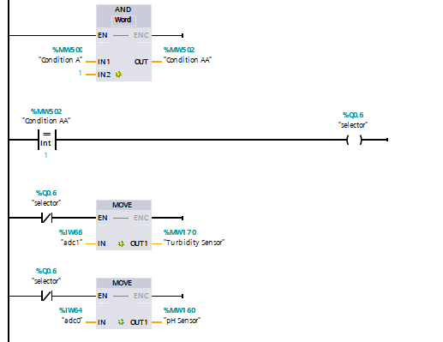
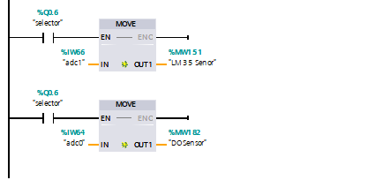
Figure 81 - Network 14

4.8 HMI Design
Below is the Root Screen of the HMI display. There is a visual display for aerator 1 with emergency stop and a manual start. The purpose is to provide the lake staff with control from the office. The 4 pilot lights will turn on when the set conditions are met. The purpose is to provide a general overview of the system. If more detail is required then the 'Data Warning' push button will take the user to the data screen.
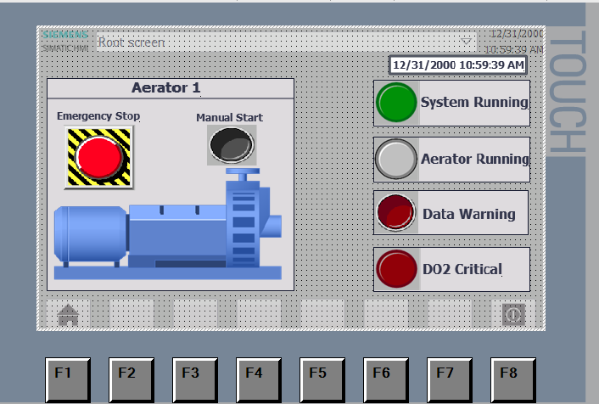
Figure 82 - HMI Root Screen
Below is the data screen layout. Each of the 4 chosen parameters have a chart which will display the data. This will be a visual representation of the data collected by the 4 sensors. LED lights are also included to display the current state. This will help reduce errors from the lake staff. There is a home button which will return the user to the root screen.
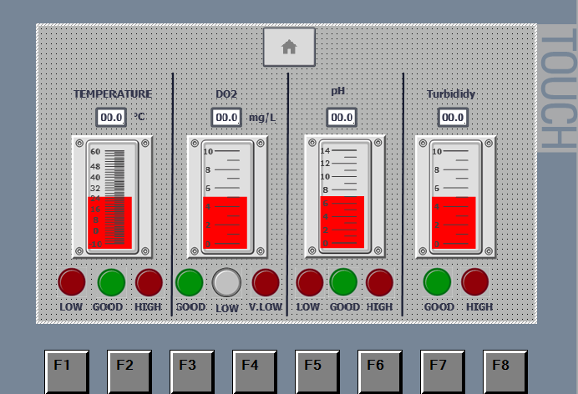
Figure 83 - HMI Data Screen

4.9 Final Layout
Below shows the final layout of the prototype. The PLC is central with plenty of airflow to prevent overheating.
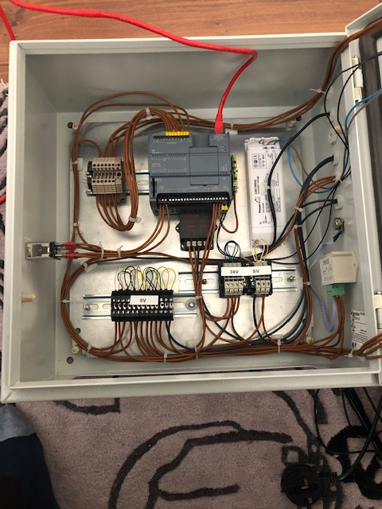
Figure 84 - Final Build

Figure 85 shows the connections on the panel door. These include 3 LED's, warning buzzer and on/off toggle switch.
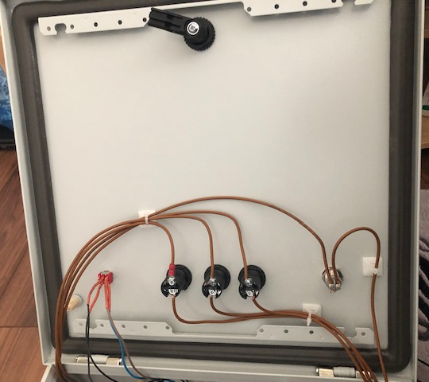
Figure 85 - Door Panel Inside
Figure 86 shows the front of the monitoring unit enclosure. This will sit at the side of the lake housing all the electrical components. The green LED will signal power on, the orange will signal aerator on, the red will signal DO very low & the buzzer will sound when the DO is critical.
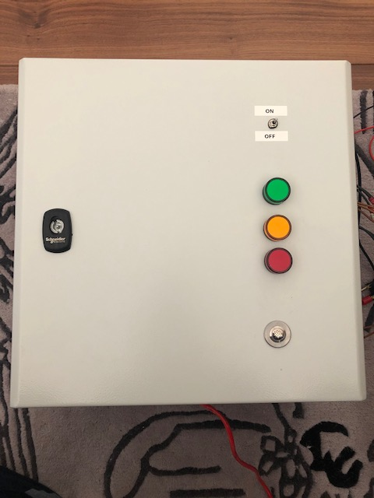
Figure 86 - Panel Door Front
Figure 87 shows the side of the electrical enclosure. This is where the connections to the sensor take place. At the bottom is the control for the dummy Dissolved Oxygen input. There is 1 gland free ready for an aerator connection.
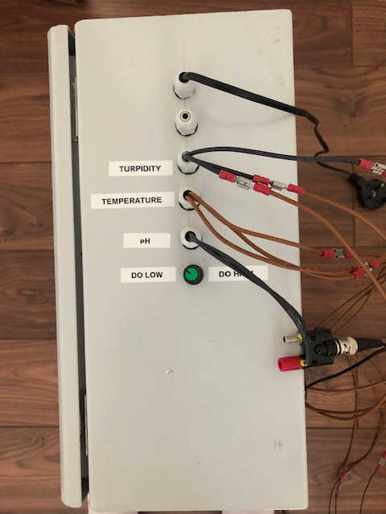
Figure 87 - Electrical Enclosure
Figure 88 and 89 show the modified LM35 sensor. The sensor has been attached to 400mm of M4 threaded bar and placed into a sandwich bag. This will allow the readings to take place under water. The plate at the top of the bar can be adjusted to change the depth of the temperature reading.
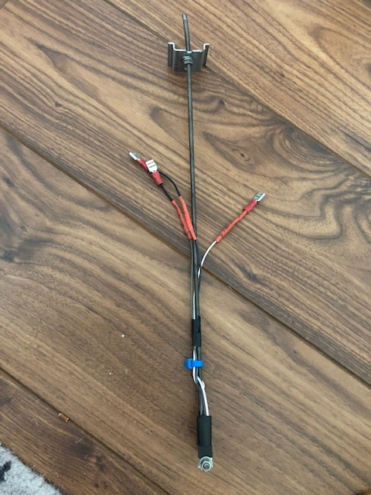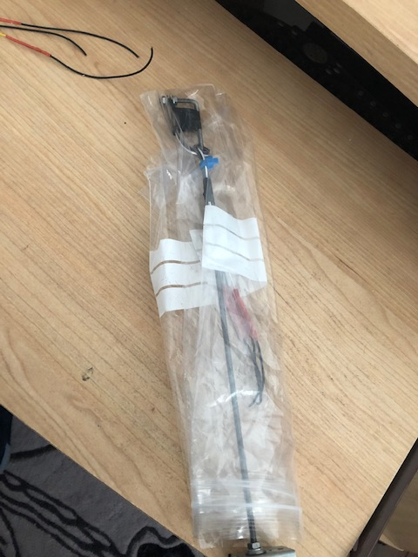
Figure 88 - LM35 Figure 89 - LM35 Waterproof

Figure 90 shows the modified pH probe. A washer has been secured to the top of the probe to allow it to sit on the floating sensor rig.
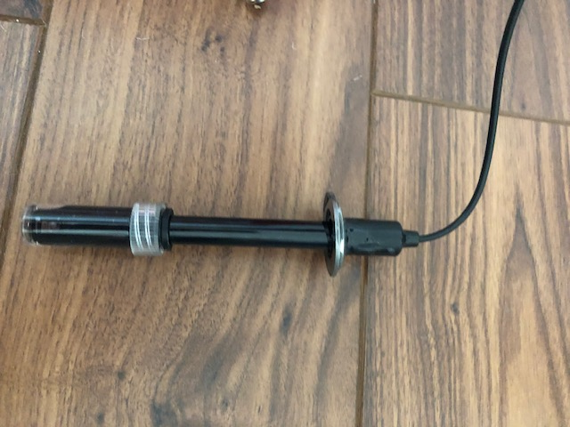
Figure 90 - pH probe
Figure 91 shows the polystyrene floating sensor rig that the 3 sensors will sit in when at the lake. Figure 92 shows the polystyrene with all 3 sensors fitted into the cut outs.
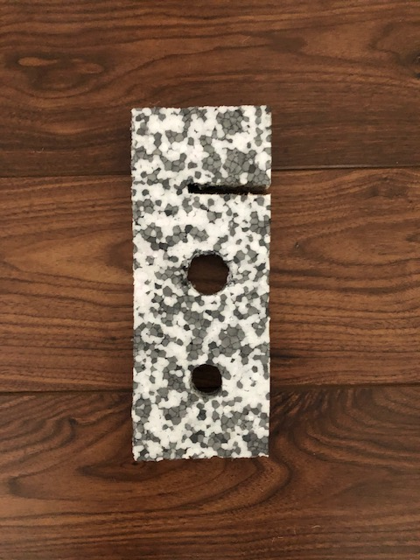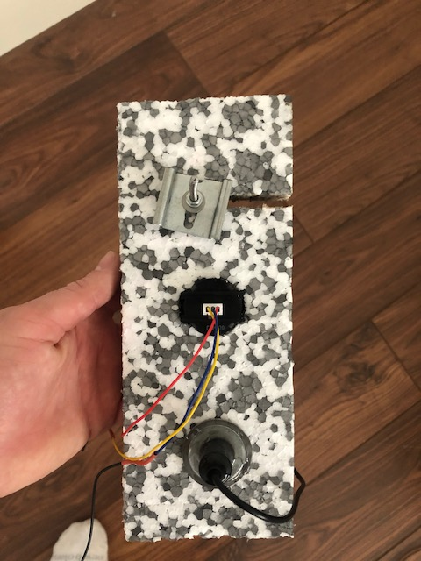
Figure 91 - Sensor Rig 2 Figure 92 - Sensor Rig

Figure 93 shows a side on angle of the sensor rig with the sensors fitted. The idea is that the polystyrene will float and allow the sensor heads to be submerged with water. The sensors can easily be fitted and removed which will allow for easy transportation. Terminal Spades have also been used on the electrical connections to improved the setup time.
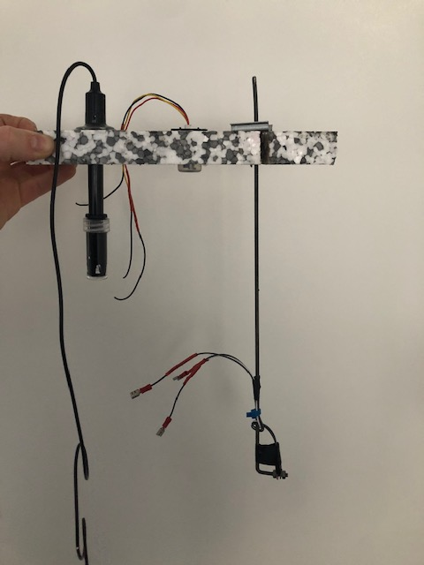
Figure 93 - Sensor Rig 3

Chapter 5 Analysis & Evaluation

5.1 Bill Of Materials
Figure 94 shows the total costing for the prototype assembly. Due to the low cost items and free issue components the total build has remained reasonable at £206.98. This cost includes spare LM35's due to a minimum order quantity. Without the rely circuit and DO alternative the project costs would have been around £1,500 as a result would not have continued. Upgraded sensors could be used at a further stage of the project development.

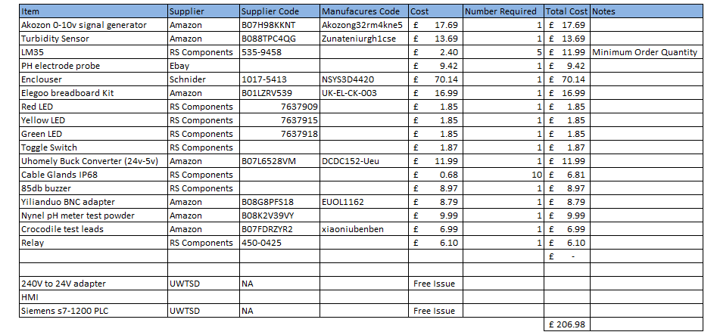
Figure 94 - Bill of Materials

5.2 Potential Cost Saving
Cost savings were one of the initial objectives. The fishery were contacted for historical data for the Dissolved oxygen figures for the past year however, the information was not available. They did provide 1 days readings for 10/04/21. Weather conditions were arm with sun/cloud. These values used for a cost savings example which can then be compared against the actual figures in 1 years time.
Match Lake:10.8mg/l - Pleasure Lake: 8.8mg/l - Specimen Lake - North: 5.7mg/l
Specimen Lake - West: 5.9mg/l - New Canal: 6mg/l - Big Pit: 9.5mg/l - New canal - South: 5.8mg/l
If these values were recorded by the monitoring unit on a warm day then only 4 of the 7 aerators would be activated at that particular time. This would result in a 43% saving.
Equation - $kWh=W x h / 1000$
Calculation $0.55kw Motor x 24 / 1000=13.2$kWh per day,
13.2kWh x 7 aerators = 92.4 kWh Per Day
Average price 14.37p x 92.4 = £1,327.78 per day.
If only 4 aerators were running the cost would be = £758.73
Potential daily saving from this example = £569.05

As the aerators are always on, it means the DO readings are already improved and the values would drop if the aerators were off. This calculation is not 100% accurate but it gives an indication to the potential cost savings that could be made with a fully functioning monitoring unit.

5.3 Final Gantt Chart
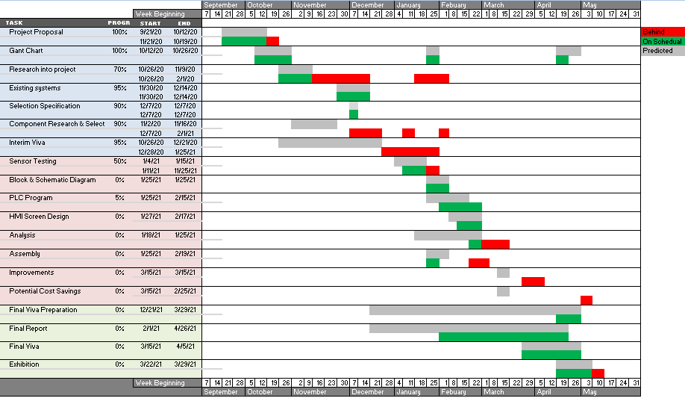
Figure 95 -Final Gantt Chart
The gantt chart shows all the major steps throughout the project. The red markings show any delays that have taken place for various reasons. As shown, most of the delays were through the December period where work gets particularly busy due to shutdowns. January was spent focusing on the interim viva and minimising delays going forward. There are a small number of tasks which have taken place a number of weeks after originally planned. Overhaul the majority of task were Completed on time an all key dates have been met.

5.4 Next Step
The next stage of development is to carry out a field test at the lake which will allow a performance review of the sensors. This will highlight any potential issues with the sensors whilst the water is very dirty and moving. This trial will also be carried out over a longer period of time to test the durability, longer term accuracy and maintenance requirements. This field test was delayed due to Covid-19 restrictions.

Chapter 6 Conclusion & Improvements
The prototype has met the required aims set out at the beginning of the project. The 4 main parameters are measured using the selected sensors and the information is fed back to the PLC. Al sensors have performed as expected during testing. The designed software then reads this information and is capable of controlling the aerator and LED's whilst also feeding live data to the HMI. As intended this has allowed the aerator to turn off when DO levels are naturally high and also turning on during low level situations. As discussed, this unit provides energy savings and reduce the maintenance costs as the equipment is being used less.
There are however a number of improvements that could be carried out in order to take the monitoring system to the next level and make it more competitive on the market. The improvements have a range of costs associated depending on how for the unit is developed.

6.1 Dissolved Oxygen
The first and most obvious improvement will be to add a dissolved oxygen sensor. The selection was carried out and many sensors met the criteria. With additional funding, this sensor could be easily added to the rig and instantly improve the accuracy and range of data collected.

6.2 Depth of Probes
The first improvement would to adapt the depth of the probes. Currently all probes sit at a maximum of 200mm below the water. DO and temperature will both have varying results as the depth changes due to the lower temperatures and lower Dissolved Oxygen levels. This information highly important for the overall water quality and would result in more reliable and accurate readings.

6.3 Turbidity Sensor
The turbidity sensor passed the bench tests and is expected to collect data during the field test. It would however be an improvement to use a sensor that sits deeper into the water. The current set up only allows the sensor emitter and receiver to be 5mm into the water. The sensor used is limited due to the fact it is not fully waterproof.

6.4 Additional Probes & Improved Quality
Firstly the probes selected are entry prices options with the main purpose of proving the concept. For the system to be developed and used full time the probes would need to be upgraded for improved accuracy and reliability. The monitoring system will have great responsibility for the health of the lake and results will need to be consistent and reliable as any false readings could be fatal.
There is scope to increase the number of probes such as:
- Sunlight hours - This would be a useful indicator for the HMI as increase sunlight hours could mean a decrease in DO levels and an increase of organic matter.
- Wind speed - High & persistent wind speeds could improve the natural aeration and diffusion.

6.5 Battery
The target market could be improved if the unit was battery powered as it would allow the monitoring system to be used in remote location without a requirement for mains electric supply. A moderate battery would allow the monitoring system to run for 7 days with the battery swapped by the lake staff. Research could also be carried out to calculate the feasibility of sola charging. This would further reduce the maintenance time required.

6.6 Remote Driven
The unit could be built onto a floating platform that incorporates a remote controlled boat. This idea is currently used by anglers to place bait in specific parts of the lake. The same idea could be used which would allow data to be collected at any location without the time and expensive of moving the fixed monitoring unit. This boat could even be automated so circle the lake for any given number of times.

6.7 App
The final improvement would be to design and develop and app that would present the collected data in a similar way as to the HMI screen. This would provide the lake staff with great flexibility to carry out their daily tasks whilst having the ability to check the real time data at any location. Any notifications or warnings would be instant meaning a greatly improved reaction time which could be critical to the wellbeing of the fish.

Chapter 7 Personal Reflection

When having to decide the project idea I was living temporary on a course fishing lake. It Was during this time that I noticed the continuous use of an aerator in the lakes. After asking a few questions I became aware of the purpose and carried out some further research. The aerator at the fishery run 24/7 which made me think improvement could be made. From her I decided to use the lake monitoring unit as my project concept.
After carrying out some initial research it became apparent that it was not only dissolved oxygen levels that influenced the water quality for aquatic life, as originally presumed. Through the research I quickly became aware of the 4 key parameters and the link between them. I found the research both enjoyable and very useful for the project as it brought to my attention a lot of information that had not originally crossed my mind.

One key sticking point for the project was the cost of a suitable Dissolved Oxygen sensor. Many hours were spent searching for a sensor that was within budget. After failing to find a sensor I contacted the fishing lake to see if any equipment was available. Unfortunately their sophisticated meter could not be used as a PLC input and meant the monitoring system would not have a dissolved oxygen probe. For this stage in the development this issue was overcome by using a 0-10v signal generator. This was not idea but without increased funding it was the only way to progress.

We were issued with a Siemens s7-1200 PLC by the university for the project. This limited the unit to 4 analogue inputs and as a result, some of the original ideas of monitoring were dropped for this stage of development and only they 4 key sensors were used. Later on in the project there were further issues as the analogue extension module was unavailable due to Covid restrictions. This issue would have limited the monitoring system to 2 analogue inputs which was unacceptable. After some design I was really pleased with the relay circuit which allowed for the use of 4 sensors.

After some disappointment with the sensor issues I was really happy with the software & HMI design. The software is capable of completing all the tasks as required and the HMI display is a personal highlight of the project. If a HMI screen became available then it could be easily fitted into the panel door which would allow the unit to run without the requirement for a laptop.
The final build was very interesting for myself as I had never been involved in any panel building or connecting a PLC. Some basic tasks took longer than they should have due to in-experience however, I will feel much greater confidence if carrying out any similar tasks in the future.
At first the project seemed quite daunting but breaking down the main tasks into smaller sub-tasks allowed me to slowly chip away. The use of a project plan helped to keep track of how much work had been completed. The original plan had many changes as the project progressed, however updating major changes to the plan meant it was useful throughout.
A personal regret is not being able to complete a planned final test run at the fishery. Covid restrictions and lockdowns meant this was not possible and as a result a final run is still to be completed.
Overhaul I am very pleased with how the project has developed. My personal knowledge has improved greatly and many skills that I have developed will be taken into my workplace.

Chapter 8 Bibliography

Bibliography

[1] | “Recreational angling,” GOV.UK, 18 October 2018. [Online]. Available: https://www.gov.uk/government/news/recreational-angling-puts-14bn-into-english-economy. [Accessed 12 October 2020].
[2] | “Oxygen Super Charger,” 5 May 2019. [Online]. Available: https://oxygensupercharger.com/oxygen-information/how-does-oxygen-get-into-water/.
[3] | “french carp and cats,” 2020. [Online]. Available: https://www.frenchcarpandcats.com/new-air-diffusion-aeration-system-installed/.
[4] | N. H. Herbold, “field Guide to Appropriate Technology,” Academic Press, 2003, p. 874.
[5] | “Dissolved Oxygen & Water,” Water science school, [Online]. Available: https://www.usgs.gov/special-topic/water-science-school/science/dissolved-oxygen-and-water?qt-science_center_objects=0#qt-science_center_objects. [Accessed 3 Jan 2021].
[6] | “Environmental Learning Center,” Nov 2013. [Online]. Available: https://www.fondriest.com/environmental-measurements/parameters/water-quality/dissolved-oxygen/.
[7] | A. Tawwab, “Effects of dissolved oxygen and fish size,” p. 14, 2015.
[8] | “Photosynthethic cells,” Nature education, [Online]. Available: https://www.nature.com/scitable/topicpage/photosynthetic-cells-14025371/.
[9] | “Aeration,” Corrosionpedia, [Online]. Available: https://www.corrosionpedia.com/definition/54/aeration. [Accessed November 2020].
[10] | “Fluence,” July 2016. [Online]. Available: https://www.fluencecorp.com/role-surface-aeration-wastewater-treatment/#:~:text=How%20Does%20Surface%20Aeration%20Work,the%20water%2C%20mixing%20in%20oxygen.&text=When%20these%20have%20a%20high,water%20treatment%20lagoons%20and%20tanks..
[11] | “Aeration, The power of oxygen,” Water-Garden, [Online]. Available: https://www.water-garden.co.uk/tech/pond-building-maintenance-advice/lake-aeration. [Accessed November 2020].
[12] | U. f. veterinarians, “Understanding Fish Kills,” 05 November 2020. [Online]. Available: http://www.sarasota.wateratlas.usf.edu/upload/documents/fish_kill_LR.pdf.
[13] | “Turbidity and Water,” [Online]. Available: https://www.usgs.gov/special-topic/water-science-school/science/turbidity-and-water?qt-science_center_objects=0#qt-science_center_objects.
[14] | “Environmental Learining Center,” November 2020. [Online]. Available: https://www.fondriest.com/environmental-measurements/parameters/water-quality/turbidity-total-suspended-solids-water-clarity/.
[15] | “What is pH,” Fondriest Environmental Learning Center, [Online]. Available: https://www.fondriest.com/environmental-measurements/parameters/water-quality/ph/. [Accessed 16 January 2021].
[16] | R. G. Wetzel, Limnology - Lake and River Ecosystems, 2001.
[17] | “Auto Aerator Unit,” Aquaculture, [Online]. Available: http://www.aquacultureequipment.co.uk/index.php/products?page=shop.product_details&flypage=flypage.tpl&product_id=17&category_id=3. [Accessed December 2020].
[18] | “Aerators & Aquaculture,” [Online]. Available: http://simon-moore.com/aerators-aquaculture/control-systems/. [Accessed 10 November 2020].
[19] | “Smart pond monitoring system,” hIOTron, [Online]. Available: https://www.hiotron.com/smart-pond-monitoring-system/. [Accessed 11 November 2020].
[20] | “How to measure dissolved oxygen,” Nexsens Technology, 24 January 2019. [Online]. Available: https://www.nexsens.com/blog/blog-measure-dissolved-oxygen.htm. [Accessed 19 December 2020].
[21] | “Dissolved Oxygen,” November 2020. [Online]. Available: http://www.sarasota.wateratlas.usf.edu/library/learn-more/learnmore.aspx?toolsection=lm_dissolvedox.

