

Programme: Master of Business Administration

Module Code: LCMB7034

Module Name: International Business Concepts

Student Name: Dhavalkumar Manubhai Ahir

Student ID: 2523550

Assessment component: Individual report

Lecturer Name: Gladius Kulothungan

Words: 5244

Table of Contents
Introduction 2
Section 1 2
1. Organizational Classification and Global Strategy 2
Strategic Categorization: 2
Global Configuration: 4
2. Macro-Environmental Appraisal and Market Attractiveness 4
Host Country (Vietnam) Analysis: 4
Market Entry: 9
3. Entry Mode Strategy and Strategic Synthesis 12
Historical Pattern Recognition 12
Strategic Fit and Justification 13
Conclusion and Recommendations 14
Section 2 15
Reflective account of the process 15
Reference List 19

Introduction
Multinational Corporations (MNCs) expand operations across borders to increase sales and profitability. Through the development and implementation of effective internationalisation strategies, MCNs enter foreign markets and achieve success (Riaz and Ijlal, 2023). The US-based multinational Electric Vehicle (EV) manufacturer, Tesla, has been expanding its international footprint over the years in order to strengthen its financial position and lead the world of EVs The report is intended to discuss the strategies for Tesla to expand into Vietnam, where the demand for EVs is significantly high. By applying different frameworks, the report analyses the global strategy, macro environment, attractiveness of the selected market and the most suitable entry mode for the company. The report also includes a section reflecting the research and analysis process considered to develop the report.

Section 1

1. Organizational Classification and Global Strategy

Strategic Categorization:
Bartlett and Ghoshal’s framework (1989), also known as the Integration-Responsiveness (IR) framework, allows organisations planning to step into the international market to select the right structure and strategy for the business. Bartlett and Ghoshal’s framework (1989) identify four primary strategies for internationalisation, such as international strategy, multi-domestic, global and transnational strategies (Meyer and Su, 2015). The global integration approach of the model reflects on the idea of standardising operations, products and services across the international markets, whereas the local responsiveness strategy is about customising products or services as per the local needs and expectations. Tesla can be found to mostly adopt the global strategy in international markets. One of the main reasons for Tesla to apply a global strategy in foreign markets is to offer customers standardised products. The global strategy of Tesla contributes to its strong brand image worldwide. The company prioritises its standardised product design and integrated services and technology for better customer experience. For instance, Model 3 and Model Y are the main products of Tesla, which are built upon standardised designs and a lot of common features. Figure 1 shows the higher sales of Model 3 and Model Y globally between 2016 and 2023, showing the positive outcomes of the standardise product offering led by the global strategy.
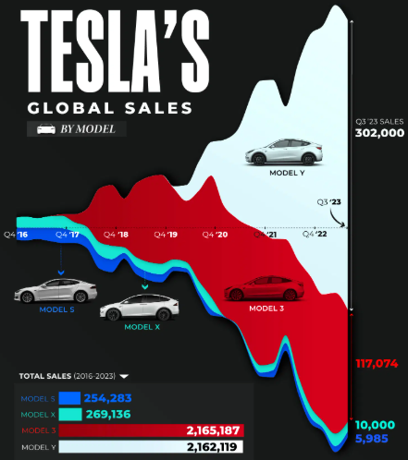
Figure 1: Tesla’s global sales between 2016 and 2023
(Source: EVBoosters, 2024)
Entering the Vietnamese EV market with the global strategy would help Tesla to offer Vietnamese customers standardised product designs, software, a vertically aligned global supply chain and centralised manufacturing and Research and Development (R&D). Through the global strategy, Tesla would be able to develop a strong brand identity in foreign markets, including Vietnam.
It can be argued that the global strategy often fails to address local needs, impacting sales and revenue in the foreign market. To address the local customers’ needs, Tesla has focused on adopting a transnational strategy, aiming at implementing both global integration and local adaptation. For instance, Tesla has opened a new data centre in China to store operational data locally (Reuters, 2021). To put it concisely, the transnational strategy appears to be an effective strategy for the Vietnamese market. Tesla should adopt the transnational strategy to address the changing needs and expectations of EV customers.

Global Configuration:
Tesla has a strong global footprint, operating majorly with transnational strategies. The company has setup its Gigafactory in the US, China and Germany (Zhao, 2022). The major strength of the widespread network of Tesla’s Gigafactory and R&D centres is the better local responsiveness and vertically aligned supply chain. Contrarily, the complex legal requirements in host markets reflects a key weakness of the international strategies. Through its international operations, Tesla focuses on strengthening its competitive advantage and creating significant value for its global customers. Two major strategies for enhancing competitive advantage, as mentioned by Michael Porter (1980), include cost leadership and differentiation (Ali and Anwar, 2021). Tesla mainly follows the differentiation strategy in foreign markets in order to offer its customers a unique experience of advanced EVs With its superior product design, highly advanced battery technology and integrated software, Tesla satisfies its global customers (Ozsevim, 2024). Tesla’s global operational strategies, including a vertically aligned supply chain, local manufacturing facilities, and a wide network of Gigafactories, contribute to the competitive advantage of the company. On the other hand, consistency in product innovation and the expansion of the supercharger network across the global platform have helped Tesla to create immense value for its customers (Business Standard, 2026). The company, therefore, can follow these strategies for competitive advantage and value creation in new foreign markets, including Vietnam.

2. Macro-Environmental Appraisal and Market Attractiveness

Host Country (Vietnam) Analysis:
Political
The government of Vietnam has initiated several strategies in order to boost the EV industry in the country, which shows a great opportunity for Tesla. The government has decided to extend tax incentives for EVs by four years to 2030 in an effort to push consumers to adopt EVs and reduce emissions across the country to a great extent (Reuters Staff, 2026). The government has also set a 2050 net-zero target, which is one of the main reasons local and foreign EV manufacturers are focused on expanding into the market. Due to the tax cut policy, annual EV sales in Vietnam increased significantly from 7,000 in 2022 to around 175,000 in 2025 (Reuters Staff, 2026).
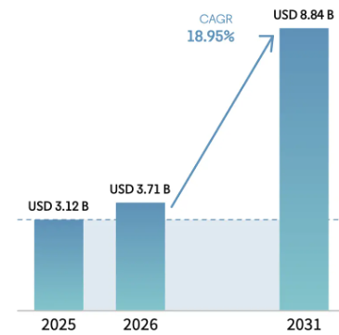
Figure 2: EV market in Vietnam
(Source: Mordor Intelligence, 2024)
The government of Vietnam has also focused on expanding the EV charging network by providing subsidies for electric prices to the charging stations. The country has over 150,000 EV charging ports as of 2024 (Reuters, 2024). Due to the government’s constant efforts, the EV market in Vietnam is rapidly growing. As shown in Figure 2, the EV industry in Vietnam is expected to reach US$ 8.84 billion by 2031 (Mordor Intelligence, 2024). Consequently, these factors show significant growth opportunities for global EV leader, Tesla.
While the government’s initiatives like favourable tax policies, long-term net zero vision and policies for expanding charging infrastructure show great opportunities for Tesla to enter the country, there are some risk factors which must be considered by the company. The major risk for foreign EV players like Tesla in Vietnam is the government-supported local EV manufacturers. VinFast, the major EV manufacturer in Vietnam, is strongly backed by the government (Thaiduong, 2026). VinFast achieved record revenue and EV deliveries in 2025 (Vietnam Plus, 2026). Tesla will face strong competition from this state-supported EV maker in Vietnam. On the other hand, the complex regulatory environment in the country also increases concerns for foreign investors planning to enter the country (Global Law Experts, 2026). However, the government has focused on streamlining the foreign investment process to boost the national economy. Tesla needs to develop effective strategies to address these issues associated with the operations of the company in Vietnam.
Economic
Vietnam has a stable and rapidly growing economy, encouraging foreign investors to consider this market for expansion. The country’s economy has shown a stable growth rate even amid global economic challenges (AMRO, 2026). The macroeconomic indicators, including the annual GDP growth rate in Vietnam (Figure 3), reflect the strong economy of the country. The annual GDP growth rate has increased from 7.94% in Q1 of 2026 to 8.39% in Q2 of 2026 (Trading Economics, 2025). The World Bank has reclassified Vietnam as an upper-middle-income economy, showing strong capital infrastructure and higher purchasing power of customers in Vietnam. Consequently, it can create significant growth opportunities for multinational global EV leader Tesla.
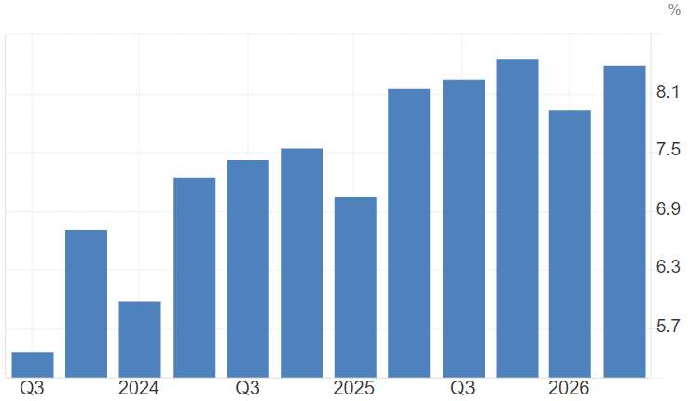
Figure 3: Vietnam GDP annual growth rate
(Source: Trading Economics, 2025)
While the annual GDP growth rate in Vietnam demonstrates strong growth opportunities for Tesla, the rising inflation rate in the country is expected to create challenges for EV makers to increase sales. As Figure 4 depicts, the inflation rate in Vietnam increased from 2.53% in January 2026 to 5.6% in May 2026 (Trading Economics, 2026).
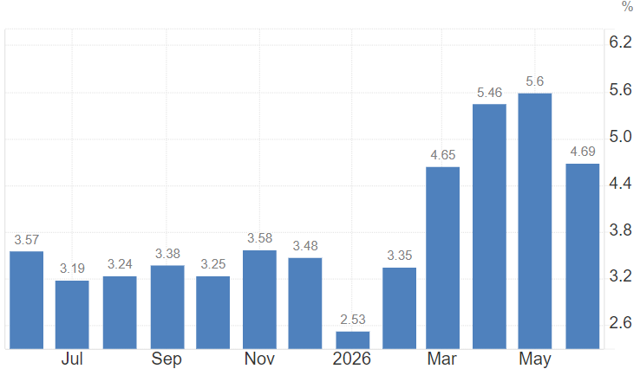
Figure 4: Vietnam inflation rate
(Source: Trading Economics, 2026)
Due to the high inflation rate, the cost of living for people belonging to the upper and middle class is rising rapidly, which will likely suppress the buying power of consumers to a great degree. Therefore, it shows a risk for Tesla to increase sales rapidly in Vietnam. Another risk factor for the foreign EV market, including Tesla, in Vietnam is the higher currency exchange rate (Trading Economics, 2026b). A significantly weak Vietnamese Dong compared to the US dollar could increase the prices of Tesla’s imported models in the country. As a result, it may affect the sales of the company in Vietnam. Therefore, both risks and opportunities are associated with the Vietnamese economy that Tesla must consider while developing a plan to enter the market.
Legal
The Vietnamese legal environment possesses both opportunities and risks for foreign companies. The Investment Law 2020 highlights several laws for foreign investors. Article 21 of the Investment Law 2020 mentions that foreign investors are allowed to enter the country as a wholly-owned enterprise (ASL, 2024). It shows a great opportunity for Tesla that operates on a vertically aligned supply chain. According to this provision, Tesla could set up its own manufacturing unit, showrooms and service centres across Vietnam. The Investment Law 2020 also discusses provisions for foreign companies to develop partnerships with local businesses to get easier access to the market (ASL, 2024). Therefore, the government’s initiative towards setting up a legal environment that attracts foreign investors could be considered by Tesla as a major opportunity to enter Vietnam and achieve success.
The evolving business regulations in Vietnam can create challenges for foreign multinational companies, including Tesla. From strict employment laws to tax regulations, MNCs operating in Vietnam are exposed to different types of legal challenges. Foreign companies often misinterpret the Social Insurance Contributions law, resulting in fines as well as reputational damage (LEXOLOGY, 2025). According to the Social Insurance Contributions policy, employers must contribute to the social, health and unemployment insurance funds. On the other hand, informal hiring practices also lead to legal consequences for foreign companies. In order to address these issues, Tesla must review the labour code and all other applicable laws while operating in Vietnam. The company also needs to register labour contracts in a proper formal way to avoid any disputes with the government (LEXOLOGY, 2025). The complex tax regulations are also often misunderstood by foreign companies, which results in fines and damage to the brand. Tesla should focus on different types of tax obligations, including corporate income tax, withholding tax and VAT, to successfully operate in Vietnam. Therefore, the Vietnamese legal environment does possess both opportunities and risks that Tesla should pay attention to when entering the market.
Cultural
Different cultural factors influence customers’ purchasing behaviour in a market. Discussing the positive cultural aspects contributing to the EV boost in Vietnam, the rapid expansion of the urban middle class is found to be a major factor. According to Vietnam Briefing, the middle-class section in the country is projected to grow to 26% by the end of this year, which is up from 13% in 2023 (Hanh, 2024). Therefore, it creates an attractive opportunity for foreign EV makers like Tesla to enter the market with a wide range of standardised EV models and target the upper-middle-class population. On the other hand, the National Statistics Office (NSO) shows through the 2024 Vietnam Household Living Standards Survey (VHLSS) results that the household income in urban areas has increased to VND 6.9 million (US$272) in 2024, around a 10% rise from 2023 (Than, 2025). It shows that the rising monthly income of people in urban areas of the country indicates a strong possibility for Tesla to influence the Vietnamese urban population to purchase their EVs
Sustainability awareness among people is one of the key cultural factors that can be found shaping consumption patterns of Vietnamese people. According to the findings of Ngo et al. (2025), the younger generation in Vietnam is found to be significantly aware of the importance of sustainable consumption. Consequently, it suggests that the investment in green transportation through EV manufacturing, distributing and selling across the country would be a feasible option for Tesla to attain the desired financial return effectively. The negative cultural factor that could be a major concern for Tesla is the ‘economic patriotism’ or ‘consumer ethnocentrism’, which are defined as consumers’ preference for domestic products in order to support the national economy (Thaiduong, 2026). People in Vietnam are found supporting VinFast, which is considered a “national champion”. Therefore, it would be difficult for Tesla to influence local Vietnamese people to prefer Tesla to VinFast. However, the differentiation approach could be applied by Tesla to gain its competitive advantage and persuade purchase decisions of customers in Vietnam.

Market Entry:
Dunning’s Eclectic Paradigm, also known as the OLI framework, is used to evaluate the benefits of investment in foreign markets. OLI framework analyses the Ownership (O), Location (L) and Internalisation (I) advantages in a specific market (Ahmed et al., 2022). Ownership benefits highlight the company-specific benefits, while ‘location’ advantages highlight the benefits associated with the host country. The ‘internalisation’ advantage discusses a company’s value-creating process.
Ownership (O) advantage
One of the sustainable competitive advantages of Tesla is its R&D, allowing the company to develop advanced EVs As mentioned in the previous sections, R&D is the global strategy of Tesla, which is focused on offering standardised EVs to customers all over the international markets (Tang, 2023). Tesla’s R&D activities pay substantial attention to the continuous innovation of EV batteries. Over the years, Tesla has made several improvements in the EV battery, from higher charging capacity to better composition of the battery. Battery safety is another area where Tesla has made significant improvements (Wu, 2023). Another differentiating factor for Tesla is its self-driving system, which is known as Full Self-Driving (FSD). FSD is an advanced driver-assistance system that performs different tasks autonomously, including steering, braking and accelerating (Tesla, 2026). As discussed in the previous section, Tesla is shifting to a transnational strategy in order to focus on both global integration and local adaptation. From opening new manufacturing units to setting up R&D centres in host countries, Tesla pays substantial attention to responding to local needs, which is considered to be an important ownership benefit.
When operating in Vietnam with these major advantages, Tesla will be able to successfully compete with the local player, VinFast, and target a large number of people seeking highly advanced EVs Compared to Vietnam’s ‘local champion’, VinFast, Tesla gains a strong edge over its competitor in software technology, autonomous driving, battery technology and charging infrastructure (Tesla, 2026b). As mentioned earlier, Tesla has a strong vertically aligned supply chain, allowing the company to fulfil the needs and demands of the market successfully. The strong financial background of the company also helps Tesla to keep investing in innovation and technology. Therefore, the discussion shows a strong possibility for Tesla to become a tough competitor to the local Vietnamese EV makers.
Location (L) advantage
As discussed earlier, the economic stability of the country is a major reason behind the rising interest of foreign investors in entering Vietnam. The country’s rising GDP growth rate is a major indicator of a stable economy, which is found to positively influence customers’ purchasing power (Vietnam Law Magazine, 2026). On the other hand, the country is also reclassified as an upper-middle-income economy by the World Bank, showing a great opportunity for multinational EV companies like Tesla to enter the Vietnamese EV market and achieve success. The government also plays an imperative part in boosting the EV industry in the country. From the expansion of the tax incentive policy tenure to setting the 2050 net-zero target, the Vietnamese government has taken multiple initiatives to encourage local urban people to shift to EVs (Van Tam, Huong Quynh and Quoc Toan, 2025). One of the critical success factors for the growth of the EV industry is the charging infrastructure development. The Vietnamese government has also shown their commitment to support the continuous growth of the EV industry through the implementation of policies subsidising electricity costs of charging stations. Therefore, the government has been playing their role effectively with an objective of boosting EV adoption across the country. These factors indicate significant ‘location’ advantages for Tesla.
While the legal environment in the country is a bit complex and focused on supporting domestic players, the government has focused on introducing new policies for foreign investors to operate successfully in Vietnam. The Investment Law 2020 mentions provisions for foreign investors to operate as a wholly-owned enterprise in the country (UNCTAD, 2020). For Tesla’s success in the foreign market, it is crucial to operate on a vertically aligned supply chain. As a wholly-owned enterprise, Tesla can set up its R&D centres, manufacturing units and service centres in Vietnam. This strategic approach will not only provide Tesla with better control over its Vietnamese operations but also help the company to achieve its corporate objectives, including stronger customer base development, higher sales and revenue generation. Therefore, the location advantages in Vietnam are likely to contribute to the sustainable performance of Tesla in the country.
Internalisation (I) advantage
One of the critical success factors for Tesla is its vertically aligned supply chain. Tesla has a strong financial background that allows the company to internal use its all operations, from product design and battery manufacturing to software development and direct distribution to customers. Tesla’s business strategies are highly internalised, due to which the company possesses strong control over its domestic and international operations successfully (Tesla, Inc., 2026). In Vietnam, Tesla can operate as a wholly-owned subsidiary, opting out of the idea of developing local partnerships. For instance, Tesla can develop a Gigafactory in Vietnam like Shanghai and Berlin (Zhao, 2022). With the internalisation of operations, Tesla would be able to maintain product quality and protect its intellectual property. Tesla also focuses on developing a supercharger network across the operating markets to provide customers with a seamless EV experience. By setting up its own ecosystem in Vietnam through the internalisation of key functions, Tesla would be able to achieve success in the rapidly growing Vietnamese EV market.
By internalising its major operational activities, Tesla can reduce its dependency on local partners. However, it can be argued that the lack of strategic partnerships with local players could create difficulties in successfully operating in Vietnam due to the insufficient knowledge and understanding of the local market needs and demands. Tesla could overcome this issue with its strong technology capacity. The company can focus on a data-driven decision-making process. Moreover, collecting feedback directly from customers will also help the company internalise customer service successfully. As mentioned earlier, ‘customer ethnocentrism’ is highly present in Vietnam (Thaiduong, 2026). Therefore, Tesla should invest directly as a wholly-owned company in Vietnam and develop the local economy through job creation and other ways. Consequently, it will allow Vietnamese customers to accept foreign EV brands like Tesla. Tesla has a strong brand reputation, market capitalisation and innovation capacity that can help it internalise the process successfully (Tesla, Inc., 2026). Therefore, Tesla’s ‘internalisation’ advantages are significantly high. Therefore, the findings of the OLI framework suggest that Tesla should capitalise on ownership, location and internalisation advantages to successfully enter the Vietnamese market.

3. Entry Mode Strategy and Strategic Synthesis
Selecting the right market entry strategy is crucial for foreign companies to thrive in the host markets. The selection of the entry mode is a critical decision for Tesla to thrive in the Vietnamese market, as the particular market can create challenges like infrastructural gap, threats of domestic players and strict laws and regulations for foreign companies. As cited by Novak (2025), the entry mode of a company into the host market reflects its corporate objective of what level of control it wants over the operations. Therefore, there are different market entry strategies applied by organisations as per their corporate goals and objectives. International businesses mostly apply entry modes, such as joint ventures, exporting, licensing, and wholly owned subsidiary. Tesla’s historical pattern of entering a market and the suitable entry strategy for Vietnam are discussed below critically.

Historical Pattern Recognition
Tesla mostly applies a wholly-owned subsidiary (WOS) entry strategy to step into foreign markets. WOS is used as an effective entry mode by Tesla and other MNCs due to its positive outcomes regarding the establishment of their own operations that offer them direct control over the market. On the other hand, the particular entry strategy is also found beneficial when MNCs concentrate on increasing the market share in the host country and boosting profit (Coudounaris and Valtonen, 2021). Tesla mainly follows the WOS entry strategy in order to possess complete control over its host country operations, branding, and customer experience. As mentioned earlier, Tesla has focused on adopting the transnational business strategy to address the local needs and expectations. However, the company is mostly found adopting the transnational strategy in the foreign market through WOS. Tesla operates on a direct-to-consumer business model in order to develop a strong connection with the customers, which results in better customer engagement with the company (Zhang and Wang, 2023). WOS has also been Tesla’s major entry strategy due to its ability to protect intellectual property of the company. For instance, as a WOS, Tesla established large-scale manufacturing units, Gigafactories, in Shanghai and Berlin (Aljazeera, 2019). Unlike its global competitors, including Volkswagen, which are mostly scale businesses through joint ventures, Tesla expanded its operations with its resources as a WOS and captured market share. For example, Volkswagen, the key competitor of Tesla, has developed a strategic partnership with the Chinese player XPeng (Raffel, 2026). Therefore, the WOS entry strategy is found to be the most successful entry strategy for Tesla.

Strategic Fit and Justification
Tesla can apply its preferred entry strategy, WOS, to step into the Vietnamese market. With this entry strategy, the company can develop its own ecosystem across the country, which will contribute to the long-term success of the company in Vietnam. Strategic partnership could be another effective entry mode for Tesla to step into the Vietnamese market. Unlike WOS, strategic partnership entry involves shared risks and investment (Mutambik, 2024). Consequently, it reduces the financial and other risks for the company in the host market.
As discussed earlier, Tesla has set up its wholly owned manufacturing units in host countries, including China and Germany, for the sustainable growth of the business in the specific international market (Boston, 2023). The company can make significant investment in the Vietnamese EV industry to influence local customers’ purchase behaviour. Operating in Vietnam with a WOS strategy would allow Tesla to enhance customer experience, maintain product quality and brand consistency.
While the WOS entry strategy can be beneficial for Tesla in many aspects in Vietnam, it has some limitations, which should be considered by the company. The EV charging infrastructure in Vietnam is in the developing phase, where the government has implemented policies to expand the charging network across the country. The largest EV charging network is owned by V-Green, which is a part of Vingroup (Morris, 2026). Tesla might not get access to the existing charging network in Vietnam if it operates as a wholly owned company. Tesla’s operations in Vietnam might be impacted by different risk factors pertinent to political, financial and operational risks. The Vietnamese government extends support to the domestic EV leader, VinFast. On the other hand, developing a supercharger network across the country will create a financial risk for the company, as it requires a huge amount of investment (Sharma, 2025). Therefore, a lack of government support and charging infrastructure availability for the company could affect Tesla’s operations significantly if the company does not make any strategic partnerships with local players. While WOS may offer Tesla better control over its operations, strategic partnerships can provide the company with a great level of flexibility. A strategic alliance with the local companies could also help Tesla get long-term benefits. For instance, a strategic partnership with the charging network company is likely to contribute to Tesla’s smooth expansion across the country regardless of the complex regulatory requirements. Therefore, Tesla can operate as a wholly-owned company in Vietnam while developing strategic partnerships with the local infrastructure providers. With this combined hybrid entry approach, Tesla would be able to successfully operate in Vietnam devoid of facing any risks.

Conclusion and Recommendations
The stable political and economic environment of Vietnam has largely contributed to the robust expansion of the EV industry across the country. It has been found that the Vietnamese government has paid substantial attention to boost the EV industry through different policies. The growing upper-middle class section in the society is another major factor contributing to the higher rate of EV adoption in Vietnam. While a developing economy, supportive government policies and rising awareness among customers for sustainable consumption can contribute to Tesla’s success in Vietnam, the ‘economic patriotism’ or ‘consumer ethnocentrism’ coupled with the strict regulatory environment and the dominance of domestic ‘champion’, VinFast, can create challenges for the company.
It is recommended that Tesla capitalise on ownership, location and internalisation advantages to achieve success in Vietnam. The company is suggested to apply a hybrid approach to enter the Vietnamese market. Tesla should operate as a wholly-owned subsidiary in Vietnam to possess complete control over product quality, customer experience and distribution. On the other hand, developing a strategic partnership with the local players, including a charging infrastructure provider, can reduce the risk of financial, political and operational challenges for the company in Vietnam.

Section 2

Reflective account of the process
Throughout the development of this assessment, I have gained knowledge and understanding of the research process, involving steps like collecting information, analysing the data and interpreting them in the most logical manner relating to the research topic. By using Gibbs' reflective cycle, I will reflect on my experiences through different stages of this assignment development process.

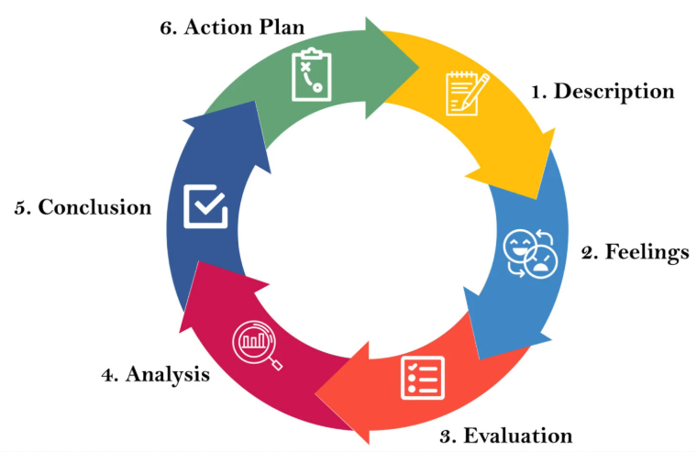
Figure 5: Gibbs Reflective Cycle
(Source: McLeod, 2025)
Description
The assessment focuses on the analysis of international expansion strategies for Tesla in Vietnam. With the application of multiple theoretical frameworks and models, the opportunities and risks involved in Vietnam for Tesla have been critically analysed. For instance, the political, economic, cultural and legal environment in Vietnam was critically analysed for Tesla’s expansion into the Vietnamese EV industry, which has been expanding rapidly in recent times. Tesla’s global strategy was also discussed in the assignment and analysed whether it would be applicable for the Vietnamese market. Tesla’s historical market entry pattern was also discussed and highlighted its potential to enter Vietnam. All data collected for the assessment were from high-quality secondary sources, including journal articles, the company’s website and newspaper articles. The learning from this course, including lecture notes, cases and discussion, was also applied in developing the previous section of the assessment.
Feelings
I was very excited for this assignment, as I was exposed to different marketing concepts and their applications in a case study of a global EV giant, Tesla. The global expansion strategies and the growth trajectory of Tesla have always inspired me to analyse this organisation’s potential in expanding into the emerging market like Vietnam. During the topic research phase, I collected a lot of information about how Tesla entered different international markets with its specific global strategies. Although the availability of information about the company and its market expansion strategies was huge, it was difficult to identify authentic and reliable data for this assessment. However, my lecture notes helped me identify the theoretical concepts for the analysis of Tesla’s market expansion strategies in Vietnam. After completing the assessment, my knowledge and understanding of market entry and international business strategies have expanded significantly. I have developed a clearer concept of how MNCs achieve success in the foreign market with different strategic approaches.
Evaluation
When it comes to throwing light on what worked well, I can mention that the research process was effortless and exciting. During the collection of information on Tesla’s global business strategies and market entry approaches, I could identify a lot of data available, making it an effortless process for me. Working on a global EV giant really helped me to accumulate information about the business strategies of the company successfully.
On the other hand, the most challenging step through the assignment development process was interpreting data with respect to the Vietnamese market. The economic environment, cultural and political landscape in Vietnam are different compared to other markets, where Tesla has already achieved success with its existing strategies. The available infrastructure in the country for EV expansion was also critically analysed with respect to Tesla’s common internationalisation strategies in other markets.
Analysis
My learning through the lectures, case examples and other readings helped me significantly in critically analysing the Vietnamese market and the best possible strategies for Tesla to enter and operate in the market. For instance, Bartlett and Ghoshal's model was applied to assess Tesla’s global strategies. On the other hand, the OLI framework was used to critically discuss ownership, location and internalisation advantages. The impacts of external business environmental factors, including political, economic, cultural and legal factors, on Tesla’s expansion into the Vietnamese market were also analysed in the assessment. Therefore, multiple theoretical concepts and frameworks changed my understanding of how different business strategies are applicable in different international markets. I applied the theories of international business strategies to conduct a thorough analysis of the Vietnamese market for Tesla. The theoretical concepts used in the assessment certainly helped me identify the right entry strategy for the company. For instance, political support for the local Vietnamese players suggests that the best way for Tesla to gain easy access to the market would be a strategic alliance with the major local companies, including the charging infrastructure developer. It shows that the interpretation of the collected data required an in-depth understanding of the Vietnamese market. The research process has improved my analytical skills, as I had to critically assess and select the right strategy for Tesla in Vietnam.

Conclusion
The assignment helped me develop knowledge and understanding of international market entry strategies. Through this assignment, my research and analysis skills have been strengthened significantly. As I have mentioned earlier, the interpretation of data or analysis part was challenging for me due to the different dynamics of the Vietnamese EV industry. Therefore, this assignment has contributed to my improved ability to apply multiple theoretical concepts and frameworks to critically assess the selected market. Based on the findings of the assignment, I have understood that the international market environment plays an imperative role in influencing the market entry and other business strategies of MNCs. Tesla’s case study shows that the historical entry strategy of the company, including a wholly-owned subsidiary, might not work well in a country with high ‘economic patriotism’ or ‘consumer ethnocentrism’. A strategic collaboration with a local player with strong access to the market may contribute to the smooth expansion of the company in the foreign market.
Action plan
In my future assignments, I will apply knowledge and experiences gathered through this project. Firstly, I will focus on collecting a wide range of academic materials, including recent journal articles discussing the theories and concepts of market expansion for MNCs. I will collect a lot of information regarding the research topic from authentic and reliable sources to critically analyse the subject. Alongside journal articles collected from different online libraries, I will also apply concepts learned through my classes, lecture notes and case examples. I will also try to make my analysis more critical to enhance the quality of the discussion in my future assignments. With these strategic approaches, I will be able to successfully develop my future assignments.

Reference List
Ahmed, B., Xie, H., Ali, Z., Ahmad, I. and Guo, M. (2022) 'Internationalization of emerging economies: Empirical investigation of cross-border mergers & acquisitions and greenfield investment by Chinese firms', Journal of Innovation & Knowledge, 7(3), pp. 1-11. https://doi.org/10.1016/j.jik.2022.100200
Ali, B.J. and Anwar, G. (2021) ‘Porter’s Generic Competitive Strategies and Its Influence on the Competitive Advantage’, International Journal of Advanced Engineering, Management and Science, 7(6), pp.42–51. Available at: https://www.researchgate.net/publication/352181915_Porter's_Generic_Competitive_Strategies_and_its_influence_on_the_Competitive_Advantage (Accessed: 16 July 2026).
Aljazeera (2019) Tesla drives into Europe with first factory in Germany. Available at: https://www.aljazeera.com/economy/2019/11/13/tesla-drives-into-europe-with-first-factory-in-germany (Accessed: 18 July 2026).
AMRO (2026) Vietnam’s Economy Maintains Strong Momentum Amid Global Uncertainties - ASEAN+3 Macroeconomic Research Office - AMRO ASIA. Available at: https://amro-asia.org/vietnams-economy-maintains-strong-momentum-amid-global-uncertainties (Accessed: 16 July 2026).
ASL (2024) Indirect Foreign Investment in Vietnam: Legal Framework and Practices. Available at: https://aslgate.com/indirect-foreign-investment-in-vietnam-legal-framework-and-practices/ (Accessed: 16 July 2026).
Boston, W. (2023) 'German Carmakers Slip Behind Tesla and China in EV Transition', The Wall Street Journal, 5 September. Available at: https://www.wsj.com/business/autos/in-ev-transition-german-carmakers-lag-behind-tesla-and-china-5f60a99f (Accessed: 18 July 2026).
Business Standard (2026) Tesla to expand supercharging network across major Indian cities: Official. Available at: https://www.business-standard.com/industry/auto/tesla-to-expand-supercharging-network-across-major-indian-cities-official-126042400629_1.html (Accessed: 16 July 2026).
Coudounaris, D.N. and Valtonen, A. (2021) 'Foreign operation entry mode of wholly-owned subsidiary as the choice of Finnish hard-service firms in Spain: A grounded theory approach', International Journal of Globalisation and Small Business, 12(4), pp. 341–368. doi:10.1504/IJGSB.2021.10043050.
EVBoosters (2024) Charting Tesla’s success: annual global sales by model. Available at: https://evboosters.com/ev-charging-news/charting-teslas-success-annual-global-sales-by-model/ (Accessed: 16 July 2026).
Global Law Experts (2026). Vietnam Investment Law For Foreign Investors. Available at: https://globallawexperts.com/vietnam-investment-law-2026-foreign-investors/ (Accessed: 16 July 2026).
Hanh, V. N. (2024) Vietnam’s Middle Class: Size, Consumer Trends, & Business Opportunities. Available at: https://www.vietnam-briefing.com/news/understanding-vietnams-middle-class-size-spending-patterns-and-opportunities-for-businesses.html/ (Accessed: 17 July 2026).
LEXOLOGY (2025) Common Mistakes in Doing Business in Vietnam and How to Avoid Them. Available at: https://www.lexology.com/library/detail.aspx?g=c29387c7-4525-4515-8485-0d71de64d7b5 (Accessed: 16 July 2026).
McLeod, S. (2025) Gibbs reflective cycle, Simply Psychology. Available at: https://www.simplypsychology.org/gibbs-reflective-cycle.html (Accessed: 20 July 2026).
Meyer, K.E. and Su, Y.-S. (2015) ‘Integration and responsiveness in subsidiaries in emerging economies’, Journal of World Business, 50(1), pp.149–158. Available at: https://www.sciencedirect.com/science/article/abs/pii/S1090951614000273 (Accessed: 16 July 2026).
Mordor Intelligence (2024) Vietnam Electric Vehicle Market Size & Share Analysis - Industry Research Report - Growth Trends. Available at: https://www.mordorintelligence.com/industry-reports/vietnam-electric-vehicle-market (Accessed: 16 July 2026).
Morris, C. (2026) Vietnamese firm V-Green to invest $380 million to deploy nationwide EV charging network. Available at: https://chargedevs.com/newswire/vietnamese-firm-v-green-to-invest-380-million-to-deploy-nationwide-ev-charging-network/ (Accessed: 18 July 2026).
Mutambik, I. (2024) 'The role of strategic partnerships and digital transformation in enhancing supply chain agility and performance', Systems, 12(11), pp. 1-29. https://doi.org/10.3390/systems12110456
Ngo, T.T.A., Pham, T.C., Tran, V.S., Le, N.B.N., Dinh, T.N. and Nguyen, Q.M.C. (2025) 'Understanding sustainable urban transport adoption in emerging economy: A study of Gen Z's intention to use electric ride-hailing services in Vietnam', Acta Psychologica, 261, 105873. Available at: https://doi.org/10.1016/j.actpsy.2025.105873 (Accessed: 17 July 2026).
Novak, K. (2025) 'International market entry strategies and their influence on global business expansion', Journal of Research in International Business and Management, 12(4), pp. 1–2. Available at: https://www.interesjournals.org/articles/international-market-entry-strategies-and-their-influence-on-global-business-expansion.pdf (Accessed: 18 July 2026).
Ozsevim, I. (2024) Tesla’s EV battery production and global gigafactory network | Article | Automotive Manufacturing Solutions. Available at: https://www.automotivemanufacturingsolutions.com/electrification/electric-dreams-teslas-gigafactory-network-and-ev-battery-production-blueprint/545858 (Accessed: 16 July 2026).
Raffel, F.-C. (2026) Automotive industry China 2026: Dominated by state-owned enterprises. Available at: https://mrl-munich.com/en/automotive-industry-china-2026-dominated-by-state-owned-enterprises/ (Accessed: 18 July 2026).
Reuters (2021) Tesla opens new China research, data centers; will store data locally. Available at: https://www.euronews.com/next/2021/10/25/tesla-china (Accessed: 16 July 2026).
Reuters (2024) Vietnam plans electricity subsidies for EV charging stations. Available at: https://www.reuters.com/world/asia-pacific/vietnam-plans-electricity-subsidies-ev-charging-stations-2024-08-12/ (Accessed: 16 July 2026).
Reuters Staff (2026) Vietnam plans to extend tax incentives for EVs until 2030. Available at: https://www.reuters.com/legal/transactional/vietnam-plans-extend-tax-incentives-evs-until-2030-2026-04-20/ (Accessed: 16 July 2026).
Riaz, K. and Ijlal, M. (2023) ‘Internationalization Strategies Of Multinational Corporations: A Critical Review’, Competitive Research Journal Archive, 1(01), pp.139-147. Available at: https://www.thecrja.com/index.php/Journal/article/download/14/14 (Accessed: 16 July 2026).
Sharma, N. (2025) Everything you need to know about Tesla Supercharger development cost. Available at: https://appinventiv.com/blog/cost-to-build-ev-fast-charging-system-like-tesla-supercharger/ (Accessed: 18 July 2026).
Tang, Y. (2023) 'Tesla’s pioneering role in the new energy vehicle industry: strategies for success', Highlights in Business Economics and Management, 23, pp. 988–991. Available at: https://doi.org/10.54097/fxhd6327 (Accessed: 17 July 2026).
Tesla (2026) Full Self-Driving (Supervised). Available at: https://www.tesla.com/en_in/fsd (Accessed: 17 July 2026).
Tesla (2026b) Powerwall – Home Battery Storage. Available at: https://www.tesla.com/en_in/powerwall (Accessed: 17 July 2026).
Tesla, Inc. (2026) Form 10-K: Annual report for the fiscal year ended December 31, 2025. Available at: https://ir.tesla.com/_flysystem/s3/sec/000162828026003952/tsla-20251231-gen.pdf (Accessed: 17 July 2026).
Thaiduong, N. (2026) ‘Vietnam’s electric dream: analyzing the public voice on electric vehicles and the rise of VinFast’, Transportation Research Interdisciplinary Perspectives, 37, pp. 1-9. Available at: https://www.sciencedirect.com/science/article/pii/S2590198226000928 (Accessed: 16 July 2026).
Thaiduong, N. (2026) 'Vietnam’s electric dream: analyzing the public voice on electric vehicles and the rise of VinFast', Transportation Research Interdisciplinary Perspectives, 37, pp. 1-9. https://doi.org/10.1016/j.trip.2026.101927 (Accessed: 17 July 2026).
Than, K. (2025) Vietnam’s Rising Purchasing Power: 2024 Living Standards Survey. Available at: https://www.vietnam-briefing.com/news/vietnams-rising-purchasing-power-2024-household-living-standards-survey.html/ (Accessed: 17 July 2026).
Trading Economics (2025) Vietnam GDP Annual Growth Rate. Available at: https://tradingeconomics.com/vietnam/gdp-growth-annual (Accessed: 16 July 2026).
Trading Economics (2026) Vietnam Inflation Rate. Available at: https://tradingeconomics.com/vietnam/inflation-cpi (Accessed: 16 July 2026).
Trading Economics (2026b) Vietnamese Dong Data. Available at: https://tradingeconomics.com/vietnam/currency (Accessed: 16 July 2026).
UNCTAD (2020) Viet Nam - Law on Investment. Available at: https://investmentpolicy.unctad.org/investment-laws/laws/550/viet-nam-law-on-investment (Accessed: 17 July 2026).
Van Tam, N., Huong Quynh, T.T. and Quoc Toan, N. (2025) 'How Vietnam can achieve net-zero carbon emissions in construction and built environment by 2050: An integrated AHP and DEMATEL approach', Building and Environment, 274, p. 112752. https://doi.org/10.1016/j.buildenv.2025.112752
Vietnam Law and Legal Forum Magazine (2026) Vietnam posts 8.02 percent GDP growth in 2025 amid challenges, Available at: https://vietnamlawmagazine.vn/vietnam-posts-802-percent-gdp-growth-in-2025-amid-challenges-76338.html (Accessed: 17 July 2026).
Vietnam Plus (2026) VinFast sets records for revenue, EV deliveries in 2025. Available at: https://en.vietnamplus.vn/vinfast-sets-records-for-revenue-ev-deliveries-in-2025-post339365.vnp (Accessed: 16 July 2026).
Wu, S. (2023) 'Analysis of the core competitive advantage of the auto industry: a case of Tesla's business model', BCP Business & Management, 36, pp. 419–425. Available at: https://doi.org/10.54691/bcpbm.v36i.3494 (Accessed: 17 July 2026).
Zhang, Z. and Wang, Y. (2023) 'New-arrival or second-hand? A direct-to-consumer business model for electric vehicles in the sustainable transportation', Energy Reports, 10, pp. 3035-3038. Available at: https://doi.org/10.1016/j.egyr.2023.09.101 (Accessed: 18 July 2026).
Zhao, S. (2022) 'Tesla Shanghai becomes world's largest production volume Gigafactory', Chinadaily.com.cn. Available at: https://global.chinadaily.com.cn/a/202207/21/WS62d903a3a310fd2b29e6daa3.html (Accessed: 17 July 2026).

