

Student name: Irma M. De Guzman

Student ID: 2414783

Module name: Component 2: Written Assignment (Essay)

Module code: BMHP5016

Lecturer name: Mr Martin Kane

TABLE OF CONTENTS

INTRODUCTION ------------------------------------------------------------------------------------------ 3

Social Model of Disability / Global Chain / Ethics of Care.
Why is it important? Why is it needed? -------------------------------------------------------3-4

The development of the social model of disability
The emergence of the concept, the way it has developed, the critiques levelled at it and the responses to these critiques. ----------------------------------------------------------4-6

Application of Concept in Practice
How the concept has been applied to health and social care policy and practice, and the problems involved. -----------------------------------------------------------------------------7-8

Recommendations for policy and practice

Present relevant recommendations for health and social care policy and practice relevant to your chosen concept. ---------------------------------------------------------------------8

Conclusion -----------------------------------------------------------------------------------------------8-9

References ----------------------------------------------------------------------------------------------9-11

Introduction

SOCIAL MODEL OF DISABILITY

The social model of Disability distinguishes between "impairment" and "disability". Impairment refers to functional limitations due to physical, mental, intellectual, or sensory conditions, whereas disability arises from societal structures that neglect or exclude individuals with impairments, preventing their participation in social activities. The model posits that disability is a form of societal oppression, emphasising that individuals do not inherently possess disabilities; rather, they experience impairments. It criticises the conflation of impairment with disability and asserts that societal failure to accommodate those with impairments leads to disability. The term "disabled people" thus applies to those affected by these social constraints, as explained by Disability Rights UK. (n.d).

The social model of disability: why it is important.
The social model of disability is important because it shifts the view of disability from a medical problem or personal tragedy to a social issue. Before, disability was seen mainly as a condition to be treated, but activists in the UK challenged this by opposing institutional care and medical control, as noted by Barnes (2019). They highlighted how poverty and exclusion from society harm disabled people. The social model helps us understand disability as caused by societal barriers and attitudes, like fear and sympathy, rather than just the impairment itself (Watson & Vehmas, 2019). This change has influenced both academic thinking and government policies on disability.
In addition to examining the governmental response to the disability "problem", the book aims to establish an understanding of "communication disablement" from the perspective of a person with speech difficulty. It explores how the social divide between disabled and non-disabled people is influenced by feelings of fear, sympathy, and revulsion.
Rights and equality, according to Owens (2015), seek to lower social barriers and hold society accountable for embracing persons with disabilities. The UK's social model of disability was established in 1975 by UPIAS (Union of the Physically Impaired against Segregation) and the Disability Alliance. This paradigm emphasises the difficulties that persons with disabilities encounter, such as discrimination, unfavourable attitudes, physical impediments, and communication problems. According to Disability Rights UK, removing these barriers advances equality and grants handicapped people greater autonomy, choice, and power.

Global Care Chain

The Global Care Chain, as explained by Nguyen et al. (2017), describes how care work and resources move from poorer to richer countries. Women from poorer nations are often hired to care for middle-class families in wealthier countries. This shift affects both the families of these migrant carers and their emotional and material lives, creating global care connections based on paid and unpaid caring work. Authors studying the ethics of care emphasise that care is a complex social process influenced by institutions and society. They explore how local and global values and practices intersect, showing mixed and changing attitudes toward care, stated by Hochschild, A.R. (2015). The study looks at how morality and market forces shape care ethics and critically examines how care boundaries and institutions interact, highlighting that these elements are interconnected and influence each other.
The "global care chain" idea helps analyse international care work, highlighting needed changes to strengthen feminist and non-feminist research by applying global commodity chain methods more rigorously, stated by Yeates, N. (2004).

The Ethics of care is a moral theory that values compassionate relationships, empathy, and the duty to care for others. Originating in feminist philosophy, it challenges traditional ethics that focus on abstract rules by emphasising the importance of context and relationships. This theory highlights caregiving as a vital but often ignored part of society and human connection. It stresses addressing power imbalances in care relationships and recognising caring tasks, mostly done by women. By focusing on building and maintaining human connections, the Ethics of care offers a valuable perspective for improving social and healthcare policies (Noddings, 1984).

The development of the Social Model of disability
The emergence of the concept, the way it has developed, the critiques levelled at it and the responses to these critiques.
The Social Model of Disability explains that people are disabled by society, not by their impairments. Barriers such as inaccessible buildings, lack of support, negative attitudes, and prejudiced policies prevent disabled people from fully participating in daily life. This model emphasises that society must change to accommodate everyone, rather than expecting individuals to “fit in” or be "fixed". Coined by Professor Mike Oliver, the first UK Professor of disability studies, the model contrasts with the medical approach, which focuses on curing impairments. It has been influential in promoting equality, accessibility, and the rights of disabled people worldwide.
According to Owens (2015), the doctrines of rights and equality, which emphasise the significance of reducing social barriers to the inclusion and involvement of disabled persons while also laying responsibility for these concerns on society, have solidified these good advancements. The Disability Alliance and the Union of the Physically Impaired against Segregation (UPIAS) held a series of debates in 1975 that gave rise to the social model of disability, particularly in the UK.
The “social model of disability", created by disability rights activists in the 1970s and 1980s, argues that people with disabilities are limited not by their bodies or minds, but by society. If the world were designed to be accessible, they could fully participate in everyday life. In other words, disability comes from society’s attitudes and physical barriers, not the individual. According to Buder and Perry (2021),
Critics of the social model of disability argue it overlooks disabled people’s actual experiences and focuses too much on social barriers, ignoring the reality of impairments (Owens, 2015). By separating the body from culture, the model has unintentionally pushed disability into medical terms, affecting disabled identities. It mainly addresses physical impairments and ignores differences. The model assumes solidarity will promote freedom, but this can limit individual recognition of impairment. Highlighting disabled people's unique experiences can reveal deep inequalities between disabled and non-disabled lives, which challenges the model’s focus on collective justice over personal identity. Changing how we talk about disability changes how we understand it. The social model of disability separates “impairments” (physical or mental limits) from “disabilities” (disadvantages caused by society). Society creates obstacles by treating impairments as abnormal and excluding people. This model has helped promote equality, accessibility, and rights for disabled people globally. It encourages focusing on removing barriers for everyone, not just “fixing” individuals. When applying this model, organisations should ask, 'What barriers exist?' How can we remove them? This approach supports inclusion for disabled, Deaf, and neurodivergent people.
According to Enright (2022), the social model of disability and the neurodiversity paradigm recognise that diverse neurotypes contribute positively to society through innovation, creativity, and divergent thinking. The social model does not focus on the causes of an individual's difficulties but aims to identify and change the ways institutions and cultural norms limit people due to ignorance or lack of accommodation. It views disability as one part of a person’s identity, caused by a mismatch between the individual and their social and physical environment. Disability arises from these barriers, not the impairment itself. The best way to reduce disability is to change society and the environment. However, negative attitudes, discrimination and oppression often prevent full inclusion and necessary environmental changes, as noted by the American Psychological Association (n.d.).
FIGURE 1: The Social Model of Disability and Neurodiversity, Enright (2022).
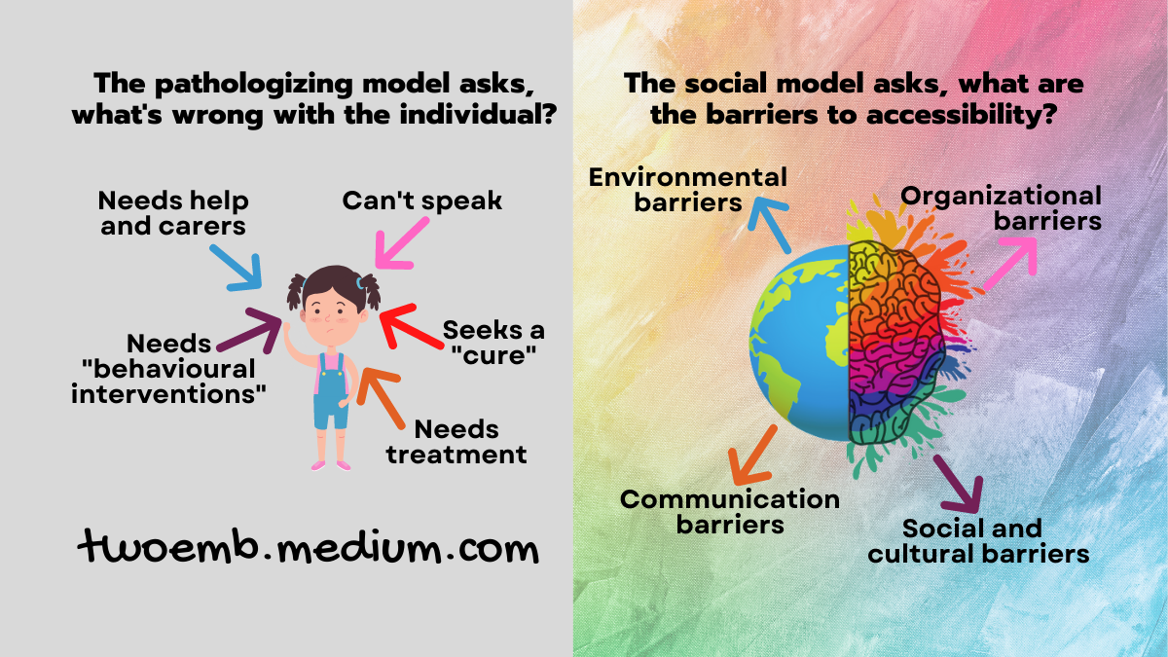
Recognising barriers is important but removing them creates equality for people with disabilities. The social model helps society make these changes to support diversity, confidence, and independence for all ages and abilities. Examples include disability advocates educating the public to change negative stereotypes. Accessible infrastructure like wide walkways, ramps, automatic doors, and restrooms helps everyone. Adaptive technology, such as audiobooks and adapted video games, allows full participation. Education improvements and communication tools like Braille and Auslan promote inclusion and accessibility, helping children with special needs engage better in learning and social life
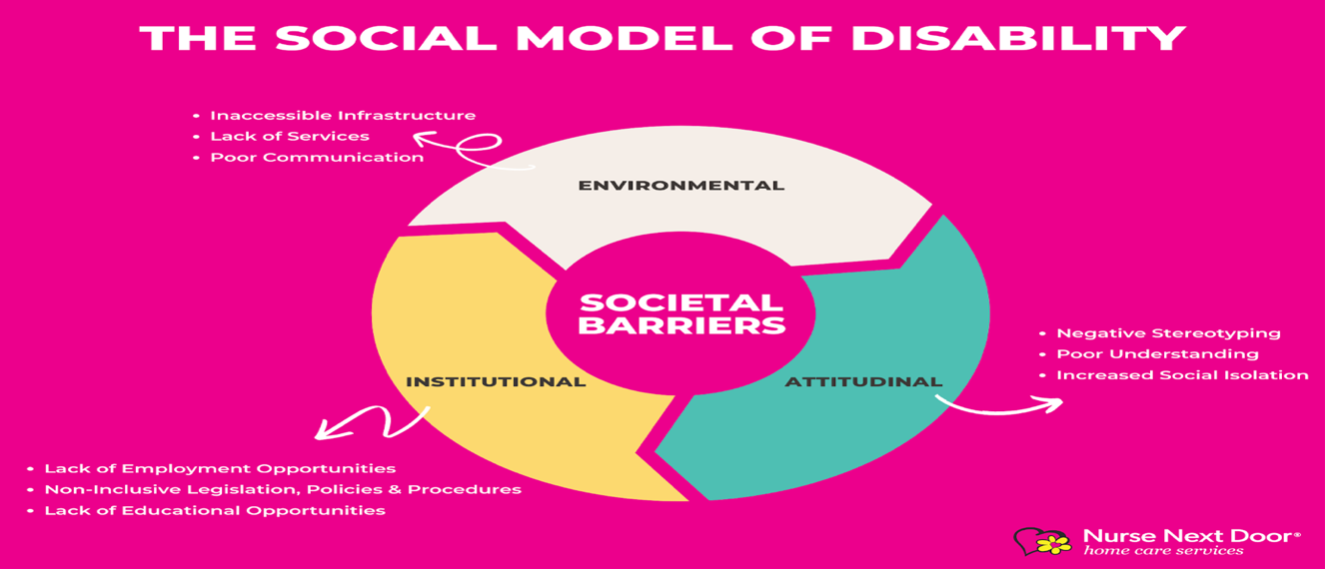
FIGURE 2: Understanding the Social Model of Disability, NEXTDOOR (2022).
Application of the concept in practice
How the concept has been applied to health and social care policy and practice, and the problems involved.

The social model of disability focuses on the attitudes people with different bodies face, as well as the structural and environmental changes needed for inclusion. It highlights how institutional rules and physical designs often assume disabled people cannot perform certain tasks, which adds to their challenges. Negative expectations about their quality of life or work ability can harm their self-esteem and increase disability. Access to social care services depends on the "risk" to a person’s independence, such as the inability to maintain family roles, work, education, housing, or relationships. These services aim to ensure disabled people can access their rights and support, helping them overcome barriers and live fuller lives, as explained by Leeds Ac.UK (n.d.)
People with disabilities and their organisations play an active role in creating and providing services, empowering them to live independently with control and choice. The Social Model for Health and Wellbeing (SMfHW) aims to reduce health inequalities and give people more control over their health. It focuses on early disease detection, prevention, and quick treatment. SMFHW highlights that good health depends on social, environmental, and biological factors. It stresses that all health services, governments, communities, businesses, and individuals is responsible for creating conditions that support health and wellbeing for all. As stated by SMFHW (n.d.)
According to Conner (n.d.), create an inclusive, culturally sensitive, and ethically based practice that is disability affirmative. Even though disability is common in clinical populations, it is still one of the areas that receives the least attention in professional training, which frequently leads to incorrect diagnoses, discriminatory behaviours, and therapy settings that do not adequately serve the needs of clients with disabilities. By providing clinicians with practical methods for incorporating disability into case conceptualisation, treatment planning, evaluation, and routine practice, this volume closes that gap. As explained by Brimblecombe et al. (2024): in England, many children and young people support family members who are handicapped, suffer from physical or mental illness, or abuse drugs or alcohol. The education, employment, health, and social involvement of children and young adults can all be adversely affected by providing care, and there are accompanying expenses. To stop and lessen these detrimental effects, assistance is required. The goal of the study was to fill in previous research gaps and offer fresh insights on the best ways to help young carers from both their own and the individuals they look after's points of view.

Recommendations for policy and practice

Present relevant recommendations for health and social care policy and practice relevant to your chosen concept.

In the UK, social care and support services work alongside healthcare and have changed to meet society's needs and policies. Despite changes, their core goals remain ensure safety, promote care and health, and give carers a break. Legal frameworks like the European Convention on Human Rights (ECHR) strengthen these goals, emphasising individual freedom, autonomy, and dignity. Social care is now focused on empowering people with disabilities rather than simply providing care for them.
Instead of separating disabled people, the goal is to fully include them in society. In July 2006, the Disability Rights Commission suggested changing old anti-discrimination laws that define disabled people only as those with physical or mental impairments that limit daily activities. Updating this definition helps prevent confusion and mixed messages about disabilities. According to Leeds.ac.UK (n.d.), many disabled people prefer to identify as 'impaired', meaning someone who faces discrimination because of their impairment, rather than being labelled simply as 'disabled'. This shift respects their experience and promotes better understanding and inclusion. This change marks important progress.
The social model of disability, proposed by Bricher (2000), views disability as a social and political issue, not just an individual problem. This model aims to empower people with disabilities and balance power in research and practice. Traditionally, health professionals have followed the medical model, which often marginalises disabled individuals. To adopt the social model widely, better communication between disabled people and medical professionals is essential.
As noted by Yang and Lin (2025), the pandemic created a reversed society for many disabled people, reshaping ideas of "normal" in disabling environments. This study shows how disabled people re-imagined physical access, mental self-identity, and social equality. It highlights the need for barrier-free spaces, disability affirmation, and institutional support to address systemic exclusion and structural inequalities.

Conclusion

The social model of disability is important for global health and social care ethics because it focuses on removing societal barriers instead of just individual impairments. It encourages inclusive practices that respect human rights and dignity and promotes teamwork among professionals to create accessible environments. This model shapes policies that emphasise equality, participation, and accommodation for everyone, pushing for systemic change. By applying these ideas in health and social care, it supports ethical decisions and better collaboration, improving the lives of people with disabilities worldwide and promoting social justice on a global scale.

References:

Brimblecombe, N. et al. (2024) ‘Types and aspects of support that young carers need and value, and barriers and enablers to access: the REBIAS-YC qualitative study’, Health and Social Care Delivery Research, 12(36), pp. 1–108. Available at: https://doi.org/10.3310/ABAT6761.

Barnes, C. (2019) ‘Understanding the social model of disability’, in Routledge Handbook of Disability Studies. Second Edition. | New York : Routledge, 2020. | Series: Routledge international handbooks | Revised edition of Routledge handbook of disability studies, 2012.: Routledge, pp. 14–31.

Bricher, G. (2000) ‘Disabled People, Health Professionals and the Social Model of Disability: Can there be a research relationship?’, Disability & Society, 15(5), pp. 781–793. Available at: https://doi.org/10.1080/713662004.
(Buder and Perry, 2021)

Buder, S. and Perry, R. (2021) The social model of disability explained, Social Creatures. Available at: https://www.thesocialcreatures.org/thecreaturetimes/the-social-model-of-disability (Accessed: 6 April 2026).

Conner, K.J. (ed.) (no date) Building a Disability-Affirmative Mental Health Practice By Rhoda Olkin.

Door Website, N.N. (2026) ‘Understanding the social model of disability’, Com.au. Nurse Next Door, 19 February. Available at: https://www.nursenextdoor.com.au/blog/understanding-the-social-model-of-disability (Accessed: 24 April 2026).

Enright, J. (2022) The social model of disability, Medium. Available at: https://medium.com/neurodiversified/the-social-model-of-disability-c7af919892e0 (Accessed: 24 April 2026).

Goering, S. (2015) ‘Rethinking disability: the social model of disability and chronic disease’, Current Reviews in Musculoskeletal Medicine, 8(2), pp. 134–138. Available at: https://doi.org/10.1007/s12178-015-9273-z.

Hochschild, A.R. (2015) ‘Global care chains and emotional surplus value’, in Justice, Politics, and the Family. Routledge, pp. 249–261..

Nguyen, M.T.N., Zavoretti, R. and Tronto, J. (2017) ‘Beyond the global care chain: Boundaries, institutions and ethics of care’, Ethics and Social Welfare, 11(3), pp. 199–212. Available at: https://doi.org/10.1080/17496535.2017.1300308.

“Not as simple as right or wrong” – a themed report on social care and support for disabled people in the UK (no date) Gov.uk. Available at: https://www.gov.uk/government/publications/social-care-and-support-for-disabled-people-in-the-uk/not-as-simple-as-right-or-wrong-a-themed-report-on-social-care-and-support-for-disabled-people-in-the-uk (Accessed: 25 April 2026).

Owens, J. (2015) ‘Exploring the critiques of the social model of disability: the transformative possibility of Arendt’s notion of power’, Sociology of Health & Illness, 37(3), pp. 385–403. Available at: https://doi.org/10.1111/1467-9566.12199.

Social model for health and wellbeing (SMFHW) (no date). Hywel Dda University Health Board. Available at: https://hduhb.nhs.wales/healthcare/services-and-teams/social-model-for-health-and-wellbeing/ (Accessed: 25 April 2026).

Watson, N. and Vehmas, S. (2019) ‘Disability studies’, in Routledge Handbook of Disability Studies. Second Edition. | New York : Routledge, 2020. | Series: Routledge international handbooks | Revised edition of Routledge handbook of disability studies, 2012.: Routledge, pp. 3–13.

Yeates, N. (2004) ‘Global Care Chains’, International Feminist Journal of Politics, 6(3), pp. 369–391. Available at: https://doi.org/10.1080/1461674042000235573.

Yang, L. and Lin, Z. (2025) ‘The re-imagined social model: the disabling space of disabled people during the pandemic’, Disability & Society, 40(3), pp. 660–679. Available at: https://doi.org/10.1080/09687599.2023.2295215.

(No date) Leeds.ac.uk. Available at: https://disability-studies.leeds.ac.uk/wp-content/uploads/sites/40/library/gb-disability-equality-training-GBDTC-Applying-the-Social-Model-of-Disability.pdf (Accessed: 24 April 2026).

(No date) Apa.org. Available at: https://www.apa.org/ed/precollege/psychology-teacher-network/introductory-psychology/disability-models (Accessed: 25 April 2026).

(No date) Disabilityrightsuk.org. Available at: https://www.disabilityrightsuk.org/social-model-disability-language?srsltid=AfmBOoom__RwCewlBVdrxG2GqJo1g6vSi9tEKhHduzYRHwxBJvZHSJ8k (Accessed: 27 April 2026).

