

University of Wales Trinity Saint David School of Engineering

Engineering Design.
Engineering Problem.
Technical Report.

Engineering Design
(ACMA4008)

Mohamed Rithwan Thangeswaran
2313855
20/01/2025
Contents
1. Introduction 3
2. Key legislation considerations 4
2.1. Maximum Safe Lifting Weights 4
2.1.1. For Men 4
2.1.2. For Women 4
3. Specification 5
4. Time plan 5
5. Literature Review 6
6. Concept Design 7
6.1. Concept 1 7
6.2. Concept 2 8
6.3. Concept 3 9
7. Final Design 10
7.1. Decision Matrix 10
8. Technical Drawing 11
9. Manufacturing Processes 13
10. Justification 16
11. Conclusion 16
12. Further work 16
13. Reference 17

Introduction
The deign project involve solving the problem in anodization process to improve the productivity The problem is related to a tank used in an anodization process. Several manufactured aluminum parts are anodized for aesthetic reasons and to protect the part from degradation. The process involves hoisting the parts into a stainless-steel tank which contains 30% sulphuric acid and is heated to 25 degrees Celsius. An illustration of the tank is below, note that all insulation, electrodes and heating elements have been removed for clarity.
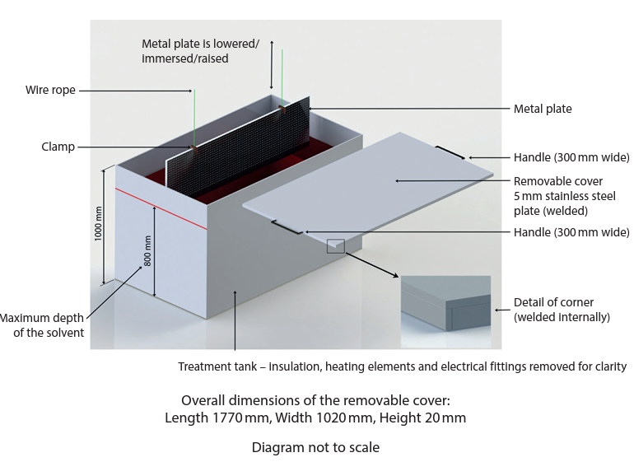
For health and safety reasons, a detachable cover (shown in the figure) is placed on top of the tank while it is not in use. Stainless steel that is 5 mm thick is currently used to make this cover. It takes two people to lift the cover, which has two grips on either side. Employees have expressed dissatisfaction at the difficulty of correctly putting the lid on, and the health and safety officer has identified this procedure as a significant risk to employees. These tanks would probably need quantities in the low hundreds because there are dozens of them at your facility and numerous others at the company's other locations.

Key legislation considerations
When designing the cover for the anodizing tank there are regulation need to follow according to health and safety requirements. The cover needs to design to operate by single person therefore there is maximum weight limitation which one human can safely operate. According to UK Manual Handling Operations Regulations 1992 following guideline is provided(“Manual handling. Manual Handling Operations Regulations 1992 - Guidance on Regulations - L23,” n.d.).

2.1. Maximum Safe Lifting Weights

For Men
- Close to the body at waist height 25 kg
- At shoulder height 10 kg
- At floor level 15 kg

For Women
- Close to the body at waist height 16 kg
- At shoulder height 7 kg
- At floor level 10 kg
If the task involves repeated lifting, the weight limits should be significantly reduced. But in our case the covering and closing the tank is not repetitive we can consider the mentioned weight. The cover has to be operated regard less of the gender and it should operate in shoulder height the maximum weight of the cover is 7kg.
Concentrated sulfuric acid, which is extremely caustic and dangerous, is present in the tank and presents serious health and safety issues. Because sulfuric acid exposure can result in serious burns, respiratory problems, and eye damage, it is imperative that the tank and its lid be handled very carefully.
Safety must be the top priority when covering or removing the tank lid to shield employees from hazardous acid fumes, splashes, or unintentional contact. To reduce these hazards, appropriate protocols and safety precautions must be put in place. When moving the tank lid, employees must wear the proper personal protective equipment.

Specification
Specification
Dimension | 1770x1020 | mm
Height | 100 | mm
Weight | 7 | kg
Operation Temperature | 25 | C
Operation Acid Concentration | 30 | %

Time plan
Task | W1 | W2 | W3 | W4 | W5 | W6 | W7 | W8 | W9 | W10
Collection of Product Requirement
Concept Development
Final concept selection
Detail Design
Manufacturing Drawings and BOM
Manufacturing of parts
Assembling
Testing and validation

Literature Review

The most important part of designing the cover for tank is select suitable material. The tank consisted of high concentration sulphuric acid. The acid properties will corrode the tank cover. Therefore, high chemical resistance material is required for the manufacture the cover. Most common material use in industry for chemical application are the stainless steel. The stainless steel has good strength similar to steel and high corrosion and chemical resistance. There are different types of stainless steel with slightly different properties for different applications. 304L Stainless Steel is the most cost-effective material for acidic chemical environment(Davis, 2000). But this material not suitable for high concentrations acid environment and high temperature application. The most used chemical resistive stainless steel in the industry is 316L Stainless Steel(Loto et al., 2020). Which has outstanding resistance to diluted sulfuric acid, especially in environments with acids and at moderate temperatures. The excellent stainless-steel material for high concentrations acid environment is Alloy 904L. Which has great resistance to concentrated sulfuric acid and chloride environments. Exclusively designed for high concentrations and aggressive acidic conditions(Verma et al., 2021).

Property | 304L | 316L | 904L
Chemical Composition | 18-20% Cr, 8-12% Ni | 16-18% Cr, 10-14% Ni, 2-3% Mo | 19-23% Cr, 23-28% Ni, 4-5% Mo, 1-2% Cu
Tensile Strength | ~485 MPa | ~515 MPa | ~490 MPa
Yield Strength | ~170 MPa | ~205 MPa | ~220 MPa
Cost | Low | Moderate | High
Weldability | Excellent | Excellent | Good but requires specialized techniques
Disadvantages | Limited acid resistance, pitting in aggressive environments. | Higher cost than 304L, limited for very high acid concentrations. | High cost and requires advanced welding and handling.

Polymer is good inexpensive choice to design the anodizing tank cover. According to the experiment PP is the most suitable polymer concentrated acidic environment. But strength is lower than the stainless steel. But weight of PP very low(Woishnis and Ebnesajjad, 2011).

Concept Design
When developing the cover for the sulfuric acid tank, three different cover designs were evaluated to determine the best alternative. Each design was kept simple and manually controlled to ensure ease of use and dependability. These proposals were thoroughly evaluated, with an emphasis on utility, practicality, and safety aspects. The advantages and disadvantages of all three designs were thoroughly considered, considering issues such as durability, cost-effectiveness, ease of operation, and resistance to the corrosive nature of sulfuric acid. This thorough examination allowed for the selection of the most suited design that met the operating needs and safety regulations.

Concept 1
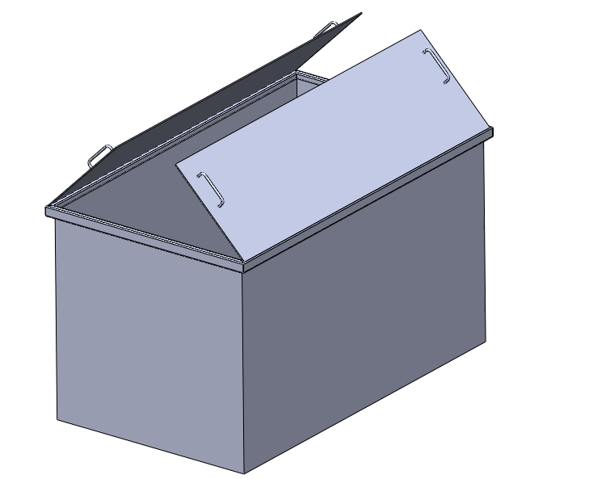
This concept represents the simplest solution for covering the sulfuric acid tank. A double-hinged door, containing of two independent door panels is the inspersion this concept. Each door panel is designed to rotate up to 270 degrees, allowing for maximum accessibility during inserting the aluminum parts inside the tank.
When the doors are closed, both panels rest flat and parallel to the top of the tank, creating a secure lock. This create a proper seal. First, close the left door panel, then the right. The right door panel overlaps slightly with the left panel, resulting in a tight and secure seal. This overlapping system ensures that there are no gaps between the panels, which improves the cover's safety. Furthermore, a stepped feature in the left door panel allows the right door panel to be completely parallel to the tank's top surface. ensuring no gaps between the cover and tank.
Each door panel consisted handles on the front and back to make operation simpler. These handles let users to simply open and close the panels from either side of the tank. To support the installation of this cover, a solid frame must be installed on top of the tank. This frame acts as the foundation for operating the two door panels together sulfuric acid tank.

Concept 2
.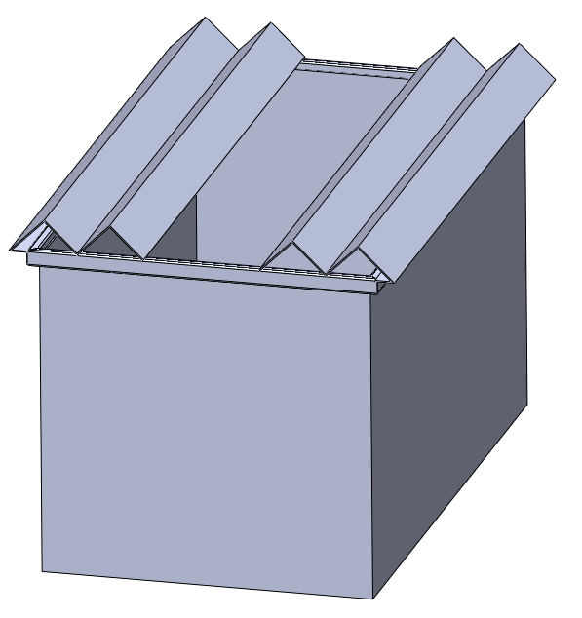
The second concept has a design with two door sections, each with four connected parts. These segments are intended to move each another, allowing each door half to expand and contract smoothly. When fully inflated, the door produces a planar surface that is parallel to the tank's top plane, thereby covering the entrance. When the door is contracted, the tank is completely opened, with the door segments arranged vertically.
In their contracted state, the sections stack together to form a compact structure that moves beyond the tank's opening. This ensures the door will fully open the top of tank. To safeguard correct installation and operation of this door mechanism, a sperate structure must be built on the top of the tank. This structure serves as a foundation, supporting the door panels. The frame also protects the mechanism's structural stability, allowing it to be used with a sulfuric acid tank.

Concept 3

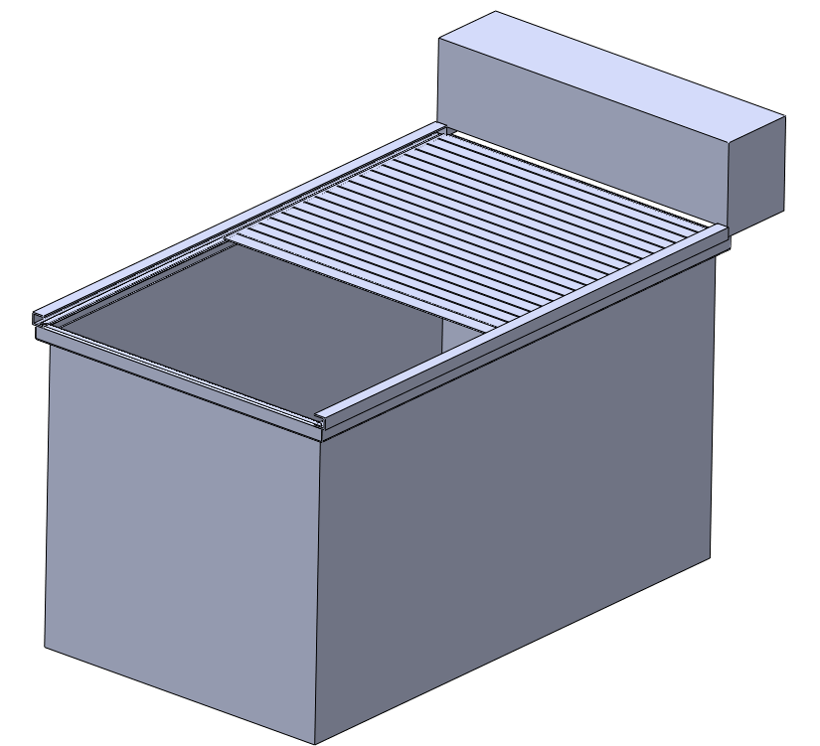
The third design concept is similar to roller doors. Which is applied in standard garage doors. The cover of a roller door is known as a curtain. The curtain slides from the right to the left side of the tank, guided by the tracks. The tracks are installed on the side of the tank. The track contains little wheels that allow the curtain to glide smoothly. There is a spring mechanism inside the barrel that allows the curtain to stop at any middle position. This technique can be readily mechanized by installing a motor within the barrel.

Final Design

Decision Matrix
Criteria | Weight | Concept 1 |  | Concept 2 |  | Concept 3
 |  | Score | Total | Score | Total | Score | Total
Feasibility | 2 | 3 | 6 | 4 | 8 | 2 | 4
Cost | 3 | 5 | 15 | 4 | 12 | 1 | 3
Easy Functionality | 2 | 1 | 2 | 4 | 8 | 5 | 10
Sustainability | 1 | 3 | 3 | 3 | 3 | 2 | 2
Safety and Risk | 3 | 2 | 6 | 3 | 9 | 5 | 15
 | Total | 16 | 32 | 18 | 40 | 17 | 34

Decision matrix is used for selection of the best concept to cover sulphuric tank. The parameters considered to are the feasibility, cost, easy functionality, sustainability and safety and risk. Weight for each there parameters are assign according to the requirements. According to the decision matrix concept 2 scored more points. Therefore concept 2 selected as for the final design.
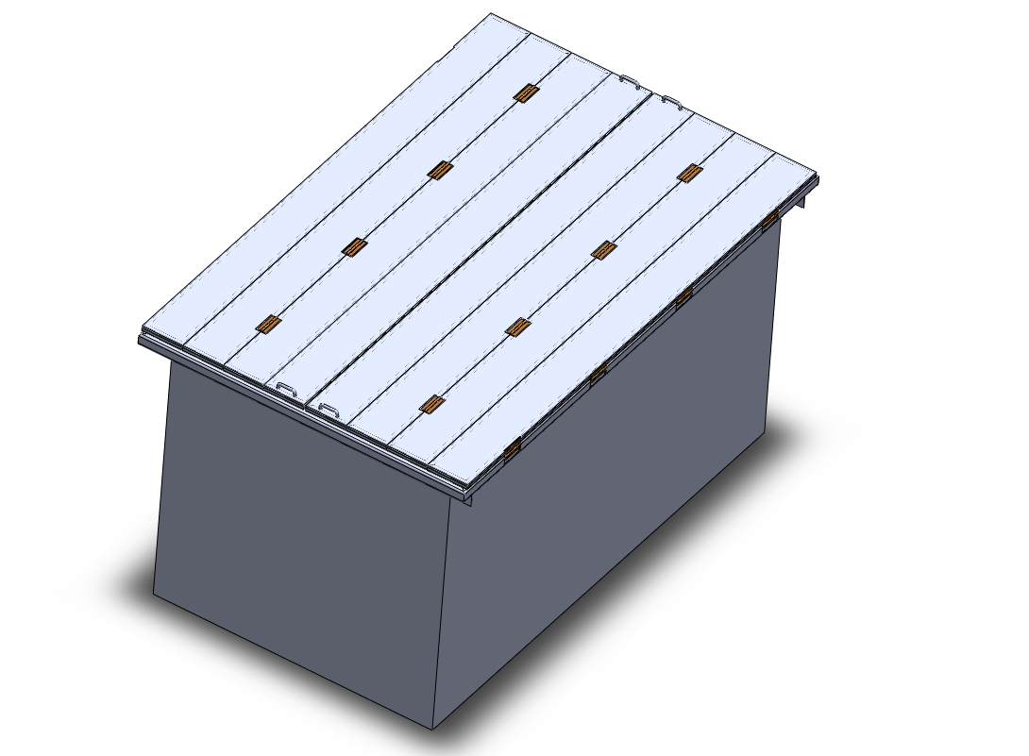

Technical Drawing
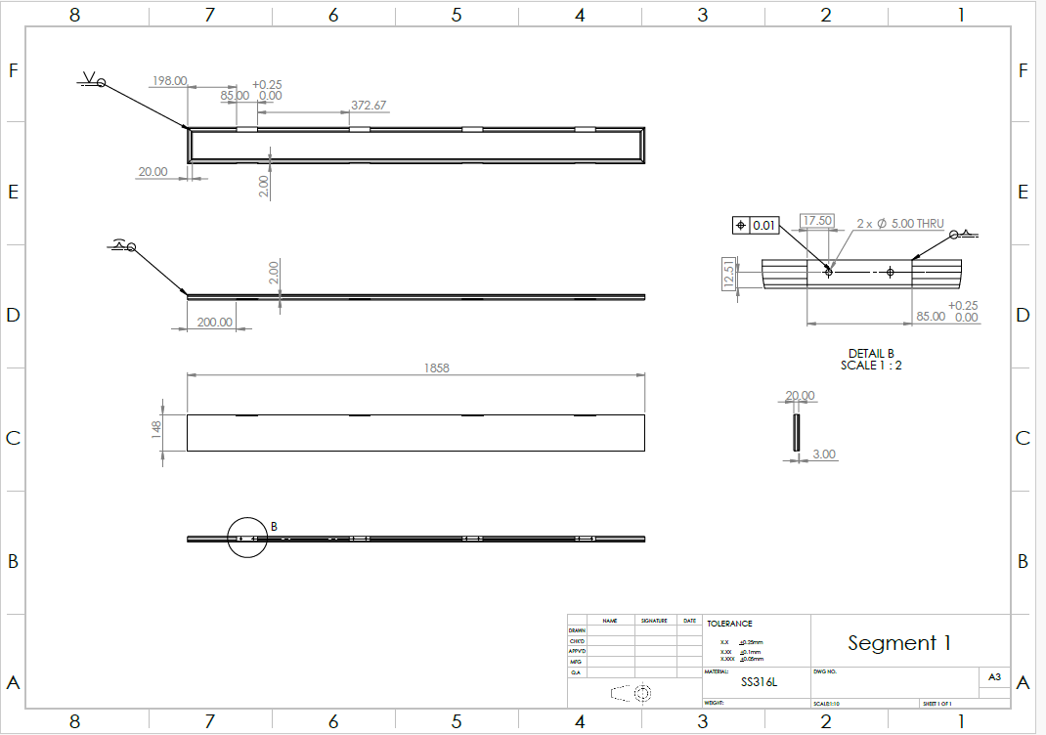
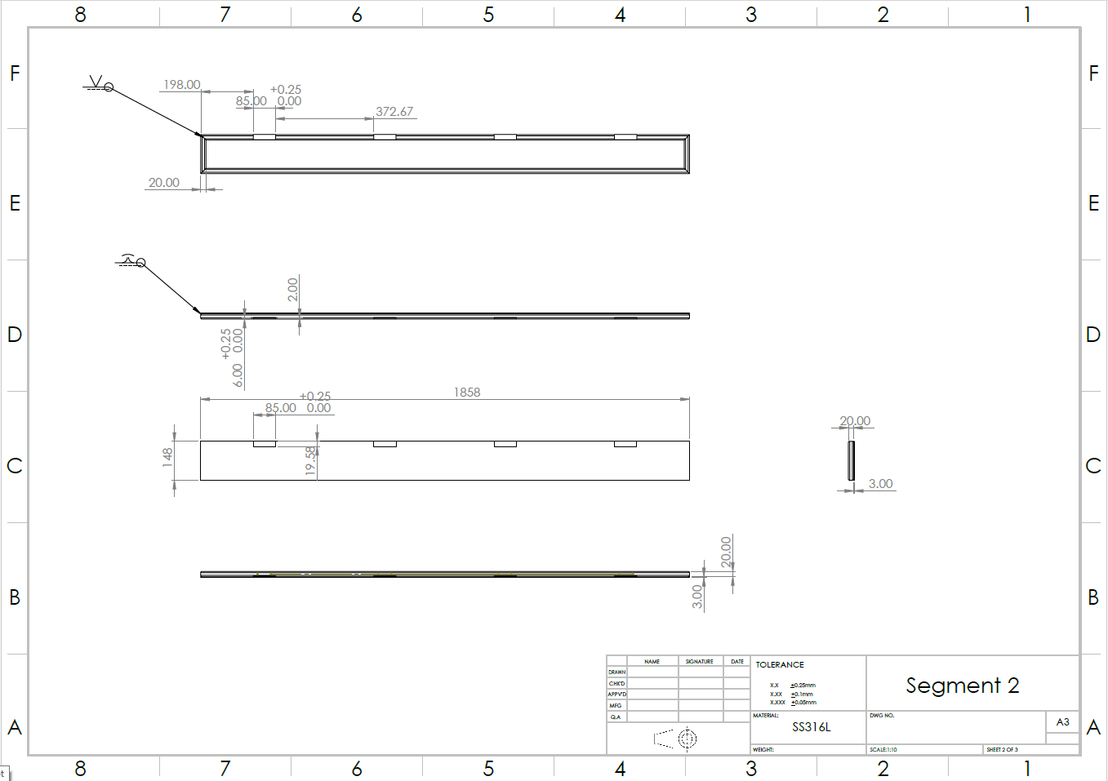
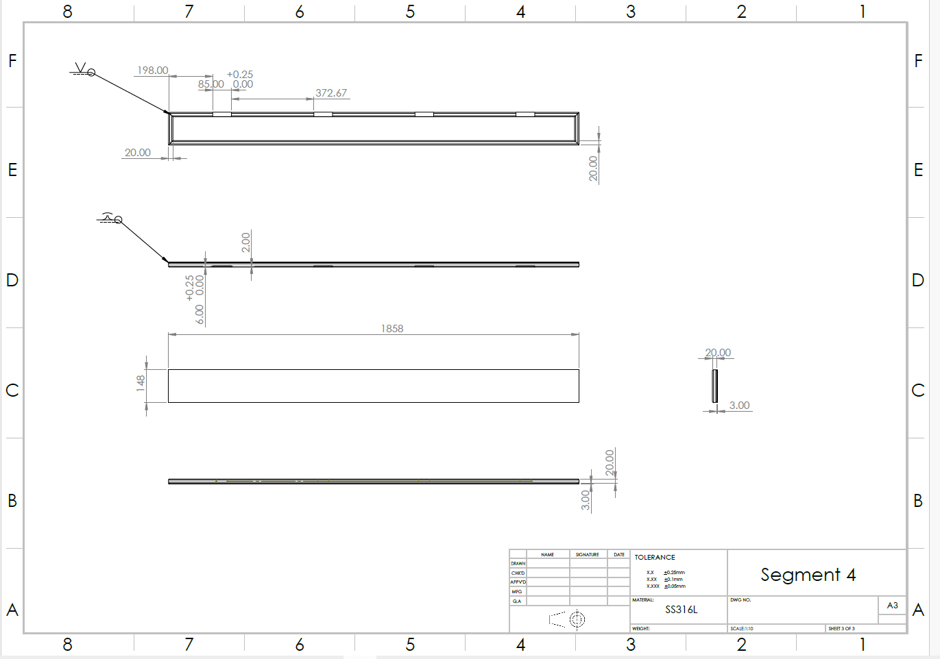
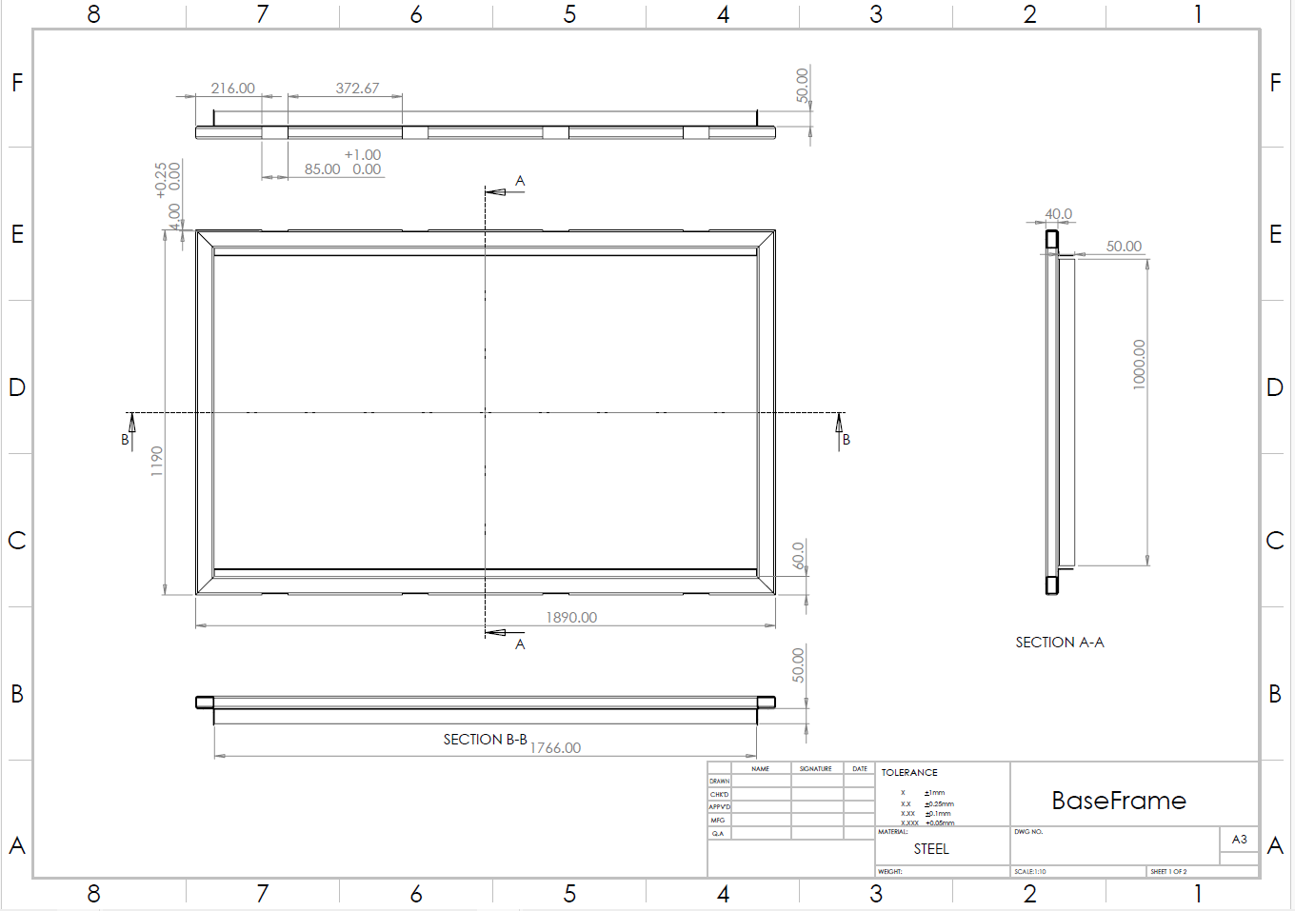
Manufacturing drawing of all parts are prepared and relevant dimensions and tolerances are provided in the drawings.

Manufacturing Processes
The main frame is manufactured using welding structural tubes. 60x30x3.2mm stainless steel tubes used to make the main structure. 4 tubes are welded together to fabricate the rectangular structure.
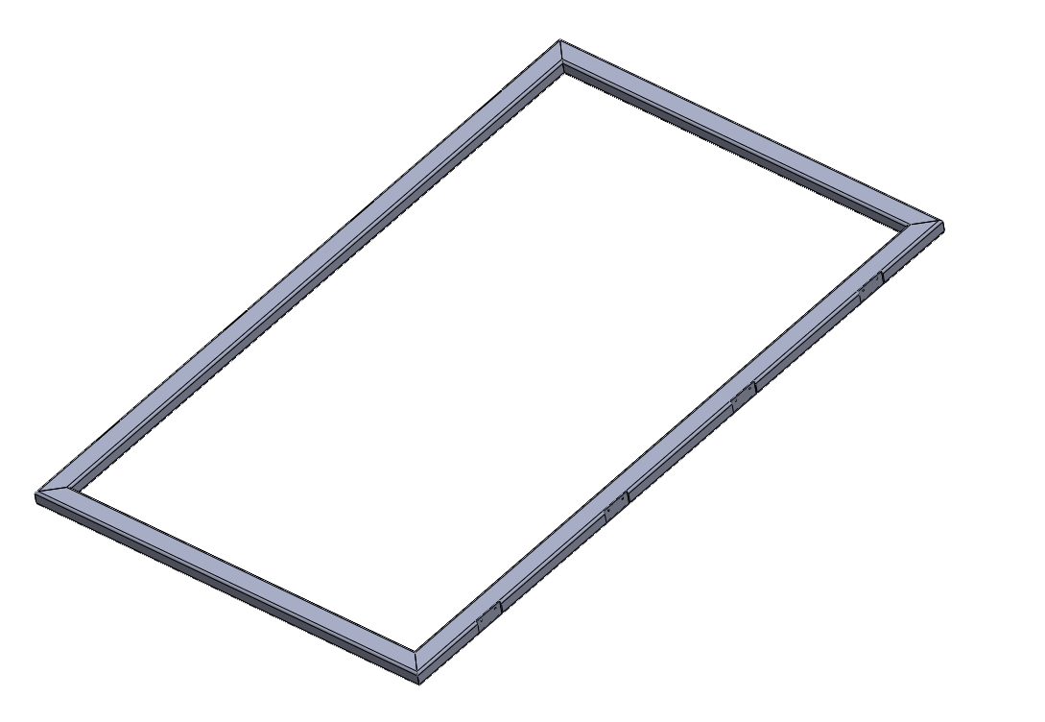
There will be 4 cutouts to mount the hingers there cut out are manufacture from removing some material from the structural member these material removal process can be done using manual milling process there will two tap holes in each cutout to mount hinges. These holes can be drilled and taped by manual milling machine. These cutout preparations need to do be welding of the structural members.
By bending 2mm stainless steel sheet bellow structure must fabricate. This structure will weld to the tank.
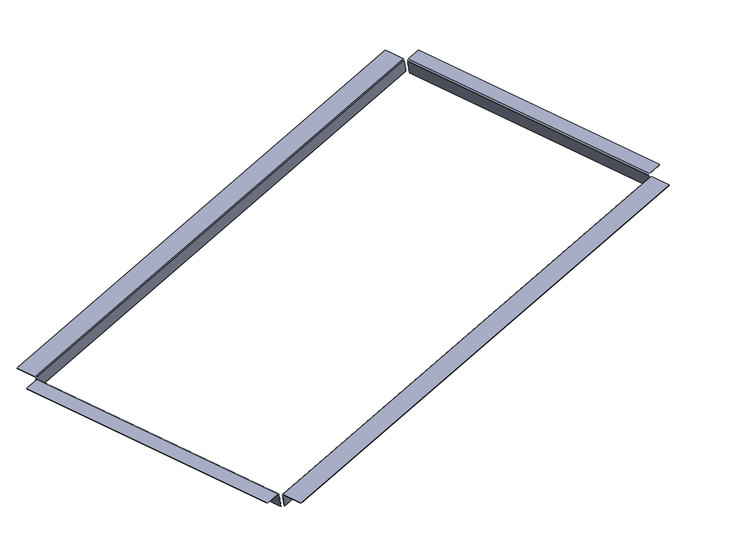
Both structures need to weld together to complete the production of main structure. Below image show the fabricated main structure.
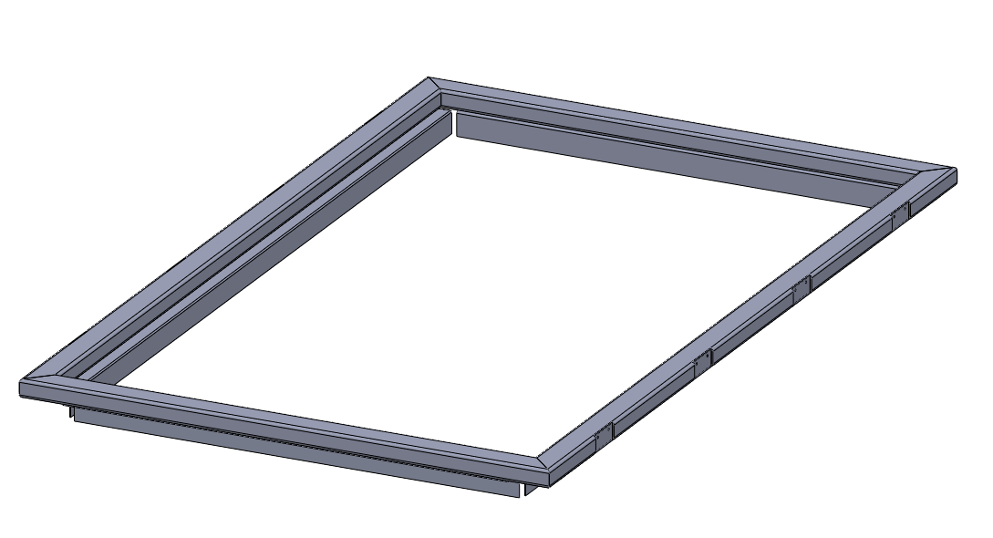
There are 3 segment design need to fabricate and assembled to complete the door. Manufacturing segments also like main frame fabrication.
First 8 cutouts to mount the hingers there cut out are manufacture from removing some material from the structural member these material removal process can be done using manual milling process there will two tap holes in each cutout to mount hinges. These holes can be drilled and taped by manual milling machine. These cutout preparations need to do be welding of the structural members. These cutout locations and directions are different in each segment. After that these structural members need to weld to form the base for the segment
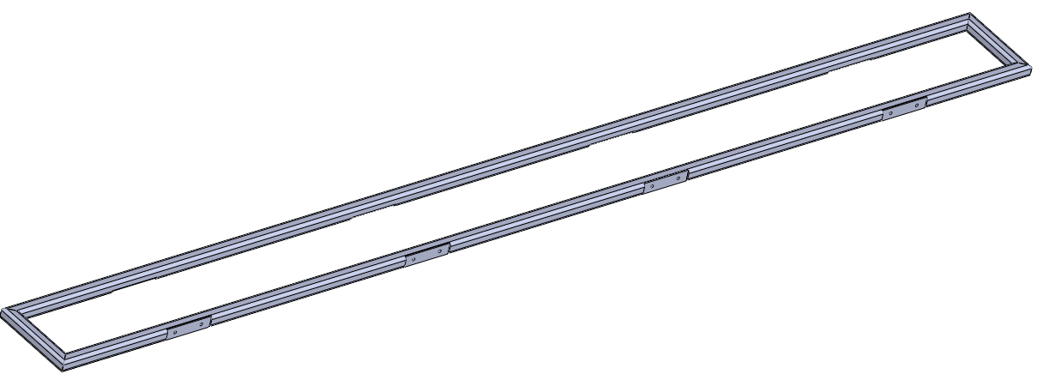
3mm stainless steel plate is welded in the top of the structure
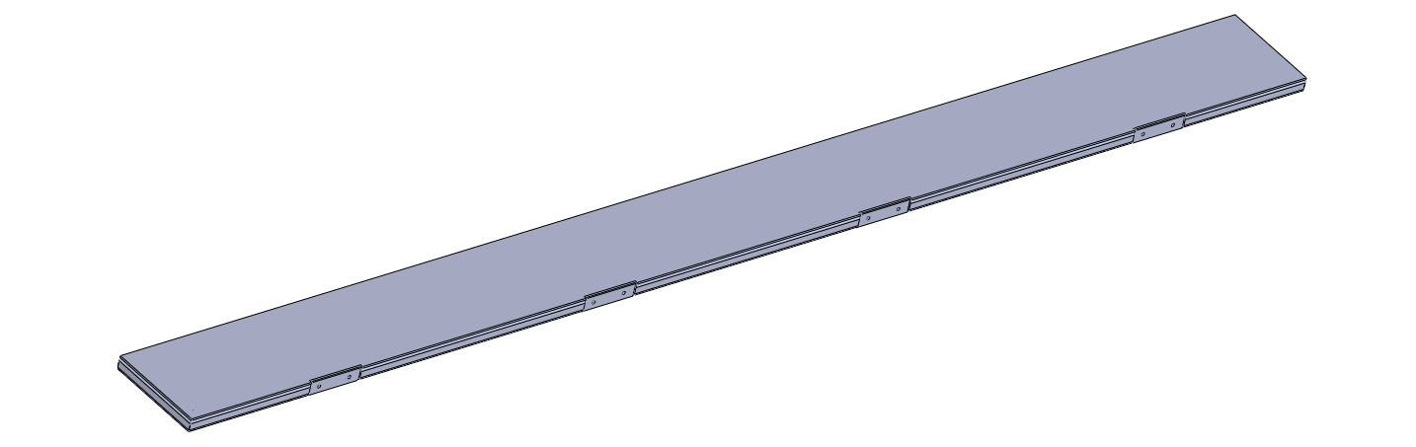
After all parts are fabricated. The segment and main structure need to be assembled. Below image show how is will be assembled.
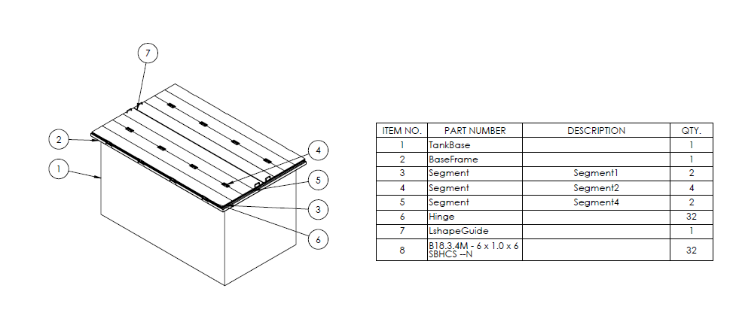

Justification
The material selected for manufacturing the cover is 316L stainless steel. Which is good for corrosion resistance in acidic environment. But best material for acidic environment is 904L stainless steel but it is expensive material. On the other hand, 904L stainless steel is difficult to weld(Weman, 2011). Advance welding techniques required for welding. Therefore, 316L stainless steel use for manufacturing the cover.
To reduce the manufacturing and operation cost manual operated door is suggested. The cover design is easy to operate by single person by hand. There is limited hand movement to open and close the cover. Therefore, it will improve the workplace safety and efficiency.
Traditional fabrication method is suggested to manufacture the tank over. Advanced expensive manufacturing techniques are not required for fabrication process. Any complex or expensive machine not required for either. Fabrication involves cutting bending and welding process. Therefore, manufacturing cost will be lower.

Conclusion
The design of the sulfuric acid tank cover is a vital step in guaranteeing the storage system's safety, efficiency, and environmental compliance. The final design reduces the danger of chemical exposure, containment failures, and occupational hazards by considering elements such as material selection, corrosion resistance, structural integrity, and operational performance. New design is suggested to minimize the drawbacks of the existing design.

Further work
A thorough structural analysis is necessary to assure the tank cover design's long-term durability and reliability. This analysis will determine the cover's ability to endure operational pressures, environmental variables, and other load conditions. Given that the cover's door mechanism will be extended and contracted several times during normal operation, it is necessary to plan for probable fatigue failure. Fatigue failure, caused by repeated cyclic loads, can drastically impair the structural integrity of the door and hinges over time.

13. Reference
Anand, A., Agarwal, M., Aggrawal, D., 2022. Multiple Criteria Decision-Making Methods: Applications for Managerial Discretion. Walter de Gruyter GmbH & Co KG.
Davis, J.R., 2000. Alloy Digest Sourcebook: Stainless Steels. ASM International.
Executive, G.B.H. and S., 2004. Manual Handling: Manual Handling Operations Regulations 1992 (as Amended). HSE Books.
K., D.R., Dagur, A.H., Kartha, A.A., Subodh, M.A., C., V., D., A., Giridharan Vijay Kumar, M., Abraham, W.S., Chatterjee, A., Abraham, Jayanthi, Abraham, Johann, 2017. Microstructure, mechanical properties and biocorrosion behavior of dissimilar welds of AISI 904L and UNS S32750. J. Manuf. Process. 30, 27–40. https://doi.org/10.1016/j.jmapro.2017.09.001
Loto, R.T., Loto, C.A., Fajobi, M., 2020. Corrosion Resistance of GX4CrNiMo16-5-1 Martensitic, 316L Austenitic, and 904L Austenitic Stainless Steels Subjected to High Temperature Variation, in: Li, J., Zhang, M., Li, B., Monteiro, S.N., Ikhmayies, S., Kalay, Y.E., Hwang, J.-Y., Escobedo-Diaz, J.P., Carpenter, J.S., Brown, A.D. (Eds.), Characterization of Minerals, Metals, and Materials 2020. Springer International Publishing, Cham, pp. 261–267. https://doi.org/10.1007/978-3-030-36628-5_24
Manual handling. Manual Handling Operations Regulations 1992 - Guidance on Regulations - L23 [WWW Document], n.d. URL https://www.hse.gov.uk/pubns/books/l23.htm (accessed 12.14.24).
Verma, P., Samuel, O.D., Verma, T.N., Dwivedi, G., 2021. Advancement in Materials, Manufacturing and Energy Engineering, Vol. I: Select Proceedings of ICAMME 2021. Springer Nature.
Weman, K., 2011. Welding Processes Handbook. Elsevier.
Woishnis, W., Ebnesajjad, S., 2011. Chemical Resistance of Thermoplastics. William Andrew.

