BLOGGING TO COMMUNICATE
By Luiza Marin

Marketing Fundamentals
05.09.2022

(Word Count: 1967)

Blogging to Communicate
Introduction
In marketing, there is always a need to achieve a competitive advantage by following different processes of marketing. The process of marketing that this paper seeks to adopt is blogging to communicate. This paper provides a collection of blogs that seek to stimulate a conversation between the company and audience. The project of interest in this paper is the ‘Launch of Rose-Flavoured Soaps’ by Unilever.
Blog Post 1: Determination of Project Processes and Stages
Have you ever wondered how companies’ structure their projects? How they come up with satisfactory stages and processes that allow the project to be completed successfully? In this blog, I will explain to how Unilever is going to build their processes and stages for the launch of the rose-flavoured soap. The first stage that the company’s marketing manager takes note of is the need to follow specific marketing stages and processes. According to Kotler and Armstrong (2015), the need to follow specific marketing process allows the company to achieve a competitive advantage that will in turn help the company in the long run. Therefore, the processes and stages that are adopted by the company aids in launching the new soap product in the marketing.
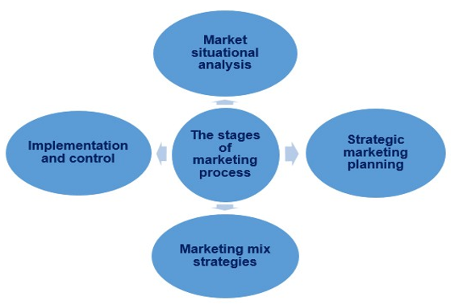
Figure 1The Marketing Process (Kotler and Armstrong, 2015)
Unilever will examine the current market climate to zero in on the most promising market niche, and they will investigate the market's history to ensure its long-term viability. Second, they'll develop a comprehensive marketing strategy for the product, with the goal of raising the standard of marketing operations worldwide. According to Zia (2016), comprehensive marketing will increase sales and will help Unilever react to the market competition by using the right marketing mix. In the end, the project's plan will be implemented in an effort to gain market dominance by amassing the greatest possible proportion of the rose scented soap market while preserving a mutually beneficial connection with its patrons. So, what do you think is the mechanism through which Unilever can measure the market success of its new soap product? And in which areas do you find gaps in client’s interest in the new product?
Blog Post 2: Identification of Risks
Assume that you are undertaking a risky activity that require due diligence? What would be the first step to do within that activity? In this project the most appropriate thing to do in the onset of the project is to identify the risks that could arise in the process. To accomplish this, Unilever takes a bold step in asking its research department to look for any loopholes that could serve as risks in the project. While utilizing the marketing principles and processes and outlined by Bither (2020), Unilever applies market situational analysis to find the most reliable strategies in market. Primary data is gathered by the company's research and development teams via interviews with prospective consumers, customers of competing brands, and current distributors of similar goods. They do a thorough examination of the market using tools like the SWOT analysis, 5C analysis, and PESTLE analysis.
They have done a thorough research of the current market conditions in the soap and beauty care industries and believe they are in a position to introduce a new brand of rose-scented soap to consumers. The product may be successfully introduced to the market because of the favourable economic, social, technical, legal, and political climate (Wiersema, 2013). In addition, Unilever has certain strengths and shortcomings that prevent it from introducing the product to the market and effectively meeting the demands of consumers in a profitable way. Cannibalization of existing brands is a major threat to the project's success in the market, which was the primary advantage. Since this is the case, do you think the marketing group will use strategic instruments of management to mitigate market dangers?
Blog Post 3: Market Segmentation, Targeting and Positioning Determination
Ever thought of being the exact target customer for a specific product? Using market scenario analysis, Unilever's research and development team identifies the prospective clients in the UK market who like the fragrance of rose in order to introduce a new rose-flavoured soap to the market. It's a calculated move to attract a new clientele that like rose-scented soap (Bonoma, 2016). Demographic, behavioural, and psychological data will be used to divide the market into several subgroups. They will divide the market into subsets based on factors such household income and level of education, cultural sensitivity, interest in personal grooming, and propensity to buy cosmetics.
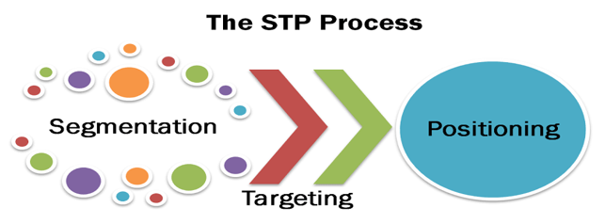
Figure 2 Segmentation, Targeting and Positioning (Dadvar, 2018)
Launching the soap in the UK's most populous cities was a smart first step. When it achieves a certain level of market penetration in the UK, it will be released across the country. The brand's positioning strategy would therefore include consistent communication with target market consumers in order to provide enough value in the market and hence increase customer lifetime value. In addition, it will provide marketing activities targeted at the market's regular customers in an effort to pique their interest in the products, therefore fostering brand loyalty and establishing the product's marketing positioning in the minds of consumers (Wickremasinghe, 2017).
Blog Post 4: Project Price and Product Strategy
What do you is the best method that a company can use in pricing their products? After carefully analysing the market for rose-scented soap and deciding on a specific advertising approach, Unilever will use the most effective method for mass-producing and, pricing and selling the product. According to Dadvar (2018), when putting the plan into action in the market, it will use McCarthy's marketing mix in order to get optimal results. Multiple manufacturers in a different part of the world will have contributed to the final product. As such, it will continue to be of a high quality that meets or exceeds all applicable global standards. Purple and pink will be used for the product's package design. The proposed project plan includes four distinct colour options. Customers will be able to pick and choose the cosmetic treatment they choose. The product price will be determined by the level at which the product can penetrate a certain market. The price structure will also consider the product's dimensions and weight (Warrink, 2018). The marketing team will meticulously calculate the cost of producing the soap based on market research and the product's expected demand, and the resulting high price will reflect the product's premium status among consumers. There are a number of ways in which consumers may learn which product will provide them with the finest results.
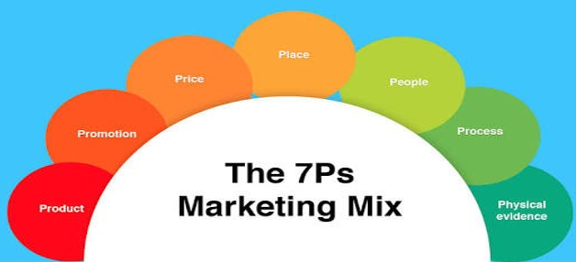
Figure 3The 7Ps of Marketing Mix (Kotler & Armstrong, 2015)
Blog Post 5: Product Distribution
How easily are you always connected to your favourite product? Is the product Unilever’s? The product will be effectively distributed by the corporation to guarantee its accessibility to consumers. The product will be sold via the firm's pre-existing network of reliable distributors. The commission paid to the distributor will be based on the total amount of merchandise sold. The distributor plans to use the highway infrastructure for product distribution and will also make extensive use of the internet retail industry in an effort to maximise product sales (Eilert, 2018). The market potential in the UK is substantial, and the firm will focus on women clients in particular. Advertising for this product will focus mostly on broadcast television and social media. The business will produce an ad on television to boost product awareness. Though expensive, it will be the most efficient method for the brand to reach its target audience. Many promotions and sponsored shows will also be launched to attract the attention of the intended audience. When it comes to spreading awareness of the brand, social media will be pivotal (Sanderson, 2016). According to the project concept, the official Facebook page and the YouTube ad will also be successful. Additionally, the firm will choose a brand ambassador from the ranks of the top female models in the UK to help spread the word about the product.
Blog Post 6: Marketing for Additional Advantages
In this endeavour, the organisation will prioritise the development of the 3Ps in line with the service marketing mix. Despite the project's solid foundation, it can only become a commercial success with the help of the expanded 3Ps. Because Unilever considers its workers to be its most valuable asset in achieving brand sustainability, the project's primary emphasis will be on managing those personnel to ensure consistent product quality and effective marketing operations (Piercy, 2019). In addition, it will keep the distributor happy, which is crucial for widespread market penetration. Reporting and documentation will be created by allowing the journalist inside the manufacturing plants to assure confidence in accordance with the rose taste. The firm hopes that doing so would boost consumer confidence in its products and services. Objective proof in the market is provided by the product itself. Shoppers may pick up bars of soap at their local grocery store or one of the many convenience stores in the neighbourhood. Unilever will make sure the product is available in every community in the United Kingdom. In the end, it's the customers who will identify the tangibility range and be the driving force behind brand loyalty.
Blog Post 7: Efficient Project Implementation
The company Unilever has finished its market study, developed a marketing strategy for rose-scented soap, identified its target market's wants and requirements, and is now ready to roll out its project. Several recruiting and selection efforts help the organisation find the most qualified and ideal workers for the manufacturing and promotion of this product. It does this by amassing the financial resources necessary for brand diversification in the market from sources such as bank loans and the budget of the firm (Bither, 2020). Additionally, the resources and raw materials required for manufacture are gathered by the brand's production staff. First, they begin production of the product and test it according to the standard that was established in the earlier phases of the marketing mix and planning. If the quality of the product is at or above the benchmark quality, it will begin to be provided in the market in order to fulfil the requirements that the consumers have established for the market. The choice that was made by senior management to serve in the market will be taken into consideration by marketers when they begin to assign jobs inside the market.
Blog Post 8: Effective Project Control
The requirements that consumers have in the market are always changing, and as a result, the marketing climate requires businesses to adapt the products and services they provide in order to continue to satisfy their clients. Unilever will assess the success of the market based on the viewpoints of the sales volume, as well as the input from employees (Sanderson, 2016). Additionally, it will gather the input of consumers about the quality of the rose-scented soap and how it should be used. The comments left by consumers will be carefully considered, and any improvements or adjustments that are deemed essential will be done. In order to evaluate the success of the project in the market, statistical tools and methodologies will be used.
In order to establish whether or not the project was successful in the market, a comparison will be made between the result of the project and the specified benchmark. In addition to these things, the corporation will keep an eye on the activities of its rivals with regard to the same brands on the market. After that, it will engage in the activities required to establish itself as the dominant player in the market for products meeting the same requirements (Zia, 2016). The marketing initiative to introduce a new product into the market was successful in accomplishing its goals as a result of the efficient contacts with the target market. The project is able to interact with the target market thanks to the support of a market campaign that is conducted via the blog because of this sequence of blog articles.

Reference List
Bither, S., 2020. Marketing Principles: The Management Process. Journal of Marketing, 39(3), pp.121-134.
Bonoma, T., 2016. Case Research in Marketing: Opportunities, Problems, and a Process. Journal of Marketing Research, 22(2), pp.199-245.
Dadvar, A., 2018. Controlling the business market: A perspective from SWOT analysis. Integrated Environmental Assessment and Management, 14(4), pp.480-488.
Eilert, M., 2018. The Impact of Cause Portfolio Focus and Contribution Amount on Target Audience Evaluations. Business & Society, 59(7), pp.1483-1514.
Kotler, P., and Armstrong, G., 2015. Principles of Marketing. 16th ed. SAGE Publications, London.
Piercy, N., 2019. The Marketing Budgeting Process: Marketing Management Implications. Journal of Marketing, 51(4), pp.45-49.
Sanderson, S., 2016. Strategic Planning and Environmental Analysis for Marketing. European Journal of Marketing, 22(2), pp.14-30.
Warrink, D., 2018. The Marketing Mix in a Marketing 3.0 Context. Journal of Marketing, 4(4), pp.7-30.
Wickremasinghe, G., 2017. Market efficiency and situational analysis during different market phases: further evidence from Malaysia. Investment Management and Financial Innovations, 14(2), pp.359-366.
Wiersema, F., 2013. Strategic Marketing Planning: Linking Marketing and Corporate Planning. European Journal of Marketing, 17(6), pp.46-56.
Zia, M., 2016. A Three-Dimensional Vertical Differentiation Model: Implications for Segmentation, Targeting, and Positioning. SSRN Electronic Journal, pp.45-49.

