Cover Sheet

Student Name: Gareth Lewis
Student Number: P147797
Course title: BA 3D Computer Animation

Module
Research Practices (Level 5) ADAD5001 - Worldbuilding
Assignment Brief
Write a proposal of 2,500 words which explores the surrounding research context for your emergent area or field of interest.
Tutors: Scott Smith
Word count (body text): 2646
Module: Research Practices (Level 5)  Module Code: ADAD5001 | Gareth Lewis P147797  BA 3D Computer Animation  9th May 2019
Practices in Context

Introduction
This report will investigate contributions from several artists, their subjects and creations, alongside keywords exploring ideas of masks, the gaze and narrative.

There may be found a degree of commonality in the subjects of masks and the gaze (or the look of the other). The processes of presenting one’s identity, having this façade examined and feeling the effect of that examination can appear intertwined.

How these presentations and judgements can interact within, around, or separate from, a story-world are discussed under the subject of narrative.

The intended outcome of these investigations is to provide a route for further exploration and the formulation of a dissertation question.

Masks
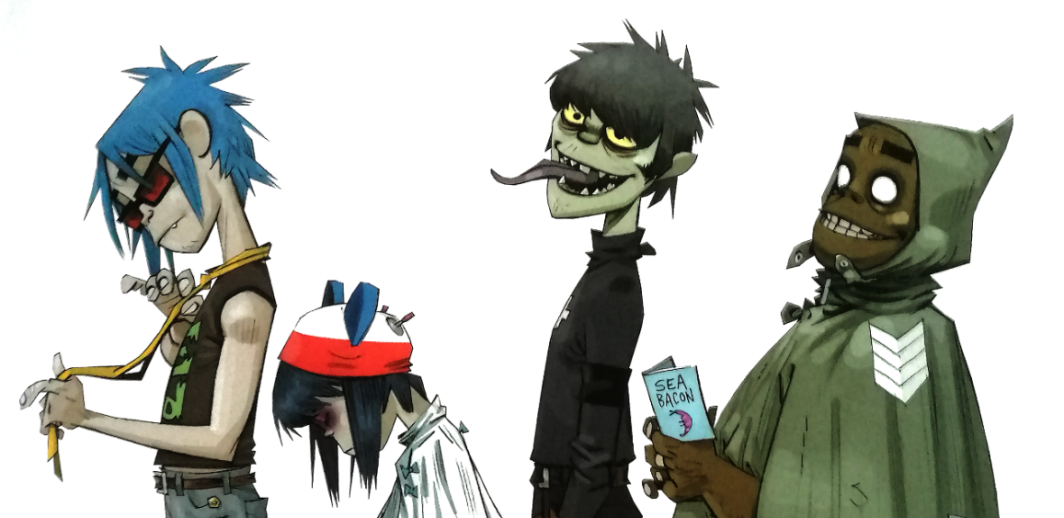
(Hewlett et al., 2017, p171)
While masks have been used for ceremony, ritual and entertainment, here we will look at their role in the presentation and disguise of identity. Sometimes a physical barrier between the wearer and their world, masks can also manifest as a psychological façade, a means of protecting the wearer’s inner-self.

Where there is anxiety in social situations, a fear of humiliation, an individual may don a mask providing protection against their own actions and the reactions of others.
(McEvoy et al, 2016, p.542)
Tseëlon talks of masks in two forms, firstly as a conventional disguise, a deception, but also as a means of exposing the “the multiplicity of our identity” where all representations of self are real. (Tseëlon, 2001, p. 4)
Lacan appears to suggest that where a mask is removed, what is revealed is not the truth (nor the original identity) but another layer of “sophistry”, a further deception (Lacan, 2007, p.224)

Albarn and Hewlett’s Gorillaz
The Gorillaz band and characters are the creation of musician Damon Albarn and cartoon artist Jamie Hewlett.  The musician is distanced from the narrative via Hewlett’s character creations, removing his physical presence and image from the story-performance entirely. The fictional artistes deliver his work. This is an extreme mimetic presentation where information is maximised and the informer, the artist, is minimised (Genette 1980, p.166).  Albarn goes as far as to state:  The Gorillaz cartoons seem more real to me than the actual people on TV. Because at least you know that there's some intelligence behind the cartoons, and there's a lot of work that's gone into it, so it can't all be just a lie.  (Gaiman, 2005) | 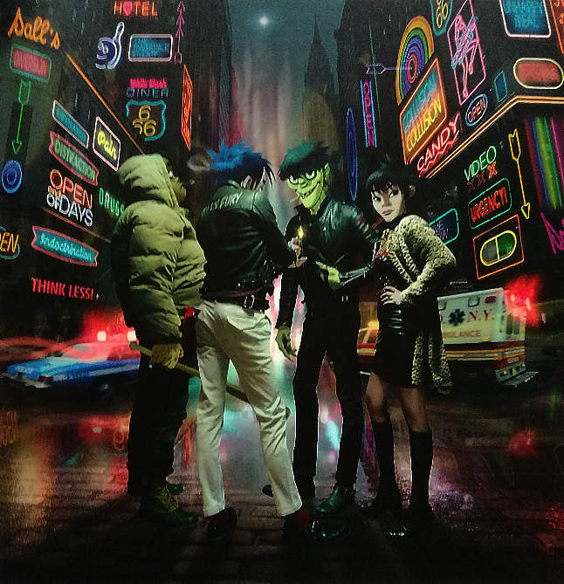  (Hewlett et al., 2017, p203)
It is no great leap of conjecture to consider Albarn’s Gorillaz as a comment on, a reaction to the flat-pack, manufactured “bands” that are peddled by music labels, their public identities not a product of their own intelligence but masks provided by the machine that produced them.
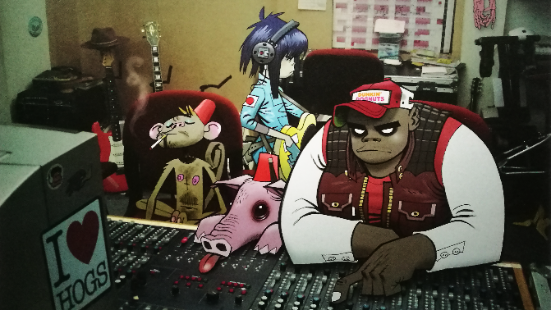  (Hewlett et al., 2017, p113) | Writing on Giambattista Vico, Hawkes talks of “man’s unique capacity not only to formulate structures, but also to submit his own nature to the demands of their structuring” (Hawkes 2005, p.5). This suggests a capacity not only to build a presentation, a façade, a mask, but also that this creation, both the act and its existence, will change the nature of its creators. From Vico’s Structuralist standpoint, Albarn and Hewlett’s contrivance would require the artists’ willing assent to the demands of their creation.
It may appear paradoxical that an artist can seek to mask themselves behind their work, remove themselves from the narrative, while that may be the very thing that shapes them, defines their nature and reveals them to the world.

Albarn and Hewlett’s creation is knowing in its presentation and, as both creator and subject-by-proxy, Albarn is free to shape his mask, the presentation of his work. Inasmuch as any artist can, he can define the image of the creator for an audience. The extent to which the demands of this creation are returned to the creator is a matter for further investigation.
Looking at another subject, one who is aware of, yet separated from the creative process, we may find a differing attitude toward their presented image.

The Destruction of Sutherland’s Portrait of Winston Churchill
Churchill asked: ‘How are you going to paint me? As a cherub, or the Bullgdog?’ To this [Sutherland] replied diplomatically: ‘It entirely depends what you show me, sir.’  Consistently… he showed me the Bull Dog.  (Berthoud, 1982, p.186)  Sutherland’s portrait had been commissioned as an 80th birthday gift from Churchill’s peers in the Houses of Parliament. Lords and Commons members contributed 1000 guineas (a current value of approximately £30,000).  Churchill was not shy in expressing his disapproval of the work. Eventually accepting it as “a striking example of modern art” (Berthoud, 1982, p.197), a phrase not intended as a compliment, it was taken into his family home and later found to have been destroyed (Berthoud, 1982, p.200).  This attitude may seem all the more surprising given the grim, loneliness exhibited in a younger Churchill’s impressionistic self-portrait. | 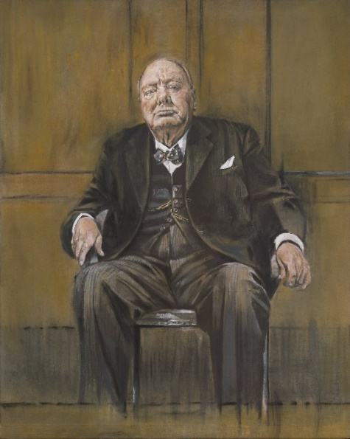  Digital recreation of Portrait of Sir Winston Churchill,  Graham Sutherland (1954)  (Lost Paintings, 2019)
It may be that Churchill had developed a mask that he did not wish displaced.  Participants present a masked or “false” version of themselves in social settings in the hopes of appearing in a way that is desired and accepted by others, to escape judgement and rejection.  (McEvoy et al, 2016, p.558)  [T]he role we are striving to live up to — this mask is our truer self, the self we would like to be. In the end, our conception of our role becomes second nature and an integral part of our personality.  (Park, 1950, p.250)  This mask had become inseparable from the person, projecting an image while protecting what lay beneath. Sutherland’s unmasking threatened to reveal this inner-self, exposing it to the gaze of the public and his peers. | 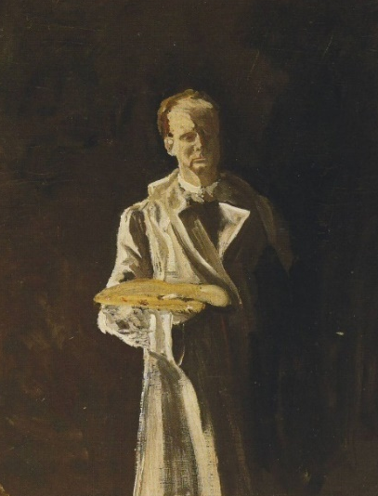  Self portrait, Winston Churchill (1915). Detail  (Churchill and Cannadine, 2018)

Gaze
This discussion concerns the effect of the ‘look’ or ‘gaze’ of the other on self. That is to say, the act, thought or feeling of being observed and how these might impact on the subject, audience and creator.

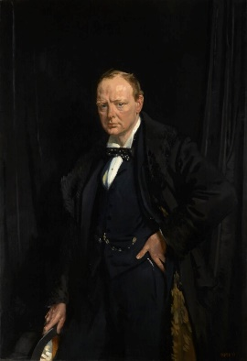 | 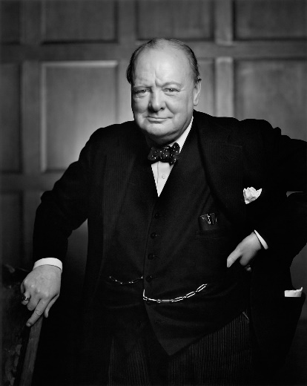 | 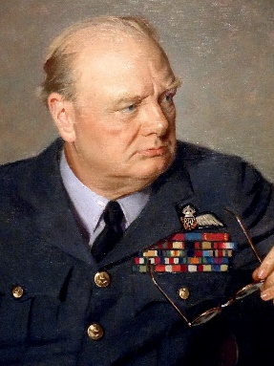
Churchill, Sir William Orpen (1916)  (collectionimages.npg.org.uk, 2019) | Winston Churchill, Youosuf Karsh (1941)  (karsh.org, 2019) | Sir Winston Churchill, Douglas Chandor (1946)  (National Portrait Gallery, 2019)

Churchill’s Image of Self
By his 80th year, Churchill had sat for many portraits. These are not snapshots, candid poses nor selfies. On every occasion he is the considered subject of a professional artist. Why then, was he so perturbed by Sutherland’s image?  The thing that moves us to pride or shame is not the mere mechanical reflection of ourselves, but an imputed sentiment, the imagined effect of this reflection upon another's mind.  (Cooley 1922, p.184)  Despite serving as prime minister through much of World War II, Churchill was ousted by the electorate in favour of Clement Attlee’s Labour in 1945, returning as head of government for a second term in 1951. In 1953, at 78 years old, he had also suffered a major stroke (Churchill and Cannadine, 2018).  These swings in fortune could only compound Churchill’s awareness of the judgements of the other mind (Cooley 1922, p.185). | 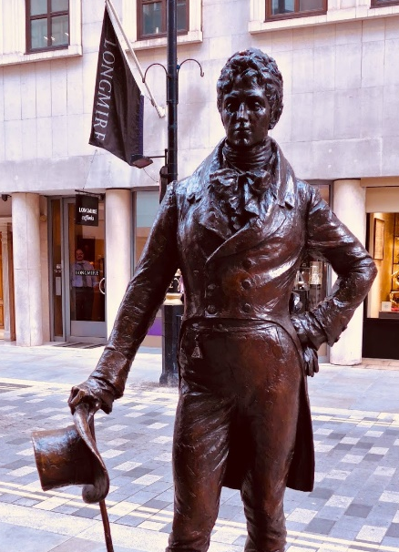  Beau Brummell, Irena Sedlecka (2002)  (London Remembers, 2019)
In portraiture, he is variously portrayed, by himself or others, as the loneliest of men, a smiling or unsmiling cavalier or hand-on-hip Brummell dandy, a stony-faced stalwart and military-uniformed leader.  None so famously upset Churchill as Sutherland’s image of an old “bulldog”.  Looking to Cooley again:  A man will boast to one person of an action—say some sharp transaction in trade—which he would be ashamed to own to another.  (Cooley 1922, p.185)  Should there be any wonder that Churchill rejected Sutherland’s image, portraying as it did, a fragility in a sagged version of his former self? | 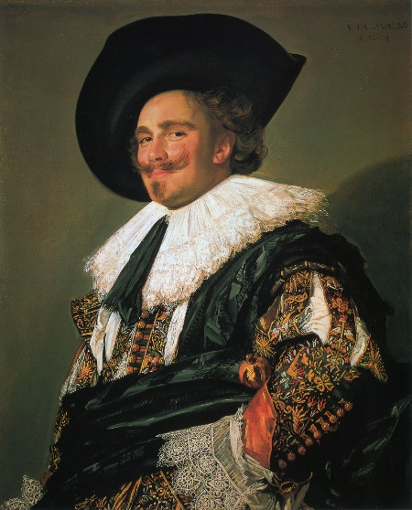  The Laughing Cavalier, Frans Hals (1624)  (The Wallace Collection, 2019)

The Gaze of Dredd and the Ideology of V
A latter-day Guy Fawkes, Alan Moore’s V (V for Vendetta, 1988) is a concentration camp survivor bent on the destruction of a system that has failed him.  The character of Judge Joseph Dredd (originally created by John Wagner and Carlos Ezquerra in 1977) is a futuristic vision of law enforcement imbued with the authority of the system.  Within Dredd’s duplicitous character, there lies both the defender and the ruthless arbiter. Within the masks worn by the Megacity judges, these powers ascend, if not to omnipotence, to an omnipresence.  Alan Moore’s V (with the conviction of a true anti-establishment-anti-hero) gives us this: | 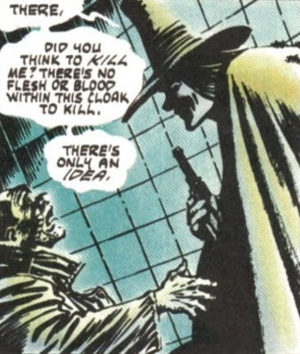  (Moore, 2018)
THERE’S NO FLESH OR BLOOD WITHIN THIS CLOAK TO KILL. THERE’S ONLY AN IDEA. IDEAS ARE BULLET-PROOF.
(Moore, 2018, p.328)

V’s existence is a signifier for an idea of revolutionary thought while Dredd is the physical embodiment of established authority.

Where anti-establishment ideology is the base of V’s strength and image, conversely, it is Dredd’s physical impenetrability, uniform appearance and a zealous adherence to the ‘law’ that supports the Judges’ ideology.  Where V struggles as an individual against the system, it is the Megacity Judges’ masked homogeneity that provides the panoptic gaze threatening a guarantee of justice and punishment (Foucault, 1995, p.96).  Above all, no crime committed must escape the gaze of those whose task it is to dispense justice. Nothing so weakens the machinery of the law than the hope of going unpunished  (Foucault, 1995, p.96)  Lacan provides a variation on this idea, more gently spoken but no less ominous: | 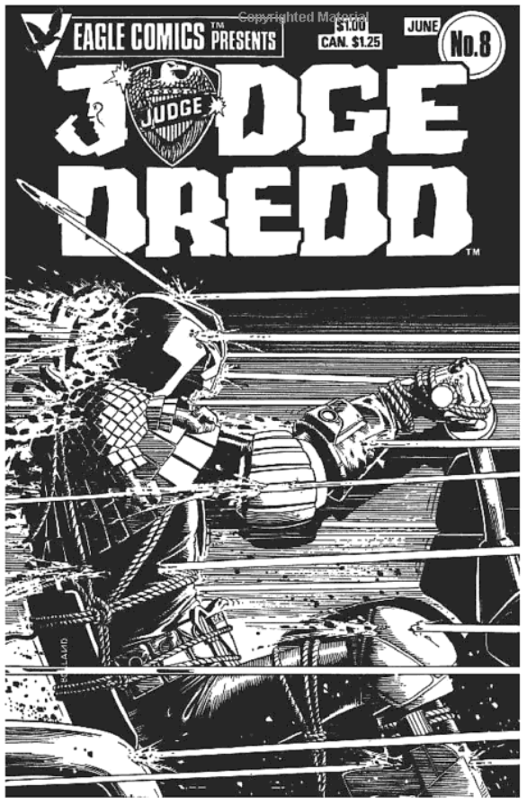  (Bolland, 2012)
I can feel myself under the gaze of someone whose eyes I do not even see, not even discern. All that is necessary is for something to signify to me that there may be others there.  I am already something other, in that I feel myself becoming an object for the gaze of others.  (Lacan, Miller and Forrester, 1991, p.215)  Cooley describes the effect of the gaze, the attention of the other. Lacan suggests that it is only the notion of this other that is required.  Looking at Foucault’s Panopticism in this light, the gaze of the other is only required to be imagined by the subject for the effects to be felt.  Dredd does not need to be all-seeing, only that he is perceived as such. | 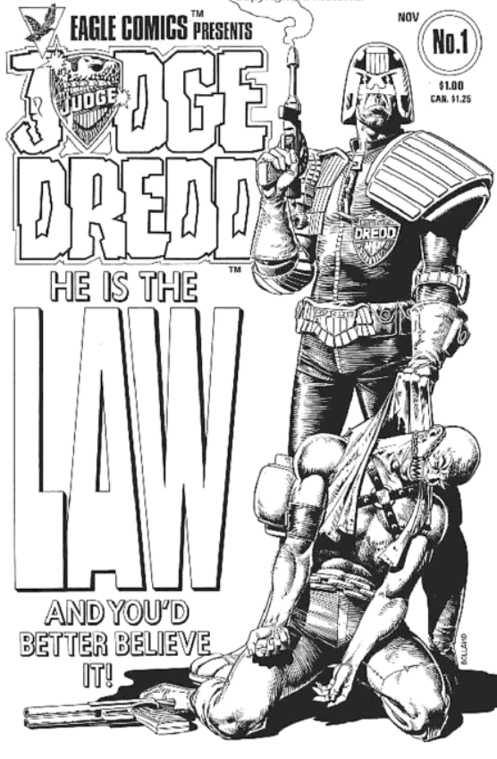  (Bolland, 2012)

Narrative
Narrative, or the presentation of events to an audience, whether by necessity, practicality or design, can deliver only a slice through the world in which the story is based.

The Russian Formalist, Victor Shklovsky differentiates between fabula, the chronological series of events around the story (the story-world), and syuzhet, the organisation of these events or the telling of the story (Stam, 1992, p.71).

The Structuralist theorist Gérard Genette recognises and expands on these terms including not only the story-world (histoire) and story-as-told (récit) but also the act and techniques of presentation (narration) (Stam, 1992, p.95).

In recognition of these distinct elements, it is only the récit that is made available. The act of narration and the story-world, all that surrounds the story, can only be inferred by the audience. (Stam, 1992, p. 96)

The Story of Gorillaz
Although Albarn, the writer and singer, has removed his image from the performance (the “performance” as a living, breathing musician rather than the band’s performance of a song), he has passed the responsibility of narration to Hewlett’s characters.  Albarn is always outside this imagined world. His characters are presented in a persistent and developing récit in a homodiegetic role (Genette 1980, p.245). The characters appear autonomous, narrating their own story while the creator is removed.  The creator has not only removed himself from the narrative, he has been replaced by his own creation. |  | 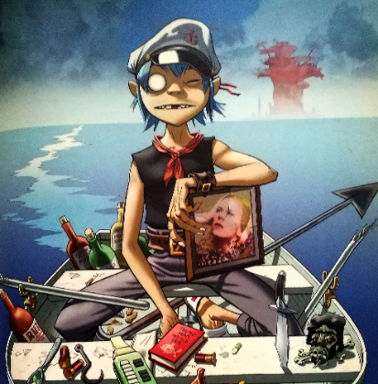  (Hewlett et al., 2017, p169)
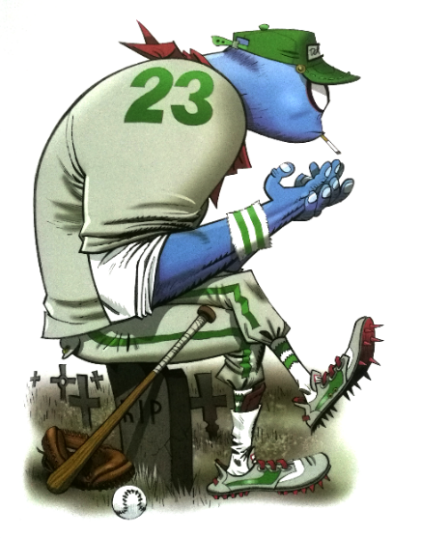  (Hewlett et al., 2017, p127) | Albarn is not be seeking to mislead his audience. Indeed, his hope is that they recognise the “intelligence behind the cartoons” (Gaiman, 2005) but, where freshly introduced to “The Gorillaz” as a band, the casual viewer may accept this narrative more easily than those who are more familiar with Albarn and Hewlett in their own right.  While no observer would be expected to take the characters as real-life entities, the long-standing fan may be more likely to consider the ‘band’ within the oeuvres of these artists and recognise their narration, the act of story-telling.  This primacy effect, the weight of early information in forming opinion (Nickerson, 1998, p.187) could be more keenly felt where the individual is aware of, and seeks to maintain a narrative that supports an existing image.
The Primacy of Churchill’s Legacy
Everyone is always and everywhere, more or less consciously, playing a role . . . It is in these roles that we know each other; it is in these roles that we know ourselves.  (Park, 1950, p. 250).  Considering Churchill’s image, the récit built around him and the lateness in this story of Sutherland’s painting, it could be argued that his reaction was one of self-defence. This portrait of a tired, old man was at odds with Churchill’s long-held image. His role had become that of the stalwart statesman, and it is this self-formed image that he would strive to live up to (Park, 1950, p. 250). |  |  | 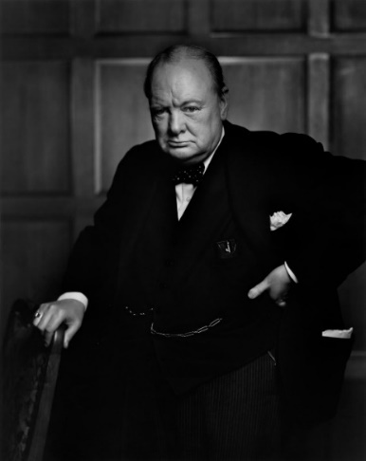  Winston Churchill, Youosuf Karsh (1941)  (karsh.org, 2019)
Sutherland’s portrayal could also be seen as a demasking, a faux pas, an act of dramaturgical disloyalty (Goffman, 1990, p.207). Sutherland had sought to capture Churchill’s image, but Churchill’s image no longer suited the récit.

In his refusal to accept Sutherland’s narration, Churchill may have underestimated his audience.

When performers make a slip of some kind, clearly exhibiting a discrepancy between the fostered impression and a disclosed reality, the audience may tactfully ‘not see’ the slip or readily accept the excuse that is offered for it.
(Goffman, 1990, p.225)

If this disruption to his performance had been allowed, he may have found solace in this audience/performer contract.

Dredd – The Restricted View as a Device
Dredd’s world is teeming with life. Crammed within the walls of Mega-City One, hundreds of millions of people live, work and play.  From necessity, the narration restricts the récit. Combined with the conventions of comic-book conciseness, the audience is presented only with the slice of story-world that contains Dredd’s adventures. Within this structure however, narrative choices have been made.  Where the audience may have been allowed to explore Dredd’s character, they are only presented with the image of the lawman.  In common with the fictional population, they never see Dredd unmasked. An ever-present personification of the law, his façade defies examination of the person beneath. | 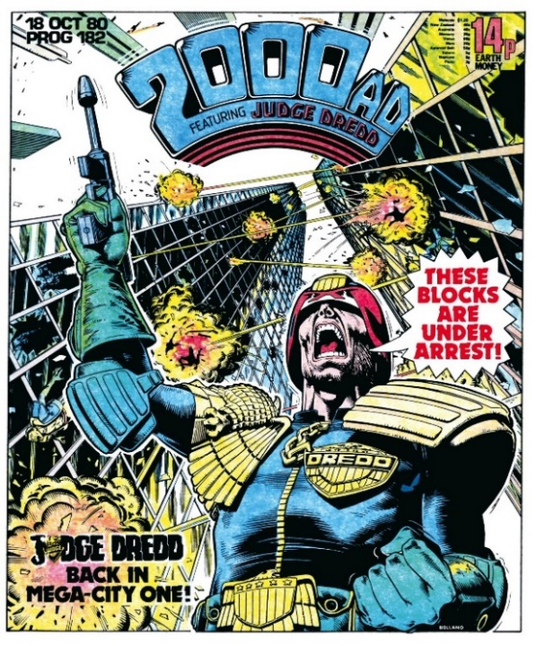  (Bolland, 2012, p.274)

Context
In contextualising this research, it is important to recognise the intended outcome. The resulting research question should be specific, achievable and relevant to the discipline of animation.

The processes of animated film production are extremely time and labour intensive. Presenting diverse, believable and expansive story-worlds is a formidable task even for the largest production companies. How, then, could a small team or individual auteur bring such a world to an audience?

Where both Formalist and Structuralist theories differentiate between story and story-world, they are also interconnected. The syuzhet exists within the fabula, while the audience may infer elements of the fabula from the syuzhet (Bordwell, 2014, pp49-50). The story-world begets the story and the story, via narration, should allow enough for the audience to build the world by inference.

From a Structuralist viewpoint, it is not the story that audience observes but rather the relationship that is created by the act of observing (Hawkes, 2005, p.7). While the gaze and, possibly to a lesser extent, masks will have their place, it is to narrative theory that we turn for our question.

Research Question
How can narrative techniques can be employed in the production of the animated short to suggest a wider story-world through a limited presentation of character and environment?

What are the limitations placed on animators in short film production?
How can identified limitations be overcome by narrative means?
How can narratological solutions combine effectively within the film production pipeline?

Reference
Bennett, T. (2003). Formalism and Marxism. London: Routledge
Berthoud, R. (1982). Graham Sutherland. London: Faber and Faber.
Bolland, B., Eisinger, J. and Robbins, R. (2012). Judge Dredd. San Diego, CA: IDW Publishing.
Bordwell, D. (2014). Narration in the fiction film. Oxford: Routledge.
Churchill, W. and Cannadine, D. (2018). Churchill - The Statesman as Artist. London: Bloomsbury.

Collectionimages.npg.org.uk. (2019). Winston Churchill by Sir William Orpen. [online] Available at: collectionimages.npg.org.uk/large/mw218844/Winston-Churchill.jpg

Cooley, Charles H. (1922). Human Nature and the Social Order. New York: Scribner’s.

Foucault, M. (1995). Discipline and punish. New York: Vintage Books.

Gaiman, N (2005), Wired [website]. Available at: https://www.wired.com/2005/07/gorillaz-2/
(Accessed: 5th March 2019)
Genette, G., Lewin, J. and Culler, J. (1980). Narrative discourse. Ithaca: Cornell University Press.
Goffman, E. (1990). The presentation of self in everyday life. London: Penguin Books.
Hawkes, T. (2005). Structuralism and Semiotics. New York: Routledge.
Hewlett, J., Mondino, J., Wiedemann, J. and Woo, K. (2017). Jamie Hewlett. Taschen.
Karsh.org. (2019). Winston Churchill. [online] Available at: karsh.org/photographs/winston-churchill/ [Accessed 8 May 2019].

Lacan, J. and Fink, B. (2007). Écrits. New York: W.W. Norton.
Lacan, J., Miller, J. and Forrester, J. (1991). The seminar of Jacques Lacan. New York: W.W. Norton.
London Remembers. (2019). Beau Brummel Statue. [online] Available at: www.londonremembers.com/memorials/beau-brummell-statue [Accessed 8 May 2019].

Lost Paintings. (2019). Mystery of The Lost Paintings – Graham Sutherland. [online] Available at:
http://lostpaintings.net/en/artwork/sutherland/ [Accessed 7 May 2019].
McEvoy, B., O'Connor, J. and McCarthy, O. (2016). Behind the Mask: A Psychodynamic Exploration of the Experiences of Individuals Diagnosed with Social Anxiety Disorder. Psychodynamic Psychiatry: Vol. 44, No. 4, pp. 541-565.

Moore, A, (2018). V for Vendetta The 30th Anniversary Deluxe Edition. Burbank, CA: DC Comics
Museumsyndicate.com. (2019). Self-Portrait by Winston Churchill. [online] Available at: http://www.museumsyndicate.com/item.php?item=24153 [Accessed 7 May 2019].

National Portrait Gallery. (2019) Sir Winston Churchill by Douglas Granville Chandor. [online] Available at:
https://npg.si.edu/object/npg_NPG.65.76 [Accessed 8 May 2019].

Nickerson, R. (1998) ‘Confirmation Bias: A Ubiquitous Phenomenon in Many Guises’ Review of General Psychology, 2(2), pp. 175-220.

Park, R. (1950). Race and Culture. Glencoe, Illinois: The Free Press

Portrait.gov.au. (2019). National Portrait Gallery. [online] Available at: http://www.portrait.gov.au/ [Accessed 7 May 2019].
Tate. (2019). Tate. [online] Available at: https://www.tate.org.uk/ [Accessed 7 May 2019].
Tseëlon, E. (2001). Masquerade and identities. London: Routledge.
The Wallace Collection. (2019). The Laughing Cavalier by Frans Hals. [online] Available at: www.wallacecollection.org/collection/laughing-cavalier [Accessed 8 May 2019].

Bibliography
Adorno, T. (2007). Aesthetics and politics. London: Verso.
Arijon, D. (1976). Grammar of the film language. Silman-James Press.
Bal, M. (2007). Narratology. 2nd ed. Toronto: University of Toronto Press.
Barthes, R. and Heath, S. (1977). Image, music, text. London: Fontana.
Baudrillard, J. and Poster, M. (1996). Selected writings. Cambridge: Polity Press.
Baudrillard, J. and Turner, C. (2008). The perfect crime. London: Verso.
Benjamin, W. (2007). Illuminations. New York: Schocken Books.
Berthoud, R. (1982). Graham Sutherland. London: Faber and Faber.
Brendon, P. (2008). The decline and fall of the British Empire, 1781-1997. London: Vintage.
Buchanan, I. (2018). Dictionary of Critical Theory. Oxford: Oxford University Press.
Campbell, J. (2008). The hero with a thousand faces. Novato, Calif.: New World Library.
Cannadine, D. (2018). Churchill. London: Bloomsbury Continuum.
Chion, M., Gorbman, C. and Murch, W. (1994). Audio-vision. New York: Columbia University Press.
Collings, M. (2007). This is modern art. London: Weidenfeld & Nicolson.
Fowler, R. (1996). Linguistic criticism. Oxford: Oxford University Press.
Freud, S., McLintock, D. and Haughton, H. (2003). The uncanny. London: Penguin.
Goffman, E. (1990). Stigma. New York: Penguin Books.
Goffman, E. (1991). Asylums. London: Penguin Books.
Gombrich, E. (1994). Art and Illusion. London: Phaidon.
Hughes, R. (1991). The Shock of the New: Art and the Century of Change. London: Thames and Hudson.
Hughes, R. (2001). Nothing if not critical. London: Harvill.
Kahneman, D. (2012). Thinking, fast and slow. New York: Penguin Books.
King, D. and Volland, E. (2015). John Heartfield. London: Tate Publishing.
Lacan, J. (1988). Seminar, Book I - Freud's Papers on Technique, 1953-1954. Norton
Marcus, G. (2011). Lipstick Traces. London: Faber and Faber.
Miles, S. (2006). Consumerism. London: Sage Publications.
Perkins, V. (1993). Film as film. New York: Da Capo Press.
Sandler, K. (1998). Reading the rabbit. New Brunswick, N.J.: Rutgers University Press.
Simpson, P. (1993). Language, ideology and point of view. London: Routledge.
Smoodin, E. (1993). Animating culture. New Brunswick, N.J.: Rutgers University Press.
Stam, R., Burgoyne, R. and Flitterman-Lewis, S. (1994). New vocabularies in film semiotics. London: Routledge.
Voegelin, S. (2014). Sonic possible worlds. New York, New York: Bloomsbury.
Wolf, M. (2013). Building imaginary worlds. New York: Routledge.

