
Developing Innovation and Creativity for Business Advantage
[Document subtitle]

Name: Shaymaa AL Abbasi
Student ID no: 1817837
Module no: BMSW6102
Lecturer name: Charles Vincent
Submission date: 6th/4/2022

Contents
Section 1. 2
Introduction 2
Customer needs and wants of the service. 4
Unique Selling Point and competitive advantage 5
SWOT analysis:: 6
Sustaining the innovative business proposition 7
Competitors of the area and how they are trading their services 8
Ecommerce 9
Marketing 10
References 12

Section 1

Introduction
Overview of the Smart Cane app & gadget
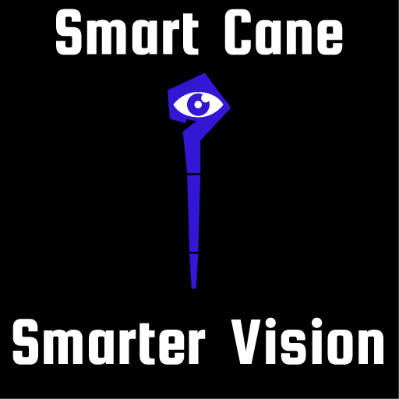
This report will be discussing a software service called Smart Cane to be introduced to the users via iOS and Google Play. It consists of a software application and comes with the bundle of the Smart Cane (white stick), and the ear pods to serve the mobility needs and wants of the sight impaired people and those with very poorly vision (Carlo, Lyytinen and Rose, 2012).
The type of this innovation is a software service, and the degree of it is incremental and its categorised as an imitated that (Dewar and Dutton,1986) alludes to a progression of enhancements made to the existing manual (white cane) by advancing it with the power of the technology to help all those who are blind and the partially sighted. Also, the classification of this innovative service is open as it incorporates external knowledge into innovation management (Obradović et al, 2021).
During this assignment, interviews were conducted with groups of blind and partially sited individuals of different age groups from males, females and were asked if the current and the available apps are serving the blind users and if it is fulfilling their needs and wants, they said: no, as these apps and the white stick do not serve their most needs and want from the advanced tech to serve them as blind people and they all answered unanimously:“ we need safer, independent outdoor mobility”.
The number of people losing their sight in the UK is dramatically increasing as the population is getting older in the UK. Further, the loss of sight is strongly associated with certain medical conditions such as the epidemic of diabetes and obesity (RNIB, 2019). The Smart Cane innovation is a service which gives continual direction to users who are blind and partially sighted as they travel indoor/outdoor.
According to the individuals who were interviewed for this study, the existing manual white cane by itself is not fulfilling their emerging demands of the mobility of the blind individuals for safer outdoor mobility as it has not advanced with the power of technology.
The innovative Smart Cane app with its assistive gadget of the smart stick and the ear pods will bring hope to the blind and partially sighted people by utilising the power of the technology to give them the freedom on their mobility.
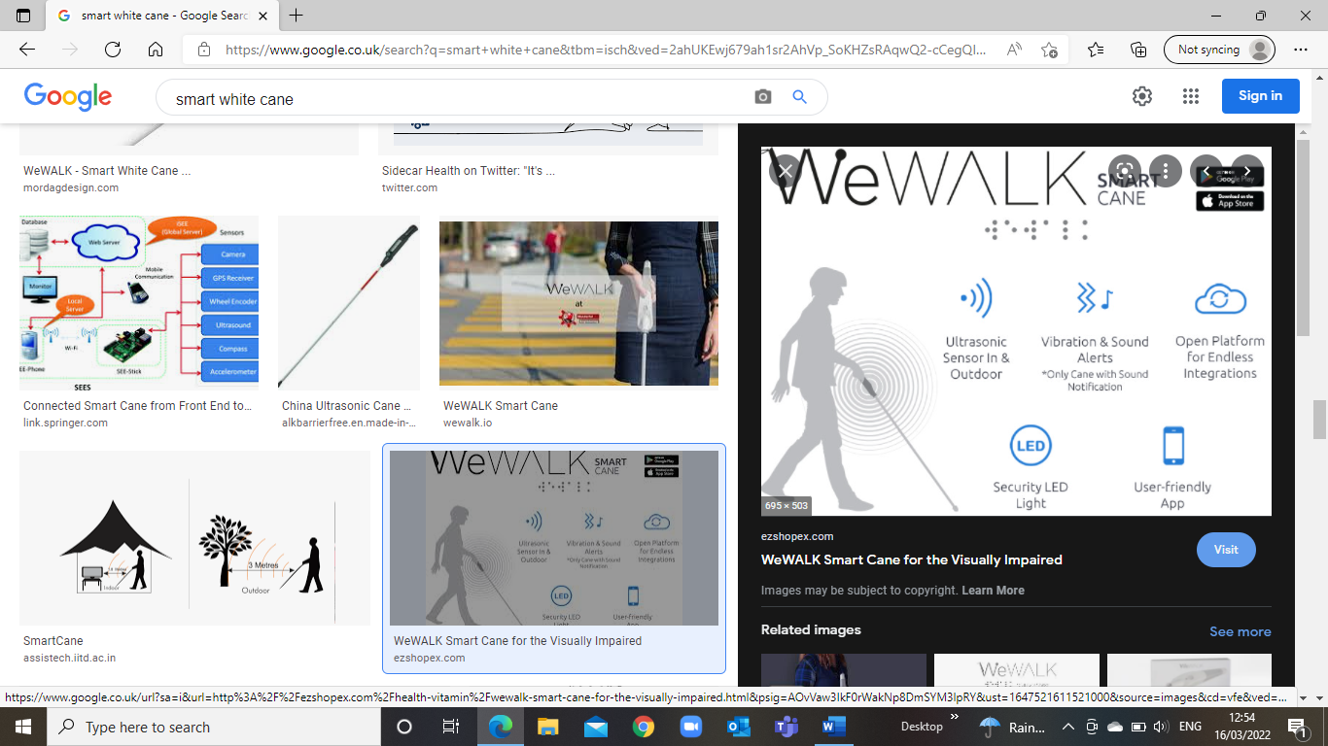
Source: ezshopex.com
The original assistive manual white cane has been in the market a long time ago and it requires long time of training the users on how to get comfortable and familiar with it (Shiizu, 2007), as blind users should be trained to use manual white stick for weeks or few months to get conformable using it, it must be held in a certain positioned to balance it with the body movements and the stick must be consistent with the user’s walking steps to ensure any obstacles in front of the user is found. No doubt that the manual white cane has served the free mobility purpose for some users. However, it clearly requires a lot of efforts and time to adapt to it with the training and not many people can adapt to it compared to smart stick, as it requires couple of sessions of training and users can adapt to it very easily as it will be advanced with Bluetooth (or other relevant techs) connectivity, ultrasonic sensor to aid the users mobility as the installed app in the users’ smart phones has Bluetooth connectivity with the stick as well as the ear-pods, the stick’s ultrasonic sensor, which is at the bottom of the stick can recognise any obstacles come along in front of it by 2m radius and send the voiceover across via the ear-pods so the user can walk out indoor/outdoor safely and independently. The app also has the option of 30 languages to choose from to suit most of users languages.
Smart memory: the app automatically detects wherever the user goes and stores the data of all places and can give direction via activating the direction mode to help users to mainly travel outdoor, all the features are powered with voice-over /voice command to ask to go to certain saved places and needs voice directions.

Section 2

2.1 Customer needs and wants of the service.
The current needs and wants of sight impaired users for the technology not just limited to special programs to support them reading, writing and arithmetic, as there is a greater need to aid them to move freely without the fear of tripping over and clashing with others.
As per the NHS website (2021), in the UK, over 2 million individuals are living with a sight loss. Of these, around 340,000 are enlisted as blind or partially sighted.
This vast number of the blind individuals have the needs and wants of a free mobility to socialise, and the current software applications are only focusing on literacy, numeracy as well as recognising the surrounding environment via using the smart phones camera through software applications.
Usually, blind individuals rely on their senses and feelings to build up an understanding of their surrounding environments, those individuals struggle with their mobility the most in terms of not being able to navigate freely because of the fear of falling or colliding with an obstacle and that is showing the main emerged demands, needs and wants for these individuals with their mobility. The Smart Cane app will be tackling these emerged needs and wants for these individuals as the app designed to assist the blind and the partially sighted by utilising the advanced technology (Shih, Shih and Chiu, 2010) to make their life and mobility easier to the maximum extent. This remarkable innovative service has Bluetooth connectivity with the stick which has the built-in ultrasonic sensor to cover a 2m radius of recognising hazards come in their way and make the grip vibrate and send the warning to the app then sends a voice message to the user via the ear pods. The Smart Cane app will be available on App Store (iOS) as well as Google Play (Android) platforms. Users will be provided with full description on how to use the app and the gadget.

2.2 Unique Selling Point and competitive advantage
USP is what makes one’s service or product standout of the rest in the market of the rivals. (Miller and Henthorne, 2007).
Nowadays, blind people are suffering by being isolated due to their sight condition as per Focus Birmingham (2022), which is a private foundation that looks after people with visual impairment and complex need and support them to investigate the depth of the mobility needs of those people and how much they struggle with it due to their sight condition; their report shows that 1 in 5 will live with a sight loss in their lifetime and 1 in 4 say they stay lonely everyday because they are always indoor and cannot go out and about without a career.
The existing competitors of this service field only focusing on general object recognition, magnifier as well as reading such as Be My Eye, Smart Magnifier and Google Text to Speak (Noisyvision, 2018).
None of the above applications have the associated gadget with app to resolve the free of fear mobility for them, even the navigation apps are limited with the assistive mobility features as it only for the indoors use.
Sight impaired needs of the technology are not just limited to reading, writing, and navigating indoors, but their needs to move freely outdoors without the fear of falling or the embarrassment of colliding with people. The unique selling proposition of the Smart Cane app is the solution and will tackle the issue of the sight impaired loneliness and isolation by making their mobility smarter, safer, and easier as the smart features of the Bluetooth connectivity to its gadget of the stick and the ear-pods to assist the users to navigate their way freely and safely outdoor/indoor, as well as the affordable competitive subscription with one-month free trial of full access of the app features.
Furthermore, what makes the proposed service stands out of the rest is that on the top of its one of kind app features with its gadget, once the users download the app, they will be required to click placing the order of the gadget (£200 the cost of the smart cane gadget) which will be funded by the RINB which is Royal National Institute of Blind People for users and deliver it to their home address. Also, the competitive offers of a free 1month trial of the app with unlimited access will allow users to test and explore the significant quality of the full-service features which will be connected between the app, the stick, and the ear pods. Additionally, when users are satisfied with service of the full bundle of the Smart Cane, they will be offered half price subscription automatically set in the app which is £1.99 for another month and after that paying the monthly subscription of £3.99 to keep the full access of the app.
This service will make a significant life changing for blind individuals in their lives and automatically take a huge burden of the NHS as this category of people may suffer a depression as they are unable to go out by their own due to their sight impairment condition, and this what makes them isolated from socializing with the rest of the outside world (Noone et al, 2020).

2.3 SWOT analysis: is an essential preparation and vital administration procedure used to assist to measure with Strengths, Weaknesses, Opportunities and Threats connected with business contest or project arranging (Leiber, Stensaker and Harvey, 2018.). The table below will be showing the internal/external factors of SWOT to the Smart Cane innovation service:
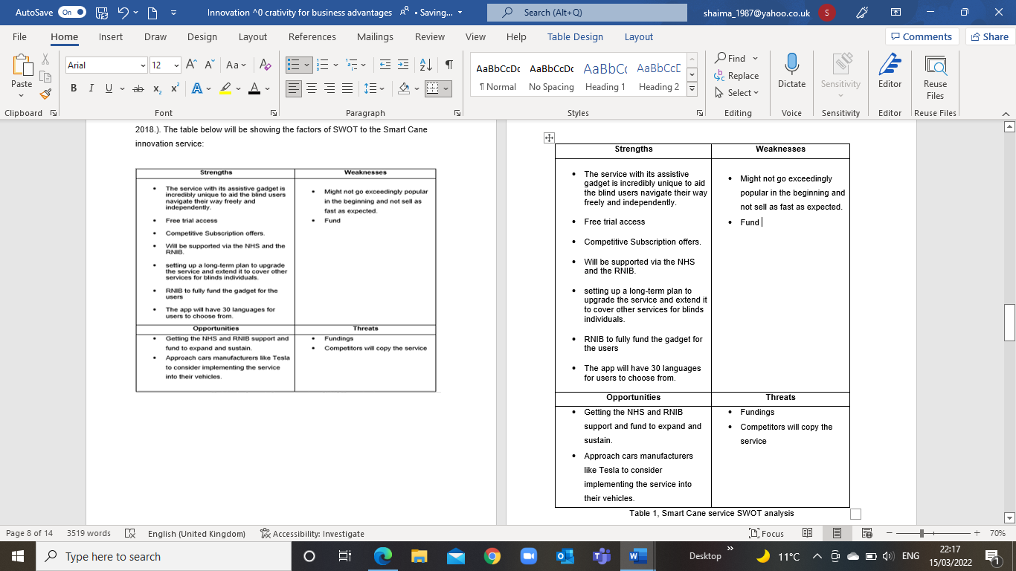
Table 1, Smart Cane service SWOT analysis
The above table illustrates the 4 main factors of the project, the first two are internal factors and they are: Strengths which is obviously the uniqueness of the innovation to assist the blind people with their mobility as well as 1-month free trail of full access of the app. However, the Weaknesses form some concerns as the developed app will need a big capital which is in principle available, but the concern is, if there will be more unexpected expenditures then it will need more fund and the waiting time for it, for example, if it gets claimed from the NHS or RNIB is unknown.
Looking at the external factors of the Opportunities and Threats and the connection between them is certain to some extent as the fundings can be applied for from the RNIB and the NHS. Also, the threat of rivals to copy Smart Cane service can be turn into an opportunity of a partnership with them to expand the service locally and globally.

2.4 Sustaining the innovative business proposition

Sustaining a service can be defined as keeping the existed service continual by advancing it to keep up with the emerged demands (Manzo et al,2015). The proposed App can be sustained in many ways, it will be proposed to a car manufacturers like Tesla as they are the most well-known with utilising a phenomenal tech to their vehicles by implementing the foundation of the Smart Cane features to allow and aid the poor/weak vision users who are allowed to drive cars in the UK meeting the minimum eyesight standards of the driving agency (DVLA, 2021), they can have a safer and more convenient driving with a full programming of the auto assistant driver.
Also, sustaining the Smart Cane service potentially will be strongly supported to be taken further by the stakeholders of NHS as well as the RNIB because of its uniqueness so it does not fail in the market. Further, another potential opportunity to sustain this app service is by going into partnership with other developers on the similar software service for this group of users so power can be integrated into business models and harnessed to help consumer make smart choices which means turning the threats of the rivals into an opportunity to expand and sustain the service locally and globally.

2.5 Competitors of the area and how they are trading their services
Competition (Tian and Yu, 2018) in this area of utilising the technology to serve the demands, needs and wants of the sight impaired is present in the race to make their life as easy and mobile as possible in an uncomplicated way. Each of the competitors have their own apps to allocate a certain area of the sight impaired needs, wants according to Noisyvision (2018) and they are 3 categories:
- General/ objects recognition: these kinds of apps are phones’ camera-based service, they are mainly relied on turning on the camera of the smart phone and face it on any object or environments to translate the seen or the view into a voiceover message to the users, such as Seeing Al, Supersense – Al for Blind, TapTapSee, Seeing Al.
- Navigation: this kind of software are audio-based technology to enable users with visual deficiency or low vision, to fabricate a more extravagant attention to their environmental elements, along these lines turning out to be surer and more engaged to get around. Not at all like bit-by-bit route applications, Soundscape uses 3D sound signals to enhance encompassing mindfulness and give a better approach to connect with the climate. It permits blind users to fabricate a psychological guide and settle on private course decisions while being more agreeable inside new spaces, such as BlindSq Event, BlindSquare etc.
- Reading: these apps are screen readers which mean they read any text comes in the screen aloud like reading text messages, news etc. These apps are Google text-To-Speech, Enabling Text to Speech, Read for the Blind
Most of the above apps are free to download with limited access unless subscribed, others to be bought with a one-off payment. Also, some of them are available on both Android and iOS, and others only available on one platform. Smart Cane app will have the greatest competitive advantage of all the above software and standout of their services as it is the only service to assist the sight impaired users with their mobility and free them up from the need of any one to assist them outdoor.

Section 3

3.1 Ecommerce
Nowadays it is vital to have an Ecommerce platform when selling both products and service. The term Ecommerce (web-based business) alludes to a plan of action that allows organizations and people to trade labour and products over the Internet (Soni, 2020).
The Smart Cane will be published on both platforms of App Store and Google Play for customers to download for free. However, to save subscription cost fees, as Apple and Google charge 30% which is a huge figure specially for new entrant of the market if they were to collect the money and transfer it to developer. Users will have to create accounts on the service provider website and then enter credit card information. To get the above transection done safely and securely, the following tools must be set up: PayPal payment gateway (Trautman, 2015) and merchant account.
It is vital to realize how the instalments are handled, as there are a couple of options. The credit cards will be run through two stages. The first is the Payment Gateway to take the payment and the Merchant Account (Xu et al, 2020) to process credit card and take the money to send it to developer’s bank account to carry out the transactions. The fees of these portals are 3% which is cheaper than Apple and Google and very affordable and can increase the profits by 1.5% which would be huge over time.

3.2 Project budget
The capital for the proposed project of the Smart Cane is £60,000. The table below shows the estimated cost of the project:
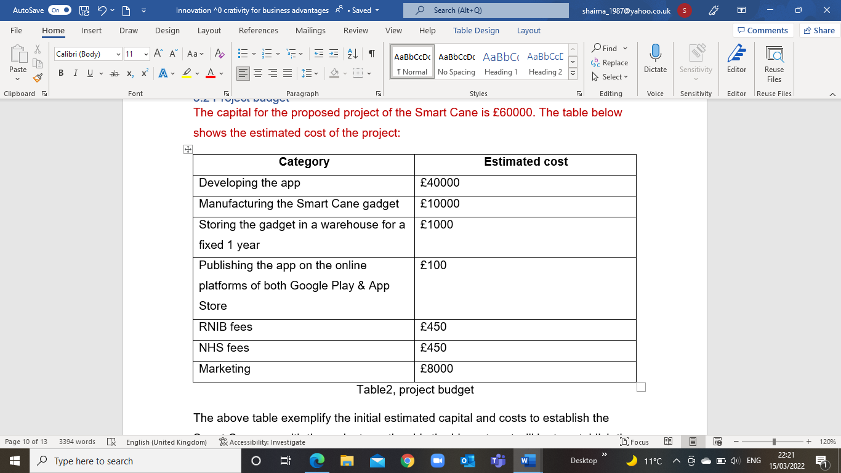Table2, project budget
The above table exemplify the initial estimated capital and costs to establish the Smart Cane app with the gadgets, noticeably the biggest cost will be to establish the foundation of the app software, to be followed with manufacturing the smart gadget and this cost is not the total as the RNIB and NHS are expected to fund the rest of the bill for the purposed project of aiding the sight impaired people, however, they still to charge for the administration fees etc, and last but not least the cost of the marketing.

3.3 Marketing
Marketing the Smart Cane service can be marketed in many ways such as social media platforms like Facebook, Instagram, and others, which is the cheapest way and the most widespread. Also, it can be advertised via (Vinic, Neely and Jovanovic, 2018) YouTube platform which will cost £0.03-£0.30 per view, with a £2000 average cost to reach 100,000 viewers for a brief period to get the attention of the largest viewers possible (WebFX, 2022). In addition, co-ordinate with the RINB to arrange a seminar event for the pre-launch to invite the sight impaired people with their families and interduce them to the proposed service with a full demonstration presentation of the service and hand out printed leaflets for them. Once the service is live and in-use, keep chasing up clients by calling them directly and run a survey with them to post it on the app reviews, and via sending feedback emails as well as push notification in the app and in case the progressing of the reservice will be up to date. The aim is to target about 300 subscribers a month to generate an estimated profit of £73,766 annually, this includes the half price of promotion, the full subscription after the promotion as well as the price of the stick gadget, below is the breakdown of the estimated profits of the project:
£200 one off payment for the gadget X 300 subscribers = £60,000
£1.99 for the first month app promotion X 300 subscribers = £597
£3.99 monthly subscription X 300 subscribers = £1,197X11months= 13,167
£60,000 + £597 + £13,167 = £73,766

References

- Carlo, J.L., Lyytinen, K. and Rose, G.M., 2012. A knowledge-based model of radical innovation in small software firms. MIS quarterly, pp.865-895.
- Dewar, R.D. and Dutton, J.E., 1986. The adoption of radical and incremental innovations: An empirical analysis. Management science, 32(11), pp.1422-1433.
- Focus Birmingham | Charity for sight loss and complex needs. 2022. Facts and figures. [online] Available at: <https://www.focusbirmingham.org.uk/facts-and-figures> [Accessed 4 March 2022].
- GOV.UK. 2021. Driver and Vehicle Licensing Agency Visual disorders: assessing fitness to drive. [online] Available at: <https://www.gov.uk/guidance/visual-disorders-assessing-fitness-to-drive#:~:text=Minimum%20eyesight%20standards%20%E2%80%93%20all%20drivers,-The%20law%20requires&text=%E2%9C%98%2D%20Any%20driver%20unable%20to,accepted%20by%20DVLA%20for%20driving.> [Accessed 22 March 2022].
- Leiber, T., Stensaker, B. and Harvey, L.C., 2018. Bridging theory and practice of impact evaluation of quality management in higher education institutions: a SWOT analysis. European Journal of Higher Education, 8(3), pp.351-365.
- Manz, C.C., Skaggs, B.C., Pearce, C.L. and Wassenaar, C.L., 2015. Serving one another: are shared and self‐leadership the keys to service sustainability? Journal of Organizational Behavior, 36(4), pp.607-612.
- Miller, M.M. and Henthorne, T.L., 2007. In search of competitive advantage in Caribbean tourism websites: Revisiting the unique selling proposition. Journal of Travel & Tourism Marketing, 21(2-3), pp.49-62.
- nhs.uk. 2021. Blindness and vision loss. [online] Available at: <https://www.nhs.uk/conditions/vision-loss/> [Accessed 4 March 2022].
- NoisyVision. 2018. Apps and devices for blind and visually impaired people - NoisyVision. [online] Available at: <https://www.noisyvision.org/2018/08/01/app-and-devices-for-blind-and-visually-impaired/?https://www.noisyvision.org/2018/08/01/app-and-devices-for-blind-and-visually-impaired/&gclid=EAIaIQobChMIzsb_ooOr9gIVwYFQBh0YWAWZEAAYASAAEgLPBPD_BwE> [Accessed 14 March 2022].
- Noone, C., McSharry, J., Smalle, M., Burns, A., Dwan, K., Devane, D. and Morrissey, E.C., 2020. Video calls for reducing social isolation and loneliness in older people: a rapid review. Cochrane Database of Systematic Reviews, (5).
- Obradović, T., Vlačić, B. and Dabić, M., 2021. Open innovation in the manufacturing industry: A review and research agenda. Technovation, 102, p.102221.
- RNIB - See differently. 2019. Key information and statistics on sight loss in the UK. [online] Available at: <https://www.rnib.org.uk/professionals/knowledge-and-research-hub/key-information-and-statistics> [Accessed 14 March 2022].
- Shih, C.H., Shih, C.T. and Chiu, H.C., 2010. Using an Extended Automatic Target Acquisition Program with dual cursor technology to assist people with developmental disabilities improve their pointing efficiency. Research in Developmental Disabilities, 31(5), pp.1091-1101.
- Shiizu, Y., Hirahara, Y., Yanashima, K. and Magatani, K., 2007, August. The development of a white cane which navigates the visually impaired. In 2007 29th Annual International Conference of the IEEE Engineering in Medicine and Biology Society (pp. 5005-5008). IEEE.
- Soni, V.D., 2020. Emerging Roles of Artificial Intelligence in ecommerce. International Journal of trend in scientific research and development, 4(5), pp.223-225.
- Tian, X.S. and Yu, M., 2018, August. Redact when competitors act--examining the threat of rivals’ product portfolio modifications. In 29th Annual Conference on Financial Economics & Accounting.
- Trautman, L.J., 2015. E-Commerce, cyber, and electronic payment system risks: lessons from PayPal. UC Davis Bus. LJ, 16, p.261.
- Visnjic, I., Neely, A. and Jovanovic, M., 2018. The path to outcome delivery: Interplay of service market strategy and open business models. Technovation, 72, pp.46-59.
- WebFX. 2022. How Much Does YouTube Advertising Cost? | YouTube Ad Pricing. [online] Available at: <https://www.webfx.com/social-media/pricing/how-much-does-youtube-advertising-cost/#:~:text=On%20average%2C%20though%2C%20YouTube%20advertising,pay%20around%20%240.10%20to%20%240.30.> [Accessed 22 March 2022].
- Xu, L., Chen, L., Gao, Z., Carranco, L., Fan, X., Shah, N., Diallo, N. and Shi, W., 2020. Supporting blockchain-based cryptocurrency mobile payment with smart devices. IEEE Consumer Electronics Magazine, 9(2), pp.26-33.

