
STUDENT ID - 2438385
Task 1 – Reading Task Template
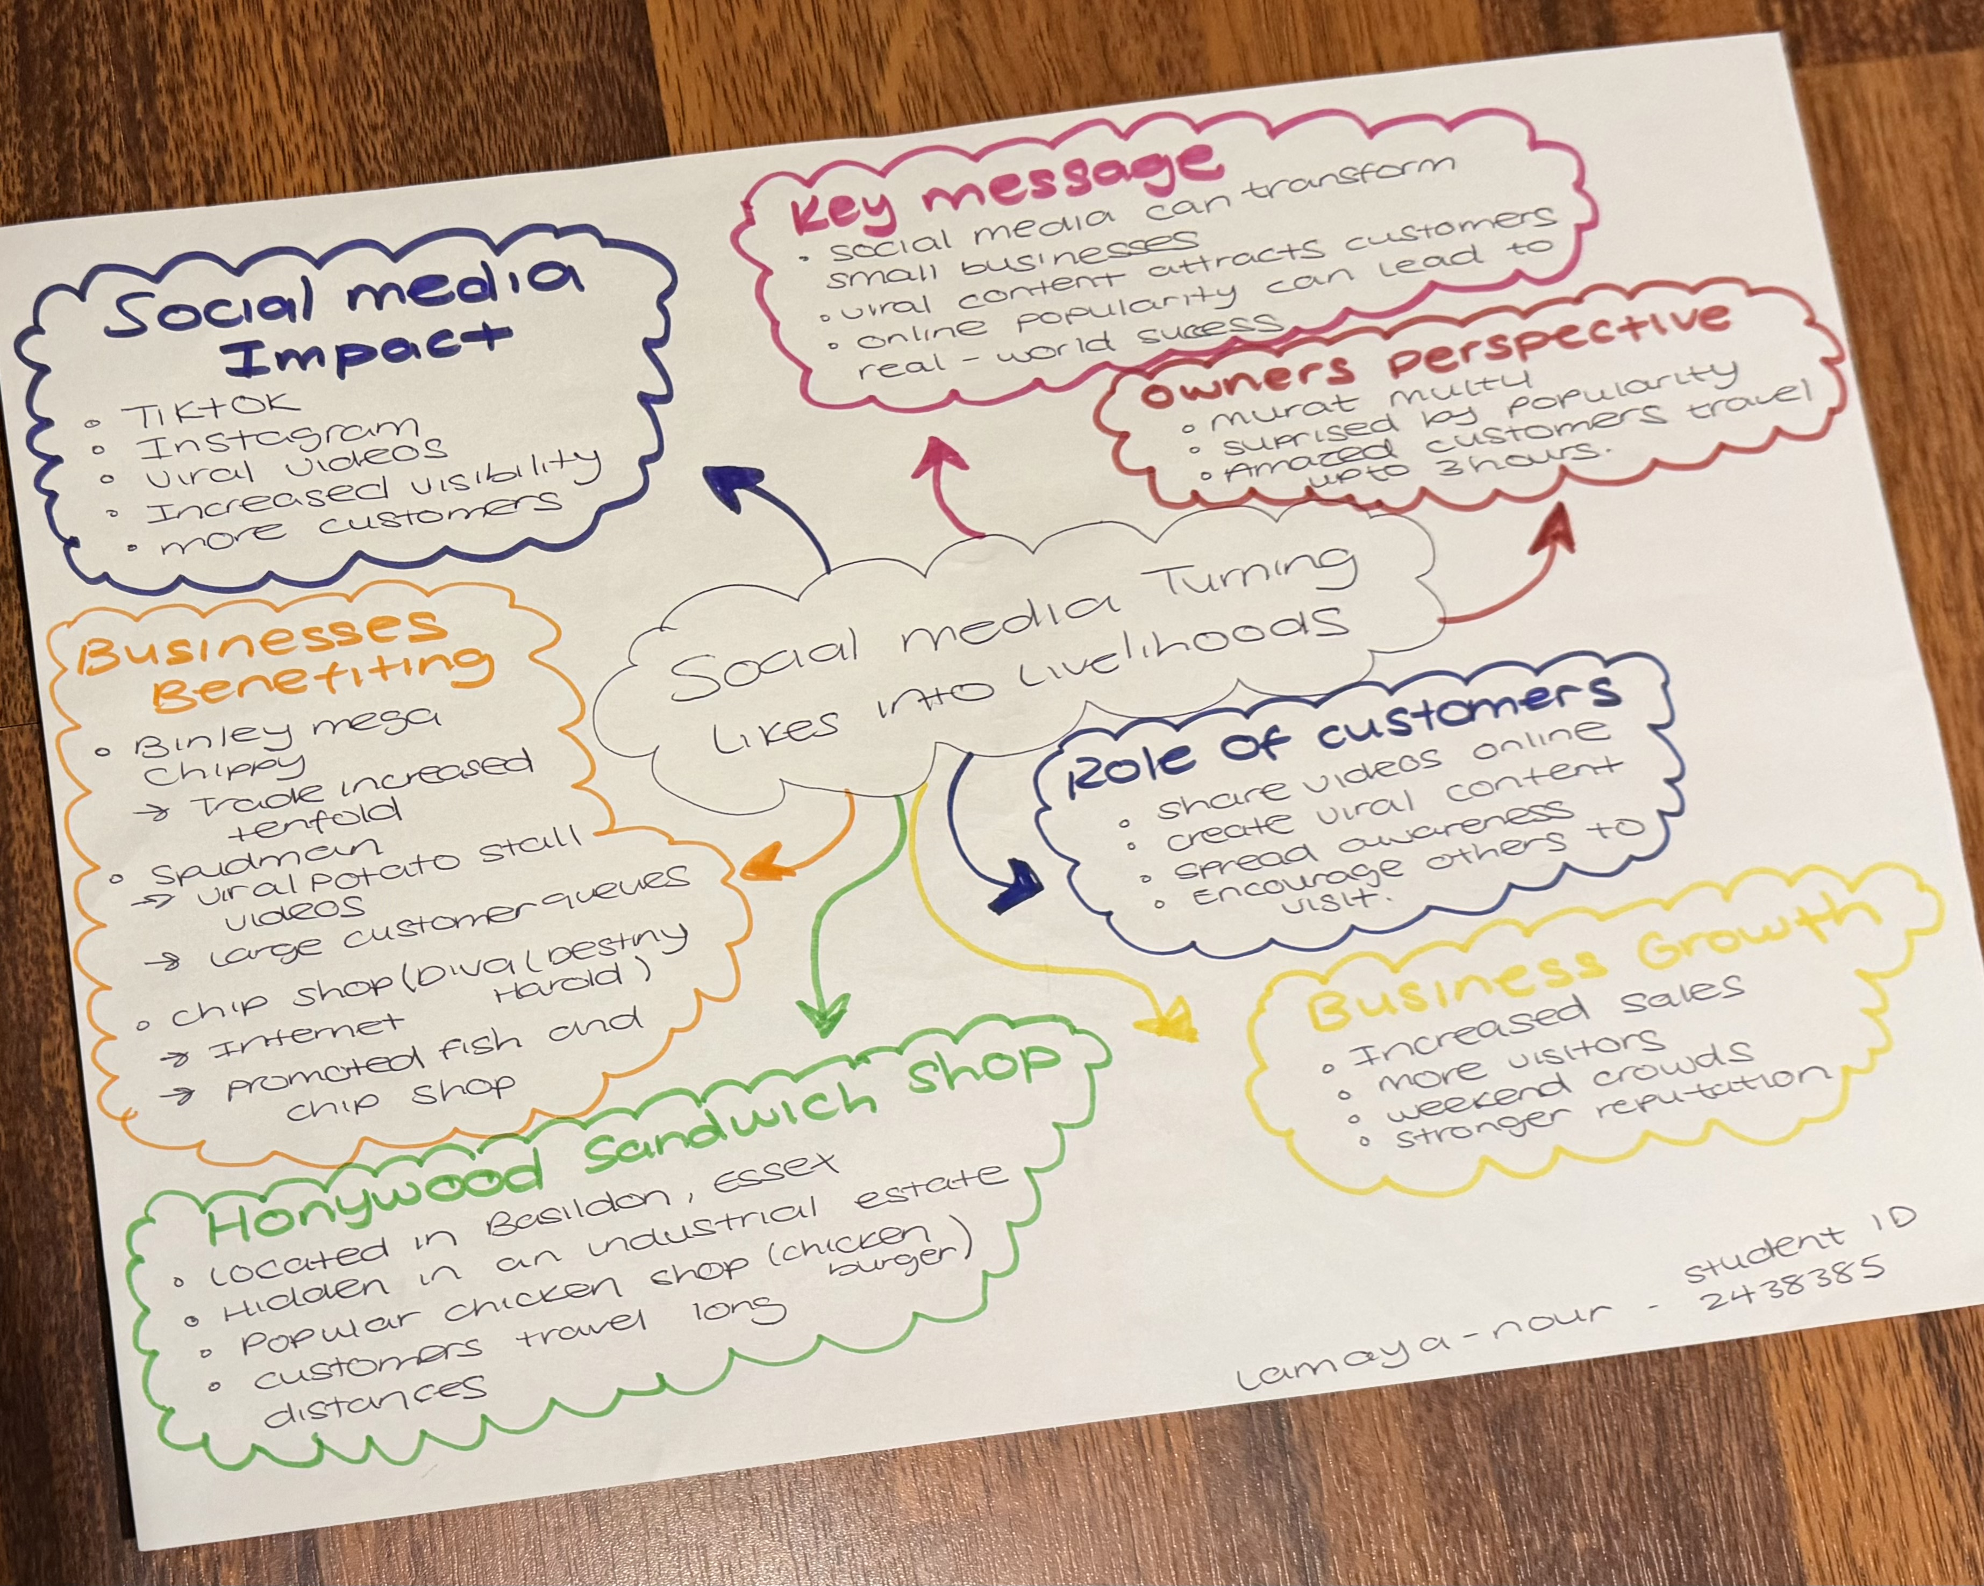

1. Answer these questions using the sentence starters below
a. What is the main idea of the text?
The main idea is that social media can transform small businesses by increasing their visibility, attracting more customers, and helping them achieve greater success.
b. What are two key points?
One key point is that viral videos on platforms such as Tiktok and Instragram can significantly increase a business’s popularity and attract new customers.
Another key point is that customers play an important role in promoting businesses by sharing content online, which encourages more people to visit and support them.

c. What part of the text did you find most important? Why?
The most important part is the key message that social media can transform small businesses, because it shows how online popularity can lead to real world success and business growth.
d. Was anything unclear or difficult to understand?
I was not sure about how some businesses became viral so quickly, but the examples helped me understand the process better.
e. How did your group help you understand the text better?
My group helped me by discussing the main ideas, sharing different viewpoints, and explaining parts of the text that I did not fully understand.
3. One sentence reflection
Question: What did you find challenging about this task?
The hardest part was summarising the text and deciding which details were the most important to include and also understanding how social media influenced the success of different business’s and explaining it in my own words.

