- Programme: BA Leadership and Management
- Assignment Title: Innovation & Customer Journey

- Student Name: Sajid Amin
- Student ID:2308943
- Module: LCLM 6002- Design Thinking and Innovation
- Module Leaders: Rexon Nting and Doreen Nyaa Amundam

Contents
Introduction of chosen Organization – Sainsbury’s 1
Sainsbury’s acquisitions 2
Key market and consumer trends and insights in supermarket industry 3
Part I 4
Approach of Sainsbury’s to Innovation 4
Customer Journey map 6
Part II 10
Recommended Technology-Driven Solution (Sainsbury’s SmartSphere) 10
Features of Sainsbury’s SmartSphere 10
Updated Customer Journey Map 12
Overview 12
Impact of the Sainsbury’s SmartSphere 13
Impact of Sainsbury’s SmartSphere on Customers 13
Impact of Sainsbury’s SmartSphere on Operations 13
Setup Blueprint 14
Measurement of the Impact and success of Sainsbury’s Smartsphere 14
Role of Leadership and Management in Delivering Sainsbury’s SmartSphere 15
Conclusion 16
References 17

Introduction of chosen Organization – Sainsbury’s
J Sainsbury plc, commonly known as Sainsbury’s, is one of the United Kingdom’s most established and recognisable supermarket chains, holding a significant place in the country’s retail landscape since its founding in 1869. As a multichannel retail group operating across groceries, clothing, home goods, banking, and energy services, Sainsbury’s has evolved into a modern retail leader with a strong digital footprint and a nationwide presence. The company operates through several brands, including Sainsbury’s supermarkets, Sainsbury’s Local convenience stores, Argos, Habitat, Tu Clothing, Nectar loyalty programme, and Sainsbury’s Bank, forming a diverse ecosystem that serves millions of customers every week.
Ranking as one of the leading food retail companies in Europe, Sainsbury’s is a household name throughout the UK. Along with one of its main competitors, Tesco, Sainsbury’s is one of the only UK retailers to feature among the top twenty European supermarkets. Sainsbury’s sales revenue reached a record £36.7 billion in the 2024/25 financial year which is an increase of more than 40 percent over the past decade (Bedford, 2025). The company is best known for its extensive grocery offerings, supported by a wide range of own-brand lines, from budget value ranges to premium “Taste the Difference” products. These items are available across a broad store portfolio, from Sainsbury’s Local convenience stores to large-format supermarkets offering everything from food and household goods to clothing and entertainment products.
Sainsbury’s strong market presence extends beyond physical stores. It is the second-largest online grocery retailer in the UK and even ranks among the top five online footwear retailers, highlighting the depth and versatility of its online operations. With 855 convenience stores, a workforce of approximately 111,900 employees, and annual retail sales of £32.6 billion, Sainsbury’s continues to compete in a highly dynamic and competitive sector.
In terms of market positioning, Sainsbury’s remains one of the largest UK supermarkets but competes closely with Asda for the second-largest market share. While Tesco leads with over 27 percent of the grocery market, recent data shows Sainsbury’s holding 12.5 percent, compared to Asda’s 13.4 percent. This competitive landscape extends to the online grocery market, where both traditional retailers and newer entrants like Amazon Fresh are targeting the same customer base.

Sainsbury’s acquisitions
Sainsbury’s strengthened its retail and digital capabilities in 2016 by acquiring Argos, a highly digital general-merchandise retailer known for its wide range of electronics, toys, clothing, small and large appliances, furniture and household essentials, supported by a strong online platform, same-day Fast Track delivery and click-and-collect services. Unlike Sainsbury’s largely food-focused supermarket model, Argos brought a fully digital retail structure that allowed Sainsbury’s to expand its non-food categories and integrate Argos concessions inside Sainsbury’s stores (Argos, 2024). The acquisition also included Habitat, a premium home and furniture brand offering contemporary furniture, lighting, décor and home accessories, now featured as mini-stores within selected Sainsbury’s outlets. Alongside these acquisitions, Sainsbury’s further enhanced its data and personalisation capabilities by taking full ownership of the Nectar loyalty programme (Sainsbury's, 2024).

Key market and consumer trends and insights in supermarket industry
Consumer behaviour in the grocery sector is shifting rapidly as shoppers increasingly look for convenience, faster service and a smooth e-commerce experience. This aligns with wider market data, where e-commerce retail sales in the UK are expected to account for 38.1 percent of all retail sales in 2025 (Coppola, 2023). With the increasing reliance on online purchase systems, consumers have been prioritising convenience, a trend that intensified after the COVID-19 pandemic (Gu et al., 2021). Modern shoppers now expect flexible omnichannel journeys that allow them to order through websites, mobile apps or rapid delivery services. This is also reflected in global retail patterns, where general merchandise retailers operate across both online and offline channels to meet evolving customer expectations (Oosthuizen et al., 2021). In response, Sainsbury’s has expanded its digital fulfilment through Home Delivery, Click and Collect, the Chop Chop one-hour service and partnerships with third-party delivery platforms, ensuring accessibility across diverse shopping formats. These services form Sainsbury’s key deliverables in its omnichannel strategy, providing consistent product availability, rapid delivery options, flexible collection services and an integrated online shopping ecosystem. Another significant trend is the rising demand for personalisation and richer digital engagement. Improving customer interaction through advanced technologies has become essential, and the utilisation of AI algorithms enables retailers to deliver more accurate personalised recommendations (Bist et al., 2022). Sainsbury’s supports this trend through the Nectar loyalty platform, personalised digital coupons and enhanced app features powered by data analytics and artificial intelligence. Broader lifestyle trends, including greater health consciousness, interest in sustainability and the demand for transparent product information, continue to influence purchasing decisions. At the industry level, the sector faces heightened competition from discounters and online-first challengers, which accelerates the need for stronger digital capabilities. Sainsbury’s has responded with significant technology investments such as SmartShop scan and go, expanded self-checkout systems and checkout-free SmartShop Pick and Go, while strategic partnerships with Microsoft, SAP, Accenture and AWS modernise its core systems and analytics infrastructure. These developments highlight how the grocery market is moving toward a fully integrated, data-driven and technology-enabled retail environment, reinforcing the need for continuous digital innovation to maintain competitiveness.

Part I

Approach of Sainsbury’s to Innovation
The Innovation Ambition Matrix, introduced by Nagi and Tuff (2012), helps organisations structure innovation into three categories: Core, Adjacent and Transformational, and these constraints applied for Sainsbury’s are illustrated in the following figure:
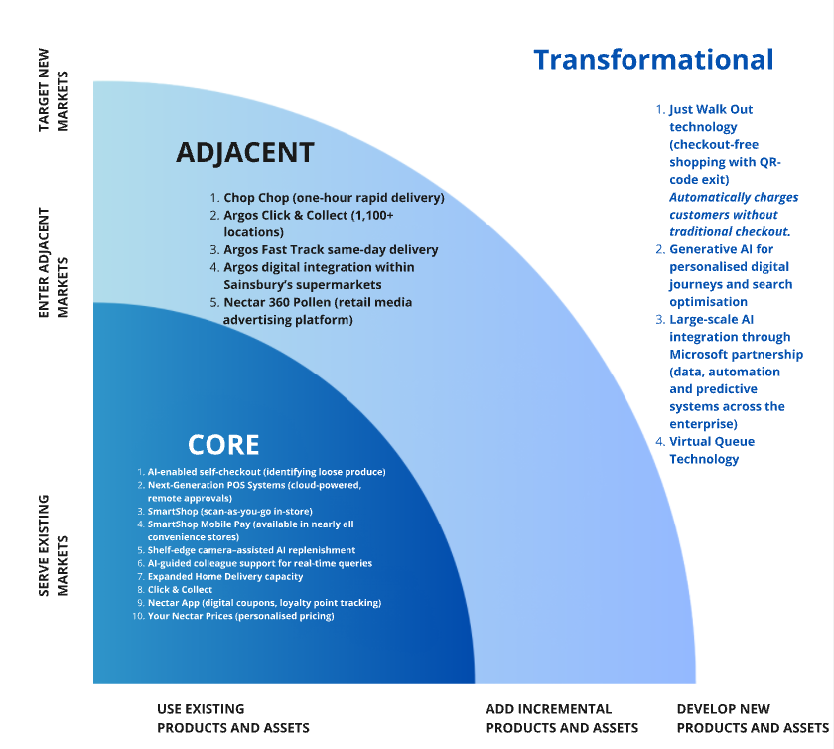
1. Artificial Intelligence, Generative AI and Smart Systems
Sainsbury’s is significantly advancing its technological capabilities through a five-year strategic partnership with Microsoft, enabling the integration of AI and generative AI across its retail operations. These technologies enhance online search, improve product discoverability and create a more intuitive digital shopping experience. This aligns with findings by Kim et al. (2022), who highlight that generative AI can enhance demand estimation, analyse consumer behaviour and reduce fraud. AI also supports store processes through real-time insights for shelf replenishment using shelf-edge cameras, while Next-Generation POS Systems use cloud and AI to accelerate checkout transactions and allow remote colleague approvals via tablets. Such digital transformation efforts contribute positively to operational performance, as emphasised by Gouveia and São Mamede (2022), who note that digital transformation significantly improves retail operational efficiency.
2. AI-Enhanced Checkout, Scan-and-Go and Checkout-Free Technologies
Sainsbury’s continues to expand frictionless shopping options through a range of smart technologies. Its AI-enabled self-checkouts recognise loose produce without barcodes, helping speed up in-store transactions. The SmartShop service, accessible via mobile app or in-store handsets, allows customers to scan products as they shop, track spending and pay quickly at dedicated checkouts. Importantly, SmartShop Mobile Pay is now available in nearly all Sainsbury’s convenience stores generating 30% of the sales (Sainsbury's, 2025), offering a fast, fully contactless payment method without queueing. This reflects wider industry shifts highlighted by Chaveesuk et al. (2021), who state that digital transformation enhances payment processes by enabling businesses to integrate multiple digital payment options.
Sainsbury’s has also piloted Just Walk Out technology along with Smartshop Pick and Go (Sainsbury's, 2025), an automated checkout-free system that identifies items customers pick up using computer vision and sensors. After shopping, customers leave the store by scanning a QR code to exit through automatic gates, and their linked payment method is charged automatically.
3. Virtual Queue and In-Store Traffic Management
To reduce physical queues and improve customer flow, Sainsbury’s trialled Virtual Queue Technology. Customers join a digital queue on their mobile device, receive real-time updates and enter the store when notified. This system enhances comfort, safety and store efficiency, particularly during peak shopping hours or special events.
4. Online Grocery, Rapid Fulfilment and Collection Services
Sainsbury’s has strengthened its online and rapid delivery capabilities to meet rising consumer demand for convenience. The retailer offers an expanded home delivery network alongside Chop Chop, which delivers selected groceries within one hour. In addition, Argos Click & Collect enables customers to collect online orders from more than 1,100 pickup points across Sainsbury’s supermarkets and dedicated Argos locations. These services create a seamless, highly efficient omnichannel shopping experience that reflects the positive operational impact of digital transformation described by Gouveia and São Mamede (2022).
5. Personalisation, Loyalty Programmes and Data-Driven Marketing
Personalisation remains a central component of Sainsbury’s digital strategy. The Nectar App enables customers to manage personalised discounts, digital coupons, loyalty points and Your Nectar Prices, which offers tailored savings on frequently purchased items. This supports the view of Khairawati (2020), who states that loyalty programmes positively shape customer perceptions and enhance brand loyalty. Complementing this is Nectar 360 Pollen, a data-driven retail media platform that uses customer behaviour insights to deliver targeted advertising across digital and in-store channels. These systems enhance customer engagement, improve marketing precision and strengthen Sainsbury’s broader digital ecosystem.
6. Argos Digital Integration and General Merchandise Innovation
The integration of Argos supports Sainsbury’s broader omnichannel strategy by bringing with it a strong set of digital services for general merchandise. Argos operates a highly developed e-commerce website and mobile app that allow customers to browse, check real-time stock availability and place orders for thousands of products, including electronics, toys, furniture and homeware. Around 70% of Argos sales originate online, supported by digital services such as Fast Track same-day delivery, Argos Click & Collect, online order tracking and in-store digital ordering points within Sainsbury’s supermarkets (Sainsbury's, 2021). Through these capabilities, Sainsbury’s has been able to extend its non-food offer, provide faster and more flexible fulfilment options and offer a unified shopping journey across multiple integrated channels.
7. Smart Charge: Ultra-Rapid EV Charging Network
Launched in 2024, Smart Charge is Sainsbury’s sustainability-focused ultra-rapid EV charging service powered entirely by renewable energy (Sainsbury's, 2024). As the first EV charging network to offer Nectar loyalty points, it combines environmental responsibility with customer rewards, reinforcing Sainsbury’s commitment to sustainable digital infrastructure.

Customer Journey map

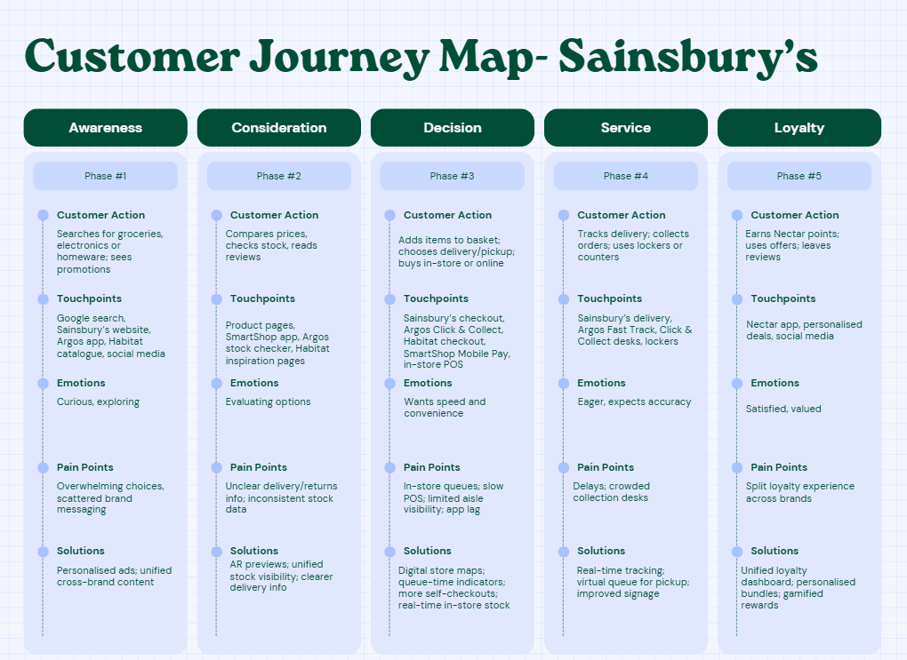
Based upon the current approach at Sainsbury’s, customers come across following pain points at respective stages. Following are the identified pain points at each stage:
1. Awareness
Customers often struggle to make sense of the wide mix of products across Sainsbury’s, Argos and Habitat. The three brands all appear separately online, which makes it hard to know where to look first. Many customers find themselves switching between different apps or websites just to understand what is available or who sells what. This makes the early stage feel scattered rather than smooth.
2. Consideration
When comparing products, customers often face practical challenges such as inconsistent stock information between stores and online channels. A product may show “in stock” online but be unavailable in-store minutes later. For Habitat furniture and Argos clothing and other try-out products, customers frequently feel that there aren’t enough real-life previews or 360° views to judge size and quality. Slow app performance during busy periods also interrupts product research and decision-making.
3. Decision (Purchase)
The buying stage brings some of the most common frustrations. In stores, customers often queue for long periods due to busy checkouts or limited staff. Self-checkouts sometimes misread items or trigger manual approvals, slowing the process further. SmartShop scanning occasionally glitches or fails to sync, forcing customers to restart the process. In-store, customers also complain about not knowing exactly where items are located, leading to time wasted searching through aisles.
4. Service (Delivery & Pickup)
Delivery and pickup services frequently cause stress. Customers experience missed delivery slots, late drivers or vague tracking updates. Argos Click & Collect desks can get crowded, especially during peak hours, resulting in long waits for orders. Some collection points inside Sainsbury’s stores are hard to locate due to unclear signage. For Habitat furniture, delivery scheduling options are sometimes limited, making it difficult for customers to fit deliveries around work or home commitments.
5. Post-Purchase Support
Returns and refunds, especially for mixed orders,are often confusing. Customers may be unsure whether to return an item to Sainsbury’s, Argos or Habitat, and staff sometimes redirect them to another channel. Customer service phone wait times can be long, and digital support options don’t always resolve issues quickly. This leaves customers feeling stuck and unsure of the correct return or warranty process.
6. Loyalty & Advocacy
Although Nectar is widely used, customers often feel that loyalty rewards don’t match their actual shopping habits. Offers may feel generic, and many customers miss out on personalised pricing because the app is not always intuitive. Another practical frustration is that shoppers cannot clearly track loyalty benefits across Sainsbury’s–Argos–Habitat together, causing the loyalty experience to feel fragmented rather than unified.
From identified pain points it is evident that Sainsbury’s can further strengthen its service delivery by adopting and leveraging newer digital technologies, which would in turn support higher customer satisfaction, increased sales and improved revenue performance like:
1. AI-Driven Personalisation and Customer Insights
Sainsbury’s can use AI analytics to understand customer behaviour more accurately and deliver hyper-personalised product recommendations and targeted advertisements across its app, website and in-store touchpoints. This counters the pain point of customers feeling overwhelmed or receiving irrelevant promotions.
2. AI-Powered Visual Search
Implementing visual search would allow customers to upload or photograph an item and instantly browse similar options from the entire Sainsbury’s, Argos and Habitat catalogue. This solves the problem of difficult product discovery and inconsistent search accuracy across channels.
3. Augmented Reality (AR) for Improved Product Evaluation
Using AI combined with AR in the app would let customers preview Habitat furniture, Argos electronics or clothing items within their own environment or on virtual body models. This addresses the lack of product previews and uncertainty about size, fit and appearance before purchase which result in enhancement of customer experience
4. AI-Optimised Delivery and Fast-Track Enhancements
AI can help optimise delivery routes and strengthen Fast-Track same-day services, reducing issues such as inaccurate ETAs, late deliveries and missed time slots, which are major customer frustrations.
5. Virtual Queuing for Smoother In-Store Flow
Introducing virtual queuing in busy stores and Click & Collect areas would ease congestion, shorten waiting times and provide more predictable service during peak hours.
6. Personalised Smart Baskets
Sainsbury’s can offer AI-generated personalised baskets based on past purchases, frequency patterns and preferences. This reduces decision fatigue and helps customers shop faster for both, online and in-store.
7. AI Chatbots for Post-Purchase Support
AI-powered chatbots can provide instant assistance for order issues, returns, refunds and product queries, addressing slow customer service response times and reducing post-purchase frustration.
8. Blockchain for Real-Time Inventory Visibility
Implementing blockchain-enabled inventory tracking would give customers accurate, real-time stock information across Sainsbury’s, Argos and Habitat. This counters frequent issues of out-of-stock items and inconsistent availability between online and in-store channels (Davenport and Mittal, 2023).

Part II

Recommended Technology-Driven Solution (Sainsbury’s SmartSphere)
Sainsbury’s SmartSphere is a comprehensive digital innovation solution that brings together the strengths of Sainsbury’s, Argos and Habitat into one seamless, intelligent and customer-centric ecosystem. The solution addresses major customer pain points across the entire shopping journey, covering product discovery, in-store navigation, checkout, fulfilment and post-purchase support. It achieves this through the strategic use of AI, augmented reality and real-time data systems to create a unified and more efficient retail experience.

Features of Sainsbury’s SmartSphere
1. AI-Powered Personalised and Automated Shopping Baskets
SmartSphere introduces an AI-driven personalised basket system designed to simplify grocery shopping and enhance convenience. Customers can generate automated baskets based on individual preferences such as price sensitivity, dietary requirements, family size or weekly goals. The app creates a customised basket preview which customers can approve, modify manually or save for future use at scheduled times. This feature reduces decision fatigue, supports consistent planning and ensures the basket remains aligned with evolving customer needs.
2. Integrated Virtual Queue and Digital Token System
To resolve in-store congestion and reduce waiting times at checkouts or Click and Collect counters, SmartSphere includes a virtual queue system built into the app. Customers can reserve a digital token or queue number before arriving at the store. When their turn approaches, they receive an app notification and can scan their digital token at the checkout point. This system enables smoother in-store movement and reduces the frustration of physical queueing.
3. AR-Based Product Visualisation for Habitat and Argos
SmartSphere combines AI with augmented reality to allow customers to preview Habitat furniture, home décor, Argos electronics and clothing items in real environments. Customers can place a sofa within their living room, check how a television fits on their wall or try on clothing through virtual body models. This significantly improves product understanding and addresses uncertainties related to size, fit and appearance before making a purchase. This will help them to have a better visualization before purchase (Reinartz, Wiegand and lmchloss, 2019).
4. AI-Enabled Visual Search Across All Brands
The visual search feature allows customers to upload or photograph any item they are interested in, such as home décor, furniture or electronics. The system instantly identifies visually similar products across the entire Sainsbury’s, Argos and Habitat catalogue. This enhances product discovery, supports customers who may not know the exact product name and reduces time spent browsing through menus.
5. AI Chatbots for Enhanced Post-Purchase Support
To improve post-purchase interactions, SmartSphere integrates advanced AI chatbots capable of assisting customers with refunds, exchanges, delivery concerns, warranty queries and general product support. This enables instant problem solving and reduces dependence on customer service queues. Automated refund processing and tracking further streamline the post-purchase experience.
6. Real-Time Inventory Visibility with Advanced Data Systems
SmartSphere incorporates real-time inventory tracking across Sainsbury’s stores, Argos stockrooms and Habitat warehouses. This may be supported by blockchain-based transparency tools to ensure accuracy and trust. Customers can view up-to-date stock information before placing an order or visiting a store. This reduces stock-related frustrations and prevents situations where items show availability online but are missing in-store.
7. In-App Store Rush Indicators and Crowd Visibility
To support better visit planning, SmartSphere offers live peak-hour and crowd level indicators. These are generated using location services and in-store sensors, enabling customers to see real-time store occupancy, queue lengths and the best times to visit. This feature promotes smoother in-store navigation and reduces anxiety during busy periods.
Sainsbury’s SmartSphere enhances the overall customer experience by creating a unified digital ecosystem that simplifies shopping across Sainsbury’s, Argos and Habitat. It reduces friction at every stage of the journey through personalised baskets, virtual queuing, AR previews and real-time stock visibility, making shopping faster and more convenient. The solution also strengthens operational efficiency by optimising delivery routes, reducing in-store congestion and improving post-purchase support with AI chatbots. Overall, SmartSphere drives higher customer satisfaction, increases loyalty and supports stronger sales performance through intelligent, technology-driven retailing.

Updated Customer Journey Map
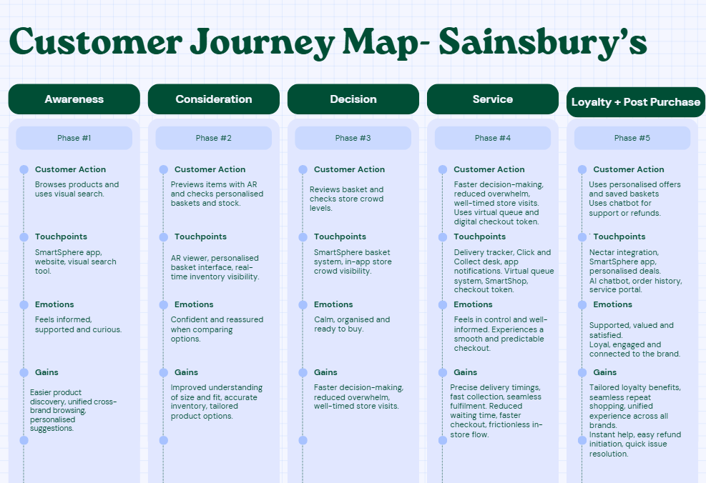

Overview
- The customer opens the SmartSphere app or website to explore products from Sainsbury’s, Argos and Habitat.
- They use visual search to find items by uploading or taking a photo, or they browse through the unified catalogue.
- Using AR tools, they preview Habitat furniture, décor, electronics or clothing in their own environment to assess fit and style.
- The customer reviews a personalised or automated shopping basket created based on their preferences and weekly needs.
- They check real-time inventory updates and store rush indicators to decide when and where to shop.
- Before visiting, the customer reserves a virtual queue token for checkout or Click and Collect.
- In-store, they use SmartShop or digital checkout options to complete their purchase efficiently.
- For delivery or pickup orders, they track real-time updates and use digital tokens to collect items quickly.
- After purchasing, the customer uses AI chatbots to handle any refunds, exchanges or support queries.
- The journey continues with personalised Nectar offers and saved baskets for future shopping, creating a seamless repeat experience.

Impact of the Sainsbury’s SmartSphere

Impact of Sainsbury’s SmartSphere on Customers
- Provides a unified shopping experience across Sainsbury’s, Argos and Habitat within one integrated platform.
- Makes product discovery easier through visual search, helping customers find items faster without knowing exact names.
- Enhances product confidence with AR previews for furniture, décor, electronics and clothing.
- Simplifies grocery planning with AI-personalised and automated shopping baskets.
- Reduces in-store waiting times through virtual queuing and digital tokens for checkout and Click and Collect.
- Offers real-time inventory visibility, helping customers avoid out-of-stock issues and unnecessary store visits.
- Delivers accurate delivery updates and reliable tracking for online orders.
- Provides instant support through AI chatbots for returns, refunds and product queries.
- Strengthens loyalty through personalised Nectar offers and seamless repeat shopping.

Impact of Sainsbury’s SmartSphere on Operations
- Improves in-store traffic flow through virtual queuing, reducing congestion at checkouts and collection desks.
- Enhances operational efficiency by integrating real-time inventory tracking across Sainsbury’s, Argos and Habitat.
- Reduces stock discrepancies and enhances replenishment accuracy using advanced data and potential blockchain tools.
- Streamlines customer service operations by offloading routine support tasks to AI chatbots.
- Strengthens personalization, loyalty initiatives, delivery and fulfilment accuracy through AI.
- Supports better demand forecasting with AI-driven insights, leading to smarter stock allocation and reduced waste.
- Lowers operational pressure on staff through more automated processes and reduced manual interventions.
- Creates a more connected and data-driven retail ecosystem, improving decision-making across departments.
- Enhances overall service quality while reducing operational costs and inefficiencies.

Setup Blueprint
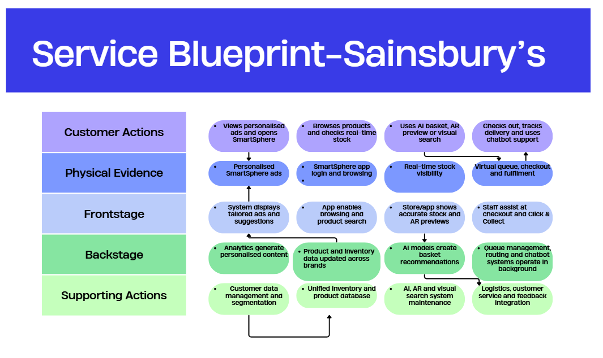

Measurement of the Impact and success of Sainsbury’s Smartsphere
The impact and overall success of Sainsbury’s SmartSphere can be evaluated through a combination of customer-centric and operational performance measures. Key customer experience indicators include changes in Net Promoter Score and results from structured customer surveys. By comparing feedback collected before and after SmartSphere’s implementation, Sainsbury’s can assess how the redesigned journey has influenced satisfaction, usability and perceived value across Sainsbury’s, Argos and Habitat (Omol, 2024). Increases in app engagement, higher usage of features such as visual search, AR previews, personalised baskets and virtual queues will provide additional insight into customer adoption and behavioural shifts.
From an operational standpoint, SmartSphere’s effectiveness can be measured by monitoring reductions in inventory discrepancies and improvements in stock accuracy. A significant drop in mismatch rates after adopting real-time inventory systems would indicate enhanced operational efficiency and stronger cross-brand coordination (Singh and Söderlund, 2020). Other measurable indicators include improvements in delivery accuracy, shorter in-store queue times, reduced customer service workload due to AI chatbots and more accurate demand forecasting.
Business performance metrics such as sales growth, increased basket sizes and higher cross-channel transactions can further demonstrate the commercial impact of the initiative. If sales performance improves following SmartSphere implementation, it would signal a positive contribution to revenue growth and customer retention (Loonam et al., 2018). Finally, the adoption rate of newly introduced mobile app features, particularly AR visualisation and personalised shopping automation, can be tracked through AI-driven analytics to determine how widely customers are engaging with the enhanced digital ecosystem. High adoption and positive customer feedback would confirm that SmartSphere has successfully elevated both service delivery and the overall retail experience.

Role of Leadership and Management in Delivering Sainsbury’s SmartSphere
For Sainsbury’s, strong leadership and effective management are fundamental to driving the successful implementation of the SmartSphere digital innovation initiative. Senior leadership is responsible for establishing a clear strategic direction that positions SmartSphere at the centre of the organisation’s digital transformation efforts. According to Abdulwase et al. (2020), the strategic vision of business organisations directly influences their corporate initiatives, meaning Sainsbury’s leadership must articulate how SmartSphere aligns with the company’s long-term goals, improves customer experience and strengthens its competitive standing. By championing innovation and communicating this vision across the business, leaders create clarity, purpose and organisational commitment to digital change.
Management plays a critical role in translating this strategic vision into practical execution across Sainsbury’s, Argos and Habitat operations. This involves coordinating collaboration between IT, store operations, supply chain teams and customer service units to ensure SmartSphere’s features such as virtual queuing, AR visualisation, AI-powered baskets and real-time inventory systems are implemented smoothly. Managers must oversee training programmes, redesign workflows where necessary and ensure staff are equipped to use new digital tools confidently. They also need to monitor performance indicators, identify operational challenges early and make iterative improvements to support continuous refinement of the system.

Conclusion
The analysis demonstrates that Sainsbury’s SmartSphere represents a transformative step in modernising the organisation’s digital capabilities and delivering a unified retail experience across Sainsbury’s, Argos and Habitat. By integrating advanced technologies such as AI-driven personalisation, AR-based product visualisation, real-time inventory systems and virtual queuing, SmartSphere effectively enhances every stage of the customer journey while streamlining operational efficiency. The initiative not only supports frictionless shopping and improved service delivery but also strengthens organisational performance through better forecasting, reduced stock discrepancies and optimised resource use.
The implementation of SmartSphere is further reinforced by strong leadership and effective management, whose strategic direction and coordination ensure smooth adoption and alignment with Sainsbury’s long-term digital strategy. As the retail environment continues to evolve, SmartSphere positions Sainsbury’s to remain competitive by responding proactively to shifting consumer expectations and technological advancements. Overall, the initiative demonstrates the organisation’s commitment to delivering enhanced value for customers while building a resilient, data-driven and future-ready retail ecosystem.

References
- Abdulwase, R., Ahmed, F., Nasr, F., Abdulwase, A., Alyousofi, A. and Yan, S. (2020) ‘The role of business strategy to create a competitive advantage in the organization’, Open Access Journal of Science, 4(4), pp.135–138. [online] Available at: https://www.researchgate.net/profile/FaroqAhmed/publication/344944641_The_role_of_business_strategy_to_create_a_competitive_advantage_in_the_organization/links/5f9a2af5299bf1b53e4edc60/The-role-of-business-strategy-to-create-a-competitive-advantage-in-the-organization.pdf [Accessed 13 Nov. 2025].
- Argos (2024) Argos. [online] Available at: https://www.about.sainsburys.co.uk/our-strategy/our-brands/argos [Accessed 15 Nov. 2025].
- Bedford, E. (2025) ‘Topic: Sainsbury group in the United Kingdom (UK)’, Statista. [online] Available at: https://www.statista.com/topics/8773/sainsbury-group-in-the-united-kingdom-uk/ [Accessed 13 Nov. 2025].
- Bist, A.S., Agarwal, V., Aini, Q. and Khofifah, N. (2022) ‘Managing digital transformation in marketing: Fusion of traditional marketing and digital marketing’, International Transactions on Artificial Intelligence, 1(1), pp.18–27. Available at: https://journal.pandawan.id/italic/article/download/86/167
- Chaveesuk, S., Khalid, B. and Chaiyasoonthorn, W. (2021) ‘Digital payment system innovations: A marketing perspective on intention and actual use in the retail sector’, Innovative Marketing, 17(3), pp.109–121. Available at: https://www.researchgate.net/publication/354281826_Digital_payment_system_innovations_A_marketing_perspective_on_intention_and_actual_use_in_the_retail_sector
- Coppola, D. (2023) ‘E-commerce share of retail sales revenue in the United Kingdom (UK) from 2020 to 2025’, Statista. [online] Available at: https://www.statista.com/statistics/285978/e-commerce-share-of-retail-sales-in-the-united-kingdom-uk/ [Accessed 15 Nov. 2025].
- Davenport, T.H. and Mittal, N. (2023) All-in on AI: How smart companies win big with artificial intelligence. Harvard Business Press.
- Gouveia, F.D. and São Mamede, H. (2022) ‘Digital transformation for SMEs in the retail industry’, Procedia Computer Science, 204, pp.671–681. Available at: https://www.sciencedirect.com/science/article/pii/S1877050922008195
- Gu, S., Ślusarczyk, B., Hajizada, S., Kovalyova, I. and Sakhbieva, A. (2021) ‘Impact of the COVID-19 pandemic on online consumer purchasing behavior’, Journal of Theoretical and Applied Electronic Commerce Research, 16(6), pp.2263–2281.
- Gupta, A. (2018) How communications by AI-enabled assistants influence customer adoption. Journal of Business Research, 33(4/5), pp.705–720.
- Khairawati, S. (2020) ‘Effect of customer loyalty program on customer satisfaction and its impact on customer loyalty’, International Journal of Research in Business and Social Science, 9(1), pp.15–23. Available at: https://ssbfnet.com/ojs/index.php/ijrbs/article/view/603
- Kim, E., Kim, M. and Kyung, Y. (2022) ‘A case study of digital transformation: focusing on the financial sector in South Korea and overseas’, Asia Pacific Journal of Information Systems, 32(3), pp.537–563. Available at: https://sspace.snu.ac.kr/bitstream/10371/187032/1/12.%20A%20Case%20Study%20of%20Digital%20Transformation.pdf
- Loonam, J., Eaves, S., Kumar, V. and Parry, G. (2018) ‘Towards digital transformation: Lessons learned from traditional organizations’, Strategic Change, 27(2), pp.101–109.
- Nagji, B. and Tuff, G. (2012) ‘Managing your innovation portfolio’, Harvard Business Review. Available at: https://hbr.org/2012/05/managing-your-innovation-portfolio
- Omol, E.J. (2024) ‘Organizational digital transformation: from evolution to future trends’, Digital Transformation and Society, 3(3), pp.240–256.
- Oosthuizen, K., Botha, E., Robertson, J. and Montecchi, M. (2021) ‘Artificial intelligence in retail: The AI-enabled value chain’, Australasian Marketing Journal, 29(3), pp.264–273. Available at: https://scholar.sun.ac.za/bitstream/handle/10019.1/124902/oosthuizen_artificial_2022.pdf
- Reinartz, W., Wiegand, N. and Imschloss, M. (2019) ‘The impact of digital transformation on the retailing value chain’, International Journal of Research in Marketing, 36(3), pp.350–366.
- Sainsbury’s (2021) Timeline. [online] Available at: https://www.sainsburyarchive.org.uk/timeline/over-150/filter/innovations
- Sainsbury’s (2024) Our brands. [online] Available at: https://corporate.sainsburys.co.uk/about-us/our-brands/ [Accessed 15 Nov. 2025].
- Sainsbury’s (2025) ‘Sainsbury’s introduces contactless, checkout-free shopping with SmartShop Pick & Go’. [online] Available at: https://corporate.sainsburys.co.uk/news/press-releases/sainsbury-s-introduces-contactless-checkout-free-shopping-with-smartshop-pick-go/ [Accessed 15 Nov. 2025].
- Singh, R. and Söderlund, M. (2020) ‘Extending the experience construct: an examination of online grocery shopping’, European Journal of Marketing, 54(10), pp.2419–2446.

