BMSK4001
Academic and Employability Skills

Name of the Student:
Syed Hossein
Student ID
1705778
Lecturer
Peter Allen
Name University
University of Wales Trinity Saint David
Course
Certificate of Higher Education in Skills for the Workplace
Semester: October 2017
Submission: Jan 2018

Table of Contents
Introduction 3
Discussion on employability skills 3
Evaluation of own effectiveness against defined objectives 6
Recommendations for improvement 8
Motivational techniques to improve quality of performance 9
Conclusion 11
Reference 12

Introduction
In last few decades employment procedure has changed to a great deal. In the modern era of globalization, employers value human skills more than any other technical or labour skills. The competition among Job seeking candidates has increased to massive level due to unemployment problem Again, every employer has his customized job requirements which almost always differs from others (Griffin and Annulis, 2013). Therefore, a fresh graduate needs to understand & prepare himself/herself for the highly competitive workplaces. This report sheds light on some of the skills that a fresh graduate might need to start his/her career. An analysis from the employee point of view & certain aspects to improve these skills are also analyzed briefly. Finally, some methods for motivating employees these skills are also provided.

Discussion on employability skills
Employment in today's UK is quite challenging. Luckily for fresh graduates, there is an attractive chance for getting job offers from the respected organization. A fresh graduate should have some skills that an employer requires for hiring graduates. A brief discussion of these skills is given below:
The specific set of skills required for landing and maintains a job is known as Employability skill. In any organization, Employability Skills helps senior managers strategically achieve their goals with available human resources. In the modern era, managers are more interested in recruiting fresh graduates from famous college & universities. But unfortunately, even if these scholars excel in academic skill, they lack a substantial amount of employability skills (Qaa.ac.uk, 2017).Despite the importance, Employability Skills have no specific elements. Every firm, company or organization has their own requirements for hiring fresh graduates. These basic skills are, Teamwork Skill, Communication skill, Planning & Organizational Skill, Problem Solving skill, Lifelong learning skill, Technological Skill, Initiative & Enterprise skill, Self-management skill etc.
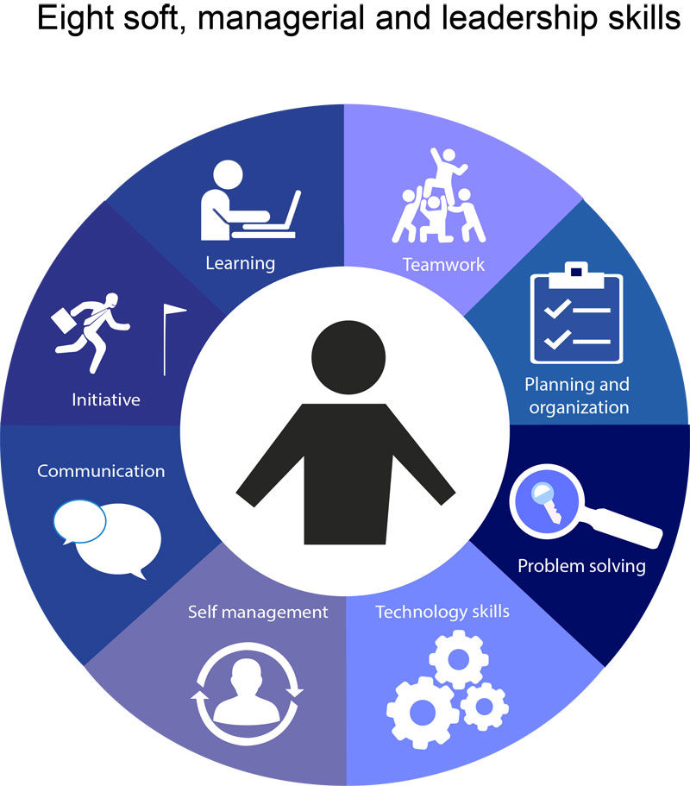
Figure 1: Employability Skills
Source: (Abeleand Suess, 2015)
Communication Skill: Having a good communication skill benefits manager, organization & employee in various aspects. An effective communication skill helps to maintain a friendly relationship with colleagues & superiors. It promotes work environment which helps an employee to become more productive. For example, an employee will have to deal with deferent representatives of different companies. An effective communication system conveys the organization strength to these delegates. A survey of over 1,400 UK employees on CIPD quarterly Labor Market Outlook found that about 40% employers rank look for this skill in employees. Next in rank are work ethic (39%) & Personality (32%) (Powell, 2013). Employers look for this skill among candidates because it promotes overall productivity & customer satisfaction of an organization. Teamwork Skill: Working in a group is one of the most common challenges a fresh graduate faces in a new organization. This skill uplifts a group's motivation, inspires them & gets work done effectively. For example, A recent research on Team Leadership & Productivity has found that top organizations have employee (Sunil Pichai) with the highest percentage of (Google, 96%) teamwork skill (Walker and Fongwa, 2017).
Problem Solving Skill: Business often faces a range of disputes, from where conflict arises. An employee is expected to face such problems. Thus, Negotiation, conflict management & Problem-Solving skills are must-have requirements for fresh graduates. For example, manufacturing organization often faces strike from labours, unions & worker parties. A graduate employee of HR management will have to handle these problems by consultation with them. The graduate will need effective problem-solving skill to come to an understanding.
Self-Management Skill: Along with teamwork skill, an employee should also be able to understand & conduct a work alone. So, the superior will not have to be boss around to pinpoint what to do & what not. Planning & Organizational Skill: This skill is essential for recruitment in managerial level. An employer expects that an employee will be able to see the big picture of strategic goals. For example, manufacturing organization often faces strike from labours, unions & worker parties. The graduate will need effective problem-solving skill to come to an understanding. Fresh graduates often provide brand new innovative ideas. They should be able to plan according to limited resources based on organizational strategy. Technological Skill: Updated technology is one of the most crucial parts of globalization (Pitan, 2016). Along with academic skill, employers require a fresh graduate to be technologically educated & efficient. For example, employees in real life handle various technologies. To land a job a graduate should know Usage of the information system, telecommunications trends, computers &most recent technological breakthrough.
Initiative & Enterprise Skill: An employer expects that employee will be able to adapt to this new situation without freaking out simply to have enterprise skill. For example, Organization sometimes shift employee to a whole new environment for learning or out of necessity. To adapt to this a fresh graduate will have to be patient, open & have Enterprise skill. Life Long Learning Skill: A fresh graduate may be academically highly efficient, but in the job sector, he/she is a novice. For example, in real life job environment is highly competitive. To survive & flourish in job sector a graduate must have the thirst for learning. This can be through training, taking a course or simply from observing. This skill is known as Life Long Learning Skill.

Evaluation of own effectiveness against defined objectives
As a retail manager of Benson for Bed Hounslow branch, I have some competitive personal skills that are badly needed for playing the role. Focus and attention, negotiation, time management, and communication skills are the main skills for that I get competitive advantage especially as a retail manager.

Figure: Own employability skills.
Focus and attention is important for achieving goals. By focusing on the goals of a retail store, so many useful ways comes to mind which can make a better result. I have assessed this core competency by observing others and following them by practicing. On the basis of a research conducted to test the hypothesis that observers' causal attributions are a role of their focus of attention, focus and attention skill helps to achieve an objective easily (Maund, Schriek, and Tinkler, 2017). I have skill of negotiation that is another important skill of a retail manager. This is the process of reaching an agreement with some other party or parties. As a manager I need to negotiate with my team members, employers, coordinators, and mostly with the subordinates for attaining the best result. It builds respect over others and increases productivity by improving the bottom line. Time management is another employability skill that I have. We can get greater productivity and efficiency by the proper management of time. I have develop this skill by maintaining some rules like delegating less important tasks, making proper list and plans of the tasks, prioritize the tasks on the basis of importance etc. This skill will also help me in the responsibility of an area manager. And the most important skill that a retail manager should have is communication that I have. A retail manager has to communicate with so many parties for the working purpose. He or she needs to manage the workers, the suppliers, employers and others to accomplish the goals. I have to communicate with the people by written and verbal communication ways. Written communication ensures more clarity whereas verbal communication provides the facility of longer conversation (Morgan, 2016).
These skills are also needed for becoming an area manager. Along with developing some skills an area manager needs to have some unique quality to offer. It is important to identify & develop these unique talents. Self-evaluation is a method for preparing thyself for job recruitment. Besides, a fresh graduate should also understand employer's perspective for hiring.
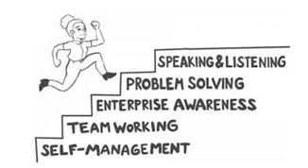
Figure 2: Develop Employability Skills
Source: (Powell, 2013)
To become an area manager, there are similar opportunity & weakness at the same time. Landing a high-quality job can be easy or hard based on the set of skill & willingness. There is the following content the SWOT analysis is given:

Figure 3: SWOT analysis
Source: (Morris, 2015)
Details about the SWOT analysis are given in this portion of that script. Some of the Strengths that a fresh graduate can rely on are Self-management skill, Lifelong learning Skill, Innovator Skill & Technological Skill (Pym, 2013).Now a day's these skills are part of academic learning and with academic course completion, a graduate gets skilled on these levels. According to employer's perspective, an employer must have to hire a graduate with high basic skill sets. Recruiting the right graduate is a prime concern for the employer. Weakness: The most concerning factors for fresh graduates are that they don’t have any prior experience of full-time corporate jobs. Another weakness is the fresh graduates may lack interpersonal skills for corporate level communication. In this case, the employer must handle the situation by taking consider the fact that they are a new incorporate field and they can be shaped very easily with their skill. However, an employer also considers the cost of training up a fresh graduate.
Opportunity: The most attractive opportunity for fresh graduates is the opportunity of learning. A new job provides a new environment, set of skills & new communication system. A trained up fresh graduate can bring new ideas to a company that may result in breakthrough evolution. However, in the modern era, a graduate is almost always in touch up to dated technology. An employer must take into account the opportunities he has in time of recruiting staffs. It would help the employer to gain company objective with the new staffs. Threat: The competition in UK job market is the most concerning threat for a fresh business graduate. The lower unemployment rate is giving this a new level. As an employer, the negative sides of the employees must have to calculate in time of recruiting. To train up graduate's employer needs a better understanding & knowledge of company policy, law & regulations. So that in any situation employer can guide & motivate graduates.
A self-evaluation of effectiveness in employment competency helps to get properly ready for the future job market. In order to attain the perfect job, a graduate needs to work on his weakness & opportunity to make it their base for employment. Also, a clear understanding of what employer wants helps in preparation for long-term employment.

Recommendations for improvement
Surviving & maintaining a respective job in corporate world requires some techniques along with knowledge. In some cases, having all necessary skill is not enough. In cases like this one needs to develop theirs by adopting various measures. Some recommendations are given below:

Figure 4: Recommendations for improvement
Source: (Walker and Fongwa, 2017)
Adaptability: A workplace is a place with people from different walks of life. Everyone has different views besides the different way of getting things done. Therefore, working with new employee removes the lacking of interpersonal skills. The organization should also monitor, motivate & show employees’ ways so that they can easily adapt to the new work environment. These way new fresh graduates can provide quality services to users (Griffin and Annulis, 2013). Personal Growth: Increasing personal strengths & constant growth through lifelong learning helps to increase experience for the future work environment. Every organization's main goal is to successfully achieve business goals along with substantial profit. For this, Employers need to promote & motivate each employee's ability. Also, the chance for personal growth fulfils graduates’ self-actualization needs.
Monitoring & Feedback: It is important to keep track of personal progress &employers’ operation. Proper monitoring makes way for transparent information flow & increase productivity. This increases the productivity & experience of a graduate employee. However, Self-evaluation &appraisal is also necessary to increase personal productivity. Employers should provide feedback based on the evaluation after monitoring. Positive feedback increases employee's concentration on work, where constructive negative feedback mends the mistakes in activities (Foerster-Pastor Foerster-Metz and Golowko, 2017). Involvement of other workers: Managers need to create a variation in different departments of office through diversification. Job redistribution, Job rotation can open new doors of learning for fresh graduates.
Every organization, every employer has their personal way & preference for recruiting, hiring & training up employees. For specific industries the scope of development is different. These recommendations vary based on the operational activity of each firm.

Motivational techniques to improve quality of performance
An academically scholar & highly skilled fresh graduate cannot give his best if the work environment is not favourable. After the hiring of fresh graduates, it is employee's duty to motivate them, so that they can become the human asset for attaining company goals & objectives. Some of the motivational technique that employee may use are given below:

Figure 5: Motivational techniques for Employees
Source: (Tibbetts, 2016)
Financial Motivator: One of the most common techniques used by manager around the world. For example, a manager or employer can provide the financial incentive for achieving some extra pieces of work. This can be provided in terms of medical reimbursement, Bonus, increased wages, salaries etc. This age-old method works because money is the first priority to engage in excels in work for many employees. Recognition: In the modern Human Resource Management it is proven that with mercerization of official activities peoples demand money is decreasing in value. Rather today's employee respect self-actualization needs money. Recognition of actual work, therefore, can be used as motivation techniques. For Example, the employee can praise or recognize graduate employees good work in front of others. This provides a win-win situation for both employer & employee. The cost of recognizing employee's good work is to minimize where the motivation is sky high.
Participation: A recent survey on Organizational Behavior has shown that an employee feels more committed toward his job when he is given the power of decision making and act upon them. For example, Top management can involve subordinates in a discussion for company well-being. The participation in organizational decision making will motivate them more toward better official performance. Status: Social Status is a self-actualization need they human crave when other prime demands are fulfilled. However, in an organization status is measured by the ranking of positions. For example, an employee can be motivated through promotion in higher ranking. Employees would want to do a better performance for promotion. In this way, the overall quality of performance will increase. Competition: It is human nature to perform better when there is competition involved (Bloom and Kitagawa, 2016).In Organizational Behavior, it is seen that, if managers can create a competitive environment then productivity goes up to 20%. For Example, managers can create a competitive environment through introducing new challenge &reward system. This motivational tool works especially in the industries where teamwork is mandatory for operational activities.
Monetary incentives like Salary, Bonus can improve performance but unfortunately, the motivation or effect of motivation wears off quickly. Again, the cost of this is higher for the organization compared to other techniques. On the contrary non-monetary incentives like Participation, status, competition is lower cost but the effect of this motivational technique can have long-term effects on employees. The view & demand success is changing. Therefore, motivational techniques are also being wide ranged based on employee demand for success.

Conclusion
To become an area manager from a retail manager, an employee must develop some additional personal skills and enhance the capabilities that the employee had before. Learning workplace ethics, observation & self-assessment goes a long way. The actual experience differs far more than academic knowledge. For the improvement in the personal skills, the internal and external strengths and weaknesses should be analyzed. An action plan to improve qualities based on official requirements should also be looked after. But to make the most out of a graduate employee, an employer also needs to make some adjustments. Keeping employees motivated & engaged is the real challenge here. They should use various methods to overcome this challenge.

Reference
Abele, M. and Suess, J. (2015). Studying the HRM System: The Impact of Employment Models on HRM Policies and Practices. Academy of Management Proceedings, 2015(1), pp.17835-17835.
Bloom, M. and Kitagawa, K. (2016). Understanding employability skills. Ottawa, Ont.: Conference Board of Canada.
Foerster-Pastor Foerster-Metz, U., and Golowko, N. (2017). Employability skills for the Romanian outsourcing industry. Proceedings of the International Conference on Business Excellence, 11(1).
Griffin, M. and Annulis, H. (2013). Employability skills in practice: the case of manufacturing education in Mississippi. International Journal of Training and Development, 17(3), pp.221-232.
Maund, A. Schriek, M. and Tinkler, P. (2017). Certificate in Higher Education: Skills for the Workplace Student Yearbook. Sage Publications.
Morgan, P. (2016). The Business Student’s Guide to Study and Employability. Sage Publications.
Morris, D. (2015). Will Skill Mismatches Persist? An Investigation into the Effect of Skill Shortages on Wages in the UK. SSRN Electronic Journal.
Pitan, O. (2016). Employability development opportunities (EDOs) as measures of students’ enhanced employability. Higher Education, Skills and Work-Based Learning, 6(3), pp.288-304.
Powell, J. (2013). Contemporary issues in modern society. Hauppauge, New York: Nova Science Publishers, Inc.
Pym, B. (2013). An academic question. Bath: Paragon.
Qaa.ac.uk. (2017). Skills for Employability. [online] Available at: http://www.qaa.ac.uk/assuring-standards-and-quality/skills-for-employability [Accessed 6 Nov. 2017].
The University of Edinburgh. (2017). What is employability and why is it important?. [online] Available at: https://www.ed.ac.uk/employability/staff-information/what-why-employability-important [Accessed 6 Nov. 2017].
Tibbetts, J. (2016). 'Extension' beyond traditional academic jobs. Science.
Times Higher Education (THE). (2017). Graduate employability: top universities in the UK ranked by employers. [online] Available at: https://www.timeshighereducation.com/student/best-universities/graduate-employability-top-universities-uk-ranked-employers [Accessed 6 Nov. 2017].
Walker, M. and Fongwa, S. (2017). Universities, Employability, and Human Development. London: Palgrave Macmillan UK.

