Problem Solving and Decision Making
Name: Fligenia Silva ID: 2122643
Module Cod: BMSW4004
Lecturer: Balendran Kandasamy

Contents;
Introduction............................................................... 1
The workplace Problem..........................................................2
Analysing Information.......................................................3
Range of Alternative Solutions........................................................4
Evaluation of Alternative Solutions..........................................5
Implementing the Solution...............................................6
Communication plan with stakeholders........................................7
Monitoring and Review Techniques..............................................8
Conclusion....................................................................9
References..............................................10

Introduction
Employers see problem solving skills as something good since it shows them that someone has a good range of competencies such as creativity, logic, imagination, resilience, determination and lateral thinking.
Tesco Plc. is one of the largest supermarket chains based in the United Kingdom. The supermarket was founded in the year 1919 by Jack Cohen. The current paper addresses the importance of skills of problems solving. The current problem being addressed is under the company of Tesco Extra where there is a lot of employee dissatisfaction regards many issues such as lack of training and a better work environment, etc.

The workplace Problem
Workplace problem has been regarded as one of the biggest factor responsible for deteriorating operational performance and productivity. Employee dissatisfaction can be described as a situation wherein the expectation and demands of employees are not met in the workplace. Tesco in the UK has also been experiencing a similar workbased problem of employee dissatisfaction due to the high level of workload and long working hours to meet the rising demands of customers during and after post Covid-19 pandemic. The actual and potential impact of lack of motivation leading to employee dissatisfaction can be experienced in the inability of Tesco to meet customer demands the issue of employee dissatisfaction could make Tesco experience issues related to employee disengagement, low team morale, high employee absenteeism, and lower productivity levels

Analysing Information
To determine the causes of the complex problem of employee dissatisfaction experienced by Tesco Extra, a root cause analysis using fishbone analysis has been done below:

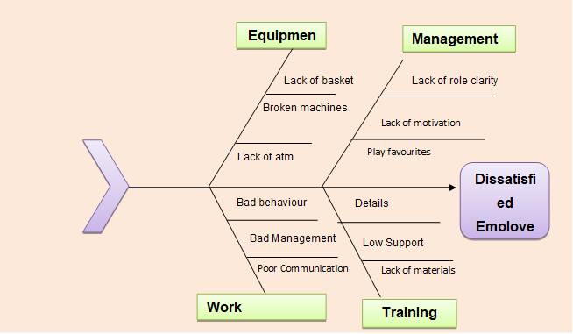
Figure 1: Fishbone Analysis
Source: Self
The employee dissatisfaction at Tesco Extra has been due to a number of possible causes which are categorised under equipment, management, work environment and training. It has been observed from the fishbone diagram under equipment, there has been a lack of baskets, broken machines and lack of atm which disrupted the functioning of the employees at the Tesco Extra shops while under the management category, Tesco Extra employees have been dissatisfied due to the lack of role clarity and motivation due to pay disputes as well as incidences of play favourites. Without a specific role, the employees’ experiences of work overlap and conflict which reduce their satisfaction level.

On the other hand, the work environment at Tesco Extra has also been poor due to bad behaviour and bad management along with poor communication which creates misunderstandings and develops a culture of mistrust for the employer, management Tesco bosses said to be nicer to staff, 2016)Under the training category, there have been no specific training details and materials with poor support from the organisation to carry out the Training activities which in turn has dissatisfied the employees of Tesco Extra. Therefore, the specific root cause of the complex problem is mainly due to the lack of motivation that has been linked with poor pay or salary and poor communication between the employer and employees (Butler, Thousands of salaried Tesco workers forced to take real-terms pay cut, 2022).

Situational Analysis
To further conduct an analysis of the complex problem of employee dissatisfaction at Tesco Extra, an environmental analysis using the PESTLE model has been conducted. As per political factor, the UK government has set national minimum wage and national living wage rates policies for the employees so that they are paid equal weekly or monthly installments (Aitken, Dolton, & Riley, 2019) . Tesco Extra has been underpaying its workers and failed to provide the minimum wage as per the UK government policy. In the case of the economic factor, the employment rate in the UK has been increasing to 75.6% in September 2022 (Tradingeconomics, 2022) . This will impact Tesco Extra by hiring more employees but also need to improve its management and facilities to keep the employees satisfied.

  - Tesco has been influenced by the trend and is offering a wide variety of products at a single store. Technological factor has influenced the UK retail sector with technological advancements such as self-service checkout points and the use of artificial intelligence (Sharma, Ueno, & Kingshott, 2021) However, with a lack of training, the employees at Tesco Extra have been dissatisfied as they are unable to operate and function the technologies efficiently.

Range of Alternative Solutions
The decision-making process can be regarded as an important step towards the identification of a wide range of solutions to mitigate the workbased problem of lack of motivation leading to employee dissatisfaction in Tesco. The decision-making process is segmented into seven stages such as Identifying decisions wherein the impact of lack of motivation leads to poor team morale and absenteeism is measured on Tesco. Gathering relevant information in the next stage wherein an employee survey would be performed followed by the identification of alternative solutions through brainstorming and mind-mapping. Evidence weighing of solutions are done by
evaluating its strength and weakness on Tesco and based on that alternative solutions are selected (de Andreis, 2020). Finally, actions and review processes are done by selecting the relevant solution to improve employee motivation and satisfaction at Tesco.

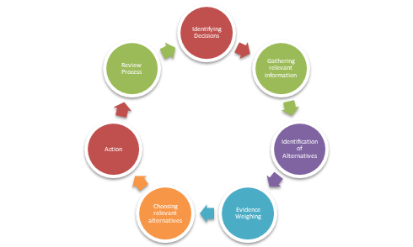Figure 2: Decision-Making Process
Source: Self
Thus, based on the above decision-making process, three alternative solutions have been developed to assist Tesco to improve motivation level and satisfaction to enhance operational performance and productivity. One such alternative solution for lack of motivation is giving individual attention to the needs and expectations of Tesco staffs. The management should look to divide the team into small groups with one to two leaders with the motive to provide more attention to performance and demands of employees to make them feel valued and important to increase their motivation and satisfaction level to work efficiently. The second alternative solution for Tesco is a salary increase and benefits. This solution would allow help in
boosting motivation and morale among employees to work long hours to earn more than others in the workplace. Thus, upon improving motivation, Tesco would be able to improve the satisfaction level of employees.

Evaluation of Alternative Solutions
The tool decision matrix would be applied to evaluate the best possible alternative solution which could prove to be effective for Tesco to improve the satisfaction level of staffs. Scores would be offered between (1-10) for every alternative solution based on flexibility, viability, cost, and speed.

 | Flexibility | Viability | Cost | Speed | Total Score
Weighted Score | 1 | 2 | 2 | 2
Give Individual Attention | 3 | 4 | 3 | 1 | 19
Salary Increase and Benefits | 4 | 6 | 5 | 8 | 42
Communication/Listening to Employee | 5 | 3 | 6 | 3 | 29

Figure 3: Decision-Matrix Tool
Source: Self
Thus, based on the outcome of the decision matrix, employee dissatisfaction. The solution scored 42 as compared to other solutions.

Implementing the Solution
Salaries with perks can be increased if Tesco Extra can cut down on its production cost and improve its operational efficiencies. The company can improve its consumer retention rates by using loyalty programs which shall be reaching out to the consumers reaching milestones (Tesco.com, 2022) . This is supposed to be one of the ways of cost-saving without the added hassle of having to attract new consumers therefore this cuts added consumer’s acquisition cost. Tesco Extra just has to track their returning rate of consumers which is around 31% in the 1st quarter of 2022, about 39% in the second quarter of 2022 and about 61% in the 3rd quarter (Tesco.com, 2022) .
The following implementation plan can be used for making sure salaries and perks are increased:

People | Actions | Critical | Deadline
Strategic Management and Financial Team | Approving a planning committee for discussing how the process can be moved forward with | High | By the next 1 month
Strategic Management and Financial Team | Calculation of return rate of consumers | Very High | By the next 1 month
Research and Development, Strategic Management and Financial Team | Running a prototype of the consumer loyalty program | Very High | By the next 2 months
Tesco Extra Management Team | Implementation of the consumer loyalty program | Very High | By the next 3-6 months
Table 1: Implementation Plan
(Source: Self)
The following Gantt Chart can be used to track the implementation of the consumer loyalty program:

Activity | Month 1 | Month 2 | Month 3 | Month 4 | Month 5 | Month 6
Approving a planning committee for discussing how the process can be moved forward with
Calculation of return rate of consumers
Running a prototype of the consumer loyalty program
Implementation of the consumer loyalty program
Table 2: Gantt Chart
(Source: Self)

Communication plan with stakeholders
The common stakeholders in this case are the employees, consumers, the local communities and the suppliers.
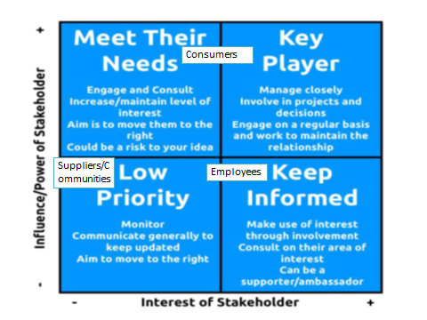
Figure 1: Power and Interest matrix
(Source: Self)

Stakeholder | Power or interest | Issues and key interests | Communication vehicle | Frequency
Employees | Power is low but interest is high since being part of a company with high profits shall look good on their resume | More new employees to train in new processes that may threaten to change the present order of the status quo within the company | In-person or video-call meetings | Bi-monthly
Consumers | High power since they can reject the loyalty program and medium to high interest since loyalty programs mean gifts and discounts | New consumers shall not be able to receive the offers repeat purchasers are getting | Press conferences, advertisements on social media or on television. | 4 times a month or once every week
Suppliers | Low power since the market is filled with many suppliers so quick switching is possible and interest is high since a company with high profits would mean increased orders from them | They have a lower amount of power since the market is filled with many suppliers so quick switching is possible | In-person or video-call meetings | 4 times a month or once every week
Local Communities | Their power is undetermined in this case since the environmental factors in this case are low however due to gifts and discounts their interests shall be high | Not applicable | Not applicable | Not applicable

Table 3: Stakeholder Engagement Plan
(Source: Self)

Monitoring and Review Techniques
Awareness | Fostering the awareness to make changes can be done by letting employees know that if the company is going to widen their bottom line it will be profitable for them as well in the long run such as creation of more positions.
Desire | Change management leaders will have to be designated so that employees are desirous of change.
Knowledge | Knowledge will have to be disseminated regards how the entire process is changing and how the consumer loyalty program can increase the perks and benefits of the employees.
Ability | Change leaders have to be placed in charge of coaching individuals so that the gap between ability and knowledge is bridged.
Reinforcement | Reinforcement can be implemented by appreciating employees for jobs that are well done for example in many companies in an attempt to recognise their employees they place small gifts on their tables which is suggested to be done here as well.

Table 4: ADKAR Gap Model
This process can be reviewed and monitored in the end by the research and development teams so that progress notes can be compared to see if the tactic being chosen is practical or not.

Conclusion
Thus, it can be said that the workbased problem of employee dissatisfaction due to lack of motivation can be managed through the identification of three alternative solutions such as giving individual attention, salary increase and benefits, and communication/listening to the employee. Decision-matrix has been performed which has allowed Tesco to select salary increases and benefits as the best possible solution to reduce employee dissatisfaction among employees.
In conclusion, it can be stated that salaries with perks can be increased if Tesco Extra can cut down on its production cost and improve its operational efficiencies. The company can improve its consumer retention rates by using loyalty programs which shall be reaching out to the consumers and reaching milestones this is supposed to be one of the ways of cost-saving without the added hassle of having to attract new consumers therefore ore this cuts added consumer’s acquisition cost.

References
Aitken, A., Dolton, P., & Riley, R. (2019). The impact of the introduction of the National Living Wage on employment, hours and wages (No. 501). National Institute of Economic and Social Research.
Asaari, M., Desa, N., & Subramaniam, L. (2019). Influence of salary, promotion, and recognition toward work motivation among government trade agency employees. International Journal of Business and Management, 14(4), 48-59.
Bawa, M. A. (2017). EMPLOYEE MOTIVATION AND PRODUCTIVITY: A REVIEW OF LITERATURE AND IMPLICATIONS FOR MANAGEMENT PRACTICE. International Journal of Commerce and Management , 7(12), 662-673.
Butler, S. (2016). Manners maketh management: Tesco bosses told to be nicer to staff. Retrieved January 10, 2023, from https://www.theguardian.com/business/2016/mar/16/tesco-managers-polite-new-initiative
Carucci, R. (2019). Balancing the Company’s Needs and Employee Satisfaction. Retrieved January 10, 2023, from https://hbr.org/2019/11/balancing-the-companys-needs-and-employee-satisfaction
Davey, J. (2021). Britain's Tesco extends net zero pledge. Retrieved January 10, 2023, from https://www.reuters.com/business/sustainable-business/britains-tesco-extends-net-zero-pledge-2021-09-23/
Dwesini, N. (2019). Causes and prevention of high employee turnover within the hospitality industry: A literature review. African Journal of Hospitality, Tourism and Leisure, 8(3), 1-15.

