

DISSERTATION

A Dissertation submitted to University of Wales Trinity Saint David

Course of BA Business Management

THE IMPACT OF THE ONLINE REVIEWS IN THE HOSPITALITY BUSINESSES: A CASE STUDY OF TRAVELODGE

By

Paolina Markova (2113318)

22/04/2024

Module code LCBB6000

With supervisor Riaz Bhatti

Contents
Chapter 1: Introduction 4
Introduction 4
Purpose of the research 5
Aim 5
Objectives 5
Research questions 5
Chapter 2: Literature Review 6
Chapter 3: Research Methods and Methodology 8
3.1 Research Philosophy 8
3.2 Research Paradigm 8
3.3 Research Approach 9
3.4 Research Methodology 9
3.5 Research Strategy 10
3.6 Sampling methods 10
3.7 Data collection methods 10
3.8 Ways of interpreting data 11
3.9 Time prospects of the research 11
3.10 Ethical consideration of the research 12
Chapter 4: Data Analysis 12
4.1 Introduction 12
4.2 Primary Data Analysis 13
4.3 Conclusion 19
4.4 Recommendation 23
References 24

Chapter 1: Introduction

Introduction
Digital transformation, especially online reviews, has greatly altered the hospitality business, which includes hotels, restaurants, and entertainment venues (Iranmanesh et al., 2022). Reviewing this sector's enterprises may greatly impact their image and finances. Customer input on TripAdvisor, Yelp, and Google Reviews may impact prospective customers in an age when consumers increasingly use these platforms to make judgments. Travelodge is a hospitality organisation which operates in the UK at low-budget, this company offers hotel and hospitality support throughout the industry (Travelodge, 2024). This company also seeks for feedback from the customers over tripadvisor, trustpilot and google as it helps the brand in gaining more awareness among the customers. Positive reviews may enhance exposure, bookings, and income, while bad reviews can dissuade consumers and damage a business's image, making it less profitable.
Significance of the topic
Studying internet reviews' influence on hospitality firms is crucial. For companies such as Travelodge to succeed in a competitive market, recognizing these evaluations' influence is vital as customers use them to plan travel and leisure. Businesses know the value of internet reviews but struggle to control them. Unresolved negative reviews may damage reputations and be hard to fix (Zhang et al., 2024). Fake and manipulated reviews have also cast doubt on review quality and authenticity, complicating matters for companies and customers. Online reviews' effects on hospitality company performance and customer choice must be examined due to this complicated web of factors (Kim and Kim, 2022). For this reason it is important for Travelodge to include an online presence so that it can resolve the problem of fake and manipulating reviews given by certain fake customers. This topic is significant for analysing the types of reviews that may affect hospitality business, strategies to gain positive reviews and its impact over the success of the organisation.

Purpose of the research
The goal of this study is to explore how internet reviews affect Travelodge performance and decision-making. The main objective of this research is to analyse the feedback of the customer over digital platforms in order to influence the reputation of the brand, evaluate its performance and influence the decision making. In hospitality organisations like Travelodge, customer satisfaction is the most important factor, accounting review of the customers and improving service can create satisfaction among travelodge customers. Ultimately this research provides evidence regarding the importance of online review over financial success of the travelodge.

Aim
This research investigates how internet reviews affect hospitality organisations' that Travelodge’s operational, strategic, and financial operations and how they might enhance performance and sustainability by managing their online reputation.

Objectives
- Evaluation of how internet reviews of Travelodge’s affect hospitality service selection and perception.
- To assess Travelodge’s financial performance after favourable and negative evaluations.
- To study how Travelodge handles internet reviews.
- Explore how online review management affects Travelodge success and customer pleasure.

Research questions
- How do internet reviews influence Travelodge’s customer choices?
- Why do internet reviews affect Travelodge’s income and booking rates?
- What impact does online review management have on Travelodge’s success and customer satisfaction?

Chapter 2: Literature Review
Wen et al (2020) researched addresses the intricate dynamics of consumer behaviour in the realm of online hotel booking, focusing on the pivotal role of extrinsic cues—namely price, online reviews, and brand familiarity. By delving into the relationships and interaction effects among these cues, the study contributes significantly to the understanding of consumer decision-making processes in this context. It underscores the paramount importance of online reviews as a critical cue, which not only moderates the influence of brand familiarity and price on booking intentions but also shapes consumer perceptions and behaviours. Notably, the findings reveal that positive online reviews amplify the impact of brand familiarity while mitigating price sensitivity, whereas negative reviews diminish the significance of these cues. If Travelodge has positive reviews regarding their hospitality service, it will gain customers even at a higher price. Moreover, the study highlights the independent effect of brand familiarity on booking intentions, underscoring its enduring influence irrespective of price considerations. Through its nuanced exploration of these factors in Travelodge, it illuminates the complexity inherent in consumer decision-making in the online hotel booking landscape, advocating for a holistic approach that considers the multifaceted interplay of various cues for a comprehensive understanding of consumer behaviour.
Travelodge can be considered as the major player in the budget hotel segment. Research indicates that online reviews regarding a hospitality organisation serves as word of mouth for an organisation. Thus, gaining online reviews is important for travelodge as it can gain high awareness among the customers. As mentioned by Kim, Lim and Brymer (2015), managing online reviews is important as they are pivotal in shaping the image of the company in public. For this reason Travelodge tends to gain feedback continuously from the customers over tripadvisor and trustpilot as it helps the brand to take strategic decisions and improve awareness among the customers. Travelodge takes initiative by sending customer emails to post their review post experience, it reflects positive guest testimonials to reflect the importance of their review. By accumulating all these reviews they can attract potential customers from the market and they also improve their service which can lead to more satisfaction of the customers.
Zeng et al. (2019) highlight that Virtual Reality (VR) has risen as a key instrument in the tourism and hospitality industries, primarily for enhancing marketing strategies and engaging consumers. As technology has advanced, VR has been increasingly utilised to simulate experiences, allowing potential travellers to virtually explore hotels and destinations before making booking decisions. The adoption of VR by major hospitality brands like Carlson Rezidor, Hilton, and Airbnb underscores its growing importance. Research indicates that VR can significantly impact consumer behaviour by providing immersive, dynamic sensory information that enhances the perceived usefulness and enjoyment of online reviews, thereby influencing purchase intentions. Despite its benefits, there remains a substantial reliance on traditional online reviews, which primarily provide verbal information, to make travel decisions. Travelodge includes well experienced technical staff and they have included the technology of AR that is augmented reality and VR within the website (Travelodge, 2022). This is the scope of additional support with the online review for attracting potential customers. Due to the implication of such technology, customers are able to observe all the rooms, amenities and 3D view of the location which influences the customers to select options from the brand.
El-Said (2019) describes how his research delves into the significant impact of Online Customer Reviews (OCR) on hotel booking intentions and performance within the hotel industry. He highlights OCR's pivotal role as a modern influencer of consumer behaviour in the tourism and hospitality sectors. Through the study, it was established that while both positive and negative review valances (PRV and NRV) influence booking decisions, NRV significantly affects these decisions and is moderated by factors like Brand Image (BI), Hotel Star Category (HSC), and Price Importance (PI). The research underscores the complexity of booking intentions, which are influenced by a myriad of factors, including consumer perceptions shaped by OCR. These findings demonstrate the necessity for hotel managers to not only be aware of but actively manage the OCR to harness their potential fully. Travelodge takes all types of booking over its online website and it includes online customer reviews which are observed by the customers before making a choice. All types of reviews are added by this organisation without biases, they include transparent communication at the period of booking which results in satisfaction and positive review from the customers.
Kim (2022) investigates the impact of Online Customer Reviews (OCR) on hotel customer satisfaction, utilising big data analytics to extract insights from text mining of online reviews. The research identifies that tourists frequently rely on electronic word of mouth (EWOM) to inform their choices, with findings showing that reviews significantly influence hotel performance and purchase decisions. Due to this reason Travelodge provides the scope of reviewing its service over every possible platform and they continuously improve their service based on such reviews. By analysing online reviews, the study categorised key hotel attributes into four clusters—destination, physical environment, service, and trip purpose—that are critical for customer satisfaction. The findings offer practical insights for hotel management, emphasising the importance of attentive service and suggesting improvements like enhanced dining experiences to maintain customer satisfaction during challenges such as the COVID-19 pandemic. Overall, the study not only enriches academic understanding of OCR's role in the hospitality industry but also provides actionable strategies for improving service quality and competitive positioning in the market.

Chapter 3: Research Methods and Methodology

3.1 Research Philosophy
The benefit of defining research philosophy is that it can help researchers understand and determine the nature of knowledge for a specific research topic and the procedure for obtaining that knowledge. This research will employ positivist research philosophy to meet the objectives of this research. The primary reason behind selecting this research philosophy is that it can help researchers to cover a broad spectrum of areas within a very short time period. According to the statement of Bergmann (2023), it can be discussed that the benefit of using positive research philosophy is that it can help to collect highly reliable information related to a research topic. In this research procedure used by Travelodge in gaining online reviews is accounted for, which requires a wide spectrum of information within a short period of time. For this reason implementation of positivism research philosophy has been selected in the research.

3.2 Research Paradigm
Selection of relevant research paradigms is crucial for investigating the impact of online reviews in the hospitality business. The term research paradigm defines a framework into which the theories and practices related to the topic fit to create the research plan. This study will use the realism research paradigm to accumulate information regarding online reviews for the Travelodge. The implementation of the realism research paradigm is effective in gathering information as it provides flexibility. This paradigm also provides objectivity, precision, and replicability in data collection and analysis. As a result, the implementation of the realism research paradigm can be considered as the most justified selection for this research.

3.3 Research Approach
Defining a research approach is significant as it provides a roadmap to researchers to ensure that their study continues in a systematic and objective manner. The implementation of deductive research approach seems to be beneficial for this research as it involves testing hypotheses associated with the research subject. According to the opinion of Casula et al. (2020), it can be explained that deductive research approach allows researchers to develop the connection between concepts and variables. The justification behind selecting this approach is that it can typically involve formulating hypotheses based on theoretical propositions. In this research there are objectives which include variable Travelodge and the concept of handling internet reviews. This correlation results in achieving the third objective of the research. In this regard, it can be stated that employing deductive research approaches is justified for this research.

3.4 Research Methodology
This research will conduct a survey by collecting numerical data from a sample of respondents. In order to do so, this research has developed questionnaires based on the research topics, aims, and objectives. It is worth mentioning that survey is a commonly used method for accumulating numerical data in quantitative research. Based on the suggestion of Zimba and Armen (2023), survey research is a unique procedure of assembling information from a large cohort. Advantages of conducting surveys include collecting information from a large population. Therefore, researchers can accumulate a greater statistical power and the ability to gather large amounts of information. The benefit of conducting survey research methodology is that it can help to gather information based on attitudes, opinions, behaviours, and characteristics of individuals or groups. Accounting of large population perspectives regarding online review impact can help in identifying success online review accumulation offer to travelodge, thus due to applications of survey method objective 4 can be effectively achieved. In this regard, it can be stated that conducting a survey is appropriate for this research to collect sample responses related to the impact of online review on the hospitality industry.

3.5 Research Strategy
The adoption of research strategy is also crucial for extracting data from a sample of respondents. This recharge free continues by implementing a primary quantity research strategy to collect first-hand information from respondents who are associated with the hospitality industry. From the perspective of Mohajan (2020), it can be stated that statistical data can be extracted from a large population with primary quantitative research strategy. The justification behind selecting this research strategy is that it can help in predetermining the questions based on the research subject. In this regard, it can be stated that researchers can collect information from customers, employees, and managers who are involved with Travelodge. Their participation helps in analysing the impact of review over Travelodge success which is an important part for the research. Therefore, the selection of primary quantitative research strategy has been used in the research.

3.6 Sampling methods
The primary goal of the sampling method used to extract a small collection or representative of people from a larger population. Simple random sampling techniques have been used in this research to select a relevant sample from the target population in a manner so that each individual has an equal chance of being selected. The justification behind employing this sampling method is that eat ensures that the sample represents the overall population. One of the most social benefits of using a simple random sampling method is that the use of this sampling removes all possibilities of hints of bias. This is important for analysing the impact of review over the service selection process with Travelodge. Thus it can be concluded due to selection of Simple Random sampling, objective 1 is achieved suitably.

3.7 Data collection methods
The Data Collection method is very crucial for continuing and executing any research as researchers need to collect the most authentic and informative data from a broad spectrum of data sources. Researchers have provided a predetermined fate of questions to respondents while conducting structured surveys. Therefore, the utilisation of structured self-administration surveys Data collection method seems to be suitable for this study. The benefit of utilising this method is that it allows respondents to finish the questionnaire independently. The predetermined questionnaire has been provided via Google form and respondents can share their opinion via this form. The set of questionnaires will include a 5-point Likert scale. According to the suggestion of Shardlow et al. (2020), it can be stated that 5-point Likert scale Includes five factors such as strongly disagree, disagree, neutral, agree, and strongly agree. Therefore, it will become easy for respondents to share their response and researchers to collect opinions of the sample. Data collection via survey method is appropriate for accounting specific data regarding a research, for analysing the handling strategies of online reviews in Travelodge specific data is required. For this reason the primary data collection procedure has been selected with the help of a survey method.

3.8 Ways of interpreting data
The interpretation of the collected data will be based on statistical analysis techniques. Researchers will need to interpret numerical data to draw a conclusion related to the impact of online reviews on the hospitality industry. In this research quantitative data has been accumulated and this data has been analysed using quantitative data analysis. Critical discussion includes correlation of primary data with the secondary data which retains the validity and reliability of the data collection and objectives achieving factor.

3.9 Time prospects of the research

Figure 1: Gantt Chart
(Source: Self-developed)

3.10 Ethical consideration of the research
Ethical consideration of a research increases credibility, transparency, and authenticity of any research. In order to do so, this research will ensure the privacy and anonymity of individuals who have posted their responses on online surveys. In addition, the is providing authentic, factual, and transfer the information regarding the impact of online review on the hospitality industry. Another focused area of this research is to eliminate any kind of biassed and manipulated information regarding the research subject. As opined by Beugelsdijk et al. (2020), maintaining transparency in collecting and analysing data in research is very crucial. This research will also mention the surname of authors of journal articles via text citation to eliminate any chance of academic misconduct. Researchers have also provided a consent form to respondents and have respected the attitude, perspective, and opinion of individual respondents. Transparency reporting method and findings is also another focus area for this research to maintain integrity and credibility. “Data protection Act 2018” has been maintained throughout the research in order to avoid data breaching within the research.

Chapter 4: Data Analysis

4.1 Introduction
The Data Analysis chapter provides an understanding of the significance of online reviews for consumers and effectively concentrates on Travelodge as a hospitality industry. This chapter tries to establish how online reviews influence the perceptions of the consumer and how they influence booking behaviours. This study seeks to examine the pattern of consumers’ decision-making when choosing an accommodation through the analysis of responses that were recorded from a public survey. An insight into these dynamics is important so that stakeholders who lay heavy emphasis on online presence, especially in the hospitality business can improve on it and also work on ways to boost the satisfaction of the customers. The chapter expands on consumers’ motives and concerns related to online reviews, thus casting light on the many types of approaches businesses might use to regulate their online presence and appeal to customers in a saturated environment.

4.2 Primary Data Analysis
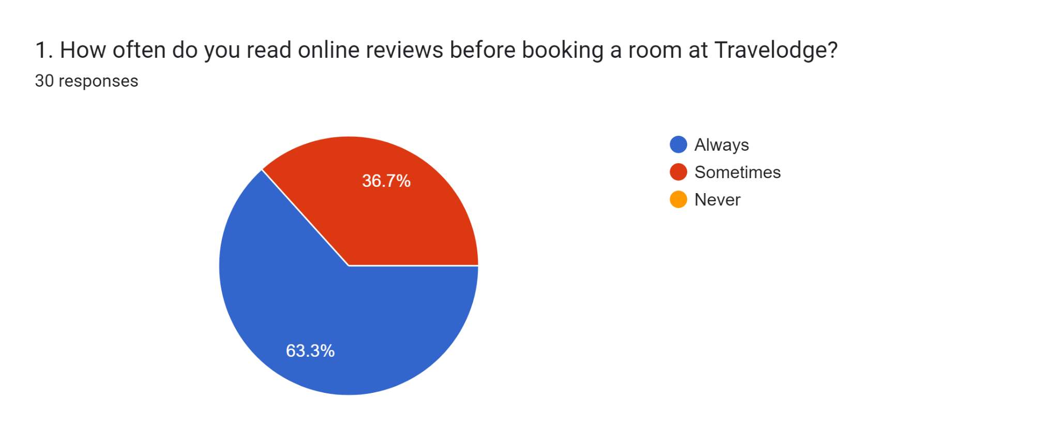
Figure 4.1.: Question 1
(Created by the Student)
As per the respondents, 63.3% always check the reviews before booking a room at Travelodge. Another 36.7% said that they sometimes check it. It underscores that most people are dependent on online reviews to make their decision about a place while booking online.
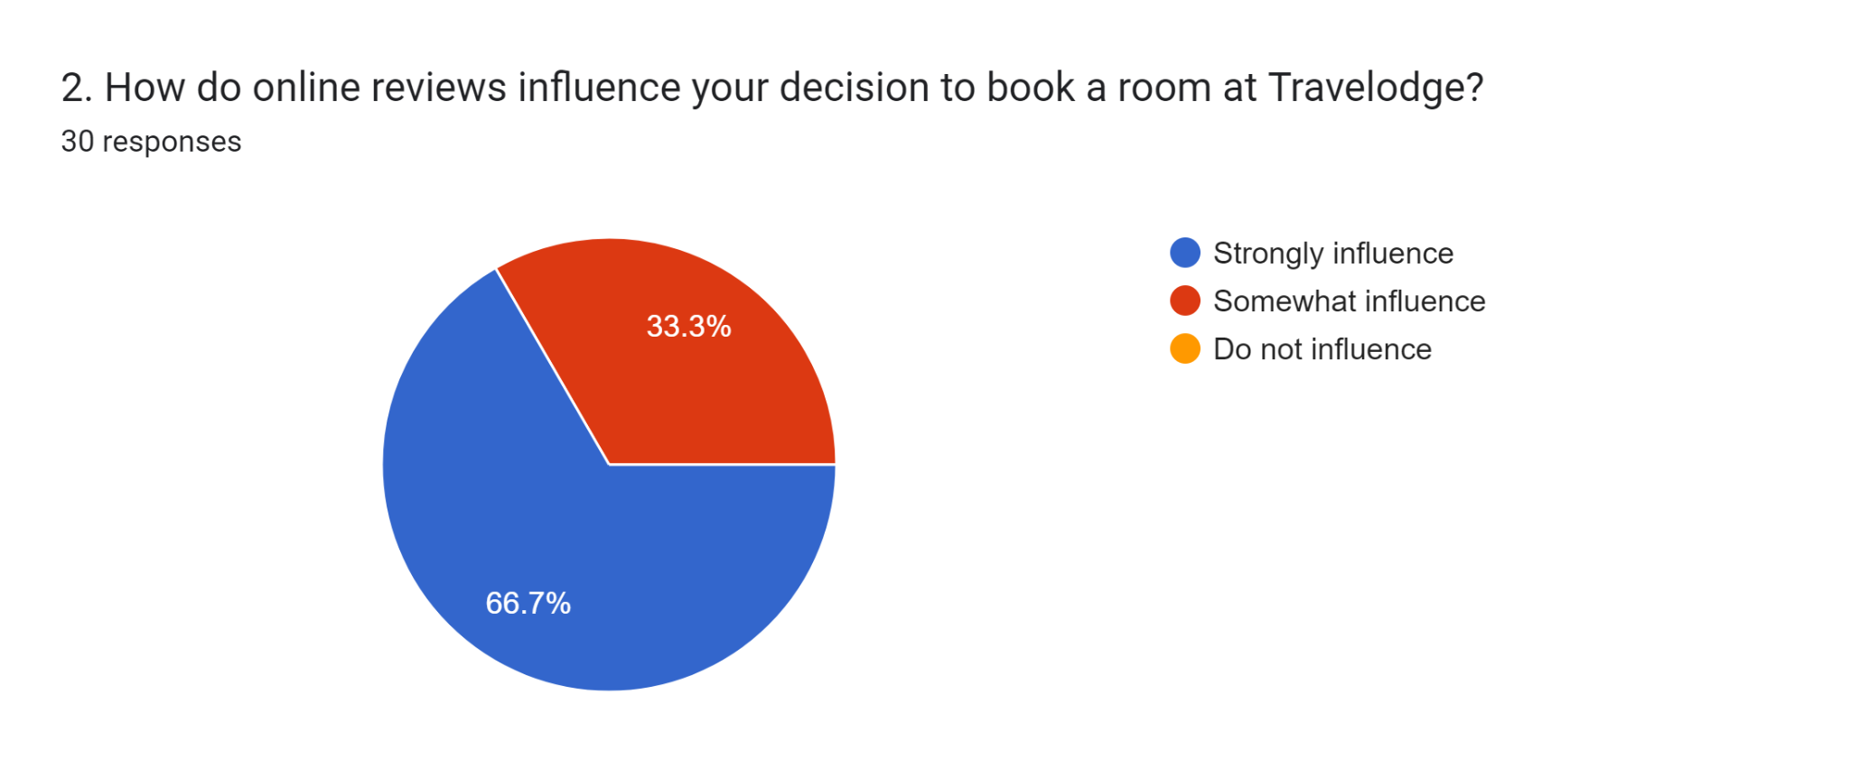
Figure 4.2: Question 2
(Created by the Student)
The reviews online largely influence the respondent’s decision to book a room at Travelodge. It is noted that 66.7% of them said that these ratings strongly influenced their decision to book a room and 33.3% said that it somewhat influenced their decision to book a room. It shows that online reviews are largely impactful on the decision-making of customers on whether to book a room or not.
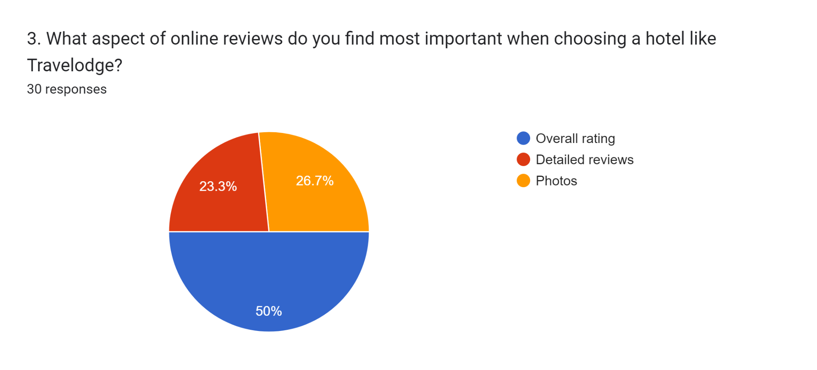
Figure 4.3: Question 3
(Created by the Student)
It is noted in the survey results, that 50% of the respondents usually think that overall rating is the most important while booking a hotel like Travelodge. However, it is also noted that 26.7% of the respondents also think that relevant pictures of the hotel room, and other related pictures are more important as they can show the exact condition of the rooms. Another 23.3% of them think that detailed reviews where the customers talk about their experience of the time they stayed in the hotel hold more value in terms of a review. The people themselves would experience the same while staying at those hotels.
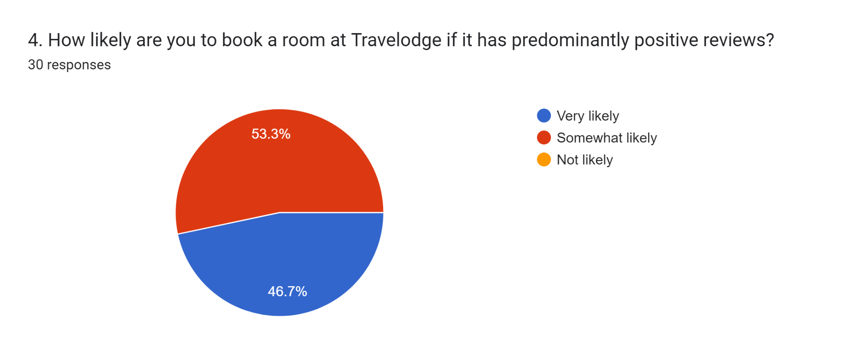
Figure 4.4: Question 4
(Created by the Student)
In the survey, it was found that 46.7% of the respondents were inclined to very likely book a room at Travelodge based on the positive reviews. Also, another 53.3% of them responded with somewhat likely to book the rooms based on the positive reviews. It shows that the positive reviews are very impactful in terms of helping people make their decisions regarding choosing Travelodge as their travel partner.
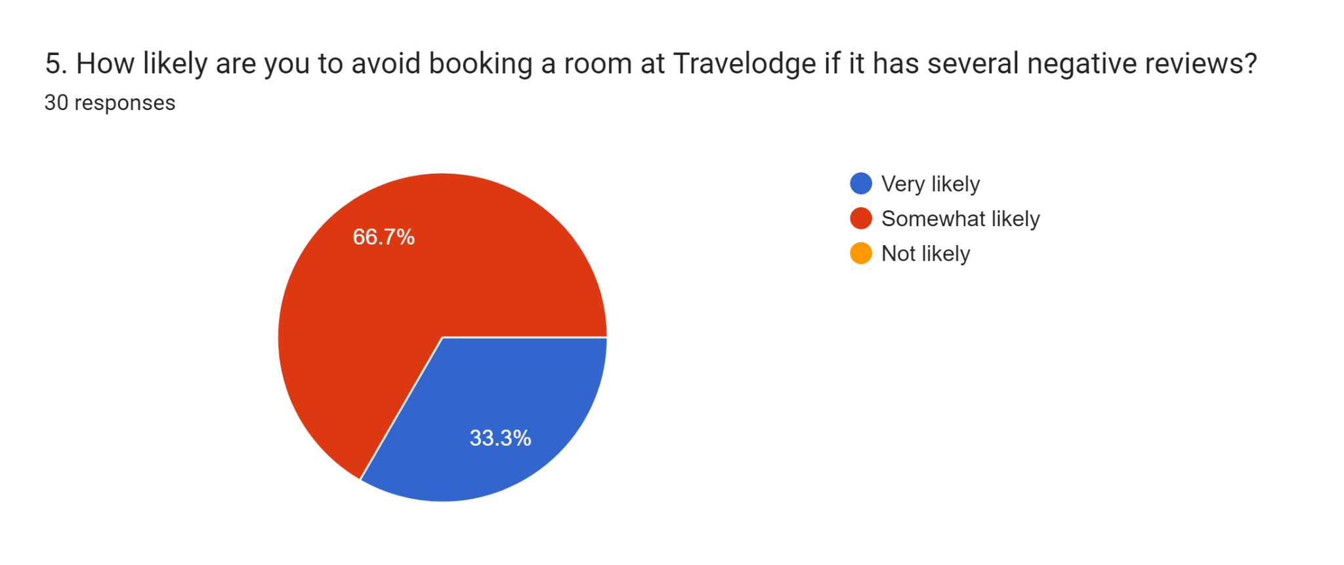
Figure 4.5: Question 5
(Created by the Student)
It is noted that 66.7% of the respondents would likely rather book something else instead of Travelodge if they find there are a lot of negative reviews about the place on the website. Another 33.3% would be very likely to avoid Travelodge based on the negative reviews on the internet. Thus, it is understandable that these reviews on the website have the power to make people avoid Travelodge if the reviews tend to be more negative than positive.
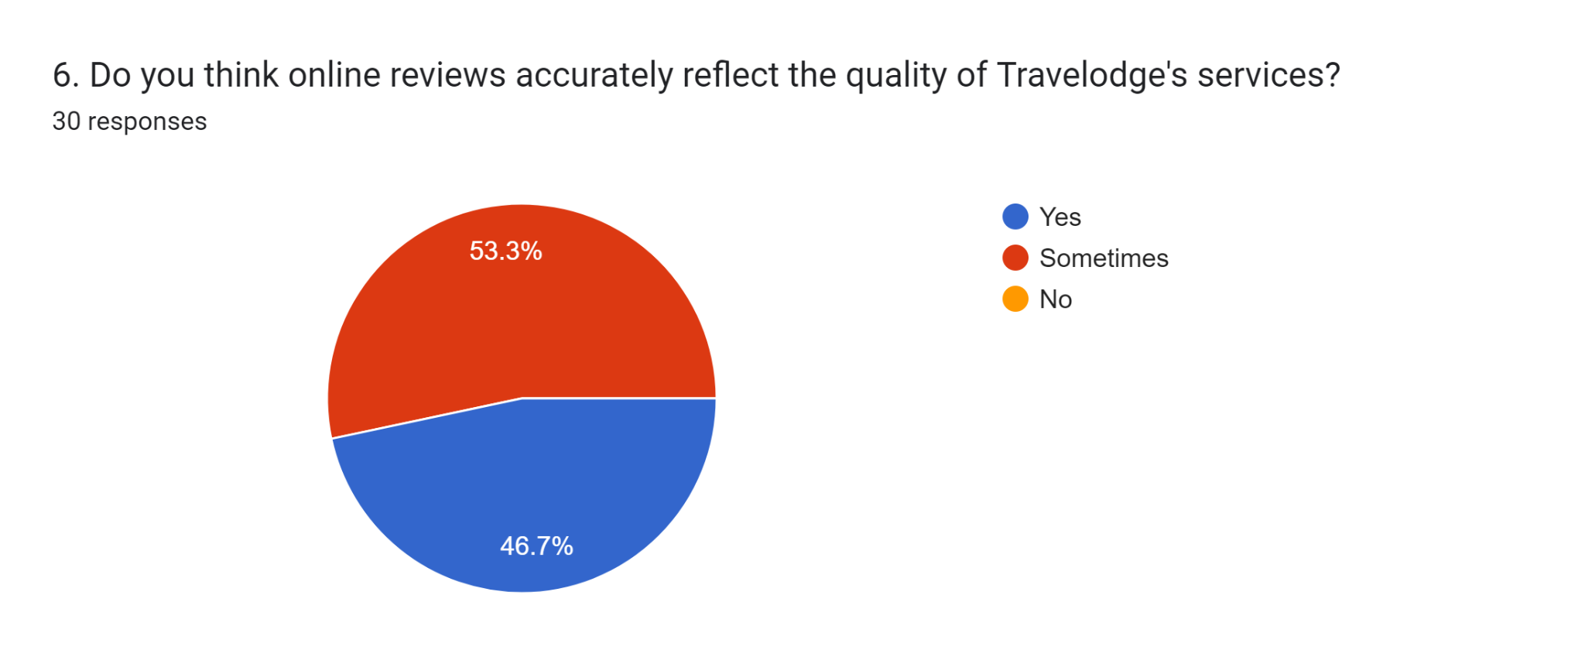
Figure 4.6: Question 6
(Created by the Student)
It is noted that 53.3% of the respondents think that online reviews sometimes accurately depict the quality of services provided by Travelodge. However, there are the other 46.7% who think that it always accurately depicts the quality of service provided by the company. Thus, it is noted that these reviews are very important for people when booking hotels. As the digital era is creeping up on people, more and more people started to be swayed by the reviews online.
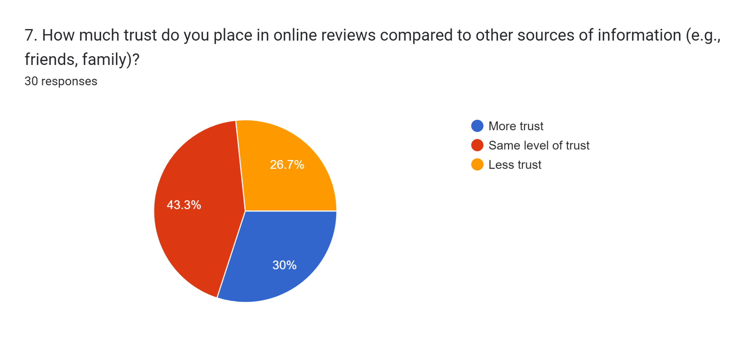
Figure 4.7: Question 7
(Created by the Student)
It is noted that 30% of the respondents would rather trust the reviews online, instead of trusting their friends or families in terms of booking a room at Travelodge. Again, another 43.3% of the respondents depicted that they would not put more trust in these reviews than their families or friends, however, they would not put any less trust in these reviews as well. The remaining 26.7% of the respondents say that they would rather trust their friends or families instead of these reviews online. Thus, it is possible to understand that these reviews online are largely effective in making decisions for people who are looking for a place to stay during their travels.
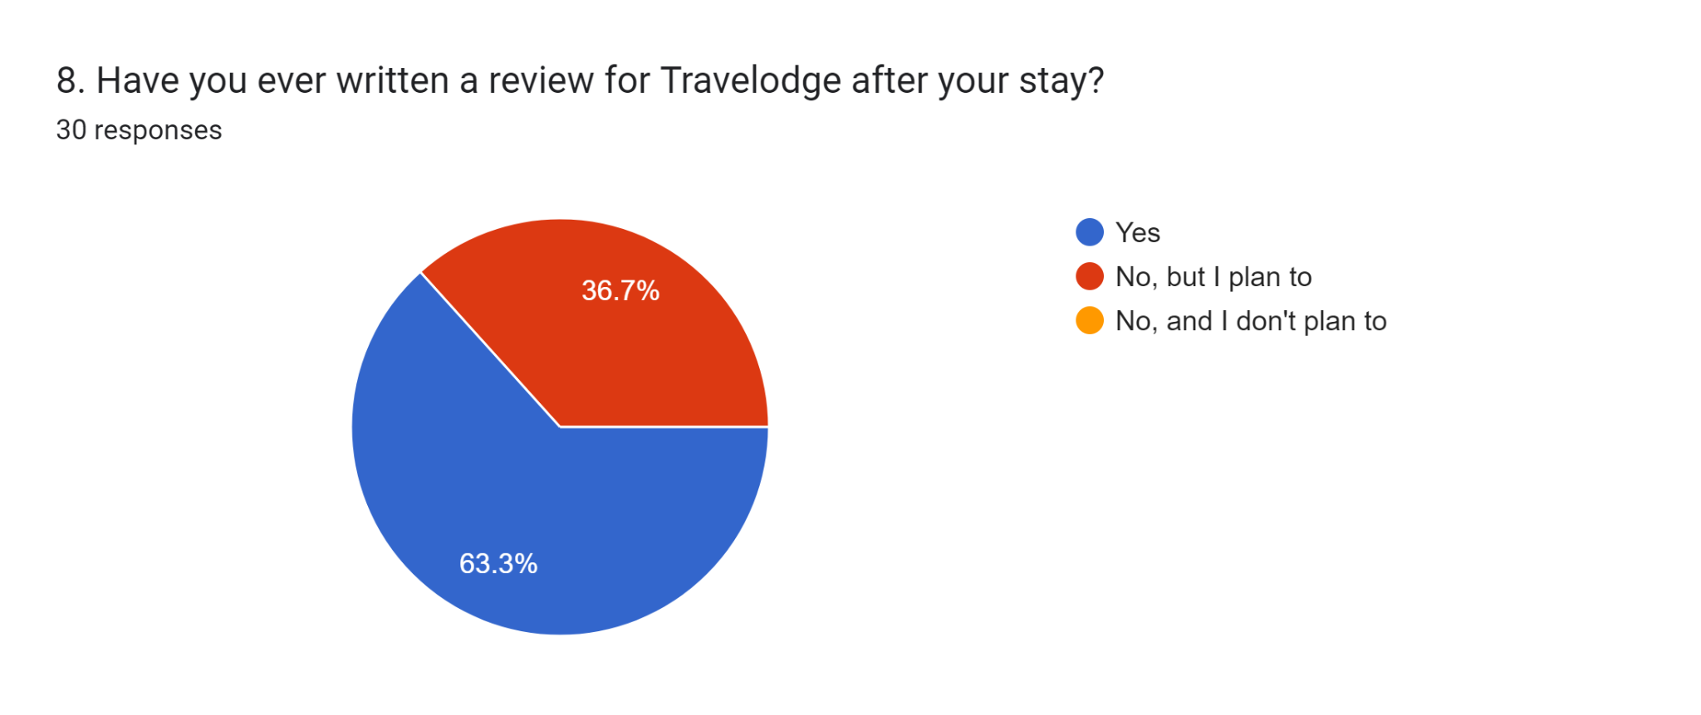
Figure 4.8: Question 8
(Created by the Student)
It shows that these respondents are experienced with Travelodge, and 63.3% of them have already stayed in one of their accommodations and also written online reviews about their stays. Another 36.7% of the respondents have not yet written any reviews but they plan on doing it soon.
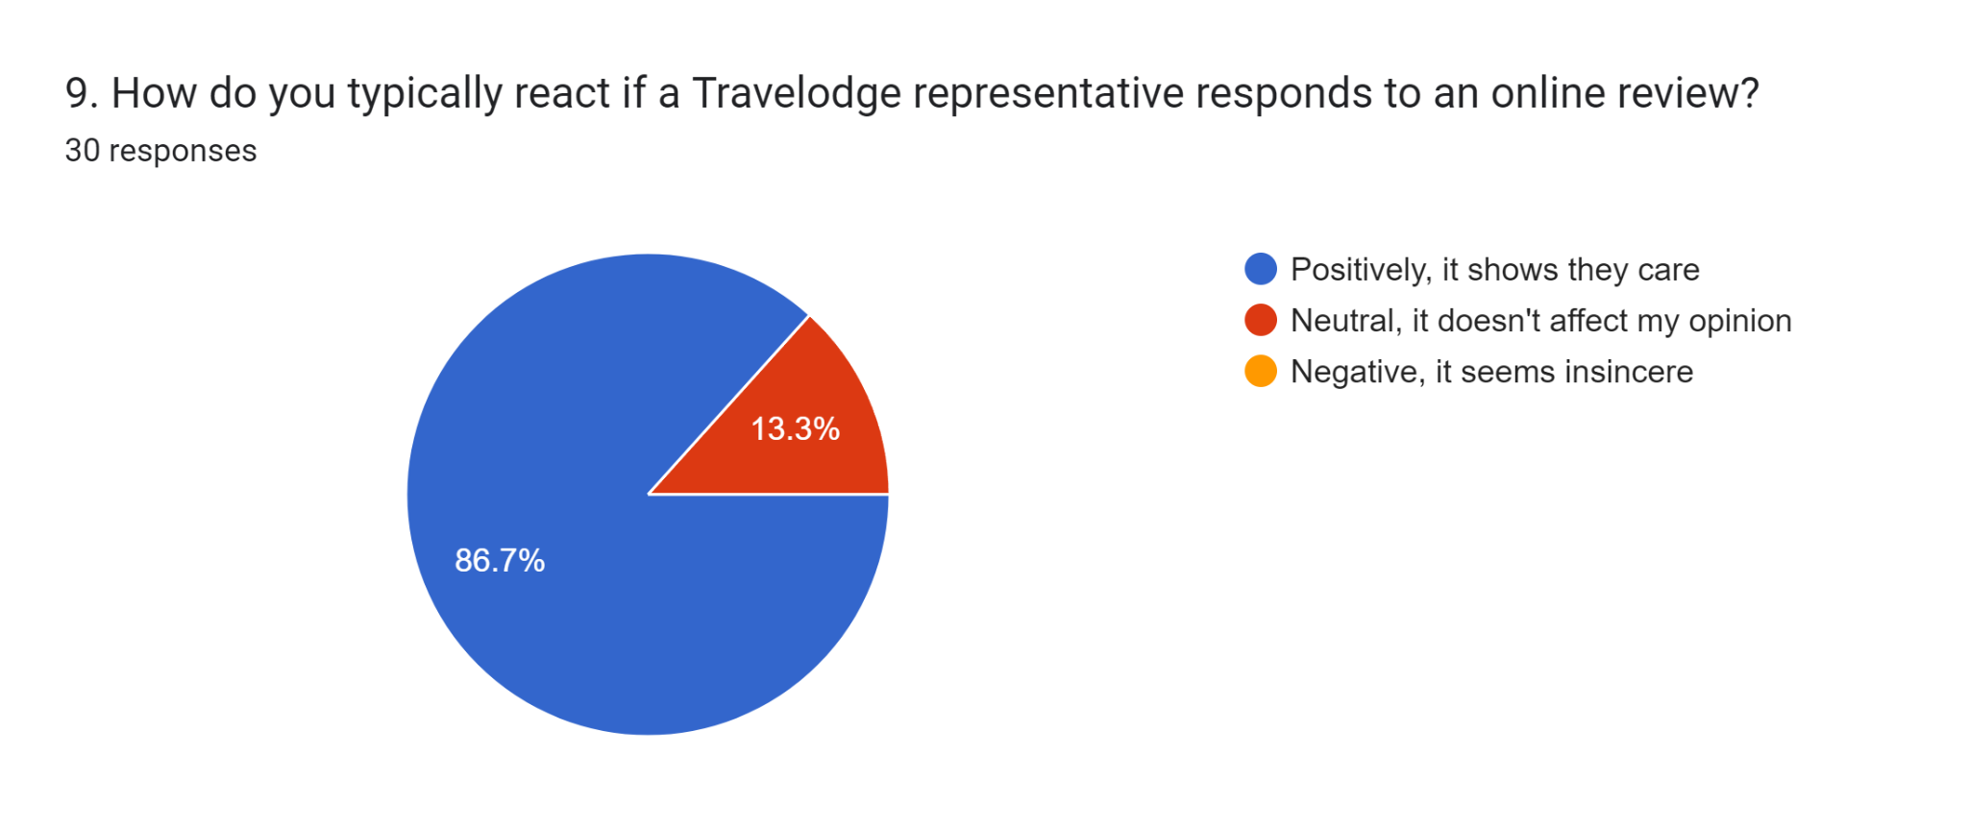
Figure 4.9: Question 9
(Created by the Student)
It is seen that the responses from Travelodge representatives have a positive effect on the respondents. 86.7% of the respondents have chosen that it shows that the representatives care about the customers. The rest were neutral about it.
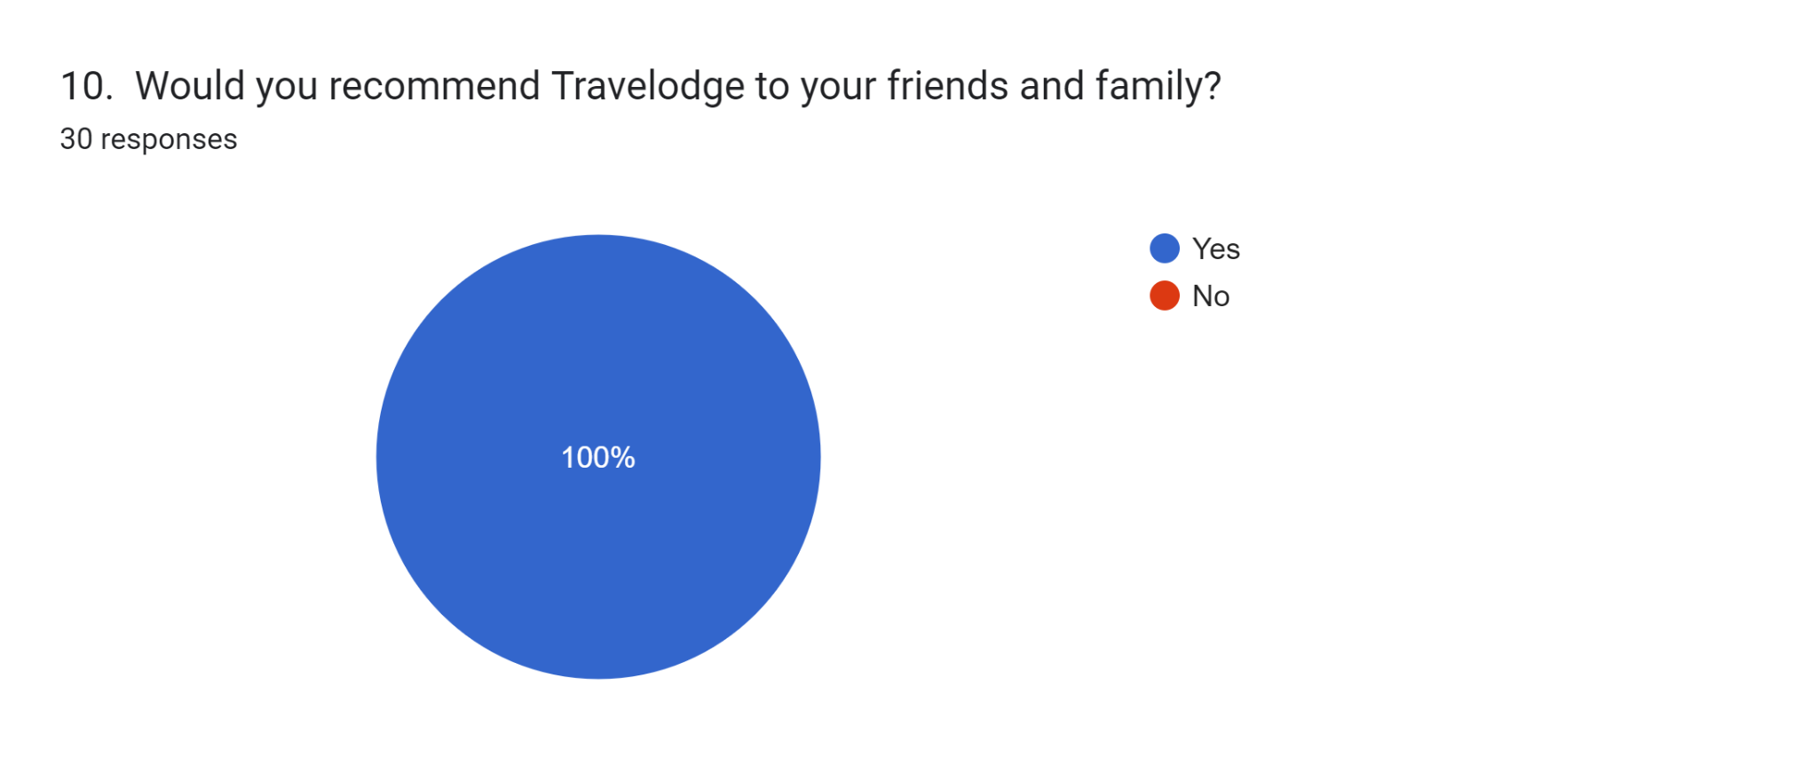
Figure 4.10: Question 10
(Created by the Student)
It is noted that all the respondents have chosen to recommend Travelodge to their friends and families. It is noteworthy as the impact of online reviews is so powerful that it makes people recommend the company to other people, thus, increasing its customer base.

4.3 Conclusion
Online reviews have established themselves as a key tool in the working of consumer choice within the sphere of hospitality, vividly illustrated by the case study of Travelodge. The survey reveals that a substantial majority of consumers, 63.3%, consistently consult reviews before making reservations at Travelodge, with an additional 36.7% doing so intermittently. This particular trend serves to strengthen this point by pointing to the importance of online reputation in that decision-making process. As the flow of detailed information is accessible at any given moment with the help of the internet, potential guests often judge the quality and credibility of the services provided based on the real-life experiences of their fellow travellers. This further establishes why hospitality businesses such as Travelodge need to be extra vigilant in their SEO strategy by fostering a positive reputation online to benefit their customers (Tran Duc Le, Thang Le-Dinh and Sylvestre Uwizeyemungu, 2024).
Consumers stated that positive reviews carry a lot of persuasiveness in their purchasing decisions. As the survey said, 46.7% of the participants strongly agreed that they would book a room at Travelodge given positive reviews about the hotel, and 53.3% said that they are somewhat affected by favourable comments. This dual impact underlines the capabilities of positive sentiments when it comes to attracting the necessary amount of guests online. On the other hand, negative reviews can have the opposite effect in that they can repel potential customers from making the purchase. A notable 66. 7% of the respondents had a high level of likelihood of avoiding Travelodge if ever they read negative reviews and another 33.3% were somewhat inclined to do so. These findings point to the significant negative effects that negative comments may have on consumers and their tendency to book a hotel.
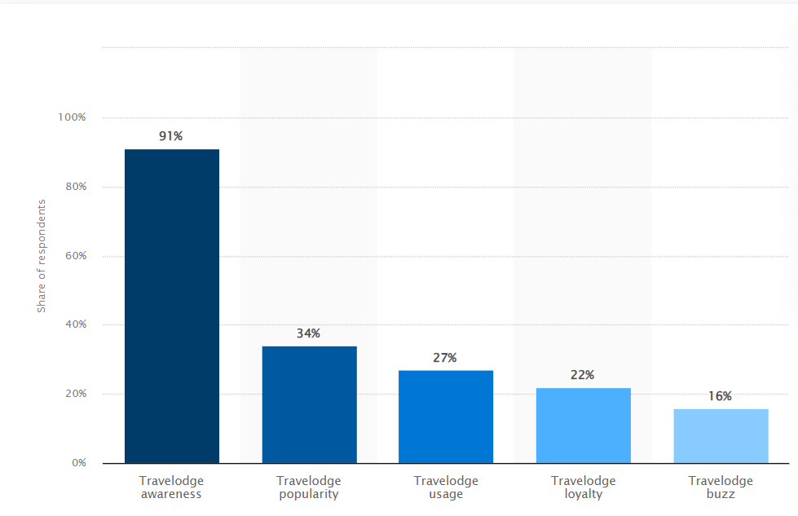
Figure 4.11: Travelodge brand awareness
(Source: Kunst, 2023)
This figure indicates that due to positive online reviews regarding all its services, Travelodge has gained high awareness in the UK, it has gained 91% awareness among all the customers (Kunst, 2023). Thus, it can be concluded that online reviews improve brand awareness and it leads to service selection of a brand. This correlation supports objective 1 of this research based on online reviews impact over service selection in Travelodge.
Consumer preferences regarding review content vary widely. While 50% of respondents prioritise overall ratings when evaluating accommodations, a substantial 26.7% place greater value on visual content such as photos depicting hotel rooms, while 23.3% value detailed customer reviews that provide insights into specific experiences. Thus, the mentioned diversity proves that online reviews are a more complex factor stimulating consumers’ perception of service quality. Besides, by adding comprehensive descriptions to their assessments, supported by visual proofs, the given reviews at the same time promote an element of credibility in a situation when potential visitors receive rather limited information about what they may encounter during their stay (Filieri, 2016). Due to accounting of online reviews Travelodge is able to attract customers that has helped the company in generating 560 million GBP in the UK (Statista Research Department, 2022). This financial development due to review supports achieving objective 2 present within the research.
However, it is clear that online reviews play an essential role in decision-making within the hospitality industry, while some limitations like the authenticity of the reviews and the inherent presenter bias have not yet been solved in the hospitality sector. According to Cheng et al. (2019), despite the apparent benefits of online reviews, it is essential to maintain the quality of such reviews by preserving the authenticity of the authors and the honesty of the opinions to sustain consumers’ confidence in such reviews and correlate them with the quality of the services provided. The survey results show that the importance of online reviews in decision-making has increased, with consumers sending a clear message they prefer online reviews to a face-to-face recommendation from a friend or a family member. This shift can be attributed to increased rational decision-making where consumers turn to references and testimonials found online as their principal source of information.
Moreover, it cannot be emphasised enough that reviews are a significant and multifaceted factor – driving customers’ evaluation of individual trips, as well as their advocacy of the brand. All the subjects agreed to recommend Travelodge to other people based on positive experiences, which shows the chain effect of positive comments online. This tallies with other research regarding the function of reviews in the development of loyalty and positive word-of-mouth in the hospitality industry. As per Gegenhuber and Dobusch (2017), firms which are open to the comments made regarding their businesses can therefore build on the positives that are being said within the public domain in a bid to promote their operations and draw the attention of new customers while at the same time cultivating a good reputation among its customers through word of mouth recommendations.
From the survey data presented it is evident that it is crucial to constantly perform an analysis and interpretation of the online reviews. Aside from this, the proactive approach helps businesses handle complaints effectively, and similarly, is true to companies’ promises of excellent customer service. Creating a culture of handling the reviews that show that the hospitality providers are responsive to issues that are complained about or recommended is a way of taming the negative aspects while at the same time enhancing the positive impacts of the sentiments to enable the growth of business (Koc, 2019). From the correlations of survey and theoretical perspectives it can be concluded that this is the procedure by which Travelodge handles the review over the internet platform in order to attract customers. This correlation supports objective 3 engaged with the research.
Furthermore, the involvement of online reviews goes beyond just affecting one’s own reservation decision. It is a very pivotal factor that is used in branding and mainly in reputation management of a given brand. Positive reviews on the other hand are a great sales pitch that ensures they get more customers and boost the firm’s credibility (Goodman, 2019). On the other hand, complaints reveal weaknesses and provide possibilities for companies to demonstrate their concern to customers by trying to rectify the situation. Travelodge uses the negative online reviews in order to improve their service. From the correlation it can be concluded that based on online review management in Travelodge the company is able to improve customer pleasure that supports their success. This perspective supports objective 4 of the research.
Finally, the importance of managing online reviews as a strategic asset to the maintenance of a competitive and sustainable hospitality business cannot be overemphasised. As a result, utilisation of digital feedback can also be strategic in helping organisations such as Travelodge improve on their delivery of services whilst at the same time cultivating a strong and positive brand image and placing the organisation as a market trendsetter. This understanding is relevant today and is likely to remain a key factor as the onset of new technologies and shifts in consumer behaviour will always be relevant to redesign the approach towards managing online reviews, and thus, developing a successful business and creating lasting relationships with guests.

4.4 Recommendation
The data analysis has suggested the shift in consumers’ actions caused by online reviews within the hospitality industry with reference to Travelodge. The findings have demonstrated that positive words have a positive impact on consumers’ choices while negative words have a negative effect on would-be guests. The survey explores the broad versatility of consumers’ preferences, ranging from focusing on the overall ratings, appreciating detailed feedback and visual material, and pointing to the mixed factors that determine the overall quality of service. Thus, the proper management of the online reputation appears to be one of the most significant factors influencing business trust for potential customers, strengthening customer portfolios, and attracting a new customer base. It is crucial to understand that information gathered from consumers is an important tool used to improve services hence augmenting marketing power. Thus, this chapter highlights the critical role of active management of the review profile of the establishment for successful branding and organisational growth in the age of the Internet.

References
Bergmann, J. (2023). Research Philosophy, Methodological Implications, and Research Design. Studien zur Migrations- und Integrationspolitik, pp.57–89. doi:https://doi.org/10.1007/978-3-658-42298-1_3.
Bergmann, J. (2023). Research Philosophy, Methodological Implications, and Research Design. Studien zur Migrations- und Integrationspolitik, pp.57–89. doi:https://doi.org/10.1007/978-3-658-42298-1_3.
Beugelsdijk, S., van Witteloostuijn, A. and Meyer, K.E. (2020). A new approach to data access and research transparency (DART). Journal of International Business Studies, 51(6), pp.887–905. doi:https://doi.org/10.1057/s41267-020-00323-z.
Beugelsdijk, S., van Witteloostuijn, A. and Meyer, K.E. (2020). A new approach to data access and research transparency (DART). Journal of International Business Studies, 51(6), pp.887–905. doi:https://doi.org/10.1057/s41267-020-00323-z.
Casula, M., Rangarajan, N. and Shields, P. (2020). The potential of working hypotheses for deductive exploratory research. Quality & Quantity, 55(1), pp.1703–1725.
Casula, M., Rangarajan, N. and Shields, P. (2020). The potential of working hypotheses for deductive exploratory research. Quality & Quantity, 55(1), pp.1703–1725.
Cheng, X., Fu, S., Sun, J., Bilgihan, A. and Okumus, F. (2019). An investigation on online reviews in sharing economy driven hospitality platforms: A viewpoint of trust. Tourism Management, 71, pp.366–377. doi:https://doi.org/10.1016/j.tourman.2018.10.020.
Chevalier, J.A. and Mayzlin, D. (2006). The Effect of Word of Mouth on Sales: Online Book Reviews. Journal of Marketing Research, 43(3), pp.345–354.
El-Said, O. A., 2019. Impact of online reviews on hotel booking intention. The moderating role of brand image, star category, and price, p. 12.
Filieri, R. (2016). What makes an online consumer review trustworthy? Annals of Tourism Research, [online] 58, pp.46–64. doi:https://doi.org/10.1016/j.annals.2015.12.019.
Gegenhuber, T. and Dobusch, L. (2017). Making an Impression Through Openness: How Open Strategy-Making Practices Change in the Evolution of New Ventures. Long Range Planning, 50(3), pp.337–354. doi:https://doi.org/10.1016/j.lrp.2016.09.001.
Goodman, J. (2019). Strategic Customer Service: Managing the Customer Experience to Increase Positive Word of Mouth, Build Loyalty, and Maximize Profits. [online] Google Books. AMACOM. Available at: https://books.google.co.in/books?hl=en&lr=&id=3edWDwAAQBAJ&oi=fnd&pg=PP1&dq=Positive+reviews+on+the+other+hand+are+a+great+sales+pitch+that+ensures+they+get+more+customers+and+boost+the+firm%E2%80%99s+credibility&ots=1eALsaBINK&sig=3XVG6UaKfLq2jQP6K0U8Vn8kdeg [Accessed 12 Jul. 2024].
Iranmanesh, M., Ghobakhloo, M., Nilashi, M., Tseng, M.-L., Yadegaridehkordi, E. and Leung, N. (2022). Applications of disruptive digital technologies in the hotel industry: A systematic review. International Journal of Hospitality Management, [online] 107, p.103304. doi:https://doi.org/10.1016/j.ijhm.2022.103304.
Kim, W.G., Lim, H. and Brymer, R.A. (2015). The effectiveness of managing social media on hotel performance. International Journal of Hospitality Management, [online] 44, pp.165–171. doi:https://doi.org/10.1016/j.ijhm.2014.10.014.
Kim, Y.-J. & Kim, H.-S., 2022. The Impact of Hotel Customer Experience on Customers. Satisfaction through Online Reviews, 14(848), p. 13.
Kim, Y.-J. and Kim, H.-S. (2022). The Impact of Hotel Customer Experience on Customer Satisfaction through Online Reviews. Sustainability, 14(2), p.848. doi:https://doi.org/10.3390/su14020848.
Koc, E. (2019). Service failures and recovery in hospitality and tourism: a review of literature and recommendations for future research. Journal of Hospitality Marketing & Management, 28(5), pp.513–537. doi:https://doi.org/10.1080/19368623.2019.1537139.
Kunst, A. (2023). Travelodge brand profile UK 2022. [online] Statista. Available at: https://www.statista.com/forecasts/1335657/travelodge-hotels-brand-profile-in-the-uk [Accessed 13 Jul. 2024].
Mohajan, H.K. (2020). Quantitative Research: A Successful Investigation in Natural and Social Sciences. Journal of Economic Development, Environment and People, [online] 9(4), pp.50–79. Available at: https://www.ceeol.com/search/article-detail?id=939590.
Mohajan, H.K. (2020). Quantitative Research: A Successful Investigation in Natural and Social Sciences. Journal of Economic Development, Environment and People, [online] 9(4), pp.50–79. Available at: https://www.ceeol.com/search/article-detail?id=939590.
Murana, S. and Rahimin, R. (2021). Application of SPSS Software in Statistical Learning to Improve Student Learning Outcomes. Indo-MathEdu Intellectuals Journal, 2(1), pp.12–23. doi:https://doi.org/10.54373/imeij.v2i1.22.
Murana, S. and Rahimin, R. (2021). Application of SPSS Software in Statistical Learning to Improve Student Learning Outcomes. Indo-MathEdu Intellectuals Journal, 2(1), pp.12–23. doi:https://doi.org/10.54373/imeij.v2i1.22.
Shardlow, M., Cooper, M. and Zampieri, M. (2020). CompLex: A New Corpus for Lexical Complexity Prediction from Likert Scale Data. [online] arXiv.org. doi:https://doi.org/10.48550/arXiv.2003.07008.
Shardlow, M., Cooper, M. and Zampieri, M. (2020). CompLex: A New Corpus for Lexical Complexity Prediction from Likert Scale Data. [online] arXiv.org. doi:https://doi.org/10.48550/arXiv.2003.07008.
Statista Research Department (2022). Travelodge UK revenue 2021. [online] Statista. Available at: https://www.statista.com/statistics/429089/travelodge-total-revenue-united-kingdom-uk/#:~:text=Travelodge%20UK%20generated%20revenues%20of [Accessed 13 Jul. 2024].
Tran Duc Le, Thang Le-Dinh and Sylvestre Uwizeyemungu (2024). Search engine optimization poisoning: A cybersecurity threat analysis and mitigation strategies for small and medium-sized enterprises. Technology in Society, pp.102470–102470. doi:https://doi.org/10.1016/j.techsoc.2024.102470.
Travelodge (2022). THE FUTURE OF SLEEP: AUGMENTED REALITY TO REVOLUTIONISE OUR SLUMBER | Travelodge. [online] travelodge.co.uk. Available at: https://travelodge.co.uk/press-centre/press-releases/FUTURE-SLEEP-AUGMENTED-REALITY-REVOLUTIONISE-OUR-SLUMBER [Accessed 13 Jul. 2024].
Travelodge (2024). Travelodge | Great value hotels throughout the UK & Ireland. [online] Travelodge. Available at: https://www.travelodge.co.uk/ [Accessed 13 Jul. 2024].
Wen, J. et al., 2020. The interaction effect of online reviews. Brand and price on consumer hotel booking decision making, 60(4), p. 41.
Yu, J., Zhang, X. & Kim , H.-S., 2023. Using Online Customer Reviews to Understand Customers’. Experience and Satisfaction with Integrated Resorts, 15(13049), p. 14.
Zeng , G., Cao , . X., Lin, . Z. & Xiao, . S. H., 2019. When online reviews meet virtual reality: Effects on consumer hotel booking. When online reviews meet virtual reality: Effects on consumer hotel booking, p. 34.
Zhang, P., Peng, B., Mi, Z., Lin, Z., Du, H., Cheng, L., Zhou, X. and Cao, G. (2024). The reduction of effective feedback reception due to negative emotions in appeals. Humanities and Social Sciences Communications, [online] 11(1), pp.1–10. doi:https://doi.org/10.1057/s41599-024-03009-1.
Zimba, O. and Armen Yuri Gasparyan (2023). Designing, Conducting, and Reporting Survey Studies: A Primer for Researchers. Journal of Korean Medical Science, 38(48). doi:https://doi.org/10.3346/jkms.2023.38.e403.
Zimba, O. and Armen Yuri Gasparyan (2023). Designing, Conducting, and Reporting Survey Studies: A Primer for Researchers. Journal of Korean Medical Science, 38(48). doi:https://doi.org/10.3346/jkms.2023.38.e403.

Appendix: Questionnaire
1. How often do you read online reviews before booking a room at Travelodge?
- Always
- Sometimes
- Never
2. How do online reviews influence your decision to book a room at Travelodge?
- Strongly influence
- Somewhat influence
- Do not influence
3. What aspect of online reviews do you find most important when choosing a hotel like Travelodge?
- Overall rating
- Detailed reviews
- Photos
4. How likely are you to book a room at Travelodge if it has predominantly positive reviews?
- Very likely
- Somewhat likely
- Not likely
5. How likely are you to avoid booking a room at Travelodge if it has several negative reviews?
- Very likely
- Somewhat likely
- Not likely
6. Do you think online reviews accurately reflect the quality of Travelodge's services?
- Yes
- Sometimes
- No
7. How much trust do you place in online reviews compared to other sources of information (e.g., friends, family)?
- More trust
- Same level of trust
- Less trust
8. Have you ever written a review for Travelodge after your stay?
- Yes
- No, but I plan to
- No, and I don't plan to
9. How do you typically react if a Travelodge representative responds to an online review?
- Positively, it shows they care
- Neutral, it doesn't affect my opinion
- Negatively, it seems insincere
10. Would you recommend Travelodge to your friends and family?
- Yes
- No

