PROJECT OUTCOMES
WRITTEN ASSIGNMENT

Student Name: Selina Shafiq
Student Number: 2028762
Module: Change makers: Creativity and Value Creation
Module Code: BMHP5014_BIRM
Assignment: Project Outcomes – Written Assignment
Lecturer: Dr Azora Hurd

CONTENTS PAGE

- Introduction ………………………………………………………………… Pg 3
- Unit 1 – Who am I? My Sense of Self ……………………………………Pg 4
- The Idea of Self ………………………………………………………….....Pg4-5
- Social Influences ……………………………………………………………Pg 5
- Developing Creative Confidence …………………………………………Pg 5
- Unit 2 – The Act of Creating Value ……………………………………… Pg 5-6
- Who and what are Changemakers ……………………………………… Pg 6
- Value Creation Pedagogy ……………………………………………….. Pg 6
- The Practise of Changemaking …………………………………………...Pg 6
- Unit 3 - Collaboration or Competition …………………………………… Pg 7
- Establishing a Supportive Network ……………………………………... Pg 7
- Stakeholders Analysis …………………………………………………… Pg 7
- Creating a Stakeholder Map ……………………………………………...Pg 8
- Unit 4 – Closing the Loop …………………………………………………Pg 8
- Skills and Attributes ………………………………………………………. Pg 8-9.
- Showing your Work …………………………………………………………Pg 9.
- Conclusion …………………………………………………………………Pg 9-10
- Bibliography/References …………………………………………………. Pg 11

INTRODUCTION
In this written assignment I will identify the key learning points that I have gained from studying and completing the activities from the online learning material in this module. In the Change makers: Creativity and Value Creation module there were four units that consisted of four topics to be completed on each unit, engaging in numerous activities also making use of student forums, written blogs and padlet posts. This assignment will reflect on my learning from these online materials and how they have assisted me in identifying my knowledge and critical understanding of innovation, creativity and inventive mind set by also taking in mind the values and contribution that creativity can make to the collective good within the Health and Social Care profession.
The topics that I will be reflecting on are the following:-
- Unit 1 - Ideas and Value
Topic 2 - Who am I? My Sense of Self
- Unit 2 - Creative Solutions
Topic 1 - The Act of Creating Value
- Unit 3 - Mobilising Support
Topic 1 - Collaboration not Competition
- Unit 4 - Evaluation
Topic 4 -Closing the Loop

UNIT 1 – Who am I? My Sense of Self
This topic was quite interesting, as the activities required me to recognise my personal passions and how these will help me progress in life. This topic helped me understand how my passions can motivate me to think of new ideas in a creative manner.
The topic was about finding interests that will help you advance. It is beneficial to understand how our passion might spur original thoughts and the generation of fresh concepts. In René Descartes' first session, there was a YouTube video (The School of Life.2015).
One of René Descartes' most well-known quotes is"I think, therefore I am." Descartes was a rationalist who trusted in the power of fundamental ideas. With six main passions, Descartes starts his investigation into the physiological impacts and influences of these six basic emotions (wonder, desire, love, hatred, joy, and sadness). Descartes supported the inherent knowledge hypothesis, arguing that everyone is born with some knowledge due to God's superior might.
It takes time to understand how your thoughts, feelings, and behaviours are influenced by others, as well as how our own and other people's perspectives of who we are differs. Tutorials on this are accessible in the second social influences session (CrashCourse,2014). (Miller, 2015).

The Idea of Self
Self is defined as an individual's genuine self, which is the understanding of either the individual or personal characteristics. Every person is a model of who they are. The confirmation of identities develops a feeling of value and worth, meanwhile the evidence of role identities and creates a sense of self-worth or competence. The acknowledgement of individual identities provides a sense of becoming one's true self. More and more, people view themselves as a bundle of personalities that they attempt to validate in their interactions with others, and based on their success, they may feel either happy or unhappy (Burke and Stets, 2009).

Social Influences
Social influence is the term used to describe deliberate and accidental attempts to alter the opinions, attitudes, or behavior of another individual. Social influence could be inadvertent or unintentional, in contrast to persuasion that is often purposeful and requires some amount of awareness on the part of the subject. Social influence seems to be the process through which people modify their behavior to fit the demands of a social situation. Minority and autonomous behavior, according to social impact studies, is what stimulates social change. A minority, for instance, could challenge the majority's ideas, leading them to rethink or reconsider their principles (Changingminds.org. 2022).

Developing Creative Confidence
The belief that creativity is indeed a method of seeing the reality rather than just the capacity to create art, literature, or structures is known as creative confidence. Loss of confidence in our abilities or concepts might result in a complete avoidance of novel concepts and the vital experimentation process. A person who doesn't believe they require the skills to be truly creative, such as a newcomer who only desires to be a content provider, avoids coming up with original ideas.

UNIT 2 – The Act of Creating Value

This topic is about change making and how change and value generation are related. Change makers are people who can see trends in their surroundings, pinpoint problems in any situation, come up with answers, put together adaptable teams, promote group action, and then make adjustments as circumstances change (Brooks, 2018). A change maker is also someone who tries to bring about the changes they wish to see in the environment by accumulating data and resources.
Makiguchi made this discovery in the field of "value," what he defined as one of the most important issues affecting our daily lives. Joy, beauty, benefit, and goodness, is a value. As an idea, happiness includes, accepts, and combines these values. The ultimate goal of Makiguchi's educational initiatives was to increase people's capacity to create value (Makiguchi, 2015).

Who and What Are Change Makers?
A change maker would be one who implements novel solutions to societal problems. Although it could seem like a simple undertaking, examining the components of the description of "change maker" shows a way to significantly alter society. When problem-solvers see an issue, they see a chance to develop a solution. They create positive impact through making use of crucial skills including leading, teamwork, as well as empathy.

Value Creation Pedagogy
Pedagogical strategies such as compassion, creativity, leadership, and collaboration encourage entrepreneurship, innovation, and critical thinking. Social entrepreneurs are fearless and determined, taking on enormous problems and offering ground-breaking solutions for social change. They inspire groups and organizations which anyone can make a difference and act as role models for the future change makers. Social entrepreneurs are a key force.
The Practice of Change Making
In order to respond effectively, the listener must listen closely to the speaker's comments. On the other side, passive listening happens when the listener simply receives the speaker's message without responding. Simply stating a different point of view, without discussion or debate. If you do not however listen to the other individual and find the time to comprehend their perspective, there would never be a connection (TEDx Talks, 2019).

UNIT 3 – Collaboration not Competition
By providing access to potentially significant resources, this topic aims to build a supporting network. These interpersonal connections can aid in the development of ideas and the long-term viability of a new business. Those networks can also aid in endurance and moral support.

Establishing a Supportive Network
A support network is a collection of friends and family who help you realize your personal and professional objectives. A support network is referred to as "your team," or perhaps the people that surround you and who could provide you with inspiration, assistance, and chances to advance personally. Your support process can be implemented up of whoever you want, but it typically consists of the people you have the closest relationships with. This could include, to name a few, your relatives, close friends, neighbors, and co-workers. These are the people you go to for advise, to get their opinion on anything, to ask for help when you need it, or just to receive advice from when times are bad. Most of the time, you'll find that you will have a large and close network of individuals you might call on (Donnancoachingservices.com. 2021).

Stakeholder Analysis
Stakeholders are important for a variety of reasons. Internal stakeholders are vital as the industry's methods depend on their ability to engage in order to reach the industry's aims. But at the other side, external stakeholders might indirectly affect the company. An organization's ultimate success depends on maintaining connections with both internal and external stakeholders.
The following categories can be used to categorize stakeholders:
• Primary: Individuals who directly benefit from or suffer from an organization's objectives.
• Secondary: A person who indirectly suffers the effects of a company's operations. (Asq.org. 2022)
Creating a Stakeholder Map

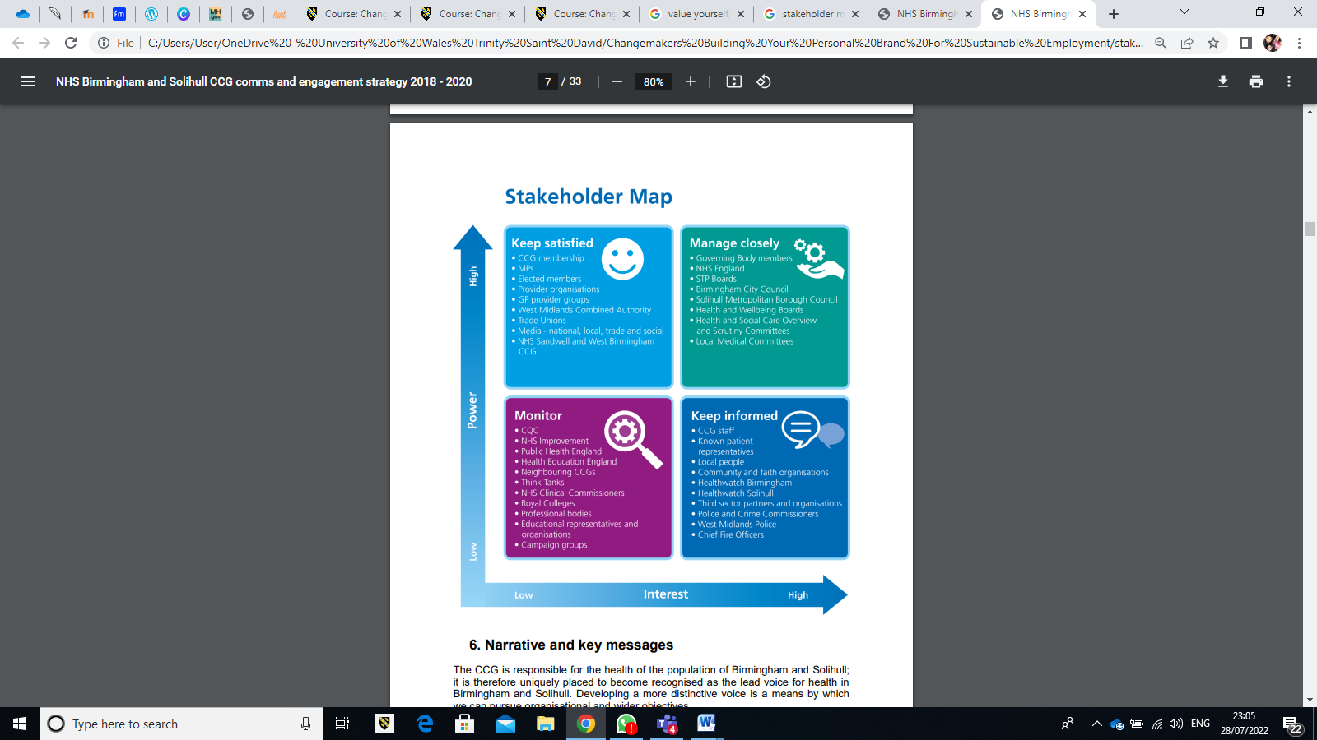(NHS, 2020)
Stakeholder map is essential for guiding your investment decisions. Identifying your stakeholders is essential since it enables you to choose your areas of concentration. To put it another way, it helps the project manager determine who the key decision makers are really at given time, enabling them to make sure they are communicating to the correct individual at the right time.

UNIT 4 – Closing the Loop
In this topic, I will evaluate our learning from the previous units and my results from each topic.

Skills and Attributes
No matter what ever your age is, never give up on a vision you have. Ideas may come true just like dreams can. All of our thoughts, dreams, and ideas eventually come true. We simply need to move them ahead. Ten years ago, I would have never considered pursuing my studies to become a social worker. Ideas can become my future. The positive traits and values I have to achieve in life are as follow:
• To be dependable, friendly, and genuine.
• To put my all into whatever I do.
• To be imaginative and creative

Showing Your Work
I've learned several different approaches to present and assess my work via the e-learning materials. I posted some work from the activities on the blog, forum and padlet. While studying level 4, one of the tutors stated that the more creative your tasks are, the higher the marks you would receive for them. I put some creativity into one of my tasks, and the tutor was pleased to find that I exceeded my expectations. As a result, I'm now motivated to go the extra mile to obtain a better grade as I know that I did my best and would feel pleased with myself.

CONCLUSION
From the learning and activities in this module and based on the resources provided, I believe every topic helped in boosting my learning, providing me with fresh perspectives and new ideas. I understood the importance of being healthy and looking after ourselves is key, in order for achievements to come to us naturally. As a healthy mind, can take you a lot further in life.
I now understand the value of creativity in establishing human connections and how real innovation can impact healthcare. Creativity acknowledges the necessity of taking chances, this is natural in everyday life. Upon completing this course I would like to pursue a career in the Health/Social Care Sector, to be professional and to achieve the best at the job you will always need to be creative and have a healthy mind set. When I take care of myself and my health, my ability to think freely and creatively will be more apparent.
Innovation has a positive effect on growth and is essential for the advancement of the economy. It enhances problem solving, which is more crucial as the scale of the world's challenges increases. Innovation helps businesses, especially those in developing countries, stay on top of problems that are always evolving. Even though they continue to succeed, it will take a while for them to attempt and change the world even though there will be setbacks.
I enjoyed learning this module, as it helped me understand my qualities and skills, also the improvements that can be made to everyday life in order to keep a healthy mind.

BIBLIOGRAPHY/REFERENCES
Brooks, D., (2018). Opinion | Everyone a Changemaker (Published 2018). [online] Nytimes.com. Available at: <https://www.nytimes.com/2018/02/08/opinion/changemaker-social-entrepreneur.html> [Accessed 26 July 2022].
Burke, P. and Stets, J., (2009). Identity theory. Oxford: Oxford University Press.
Changingminds.org. (2022). Social Influence. [online] Available at: <http://changingminds.org/explanations/theories/social_influence.htm> [Accessed 26 July 2022].
CrashCourse,(2014), Social Influence: Crash Course Psychology #38,Youtube.com. (2014). [video].Available at: <https://www.youtube.com/watch?v=UGxGDdQnC1Y&t=334s> [Accessed 24 July 2022].
Donnancoachingservices.com. (2021). [online] Available at: <https://www.donnancoachingservices.com/post/the-importance-of-building-support-networks> [Accessed 28 July 2022].
Miller, B., (2015). Charles Cooley- Looking glass self | Individuals and Society | MCAT | Khan Academy, Youtube.com [online]. Available at: <https://www.youtube.com/watch?v=bU0BQUa11ek> [Accessed 22 July 2022].
NHS, (2020). [online] Birminghamandsolihullccg.nhs.uk. Available at: <https://www.birminghamandsolihullccg.nhs.uk/about-us/publications/strategic/2179-nhs-birmingham-and-solihull-ccg-communications-and-engagement-strategy-2018-20/file> [Accessed 28 July 2022].
TEDx Talks, ( 2019). How to actively listen to others | Scott Pierce | TEDxBirmingham Youtube.com. [online]. Available at: <https://www.youtube.com/watch?v=Yq5pJ0q3xuc> [Accessed 26 July 2022].
The School of Life, (2015). PHILOSOPHY - René DescartesYoutube.com. [video]. Availableat:&lt;https://www.youtube.com/watchv=CAjWUrwvxs4&amp;t=202s&gt; [Accessed 20 July 2022].

