Title
Student Name: Jervis Alexis Payne
Student Number: 2127853
Course Name: MSc Data and AI
Module Name: Data Mining & Visualisation
Module Code: ACCA7015
Assignment Title: Exploratory Data Analysis – Report and Demonstration
Submission Date: 21st November 2025
14:00 (2PM)

Table of Contents
1 Title 1
2 Table of Contents 2
3 List of Figures 3
4 Abstract 3
5 Introduction 4
6 Literature Review 5
6.1 Predictive Analytics in Air BnB and Tourism Domain. 5
6.2 Modelling Classifications: Theoretical Underpinnings and History. 5
6.3 Hospitality Analytics: Clustering Techniques. 6
6.4 Evaluation Measures and Model Evaluation. 6
6.5 Critical Reflections and Synthesis 6
7 Dataset Description 7
8 Model Implementation and Evaluation 8
8.1 Analytical Framework 8
8.2 Classification Techniques 8
8.3 Evaluation Metrics 8
8.4 Clustering Techniques 9
8.5 Implementation in WEKA 9
8.6 Ethical Grey Area and Limitations. 9
9 Results Analysis 9
9.1 Classification Results 9
9.2 Clustering Results (K-Means) 12
10 Discussion Of Findings 14
10.1 Model Performance 14
10.2 Misclassification Patterns 14
10.3 Clustering Insights 14
10.4 Methodological Adequacy and Limitations. 14
11 Business Recommendations 15
12 Conclusion 15
13 References 16

List of Figures
Figure 1 SCREENSHOT: J48 Summary (Accuracy/Kappa/Errors) 10
Figure 2 SCREENSHOT: J48 Confusion Matrix 11
Figure 3 SCREENSHOT: RandomForest Summary (Accuracy/Kappa/Errors) 11
Figure 4 SCREENSHOT: RandomForest Confusion Matrix 12
Figure 5 SCREENSHOT: K‑Means Cluster Summary 13
Figure 6 SCREENSHOT: K‑Means Centroid Table 14

Abstract
This research examines the idea of predictive analytics on Airbnb listing classification to discover structural trends that facilitate the creation of data-driven decision-making in the short-term accommodation market. Using the publicly available dataset called ABNYC2019, two controlled classification models, namely the J48 decision tree and the Random Forest (RF), were created to classify the listing by the room type, a feature which has a strong impact on the quality of the guest experience, price formation and definition of the host policies. Modelling performance was consequently validated using 10-fold cross-validation after which it was also measured using measures such as precision in accuracy, Kappa statistic, and class level as measures of precision, recall, and F-measure. As an addition to the classification investigation, the K-Means clustering method was used with aim to calculate natural groupings of listings using the price, neighbourhood group, availability, and review activity features.
The derived classification tests show that the predictive accuracy and stability of RandomForest behaviour is higher and more robust in relation to classes than that of J48, which is consistent with modern machine learning studies. K-Means clustering further outlines in different listing segments varying in the type of room, price ranges and geographical distribution throughout New York City therefore, providing useful information about the positioning of hosts and guest preferences. The report indicates the way in which a combination of supervised and unsupervised methods can produce practical intelligence to be used by hosts, property managers, and platform operators aiming at maximising their prices, segmenting their listings and understanding market dynamics in competitive city settings.

Introduction
The growth of the peer-to-peer accommodation sites has significantly altered the world of tourism and hospitality industry. Airbnb as the leading service in this sphere has empowered millions of hosts to provide guests all over the world with a wide variety of short-term rent. The fast development of the platform has achieved large volumes of listing data that include features in room type, geographical location, price, availability and host features [1]. The richness of this data has many predictive analytics and data-mining opportunities, which can be used to assist in strategic decision-making, competitive edge and the overall quality of the accommodation service. The most recent studies note the growing popularity among machine learning techniques in the tourism and hospitality industry, especially in price prediction, occupancy expectations and better understanding of host performance dynamics [2].
There is a wealth of literature that uses machine learning algorithms to process Airbnb data to forecast the prices of listings, rate neighbourhood desirability and demand dynamics. Scientific research supports the claim of effectiveness in tree-based models and ensemble techniques and regressions to use listing attributes in the generation of the precise predictions. In line with that, studies prove the value of combining structured listing data and machine learning algorithms to assist hosts and policymakers in making sense of market behaviour [3]. However, when compared to price prediction and revenue modelling which are the prevailing solutions in existing literature there is a relative dearth of studies that have focused on categorising listings based on intrinsic features (i.e., room type) or apply unsupervised practises to identify structures. The insights into the linkage of listing features into meaningful clusters can assist greatly in segmentation, pricing decisions, and optimisation decision-making on a platform level [4].
This report fills these research gaps by applying the data-mining method to ABNYC2019 dataset and its backup aims are these two. To begin with the supervised classification models, such as the J48 decision tree and Random Forest, are used to classify the listings by the room type. It is understandable why the room type will be the target variable since it is an essential variable that contributes to the expectations of the guests and the host to set prices, which makes it not only an appropriate variable but also a very convenient variable to use [5]. Second, unsupervised K-means clustering analysis is performed to identify natural groupings of listings, according to characteristics of price, neighbourhood groups, minimum required nights to stay and review activity. This two-step analytical framework allows one to get a further insight into predictive relationships and the structural patterns underlying the data [6].
The overall objective of the given assignment is to deploy classification methods to classify Airbnb listings, as well as support this analysis with the usage of clustering, which will provide further insights relevant to the real-world decision-making. The following objectives will be formulated: (1) to deploy and test at least two classification procedures to classify listings; (2) to stereotype K-Means clustering to see notable patterns and groupings in the data; (3) to evaluate the results critically and appropriately; and (4) to derive actionable intelligence using the results to the hosts property managers and the platform operators.
The other part of this report talks about the dataset, the modelling approach, the modelling evaluation and clustering outcomes, and the conclusion followed by recommendations on the use of the data in the decision making in Airbnb market.

Literature Review
The booming growth of online accommodation web applications, including Airbnb has triggered a wave of academic research in the field of data mining and machine-learning to clarify market dynamics, predict listing performance, and support evidence-based decision-making. In this paradigm, predictive analytics has played a central role in breaking down large volumes of hospitality data so that researchers and practitioners alike can categorise listings, forecast their prices and segment their markets with an increasing level of micro-granularity. In the recent studies, both supervised and unsupervised learning have been highly advanced in the domain of Airbnb, especially due to decision trees, ensemble techniques, and clustering algorithms [7], [8].

Predictive Analytics in Air BnB and Tourism Domain.
An expanding body of literature tells of machine-learning enhancing predictive accuracy in the tourism context, be it in forecasting prices, estimating occupancy, or determining host-behaviour relationships. Other researchers have used tree-based and ensemble methods to predict prices at Airbnb and explain that the capabilities of RandomForest, Gradient Boosting, and XGBoost as compared to traditional regression models include nonlinear association and interaction between listing features. These papers highlight the multidimensionality of the Airbnb data, where room type, neighbourhood group, frequency of reviews, and availability variables are interconnected and, therefore, machine-learning is especially the most suitable. Additionally, the combination of sentiment analysis and machine-learned models shows that textual and structural data synthesising data is predictive and, thus, the usefulness of heterogeneous feature clusters on Airbnb modelling [9], [10] .
Widely outside the research specifically on Airbnb, overall tourism analytics literature attests to the growing power of machine-learning in market segmentation and visitor-behaviour studies. Other studies address the need to separate different types of tourism by using K-Means clustering and use classification models to predict the preferences of a destination. These other works reinforce the applicability of both the supervised and unsupervised methods to derive actionable information of large hospitality data and present a theoretical rationale to the methodological options taken here [11].

Modelling Classifications: Theoretical Underpinnings and History.
Classification is an attempt to categorise instances into prespecified categories depending on observed properties. The most common targets in Airbnb datasets are price range, reliability of the host, room vacancy, and room type. The decision-tree algorithms, including C4.5 (which is also available as J48 in Weka) are still widely used because they are more interpretable and can capture hierarchical decision logic. J48 constructs a tree by recursively partitioning data according to information gain or entropy reduction and subsequently applies pruning to mitigate overfitting. The advantages of this transparency are that the stakeholders need intelligible rules of decisions, such as explaining whether price, location or availability will be the main key determinants of what room-type to classify [12], [13].
RandomForest, is an aggregation of many decision trees that are having been trained on bootstrap samples. It elevates predictive accuracy and generalisability by averaging the predictions of multiple weak learners while reducing variance. Recent evidence consistently shows RandomForest outperforming single‑tree models across Airbnb and tourism datasets, owing to its robustness to noise, capacity to model complex interactions, and resilience against overfitting. Nonetheless, RandomForest sacrifices interpretability for predictive prowess, a trade‑off that proves consequential within policy and host‑decision‑making contexts. The conflict between transparency (J48) and precision (RandomForest) is long-standing and is well stated in the machine-learning canon and used to inform the current methodological justification of the study of fitting both models [14], [15].

Hospitality Analytics: Clustering Techniques.
Clustering is an unsupervised method that attempts to identify inherent patterns of data that are not specified. K-Means the method is known to be easy, scalable and work with numerical Airbnb factors (e.g. price, availability, number of nights) by reducing inter-cluster variance. K-Means are regularly used in tourism research to segment tourism tourists, including, but not limited to, matching travellers by similarity, characterising hotels by review patterns or even identifying season demand patterns [16].
Clustering in Airbnb scholarship has explained the typologies of latent listing, diversified the host strategies and illuminated the spatial market segmentation. Price based cluster can roughly conform to the neighbourhood desirability, property size, or room type, and the availability-based clusters reveals the differing commitments of hosts or seasonal booking patterns. Combinations of clustering and classification enable a researcher to test the kind of predictive results with naturally occurring data structures or draw new separations/markers that cannot be identified by classification. This fits the modern demands of multi-method frameworks that incorporate predictive modelling with unsupervised pattern recognition to produce more detailed and deeper insights [17], [18].

Evaluation Measures and Model Evaluation.
Strong assessment is essential toward the determination of model suitability and reliability in decision- Making situations. The essential metrics are accuracy, precision, recall, F-measure, and Kappa statistic with each providing different points of view on performance. Accuracy within itself does not provide much information since it can be hidden with class-imbalance biases. Kappa eliminates chance congruence which is particularly beneficial in multi class problems like room type classification. Precision and recall are class-level performance which is a highly important factor in Airbnb settings where different performance operational outcomes can be obtained by misclassifying shared-room/private-room listings. An Integrated score, the F -measure is the harmonic average of preciseness and recall, that gives a balanced assessment that is both sensitive to false positives and false negatives [19], [20].
In clustering, evaluation concentrates on cohesion and separation indices, including within‑cluster sum of squares, silhouette scores, or the interpretability of cluster centroids. Even though K-means does not provide intrinsic labels, a literature emphasises the need of both domain knowledge to provide meaningful interpretations to clusters especially when a company tries to identify same in a heterogeneous market like Airbnb [21].

Critical Reflections and Synthesis
Thoughtful review of literature highlights the strong weight to machine-learning applications on the data of Airbnb but also identifies significant gaps that contribute to the existing investigation. Although price prediction summarises the discussion, listing attribute classification, in particular room type, has not been examined sufficiently. In addition, not many studies integrate well-balanced supervised and unsupervised methods to provide the complementary knowledge. This research fits the current knowledge on the use of hybrid methods in analysis involving the combination of classification (J48 and RandomForest) and K-Means clustering as studies in this field insist on the need to provide predictive capabilities and structural insights. Overall, the literature available provides a substantive theoretical framework to the methodological choices adopted in this study, stipulating the relevance of decision trees, ensemble learning, and clustering to add light to the market dynamics of Airbnb. At the same time, the mentioned gaps in listing-attribute categorization and the combination of the methods of clustering are the elements that justify the analysis value of this study [22], [23].

Dataset Description
The data that will be used in the given investigation is the publicly available resource of ABNYC2019 dataset, which will provide a comprehensive, city-wide overview of Airbnb listings in New York City. The dataset containing 48,895 observations comprises a myriad of attributes defining listing attributes, host behaviour, pricing factors, geographic dispersion, availability as well as guest interaction. The fact that it has been extensively used in the academic literature is due to its complex arrangements of structure and elaborated representation of fluid short-term rental market. The data set involves continuous and categorical types of variables. Continuous descriptors are price, minimumnights, numberofreviews, reviewspermonth, calculatedhostlistingscount and availability365.
The measures provide subtle information about the pricing policies, hospital professionalism, and reservation trends. The categorical entries include neighbourhoodgroup, neighbourhood, roomtype and hosted. The variety of types of attributes makes the dataset highly applicable to the supervised and unsupervised machine-learning approaches. The data were carefully pre-processed before the development of the model to ensure consistency and analysis appropriately. Missing values audit was done; examples are null values in reviewspermonth, which was substituted with 0 to ensure a numerical integrity.
Textual fields (name, hostname) filled with unstructured non-predicting content were removed, such inclusion would add sparse and high-cardinality nominal variables that would add no value to the analysis. Similarly, such identifiers as id and hosted were not used to prevent the chance of the models to find idiosyncratic but non-generalizable patterns. Room type was chosen as the dependent variable in the classification aspect due to its central role in determining prices, expectations of guests and property differentiation in the Airbnb framework. This variable presents three different categories, namely, entire home/apt, private room, and shared room which leads to clear multiclassification problem.
The features chosen included variables that are relevant, and theoretically so, to the room type like price, location, and availability along with the number of hosts as feature selections. To perform clustering, all relevant numeric attributes were internalised by the algorithm to standardise and therefore K-Means can work regardless of the mixed attribute scales. The data was then translated into the ARFF format, and the dataset was loaded into WEKA (version 3.9.6) where preprocessing, model training and clustering operations were conducted. This analytically ready data forms the basis of the supervised classification analysis as well as the unsupervised segmentation analyses covered in the following section.

Model Implementation and Evaluation
The investigation uses a hybrid analytical approach to question the dataset of ABNYC2019 by combining the supervised classification approach with unsupervised clustering to produce complementary results. The approach is grounded in the recent studies of machine-learning and appropriately adapted to specifics of the dataset. The method aims to provide actionable intelligence to Airbnb stakeholders: hosts, property managers, and the platform operators through the combination of predictive modelling and the structural exploration [24].

Analytical Framework
The discursive structure is developed through two phases. First, supervised classification models are assembled to classify listings based on the types of rooms which is one of the central variables about guest expectations, host pricing strategies, and policy design. Two algorithms are used, namely J48 decision tree and the RandomForest ensemble classifier. This is followed by the unsupervised clustering using SimpleKMeans that identifies the natural groupings of listing in terms of the listing attribute on price, neighbourhood group, minimum nights and review activity. These approaches have predictive accuracy and structural segmentation in concert [25].

Classification Techniques

J48 Decision Tree:
As an extension of the C4.5 decision tree, the J48 algorithm available as a part of the WEKA framework divides data recursively, based on the attribute, with the highest information gain. This produces intuitive if‑then rules that illuminate the hierarchical organisation of determinants influencing room type. J48 accommodates both nominal and numeric variables and incorporates pruning to mitigate overfitting. To conduct this research, default parameters were omitted, and the performance of this work was tested using ten-fold stratified cross-validation. The tree was chosen based on the interpretation, transparency and appropriateness of the tree as a simple framework through which more complex models can be evaluated. Measurements of evaluation were based on the tree structure, accuracy, Kappa statistic, and the confusions-matrix results.

Random Forest:
RandomForest extends decision‑tree learning by assembling an ensemble of trees via bootstrap sampling and random feature selection. The trees will vote on the likely classification, and the final classification will be based on the overall majority decision. This ensemble approach reduces variance, curtails overfitting, and augments predictive accuracy. In WEKA, the default settings of RandomForest were used, i.e., M=100 trees, auto-calculated splits of the features, infinite tree depth, and constant seed to obtain the same results and be reproducible. Like J48, RandomForest had been tested on ten-fold cross-validation, which makes the models equal. It was chosen for its robustness to noise, resilience within complex datasets, and superior predictive performance in the Airbnb context.

Evaluation Metrics
A set of measures to measure model performance was based on measures of different aspects of accuracy and reliability. Accuracy was overall correctness of results and Kappa statistic was agreement above chance - a factor of relevance that is likely of importance in multi-class classification. Precision, recall, and F - measure provided class level information, with trade-offs between the false positives and the false negatives. The confusion matrix provided a detailed perspective of misclassifications pointing to where the models had problems with certain kinds of rooms. These measures are quite standard to the machine-learning praxis, and these measurements are very suitable when it comes to evaluating models, in case of imbalanced datasets such as the Airbnb listings.

Clustering Techniques

SimpleKMeans:
WEKA algorithm SimpleKMeans was used to make groupings by clustering data into k (here, 6) clusters through minimising within-cluster variance. Implicit encoding of nominal attributes was done, and Euclidean distance was used as a similarity measure. Clustering was done with a set number of three, which was informed by the considerations of interpretability, balance, and diminishing returns as the number of clusters increased after *k* 3. This structure was intuitive to Airbnb market segmentations: low-end listings, mid-range, and long-term/professional listings. The resulting clusters revealed individual spatial, behavioural, and pricing patterns, which provided an insight on the host strategies and preferences of the guests.

Implementation in WEKA
The whole process was done in WEKA 3.9.6. To classify, the ARFF data were loaded, the class variable named room type was set, and the models were run with a ten-fold cross-validation. Outputs encompassed accuracy, Kappa, per‑class metrics, and confusion matrices. To perform clustering, SimpleKMeans was used (k= 3) resulting in cluster sizes and centroid records. They were captured in the form of screenshots and utilised in the analysis storey.

Ethical Grey Area and Limitations.
ABNyC2019 dataset is open and anonymised, and thus it meets the research-ethics conditions. However, some shortcomings were realised. Class imbalance may impact classification accuracy, while k‑means is notoriously sensitive to feature scaling and less effective at handling outliers or intricate categorical structures without appropriate transformation. Such limitations were manifested in the analysis of findings and conclusion making [26].

Results Analysis
Here, the results of the classification and clustering jobs performed on the purged ABNYC2019 dataset are described. The focus here is on modelling efficacy metrics presentation, the analysis of per-category performance, the analysis of confusion matrices and the elucidation of substantive structures in the data by the use of K-Means clustering. WEKA produced visual artefacts are marked at the points of the specified marks were chosen to be corroborated empirically.

Classification Results
J48 Decision Tree Results: The J48 decision tree was trained using ten existing cross stratified validation folding. The model that was obtained an overall accuracy of 81.97, putting it at the right place and correctly classified 40,078 out of 48,895 listings. The Kappa value obtained was 0.649 which indicates that the level of agreement was substantive as opposed to expectation on chance. This algorithm generated a pruned tree with 2,923 node and 2,450 leaf, which is indicative of the rich relational structure of the dataset, as well as the extreme heterogeneity amongst listing properties in New York City.
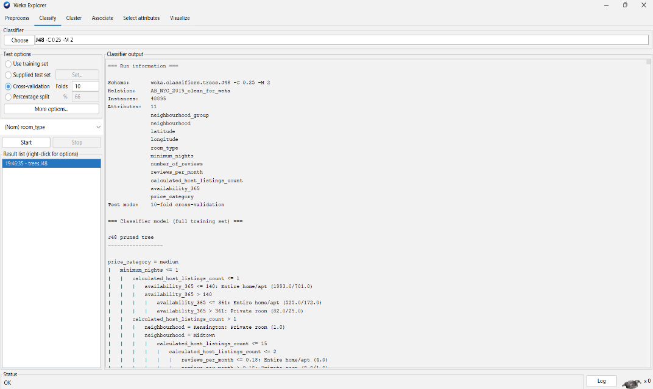
Figure 1 SCREENSHOT: J48 Summary (Accuracy/Kappa/Errors)
The dominant categories portray interesting performance at the class level. In case of private rooms, it achieved a precision of 0.802, a recall of 0.812, and an F -measure of 0.807. In the case of complete homes/apartments, the outcomes were equally strong, with a precision of 0.837, recall of 0.850, and F -measures of 0.844. Performance in the minority class, shared rooms, was significantly lower, as the recall was 0.284 and F -measure was 0.402. This is expected due to the high level of class discrimination, overlapping of prices, availability and spatial characteristics between cheap private rooms and common areas.

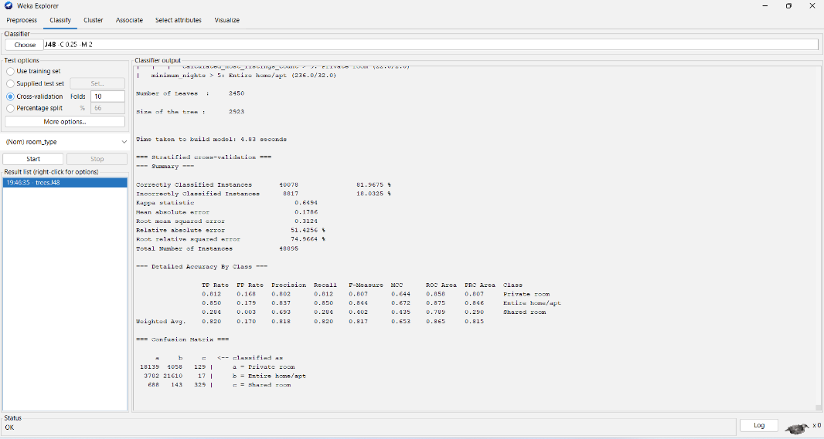
Figure 2 SCREENSHOT: J48 Confusion Matrix
The confusion matrix highlights two salient patterns:
Firstly, a significant amount of muddiness between individual rooms and whole houses, especially to the case of a moderate priced and centrally located listing, and lastly a systematic misclassification of shared rooms as personal rooms, due to the shared success on the low pricing and similar availability trend.

RandomForest Results:
Tenfold cross-validation with 100 decision trees was applied to implement random forest. The model had a 82.22% accuracy which is a significant yet a small, better score than J48. The Kappa also increased to 0.654, which shows that there is more concordance between the actual and the predicted classes.

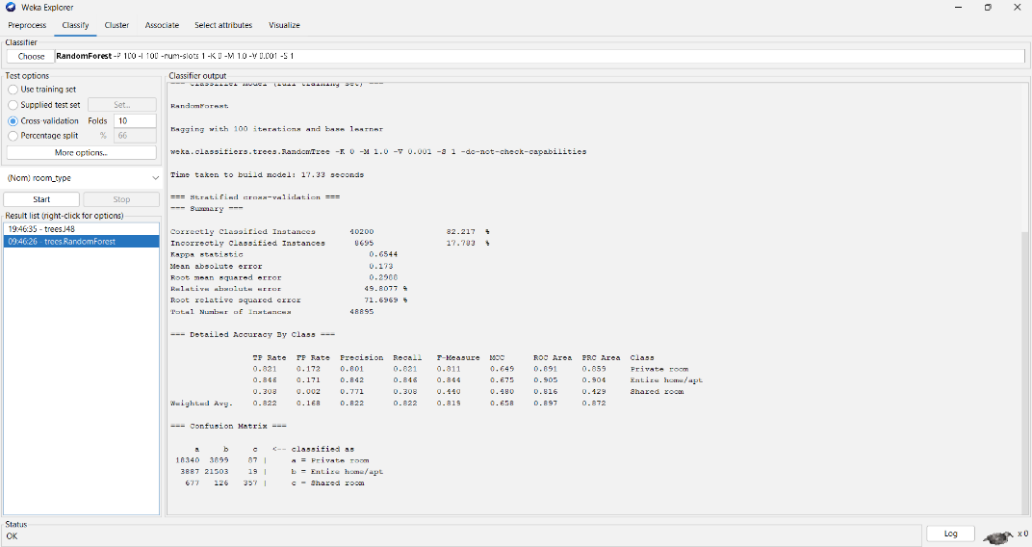
Figure 3 SCREENSHOT: RandomForest Summary (Accuracy/Kappa/Errors)
The per-class output was consistent with the J48 model except for the RandomForest having better precision and F-measure on the minority category. In the case of private rooms, model precision was 0.801, a recall of 0.821 and F-measure of 0.811. In the whole homes/apartments, the precision and recall are 0.846 and 0.842, respectively, with an F -measure of 0.844. It is worth noting that it was noted that the shared room category had measurable gains with precision of 0.771 and F-measure of 0.440 raising the view that the ensemble approach yielded predictive stability on low-frequency patterns.

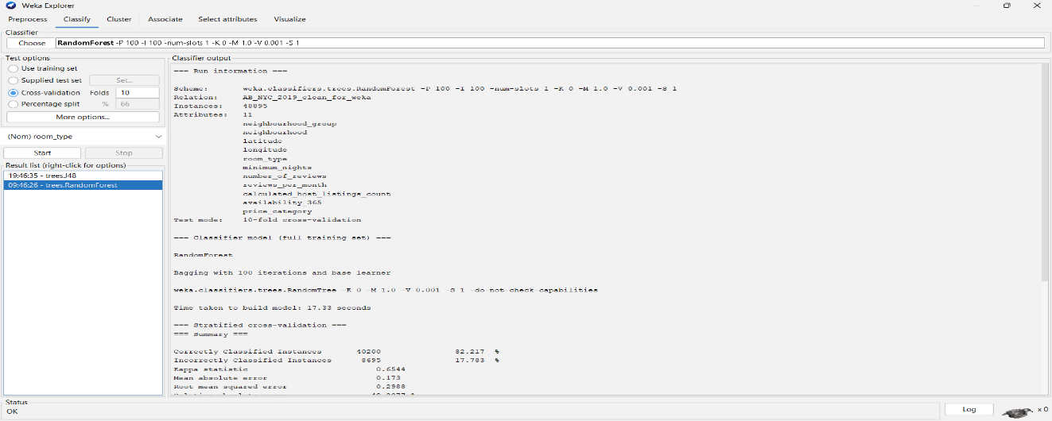
Figure 4 SCREENSHOT: RandomForest Confusion Matrix
RandomForest has fewer misclassifications that are extreme and less error dispersion than J48. Specifically, there were fewer misclassifications of shared rooms, 143 (in J48) and 688 to 677 when there was a misclassification to the rest of the home/apt category and then to the private rooms category respectively. Such improvements align with well‑established advantages of ensemble methods, notably variance reduction and robustness to noise.

Comparative Overview of Classification Models:
RandomForest continues to beat J48 in all areas of evaluation, albeit by small margins, as opposed to revolutionary ones. The accuracy medication and Kappa enrichment both show an improvement of (+0.25 percentage points) and (+0.005), respectively, in demonstrating high-quality generalisation, and the enhanced minority-class performance serves to highlight the strengths of RandomForest as a means of detecting the importance of subtle interplay of attributes. These results agree with the literature that states that ensemble tree models generally provide high-quality predictive results in heterogeneous, high-dimensional data. However, J48 still has some clear benefits in interpretability with its ability to display visible rule paths which are easy to have a visual look at and understand.

Clustering Results (K-Means)

Cluster Distribution and Convergence:
K-means clustering was done with k=3 based on the Euclidean distance. The algorithm converged in seven iterations, indicating that there were effective partitioning and groups are well separated. The final cluster distribution was:
- Cluster 0: 21,783 listings (45 %)
- Cluster 1: 5,206 listings (11 %)
- Cluster 2: 21,906 listings (45 %)

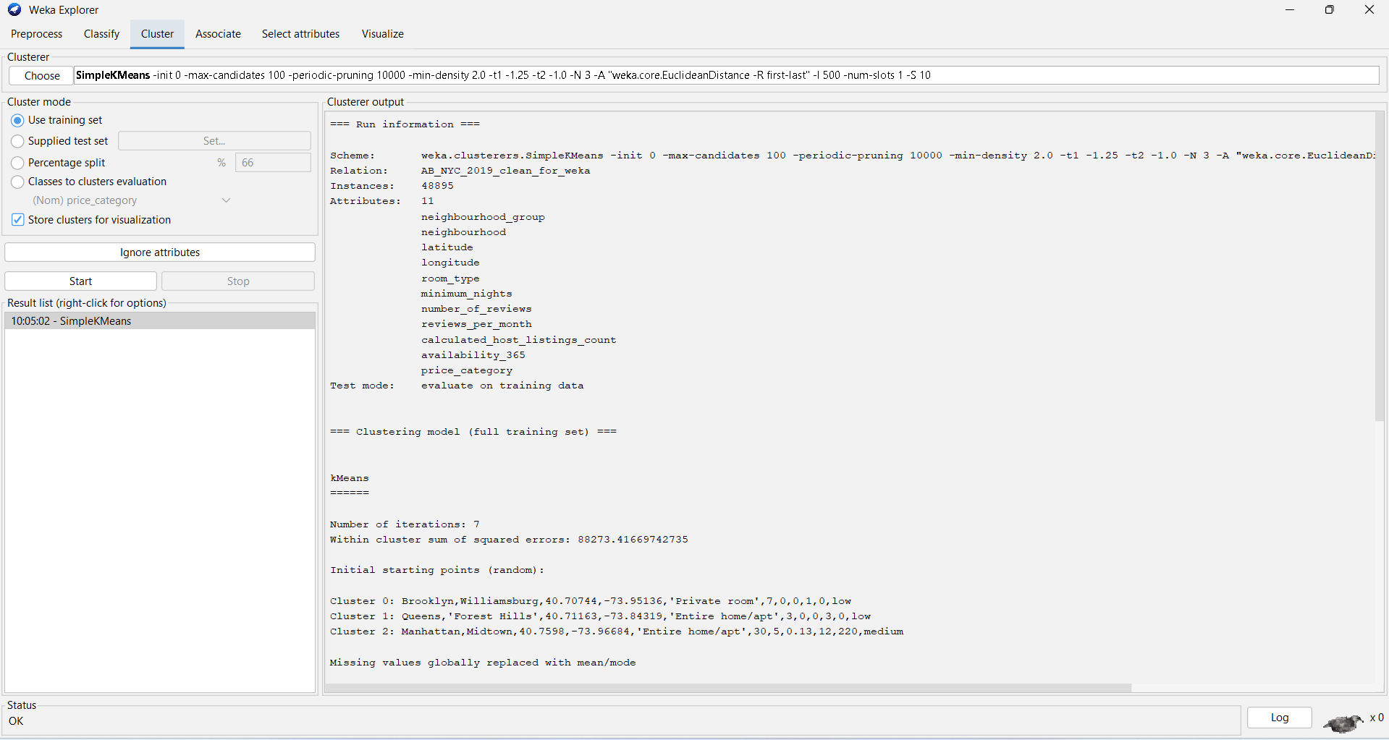

Figure 5 SCREENSHOT: K‑Means Cluster Summary
Such distribution suggests that there are two larger types of listing with one smaller and distinctive market segment.

Cluster Interpretations:
The centroid values have some significant structural trends in the Airbnb market.
Cluster 0 - Budget Private Rooms in Brooklyn (45%). This cluster is characterised by:
- Private rooms mostly dominate.
- The Brooklyn neighbourhoods of Brooklyn, particularly Williamsburg, are where the concentration occurs.
- I cheap pricing and high guest turnover (= ca. 1.2 reviews/month)
- Single‑property or casual hosts (average host listings @ 2.5)
- Moderate per year availability (84 days)
There are stiff competition and demand in this segment, which is rated on affordability.
Cluster 1 - Long-Stay Entire Homes in Queens (11%). Cluster 1 consists primarily of:
- Entire homes or apartments
- Astoria and Forest Hills in Queens.
- Extremely low minimum night requirements (= 33 nights)
- Availability (> 200 days) that is extremely high.
- Semi-professional hosts operating four and above properties.
This cluster is a niche sub- market with long- term travellers or seasonal accommodation, which might have reduced occupancy by the location and minimum stay factors.
Cluster 2 - Mid‑Price Entire Homes in Manhattan (45 %)
Cluster 2 includes:
- Entire home listings
- Co-located in high-demand neighbourhoods (such as Midtown and Hell’s Kitchen).
- The middle price and accommodation.
- Professional hosts (12 on average)
- Smaller minimum stays as compared to Cluster 1 (around 8 nights)
This group is the centre of the Airbnb Manhattan portfolio and correlates with the existing tourist behaviours and host professionalisation trends.
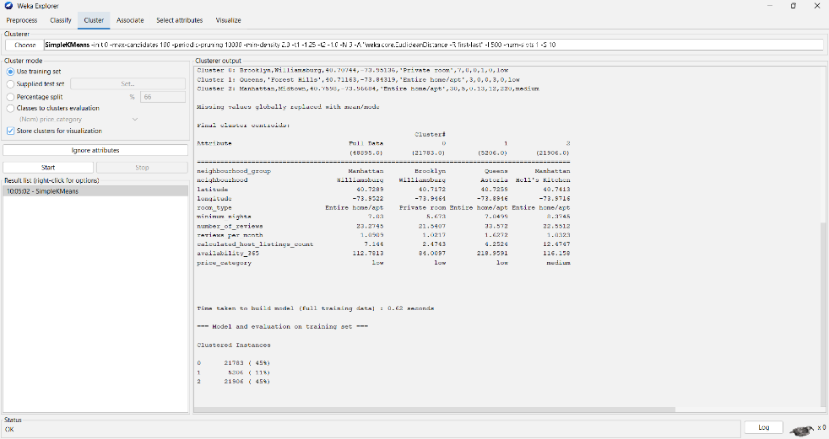
Figure 6 SCREENSHOT: K‑Means Centroid Table

Discussion Of Findings
This discussion is a critical evaluation of how the machine-learning methods used were effective, how the empirical data can fit into the working environment of Airbnb, and how the methodology employed can be considered sound. Combining classification and clustering techniques, the analysis offers the global view of market structure and model behaviour, which is consistent with the multifaceted needs of the modern data-mining research.

Model Performance
The J48 decision-tree presented a solid baseline with a accuracy of about 82 -percent. It was open in its lines of decision that revealed the salient predictors of price, availability and host activity, which proved to be crippling discriminators. The depth of the tree was, however, indicative of an overfitting tendency that would restrict generalisation to uncharacteristic cases at the boundary. RandomForest, in contrast, ranked modestly higher in predictive error rate than J48, therefore supporting the theory of ensemble learning. RandomForest reduced the variance by combining a set of trees using bagging, a technique that boosts stability, especially when there is a minority group e.g. shared room. Its resilience to noise, irregularities, and overlapping feature distributions further reinforced its robustness. Even though it increased the amount of computational overhead, the improvement in the accuracy and reliability justified its use by the attendant. The observations can be compared with modern literature where RandomForest is considered one of the most successful classical algorithms to deal with tabular data [27].

Misclassification Patterns
The systematic tendencies of misclassification were covered in confusion matrices. The poor recall in shared rooms, which is underrepresented in the sample set, was since machine-learning models require adequate numbers of exemplars to draw decision boundaries. There was also materialising of overlaps between individual rooms as well as the whole of the home/apartment in consideration of the subtle market realities. On the boroughs like Manhattan and Brooklyn, in private rooms located in high-quality buildings, the price and the aesthetical qualities tended to be in the range of a small studio, hence making categorical distinctions more difficult [28].

Clustering Insights
Clustering analysis provided very useful background information on classification results. Clusters of Brooklyn that represented private rooms and Manhattan that represented mid-price whole homes were large and coherent and easily merged into the models with the assistance of good separability in review activity and availability. On the other hand, a small group of long-stay single-family houses in Queens represented a desirable and unusual admixture of elements, which created a doubt as to classification. Shared rooms were not realising a separate cluster and, therefore, the reason they did not receive consistent treatment in both J48 and RandomForest [29].

Methodological Adequacy and Limitations.
The adopted methodological decisions were in alignment with the aims of the study. J48 was interpretable whereas the RandomForest had excellent predictive reliability. The K-means clustering was successful to reveal market segments and supplemented geographic and pricing heterogeneity. However, there were disadvantages such as the sensitivity of initialisation and scaling of K-Means, poor results with the outliers, difficulties with modelling the rare classes, along with the trade-offs between the performance and transparency of RandomForest and J48. This can be reduced by future work by use of class-balancing methods like SMOTE, just feature scaling, or other density-based methods like DBSCAN [30].

Business Recommendations

Based on the results of our classification and clustering analyses, I would set out some action plans based on evidence-based best practises. In the case of hosts that operate in the low-end prayer room category, which is marked as Cluster 0, I will suggest the introduction of dynamic pricing considerations to be able to remain competitive, specific investments through the application of cost-effective quality improvements, and the implementation of unique services including early cheque-in, at-work facilities, or self-cheque-in services.
Regarding hosts providing long-term whole house services, which will fall into the Cluster 1, I would suggest the reduction of the minimum number of nights stay to boost the booking rates, transforming the listings to attract digital nomads, as well as corporate travellers, and discussing mid-term rental options that can supplement Airbnb bookings.
Lastly, the measures that can be justified among professional Manhattan hosts, which are outlined as Cluster 2, include the optimization of pricing based on the high demand in the chosen seasons by consulting the historical booking data, optional additions of additional services (professional cleaning or late cheque-out) to the offered services to increase revenue, and increased exposure via high-quality professional photos and key words. At platform level, Airbnb can optimise its recommendation strategy to more effectively reveal similarity cluster features, support personal pricing strategies and identify high availability segmentation that can drive targeted host support programmes,

Conclusion
In this research that used the predictive analytics applied to the ABNYC2019 data dataset to separate Airbnb listings based on the room typology, in addition to using clustering approaches to explain underlying structural trends. The synthesis of both supervised and unsupervised machine-learning paradigms provided a comprehensive picture of the associations between listing features and room typologies, geometrical dispersion, host behaviour, and the current market forces within the New York city. The empirical findings met all four specified research goals and supported the pedagogic significance of the combination of classification and clustering to support the pragmatic decision-making in the short-term rental business environment.
Using a dual-model approach we used a J48 decision-tree classifier and a randomforest ensemble to classify the listings to any of the three categories which are entire homesteads/apartments, personal room and shared room. Both algorithms showed semi-good performances in discriminative, having 81.97 and 82.22 accuracies respectively. RandomForest marginally outperformed J48 in three key terms of evaluation, such as Kappa coefficient, F -measure, and minority -class precision, thus confirming its better generalisation ability. This small difference agrees with the existing theory, as ensemble methods generally decrease variance and strengthen predictive consistency in non-homogeneous information settings.
However, J48 offers interesting interpretability through its inherent hierarchical procedural rule, thus explaining the role of variables approached, including price, geographic location, and host interaction in the moderation of room-type forecasts. The given shortcomings in the proper classification of shared rooms can be explained by the high level of class imbalance and the corresponding overlapping of the features, illustrating the fact that the study of the categories that are represented thinly is quite challenging. Enhancing back the classification effort, the K-Means clustering produced a tri-cluster that was cogent and made differentiated market segments.
Cluster 0 included economically modestly priced private rooms, mainly based in Brooklyn; Cluster 1 included long-term whole homes, with high minimum upon night stays, based in the tourist precincts of Manhattan; and Cluster 2 covered whole-home, moderately priced, and often professionally managed properties. This kind of stratification reflects spatial, behavioural, and price-structural patterns that are supported by preceding literature hence provides subtle explanations of host operating plans and guest decision-making. In addition, these clusters put the classification results into context making it clear that some room typologies are particularly more difficult to predict and why shared rooms also form a persistent challenge.
The synthesis of the classification and the clustering formed a powerful methodological framework which could produce practical insights related to the Airbnb stakeholders. The models of classification provide robotic listing classification and possible improvements on search engine optimisation, whereas the clustering provides fine market classification and enables accuracy pricing in approaches. In concert, these techniques encapsulate both overt behavioural regularities and subtle latent structures inherent in complex, high‑dimensional datasets.
Altogether, this research measured up to its required goals in that it provided predictive, structural, and strategic information about the New York City Airbnb market. Empirical results shed light on whether machine-learning methods can support data-driven decision-making in the field of short-term rental and establish an academic base to conduct further research that can involve longitudinal analytics and advanced clustering algorithms and intervention policies to eliminate the class imbalance.

References

[1] | N. a. d. T. G. a. F. G. a. G. S. Camatti, “Predicting Airbnb pricing: a comparative analysis of artificial intelligence and traditional approaches,” Computational Management Science, vol. 21, no. 1, p. 30, 2024.
[2] | A. a. A. E. a. J. S. Lektorov, “Airbnb rental price prediction using machine learning models,” in 2023 IEEE 13th Annual Computing and Communication Workshop and Conference (CCWC), Las Vegas, IEEE, 2023, pp. 0339 - 0344.
[3] | T. a. M. M. a. S. C. Dogru, “Adding evidence to the debate: Quantifying Airbnb's disruptive impact on ten key hotel markets,” Tourism Management, vol. 72, pp. 27 - 38, 2019.
[4] | F. N. H. A. H. M. M. H. A. B. O. G. a. N. A. P. R. Yoseph, “The impact of big data market segmentation using data mining and clustering techniques,” Journal of Intelligent & Fuzzy Systems, vol. 38, no. 5, pp. 6159 - 6173, 2020.
[5] | E. Kirkos, “Airbnb listings’ performance: Determinants and predictive models,” European Journal of Tourism Research, vol. 30, pp. 1 - 25, 2022.
[6] | A. a. V. Z. Domènech, “Geographical dimensions of Airbnb in mountain areas: The case of Andorra,” Journal of Rural Studies, vol. 79, pp. 361 - 372, 2020.
[7] | G. a. P. D. a. B. J. W. Zervas, “A first look at online reputation on Airbnb, where every stay is above average,” Marketing Letters, vol. 32, no. 1, pp. 1 - 16, 2021.
[8] | Z. H. Alharbi, “A sustainable price prediction model for airbnb listings using machine learning and sentiment analysis,” Sustainability, vol. 15, no. 17, p. 13159, 2023.
[9] | N. a. d. T. G. a. F. G. a. G. S. Camatti, “Predicting Airbnb pricing: a comparative analysis of artificial intelligence and traditional approaches,” Computational Management Science, vol. 21, no. 1, p. 30, 2024.
[10] | Y. Liu, “Airbnb pricing based on statistical machine learning model,” in 2021 International Conference on Signal Processing and Machine Learning (CONF-SPML), 2021, pp. 175 - 185.
[11] | H. Y. a. Y. S.-C. Yoon, “Finding tourism niche on image-based social media: Integrating computational methods,” Journal of Vacation Marketing, vol. 30, no. 4, pp. 874 - 889, 2024.
[12] | C. a. L. M. a. S. S. a. T. L. a. W. S. Zhang, “Decomposition methods for tourism demand forecasting: A comparative study,” Journal of Travel Research, vol. 61, no. 7, pp. 1682 - 1699, 2022.
[13] | R. a. L. G. a. F. D. K. C. a. H. X. Law, “Tourism demand forecasting: A deep learning approach,” Annals of tourism research, vol. 75, pp. 410 - 423, 2019.
[14] | L. a. Z. W. Huang, “Hotel demand forecasting: a comprehensive literature review,” Tourism Review, vol. 78, no. 1, pp. 218 - 244, 2023.
[15] | “Random forest, bagging, and boosting of decision trees,” in Machine Learning and Artificial Intelligence in Marketing and Sales: Essential Reference for Practitioners and Data Scientists, Emerald Publishing Limited, 2021, pp. 139 - 182.
[16] | V. a. E. R. a. Y. J. Arefieva, “A machine learning approach to cluster destination image on Instagram,” Tourism Management, vol. 85, p. 104318, 2021.
[17] | Y. a. S. S. Chung, “Understanding host marketing strategies on Airbnb and their impact on listing performance: a text analytics approach,” Information Technology & People, vol. 35, no. 7, pp. 2075--2097, 2022.
[18] | D. M. R. a. E. V. D. Z. Ioannides, “Airbnb as an instigator of ‘tourism bubble’expansion in Utrecht's Lombok neighbourhood,” Tourism Geographies, vol. 21, no. 5, pp. 822 - 840, 2019.
[19] | D. a. J. G. Chicco, “The advantages of the Matthews correlation coefficient (MCC) over F1 score and accuracy in binary classification evaluation,” BMC genomics, vol. 21, no. 1, p. 6, 2020.
[20] | R. a. T. X.-A. Delgado, “Why Cohen’s Kappa should be avoided as performance measure in classification,” PloS one, vol. 14, no. 9, p. e0222916, 2019.
[21] | M. a. o. Maechler, “Finding groups in data: Cluster analysis extended Rousseeuw et al,” R package version, vol. 2, no. 0, pp. 242 - 248, 2019.
[22] | Y.-C. Hu, “Combination forecasting using multiple attribute decision making in tourism demand,” Tourism Review, vol. 77, no. 3, pp. 731- 750, 2022.
[23] | S. a. L. Y. a. G. J.-e. a. W. S. Sun, “Tourism demand forecasting: An ensemble deep learning approach,” Tourism Economics, vol. 28, no. 8, pp. 2021- 2049, 2022.
[24] | X. a. C. Z. Zhou, “Destination attraction clustering: segmenting tourist movement patterns with geotagged information,” Tourism Geographies, vol. 25, no. 2 - 3, pp. 797- 819, 2023.
[25] | M. a. M. A. a. L. H. a. A. H. a. M. A. A. a. A. W. Nilashi, “A hybrid method with TOPSIS and machine learning techniques for sustainable development of green hotels considering online reviews,” Sustainability, vol. 11, no. 21, p. 6013, 2019.
[26] | S. Nirmal, “Comparative study between k-means and k-medoids clustering algorithms,” Int. Res. J. Eng. Technol, vol. 839, no. 1, pp. 839--844, 2019.
[27] | L. a. C. X. a. D. V. J. a. L. X. a. W. F. Cheng, “Applying a random forest method approach to model travel mode choice behavior,” Travel behaviour and society, vol. 14, pp. 1--10, 2019.
[28] | H. a. S. K. Li, “Competitive dynamics in the sharing economy: An analysis in the context of Airbnb and hotels,” Marketing Science, vol. 38, no. 3, pp. 365--391, 2019.
[29] | U. a. Z. B. a. M. F. L. Gunter, “Modelling and forecasting European Airbnb occupancy during the pandemic: The specific merits of panel-data and Markov-switching models,” Tourism Economics, vol. 31, no. 4, pp. 695--713, 2025.
[30] | P. a. B. R. a. G. K. a. B. A. Kumar, “Classification of imbalanced data: review of methods and applications,” in IOP conference series: materials science and engineering, IOP Publishing, 2021, p. 012077.

