International Financial Management

Ivan Georgiev
1914979
LCBB6002

Table of Contents
1. Introduction 3
2. Discussion 3
5. Conclusion 8
References 10

Company name: Coca-Cola

1. Introduction
This study elaborates the dividend distribution policy of multinational beverage corporations and highlights the efficient market hypothesis theory market to predict the performance of the company and, most importantly, determine the stock price movements. Coca-cola is the global leader in beverage companies. This company has an interest in soft drinks and energy drinks. The company has operated for more than nine decades, and most importantly, the company adopts a high dependency policy. This present study has discussed the appraising project method of Coca-Cola, including the dividend distribution policy.

2. Discussion
2.1 Dividend distribution policy of Coca-Cola
The main purpose of International financial management is to maximise the wealth of the company's stakeholders. This process has been discussed based on currency, political situation, and, most importantly, diversified opportunity sets.
According to the report, the coca-cola company pays dividends consistently, and the company has adopted a dividend policy since 1963. The company has a strong dividend policy, and first and foremost, this company (The Coca-Cola Company. 2022) has a high credit rating, and the overall performance of this company is highly impressive, according to the financial statement
2.1.1 Final Dividend
Final dividend
A final dividend policy refers to the dividend policy declared by the company for a given fiscal year, and this method has been calculated after all year-end financial statements. With the application of this policy, the board members of the company could be able to analyse the profitability and enhance awareness about the financial health. According to the report, the performance of dividend per share received by the stakeholders is excellent for coca-cola company. This is the cash payment method, and this method is forecasted by the analysts. The major significant factor is that the Coca-Cola company has been able to increase per share over the last five years. The annual dividend growth of the company is 8% and 10 % for the entire period (Gkeka et al., 2018, p.44).
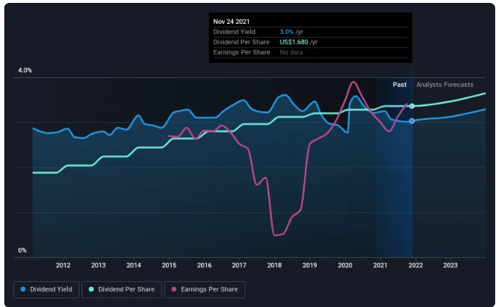

Figure 1: Final dividend
(Source: Svogun, 2020)

2.1.2 Interim Dividend
The interim dividend is the dividend payment method, and the interim dividend method is paid out ahead of the firm's general meetings. The interim dividend has been calculated before the release of the final financial statement. In this case, the final approval is given by the stakeholders. The Coca-Cola company has lifted its dividend dependency growth by about 6.0% yearly. According to the report, the next dividend payment of this company is about the US $ 0.42 per share (Gómez, 2019, p.520).
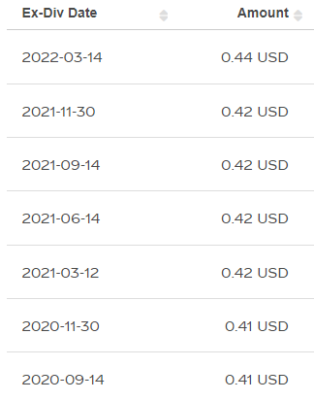
Figure 2: Interim Dividend of Coca-cola from 14/09/2020
(Source: Arab, 2018)
2.1.3 Application of Gordon's model of dividend policy
Gordon's model of dividend policy plays a significant role analyse the optimum payout ratio and evaluating the financial investment of the company. With the application of this model, the company could be able to understand the constant growth in dividends. The main purpose of this model is to examine the market value of the share and, most importantly, evaluate the cost of capital and expected annual growth of the company.
3. Market hypothesis theory related to Coca-Cola
3.1 Application of Efficient market hypothesis theory
Samuelson and Fama have developed the efficient market theory for the analysis of share prices and stock trade policy. The market hypothesis theory highlights the share price information. Moreover, the application of the efficient market theory helps the company to operate efficiently. The major significant factor is that this theory explains the stick trade on the fair market value and the efficient market hypothesis theory helps to provide important information such as current stock price and stock trade at fair value. With the implementation of the efficient market hypothesis, the investors are able to fundamental analysis, and this theory helps to achieve the same profit on average. The market hypothesis theory has three forms that are weak form, semi-strong form, and strong form. The weak form of efficient market hypothesis theory assumes the price of securities reflects all available market information. Semi strong form of efficient market hypothesis highlights the current stock price and fairly reflects all market information. On the other hand, a strong form of efficient market hypothesis highlights the current stock price, and this process helps to analyse the internal development of rolling out the new product of the company (Bogataj and Bogataj, 2019, p.5137).
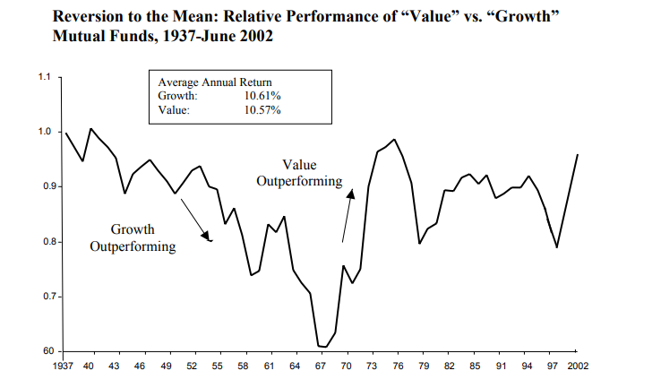
Figure 3: Efficient market hypothesis theory
(Source: Abdelhady, 2021, p.332)
3.2 Challenges faced by the company in different international financial markets
Many obstacles are faced by the Coca-Cola company, and according to the world health organisation, the maximum consumption of Coca-Cola might be harmful to health and paper bottle waste and water scarcity are caused by the Coca-Cola company. Due to this reason, the company faced severe challenges, and the beverage industry is highly competitive. The major competitor of this company is PepsiCo. According to the data, three tons of plastic have been used by the company. On the other hand, a large number of plastics have been disposed of within the surroundings. These disappointing factors could be able to create environmental pollution, and the main ingredient of this company is water. Pollution is the biggest environmental condition, and due to this reason, the coca-cola company focuses on minimising the problem issues related to the plastic solution (Rey-López and Gonzalez, 2019, p.810). The major significant factor is that in 2018, the company announced plans to reduce the usage of plastics. The company has designed its packages in an innovative way to reduce the amount of raw material and as well as enhance the economy in a strategic way.

4. Methods of appraising projects of Coca-Cola
4.1 NPV Method
This method helps to calculate the current total value of the future system and the major significant factor is that if the NPV of a project or the investment is positive, this factor indicates the discounted future values of invested cash flows. For the calculation of the NPV, the estimation of the future cash flow is mandatory. This method helps to determine the current discount rate, and this provides a beneficial opportunity to understand the profitability or loss of a particular project or any given investment. On the other hand, NPV helps to determine the present value of the future investment in the cash flow. This method assists in analysing the possible earnings. Coca-cola follows this NPV method to analyse the future cash flow and determine the future investment of the cash flow. A positive NPV value indicates the projected earrings generated by the project, and this factor indicates the profitability regarding investment in the particular project. On the other hand, negative NPV indicates the net loss of a particular project (Mari et al., 2020). For the NPV calculation, identification of the number of periods and as well as the examination of the discount rate is a mandatory factor in analysing the future cash flow in an effective way. This is used in the capital budgeting, and the NPV method helps to determine the current value and, most importantly, analyse the future cash flow generated by the project.
4.2 IRR Method
IRR method help to determine the profitability of the potential investment, and this method helps to an annual rate of growth. This method is used for the yearly budgeting for any specific project. This is the simplest way to assume the profitability of the estimated project in an appropriate way. With the application of this method, Coca-cola could be able to understand the potential savings and examine the future growth rate related to the estimation of any project. This method provides a quick snapshot of the potential value or savings, and this is the most effective and significant way to understand the variable cash flow over the investment. This innovative and effective method provides a beneficial opportunity for the analysis of the performance benchmark, and this process evaluates the investment or project. This method estimates the rate of return to indicate the profitability of the project.

5. Conclusion
This study has discussed the final dividend and interim dividend dependency policy of multinational beverage company Coca-Cola. It evaluates the application of the efficient market hypothesis theory to analyse the stock trade on the fair market value. This theory highlights the important information related to the current stock price and stock trade at fair value. This present study explains the challenges of this company in different international financial markets. This current study also discusses the strategies of this company to overcome the challenging factors. This study has mentioned two methods of appraising projects that are NPV and IRR, to understand the profitability or loss of a particular project or any given investment. These methods assist in determining the present value of the future investment, which can help the company to understand the requirements of an investment.

References
Abdelhady, S., 2021. Performance and cost evaluation of solar dish power plant: sensitivity analysis of levelized cost of electricity (LCOE) and net present value (NPV). Renewable Energy, 168, pp.332-342.https://www.sciencedirect.com/science/article/pii/S0960148120320140
Arab, N., 2018. Relationship between dimensions of Brand Equity and 4Ps of Marketing Mix-Place, Product, Promotion, & Price: Coca Cola-Consumer Based Qualitative Survey.https://mpra.ub.uni-muenchen.de/id/eprint/85086
Bogataj, D. and Bogataj, M., 2019. NPV approach to material requirements planning theory–a 50-year review of these research achievements. International Journal of Production Research, 57(15-16), pp.5137-5153.https://www.tandfonline.com/doi/abs/10.1080/00207543.2018.1524167
Gkeka, E., Kosmidis, K. and Simitsis, G., 2018. The value relevance of dividend announcement: An empirical study of the Greek Stock Market. International Journal of Business and Economic Sciences Applied Research (IJBESAR), 11(2), pp.44-50.https://www.ceeol.com/search/article-detail?id=713339
Gómez, E.J., 2019. Coca-Cola's political and policy influence in Mexico: understanding the role of institutions, interests and divided society. Health policy and planning, 34(7), pp.520-528.https://academic.oup.com/heapol/article-abstract/34/7/520/5543873
Investopedia. 2022. Internal Rate of Return (IRR). [online] Available at: <https://www.investopedia.com/terms/i/irr.asp#:~:text=The%20internal%20rate%20of%20return,same%20formula%20as%20NPV%20does.> [Accessed 30 March 2022].
Mari, C., 2020. Stochastic NPV based vs stochastic LCOE based power portfolio selection under uncertainty. Energies, 13(14), p.3677.https://www.mdpi.com/771114
Rey-López, J.P. and Gonzalez, C.A., 2019. Research partnerships between Coca-Cola and health organisations in Spain. European journal of public health, 29(5), pp.810-815.https://academic.oup.com/eurpub/article-abstract/29/5/810/5086412
Svogun, D.P., 2020. Momentum-Based Learning Strategies for Technical Analysis: Implications for the Efficient Market Hypothesis (Doctoral dissertation, Fordham University).https://search.proquest.com/openview/ed26afaac475dc06712c99bf84c577d0/1?pq-origsite=gscholar&cbl=51922&diss=y
The Coca-Cola Company. 2022. The Coca-Cola Company: Refresh the World. Make a Difference. [online] Available at: <https://www.coca-colacompany.com/> [Accessed 31 March 2022].

