Critique an Essay-- Using Multimodal Resources to Design EFL Classroom Lead-ins--A Multimodal Pedagogical Stylistics Perspective
- Introduction
In recent years, with the development of science and technology, the application of multimedia information technology in classroom teaching has changed how meaning is constructed in classroom teaching discourse. Language is no longer the only modality or the main modality of classroom teaching, and the classroom becomes a multimodal discourse where ‘space, gesture, eye contact, movement, voice, accent, music, three-dimensional things, spoken words, written words, tables, drawings, animations, etc., co-construct meaning. (Jewitt, 2014). Furthermore, I tend to explore how to enhance the efficiency of English as a Foreign Language (referred to as EFL) teaching with multimodal resources in my thesis. Given this, I have selected an essay related to EFL teaching from a multimodal perspective to critique, expecting that the essay can shed enlightenment on me in theoretical frameworks, the application of methodology and research design.
The title of this essay is Using Multimodal Resources to Design EFL Classroom Lead-ins--A Multimodal Pedagogical Stylistics Perspective (Lei and Zhang, 2024). It is in Linguistics and Education, an international peer-reviewed journal concerning advanced knowledge, theory, or methodology at the intersections of linguistics and education. Based on the theory of multimodal stylistics, the essay proposes a multimodal stylistic analysis path for EFL classroom teaching and studies how EFL teachers can use multimodal resources to design classroom lead-ins to improve students’ engagement and teaching efficiency.
In the spirit of learning with an open mind, this article will critique the selected essay from the research question and objectives, literature review, theoretical framework, research methodology, findings and discussion in five directions. I tend to put forward my own viewpoints on the key parts and draw on the strengths of the selected essay in the hope that I can be inspired by it.
- Critiques of Main Parts
  - Critique of Research Problems and Purpose
The introduction section of this essay highlights that previous studies have predominantly concentrated on the beneficial aspects of classroom lead-ins. Nevertheless, there is a dearth of research into the significance of lead-in sessions in EFL teaching, particularly in university-level English education, thus researchers highlight the necessity for further studies in this area. Concurrently, Lim (2020) proposes that English teaching is a multimodal process where teachers use both language and non-verbal resources, such as gestures, facial expressions, and technological tools, to achieve their teaching objectives. Therefore, researchers attempt to address how to use multimodal resources to enhance the format of the lead-in session in EFL teaching and to provide guiding principles for teachers when designing multimodal classroom lead-ins.
According to researchers, there are no systematic studies of the multimodality of EFL classroom discourse to design effective lead-ins, thus this essay has a clear purpose that researchers intend to explore the effective ways to help EFL teachers use multimodal resources to introduce new topics and actively engage students during classroom lead-ins, focusing on the framework of multimodal pedagogical stylistics.
  - Critiques of Literature Review
Section two of the essay is a general overview of previous studies of classroom lead-ins and multimodal pedagogical discourse. On the critiques of the literature review, this part is going to be detailed in following aspects: the comprehensiveness, the time and the original of literatures, the guiding theoretical or conceptual framework and the rationality of structural arrangements.
According to Boswell and Cannon (2017), a thorough literature review allows for credibility of the study and provides the foundation for the study’s significance and relationship to practice. The essay presents a comprehensive and systematic account of literature pertinent to the study problem in the introduction section, exhibiting a clear and logical progression. It can be divided into two parts: one is about the theme of this study, classroom lead-ins, and other focuses on the previous studies of guiding theoretical framework, providing a solid foundation for section three of the essay.
In terms of lead-ins, the essay introduces previous studies on the function of classroom openings, strategies and guidelines for the pedagogical design, and the neglect of lead-ins in university EFL classrooms. The elaboration of the role of lead-ins and the neglect of lead-ins in EFL classrooms confirm the necessity and significance of studying the pedagogical design of lead-in sessions. In particular, the literature review section on the instructional design of lead-ins cites the work of Aung and Tepsuriwong (2017). Based on the observations of five undergraduate English classroom lead-in sessions, they have established the affective and cognitive frameworks. The researchers of the essay are inspired of these frameworks to develop These frameworks guiding principles related to their study. As for the brief overview of studies on meaning construction in multimodal pedagogical discourse, researchers have elaborated on the concept of multimodal classroom teaching originally proposed by The New London Group (1996), stating that teaching does not rely solely on the language mode but also on the combined use of multiple modalities. Concurrently, the researchers examine the theoretical foundations of previous studies on multimodal pedagogical discourse, mainly based on social semiotics and systemic-functional multimodal analysis. Furthermore, researchers analyze the previous literature on multimodal pedagogical discourse from diverse perspectives, including the study subject (from pre-school to higher education), the theme (English, science and mathematics), and the specific modality (language, images, gestures, gaze, space, technology). In addition, the researchers have reviewed previous studies on how to use multimodal resources to motivate students to participate in the classroom from different perspectives. This confirms the necessity of analyzing the relations between modes and the rational selection of modal resources, thereby paving the way for the specific research questions to be drawn out later in the essay.
Most of the literature reviewed by the researchers is primary and cutting-edge research within the last 10 years in the field of multimodal teaching and learning, including the core literature in the field (Lim, 2020; Lim and Querol-Julian,2024). Meanwhile, the literature review provides a clear explanation of the conceptual framework and theoretical foundations of multimodal discourse research, which serves as the foundation for the development of the theoretical framework of the essay in section three.
In terms of structural arrangement, the essay does not provide a general introduction and summary (Boswell and Cannon,2017). Instead, it proceeds directly to the subject matter, reviewing relevant literature in accordance with the research theme and theoretical framework. Consequently, the literature review is not well-organized to some extent so readers cannot intuitively grasp the relationship between the literature review and the practical research. CiteSpace is a multivariate, time-shifted, dynamic citation visualization and analysis software that helps researchers analyze the potential knowledge embedded in literature (Jie Li and Chaomei Chen, 2017). It has evolved in the context of scientometric, data and information visualization. In this essay, if the researchers employ this software to statistically analyze the keywords, timeline and principal researchers associated with the relevant studies in the literature review section, they can visualize the development of the study with data and enhance the credibility of the literature review through mapping (figure 1).
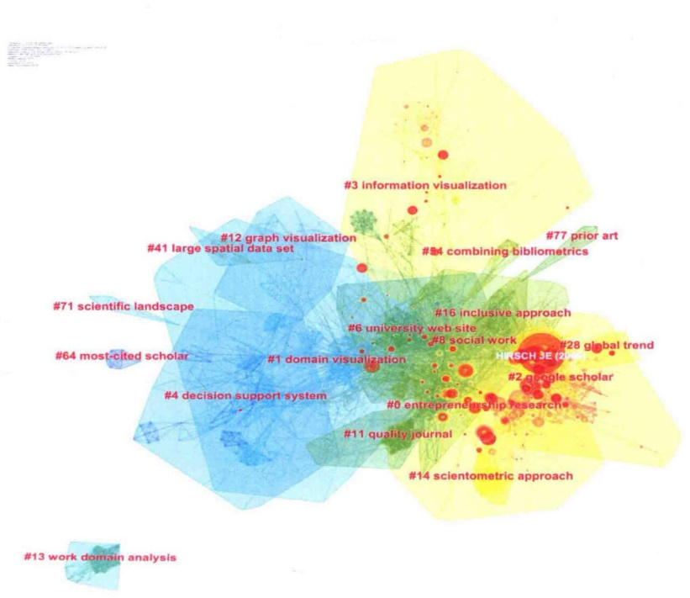
Figure1 The Example of CiteSpace Mapping
In conclusion, the literature review section of this essay reviews the core research in the field of multimodal education research in the last 5-10 years. It emphasizes the necessity and importance of this field of study, as set out in the introduction and paves the way for the emergence of a theoretical framework for the present research in the following section. The core literature that has been reviewed by the researchers has provided me with arguments to support my future thesis and opened the horizon of my research.
  - Critiques of Theoretical Framework
As mentioned in literature review, researchers give a brief review of the studies on meaning construction of multimodal pedagogical discourse. Based on this, researchers focus on the theoretical development of multimodal pedagogical stylistics and further propose the multimodal stylistic analytical framework for classroom lead-ins in section three. Moreover, as is shown from figure 2 and figure 3, the multimodal functional stylistic framework (Zhang and Mu,2012) and the multimodal stylistic analytical framework for classroom teaching discourse (Lei and Zhang,2022) are both based on theories of systematic functional linguistics (Halliday,1971). Therefore, researchers verify that classroom lead-ins, a stage of classroom teaching discourse, share all the features of dynamic multimodal classroom teaching discourse and propose the multimodal stylistic analytical framework for classroom lead-ins according to research objective (figure 4) based on present multimodal functional stylistic theories.
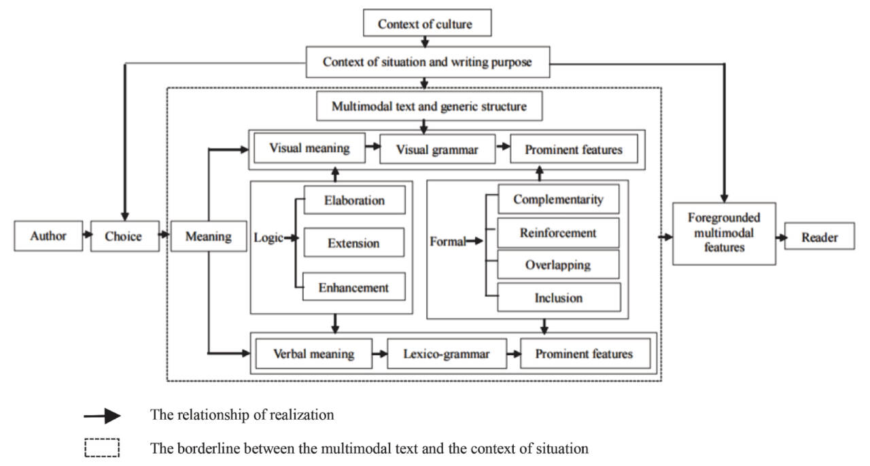
Figure 2 Multimodal functional stylistic framework (Zhang and Mu, 2012)
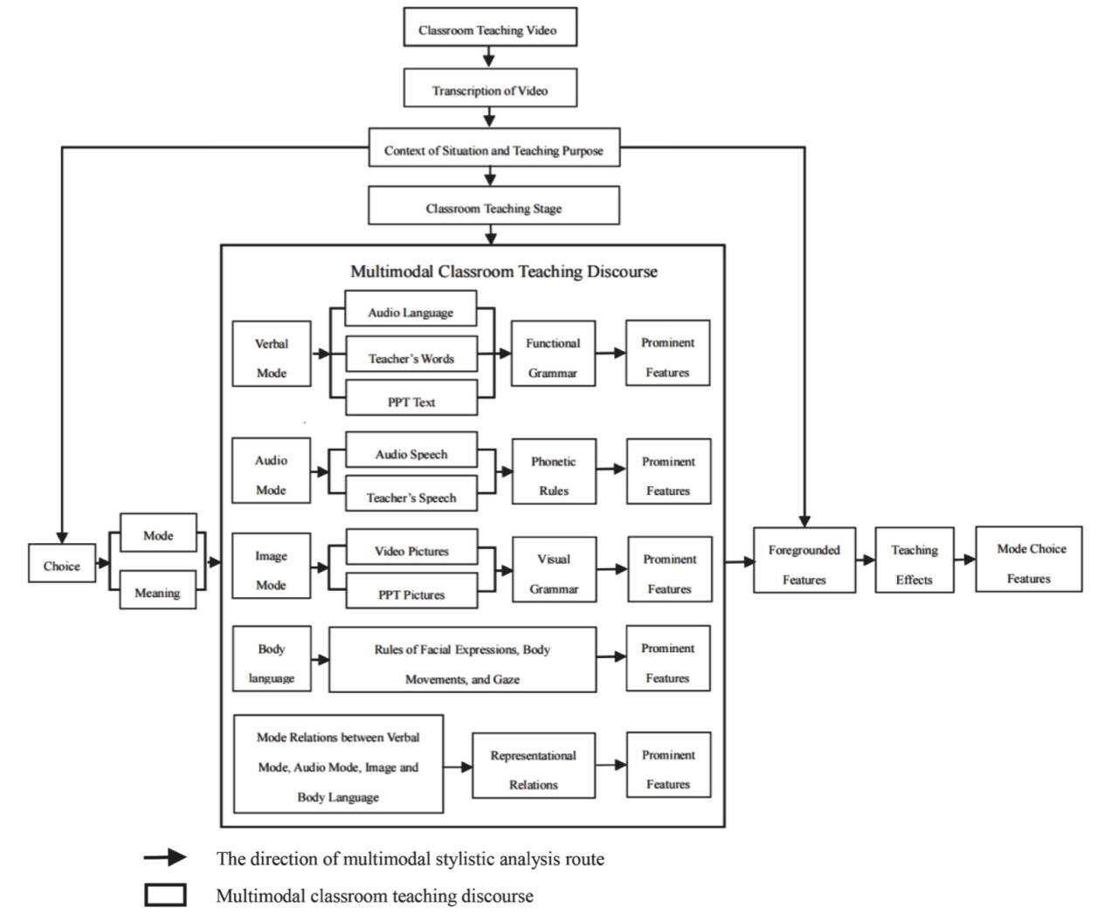
Figure 3 Multimodal stylistic analytical framework for classroom teaching discourse (Lei and Zhang, 2022)
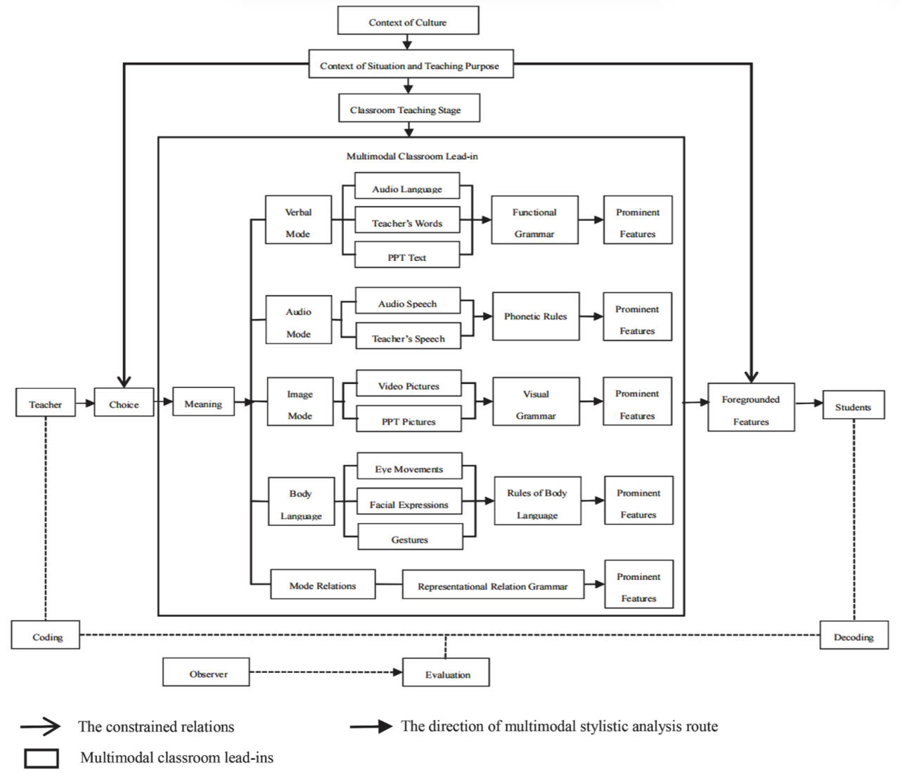
Figure 4 Multimodal stylistic analytical framework for classroom lead-ins (Lei and Zhang, 2024)
By analyzing the theoretical evolution of the multimodal stylistic analysis framework, the researchers cut through the layers and propose a multimodal analysis framework for lead-in sessions of the EFL classroom, which aims to guide the subsequent analysis and discussion.
2.4 Critiques of Methodology
Methodology refers to the nuts and bolts of how a research study is undertaken (Coughlan, Cronin and Ryan, 2013). Moreover, the rational application of methodology plays a significant role in ensuring the credibility and validity of the research. In general, the selected essay applies the quantitative research method. In this part, I am going to provide my views of the methodology of the essay in following aspects: the logical consistency of research questions and objectives, research samples and procedures.
It is essential for researchers to propose questions reflecting the purpose of the study. In this essay, researchers put forward three research questions clearly based on the specific part of literature review, including 1). What are the foregrounded features of the modes and mode relations in classroom lead-ins; 2). What are the features of the teachers’ mode choices; 3). What are the guidelines for the design of multimodal classroom lead-ins based on multimodal stylistic analyses of these lead-ins. Furthermore, the specific research objective which is to explore how teachers choose diverse modes and the grammatical structures of the modes to design effective EFL classroom lead-ins is proposed in the elaboration of multimodal stylistic analytical framework for classroom lead-ins in section three. It is clear to show that the research questions well match the purpose of the present study. With the great understanding of characteristics of various modes and principles of EFL classroom lead-ins with multimodality, teachers can make sure the efficiency of EFL classroom lead-ins design. However, I suppose that the research questions and objectives need to be elaborated in section four, the methods part so that readers can better target the key points of the research than elaborate separately.
In terms of research samples, the extent to which a sample reflects the population from which it was drawn is called representativeness, and in quantitative research, this is a crucial factor in determining the adequacy of the study (Polit and Beck, 2010). This research explores the lead-ins of six award-winning videos sharing the same topic in audio-visual group of the 10th Chinese National College English Teaching Contest held in 2019. All six lead-ins are excerpted from six 20-minutes teaching videos and the duration of the lead-in in each video is about 2-6 minutes. Moreover, the six teachers are all female EFL university teachers, and the students involved are all non-English majors with intermediate English level. Then, researchers show the similarity of teaching duration and the modes, as well as classroom space. As for the rationality of the sample, all videos are rewarded in the context of competition, so they are successful in the aspect of teaching methods, classroom atmosphere and pedagogical effectiveness. Meanwhile, the similar mode used by teachers can minimize the influence of irrelevant factors on mode choice study. However, as for the sample size, I deem that the six classroom lead-ins are too small to ensure the credibility of the research, so the research of mode choice should be explored based on larger data and diverse teaching context.
There are several types of quantitative studies that can be structured under the headings of true experimental, quasi-experimental and non-experimental designs (Robson, 2002). The selected essay analyzes the relationship between several variables based on data collection and analysis, so it is a non-experimental design. As for data collection, researchers download the videos of the six teaching demonstrations and judges’ comments from the official website and intercept the six lead-ins with the help of audio clip software “Audio & Video Editors”. Before doing this, researchers have contacted six teachers to get their permission to analyze their teaching videos and publicize the results. Therefore, the researchers obey the ethical principles of truthfulness, privacy, confidentiality and fidelity.
In research procedures, the study strictly follows three stages based on the theoretical framework, including data annotation, multimodal stylistic analysis of six videos based on the analytical framework, and the discussion of features of mode choices and general principles of classroom lead-ins design with multimodal resources. In the process of data annotation, researchers use multimodal software ELAN to annotate the body language and speech annotation Praat to annotate the features of audio mode in six videos. I am enlightened by the annotation process which is beneficial to apply the software mentioned in my own thesis to conduct the data collection. As for reliability, researchers have organized three group discussions to make final decisions on the controversial annotations in mode and mode relations. Thus, the validity and reliability of data can be guaranteed to give information about the research questions.
As for the research design, the sequential explanatory mixed method research design can provide a fuller and richer understanding of the research problem than the sole quantitative or qualitative research method. The sequential explanatory MMR design (Creswell and Plano, 2017) is divided into two stages and the general process is to collect and analyze the quantitative data first, and then collect and analyze the qualitative data. The second stage is based on or extends the quantitative results of the first stage as shown in figure 5. In my view, the selected essay can conduct quantitative research firstly through the observation of research objects and questionnaires about students’ opinions of EFL classroom lead-ins design. Then, researchers can interview teachers to discuss the mode choices in the design of EFL classroom lead-ins based on the quantitative results. The sequential MMR design can enhance the validity through the triangulation of data from different resources.
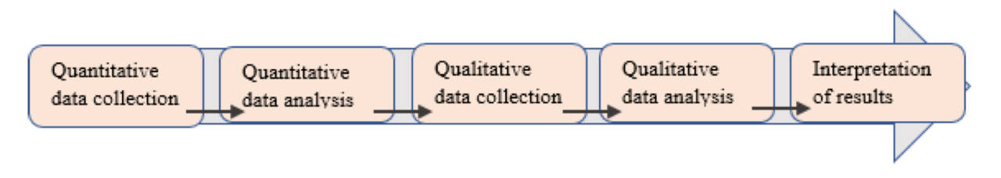
Figure 5 Sequential explanatory MMR design
In conclusion, the selected essay applies to the quantitative research method, and clearly states the research questions corresponding to research purposes. However, the limitations of research design lie in the small sample size and the single form of the teaching situation. Thus, it is suggested that researchers can adopt mixed research methods and add the questionnaire and interview in the research procedure to enhance the validity of the study.
2.5 Critiques of Data Analysis and Discussion of Results
In quantitative research studies, data analysis is seen as a challenging process that researchers should clearly identify what statistical tests are undertaken and what are the results (Coughlan, Cronin and Ryan, 2013). In the selected essay, researchers analyze the foregrounded features of four modes and the mode relations of the research sample and show the results according to data analysis. This part will discuss the logical consistency of data analysis and researchers’ discussion of the findings.
In terms of data analysis and research results, the results of data annotation are shown in the form of tables. According to the annotation, researchers give an extremely detailed analysis of the foregrounded features of verbal mode, audio mode, images and body language, as well as the mode relations between verbal & image, verbal & audio, verbal & body language, body language & image, and verbal & audio & image. Through data analysis, the research results effectively address the research question one that what are the features of the modes and mode relations in classroom lead-in. For example, in the verbal mode, researchers analyze the foregrounded verbal features of searcher’s word shown as in table 1. According to the data annotation, one of the features of verbal mode in EFL classroom lead-in is the relational processes which can help students understand abstract concepts. However, as for the description of findings, the researchers do not show a concise summary since various and detailed elements need to be analyzed. In the light of this, it is suggested that researchers can list the findings in the form of tables which help to show the findings clearly.
Table 1
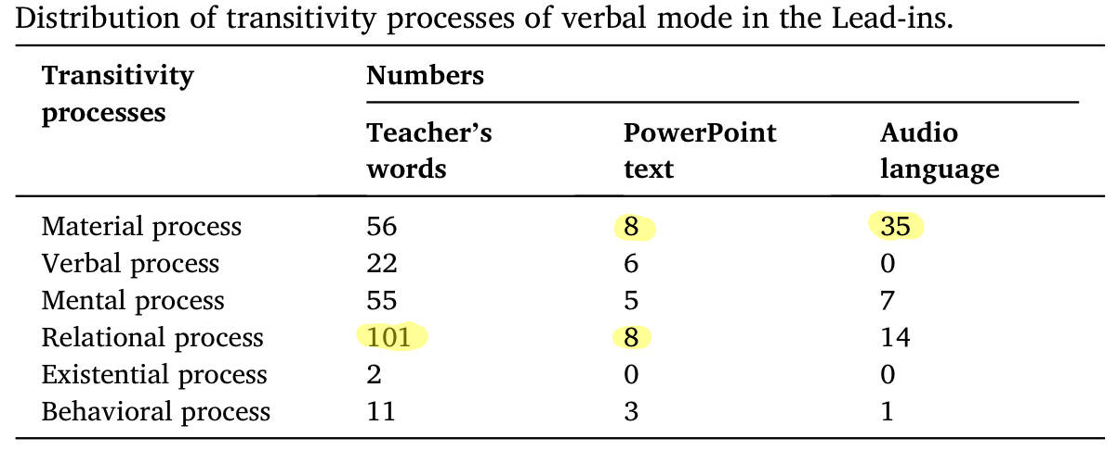
In the discussion section, researchers have summarized the features of mode choices based on the multimodal stylistic analysis and the results of foregrounded features of each mode and model relations of EFL classroom lead-ins. Moreover, all foregrounded multimodal features are chosen purposely by EFL teachers to engage students and introduce new topics, so the discussion of multimodal choices both address the research question two and concern the research objective that help teachers design effective EFL classroom lead-ins to active students’ engagement. Furthermore, researchers have discussed six general guidelines for designing multimodal classroom lead-ins based on the analyses of six classroom lead-ins. All findings are linked back to the literature review. The discussion of features of multimodal choices and general guidelines indicates that EFL teachers need to enhance the awareness of designing students’ learning experiences through the proper choice of modes.
Finally, researchers propose the recommendations for further research that multimodal stylistic analysis of authentic classroom lead-ins or other sessions can be conducted due to the difference between teaching contests and everyday classroom.
- Conclusion
This article conducts critical thinking of the selected essay in the field of multimodal pedagogical studies in the following parts: critiques of source and abstract, literature review, theoretical framework, methodology, data analysis and discussion. In general, researchers have achieved logical consistency among the theoretical framework, research questions and research objectives, showing the general guidelines related to the design of multimodal classroom lead-ins, which fit into the broader literature about the studies of multimodal pedagogy. Moreover, the limitations of the essay in the aspect of sample size and research method are proposed in my own view. In conclusion, the selected essay shed light on advanced ideas for my future thesis.
- References


