Structural and fluid analysis- designing a race car wing: Fluid Flow assessment
ACMA 6010

June 9, 2023
University of Wales Trinity Saint David

Table of Contents
Introduction 2
Main Findings 2
Reynolds Numbers 2
Boundary Flow and Layers 5
Carbon Fibre Reinforced Plastic 6
Fluid Flow Modelling Techniques 7
Computational Fluid Dynamics (CFD) 7
Wind Tunnel Testing 8
Laboratory Prototype Testing and Comparison with Computer Simulations. 9
Conclusion 10
References 12

Introduction
This report's objective is to analyse how fluid flows around an object and to break down the process to gain a better understanding of how the fluid and the object interact. Firstly, the report discusses Reynolds number, explaining what it is, its importance to fluid flow and its use in calculations to help predict the characteristic and behaviours of an object passing through a fluid.
The report then investigates boundary layers behaviour around the rear wing of a race car. Showing how the design of the wing will affect how the fluid passing over it separates and the potential of it causing turbulence.
Part three investigates the use of carbon fibre reinforced plastic (CFRP) as the material from which to make this wing. Including the history of CFRP use for such applications, how it is currently in use and how it can be used in the future. The report will also look at the implications of using CFRP as a material for this specific application.
Part four of this report is a discussion and investigation into the possible modelling techniques such as computational fluid dynamics and wind tunnel testing as options to aid with the design of a racing cars rear wing or any other components, stating the benefits and downfalls of the techniques available.
Finally, the report will suggest how to conduct a laboratory experiment to analyse the performance of the race car rear wing and compare the results obtained with those that can be obtained from using a computer model.

Main Findings

Reynolds Numbers
Reynolds number is a dimensionless number correlating the inertia forces and viscous forces of a particle or object and a fluid when either one is in motion. Osbourne Reynolds published a paper in 1883 of a study on fluid flow through a pipe. The experiment found that altering the flow rate through the pipe (observed with dye) altered the fluids behaviour from a smooth laminar flow to a transient state on to a turbulent state as the fluid velocity increased. Below are two methods of many to obtain Reynold number for an object or fluid. (Rapp, 2017)

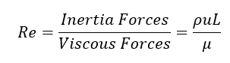
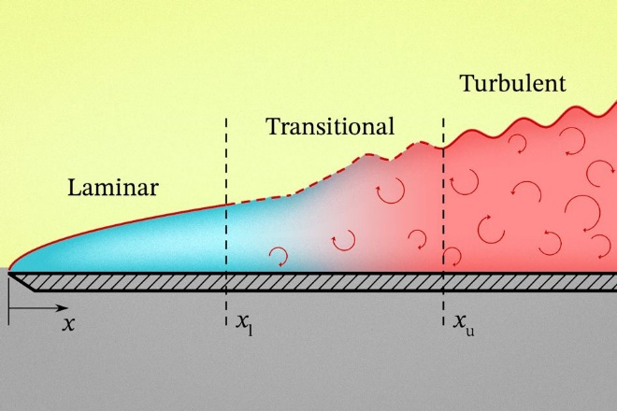
Figure 1- Diagram showing how laminar flow transitions into turbulent as it detaches from the surface of an object. (Chandler, 2020)
A high Reynolds number above 4000 is considered to represent turbulent fluid flow, lower Reynolds values between 2300 and 4000 represent transient flows and less than 2300 the flow is considered smooth and laminar (Engineering Tool Box, 2018). This is important to know when something is going to be moving through a fluid such as a race cars rear wing. The purpose of a race cars rear wing is to provide downforce that increases traction for the rear tyres, simultaneously, it is not desirable to have the rear wing create too much drag, a result of turbulence and a high Reynolds number, reducing the cars top speed and acceleration performance (Stoll, et al., 2016). This highlights Reynolds number importance when designing anything that moves through a fluid or something a fluid moves around, a compromise between using the air flow to push the car downwards and not disrupting the laminar air flow too much is needed.
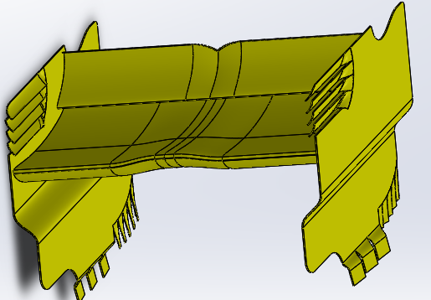
Figure 2- Race Car Rear Wing CAD Model.
To estimate the Reynolds number of the wing pictured above research-based assumptions must be made, including density of the fluid being constant, however in the real world it will vary due to altitude, atmospheric pressure, humidity, and temperature. NASA states that pure dry air has a pressure of 101.3 kPa and temperature of 273K is 1.293kg/m³ (NASA, 2023). Airs dynamic viscosity in the same conditions is 17.14x10⁻⁶ Ns/m² (Engineering Toolbox, 2023).
Another assumption is that the wings' structure or its position on the car does not alter at speed where in reality it will slightly, and previous formula 1 designs have been made to do this to help reduce turbulent flow at higher speeds. It is also assumed that the wing has no drag reduction system.
The velocity of the car moving through the fluid would be constantly varying as the car accelerates decelerates, because of this the value being used is the 156mph or 69.7 m/s. This is Lewis Hamilton’s average speed around Silverstone during the 2022 British GP (Oversteer48, 2023).
It is difficult to achieve a value for the characteristic length of the rear wing as it is an open system as opposed to analysis of fluid flow through a pipe, because of this it is recommended to use the chord length, the distance between the aerofoils leading and trailing edges, 428.82mm (Lissaman, 1983). It should also be noted that this design is a multielement wing with different angles of attack so in the real world they will have different characteristics and two smaller chord lengths, but for this they are being treated as one surface.
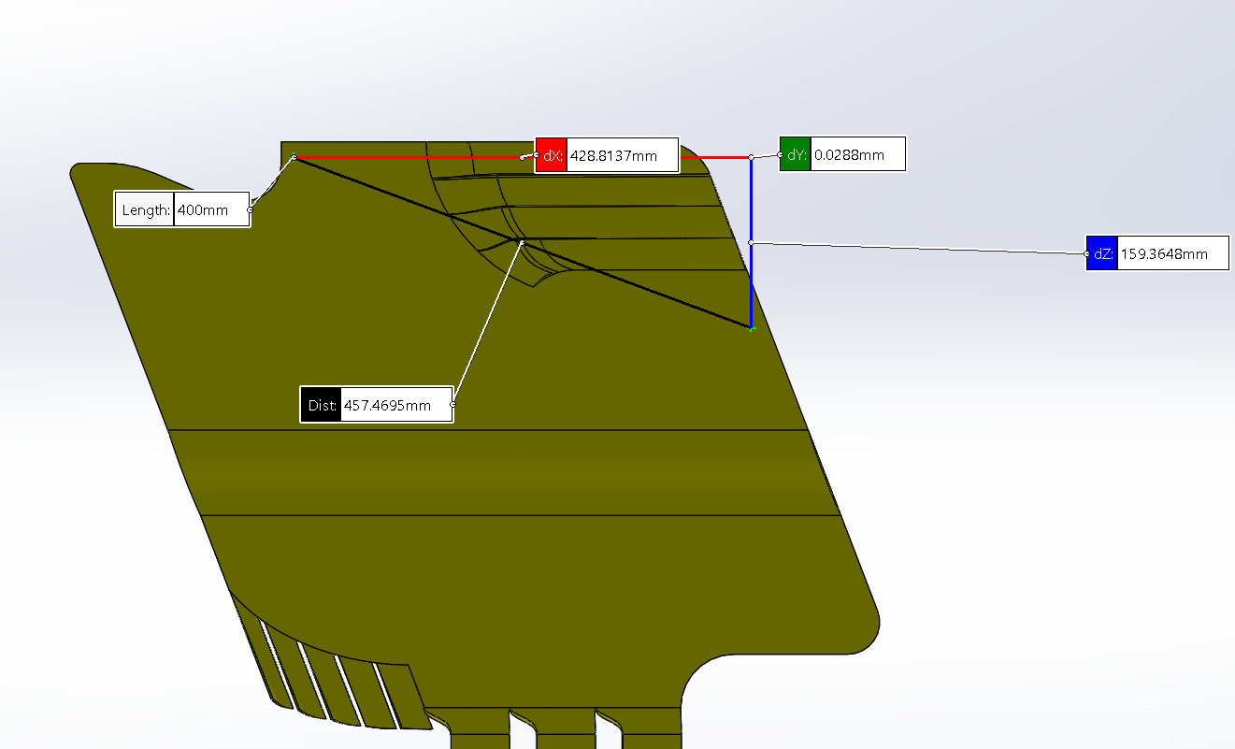
Figure 3- Race car rear wing chord length measurement
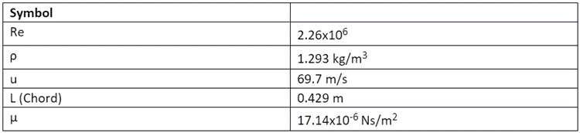
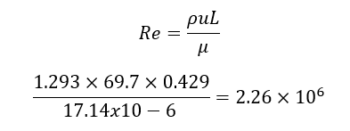
The Reynolds number of the rear wing is calculated to be 2.26x10⁶, this is a similar value to that used and stated in the paper ‘Study on airflow characteristics of rear wing of F1 car’ of 3x10⁶ (Azmi, 2017). Meaning that under the conditions and velocity stated the rear wing will be creating substantial amounts of turbulence as a trade-off for downforce. However, this calculation does not consider the various shapes of the wing like the side louvers that will create significant amounts of turbulence as they release pressure from the aerofoils surface.

Boundary Flow and Layers
Boundary Flow and layers are the terms used to describe the interaction between an object moving through a viscous fluid. As an object passes through a viscous fluid such as a race cars rear wing through air the air will flow around the boundary of the wing. The molecules of air closest to the wings surface will be stationary relative to the wing and effectively stick it due to friction, then every molecule further away from the surface will be moving slightly slower relative to the wings velocity until the molecules are stationary, this zone of the fluid unaffected by the wing is known as the ‘free stream.’ The section of air that goes from moving at the wings velocity to stationary is called the boundary layer. (What is a Boundary Layer - Laminar and Turbulent boundary layers explained, 2021)
Boundary flow can be laminar or turbulent, depending on the surfaces design. Fluid particle velocity within a laminar boundary layer changes consistently and the particles move parallel to the object surface as opposed to a turbulent boundary layer that is unorganised with particles moving in random directions. (NASA, 2021)
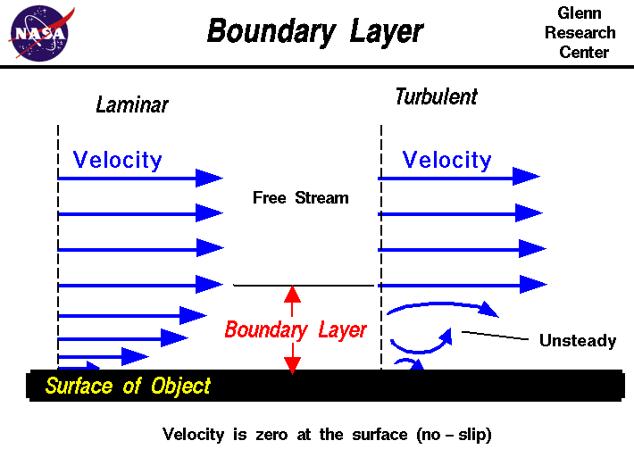
Figure 4- Illustration displaying laminar and turbulent boundary layers- (NASA, 2021)
In the event of some turbulent boundary flows the effective size of the object can be increased due to the fluid due to a larger boundary layer. Turbulent boundary flows contain more energy therefore create more drag; however, they are less susceptible to boundary separation where the boundary layer completely separates from the surface of the object. Separation on a race cars rear wing is undesirable as the downforce it is producing will be lost causing instability and poor traction. Boundary layer separation is caused by an adverse, negative pressure change of the fluid moving across on object. For the rear wing of a race car this could be due to gusting winds, driving in the turbulent wake of a car in front or from the turbulent wake of other parts of the car (What is a Boundary Layer? | Cause of Boundary Layer Formation | Types and Impact of Boundary Layers, 2022).
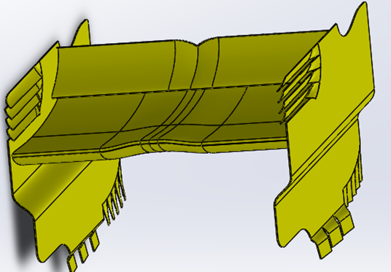
Figure 5- Race Car Rear Wing CAD Model
Analysing the CAD model above, it is clear to see that the shape of the centre portion that curves upwards smoothly is used to produce a laminar boundary layer and direct air upwards, in turn pushing the wing downwards. The endplates of the wings are in place to separate the high-pressure air on the top surface of the wing from the low pressure below and the atmospheric pressure, free stream to the sides, aiding in preventing separation of the boundary flow from the wings surface, increasing predictability and downforce across the wing.
This design is multi element, the two horizontal aerofoils are separate, allowing air flow between them but they both serve a similar purpose. This design reduces separation of the low-pressure boundary layer on the underside of the wing towards the trailing edge. By having multiple elements to the wing, the chance of boundary separation is reduced meaning the angle of attack can be increased allowing more downforce to be produced.
This design also features louvers on the end plates. These reduce pressure and velocity differentials between the outer and inner portions of the wing reducing drag by creating boundary separation (How do F1 Rear Wings Work?, 2015).

Carbon Fibre Reinforced Plastic
Carbon fibre reinforced plastic (CFRP) race car wing construction is nothing new, McLaren introduced it to their race car during the 1980’s (Thomas, 2013). CFRP is a composite, consisting of multiple layers of weaves or randomly oriented carbon fibres embedded in a matrix such as epoxy resin, larger structures will incorporate rib or honeycomb structures to support the outer skins. CFRP allowed designs to evolve, become more intricate in shape and extra air flow controlling wings and winglets. These intricate shapes could only be produced strong and light enough to withstand the aerodynamic forces thanks to the development of CFRP.
CFRP is recommended due to its high stiffness to weight ratio compared to alternative materials like aluminium alloys and steels. Wings can be produced lighter using CFRP, yet rigid enough to withstand the high forces (Element 6 Composites, 2023). CFRP can be two to five times stiffer than aluminium or steel as aluminium has a specific modulus of $26×{10}^{6}m^{2}s^{-2}$ compared with high modulus carbon fibre that has a specific modulus of $120×{10}^{6}m^{2}s^{-2}$ (Dexcraft, 2015). The direction of the carbon fibre weave, fibre thickness and length along with the matrix material used has a direct effect on stiffness and CFRP components will often be designed and manufactured to withstand loads in certain directions, making them comparatively less strong in other directions compared to a metallic equivalent. This also means that CFRP is compromised when used for such applications as a race car wing because is construction has been optimised for loading from air passing over it to reduce its total weight, meaning it can be easily damaged if struck by debris or in a crash, even if it is not directly impacted.
In the past, some race cars used wing designs that could deform under larger loads. This aeroelastic feature allowed the wings to deform for reduced drag at high speeds, then return to provide downforce for cornering and braking at lower speeds. However, most racing series now prohibit this practice due to the fragility of aeroelastic wings, which can fail under normal conditions and cause unpredictable handling. (Anon., 2008).
Construction of laminates such as CFRP is often governed in race series limiting maximum fibre lengths for short fibre reinforcement, matrix ingredients and fibre weight per square meter. For example, in the 2023 formula 1 technical regulations short fibre reinforcement are limited to a fibre length of 13mm, three-dimensional fibre reinforced polymer composites are prohibited, reinforced composites must have a “nominal tensile modulus <550GPa” and a “nominal tensile strength <7100 MPa”. The regulations also state specific matrix systems permitted to construct fibre reinforce components such as CFRP (FIA, 2023, pp. 126-128).
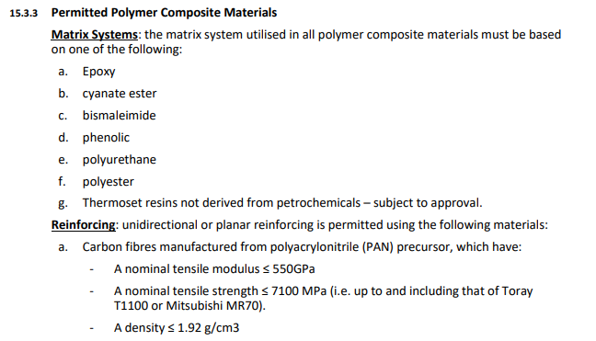
Figure 6- 2023 F1 Technical Regulations governing matrix materials- (FIA, 2023, p. 126)
Carbon fibre production is also governed by multiple industry standards, meaning that CFRP components can be labelled as meeting a certain British, ISO or other recognised organisation depending on the raw fibre length to diameter ratio, matrix material, tensile strength, deformation after impact properties, production health and safety and end of life recyclability (bsi, 2021), (ISO, 2009).

Fluid Flow Modelling Techniques
To evaluate the air flow around a proposed wing design, there are various methods available. One approach is to use computational fluid dynamics (CFD) software to create a computer model of the wings and simulate the air behaviour and drag. Another option is to construct a physical model of the wing, either full-size or scaled down, and place it in a wind tunnel. This allows for visual observation and data collection using sensors like pressure monometers or pitot tubes.

Computational Fluid Dynamics (CFD)
Various CFD software options can import CAD models to simulate the race car's rear wing. These software packages offer a range of simulations, including different wind conditions, pressures, and viscosities. The software divides the model and surrounding air into small geometric shapes chosen by the operator. Each section is analysed individually, and the results are combined to provide an overall system outcome.

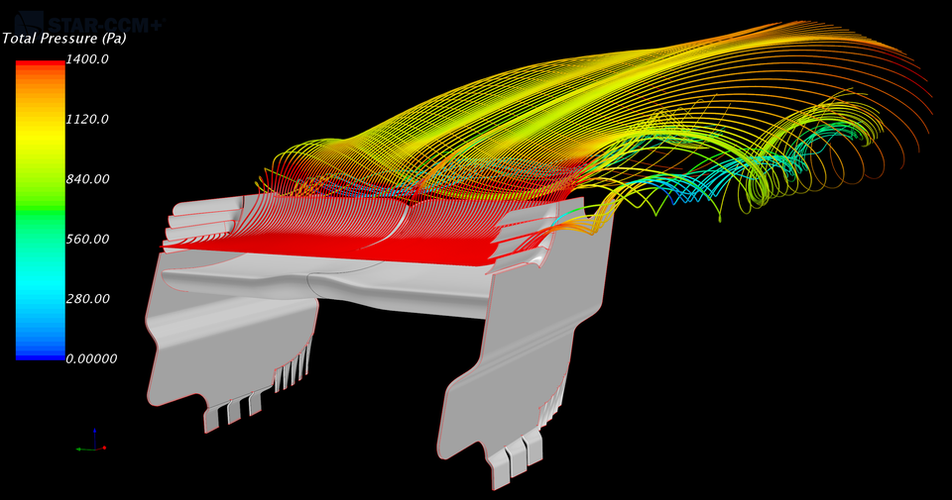
Figure 7- CFD Model of race car rear wing- (Pangerl, 2018)
Using a CFD model for analysing airflow around the wing offers several advantages. It saves time and costs since there is no need to create physical models. Additionally, design changes can be implemented quickly by rerunning the simulation instead of creating new models for wind tunnel testing. While CFD modelling has faced criticism for producing inaccurate results in the past, recent advancements in computing power have improved its reliability and accuracy. In fact, CFD now surpasses wind tunnel testing for analysing complex fluid flows and generating substantial data. Another benefit is that CFD eliminates the need for manual completion of complex mathematical equations like the Navier-Stokes equations, reducing math errors and accelerating result production. (Quadco Engineering, 2023).
CFD modelling has drawbacks. It requires powerful software and hardware to generate accurate and dependable models efficiently. Without proper equipment, processing models can be time-consuming or even impossible. This can result in high costs, depending on usage frequency. Moreover, the software must be operated by knowledgeable engineers or aerodynamicists; otherwise, incorrect results may be obtained, leading to misguided future developments. (Quadco Engineering, 2023).

Wind Tunnel Testing
Wind tunnel testing involves creating a model of the object, either full-sized or scaled down, and placing it in a wind tunnel. Sensors like pressure monometers and pitot tubes measure flow velocity changes and pressure differences. An aerodynamicist interprets the results to understand the airflow and its impact on performance. Visual observations of boundary layers and air separation can be made using smoke trails. Additionally, structural deformation under high loads can be assessed.
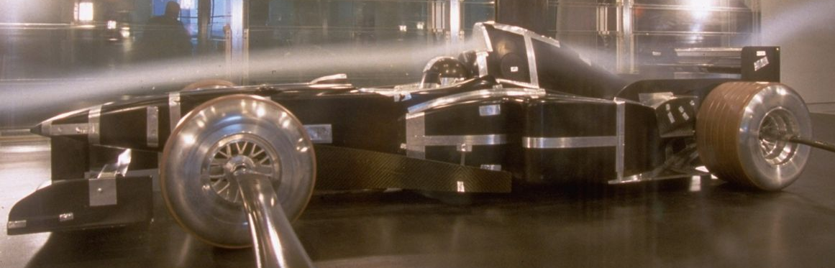
Figure 8- Wind tunnel testing using smoke- (Pryson, 2020)
Wind tunnel testing provides accurate and reliable data with fewer assumptions than other modelling techniques. It offers data and visual representation of air flow, separations, downforce production, and potential instability issues in the case of a race car's rear wing (Aero Performance Engineering, 2016). In comparison to large and accurate computational fluid dynamics (CFD) models, wind tunnel tests are often faster in obtaining equally useful data. This is particularly advantageous when considering turbulence caused by rotating wheels and ground effects in the car.
Wind tunnel testing has several disadvantages. Firstly, it involves the cost of producing full-sized or scaled models, as well as the time required to create these models for design changes. The expenses associated with running these tests are also high, including the purchase and operation of equipment, as well as the employment of engineers and technicians.
The repeatability of wind tunnel tests and data is another concern. Factors such as changes in fluid pressure, humidity, temperature, and turbulence from fixings and surrounding instrumentation can introduce biases and affect the accuracy of results.
When using scale models in wind tunnel testing, there are additional challenges. The scale's limitation is determined by the Reynolds number of the object, meaning that as the model size decreases, the fluid velocity must be increased proportionally. This constraint restricts how small-scale versions can be due to the wind tunnel's maximum air speed.
For cars, the rotating wheels generate significant turbulent air, and the interaction of the vehicle with the ground also affects its aerodynamics. To obtain accurate results, it is important to use a wind tunnel with a moving floor, like a treadmill, to simulate ground effects and the turbulence caused by rotating wheels (Aero Performance Engineering, 2016).

Laboratory Prototype Testing and Comparison with Computer Simulations.
To conduct a laboratory test of a race car's rear wing, several components are required. These include a model of the wing, a wind tunnel, and sensing equipment for measuring air flow velocity, pressures, and smoke trails to visualize boundary layers and separation zones.
The size of the model depends on factors such as the dimensions of the wind tunnel, the cost of model production, and the regulations governing the specific race car. For instance, in Formula 1, wind tunnel test models are limited to 60% of the final size (Everything You Need to Know About Wind Tunnels, 2021).
To collect data on static air pressure around the wing, pressure taps can be utilized. These taps are positioned at various locations on the wing, perpendicular to the surface. They capture pressure at a single point, which is then interpreted by a pressure transducer and output as a digital signal to a computer (How Wind tunnels Work, 2021). Consequently, the scaled model needs to be designed to accommodate this internal equipment.
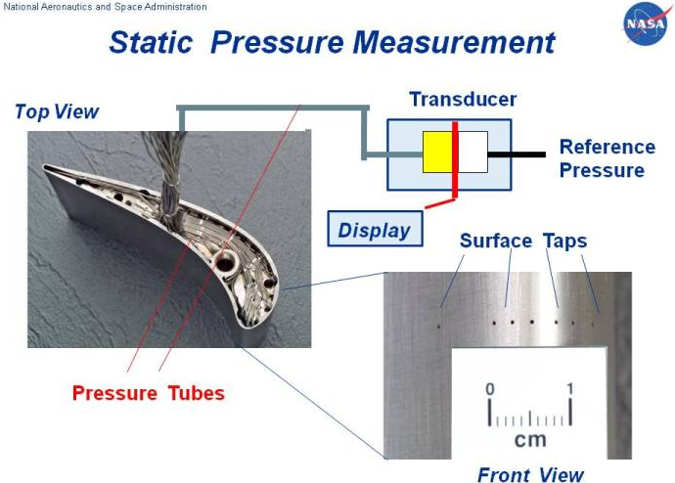
Figure 9- Demonstration of how pressure taps and transducers are used- (NASA, 2021).
Another method to analyse the rear wing design is using smoke trails released upstream of the wing. This helps identify high- and low-pressure areas as the trails converge or diverge, as well as large vortices and the air separation point behind the wing (Figure 8). This data can be compared with CFD simulations.
Monitoring the air flow velocity passing the wing has historically been challenging. However, techniques such as particle image velocimetry (PIV) and three-dimensional measurement probes have emerged. PIV employs small particles carried by the airflow, tracked with a high-speed camera to determine velocity over different wing sections.
Three-dimensional measurement probes measure both total and static pressure. When combined with mapping software, the probe can be moved to create a pressure map of the wing, like CFD-generated maps (How Wind tunnels Work, 2021).
The results of these laboratory measurements and tests should be compared to CFD analysis to validate the CFD results, identify anomalies, or detect errors arising from software setup. This real-world data can also help fine-tune the software setup for future efficiency (Watts, 2018).

Conclusion
This report explores the relationship between Reynolds number and fluid flow characteristics, determining that a Reynolds number above 4000 indicates turbulent flow, 2300-4000 denotes transient flow, and below 2300 suggests laminar flow. Applying this knowledge to a race car's rear wing, the estimated Reynolds number is 2.26x10⁶, indicating significant turbulent flow for increased downforce.
Additionally, the report examines the connection between boundary layers, boundary flows, separation layers, Reynolds number, and turbulent/laminar flow, highlighting the impact of frictional forces between fluid molecules and object surfaces. Analysis of the race car rear wing suggests that the centre promotes laminar flow, while the end plate louvers relieve high-pressure air, resulting in vortices and turbulence.
The subsequent section focuses on the use of carbon fibre reinforced plastic (CFRP) for constructing race car rear wings. It explores the evolving applications, emphasizing CFRP's high strength-to-weight ratio and stiffness, which can be influenced by fibre lengths, weave patterns, layer count, and matrix type. Relevant industry standards and Formula 1 regulations regarding CFRP usage and construction are also considered.
Furthermore, the report investigates and compares computational fluid dynamics (CFD) and wind tunnel testing, examining parameter usage and data collection from computer and real-life models. It concludes by providing suggestions for conducting a laboratory test on a rear wing model, collecting valuable fluid flow data, and subsequently comparing it with CFD results to validate or enhance the CFD setup for future reliability.

References
Aero Performance Engineering, 2016. Wind Tunnel Testing: Aero Performance Engineering. [Online]
Available at: http://www.aero-performance-engineering.co.uk/wind-tunnel-testing
[Accessed 17 06 2023].
Anon., 2008. Aeroelastic Tailoring of a Formula One Car Rear Wing, s.l.: s.n.
Azmi, A., 2017. Study on airflow of rear wing of F1 car, s.l.: s.n.
bsi, 2021. Composites, standards and the future of automotive manufacturing: bsi Knowledge. [Online]
Available at: https://knowledge.bsigroup.com/articles/composites-standards-and-the-future-of-automotive-manufacturing
[Accessed 17 06 2023].
Chandler, D. L., 2020. Understanding how fluids heat or cool surface: MIT News. [Online]
Available at: https://news.mit.edu/2020/how-fluids-heat-cool-surfaces-0428
[Accessed 10 06 2023].
Dexcraft, 2015. Aluminium vs carbon fiber – comparison of materials: Dexcraft. [Online]
Available at: http://www.dexcraft.com/articles/carbon-fiber-composites/aluminium-vs-carbon-fiber-comparison-of-materials/#:~:text=Carbon%20fiber%20is%20a%20material,used)%20than%20aluminium%20and%20steel.
[Accessed 16 06 2023].
Element 6 Composites, 2023. THE ULTIMATE GUIDE TO CARBON FIBER DESIGN AND APPLICATION. [Online]
Available at: https://element6composites.com/a-comprehensive-guide-to-carbon-fiber-design-and-application/#:~:text=The%20primary%20reason%20why%20one,by%20its%20modulus%20of%20elasticity.
[Accessed 11 06 2023].
Engineering Tool Box, 2018. Reynolds Number: Engineering Tool Box. [Online]
Available at: https://www.engineeringtoolbox.com/reynolds-number-d_237.html
[Accessed 10 06 2023].
Engineering Toolbox, 2023. Air- Dynamic and Kinematic Viscosity. [Online]
Available at: https://www.engineeringtoolbox.com/air-absolute-kinematic-viscosity-d_601.html
[Accessed 10 06 2023].
Everything You Need to Know About Wind Tunnels. 2021. [Film] s.l.: Mercedes-AMG Petronas Formula One Team.
FIA, 2023. FIA 2023 Formula 1 Technical Regulations, s.l.: s.n.
How do F1 Rear Wings Work?. 2015. [Film] s.l.: KYLE.ENGINEERS.
How Wind tunnels Work. 2021. [Film] s.l.: Air Shaper.
ISO, 2009. Carbon-fibre-reinforced plastics — Determination of compression-after-impact properties at a specified impact-energy level: ISO. [Online]
Available at: Carbon-fibre-reinforced plastics — Determination of compression-after-impact properties at a specified impact-energy level
[Accessed 17 06 2023].
Lissaman, P. B. S., 1983. Annual Review of Fluid Mechanics. In: Low-Reynold-Number Airfoild. s.l.:s.n., pp. 223-239.
NASA, 2021. Boundary Layer: National Aeronautics and Space Administration. [Online]
Available at: https://www.grc.nasa.gov/www/k-12/BGP/boundlay.html
[Accessed 11 06 2023].
NASA, 2021. Static Pressure Measurment: NASA. [Online]
Available at: https://www.grc.nasa.gov/www/k-12/airplane/tunpsm.html
[Accessed 18 06 2023].
NASA, 2023. Air Mass Density: NASA. [Online]
Available at: https://www.earthdata.nasa.gov/topics/atmosphere/atmospheric-pressure/air-mass-density#:~:text=Pure%2C%20dry%20air%20has%20a,of%20at%20least%2050%20km.
[Accessed 10 06 2023].
Oversteer48, 2023. Fastest Silverstone Lap Times & Records: Oversteer48. [Online]
Available at: https://oversteer48.com/silverstone-lap-times/
[Accessed 10 04 2023].
Pangerl, J., 2018. F1 Rear Wing CFD Study: Grab CAD. [Online]
Available at: https://grabcad.com/library/f1-rear-wing-cfd-study-1
[Accessed 17 06 2023].
Pryson, M., 2020. Talk Of A Wind Tunnel Ban Coming To F1 Is More Than Just Hot Air:. [Online]
Available at: https://www.autoweek.com/racing/formula-1/a34676237/talk-of-a-wind-tunnel-ban-coming-to-f1-is-more-than-just-hot-air/
[Accessed 06 17 2023].
Quadco Engineering, 2023. Advantages and disadvantages of Computational Fluid Dynamics: Quadco Engineering. [Online]
Available at: https://www.quadco.engineering/en/know-how/cfd-advantages-and-disadvantages.htm
[Accessed 17 06 2023].
Rapp, B. E., 2017. Microfluidics: Modeling, Mechanics and Mathematics. s.l.:s.n.
Stoll, D., Schoenleber, C. & Wittmeier, F., 2016. Investigation of Aerodynamic Drag in Turbulent Flow Conditions. 2 ed. s.l.:SAE International.
Thomas, G., 2013. Azom. [Online]
Available at: https://www.azom.com/article.aspx?ArticleID=8194
[Accessed 11 06 2023].
Watts, C., 2018. CFD vs Wind Tunnel Analysis in the design phase of the construction industry: LinkedIn. [Online]
Available at: https://www.linkedin.com/pulse/cfd-vs-wind-tunnel-analysis-design-phase-construction-catherine-watts/
[Accessed 18 06 2023].
What is a Boundary Layer - Laminar and Turbulent boundary layers explained. 2021. [Film] s.l.: Air Shaper.
What is a Boundary Layer? | Cause of Boundary Layer Formation | Types and Impact of Boundary Layers. 2022. [Film] s.l.: JxJ Aviation.

