
Innovation in Crisis – Why Is It More Critical Than Ever? – Netflix
Halima Miah - 1712451


Executive Summary
April 20, 2021
University of Wales Trinity Saint David

This report will examine how Netflix can take advantage of the current COVID-19 pandemic to gain competitive advantage, boost creativity and innovation within the company.
Research emphasises how many organisations have taken the current crisis to their advantage to become more innovated. The McKinsey & Co, (2020) survey indicates that 75% of business will benefit and exceed growth during the COVID-19 pandemic. The article highlights COVID-19 will “create significant new opportunities for growth”. This demonstrates that many organisations are using the pandemic to their business advantage. Brown, (2016) adds, organisations must be innovated to keep up in the competitive VUCA world.
A vast variety of models have been applied to Netflix which highlights and identifies areas where the organisation can become more innovated.
The first model which was applied is a SWOT analysis which outlined the internal and external risk factors. According to the findings, Netflix should build and innovate a new service on top of their current online entertainment platform to become more innovative during the pandemic.
The opportunity which was highlighted was for Netflix to create a new exercise/health service.

Applying the Innovation matrix to Netflix, it identified that Netflix is using a mixed approach of innovation types such as, ‘Technology, Incremental & Radical’ innovation type to their opportunity. Technology innovation was identified as Netflix is already an online streaming company and by adding an additional service will not change their business model, it will benefit the organisation in profit and growth. Netflix can be seen to be applying Incremental innovation type to their opportunity, as the organisation will be making improvements to their current platform, by adding additional exercise/health services for its subscribers. Finally, Radical innovation type can also be seen to be applied as this innovation opportunity is completely brand-new to Netflix and has never been embedded previously, therefore, a Radical innovation type would enhance production and target a larger stakeholder group.
To evaluate the effectiveness, Lewin’s force field analysis was applied to highlight the forces FOR and Against the opportunity. The results indicated that the forces FOR the opportunity outweighed the forces Against. Ultimately suggesting that if Netflix would to implement the new exercise/health service it would gain the organisation business advantage, benefitting them in growth, profit and future gains. However, the analysis also highlighted the risk factors against the opportunity, such as the cost element. If Netflix would to implement this opportunity it would add to their existing debts and also introducing expertise such as ‘Joe Wick’s’ would be expensive as Netflix may need to consider paying ‘Royalty’ fees and endorsements. However, this can also be seen as a long-term benefit, as it would enhance Netflix in growth, gain more subscribers and eliminate outstanding debts in the future.
After analysing the report's findings, analysis indicates that it would be feasible for Netflix to take advantage of this opportunity to gain a competitive advantage during the current pandemic.

Table of Contents
Executive Summary
1.0 – Introduction 3
1.1 – Introduction to organisation 3
1.2– Creativity Vs Innovation. 3
2.0 – Main Findings 4
2.1 – Innovation opportunity 4
2.1.1 – SWOT Analysis 4
2.2 – The Innovation Matrix 5
2.3 – Models of Innovation 7
2.3.1 – Open and Closed Innovation 7
2.3.2 The Innovation Process 8
2.3.3 – The 4’Ps to Innovation (The Innovation Mix) 10
2.4 – Assessment of the Effectiveness 11
2.4.1 - Lewin’s Force Field analysis 11
3.0 – Conclusion 13
4.0 – Recommendations 13
References
Bibliography

1.0 – Introduction
This report was requested by the CEO of Netflix, Mr Reed Hastings on the 23rd of April 2021. The purpose of this report is to highlight how COVID-19 has provided Netflix with the opportunity to be creative and innovated in their business practices, which will allow the organisation to grow and provide them with the business advantages for the future. The report has been complied by a former employee from the research and development department within Netflix who has been tasked to create and identify new innovation opportunities for Netflix to grow within the current crisis. Secondary research was used to compile this report with the use of textbooks, articles, journals and websites.

1.1 – Introduction to organisation
Highlighted by Burgess, (2020) Netflix was Co-founded by Reed Hastings and Marc Randolph in 1998. The organisation was conceived as a media rental service which offered flat rate rental by mail to customers in the US. Now Netflix is one of the largest online media streaming company with worldwide consumers.

1.2– Creativity Vs Innovation.
According to Naiman, (2020) creativity is defined as the process of bringing new and creative concepts to life. The ability to view the world in different ways, to identify hidden patterns, to make associations between seemingly unrelated phenomena, and to produce solutions are all characteristics of creativity. Similarly, Stamm B V (2008) sheds light upon John Hunt interpretation that “Creativity is not something where someone who has never worked in that field suddenly gets this marvellous idea. Creativity is relating a concept to a particular body of knowledge". This demonstrates creativity does not just come out of the blue, a certain amount of expert knowledge is needed.
Innovation is the act of introducing something new. It could be a new idea, product or process. Rajpal, (2008) highlights Peter Drucker’s definition of innovation, “Innovation is change that creates a new dimension of performance”. Similarly, Bledow et al (2009) states innovation is best described as individuals, teams, and organisations who create and intentionally introduce new and useful ideas. However, Carlson & Wilmot, (2006) argues that innovation is the process that turns an idea into value for the customer and results in sustainable profit for the enterprise. This demonstrates that innovation is not just beneficial internally, but also externally for organisations, as it produces high demand for a successful profitable organisation.
Research suggests that creativity and innovation come hand in hand, however they both differ. To be a creative individual or team, an organisation needs to create new ideas, and to be innovated the organisation must act on these new ideas. Emphasised by Marshall, (2013) the act of unleashing the mind's ability to conceive new concepts is referred to as creativity. Creativity is subjective and is hard to measure however, on the other hand innovation is measurable. Rowlands, (2018) states innovation is taking a newly created idea and developing it into something useful and practical. innovation is converting ideas into an action.

2.0 – Main Findings

2.1 – Innovation opportunity
Following initial investigations, it has identified and formulated areas where Netflix’s can become more innovated during the current Pandemic. Statistics from the McKinsey & Company (2020) survey indicates 90% of respondents expected the pandemic's effects to change how companies work, with 75% agreeing that the pandemic would "create substantial new opportunities for growth." This demonstrates that the pandemic has provided an incentive for companies to become more creative and innovative in order to drive growth.

2.1.1 – SWOT Analysis
A SWOT analysis was conducted to highlight the internal/external risk areas within Netflix.
According to Mindtools, (2020) a SWOT analysis is a simple helpful tool used to highlight four areas of one’s business. A SWOT analysis identifies the areas where the organisation is thriving and could be lacking. By compiling a SWOT on any organisation, it eliminates risks that may occur, using this as a business advantage.
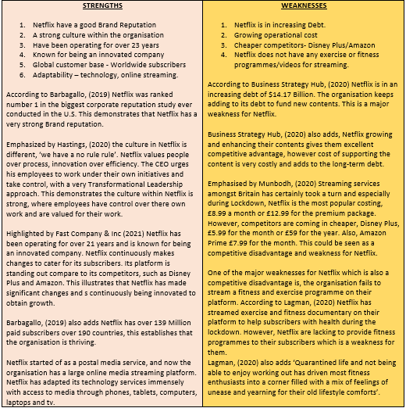

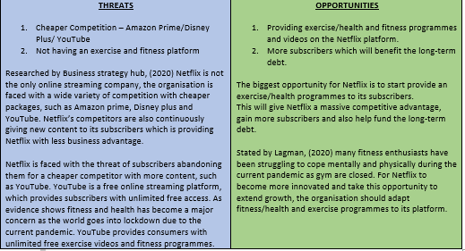

Figure 1 – SWOT Analysis

Analysing the results from the SWOT analysis (figure 1 above) the results have formulated a new creative and innovated idea for Netflix to grow during the current crisis. The opportunities highlighted from the SWOT is that Netflix should adopt an exercise/health programmes and fitness sessions on their platform. This new innovation could provide Netflix with the ultimate growth as gyms are closed due to the national lockdown, giving Netflix the opportunity to provide consumers with exercise programmes from their home, gaining new subscribers which would help eliminate the weakness that Netflix face of the long-term debt. Providing a new fitness content to Netflix gives the organisation competitive advantage. The organisation has many strengths such as a strong culture and good branding which will provide them with the business advantage to overcome a new innovation strategy, emphasised by Dyer, (2018) culture is the bedrock of a successful business.

2.2 – The Innovation Matrix
According to Weber, et al (2018) business models enhance how a business creates, sells and delivers value; business models can drive innovation. There are many different models which can be applied to organisations to help identify which type of innovation is being used during an innovation opportunity. Netflix has applied the innovation matrix to highlight and identify which type of innovation is being considered.
Davila, et al (2012) emphasises that the innovation matrix is a simple yet powerful tool used to understand the four types of innovation available to help organisations generate and apply their idea to find the innovation type which best fits their innovation opportunity.

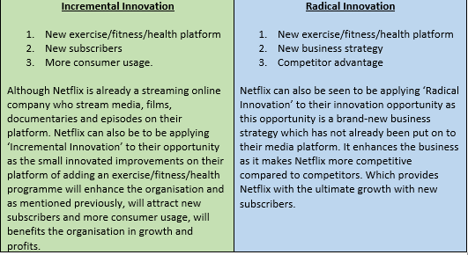
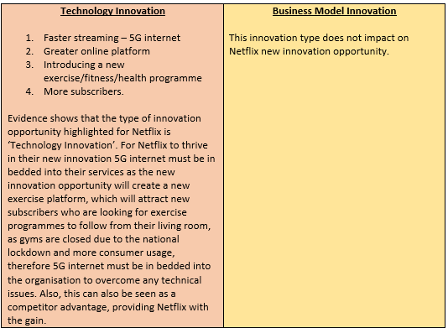

Figure 2 – Innovation Matrix
The results from the innovation matrix (above in figure 2) has identified that Netflix is following a mixed approach of innovation as the innovation opportunity can be seen to be applying the three types of innovation.
To discuss the findings further a table has been drawn,

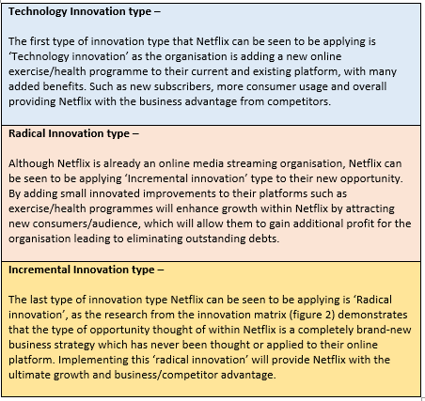

Research demonstrates that Netflix is following a mixed approach of innovation types, Kylliäinen, (2018) states many businesses fail to recognise that there are many different forms of innovation and opportunities for businesses to explore, and that there is no one-size-fits-all approach to innovation. This demonstrates the best innovation opportunities use a mix approach of innovation types.
Jeyakodi and Ros (2019) emphasise, the innovation matrix has many advantages as it is a simple, effective tool which is easily applied and identifies the innovation type being applied to the opportunity. ‘Radical and Incremental’ innovation type allows organisations to highlight and gain significant competitor advantage and how the innovation opportunity will provide higher level growth. However, the disadvantage and limitations of this matrix is competition will soon catch up and organisations are left again rethinking how to be more innovated.

2.3 – Models of Innovation

2.3.1 – Open and Closed Innovation
Zapfl, (2018) highlights the difference between open and closed innovation is dictated by the the process of innovation development. Open Innovation integrates external expertise into innovation management, while closed innovation is built in a self-contained company setting.
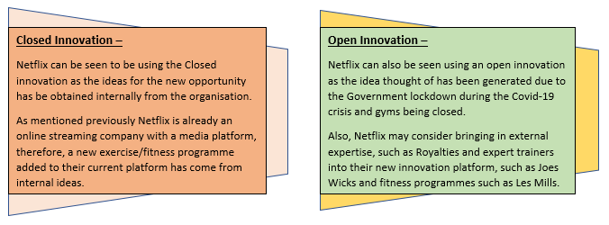
Figure 3 – Open and Closed Innovation
Examining the results from the open and closed innovation model in figure 3 above, research demonstrates that Netflix are using a mix approach of both open and closed innovation as the idea was thought of internally and they have the expertise to implement the opportunity. Weller and Weller (2002) state having ‘expert knowledge’ allows organisations to bench mark against their competitors. However, the idea was generated externally by the Government guidelines of the closure of gyms due to the current crisis. Adding to this Netflix may consider buying in expertise in fitness and exercise to enhance their platform. This would be of benefit to Netflix as they would have the expert trainers on their platform which would enhance growth. However, it could be very costly which would add to their debts.
Nunes and Abreu, (2021) state, the model has many advantages such as Closed innovation is cost efficient, as the organisation already obtain the expertise internally, and leaders have full control of the innovative process. The benefits of Open innovation allow knowledge to be transferred throughout the organisation, allowing expert knowledge to be gained. However, the model also has limitations, stated by Zapfl, (2018) closed innovation places very high demands on employees, which can be demotivating.

2.3.2 The Innovation Process
According to Lead Innovation Management (2021) the innovation process describes the systematic conversion of existing and/or new discoveries into marketable solutions, from concept development and evaluation to implementation. Tidd & Bessant (2014) imply that there are four stages in the innovation Process, as illustrated in figure 4.

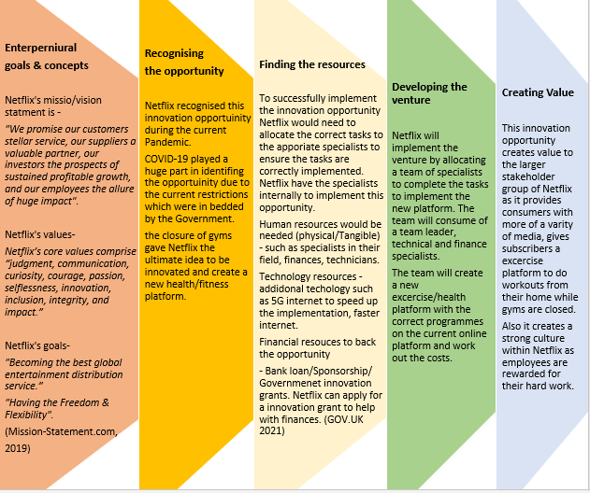

Figure 4 – The Innovation Process
Analysing the research compiled from the innovation process applied to Netflix in figure 4 above. It has been identified that the current pandemic influenced Netflix to generate this opportunity, as the world is in lockdown due to Government rules. This has provided Netflix with the ultimate benefit to creating a new and innovated exercise/health programme on their current online platform. This creates value for the larger stakeholders of Netflix as they gain access to exercise workouts from the comfort of their homes while gyms are closed, benefitting the organisation in growth, profit and business/competitor advantage. Stated by Zapfl, (2021) a professionally designed innovation process is central to successful innovations.
The innovation process is a useful effective tool which has helped Netflix identify how the organisation will implement the opportunity by using human and technology resources and the value that will come from implementation. Luenendonk, (2019) highlights, the innovation process is a simple step by step process which creates a sense of urgency for organisations to implement the opportunity. The model increases efficiency and effectiveness and pushes performance as reward and recognition is identified as teams successfully implement the innovation opportunity. However, Ipacso, (2021) critics and highlights Kline and Rosenberg (1986) view, it's worth noting that models that portray innovation as a "smooth, well-behaved linear mechanism" misrepresent the essence and direction of the causal factors at work. Innovation is dynamic, unpredictable, disorganised, and subject to a variety of changes.” This demonstrates that new innovation strategies don’t always run smoothly and unforeseen problems may occur.

2.3.3 – The 4’Ps to Innovation (The Innovation Mix)
The 4’Ps to innovation was developed by Tidd and Bessant (2018). The model enables innovators to determine how the innovation process can be improved and what benefits it can bring to the organisation.
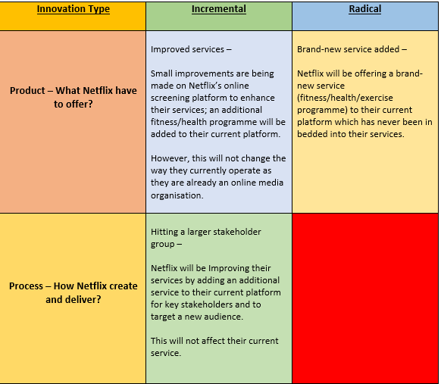

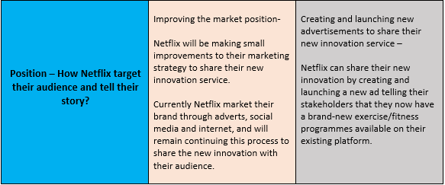



Figure 5 – The 4’Ps to Innovation
Examining the results from the 4’Ps to Innovation in figure 5 above, it has been identified that Netflix again are using a mixed approach of the 4’Ps on their innovation. Netflix have used both ‘Radical & Incremental’ innovation for their opportunity.
Product/Service - Netflix will be applying ‘Radical’ innovation as the opportunity is a brand-new programme/service. However, it is also seen as a ‘Incremental’ innovation as small improvements are being made to enhance Netflix’s original existing platform. Therefore, this demonstrates that the innovation opportunity for Netflix is both ‘Radical & Incremental’ innovation.
Paradigm – Netflix can be seen to be enhancing their original business model by making improvements. This falls under ‘Incremental’ innovation as Netflix is not changing their existing business model as they are already an online streaming organisation. However, they are making small improvements to enhance their business and services.
According to Inácio, (ND) the model's benefits include displaying the four categories and demonstrating how creativity and change interact. It unifies and simplifies a variety of marketing concepts, making marketing more manageable. However, Agola and Hunter (2016) criticise the model, claiming that it lacks comprehension of developing and weak markets. According to the author's studies, the model should include a fifth factor: payment creativity. This 5th P focuses on how payment for the product/services can be expedited in order to resolve the problem of insufficient funds.
2.4 – Assessment of the Effectiveness

2.4.1 - Lewin’s Force Field analysis
Emphasised by Mindtools, (2021) the Force Field Analysis was created by Kurt Lewin in the 1940s, the model is used in many organisations for making and communicating decisions. The model assumes that conditions are maintained by a combination of forces that drive change and those that resist it. For change to occur, the driving forces must be strengthened while the resisting forces must be weakened.

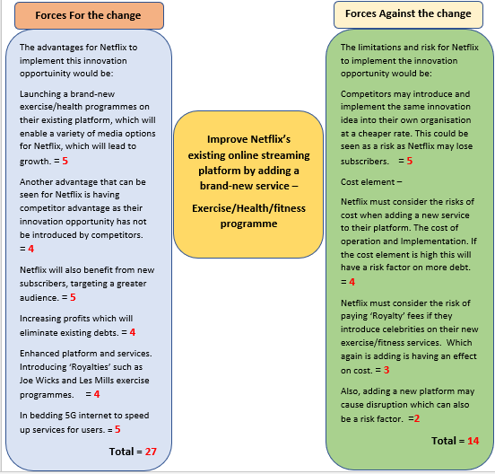
Figure 6 - Force Field analysis
After analysing the results conducted from the force field analysis in figure 6 above, it is evident that the factors FOR the innovation opportunity, outweigh the factors AGAINST. Figure 6 above demonstrates the advantages that Netflix will benefit from when implementing this innovation opportunity, such as targeting a new stakeholder audience which would result in additional subscribers and increased growth. Netflix would also benefit from amplified profits which would help eliminate outstanding debts. However, analysing the factors AGAINST the major risk highlighted is the cost element. For Netflix to implement this innovation opportunity they must consider the risk factors of operational cost, implementation cost and also the cost of ‘Royalty’ fees if they introduce celebrities on to the exercise services, such as Joes Wicks. Adding additional debts on to the organisation’s finances. However, although this is a current risk factor, this can also be seen as an advantage for Netflix. The cost of adding ‘Royalties’ to the organisation currently may have a cost element and be expensive, however for future benefits, this could be a major advantage as it would gain increased viewers and subscribers, benefiting Netflix for future profit and growth. Netflix could fund this opportunity as an additional investment or apply for an innovation grant.
According to Brent, (2018) the force field analysis has many benefits such as It gives a visual representation of all the different variables that support and oppose a particular plan, as well as qualitative factors that could affect the success or failure of the decision under consideration. However, Brent, (2020) argues, to provide the accurate information needed for an effective analysis, force field analysis necessitates the full participation of all parties concerned. When full participation isn't feasible, this can be a drawback, resulting in an analysis that doesn't provide a realistic image of the supporting and opposing powers.

3.0 – Conclusion
The aim of this report was to identify how Netflix could become more innovative in the face of the current pandemic. The McKinsey & Co (2020) survey indicated that the Pandemic has provided organisations with the benefits to push growth.
Through investigations the research of this report identified that the innovation opportunity for Netflix is to add an additional exercise/health service to their current platform.
After conducting a SWOT analysis, the results suggested that for Netflix to become more innovated during the current Pandemic, the organisation should utilise COVID-19 as a major opportunity to become more innovated. As the SWOT analysis implied many benefits within Netflix, if this opportunity was implemented, as gyms are closed due to the Government lockdown rules. This would provide Netflix with the ultimate growth as current and new subscribers would use this new service to exercise from home, providing Netflix with business/competitor advantage to push expansion.
Secondly, the results from the Innovation matrix identified that the innovation opportunity highlighted a mixed approach of innovation type, such as technology, radical and incremental type. Netflix is already a technological organisation, therefore adding an additional service would provide Netflix with improvements to their services (incremental innovation). However, this can also be seen as a Radical innovation type, as adding an exercise/health programme to Netflix’s platform is completely brand new and has never been embedded into their services. Therefore, the results demonstrated that the innovation type is a mix of technology, radical and incremental.
Finally, to evaluate the effectiveness, Lewin’s force field analysis was applied to Netflix, which highlighted that the forces FOR the opportunity outweighed the forces AGAINST. The benefits of Netflix implementing the new exercise service would provide the organisation with competitor advantage, growth, a larger target audience, and increased subscribers, which would ultimately result in profit, eliminating outstanding debts. However, the analysis also highlighted a major risk factor of cost. Netflix would need to consider operational cost, implementation cost and also ‘Royalty’ fees during implementation. If Netflix introduce celebrities on to their exercise service, they may need to pay a fee or endorsement which would add to the organisations outstanding debt. However, this can also be seen as an advantage for future gains, as it would bring in more subscribers, viewers and increased profit. Benefiting Netflix in the future.
The innovation opportunity highlighted for Netflix appears to be a feasible opportunity which should be implemented as evidence suggests the innovation opportunity will bring many advantages to Netflix during the current pandemic.

4.0 – Recommendations
An operational plan has been drawn to aid Netflix during implementation.
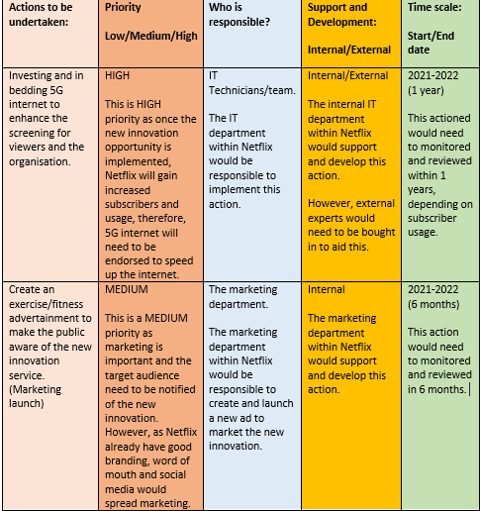

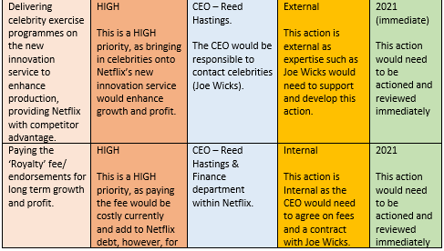

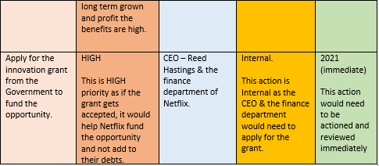

References
1/ Agola & Hunter, (2016) Inclusive Innovation for Sustainable Development: Theory and Practice. London :Palgrave Macmillan UK
2/ Barbagallo, J (2019) Netflix Ranks as #1 in the Reputation Institute 2019 U.S. RepTrak 100 - the Biggest Ever Corporate Reputation Survey in the U.S.
Available at: https://www.businesswire.com/news/home/20190403005250/en/Netflix-Ranks-as-1-in-the-Reputation-Institute-2019-U.S.-RepTrak-100---the-Biggest-Ever-Corporate-Reputation-Survey-in-the- U.S.#:~:text=U.S.%20%7C%20Business%20Wire-,Netflix%20Ranks%20as%20%231%20in%20the%20Reputation%20Institute%202019%20U.S.,Reputation%20Survey%20in%20the%20U.S.&text=BOSTON%2D%2D(BUSINESS%20WIRE)%2D%2DNetflix%2C%20Inc.&text=Google%20dropped%2063%20spots%2C%20falling,100%20for%20the%20first%20time. (Accessed: 13/04/2021)
3/ Bledow, R., Frese, M., Anderson, N., Erez, M., & Farr, J. (2009). A dialectic perspective on innovation: Conflicting demands, multiple pathways, and ambidexterity. Industrial and Organizational Psychology, 2, 305-337.
4/ Brent, M (2018) Advantages & Disadvantages of the Force Field Analysis. Available at: https://careertrend.com/info-8613855-advantages-disadvantages-force-field-analysis.html (Accessed: 19/04/2021)
5/ Brent, M (2020) Advantages & Disadvantages of the Force Field Analysis. Available at: https://www.ehow.co.uk/info_8613855_advantages-disadvantages-force-field-analysis.html (Accessed: 19/04/2021)
6/Brown, T (2016) Innovation - Leaders Can Turn Creativity into a Competitive Advantage
Available at: https://hbr.org/2016/11/leaders-can-turn-creativity-into-a-competitive-advantage (Accessed:21/04/2021)
7/ Burgess, M (2020) Reed Hastings, Building Netflix. UK: Hachette
8/ Business Strategy Hub. (2020) Netflix SWOT Analysis 2020 | SWOT Analysis of Netflix.
Available at: https://bstrategyhub.com/swot-analysis-of-netflix-2019-netflix-swot-analysis/ (Accessed: 13/04/2021)
9/ Carlson C.C., & Wilmot, W.W. (2006). Innovation: The five disciplines for creating what customers want. New York: Crown Business.
10/ Connelly, M (2021) Eight Reasons To Use A Change Management Model. Available at: https://www.change-management-coach.com/change-management-model.html (Accessed: 21/04/2021)
11/ Davila, T. Epstein, M. Shelton, R (2012) Making Innovation Work. How to Manage It, Measure It, and Profit from It. Pearson Education. Available at: https://www.google.co.uk/books/edition/Making_Innovation_Work/F2_S8FFaSKMC?hl=en&gbpv=1 (Accessed: 16/04/2021)
12/ Dyer, C (2018) The Power of Company Culture: How any business can build a culture that improves productivity, performance and profits. Great Britain: Kogan Page Publishers
13/ Fast Company & Inc (2021) MOST INNOVATIVE COMPANIES – Netflix. Available at: https://www.fastcompany.com/company/netflix (Accessed: 13/04/2021)
14/ GOV.UK (2021) Innovation Funding Service. Available at: https://apply-for-innovation-funding.service.gov.uk/competition/search?innovationAreaId=&keywords=smart (Accessed:22/04/2021)
15/ Hastings, R and Meyer, E (2020) No Rules Rules - Netflix and the Culture of Reinvention. Ebury Publishing. Available at: https://www.google.co.uk/books/edition/No_Rules_Rules/M1XADwAAQBAJ?hl=en&gbpv=1&kptab=overview (Accessed: 13/04/2021)
16/ Ipacso, (2021) Innovation Model Analysis -The Evolution of Innovation Framework Models
Available at: https://ipacso.eu/innovation-modelling/innovation-model-analysis.html (Accessed: 18/04/2021)
17/ Inácio, (ND) Marketing Mix: Advantages and Disadvantages. Available at: https://agendamahala.com/marketing-mix-advantages-and-disadvantages (Accessed: 19/04/2021)
18/ Jeyakodi, D and Ros, M (2019) Innovation Matrix. Netherlands: BIS Publishers
19/ Kylliäinen, J (2018) Key Innovation Management Models and Theories.
Available at: https://www.viima.com/blog/innovation-management-models (Accessed:18/04/2021)
20/ Lawrie, E (2016) 'Our obsession with ownership is at a tipping point': As he gives £1m to UK start-ups Richard Branson reveals why he's backing the sharing economy. Available at: https://www.thisismoney.co.uk/money/smallbusiness/article-3663869/Richard-Branson-obsession- ownership-tipping-point.html (Accessed:07/04/2021)
21/ Lagman, M (2020) 9 Fitness-related Netflix Shows to Watch.
Available at: https://www.pinoyfitness.com/2020/04/fitness-related-netflix-shows-to-watch/ (Accessed: 13/04/2021)
22/ LEAD INNOVATION MANAGEMENT GMBH, (2021) Defining the innovation process. Available at: https://www.lead-innovation.com/en/innovation-process (Accessed: 18/04/2021)
23/ Luenendonk, M (2019) The Innovation Process: Definition, Models, Tips. Available at: https://www.cleverism.com/innovation-process-definition-models-tips/ (Accessed: 18/04/2021)
24/ McKinsey & Company (2020) Innovation in a crisis: Why it is more critical than ever. Available at: https://www.mckinsey.com/business-functions/strategy-and-corporate-finance/our-insights/innovation-in-a-crisis-why-it-is-more-critical-than-ever (Accessed: 09/04/2021)
25/ MindTools, (2021) Force Field Analysis: Analysing the Pressures For and Against Change. Available at: https://www.mindtools.com/pages/article/newTED_06.htm#:~:text=Force%20Field%20Analysis%20helps%20you%20to%20think%20about%20the%20pressures,piece%20of%20paper%20or%20whiteboard. (Accessed: 19/04/2021)
26/ Mindtools, (2020) SWOT Analysis How to Develop a Strategy For Success. Available at: https://www.mindtools.com/pages/article/newTMC_05.htm (Accessed: 16/04/2020)
27/ Mission-statement.com (2019) Netflix Mission and Vision Statement Analysis.
Available at: https://mission-statement.com/netflix/ (Accessed:18/04/2021)
28/ Munbodh, E (2020) Best Netflix alternatives and free ways to watch your favourite TV shows in the UK. Available at: https://www.mirror.co.uk/money/5-netflix-alternatives-more-free-8471555 (Accessed: 13/04/2021)
29/ Naiman, L (2020) What is Creativity? (And why is it a crucial factor for business success?) Available at: https://www.creativityatwork.com/2014/02/17/what-is-creativity/ (Accessed: 06/04/2021)
30/ Nunes, M and Abreu, A (2020) Managing Open Innovation Project Risks Based on a Social Network Analysis Perspective. Available at: https://www.researchgate.net/publication/340627960_Managing_Open_Innovation_Project_Risks_Based_on_a_Social_Network_Analysis_Perspective (Accessed: 18/04/2021)
31/ Rajpal, P, (2008) Five Thinkings to Win. New Delhi: Om Books International
32/ Rowlands, D (2018) What is the Difference Between Creativity and Innovation? Available at: https://weareive.org/what-is-the-difference-between-creativity-and-innovation/?ppc_keyword=creativity%20innovation&gclid=EAIaIQobChMIrP_T19vs7wIV5OjtCh0BTwpcEAAYASAAEgLt-fD_BwE (accessed: 07/04/2021)
33/ Stamm, B V, (2008) Managing Innovation, Design and Creativity. 2nd Edn. UK: John Wiley & Sons Ltd
34/ Lee, J and Wang, Y, (2020) Co-Creation with Amateur Designers via Open Innovation. American Journal of Industrial and Business Management. Available at: https://www.researchgate.net/figure/The-closed-left-vs-open-right-innovation-model-Source-Chemeuropecom_fig1_339858289 (Accessed:21/04/2020)

35/ Weber, Y. Thrassou, A. Shams, S M. Tsoukatos, E T. (2018) Innovation and Capacity Building: Cross-disciplinary Management Theories for Practical Applications. Switzerland: Springer International Publishing
36/ Weller, D L and Weller, S J. (2002) The Assistant Principal: Essentials for Effective School Leadership. California: Corwin Press, Inc
37/ Tidd, J and Bessant, J (2007) Innovation and Entrepreneurship. 1st Edn. Chichester: Wiley Publishing
38/ Tidd, J and Bessant, J (2011) Innovation and Entrepreneurship. 2nd Edn. Chichester: Wiley
39/ Tidd, J and Bessant, J (2014) Managing Innovation Integrating Technological, Market and Organizational Change. 5th Edn. Chichester: Wiley
40/Tidd, J. and Bessant, J. (2018), Managing Innovation: Integrating Technological, Market and Organizational Change, 6th ed, Chichester: John Wiley.
41/ Zapfl, D (2018) Open Innovation vs. Closed Innovation. Available at:
https://www.lead-innovation.com/english-blog/open-innovation-vs.-closed-innovation (Accessed: 18/04/2021)
42/ Zapfl, D (2021) Innovation Process. Available at: https://moodle.uwtsd.ac.uk/pluginfile.php/370920/mod_resource/content/0/The%20Innovation%20Process.pdf (Accessed:18/04/2021)

Bibliography
1/ Trott, P. (2017), Innovation Management and New Product Development, 6th ed, Harlow: FT Prentice Hall.
2/ Tidd, J. and Bessant, J. (2015), Innovation and Entrepreneurship. 3rd Edn. Chichester: John Wiley.
3/ Brown, T., (2016). Leaders Can Turn Creativity into a Competitive Advantage. Available at:
https://hbr.org/2016/11/leaders-can-turn-creativity-into-a-competitive-advantage (Accessed:21/04/2021)

