ethics Management Draft

CSR theory of Turkish Airlines
Student name: Phils Muobike
Student number: 1706873
Module name: Management Ethics
Module code: M5X00803
Lecturer: Caroline Jawad


Table of Contents
Introduction 2
Main findings 2
Business ethics in general 2
Corporate Social Responsibility 3
Stakeholder theory 3
Conclusion 5
Recommendations 5

Figure 1 Carroll's CSR model 3
Figure 2 Stakeholder mapping 4
Figure 3 Turkish Airlines Stakeholder Map 5

Introduction
This report begins with the creation of a poster designed to communicate effectively about the ethical issue concerning cyber-security; the author of the report will be focusing on the consequences of poor cyber-security in international Airports. The poster was created and designed from the point of view of Hackers criminal acts and cyber-security in general.

Utilised model and theories are Corporate Social Responsibility (CSR), Freeman’s Stakeholder mapping, Carroll’s CSR Pyramid, the different points of view of Friedman and Freeman and other important points. In each section, there will be a discussion with reliable resources and the report will, moreover, include Gibbs’ Model of Reflection to confirm the experience acquired by the author. A section for recommendations will follow the main body, where advice and suggestions for improvements will be given.

Main findings

Cyber-security is the protection of the technology-based systems where information is transmitted or saved (Whitman and Mattord, 2013). Cyber-security protects software, hardware and data from cyber-attacks. Companies use cyber-security and physical-security to protect themselves against unwanted access to their computer systems and the data centres (Von Solms and Van Niekerk, 2013).

Most airports are vulnerable to cyber-attacks, although airports have many security people protecting the airports physically; but they do not have protection in a cyber way. According to de Gramatica et al., (2017), people must consider that the threats are imminent because there are well-trained terrorists who are planning to attack various airports and there are also hackers who try to access the interconnected airport system through IT in order to hit the news by hacking the screens or accessing the airport Wi-Fi.

As reported by the BBC (2016), the flight screens and the sound systems at the Ho Chi Minh and Hanoi airports were announced anti-Vietnamese and Philippines slogans. Due to political reasons, a Chinese tourist was accused of the hacking issue and there were also accusations regarding the tourist’s passport. China asked Vietnam to investigate the Chinese passenger’s passport crosscheck any irregularities and they found out it was only the Chinese map and the “nine-dash-line” (BBC 2016).

de Gramatica et al., (2017) argues that among all the countries in the world, the Turkish citizens and tourists suffered the most due to the various terrorist attacks between 2001 and 2013. The authors believe the main problems behind all the nearly successful terrorists’ attempt are the lack of efficient cyber-security systems; usage of fake passports enables to enter the airport and commit crimes without revealing the real identity. The last attack was a cyber-attack where the Custom Systems of two airports in Turkey were blocked and delayed many flights. Through the enhancement of the physical and cyber security hackers and terrorist will minimize or cease their attacks (Whitman and Mattord, 2013).

Business ethics in general

Business ethics are a series of rules and morals that guide how businesses take a decision, how businesses operate, how Shareholders and customers are treated. According to Heath (2014), business ethics is a subject which is concerned mainly with the moral responsibilities of managers. He also stated that managers are found in an uncomfortable situation because they have to increase the shareholders’ value instead of thinking of their self- interest (Taylor, Fritsch and Liederbach, 2014).

Corporate Social Responsibility

CSR is the abbreviation of Corporate Social Responsibility and has the aim to make sure that organisations run their business in an ethical way. CSR could include some activities such as improving the relationship with customers and employees, environmental sustainability, and protection and working in partnership with local communities (Carroll and Buchholtz, 2014).

As reported by the Turkish Airlines website, Turkish Airlines company are committed to sustainable development; They improved their sustainability agenda, which depends on Governance, Environment, Economy and Society. Turkish Airlines state that they respect the international regulations and they collaborate with their partners, suppliers, academic institutions and Non-governmental organisation (Turkish Airlines, 2018).

Figure 1 Carroll's CSR model
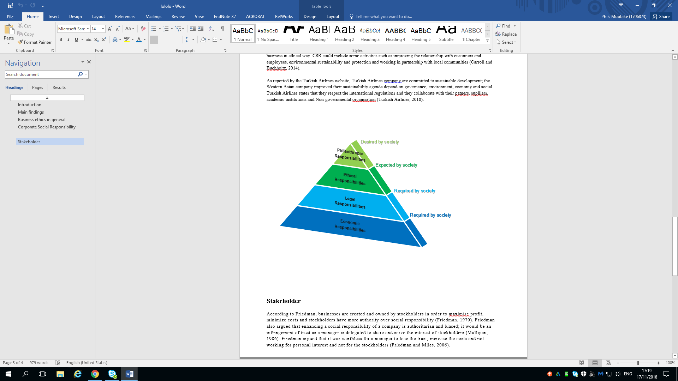
Source: (Carroll, 2016) Created: (Author of the report)

Stakeholder theory

According to Friedman, businesses are created and owned by stockholders in order to maximise profit, minimize costs and stockholders have more authority over social responsibility (Friedman, 1970). Friedman also argued that enhancing a social responsibility of a company is authoritarian and biased; it would be an infringement of trust as a manager is delegated to share and serve the interest of stockholders (Mulligan, 1986). Friedman argued that it was worthless for a manager to lose the trust, increase the costs and not work for personal interest nor for the stockholders (Friedman and Miles, 2006).

“There is one and only one social responsibility of business - to use its resources and engage in activities designed to increase its profits so long as it stays within the rules of the game, which is to say, engages in open and free competition without deception or fraud” (Friedman, 1970).

The word Stakeholder replaced the word stockholder to emphasise and draw the attention of organisations over the non-stockholding group (Tafoya, 2013). Freeman had an opposing view about the Stockholders theory, he introduced the successful Stakeholder theory and he defined a Stakeholder as a person, a group of people or an organisation that have the same interest in a company which could affect or be affected by the accomplishment made by the organization (Freeman et al., 2010). As described by Freeman (2010), there might be many external factors that could influence the pace of a business also known as Stakeholders. Freeman states these influencers have the authority to change the operating method of an organisation.

Figure 2 Stakeholder mapping

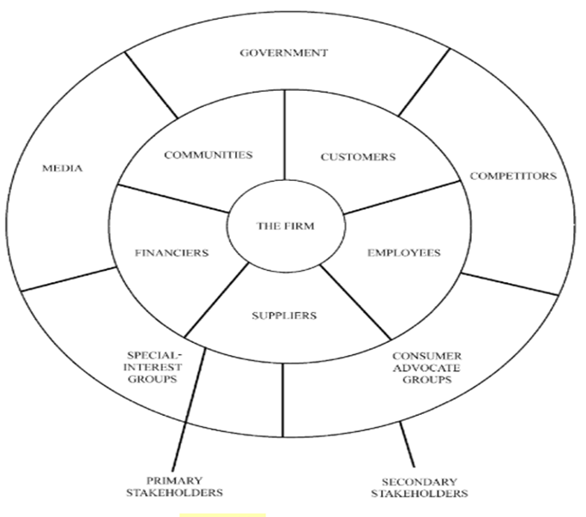
Source: (Freeman et al, 2007)

Figure 3 Turkish Airlines Stakeholder Map
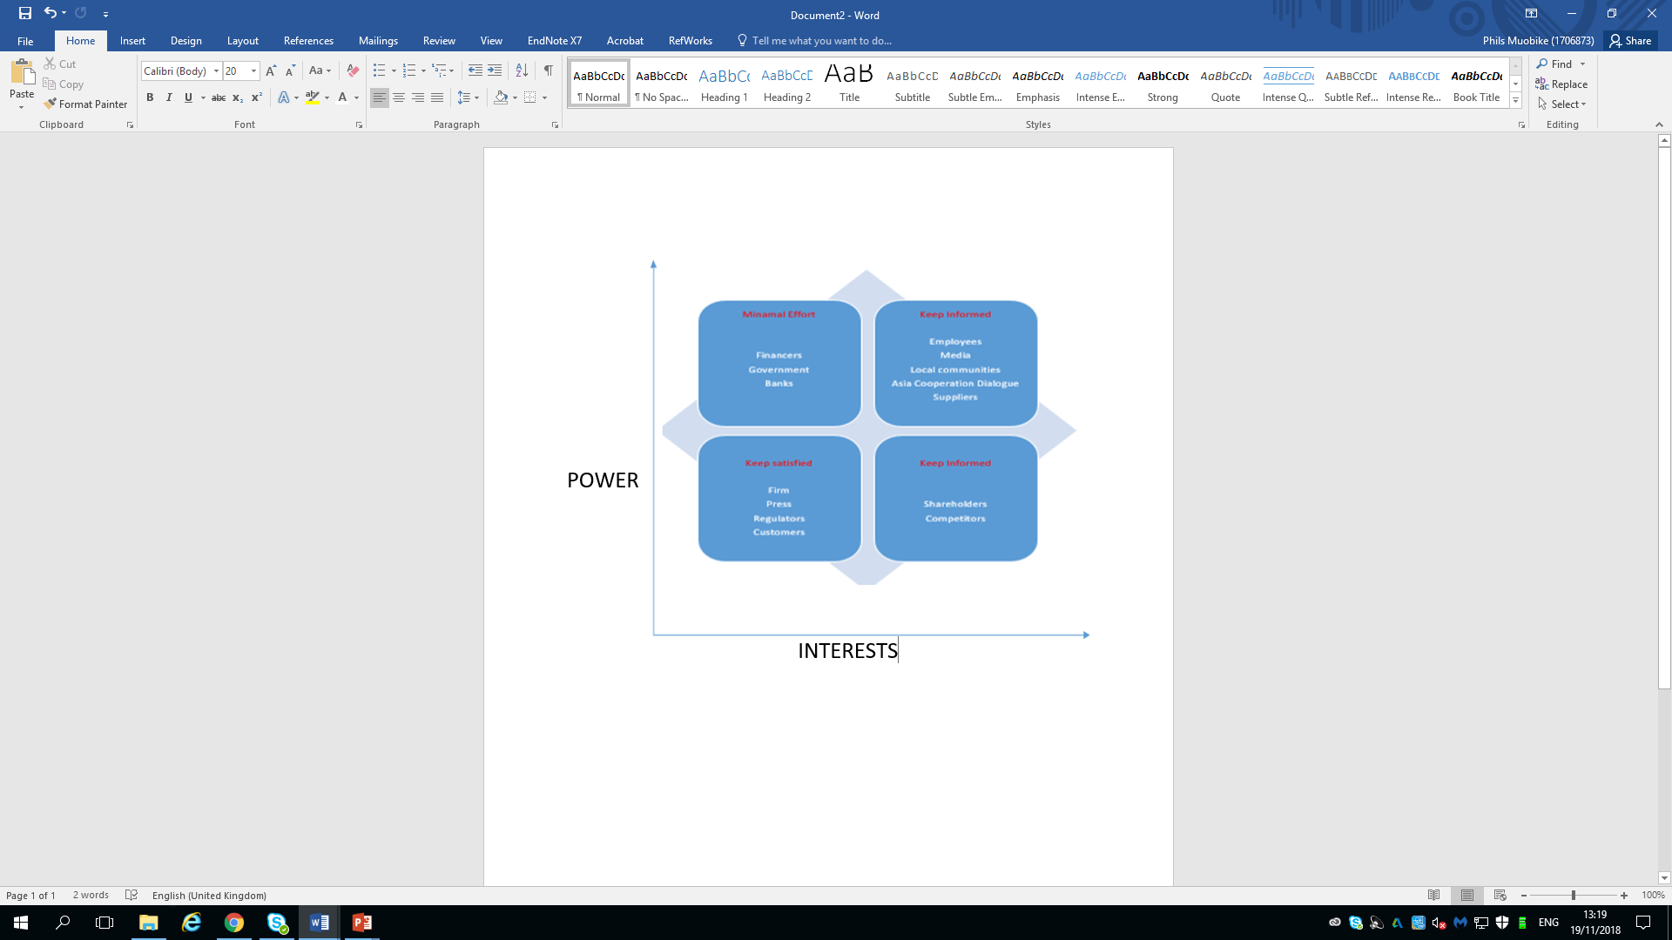
Source: the author of the report)

Conclusion

In conclusion, sustainability models and CSR are becoming essential to encourage businesses to follow ethical policies. Due to limitations on word count, the author of the report could not give a detailed explanation of the theme. In the following section, there will be some recommendations which the author believes should be considered for cyber-security.

Recommendations

To protect people and companies from cyber-attack the Government should have more collaboration with their Stakeholders. Government workers should know the security protocols and risks when utilising smartphones and using the cloud to save personal data. There should be more people educating organisations and people about cyber-security in order to teach them how to protect their data.

The author of the report believes that Public service should invest more capitals to create a stable and strong cyber-security. By investing more in this field, the cyber-security teams could learn more and overcome the threats. The author suggests that anti-spyware software should be free to enable users to detect the cyber-spies.

References

BBC News. (2016) South China Sea: Vietnam airport screens hacked. [Online] Available from: https://www.bbc.co.uk/news/world-asia-36927674. [Accessed: 12 Nov 2018]
Carroll, A., and Buchholtz, A. (2014). Business and Society: Ethics, sustainability, and stakeholder management. Nelson Education.
de Gramatica, M. et al (2017). Agency Problems and Airport Security: Quantitative and Qualitative Evidence on the Impact of Security Training. Risk Analysis, 37(2), 372-395.
European Council (2018) Reform of cybersecurity in Europe. https://www.consilium.europa.eu/en/policies/cyber-security/. [Accessed: 17 Nov 2018]
Freeman, R. Edwards. (2010). Strategic management: A stakeholder approach. Cambridge university press.
Freeman, R.E. et al (2007). Managing for stakeholders: Survival, reputation, and success. Yale University Press.
Freeman, R.E. et al. (2010). Stakeholder theory: The state of the art. Cambridge University Press.
Friedman, A.L. and Miles, S., (2006). Stakeholders: Theory and practice. Oxford University Press on Demand.
Friedman, M. (1970). The Social Responsibility of Business is to increase its profits. New York Times.
Gopalakrishnan, K. et al. (2013). Cyber security for airports. International Journal for Traffic and Transport Engineering, 3(4), pp.365-376.
Haddock, L.R. and Whitman, J.S. eds., 2018. Preparing the Educator in Counselor Education: A Comprehensive Guide to Building Knowledge and Developing Skills. Routledge.
Heath, J. (2014). Morality, competition, and the firm: The market failures approach to business ethics. Oxford University Press.
Jacobson, D. and Idziorek, J. (2016). Computer security literacy: Staying safe in a digital world. Chapman and Hall/CRC.
Kolb, D.A., (2014). Experiential learning: Experience as the source of learning and development. FT press.
Kumar, V., Rahman, Z., & Kazmi, A. A. (2016). Stakeholder identification and classification: a sustainability marketing perspective. Management Research Review, 39(1), 35-61.
Michaelis, P.R. et al. (2015). Determination by PSAPs of caller location based on the WiFi hot spots detected and reported by the caller's device (s). U.S. Patent 8,965,326.
Mulligan, T., (1986). A critique of Milton Friedman's essay ‘the social responsibility of business is to increase its profits’. Journal of Business Ethics. 5(4), pp.265-269.
Tafoya, D., (2013). Organizations in the face of crisis: managing the brand and stakeholders. Springer.
Taylor, R.W., Fritsch, E.J. and Liederbach, J., (2014). Digital crime and digital terrorism. Prentice Hall Press.
The Uk Copyright Service. (2018). UK copyright law. [Online] Available from: https://www.copyrightservice.co.uk/copyright/p01_uk_copyright_law. [Accessed: 19 Nov 2018]
Turkish Airlines. (2018) Sustainability. [Online] Available from: http://investor.turkishairlines.com/en/governance/code-of-ethics. [Accessed: 12 Nov 2018]
Von Solms, R. and Van Niekerk, J., (2013). From information security to cyber security. Computers & Security, 38, pp.97-102.
Whitman, M. and Mattord, H., (2013). Management of information security. Nelson Education.

