Providing Better Project Effectiveness Within Construction and management

Written by
Deri Jones

Written for
Rhodri Thomas

INDEX

- Introduction 3

- Quality management 3

- Quality assurance 3-4

- Quality control 4-5

- Current overview 5

- Total quality management 5-6

- Summary 6

8.0 References 7

1.0 Introduction
In this essay my given title is “quality assurance and quality control for project effectiveness in construction management” (UWTSD,2022). Firstly, I will be describing what is quality management. I will then be looking at quality assurance and quality control and both of their benefits and weaknesses in construction management. Finally, I will be looking at the second part of the assignment which is if “total quality management would provide better effectiveness” (uwtsd,2022).

2.0 Quality management
The main aspect to quality management is making sure that the product we are providing is delivered to the client and is the best it can be. Quality management puts prevention steps into the process to try and minimise the defects. There are two main methods within construction to control the product. The first is quality assurance, it “covers activities from design, development, production and installation” (sitemate,2022). This means it controls the product throughout all stages at the builds. This is usually done with forms and logged as part of administration which gets audited to ensure the relative checks are being made. The second is quality control. Unlike quality assurance it focusses on the finished product. If there is then mistakes picked up on the final product it will detect which part of the build is lacking and improve in that sector.
For quality management within construction there is a triangle that is used called a “scope triangle or a quality triangle” (project primer,2022). This is used to determine the 3 main factors that goes into a construction project, they are time, cost and quality. Within a construction project one main factor is usually looked at out of the three and then the other one will depend on the circumstances. They will never always work together as for example if you needed a project complete in a short frame of time to a good quality standard then the cost is going to raise.

3.0 Quality assurance
Quality assurance is a method of having a proactive approach and rewarding workers for success. The majority of the higher volume companies will use “quality assurance chart that will specify various checks at different levels” (constructor,2022). For example, if it is used on a housing development it would be at each stage of the build e.g. pre-plaster, pre-paint, pre-handover. By carrying out the checks It ensures that the any issues that arise before the next stage of the build are dealt with and not having to go back to fix at a later date. If quality assurance methods are not being followed then major costs can be implicated further on in the project. “defects or failures in design and construction cost members of the construction industry more than £100 million” (Lathum,P.G 79).
To make sure that areas were not being missed and the client having a bad quality product, BS5750 was brought in. Within this British standard it gives the client reassurance that the product is being completed to a good standard. The issue that companies faced was it “slows down the process, which reduces the profits and could, in the extreme, lead to cessation of trading” (DRF, 1995).
There are 4 main areas which company’s use to make sure that the quality assurance is being implicated.
- Training staff and employees to learn what to look out for when inspecting the product at different stages of the build.
- A correct procurement procedure to minimise the risks in bad quality materials or labour.
- Rewarding the workers who meet deadlines or over succeed. This could be through incentives or other types of physical reward.
- Progressing within the company into the hierarchy management. This could also be shown by settling example and promoting within.
Within quality assurance it draws down on specific areas of the build in order to achieve project effectiveness. This could be through different elements that goes into a project such as materials, equipment, documenting quality checks and lastly the qualifications and experience of the workers. The materials that are used are a big part of the project as they will determine the longevity of the product and the overall quality. “quality assurance is about setting standards” (planradar,2022). If all of the elements are in place i.e. materials and competent contractors then it will just be a case of making sure everything stays on target.

4.0 Quality control
Quality control unlike quality assurance takes a “periodic inspection of the construction activities and facilities in order to meet the desired standardisation as per the contract” (constructor,2022). Quality control works by taking random inspections throughout the process and making sure that it is meeting its requirements. It uses current standards and building regulations to ensure that the product meets expectations and is within regulations when tested.
The process of quality control ensure that checks are made on the materials for the project and are compliant to current standards. The materials used will be on the drawings and plans that was given by the architect at pre-construction phase. Regular inspections are conducted to the personnel working on the project to make sure that they are following the drawings and using the materials that are specific to that design and the quality assurance standards that have been put into place. Inspections are made by testing the part of the product to ensure “that prospective suppliers meet the criteria” (assignar,2022).
Within quality control many methods are used for conducting the necessary checks. There is a four-step process as shown below in the diagram. This process is put into place to examine the product to look for any visual defects. The product is then sent off to have the testing completed. This ensures that the product meets current regulations, BSA standards and if it meets the acquired strength for the use. If there are any issues picked up in the testing stage then the product is put back into manufacturing and a retest is conducted once complete. Unlike quality assurance it draws down onto the specific components of the product before it is put into manufacturing. By following this method, it minimises the defects and ensures that products meet building standards.
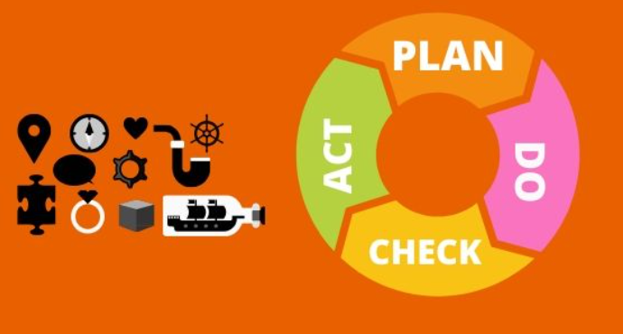
(taken from indiees education 2020)
5.0 Current overview
In my opinion with the research that I have gathered project control is put into place to control the bsa standards and regulations of the project. For project effectiveness this method will speed up the project as it will minimise the defects found within the final product. unlike quality assurance it controls the product with the raw materials used to bring the project together. This will cut out the need for snagging throughout the construction phase unlike quality assurance. Quality assurance documents the stages of the construction phase to make sure that targets are going to be achieved and the product it meeting the standards put into place by the design team. Quality assurance also rewards with incentives for achievement of the final product if it is within the allocated timeline. To summarise in my opinion quality assurance needs quality control to be put into place for project effectiveness. Quality control controls the product and the resources for the final product while quality assurance keeps all the parts that are being constructed together correctly.

6.0 Total quality management
Total quality management is a concept that forms “both quality and productivity” (c.p,2020). The method used is on the basis that everyone who is involved in the product has the same mindset that they want to over achieve and produce a product to the best of their ability. Total quality control uses both quality assurance and project effectiveness as well as inspection. It forms a four-step process. Firstly, is the inspection process. This takes the product and tests to make sure it performs as per the acquired use. Secondly is the quality control. This takes elements of the product and tests for defects in the product and gives guidance on improvement. Next is the quality assurance which helps monitor the product throughout the process in making sure that it meets requirements. Finally, is the total quality management which gives the workers who are assembling the product the ambition to over achieve and create the best product to their ability.
Total quality management works by providing the team with “formulation, visualization, and achievement with an emphasis on innovation and new technology” (C.P,2020). This will ensure that when the product is being pieced together the worker will have all of the skills and the current and up to date training in order to achieve. By getting all the workers to support the product and have pride in the product it will ensure the defect stage will be minimised and this in turn will decrease the time needed to deliver the product. Total quality management works on working around the six areas as below in the image. The commitment needs to be achieved by all the staff involved so there are no areas that are being missed. The culture needs to be adapted to the modern methods in working and the most efficient methods. Everyone needs to be able to improve and adapt for when regulations change. Within a team cooperation needs to be open and honest and promoting this is a big factor as the teams can then be assessed on individual ability for improved efficiency. The customer focus is on the customers’ demands, expectations and requirements to ensure that they are being delivered. Finally, is the control. This is achieved by managing expectations and ensuring that the working days are being as efficient as possible to achieve the most.
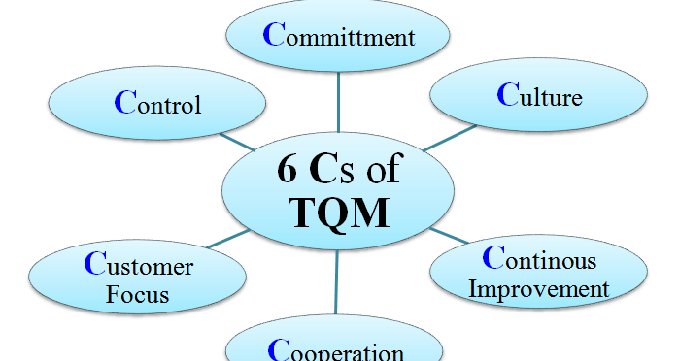
(image taken from constructionplacements.com)

Total quality control provides better project effectiveness as it does not just focus on one area of the build instead it breaks it down into sections to minimise the defects. It also gives the workers the determination, motivation and training needed to change their mindset when producing the product. This will give the workers more control of the quality of the end finished product. “Total quality management is a way of managing an organisation to ensure the satisfaction at every stage” (lathum, pg79). This gives reference to making sure that by exceeding on each target once all constructed together will form a product that has minimal defects when it comes to the snagging phase. If there are any defects picked up it can then be addressed as it will be apparent in which sector the defect is picked up. This can be relayed back and the relevant training given if needed. In my opinion total quality management gives the better project effectiveness so long as all of the steps are being followed in order to achieve. If the individual steps are not being followed then it will fail. As lathum describes it is a “philosophy of teamwork and co-operation, not confrontation and conflict, is long overdue" (Lathum, pg79). This means to minimise the direct conflict and try to become a team instead of just a job and work colleges.

7.0 Summary
In this assignment I have firstly looked at quality assurance and how it effects the construction industry. I have then gone on to looking at quality control and how it covers the different aspects too quality assurance. Finally, I have looked at total quality control and how it provides the best project effectiveness. Throughout this assignment I have also given my opinion on the information I have gathered and how it effects project effectiveness.

8.0 References
Quality management
Author Lance Hodgson, title-quality management in construction, updated 2022, url- Quality management in construction: Here's what you need to know (sitemate.com)
Author-Nick Jenkins, title-a project management primer, updated 2022, URL-A Project Management Primer: Basic Principles - Scope Triangle (projectsmart.co.uk)

Quality assurance
Author-Gopal Mishra, Title-quality assurance in construction, updated 2022, URL-Quality in Construction Industry -Objectives, Factors Affecting Quality - The Constructor
Author-Sir Michael Latham, title- constructing the team, written on July 1994, book reference-pg. 79.
Author- D.J. Pratt, title- British standard 5750, written in 1994, URL-British Standard (BS) 5750 - quality assurance? | O&P Virtual Library (oandplibrary.org)
Author-Michael Harenburg, title-quality assurance in construction, written on June 2022, URL-Quality assurance in construction: 5 golden rules - PlanRadar

Quality control
Author-Gopal Mishra, Title-quality assurance in construction, updated 2022, URL-Quality in Construction Industry -Objectives, Factors Affecting Quality - The Constructor
Author-Assignar(company),title-quality control on construction project, written on September 2017, URL- Quality Assurance (QA) & Quality Control (QC) In Construction - Assignar
Author-Naveed, title-safety and quality control in the construction industry, written on may 2020, URL-Safety and Quality control in the Construction industry. (indieseducation.com)

Total quality management
Author-construction placements, title-total quality management, written on march 2020, URL-Total Quality Management-TQM in Construction Industry (constructionplacements.com)
Author-Gaurav Akani ,title-total quality management 6 TQM,S,written on April 2012, URL-How to Implement Total Quality Management TQM? 6 Cs of TQM (kalyan-city.blogspot.com)

