

Community Engagement

Executive Summary
The report showed the importance of community engagement from a practitioner's point of view. A small description of the community engagement is included within the report. Stakeholders' participation and influence are also major topics of discussion in the report. Social media plays an important role in the promotion of the plan to the local communities, which has been highlighted within the report. Several avenues are used in the promotion of the plan, which is included in the report. A forward-looking approach has been shared in the report as well a few recommendations are provided for the future use of the practitioner.
Table of Contents
Introduction 4
Description of the beating crime plan and stakeholder’s participation in it 5
Relationship with the stakeholders and promotion on the social media platforms 6
Avenues to promote the crime beating plan in the UK 8
Forward-looking approach 9
Conclusion 10
Reference List 11

Introduction
Community engagement practitioner in the local community is responsible for looking after past outbreaks such as beating crimes within the UK country (Gilmore et al., 2020). The main work of the practitioner is to engage the social communities in the issues within the country and provide a solution to the issue. Community engagement is an important factor for the growth of the country's culture and values as it reduces the issues such as crimes within the country. The report will contain the importance of community engagement practitioners. The relationship between stakeholders and strategies that are suitable for engaging the community will be shown in the report. Community promotion is also a major topic of discussion that will be highlighted within the report. Education provided by the community engagement practitioner will be included in the report for understanding the need of the practitioner in the UK.
Crimes are a major issue in all the countries, which are increasing on a daily basis, and community practitioners are trying to reduce the crime rates within the country. Recently crime rates within the country are falling as the practitioners are providing several plans to develop the communities. As per the research, the Crime rate in the UK reduced from 89.85 to 77.6% in every 1000 people (statista.com, 2022).

Description of the beating crime plan and stakeholder’s participation in it
Community engagement refers to the gathering of a group to solve an issue that is affecting their social life. Beating crime plan is a project that started in 2021 and its main objective is to make a peaceful and safe country with lower rates of victims within it (publishing.service.gov.uk, 2021). The case revolves around providing support and confidence to walk in the streets without any fear of being a victim of beating. Making the country safer is one of the main motives of the plan and helping the local social community is an important job role filled by the practitioner. It is a huge issue in the streets of the country as it is making the people of the country terrified. Combining the prevention of the citizens with both male and female police staff is one of the main sources in the plan (publishing.service.gov.uk, 2021). Crimes within the country are making lives miserable for a lot of people in the UK country. The government of the company took several measures to ensure lesser crimes within the country as it will help the country to make better progress in reducing the crime rates. Providing a sense of security for the victims is one of the examples to make this plan recognised more.
There are several practices in the programme that are making huge efforts to reduce the crime rates within the country. Some of the best practices within the country’s plan of beating crime plan that was started in the year 2021 can be seen in the report. One of the practices that can be considered to be a great plan is monitoring the old criminals. As per the records, it will practice monitoring all the prisoners who will leave with electronic gadgets for 24hrs a day (bbc.com, 2021). The monitoring process will help in reducing crime, as many old criminals tend to start criminal activities again after leaving prison.
The plan can be considered to fulfil the principles of community engagement as it makes a productive approach to the community’s issues. Stakeholders enjoy the benefit of understanding the value of both the family as well as the business of the family (Geng, 2021.). Gathering knowledge about the family of the business serves as a benefit for the stakeholders. Crimes are mostly seen from the insiders and therefore, knowing about the family business of the social communities may help to reduce the crime rate in the country. Another best practice of the plan can be stated as ankle wear tags for the criminals that can also trace their location if required (bbc.com, 2021). It can be argued that the plan can help the communities to engage in the process of reducing the crime rate in the country UK.

Relationship with the stakeholders and promotion on the social media platforms
The Internet has become a medium to make the world do whatever they want as it makes the communication process easier for all the people of the world. Social media has become a place that is also involved in crimes but it also provides several benefits for the community engagement services. Stakeholders and the public of the UK country did not believe that the government would take any action against the increasing crime rates within the country. Approximately 35% of the public are confident in the government for taking an action against the increasing beating crime within the UK country (Dodd, 2022). Stakeholders can be engaged with social media by making them converse within the social media platforms. Making them converse on social media platforms can be a great strategy to involve them with the current issue within the country. Targeting stakeholders by their interests can be a good strategy for the involvement of the stakeholders through social media. WhatsApp is the most used social media platform in the UK country and by making the stakeholders involved in the conversations their huge promotion can be achieved for the beating plan (statista.com, 2022).

Figure 1: YouTube promotion of the beating crime plan
(Source: youtube.com, 2021)
Social media is a great place to promote the plan made and increase the awareness of beating crime in the UK. Boris Johnson tried to ensure less crime in the country as it can make beating development plan more aware in the UK market. He also made a promise to reduce crime during the pandemic situation as social media were on a high trend during the time (Morris, 2021). Social media can help to promote the crime reduction plan as it targets a wide range of people in a lesser time. Promotion of the beating crime plan on social media can help in achieving more people for supporting the plan. The UK home office started the promotion on YouTube that captured a view of approximately 68,465 views within the country, which is a huge engagement from the community (youtube.com, 2021). Several other social media can be used to make the plan known to the local communities.
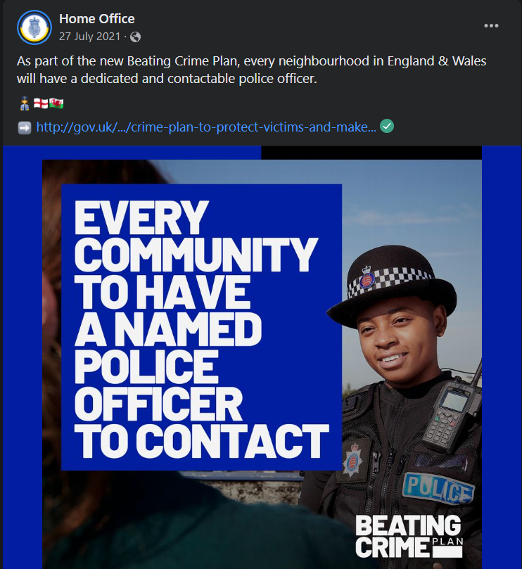
Figure 2: Facebook promotion of the beati
(Source: facebook.com, 2021)
Community engagement is a job role that is filled by the community engagement practitioner and using the social media platforms, it can be enhanced. The Internet penetration rate of the UK is approximately 92.52 % in the year 2021 (O'Dea, 2021). As the internet usage is high it can be stated that promotion through social media can make a great attraction for the engagement of the local communities to the plan. Social media such as Facebook can be used to promote the plan as it can attract a great number of individuals to adopt the plan. It can be argued that the social media platform plays a huge role in the promotion of the beating crime plan. Creative thinking such as emotional intelligence is an interpersonal skill required in the promotion of the beating crime plan UK 2021.

Avenues to promote the crime beating plan in the UK
Community participation is an important thing for the community engagement practitioner as it is the main purpose of the practitioner to involve the entire community. Several avenues are there that promote different issues in the UK country. An example of one of the plans that involve the same crime-related issue is the police and crime plan 2021 (pcc.gov.uk, 2021). The plan was started in the year 2021 which the goal of providing more police in the streets to make the roads safer place. Both the plans have a more or less similar objective and making the communities participate in the promotion of these plans it can make crime rates very low for the entire country. As the motive of the police commissioner, Dona Jones who launched the plan, a similar collaboration of both the plans can be done to promote it faster within the country. As per the research after the Euro 2020 finals police have arrested approximately 11 people for sending racist comments on the social media platforms (Lee, 2021). Diversity is promoted in the beating plan, as no one should be abusing different cultures or social backgrounds in the UK as per law.
Group engagement in a crime makes it more difficult for the plans as it makes the local communities scared to step forward. The act of arrest of the 11 people after the euro finals can be considered as inclusion of racism within the country (Lee, 2021). Engaging the communities to make the plan promoted and collaboration with another plan makes the crime plan known to a wide range of people within the country. The involvement of local communities in the plans also gives a boost to the process of reducing crime in the country as it involves the community itself. More police in the streets will make the road safer and it can also help to reduce the domestic violence or beating plan.

Forward-looking approach
Internal factors for the community engagement can be perused with the help of the following approach
Popular or broad-based participation: Popular or broad-based participation refers to the engagement of large groups in the adoption of a certain plan to change the community by gathering individuals (Pike et al., 2018). Beating crime plans can use the popular participation approach and engage the local communities to adopt the plan. More promotion within the country will help to make the growth of adoption rate of the plan to a wider group of people through participation together in some events. By engaging the community with the project, it gets sustainable within the country and more spread of the plan is achieved.
Community-based development: CBD refers to the approach of the community to get involved more in the social projects, which also helps to make the project effective. People who get involved with the criminal activities often get arrested but beating the crime plan makes the community face several issues that can be omitted by educating them (Lorvick et al., 2018). Beating crime involves both internal as well as external factors that make the person commit a series of crimes within the country. As per the research, the beating crime plan is already making great progress as approximately 9,000 new police officers joined the task force of the plan (bbc.com, 2021). More staff involved in the community can make them realise the importance of this development plan within the country.

Conclusion
The report concludes the importance of community engagement within the country to make an issue solved by the involvement of the social communities. Community engagement is an important factor for the social communities as it makes the problems faced by the local communities highlighted in front of the government. Beating crime plan is a social issue that is faced in the UK and the government of the nation launched a new plan to make the crime rate reduced within the country. Stakeholders also take a part in the engagement of the social communities to make the issue highlighted even further.
Social media plays an important role in the promotion of the plans to fight against the issue of the social community by involving them within the plan. YouTube and Facebook are used by the home office to promote the beating crime plan for community engagement. Stakeholders also make an active part that helping the community to mark the criminal issue in the country. Different avenues can also be used to promote the beating crime plan and spread awareness within the country. The forward looking approach of the community engagement practitioner is also a part of the report that is highlighted to understand the steps required to engage a community.
Few recommendations can be provided to the community practitioner for the better promotion and better engagement of the criminal issue within the country. The practitioner can make the engagement of the plan by providing advertising about the plan in the local channels. A better grasp of the plan can make the people understand its importance and it can also attract them to get involved with the plan on a personal level. Several leaflets and brochures can be produced and delivered to make the people aware of the beating crime plan that has been launched in the UK in the year 2021.

Reference List
bbc.com, 2021. Boris Johnson pledges to to target crime and anti-social behaviour [Online] Available at: https://www.bbc.com/news/uk-politics-57978618 [Accessed 27 April 2022]
bbc.com, 2021. Boris Johnson pledges to to target crime and anti-social behaviour [Online] Available at: https://www.bbc.com/news/uk-politics-57978618 [Accessed 27 April 2022]
Dodd, V., 2022. UK public do not believe government will tackle crime, documents show [Online] Available at: https://www.theguardian.com/uk-news/2022/apr/04/uk-public-do-not-believe-government-will-tackle-crime-documents-show [Accessed 27 April 2022]
facebook.com, 2021. As part of the new Beating Crime Plan, every neighbourhood in England & Wales will have a dedicated and contactable police officer. [Online] Available at: https://www.facebook.com/ukhomeofficegov/posts/1786000294920267 [Accessed 27 April 2022]
Geng, F., 2021. WHAT ARE THE BENEFITS OF COMMUNITY ENGAGEMENT ACTIVITIES FOR FAMILY BUSINESSES? [Online] Available at: https://www.ifb.org.uk/ifb-research-foundation/articles/what-are-the-benefits-of-community-engagement-activities-for-family-businesses/ [Accessed 27 April 2022]
Gilmore, B., Ndejjo, R., Tchetchia, A., De Claro, V., Mago, E., Lopes, C. and Bhattacharyya, S., 2020. Community engagement for COVID-19 prevention and control: a rapid evidence synthesis. BMJ global health, 5(10), p.e003188.
Lee, J., 2021. Euro 2020 racist abuse - 11 people arrested [Online] Available at: https://www.bbc.com/news/uk-58094408 [Accessed 27 April 2022]
Lorvick, J., Comfort, M., Kral, A.H. and Lambdin, B.H., 2018. Exploring lifetime accumulation of criminal justice involvement and associated health and social outcomes in a community-based sample of women who use drugs. Journal of Urban Health, 95(4), pp.584-593.
Morris, S., 2021. Boris Johnson pledges to ensure 'less crime, fewer victims and a safer society' through new Beating Crime Plan [Online] Available at: https://news.sky.com/story/boris-johnson-pledges-to-ensure-less-crime-fewer-victims-and-a-safer-society-through-new-beating-crime-plan-12364746 [Accessed 27 April 2022]
O'Dea, S., 2021. Internet penetration in the United Kingdom (UK) 2000-2020 [Online] Available at: https://www.statista.com/statistics/468663/uk-internet-penetration/ [Accessed 27 April 2022]
pcc.gov.uk, 2021. POLICE AND CRIME PLAN 2021 TO 2024 [Online] Available at: https://www.hampshire-pcc.gov.uk/wp-content/uploads/2021/09/Police-and-Crime-Plan-Donna-Jones-2021-DRAFT09-Spreads.pdf [Accessed 27 April 2022]
Pike, A., Puchert, J. and Chinyamurindi, W.T., 2018. Analysing the future of Broad-Based Black Economic Empowerment through the lens of small and medium enterprises. Acta Commercii, 18(1), pp.1-10.
publishing.service.gov.uk, 2021. BEATING CRIME PLAN [Online] Available at: https://assets.publishing.service.gov.uk/government/uploads/system/uploads/attachment_data/file/1015382/Crime-plan-v10.pdf [Accessed 27 April 2022]
statista.com, 2022. Crime rate in the UK by country 2002-2021 [Online] Available at: https://www.statista.com/statistics/1030625/crime-rate-uk/#:~:text=In%20England%20and%20Wales%2C%20the,49.8%20crimes%20per%20thousand%20population. [Accessed 27 April 2022]
statista.com, 2022. Leading social networks in the United Kingdom (UK) 2021, by reach [Online] Available at: https://www.statista.com/statistics/284506/united-kingdom-social-network-penetration/ [Accessed 27 April 2022]
youtube.com, 2021. Government sets out new 'beating crime plan' [Online] Available at: https://www.youtube.com/watch?v=VFx9DJqV1q4 [Accessed 27 April 2022]

