The effects of the Russia and Ukraine War on Global Businesses
Aidan Aldred
2317625
UWTSD Business School
Assignment 1 2024/25

The effects of the Russia and Ukraine War on Global Businesses
The war in Ukraine, which has become one of the most significant conflicts in Europe in recent decades, has deep historical and geopolitical roots. It began with a pivotal moment in November 2013, when President Viktor Yanukovych, who was pro-Russian, decided to suspend an agreement with the EU that would have moved Ukraine closer to Europe. Instead, Yanukovych opted to strengthen ties with Russia, a move that sparked mass protests across the country. These protests, known as the ‘Euromaidan’ movement, called for closer integration with the EU and demanded democratic reform. (BBC News, 2014)
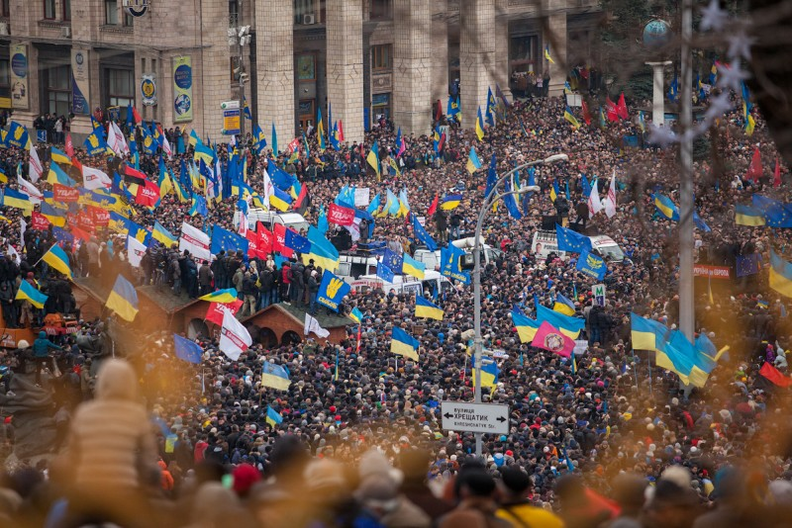
Picture: Euromaidan Protests (Ellison Centre, 2014)
By February 2014, escalating protests led to the dismissal of President Yanukovych and the rise of a pro-Western government in Kyiv. Viewing this as a threat to its influence, Russia annexed Crimea in March 2014, while pro-Russian separatists in Donbas declared independence, sparking a prolonged conflict. (BBC News, 2014)
In February 2022, Russia launched a full-scale invasion of Ukraine, citing NATO's eastward expansion and Ukraine's closer ties with the West as key threats. President Putin claimed the goal was to "demilitarize" and "denazify" Ukraine, justifications widely rejected internationally. For Russia, Ukraine’s move toward NATO and the EU threatened its regional dominance, while Ukraine sought to defend its sovereignty and strengthen its European integration. (BBC News, 2022)
This conflict, born of geopolitical tensions and competing visions for Ukraine's future, has since evolved into a full-blown war with profound implications for both Ukraine and the broader international business community.
The war in Ukraine has caused severe disruptions to global supply chains, particularly in industries that depend on key raw materials and products from the region. Both Ukraine and Russia are major suppliers of critical commodities such as agricultural products, metals, and energy. The conflict has resulted in transportation delays, labour shortages, and difficulties in securing raw materials.
Ukraine, one of the world's largest exporters of wheat, maize, and sunflower oil, has seen its agricultural exports severely impacted by the war. This disruption has led to food shortages and rising prices globally, especially in regions like the Middle East and North Africa, which rely heavily on these imports (Hodges, 2022). The United Nations World Food Programme (WFP) has warned of increased hunger in vulnerable areas due to the lack of Ukrainian grain (WFP, 2022).
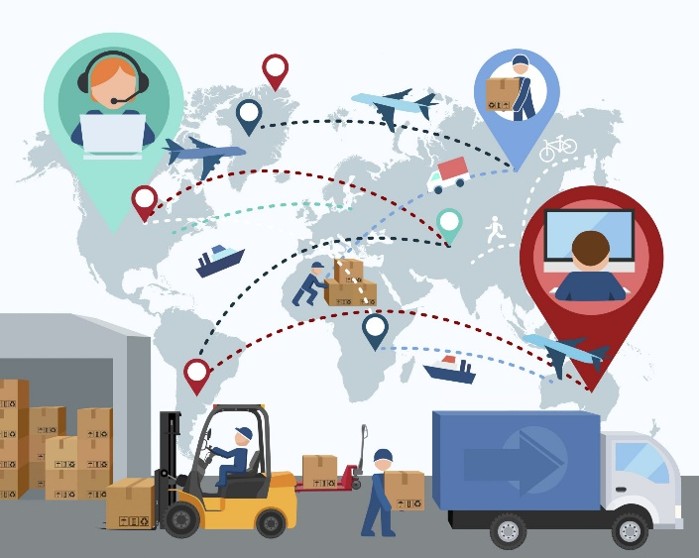
Picture: Supply Chains (LiquidPlanner, n.d.)
As a result, demand for alternative agricultural products and substitutes has surged, creating new business opportunities in the agriculture, food processing, and plant-based food sectors. With Ukraine and Russia accounting for a significant portion of global wheat exports, countries and companies that traditionally imported from these nations have turned to other suppliers. U.S. and Canadian wheat producers have seen increased demand for their crops, and companies like Cargill and ADM have expanded their supply to countries facing shortages due to the war (Reuters, 2022).
One of the most significant impacts of the war on global business has been the sharp rise in energy prices, particularly in Europe, which is heavily dependent on Russian natural gas. As European countries reduce or halt energy imports from Russia, businesses worldwide have been forced to contend with much higher fuel and electricity costs. Airlines, for example, have faced rising fuel prices, leading to higher ticket costs for consumers. This has further complicated the recovery of air travel from the COVID-19 pandemic and negatively impacted the broader travel and tourism industries (Deloitte, 2022).
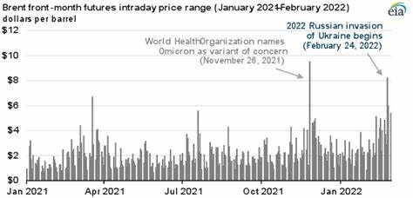
Picture: Showing the spike in Oil prices after Russia invasion of Ukraine. (U.S. Energy Information Administration, 2022)
As the war disrupts global energy markets, particularly in Europe, where Russian oil and gas supplies have significantly decreased, there has been growing demand for alternative energy sources. This shift has created new opportunities for businesses in the energy sector, particularly those involved in renewables, natural gas, and energy storage.
The European Union, in particular, has accelerated its efforts to diversify energy sources, creating opportunities for companies in the renewable energy sector. For example, firms like Ørsted (a Danish renewable energy company) and Siemens Gamesa have benefited from increased demand for wind and solar power projects, especially in countries aiming to reduce their dependence on Russian energy (European Commission, 2022).
Economic sanctions imposed by Western countries on Russia have disrupted trade relationships and created barriers for businesses. Companies that previously relied on Russian markets or supply chains have been forced to exit or adjust their operations. For example, major firms like McDonald's, Coca-Cola, and Starbucks suspended operations in Russia, incurring significant financial losses. McDonald's alone was forced to write off over $1 billion in assets after selling its Russian operations (Morris, 2022).
The war in Ukraine has also prompted businesses to reconsider their reliance on certain regions, particularly Russia and Ukraine, for supply chains. This has opened up opportunities for companies to diversify suppliers and manufacturing locations, which can help reduce risk and access new markets.
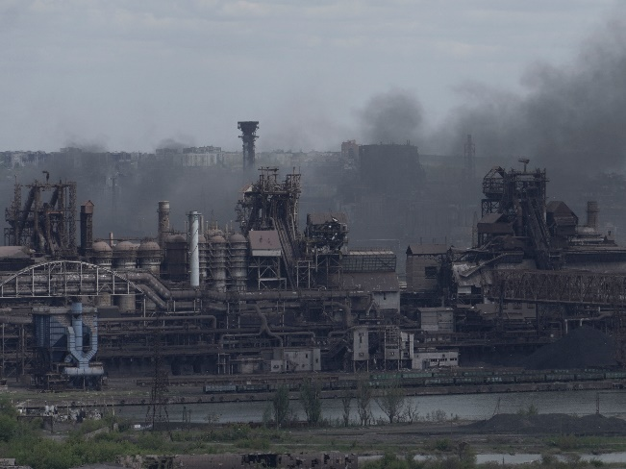
Picture: Russian Steel Factory (Houston Public Media, 2022)
In the automotive sector, companies like Volkswagen and BMW have restructured their supply chains to reduce dependence on Russian steel and Ukrainian parts. These companies have started shifting to alternative suppliers in Europe, Asia, and the U.S., which could help stabilize their operations and create new opportunities in these regions (Automotive News, 2022).
The war in Ukraine has underscored the growing importance of cybersecurity, with both sides engaging in cyber warfare. Businesses worldwide have become targets of cyberattacks, including ransomware, data breaches, and denial-of-service attacks, prompting organizations to strengthen their cybersecurity measures.
Russian-backed hacker groups have targeted Ukrainian government systems and critical infrastructure, while there has also been an increase in cyberattacks on Western businesses with ties to Ukraine or Russia. Major international corporations, such as Microsoft and Google, have reported heightened threats, leading to significant investments in cybersecurity defences (New York Times, 2022).

Picture: Cybersecurity (NetTrust. n.d.)
The conflict has also sparked a global reassessment of security and defence needs, resulting in a substantial increase in defence spending. This creates a major opportunity for companies in the defence and cybersecurity sectors, as governments, particularly in NATO countries, raise their defence budgets.
European nations like Germany and France have pledged to significantly boost defence spending in response to the threat posed by Russia, driving demand for military equipment, weapons systems, and defence technologies. Companies such as Lockheed Martin, BAE Systems, and Thales have seen a rise in orders for advanced fighter jets, missile defence systems, and cyber defence solutions (Defence News, 2022).
The war in Ukraine has not only been a devastating conflict for the region and its people but has also had profound global repercussions, reshaping international business landscapes and geopolitical dynamics. What began as a political crisis over Ukraine’s alignment with the West has escalated into a major conflict that continues to disrupt global supply chains, energy markets, and trade relationships. (Georgetown University, 2023).
The war in Ukraine has highlighted significant vulnerabilities in industries reliant on Ukrainian and Russian exports, particularly in agriculture, energy, and critical materials. The disruption of key agricultural exports, such as wheat, maize, and sunflower oil, has led to food shortages and price increases, disproportionately affecting regions such as the Middle East and North Africa, which are heavily dependent on these imports (International Institute for Strategic Studies, 2024; NATO, 2024).
The energy crisis, driven by halted Russian natural gas supplies, has significantly increased energy prices across Europe and beyond, raising operational costs for businesses globally. This crisis has accelerated efforts to transition to alternative energy sources, fostering growth opportunities for renewable energy companies as European nations reduce dependence on Russian energy (National Defence Magazine, 2024; NATO, 2024).
Economic sanctions on Russia have forced many companies to diversify supply chains and manufacturing locations to mitigate geopolitical risks. In the automotive sector, for example, businesses are restructuring operations to enhance resilience. Meanwhile, the defence and cybersecurity sectors are witnessing substantial growth as NATO countries increase spending to address heightened security concerns, driving demand for advanced military systems and cybersecurity technologies (NATO, 2024; International Institute for Strategic Studies, 2024).
In the digital space, the war has exposed vulnerabilities in global business networks, with increased cyberattacks targeting both Ukrainian infrastructure and Western businesses. This has prompted significant investment in cybersecurity measures, reinforcing the need for robust digital defences (National Defence Magazine, 2024; Defence News, 2024).
The conflict underscores the need for resilience, diversification, and adaptability in global business strategies. While some industries face ongoing challenges, sectors like renewable energy and cybersecurity are finding opportunities for innovation and growth in the evolving geopolitical landscape (NATO, 2024; International Institute for Strategic Studies, 2024).

References
Automotive News. (2022). Automotive supply chain diversification after the Ukraine crisis. Automotive News. Retrieved from https://www.autonews.com
BBC News. (2014, March 3). Ukraine crisis: Timeline. BBC News. Retrieved from https://www.bbc.co.uk/news/world-europe-26270341
BBC News. (2022, February 25). Russia's invasion of Ukraine: What you need to know. BBC News. Retrieved from https://www.bbc.co.uk/news/world-europe-60513807
Defence News. (2022). Defence spending surge amid Ukraine war. Defence News. Retrieved from https://www.defensenews.com
Defence News. (2024). NATO allies ramp up record defence spending. Defence News. Retrieved from https://www.defensenews.com
Deloitte. (2022). Global air travel and the impact of rising energy costs. Deloitte Insights. Retrieved from https://www.deloitte.com
Ellison Centre for Russian, East European, and Central Asian Studies. (2014, January 22). Ukrainians demand change in Euromaidan protests [Photograph]. Jackson School of International Studies, University of Washington. Retrieved from https://jsis.washington.edu/ellisoncenter/news/ukrainians-demand-change-in-euromaidan-protests/
European Commission. (2022). EU energy strategy amid the Ukraine crisis. European Commission. Retrieved from https://ec.europa.eu
Georgetown University. (2023). NATO, the Russian invasion of Ukraine, and the 2022 strategic concept. Georgetown Journal of International Affairs. Retrieved from https://gjia.georgetown.edu
Houston Public Media. (2022, May 16). Hundreds of Ukrainian soldiers evacuated from steel plant to Russian-held territory. NPR. Retrieved from https://www.houstonpublicmedia.org/npr/2022/05/16/1099369421/hundreds-of-ukrainian-soldiers-evacuated-from-steel-plant-to-russian-held-territory/
Hodges, M. (2022). How the Ukraine war affects global food supply chains. The Conversation. Retrieved from https://theconversation.com
International Institute for Strategic Studies. (2024). NATO defence spending: A bumper year. Retrieved from https://www.iiss.org/online-analysis/military-balance/2024/07/nato-defence-spending-a-bumper-year
LiquidPlanner. (n.d.). Manage supply chain complexity using project management. LiquidPlanner. Retrieved from https://www.liquidplanner.com/blog/manage-supply-chain-complexity-using-project-management/
Morris, H. (2022). The cost of exiting Russia: McDonald's, Coca-Cola, and Starbucks. The Wall Street Journal. Retrieved from https://www.wsj.com
National Defence Magazine. (2024). NATO leaders call for smarter defence spending. National Defence Magazine. Retrieved from https://www.nationaldefensemagazine.org
NetTrust. (n.d.). Why is cybersecurity important in this day and age? NetTrust. Retrieved from https://www.netrust.net/blog/why-is-cyber-security-important-in-this-day-and-age/
New York Times. (2022). Cybersecurity in the wake of the Ukraine war. The New York Times. Retrieved from https://www.nytimes.com
Reuters. (2022). Global wheat shortages and the rise of alternative suppliers. Reuters. Retrieved from https://www.reuters.com
U.S. Energy Information Administration. (2022, August 16). Natural gas prices in the U.S. reached record highs in 2022, driven by tight global markets. U.S. Energy Information Administration. Retrieved from https://www.eia.gov/todayinenergy/detail.php?id=51498
WFP. (2022). Impact of the war in Ukraine on global food security. World Food Programme. Retrieved from https://www.wfp.org
NATO. (2024). Secretary general welcomes unprecedented rise in NATO defence spending. NATO. Retrieved from https://www.nato.int

