Strategic Assessment of Amazon Delivery and Logistics Operating Environment.

By Gavin Styane.

Submission date: 17-DEC-2021
Submission ID: 2105306
File name: Global Business Challenges Assignment Amazon Logistics
Word count: 4817

Executive summary

Amazon is the largest online retailer in the world, starting out in 2007 as a website selling books. Over the subsequent 24 years the business has grown to one the world most well-known brands with a presence in 113 countries. It distributes through its own distribution networks in 13 countries.

Amazon’s mission statement is “We aim to be Earth’s most customer centric company. Our mission is to continually raise the bar of the customer experience by using the internet and technology to help consumers find, discover and buy anything, and empower businesses and content creators to maximise their success.” (about amazon, 2021)

Macro-economic trends are discussed through PESTEL frameworks with further analysis on economic, ecological and legal trends.

Micro environmental trends have been discussed and analysed through Porters five forces and a SWOT and TOWS frameworks. The report provides assessment on areas where the Amazon logistics and retail can take advantage of potential weaknesses and how it can defend its vulnerabilities.

Key findings and recommendations are given using current global strategies whilst taking into account all evidence obtained through the frameworks and analysis. Further competitive advantage can be obtained using transnational expansion strategies, managing current legal and human resource strategies. Leveraging their success of achieving their goal of being carbon neutral by 2030 will help drive consumer sentiment and achieve sustainable financial results.

Table of contents

1.0 Introduction 5
1.1 Amazon Delivery and Logistics Overview 5
2.0 Macro Economic Environmental Analysis 6
2.1 PESTEL Framework 6
3.0 MICRO ENVIRONMENTAL FRAMEWORKS 10
3.1 PORTERS FIVE FORCES 10
3.2 SWOT 12
3.3 TOWS MATRIX 14
4.0 Critical assessment of Amazon Logistics and Delivery. 16
4.1 Macro environmental analysis. 16
4.1.1 Economics 16
4.1.2 Ecological Environment 17
4.1.3 Legal 18
4.2 Micro economic environment analysis 19
5.0 Strategic Decisions of Amazon Logistics and Delivery 21
6.0 Recommendations for future strategy and Goals. 22
7.0 Conclusion 23
8.0 references 24
9.0 bibliography 26

List of abbreviations

UK – United Kingdom
EU – European Union
GDP – Gross Domestic Product
OECD – Organization of economic coordination and development

1.0 Introduction

This report aims to assess the current macro and micro environmental conditions in which Amazon delivery and logistics operates globally and the effect that the environment has on the organization. Using tools and frameworks it will allow for the identification of key trends, opportunities and obstacles for Amazon delivery and logistics. The report will then provide a critical analysis on the environmental conditions which will provide key insight into what strategies can be taken in order for Amazon delivery and logistics to have continued success and growth.

1.1 Amazon Delivery and Logistics Overview

Jeff Bezos founded Amazon as an online book store in 1994. The website selling books debuted in July 1995. It quickly became the number one book related website in the world. In 1997 Amazon went public and was able to use the money gained from the listing to expand its distribution network. In 1997 the company reached $147 million dollars in sales, by 2001 sales had increased to $3.12 Billion dollars. (Company Profile, 2019)

As of September 2021 Amazon delivery and Logistics recorded net sales of products in excess of $180 billion (NASDAQ: AMZN), operating about 175 fulfilment centres in 13 countries around the world (aboutamazon, 2021) and selling over 12 million different products (Business Wire, 2021), they do additionally ship products through delivery partners in another 100 countries.

2.0 Macro Economic Environmental Analysis

2.1 PESTEL Framework

PESTEL FRAMEWORK
 | GLOBAL | REGIONAL(UK)
Political | Western countries provide more stability, freedom to access their markets and operate in a capitalistic business model. | UK has traditionally had a stable political base, recently they have gone through multiple changes stemming from the leaving the European union. This has had a radical effect on multinationals trading across Europe.
 | Global policy makers have recently brought about a global taxation global minimum tax standard on certain large multinationals. | UK is part of the global policy makers that have approved the decision to create a global minimum tax standard on certain large multinationals.
 | Western or developing countries can have a much harder political landscapes to navigate. China for instance have policies to support local business that make it harder for international companies to establish substantial local footprints. African countries have been difficult
Economics | Global GDP indicates the health of the world economy and can be used to identify areas of potential growth and reduction. This helps to identify when to make investments and when to hold back. | The UK economy has grown considerably over the last decade.
 | Gini coefficient indicates the available spending power of the population. The higher the score the higher the spending power of the total population. | The UK Gini coefficient has decreased over the past few years, meaning that the bulk of the population has less spending power.
 | Exchange rates are another major factor to consider when looking at the global market. Exchange rates could have large implications on profit. | Exchange rate of the UK has been quite strong over the last decade with relative stability.
Social | The first aspect of the Social element is how it can have an impact within the economic cycle to effect supply and demand, this is achieved through culture, demographics, wealth distribution and geography. Globally these are unique to different regions and research must be made on individual environments. | The UK have a broad demographic with majority of the populations congregated in larger cities and towns. Wealth distribution is fair but has been declining over the past decade.
 | The second aspect is usually referred to as the organizational field, which in brief is the way in which communities within the organization sphere interact with each other. They have the ability to shape of the effectiveness, innovation and efficiencies of the market within which the business operates. | The UK follows traditional western patterns in most areas of influence. Free trade and fairness policies govern most business activities. Governing bodies with the most influence are politicians with some smaller entities such as unions and large businesses having influence.
Technological | Technology is a major factor in determining the ability for organisations to conduct business. There are a number of different technologies that individual organisations need to look at such as power, internet access and infrastructure and access to greener technologies. | The UK has a highly developed technological system with good infrastructure. Majority of the population have access to internet through either mobile or broadband.
Ecological Environment | Global Emissions is a major factor for many consumers and countries around the world. New targets and policies are constantly being set. Consumer are starting to show their support through spending on "greener products and companies'. There are many factors to look at such as packaging, waste reduction and disposal, energy usage. | The UK has been a strong proponent of becoming carbon neutral and has invested in green technologies such as hybrid buses, wind power plants. At the UN climate change conference (COP26) the UK agreed to become carbon neutral by 2050. Any company operating within the UK will need to meet emissions targets.
Legal | Legal aspects vary from country to country and some circumstances region to region. It is important for any organisation to understand the full scope of all legal implications of the environment in which it operates. Legal implications range from taxes, health and safety laws, minimum wages, bans on certain products. Companies should not only look at the current laws but also future laws that could possibly impact the business. | The UK has a robust legal system which governs many aspects of business. Minimum wages for example has the 8th highest minimum wage in the world (Statista, 2020). The UK also has intricate health and safety laws, strict import and export policies, strict data protection laws, tax laws and are implementing laws to reach its carbon emission goals.

The above table gives us insight into a variety of macro environmental factors that Amazon would have to look at when creating and maintaining strategies. We will discuss the implications of the PESTEL framework in the critical assessment portion of the assignment.

3.0 MICRO ENVIRONMENTAL FRAMEWORKS

3.1 PORTERS FIVE FORCES

The framework of porters five forces is aimed at defining the attractiveness of specific industries. The framework provides a general overview of the attractiveness of industries within both a global economy and local economies. The framework also provides a valuable assessment which can be used to drive key decisions in order to gain control and create a competitive advantage for the organization (Whittington, 2020). The diagram (Figure 3.1 1) and subsequent table show the types of forces that need to be looked at in order to create an overall framework, the key details of the five forces will be used in the critical assessment of Amazon logistics and retail.

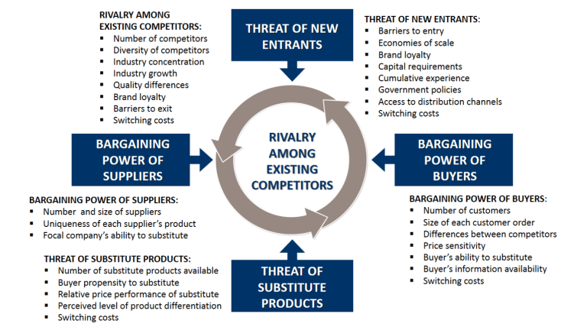
Figure 3.1 1
Source: Lars de Bruin (2016).

Porters Five Forces - Amazon Logistics and delivery | RISK FACTOR
Threat of new entrants | HIGH
Barriers to entry | low
Economies of scale | high
Brand Loyalty | medium
Capital Requirements | low
Cumulative experience | high
government policies | low
Access to distribution channels | high
Switching costs | low
Bargaining Power of buyers | HIGH
Number of Customers | high
Size of customer orders | low
Differences between competitors | low
Price sensitivity | high
Buyers ability to substitute | high
Buyers information ability | high
Switching costs | low
Threat of Substitutes | HIGH
Number of substitutes available | high
Buyer propensity to substitute | medium
Relative price performance of substitutes | low
Perceived level of product differentiation | low
Switching costs | low
Bargaining power of Suppliers | medium
Number and size of suppliers | high
Uniqueness of supplier products | low
Buyers ability to substitute | high

3.2 SWOT

The SWOT and TOWS analysis provides with us with a summary of various analysis done in the macro and micro frameworks with the aim to give direction to strategic decisions of Amazon’s logistics and delivery business.

Strengths

- As an online retailer amazon has a very established distribution network that allows it to offer next day delivery and often same day delivery to its customers. Very few retailers in the world can say this.
- Amazon has a huge global customer base and this can use this competitive advantage to negotiate suppliers prices down in order to beat other competitors.
- The company has generated huge revenues and has immense spending power to invest in new technologies, infrastructure and marketing.
- It currently enjoys a very prominent brand image in society and thus has a large advantage over many competitors as this is often the first name that comes to people when they are looking to purchase something online.
- Amazon has some of the best online payments systems in the world which allows it to offer more convenience to its consumers. It does however sell this technology to other suppliers.
- Amazon has huge amounts of data at its disposal, this data would not be easy to come by for many of its competitors. Amazon has the benefit of being able to leverage this position to create value to its consumers.

Weaknesses

- Amazon has grown very big very fast and is suffering from diseconomies of scale. The large organisation has become very difficult to manage with costs to manage the business increasingly growing.
- Its business model is based on high volume and low margins, this leaves profits extremely low for a business with the turnover that it has.
- One of the core strengths of delivery service is also one of its weaknesses as the cost to keep its delivery promise is very high.
- In terms of retail it still face competition from brands that have both online and physical presence which allows consumers flexibility in how they shop. They have recently launched stores called Amazon fresh in the UK and amazon Go in the USA, however they are still in their infancy.

Opportunities

- Amazon can develop its own brand of products to compete other products, it has the advantage that it has immense amount of data to decide on which products they want to produce and the qualities that the consumers like about the products.
- Amazon can increase its product portfolio far easier than most of the competition as the distribution system allows for more products at lower costs than the traditional retailers.
- Amazon has the opportunity to continue to expand its distribution network by building more facilities, this will enable it to continually offer the best service possible in terms of delivery speed.
- By rolling out its own online payment system, Amazon has the opportunity to scale up considerably considering the fact that concerns over online shopping as far as security and privacy are concerned are among the topmost issues on the minds of consumers. Further, this would improve the company’s margins as it lets it reap the advantages of using its own payment gateway.

Threats

- One of the biggest threats to Amazon’s success is the increasing concern over online shopping because of identity theft and hacking which leaves its consumer data exposed. Therefore, Amazon has to move quickly to allay consumer concerns over its site and ensure that online privacy and security are guaranteed.
- Because of its aggressive pricing strategies, the company has had to face lawsuits from publishers and rivals in the retailing industry. The obsessive focus on cost leadership that Amazon follows has become a source of trouble for the company because of the competitors being upset with Amazon taking away the business from them.
- Finally, Amazon faces significant competition from local online retailers who are more agile and nimble when compared to its behemoth type of strategy. This means that the company cannot lose sight of its local market conditions in the pursuit of its global strategy.
- Another major threat is the reputation Amazon has of employee treatment, manipulating and using data at the expense of suppliers and consumers, tax evasion.

3.3 TOWS MATRIX
Figure 3.1 2
Source: (Weinrich, 1982) & (Aslan et al, 2012)

Strengths/opportunities (SO)
  - Expand distribution network
  - Develop more own products.
  - Invest in more technologies to improve delivery times and options for consumers.

Strengths/Threats (ST)
- Engage with suppliers more and have open communications to prevent further law suits. Amazon needs a symbiotic relationship and needs to nurture these relationship they want to continue being successful.
- Amazon could look to partner with competition to reduce threats or adopt an acquisition model to prevent threats becoming too large.

Weakness/Opportunities (WO)
- Use data to focus on more specific products and cut products that are not profitable.
- Development of further technologies to reduce costs and improve profits.
- Targeted marketing to reduce the threat of small competitors. Improve product offering to match those of smaller retailers.
Weaknesses/Threats (WT)
- Technology will be the best strategy to address fraud and privacy concerns.
- Protectionism policies could be alleviated with investment into local business and partnership.

4.0 Critical assessment of Amazon Logistics and Delivery.

4.1 Macro environmental analysis.

The PESTEL frameworks give us a very good indication of the size and scale of the global environment that Amazon logistics and delivery business operates in. In this report we will only focus on a few key areas of the macro environment which be economics, ecological and legal. It is important to note that all areas of the macro environment are important to address in order for the Amazon Logistics and delivery business to be as successful as possible.

4.1.1 Economics

It is vital for business to understand the economic environment and the impacts of government policies in order to ensure that future demand forecasts are as accurate as possible (Sloman, 2019).

GDP growth is a primary indicator used to measure the health of the world economy, we would also look at anticipated GDP growth in order to support future strategic decisions. Figure 4.1 1 highlights the anticipated global GDP growth rates. Global recovery looks to be robust, these figures are however a prediction and do not take into account in further economic shocks such as the COVID-19 pandemic.

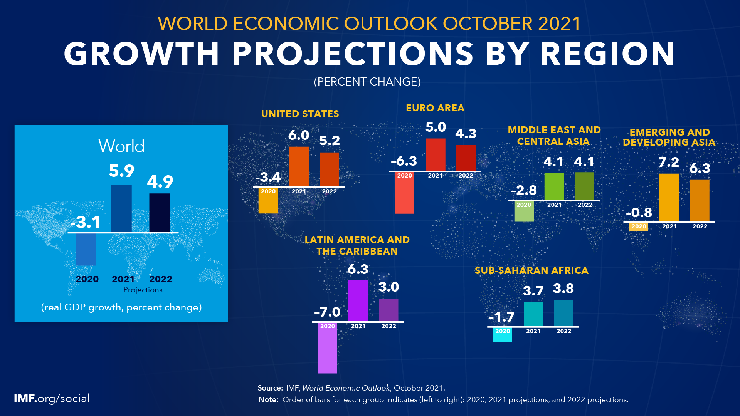
Figure 4.1 1

The Gini coefficient is another indicator of the economy, the Gini coefficient gives us insight into the spending power of the consumers within a specific region. (OECD, 2021). The value of the Gini coefficient goes beyond the consumer spending, it also serves to highlight differences in government policies and goals (Sloman, 2019). Figure 4.1 2 indicates the UK has a lower Gini coefficient score when compared to many other EU countries, Amazon will need to weigh up the opportunity cost of further investment in the UK when compared to alternative countries such as Sweden.

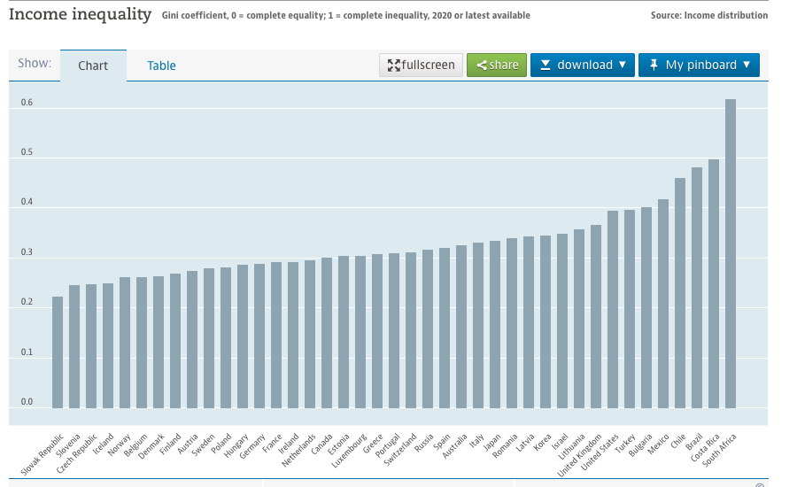
Figure 4.1 2 (OECD, 2021).

4.1.2 Ecological Environment

Amazon has to date been a very big proponent of cutting their carbon footprint. As of 2020 they are the single largest purchaser or renewable energy in the world, they made large financial commitments to research and development such as a recent investment of $2billion dollars into Hippo Harvest through its climate pledge fund (aboutamazon.com, 2021). The investments give us a good indication that no matter the motive Amazon is taking ecological environment seriously.

The ecological environment is currently one of the most serious issues in the global markets. COP 26 held an annual conference in November 2021 in which over 100 countries agreed more aggressive methods to reduce deforestation and over 40 members agreed to more drastic measures to achieve improved carbon emission targets by 2030 with the ultimate goal of being carbon neutral by 2050 (ukcop26, 2021). Amazon is going to have to be prepared to meet the required carbon emission reductions that will be required by the countries in which it operates. Countries are not the only entities putting pressure on companies, many stakeholders from consumers to fund managers are putting pressure on companies to reduce their carbon footprint (Bocken et al, 2012). Amazon will have to continue to meet targets to ensure they have continued support from stakeholders.

There is lots to do when it comes to reducing emissions and although daunting it also represent a major opportunity for Amazon. There are very few competitors that have the financial capacity to make the investment needed to be carbon neutral on the scale that Amazon can whilst still keeping prices affordable for consumers, the long term benefits of achieving these goals using processes such as lean six sigma have shown to increase profitability (Byrne et al, 2007).

4.1.3 Legal

Legal issues form an important part of the macro environmental analysis. Legal frameworks or so called ‘rules’ of business operate at both a regional and international level. The framework should include formal and informal ‘rules’. Formal rules would be considered laws and informal ‘rules’ would be considered behavioral norms, breaching either of these ‘rules’ could have major consequences from governing bodies to public outcry. (Regner, Patrick, et al. 2019)

Amazon needs be aware of the legal frameworks within which it operates. Amazons size has created the downside consequence of being targeted by many stakeholders from governing bodies, unions and consumers. In 2020 the subcommittee on antitrust commercial and administrative law of the committee on the judiciary released a 400 page report citing numerous ways in which Amazon has behaved uncompetitively (Atkinson, R. D, 2020). Amazon needs to be prepared for the consequences that the report might have on future laws that are to be passed.

In 2020 Organisation for economic co-operation and development reached an agreement with 130 countries to impose a minimum corporate income tax of 15% for large technological companies that operate within each nation’s borders, one of which is Amazon. This could have significant consequences for Amazon and will likely impact profitability (Tankersley, J. 2019), (OCED, 2021).

4.2 Micro economic environment analysis

Porters five forces gives insight into the conditions of the market in which Amazon logistics and Delivery is operating. The idea behind Porters is not to list the conditions rather to provide insights that allow management to make strategic decisions to exploit competitors weakness or defend itself against competitor strengths (Whittington et al, 2020).

Porters five forces of Amazon’s logistics and delivery business as shown in section 3.1 tells us that the organization operates in a highly competitive environment. In order create strategies to take advantage of any competitor weakness or protect the business from risks. Management needs to fully understand the implications of the micro environment in which its operates. complementary analysis of the industry life cycle as depicted in figure 4.2 1 shows where in the life cycle the business is to enable it to have a more complete picture.

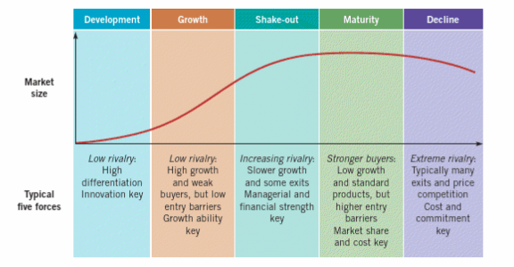
Figure 4.2 1 (Regner, Patrick, et al. 2019)

Blue Ocean strategy is a critical success factor where an organisation differentiates itself from the current market through innovation. In doing so it could regenerate it’s life cycle and find itself with very little competition as competitors would have to re-enter the new market to compete. Amazon did this in the past when it launched its online book store which created an entirely new market, and the way it engaged with consumers. It will have to continually develop its products and service offering to enter new markets and differentiate itself. Figure 4.2 2 shows how companies are able to do this.

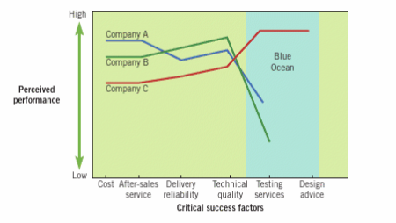
Figure 4.2 2 (Regner, Patrick, et al. 2019)

5.0 Strategic Decisions of Amazon Logistics and Delivery
Figure 5.1 shows us business strategies by incorporating 3 main themes.
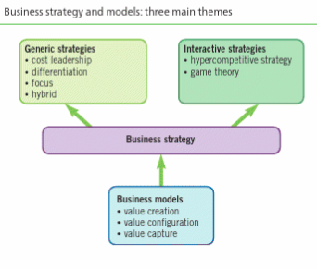
Figure 5.1 1 (Regner, Patrick, et al. 2019)
Traditionally Amazon logistics and delivery business has taken a generic hybrid strategy incorporating cost leadership and differentiation strategies. Cost leadership is achieved through having the lowest priced goods while maintaining profits through cutting costs through economies of scale, reducing delivery and logistics costs and using the benefit of experience. Differentiation is achieved through having the best delivery service on the market, unique delivery methods such as drones and continually investing in bring ‘green’ ways to deliver products. This is achieved through using a multi sided business model linking sellers, merchants, advertisers and products (Regner, Patrick, et al. 2019).
Amazon logistics and delivery business recently made the announcement to remove VISA cards as a payment method, citing that the fees were to high. This is clearly a part of the cost leadership strategy that the organisation has taken. There is a potential risk of the cost cutting having an adverse effect. In section 4.1.3 the report cited a report on the anti-competitive behaviours of Amazon, this act to cut payment from the largest card provider in the world (Nilson, 2019), a bold move like this could serve to have a major impact, providing more ammunition for policy makers.

Amazon logistics and retail has great success with its international expansion strategy. It currently operates in 13 countries with export through partners of an additional 100 countries. (Dogterom, L, 2014). Amazon logistics and delivery business has achieved this through a Transnational strategy. The transnational strategy is the most complex strategy to implement, it attempts to marry integration with the ability to respond to changing regional conditions. Amazon logistics and delivery business delivers this through standard product and service offering as much as possible with allowing the regional headquarters to have a degree of independence to enable it to react and make strategic decisions (Regner, Patrick, et al. 2019).

6.0 Recommendations for future strategy and Goals.

Amazon should continue implementing solutions to reduce their carbon footprint. The issue is predicted to continue to be at the forefront of global discussions for many nations and consumers, with many countries as mentioned in section 4.1.2 already having signed further measures to reach a carbon neutral goal by 2050. This should lead to long term sustainable growth as research has shown previously in this report.

In addressing the ever increasing legal pressures faced by Amazon, a careful and considered approach to strategy needs to be taken. The decision to remove VISA as a payment service could have huge global ramifications from lawsuits to new laws been introduced and a loss of customers. This is not the only controversial decision that has been taken, in 2021 Amazon logistics and delivery business announced incentive bonuses of up to £3000.00 to recruit staff, this is the midst of global unrest about labour conditions and pay, with global strikes being held (business insider, 2021). Amazons third quarter report show a net sales increase of 15% to $110 billion (NASDAQ: AMZN). This reflects negatively on Amazon as the message comes across that Amazon have money to spend on incentives for new staff but not to take care of their current staff. Amazon need to have a clearly defined strategy so that their decisions do not appear nonsensical to all stakeholders.

Global expansion strategies should ensure that countries that they are targeting have good GDP growth potential, political stability, geographical dense enough to ensure that delivery promises can be kept and that they can utilise their central distribution model, enough infrastructure to utilise the technology that Amazon uses to engage with its potential customer base. An example of such a country would be Sweden. The population as of September 2021 is 10 435 447 million people with the majority of people living in cities. They have one the world’s lowest Gini coefficient scores at 0.280 as shown in figure 4.1 2, this would indicate a high level of disposable income. They have excellent infrastructure, an affinity for technology shown by the fact that they have spent over $13billion dollars on online retail in 2020 (ecommercedb.com, Statista 2020). It would also create a platform to develop into other Nordic regions. There is some argument that the population is small and thus not a priority for Amazon however Northern Ireland who has a population of 1.8 million has two fulfilment centres and a much lower Gini coefficient which suggests that Sweden would be a better use of resource allocation in the long term.

7.0 Conclusion

The aim of this report was to provide insight into the macro and micro environmental conditions that Amazon logistics and delivery business operate in. The PESTEL analysis shows that the business has many environmental conditions to navigate with the key areas addressed being economic, ecological and legal. Porters five forces gives us insight into how competitive the environment is and that STOW and TOWS matrix gives us considerable insight as to how the business can reduce risks and take advantage of opportunities using both macro and micro frameworks to support global and regional strategy decisions. Frameworks and insight are used in conjunction with other indicator to provide recommendation on current and future strategies.

8.0 references

- Aboutamazon.com – news, sustainability (2021) https://www.aboutamazon.com/news/sustainability/amazon-becomes-the-worlds-largest-corporate-purchaser-of-renewable-energy
- Amazon.com, Inc. - Company Profile, Information, Business Description, History, Background Information on Amazon.com, Inc. (2019). Retrieved from https://www.referenceforbusiness.com/history2/35/Amazon-com-Inc.html
- Amazon.com, Inc. - Company Profile, Information, Business Description, History, Background Information on Amazon.com, Inc. (2019). Retrieved from https://www.referenceforbusiness.com/history2/35/Amazon-com-Inc.html
- Aslan, Cinar, O., & Kumpikaite, V. (2012). CREATING STRATEGIES FROM TOWS MATRIX FOR STRATEGIC SUSTAINABLE DEVELOPMENT OF KIPAŞ GROUP / DARNAUS VYSTYMOSI KIPAS GRUPĖJE STRATEGIJŲ KŪRIMAS REMIANTIS GGSS MATRICA. Journal of Business Economics and Management, 13(1), 95–110. https://doi.org/10.3846/16111699.2011.620134
- Atkinson, R. D. (2020). Seventeen Flaws in the Cicilline Antitrust Report on Competition in Digital Markets. Information Technology and Innovation Foundation.
- Bocken, N. M., & Allwood, J. M. (2012). Strategies to reduce the carbon footprint of consumer goods by influencing stakeholders. Journal of Cleaner Production, 35, 118-129.
- Business Insider (2021). https://www.businessinsider.com/make-amazon-pay-campaign-staffers-will-strike-on-black-friday-2021-11?r=US&IR=T
- Byrne, G., Lubowe, D., & Blitz, A. (2007). Using a Lean Six Sigma approach to drive innovation. Strategy & Leadership.
- Dobbs, M. E. (2014). Guidelines for applying Porter's five forces framework: a set of industry analysis templates. Competitiveness Review.
- Elliott, L. (2018) Even Amazon isn’t immune to political and economic pressure, available at: https://www.theguardian.com/technology/2018/oct/02/even-amazon-must-heed-laws-politics-and-economics
- Elliott, L. (2018) Even Amazon isn’t immune to political and economic pressure, available at: https://www.theguardian.com/technology/2018/oct/02/even-amazon-must-heed-laws-politics-and-economics
- https://www.aboutamazon.co.uk/amazon-fulfilment/our-fulfilment-centres/why-amazon-warehouses-are-called-fulfilment-centers
- https://www.businesswire.com/news/home/20160614006063/en/How-Many-Products-Does-Amazon-Actually-Carry-And-in-What-Categories
- https://www.theguardian.com/global-development/poverty-matters/2011/jul/13/global-business-regulation
- Lars de Bruin (2016). Porters fiver forces. Business-to-you (https://www.business-to-you.com/porters-five-forces)
- Morrison. (2020). The global business environment : towards sustainability? (Fifth edition.). Macmillan Education.
- Mulder, P. (2018). Heckscher Ohlin Model. Retrieved 31/Oct/2021 from ToolsHero: https://www.toolshero.com/strategy/heckscher-ohlin-model/
- Nilson Report (2019). "The Nilson Report Issue 1163 | October 2019
- OECD (2021), Income inequality (indicator). doi: 10.1787/459aa7f1-en (Accessed on 06 December 2021)
- OECD (2021), Statement on a Two-Pillar Solution to Address the Tax Challenges Arising from the Digitalisation of the Economy – 8 October 2021, OECD, Paris, www.oecd.org/tax/beps/statement-on-a-twopillar-solution-to-address-the-tax-challengesarising-from-the-digitalisation-of-the-economyoctober-2021.htm.
- Regner, Patrick, et al. Exploring Strategy Text and Cases PDF EBook, Pearson Higher Education & Professional Group, 2019. ProQuest Ebook Central, https://ebookcentral.proquest.com/lib/trinity/detail.action?docID=5987036.
- Sloman. (2019). Economics for business (Eighth edition). Pearson.
- UKCOP26, World leaders summit summary 2021, https://ukcop26.org/cop26-world-leaders-summit-presidency-summary.
- Whittington. (2020). Exploring strategy : text and cases (Regnér, D. Angwin, G. Johnson, & K. Scholes, Eds.; 12th ed., p. 1 online resource (xxvi, 810 p.) :). Pearson.
- World Bank national accounts data, and OECD National Accounts data files.
- World Bank. 2021. The Changing Wealth of Nations 2021 : Managing Assets for the Future. Washington, DC: World Bank. © World Bank. https://openknowledge.worldbank.org/handle/10986/36400 License: CC BY 3.0 IGO.”

