  Component One:  What are the key skills required when working in the housekeeping team? 750 words (+/- 10%)  Contribution to Overall Module Assessment: 25% | Student  No: | Printesa Eftimie  2206215
 | Module Title: | Operating Hotel Facilities
 | Module Code: | BMIH4006
 | Lecturer: | Lisa Bassler
Effective housekeeping it is not just about doing cleaning, but it is demanding also relevant abilities that different than the employability one such as technical one can be. Therefore, bellow we have considered to explore some of these activities in details:
First it is all about attention to detail that of course it is essential when it comes to a housekeeper. Each client may have unique requirements, and missing minor details can lead to dissatisfaction. This involves noticing stains on the carpet, dust on the blinds, or soap scum in the bathroom. Good housekeepers will notice these things and take care of them proactively( O’Fallon and Rutherford,2011)Now in this context it is important to consider another relevant skill relevant which it is the physical stamina and agility as this it is a job that it is physically demanding, involving tasks like lifting heavy items, being on your feet for extended periods, and reaching hard-to-clean areas( Branson and Lennox1990)Therefore, physical stamina and agility are essential to perform the duties efficiently.Of course being in time and regulating it very good it is also essential in this case as this job it is all about working within a set schedule, and there may be multiple rooms or properties to clean within a specific time frame. Good time management skills can help a housekeeper stay organized and efficient, ensuring that no tasks are left unfinished(Bardi,2011)
Now considering another skill that it is very relevant in this context it is the being able to utilize the cleaning tools and relevant equipment related and here it is all about utilizing a range of instruments such as vacuum cleaners, floor buffers, and power washers(Woods,2011) Familiarity with these tools and the ability to use them properly and safely is a crucial technical skill. Another relevant skill in this context it is the one related to having knowledge of the cleaning items and being all the time updated in terms of the cleaning produces and as a house cleaning it is very relevant for housekeepers to understand the different cleaning products available and their appropriate uses, including knowledge of eco-friendly alternatives. It's also necessary to know various cleaning procedures to clean different types of surfaces and materials without causing damage( Tingle and Thyrne,2008)Considering the services and skills it is all about customer one as a housekeeper it is demanding all the time to interact with people and in this context it is important to be stated that having excellent customer service skills is important. This includes being polite and respectful, responding to client requests or complaints promptly, and maintaining a professional demeanor at all times. Now, another relevant skill here it is the problem-solving ability as every housekeeping job goes as planned. Housekeepers may encounter stubborn stains, broken equipment, or other unexpected issues. Being able to quickly and effectively solve these problems is a valuable skill. Integrity and trustworthiness it are all essential as customers have the trust in the
respectful of clients' privacy and possessions. This also involves adhering to professional ethics and standards.
Every client and every home is different, with different needs and expectations. A good housekeeper is adaptable, able to adjust their routine to fit the specific requirements of each job(Younes,2016).
Clear communication is a key also in this context as this it is assuring that all people desire are reached and everyone is on the same page about what needs to be done, and can help avoid misunderstandings and mistakes.Housekeeping can sometimes be a solitary job, and it may require a great deal of self-discipline and self-motivation to maintain a high standard of work.Considering the current situation in terms of the technological development I can simple state that I want mention about the one related to practice as it is must be aware of being able to address problems as they arise, report issues that require attention, and suggest improvements to cleaning practices or protocols.Additionally, in the context of digital era being able to use the technology and being adabtable in this context it is also very relevant and a good housekeeper stays informed about the latest developments in cleaning equipment, tools, and supplies, and seeks opportunities to learn how to use them.
In diverse work settings or locations that cater to international clients, cultural sensitivity can be a valuable skill. This involves understanding and respecting the different cultural norms, practices, and expectations of clients( Raghubalan and Raghubaln,2015)

In conclusion, housekeeping is a multifaceted profession that requires a comprehensive set of skills beyond simply cleaning and it is all about being adaptable, paying attention to details, physical endurance, being good when it comes to quality physical endurance and of course customer service and communication as this it is a job that demands a good relationship between the client and the staff.

Word Count | 810

Component Two:
Contribution to Overall Module Assessment: 25%
In this scenario – You have just been promoted to team leader for a floor within the hotel. A guest complains that on their arrival, their room had not been properly cleaned. Create an action plan and answer the following questions.

Problem | Why did it happen? | What are you going to do? | How will you prevent this from happening in the future? | What measures would you introduce to improve team effectiveness?
The room it is not clean. | The room status might have been erroneously marked as cleaned in the system when it was not. | Ask for an immediate good cleaning while offering to the tourists complimentary /additionally services because of late booking (Seymer,2007) | Implement a double-check system where housekeeping staff must confirm room cleanliness before updating the system. | Regular training sessions on the importance of accuracy and responsibility in their work
Leftover trash in room, | The housekeeper overlooked trash during the cleaning process. | Clean the room again and apologize for this. | Implement a cleaning checklist to tick that everything has been done | Reward system
Unsanitary Bathroom | The room has been cleaning while the bathroom has not done properly | Immediately clean and sanitize the bathroom and offer an apology to the guest. | Monitor the time spent on each cleaning job to ensure housekeepers are not rushing. | Regular training in terms of better cleaning practices.
Dust in the room | The housekeeper missed dusting certain areas. | Clean the dust | Implement training on detailed cleaning processes and stress the importance of dusting all areas. | Peer review system where colleagues check one and another
linen not replaced. | Forgot to replace used linen | Replace all of them and apologize | Develop a mandatory linen replacement policy for every room cleaning(Seymer,2007) | Regularly update the staff on the importance of each step in the cleaning process and its impact on guest satisfaction.

Component Three:
Contribution to Overall Module Assessment: 50%
Your task is to create and prepare a presentation following the detailed scenario provided below.

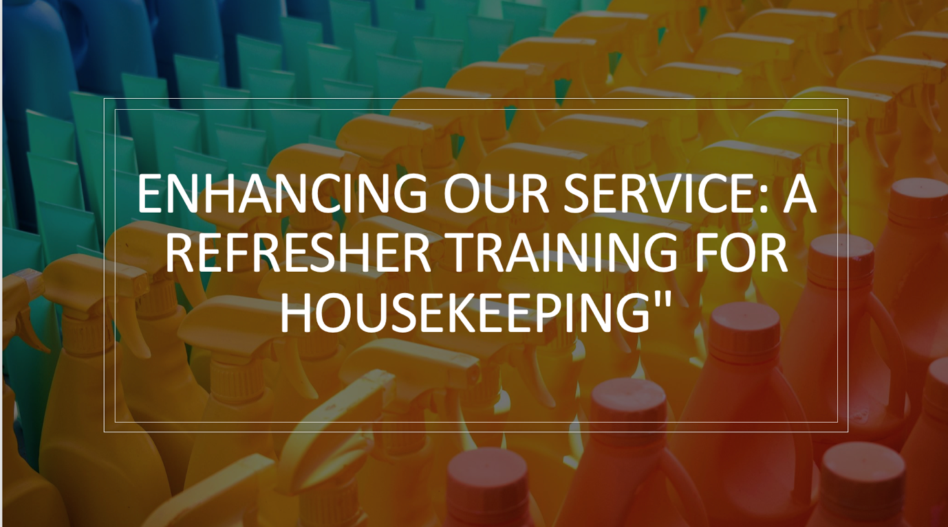

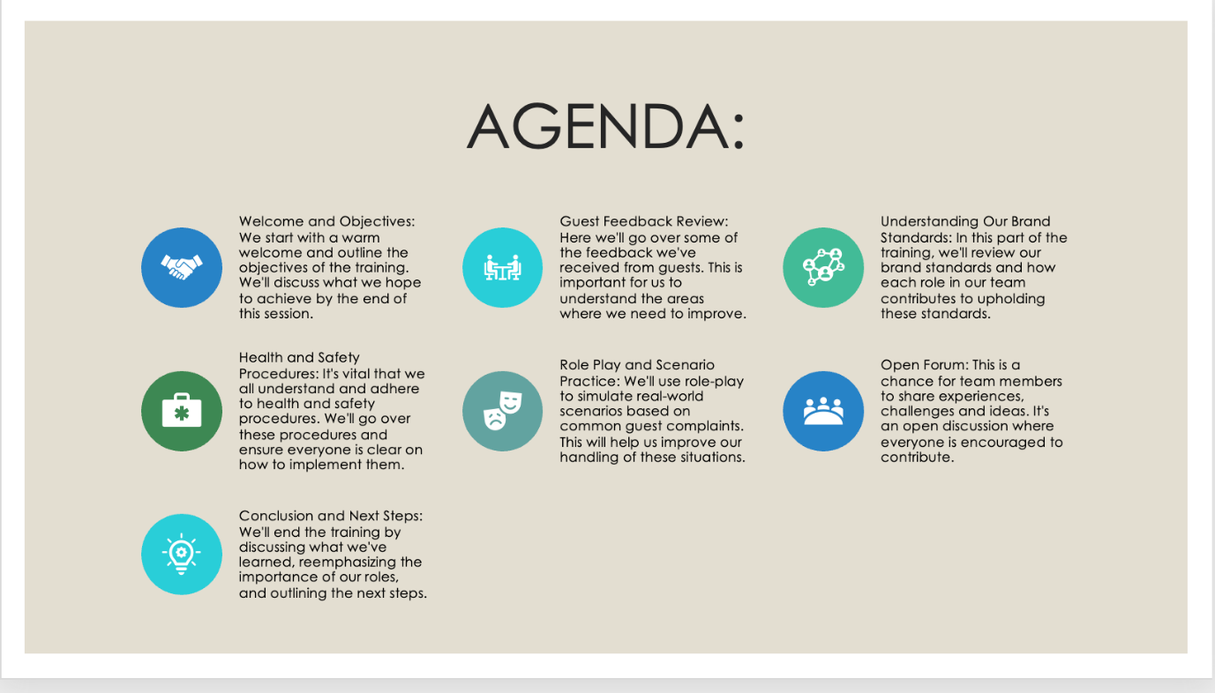

Training Notes: Enhancing Our Service: Welcome to our refresher training session for the housekeeping team titled "Enhancing Our Service". This training is being led by MIHAELA and is taking place on 7 JUNE 2023
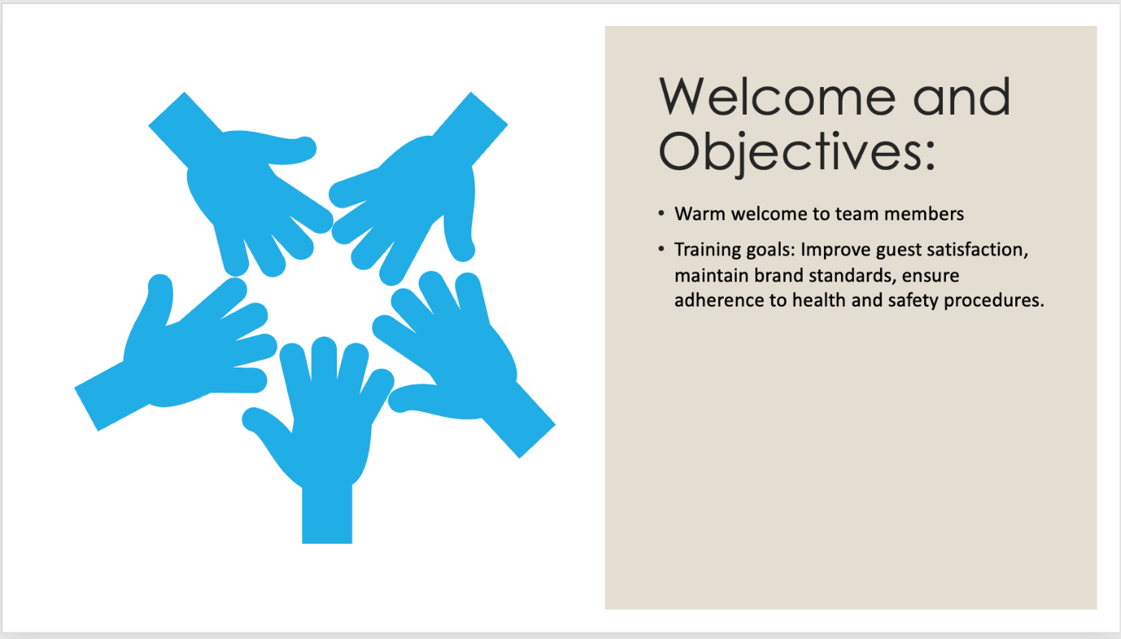

Training Notes: Our training today will be divided into several segments. We'll begin with a warm welcome and a rundown of our objectives for the day. Next, we will engage with the cleaning practices along with the feedback that we already have from the guests, and this will lead us to a discussion about our brand standards and what they mean for us as a housekeeping team. We'll then refresh our knowledge on health and safety procedures. The training will continue with role plays and scenario practice based on common guest complaints. We'll provide a platform for open discussion in the forum segment and wrap up the session with concluding remarks and discussing the next steps forward.
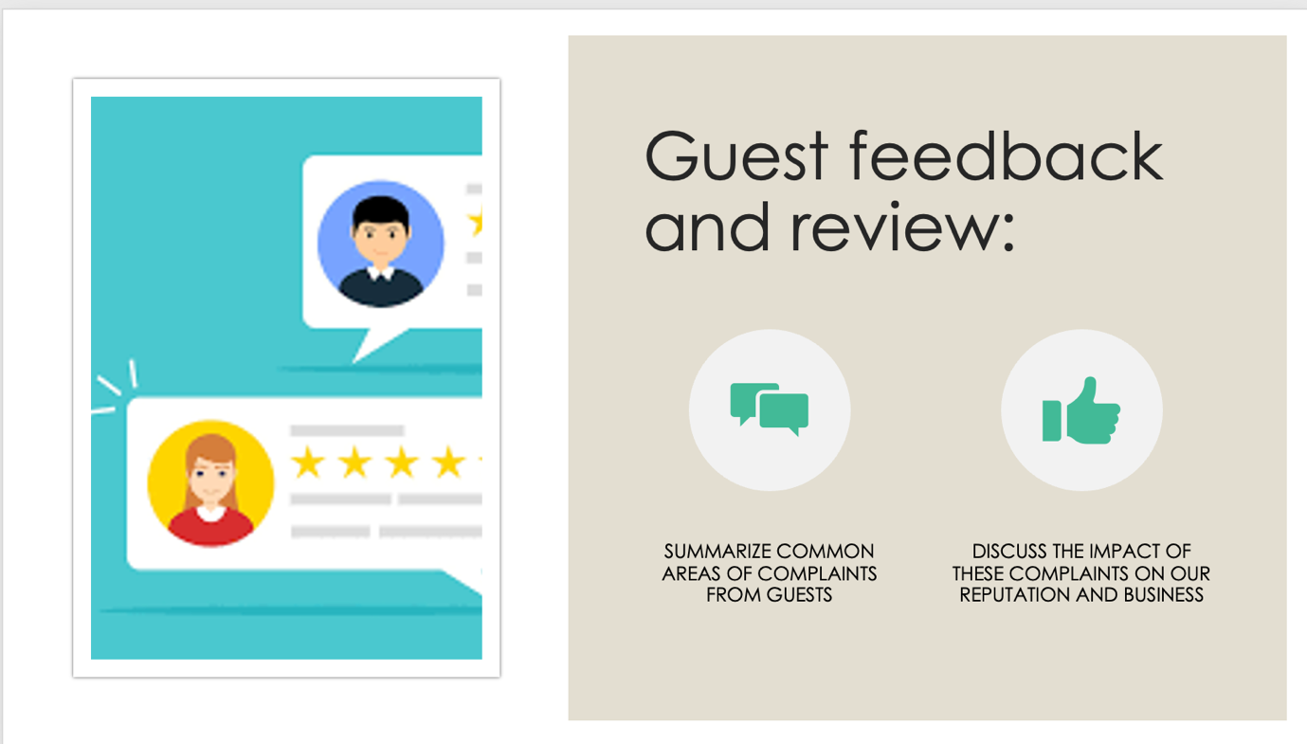

Training Notes: I would like to warmly welcome each one of you to this training and in this context, it is important to be stated that our primary goal of this session it is to increase the efforts in terms of making customer more satisfied and of course keeping all the time the brand's service standards and ensuring that all health and safety procedures are followed diligently.
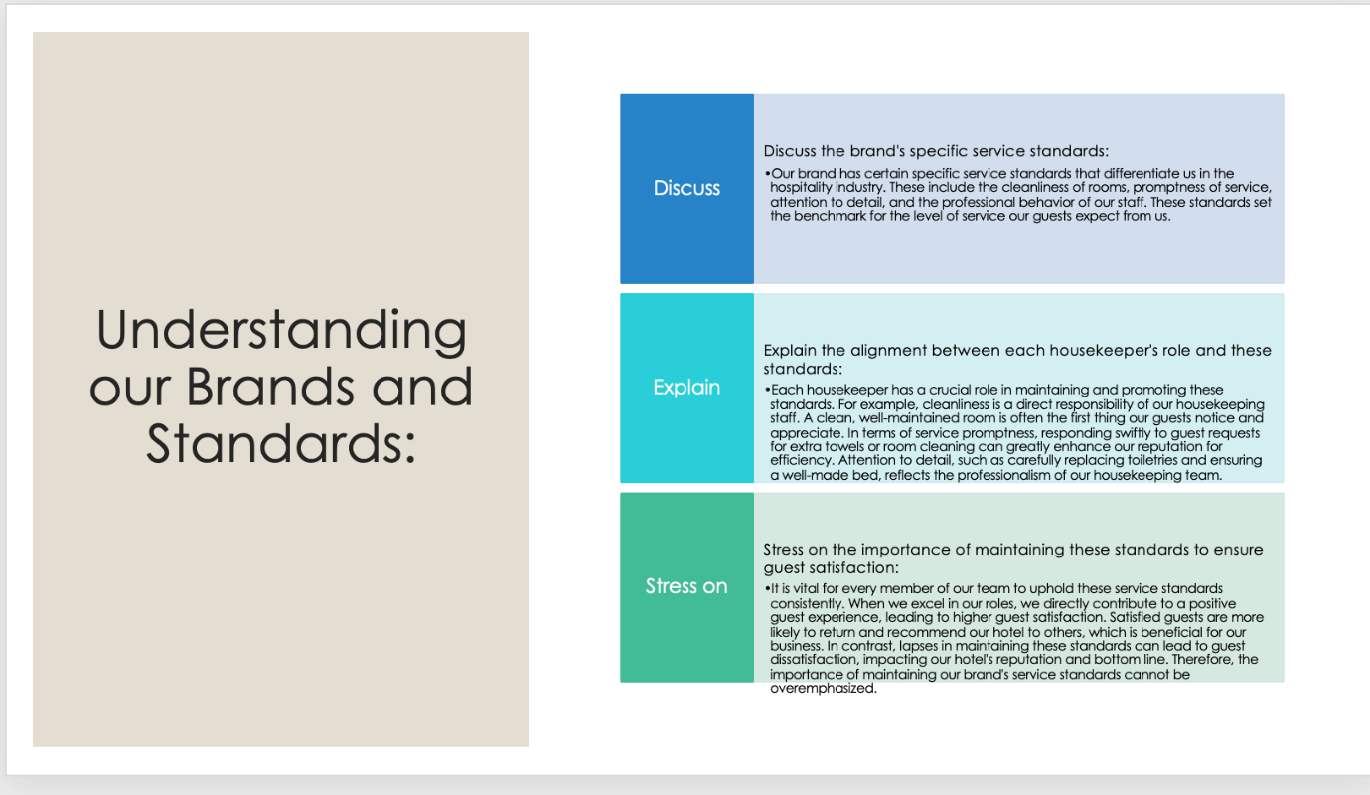

Training Notes: We'll begin by reviewing feedback from our guests, focusing on common areas of complaint. These issues directly affect our hotel's reputation and overall business. By addressing them proactively, we can improve our service delivery and guest satisfaction.
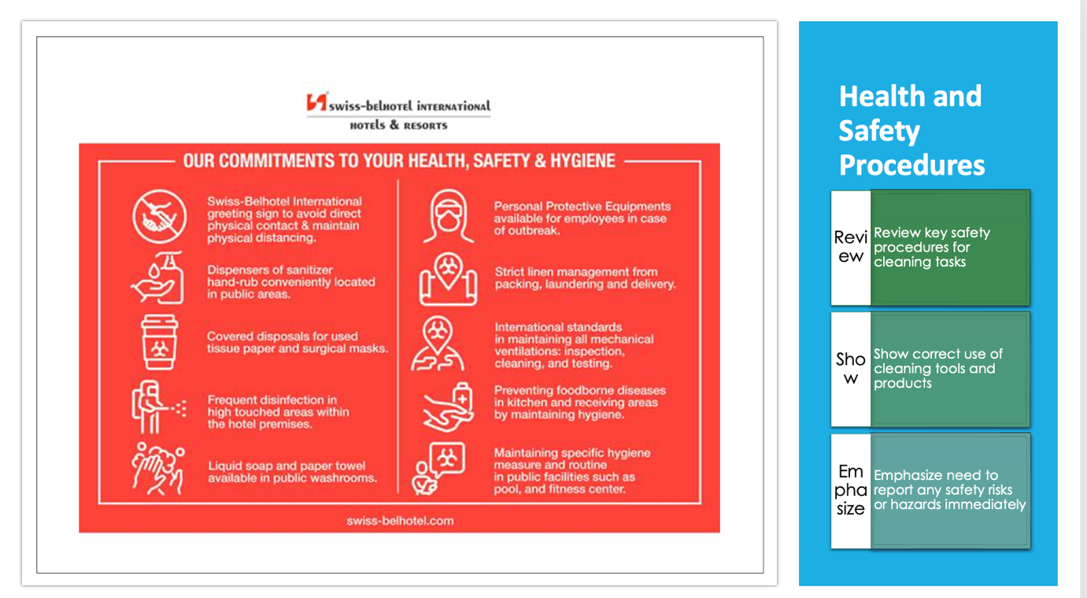

Training Notes: Our brand has set high standards of service that we must strive to achieve. As members of the housekeeping team, each one of us plays a vital role in maintaining these standards. By consistently delivering on these standards, we can significantly improve our guest satisfaction rate.

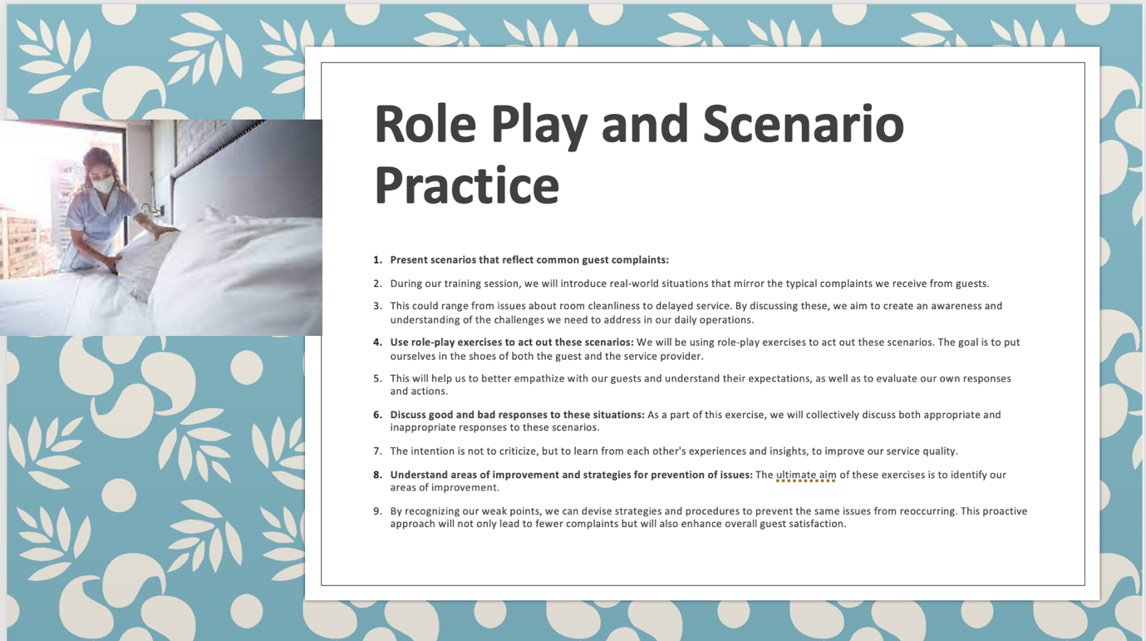

Training Notes: Health and safety are paramount in our line of work. We'll take some time to go over important safety procedures that it is important to be consider and each of you should be aware of these and of course I will consider delivering training to demonstrate the correct use of cleaning equipment and products. Remember, promptly reporting any potential safety hazards is crucial to maintaining a safe working environment.
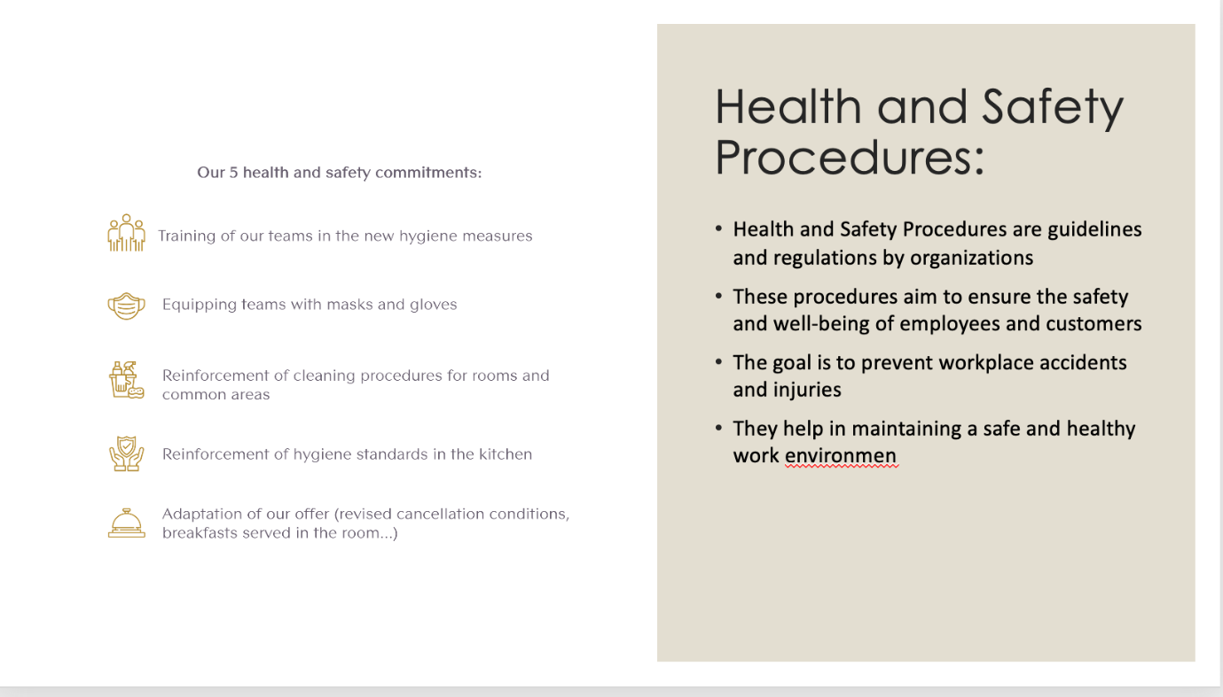

Training Notes: During our training we have consider a lot of examples in terms of real examples to better understand what it is needed from us and thus has been created an awareness and understanding of the challenges we need to address in our daily operations. There has been sed to act on this example and understand what exactly the clien tit is expecting from us and coming with relevant ways to reach the customers experiences.

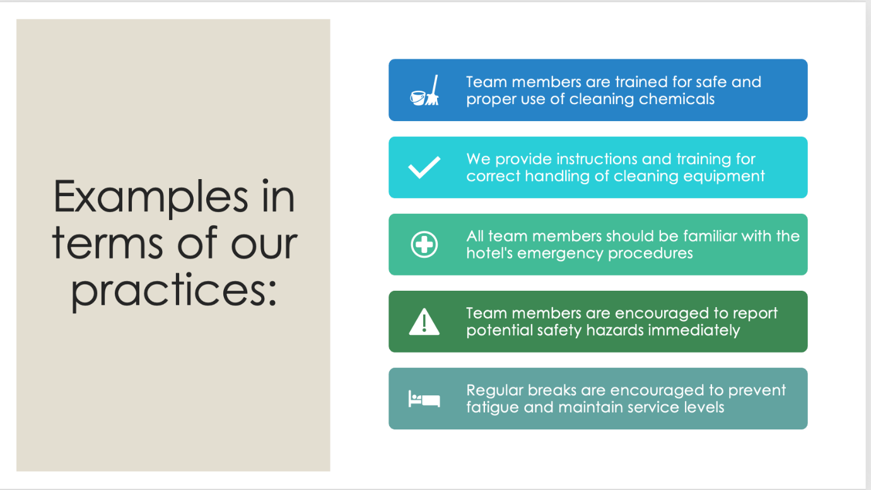

Training Notes: Health and Safety Procedures it is all about the guidelines related that the business has implemented in terms of wellbeing and safety of the workers and of course clietns and to assure that these are all the time in their palce.

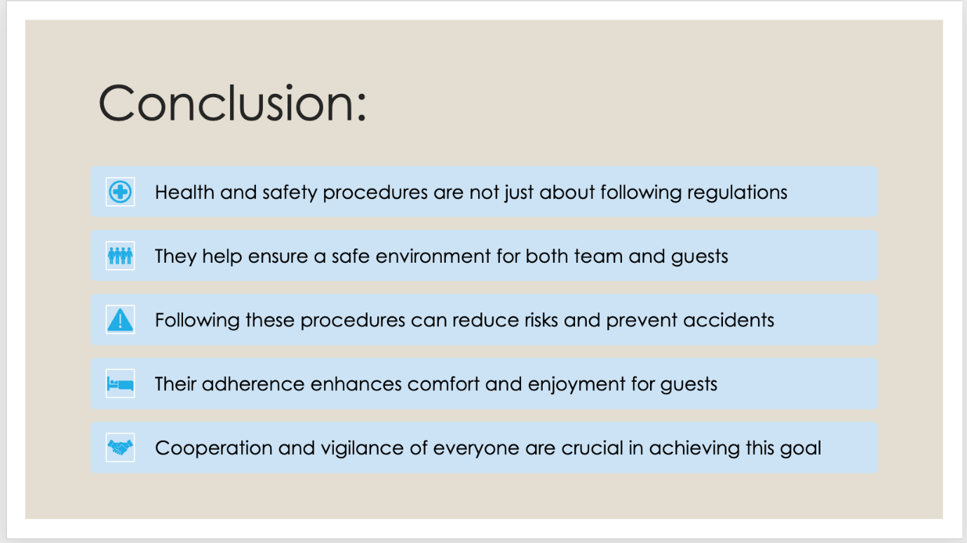

Training Notes:
Our team's practices focus on ensuring safety and promoting well-being, which includes appropriate use of cleaning chemicals, correct handling of equipment, adherence to emergency procedures, prompt reporting of potential hazards, and regular breaks. Through comprehensive training, we ensure that all team members use cleaning chemicals and equipment safely and correctly. Also, by acquainting them with the hotel's emergency procedures and encouraging prompt hazard reporting and regular breaks, we maintain a safe, efficient work environment.

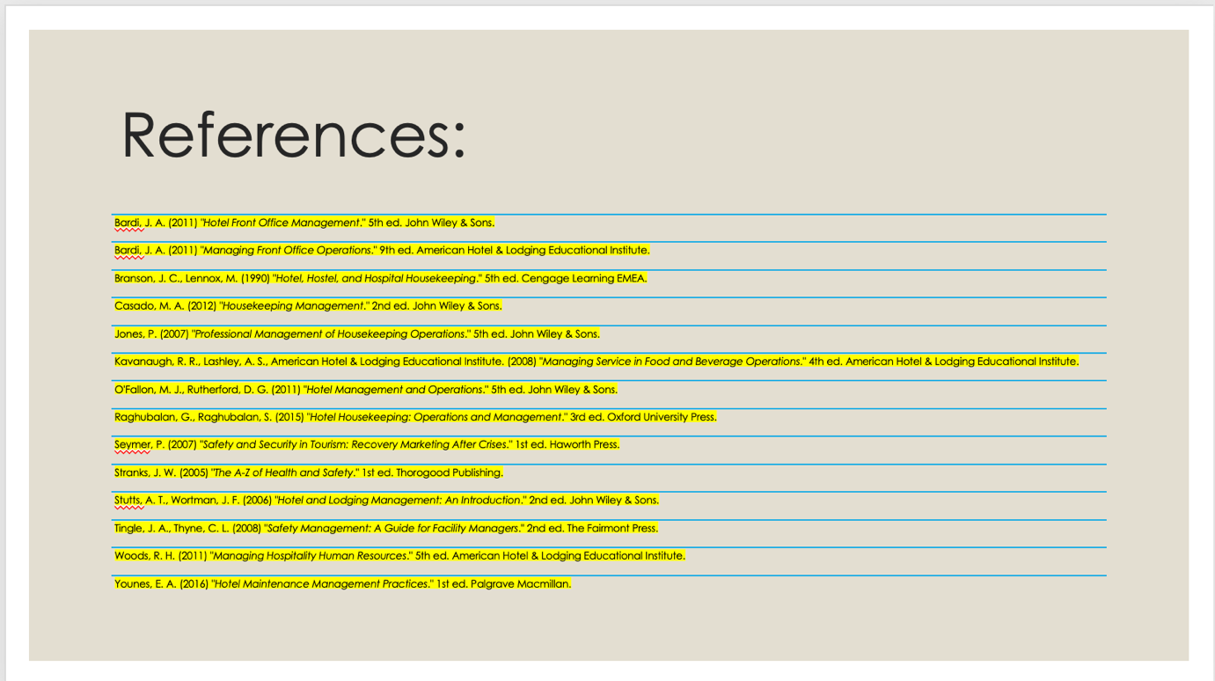

Training Notes:
Maintaining health and safety procedures is not just about adhering to regulations; it is about ensuring that our hotel is a safe environment for both our team and our guests, and it is important to be stated that by following these we can prevent any type of accidents and assuring a great stay for each of us.

References

Badri, J. A. (2011) "Hotel Front Office Management." 5th ed. John Wiley & Sons.
Badri, J. A. (2011) "Managing Front Office Operations." 9th ed. American Hotel & Lodging Educational Institute.
Branson, J. C., Lennox, M. (1990) "Hotel, Hostel, and Hospital Housekeeping." 5th ed. Cengage Learning EMEA.
Casado, M. A. (2012) "Housekeeping Management." 2nd ed. John Wiley & Sons.
Jones, P. (2007) "Professional Management of Housekeeping Operations." 5th ed. John Wiley & Sons.
Kavanaugh, R. R., Lashley, A. S., American Hotel & Lodging Educational Institute. (2008) "Managing Service in Food and Beverage Operations." 4th ed. American Hotel & Lodging Educational Institute.
O'Fallon, M. J., Rutherford, D. G. (2011) "Hotel Management and Operations." 5th ed. John Wiley & Sons.
Raghubalan, G., Raghubalan, S. (2015) "Hotel Housekeeping: Operations and Management." 3rd ed. Oxford University Press.
Seyer, P. (2007) "Safety and Security in Tourism: Recovery Marketing After Crises." 1st ed. Haworth Press.
Strands, J. W. (2005) "The A-Z of Health and Safety." 1st ed. Thorogood Publishing.
Stutt’s, A. T., Wortman, J. F. (2006) "Hotel and Lodging Management: An Introduction." 2nd ed. John Wiley & Sons.
Tingle, J. A., Thyme, C. L. (2008) "Safety Management: A Guide for Facility Managers." 2nd ed. The Fairmont Press.
Woods, R. H. (2011) "Managing Hospitality Human Resources." 5th ed. American Hotel & Lodging Educational Institute.
Younes, E. A. (2016) "Hotel Maintenance Management Practices." 1st ed. Palgrave Macmillan.

