
UNIVERSITY OF WALES TRINITY SAINT DAVID, LONDON
Module: Ethical Hacking
Assessment: Research into Cyber Security Attacks & Penetration Testing
Student Name: Shah Neelkumar Jigarkumar
Student ID: 2506171
Programme: MSc Cybersecurity and Digital Forensics
ADVERSARY EMULATION AND RED-TEAM ASSESSMENT OF A RESEARCH WORKSTATION USING THE MITRE ATT&CK FRAMEWORK

Abstract
A report, red-team test is undertaken in a closed virtual society to test the effectiveness of a research-oriented organisation in response to security threats. It was an emulated adversary test that was carried out following the MITRE ATT&CK framework and simulated a realistic attack on sensitive clinical research data stored on a Windows 10 workstation. The campaign observed a complete attacker life cycle, comprising reconnaissance, initial access with credentials, running native system utilities, network reconnaissance into data repositories and network shares, targeting high-value files, and exfiltration using SMB protocols. All actions were coded to selected ATT&CK techniques to ensure methodological rigour and traceability.
This exercise helped highlight the critical gaps in detection at different stages in the intrusion, which were primarily due to the unavailability of endpoints, lax authentication requirements, lax SMB configurations, and the centralised monitoring. The presence of these loopholes enabled the attacker to do so without notice or friction. Strategic solutions to mitigate these shortcomings included improved logging, EDR, MFA, and enhanced share controls. The cost and benefit analysis also revealed such controls were economically justified.
Keywords: Red Teaming, MITRE ATT&CK, Reconnaissance, SMB Exfiltration, Threat Emulation, Detection Gap, Clinical Data Security.

Table of Contents
Introduction 5
TASK 1 – Real Healthcare Sector Attack Analysis (HSE Ireland, 2021) 5
Root Cause Analysis 6
MITRE ATT&CK Mapping Table (10 TTPs) 7
Attack Flow Diagram 8
Task 2: Red Team Engagement Overview 9
Rules of Engagement 9
Virtual Environment Design 10
Hybrid Environment Threat Model 11
Threat Emulation Plan 13
Attack Narrative 14
Reconnaissance 14
Initial Access 16
Execution 17
Discovery 18
Collection 19
Exfiltration 20
Advanced Attack Simulation 20
Detection Gap Analysis 22
Strategic Recommendations 23
Executive Brief for Senior Leadership 24
Business Risk Summary 25
Business Risk Assessment Table 25
Cost–Benefit Analysis 26
Reflection 27
Conclusion 27
References 28
Appendix 30

Introduction
Health care organisations and research facilities containing sensitive data encounter more and more advanced cyber threats, which are frequently organized by advanced persistent threat (APT) groups and conducted in a multi-stage intrusion campaign. Attackers keep up with the changes in defensive technologies, and they take advantage of the gaps in authentication, monitoring, and endpoint settings. Red-team simulation is thus vital in evaluating organisational resilience by simulating a realistic adversary behaviour in a controlled but ethical test environment.
The report describes an offensive security exercise in a virtualised lab, with a Kali Linux attacker targeting a Windows 10 research workstation after a full attacker lifecycle of reconnaissance, initial access, execution, discovery, collection and exfiltration is mapped to MITRE ATT&CK techniques. In this report, a real-life example of a cyber-attack on a healthcare organisation is analysed in detail and mapped to ten MITRE ATT&CK techniques, such as evaluation of the full root-cause and modelling of the attack-flow. Also, the report locates vulnerabilities in detection, assesses defensive vulnerabilities, and offers strategic advice informed with cost-benefit insights.

TASK 1 – Real Healthcare Sector Attack Analysis (HSE Ireland, 2021)
One of the most disruptive healthcare cyber-attacks in Europe occurred in 2021 when the Conti ransomware group breached national clinical systems of the Health Service Executive (HSE) of Ireland. The attack commenced with a phishing email that deployed a remote access trojan, which allowed the attackers to gain valid user credentials and execute a lateral movement across unsegmented hospital networks. Upon gaining access, the attackers performed wide-ranging reconnaissance, enhanced privileges, and gained access to essential servers with diagnostic, laboratory, and patient-care information.
A subsequent root-cause analysis identified a number of vulnerabilities: unsupported Windows platforms, flat network design, lax authentication measures, and inadequate endpoint monitoring. These characteristics enabled attackers to run PowerShell instructions, install ransomware, and steal sensitive data without being detected in weeks. Post-incident analysis revealed ten MITRE ATT&CK techniques such as T1566 (Phishing), T1078 (Valid Accounts), T1059 (Command Execution), T1083 (File Discovery), and T1041 (Exfiltration).
It was a devastating attack that disrupted the delivery of healthcare across the country as it closed down radiology, oncology, maternity, and appointment systems. This event underscores the necessity to enhance authentication, segmentation, ongoing monitoring, and active red-team testing to protect healthcare infrastructures.

Root Cause Analysis
The HSE Ireland ransomware attack revealed a number of systemic vulnerabilities that allowed the Conti group to penetrate and go unnoticed. The underlying cause was a poorly configured authentication where many of the systems were not configured with multi-factor authentication, and used old-fashioned password controls. After stealing credentials by phishing, attackers could authenticate and lateralized effortlessly. This organisation also had a flat, unsegmented network, which enabled the threat actor to move across clinical, research, and administrative systems without limitations. The attack surface was further extended by the use of unsupported Windows servers and legacy endpoints. Lack of endpoint telemetry and poor PowerShell logging ensured that malicious scripts, reconnaissance, and credential harvesting efforts went undetected in time. Lastly, the lack of both real-time threat monitoring and incident-response preparedness allowed assailants to take weeks before unleashing ransomware. All these elements resulted in a scenario where a single phishing email turned into a healthcare disruption on a national scale.

MITRE ATT&CK Mapping Table (10 TTPs)
Attack Phase | MITRE Technique ID | Technique Name | How It Appeared in HSE Attack
Reconnaissance | T1595 | Active Scanning | Attackers probed exposed external services before phishing.
Initial Access | T1566.001 | Phishing – Spearphishing Email | Malicious email delivered initial payload.
Execution | T1059.001 | PowerShell | Used to execute scripts and run commands remotely.
Persistence | T1053.005 | Scheduled Task | Attackers created tasks to maintain access.
Credential Access | T1078 | Valid Accounts | Stolen credentials used to authenticate internally.
Lateral Movement | T1021.002 | SMB / Windows Admin Shares | Attackers moved across servers via unsegmented network.
Discovery | T1083 | File & Directory Discovery | Located critical clinical and patient-care data.
Privilege Escalation | T1068 | Exploitation for Privilege Escalation | Used unpatched systems to elevate privileges.
Collection | T1119 | Automated Collection | Aggregated data before ransomware deployment.
Exfiltration | T1041 | Exfiltration Over C2 Channel | Clinical data exfiltrated to attacker-controlled servers.

Attack Flow Diagram
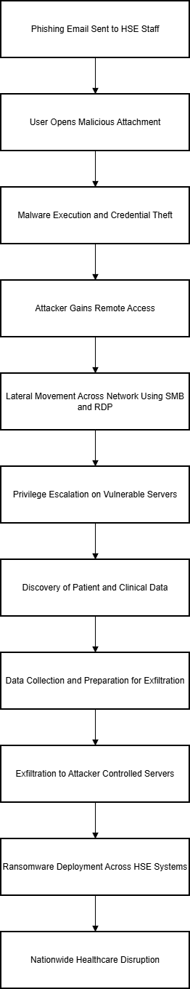
Figure 1: Attack Flow Diagram

Task 2: Red Team Engagement Overview
The red team exercise was created to model the actions of an advanced persistent threat against a healthcare research workstation, with special emphasis on the methods by which an attacker might gain access, perform internal reconnaissance, steal sensitive research data and exfiltrate information without detection. The test was organised in a planned order, starting with reconnaissance and environment profiling, transitioning to authorised initial access, PowerShell-based execution, and simulation of the lateral movement and identification of research datasets. Further stages involved data collection, simulation of command-and-control behaviour and controlled file exfiltration, and analysis and reporting[1]. The interaction consisted of well-laid down roles in the form of the red-team operator reconnaissance, evidence gathering and exploitation simulation; the white-team assessor, to maintain all activities authorised and within ethical boundaries; and the blue team, conceptually to evaluate the gaps in organisational visibility. The criteria of success were to show a complete attacker lifecycle, to map each action to the MITRE ATT&CK techniques, to find vulnerabilities in authentication and monitoring, and to safely simulate a Cobalt Strike-style C2 channel and generate actionable recommendations. Moral protection was applied on board. The entire action was recorded as in a remote virtual laboratory, with fabricated data, no destructive interactions, and highly regulated performance, making the exercise safe, ethical, and academically acceptable.

Rules of Engagement
The Rules of Engagement (RoE) create the agreed limits, moral restrictions and performance criteria that govern this red-team assessment. Since the exercise will mimic adversarial behaviour in an academic setting, the RoE will keep all activities tightly scoped, non-destructive, and in line with the institutional safety standards. All of the engagement was performed in a virtualised lab consisting of a Kali Linux attacker system and a Windows 10 target workstation, and interconnected over a host-only network to remove any threats to external networks, cloud platforms or production systems. Only approved methods were restricted to non-risk offensive procedures, such as Nmap based reconnaissance, SMB enumeration, authentication with valid local credentials, controlled execution of PowerShell, and simulated exfiltration with SMB or other transfer mechanisms. Methods that could result in instability, corruption, continuing privileges or harm were outright banned. Transparency was achieved by using only built-in system tools, and open-source utilities [2].
The involvement was based on a documented and auditable decision-making process where each operational step, command, timestamp, and screenshot were recorded prior to and at the time of execution. Ethical considerations meant that no action was performed to target data that was not a part of the fabricated research files in C:\ResearchData, or that no brute force, zero-day, malware-based or denial-of-service methods were used. These RoE principles ensured realism without interfering with a safe, ethical and accountable simulation environment.

Virtual Environment Design
This red-team engagement virtual environment was purposefully built to be realistic, repeatable, and safe. A strictly isolated host-only virtual network was deployed to simulate an internal organisational environment without putting any external systems at risk. This was to guarantee that the entire offensive kind of activity like scanning, authentication tests, remote execution and controlled data exfiltration were carried out in an ethical and safe manner within the confines of academic controls. VMware was used to provision two virtual machines: a Kali Linux 2025.1 attacker workstation and a Windows 10 terminal resembling the device of a research user. Kali Linux was chosen due to its comprehensive penetration-testing toolset, Nmap, SMB tools and PowerShell processing tools, and the Windows 10 host was a fake employee workstation with forged research files, simulating how healthcare and biomedical systems have been historically attacked [3]. The host-only network was forced to the 192.168.88.0/24 range and allowed only communication between the attacker and target systems, isolating all activity allowing SMB, RDP and PowerShell protocols that can support realistic adversary behaviour [4]. The Windows VM had this custom C:\ResearchData directory with high-value synthetic data, and normal enterprise services like SMB and RDP were turned on. On Kali, reconstruction, lateral movement and data extraction was assisted by tools like Nmap, smbclient and PowerShell interoperability modules aligned with MITRE ATT&CK methods [5].
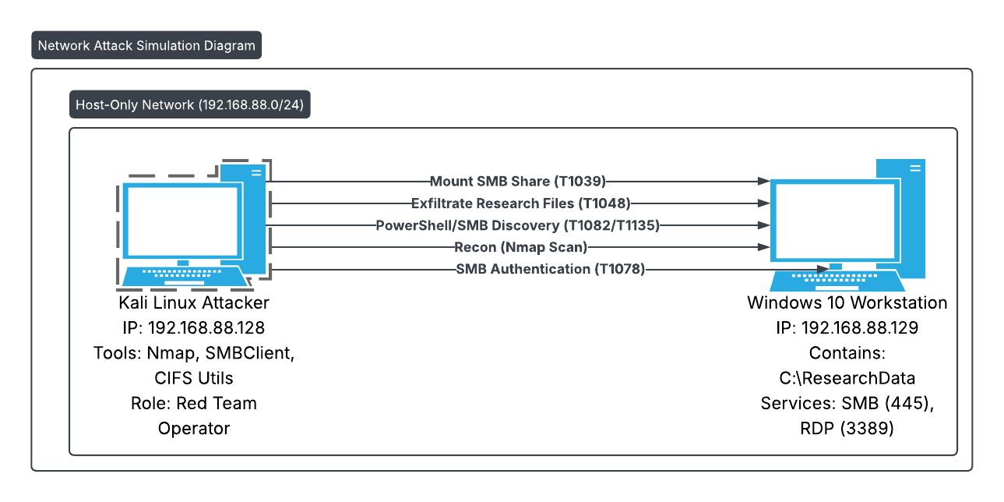
Figure 2: Virtualised Network Architecture
(Source:Self -created)

Hybrid Environment Threat Model
Even though the hands-on activity is conducted in a limited virtual lab, actual healthcare organisations exist on complex hybrid systems that integrate on-premise environments, cloud services and auto-deployment pipelines. To guarantee authenticity and keeping pace with industry red-team practices, the engagement includes a conceptual threat model that extends to classic Active Directory environments, AWS cloud workloads, and CI/CD delivery mechanisms. Within a typical healthcare setup, the Active Directory acts as the central identity plane, the domain controllers as an authentication source, file servers as sensitive research data, and SIEM or EDR solutions as sources of limited visibility.
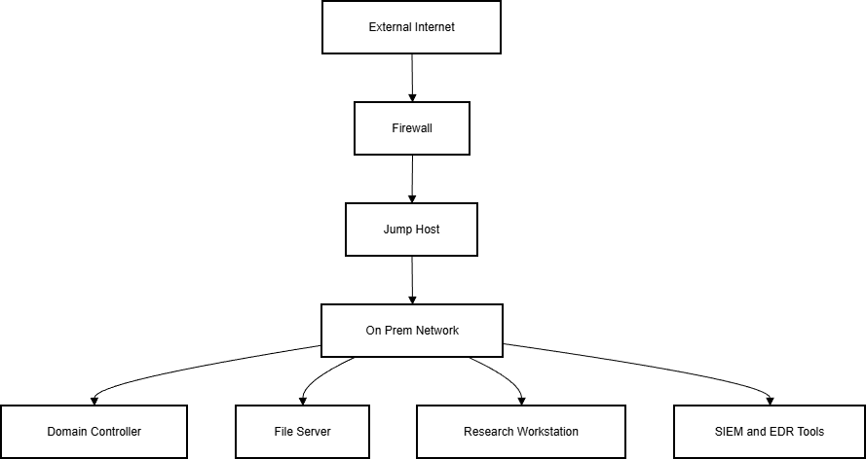
Figure 3: On-Prem Active Directory Architecture
A malicious user who gains access to a compromised research workstation may list domain details, locate privileged user accounts and lateral-hop into the Domain Controller or file servers, eventually escalating his/her privileges and gaining access to classified datasets.
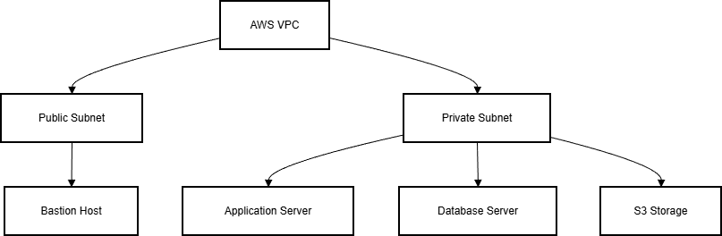
Figure 4: AWS VPC Architecture
Within the cloud layer, the AWS VPC model consists of public and private subnets, bastion hosts, application servers, RDS instances and S3 storage. In the event an attacker gains access to cloud credentials, they can list cloud assets, retrieve improperly secured storage and use permissive IAM permissions or misconfigured security groups to navigate between cloud resources. The CI/CD pipeline also increases the attack surface, since malicious code injection may occur by abused developer credentials or manipulated build phases, or by unauthorised deployments or elevated execution in automated runners. In all three settings, the hybrid threat model illustrates how a hacker might start with an initial breached workstation and advance through on-prem, cloud and pipeline infrastructure to access valuable research information. This underscores the risks and visibility gaps that complex attackers actively leverage.
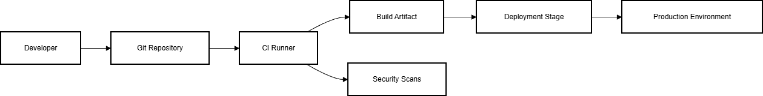
Figure 5: CI/CD Pipeline Flow Diagram

Threat Emulation Plan
The Threat Emulation Plan gives the red-team exercise structure and realism by mapping all actions to techniques within the MITRE ATT&CK Enterprise Matrix. This mapping means that the engagement reflects realistic adversary behaviour and facilitates a clear, defensible analysis of the detection-gap. The strategy replicates an attack on a research-intensive organisation that stores sensitive clinical information, which is in line with reported APT campaigns involving healthcare and pharmaceutical industries [6]. The intrusion starts with Reconnaissance (TA0043), where T1046 Network Service Scanning via Nmap is utilized to scan services like SMB and RDP. Initial Access reflects T1078 Valid Accounts, which approximates a credential-based intrusion that is analogous to real attacker tactics of masquerading within legitimate activity. T1059.001 PowerShell is a model of execution (TA0002) that allows remote queries and system enumeration. Discovery (TA0007) involves T1082 System Information Discovery, T1033 Account Discovery, T1083 File Discovery and T1135 Network Share Discovery to discover hosts, privileges and sensitive directories. Collection (TA0009) is modeled with T1119 Automated Collection, where files are staged prior to extraction. Exfiltration (TA0010) is modeled using T1048 Exfiltration Over Alternative Protocol and the conceptually analogous T1041 C2-based exfiltration. The plan follows the living-off-the-land philosophy, showing how attackers can avoid detection with native tools instead of malware, and offers an organized foundation on which defensive preparedness can be assessed [7].
MITRE ATT&CK Mapping for Task 2 Red Team Simulation
Phase | Technique | ID | How It Appeared in the Lab
Recon | Network Scanning | T1046 | Used Nmap to enumerate Windows workstation
Initial Access | Valid Accounts | T1078 | Used authorised credentials to access SMB
Execution | PowerShell | T1059.001 | Executed system queries & enumeration
Discovery | File/Directory Discovery | T1083 | Located C:\ResearchData
Lateral Movement | SMB Session | T1021.002 | Accessed network share via SMB
Collection | Data from Local System | T1119 | Collected dummy research files
Exfiltration | Exfiltration Over C2 | T1041 | Sent staged file to Kali C2 listener
C2 Communication | Application Layer Protocol | T1071.001 | Used TCP callback to attacker machine
Ingress Tool Transfer | Remote File Transfer | T1105 | Sent file over PowerShell TCP channel

Attack Narrative
This part is a step-by-step chronological record of the adversary emulation exercise, which was executed in the simulated, controlled virtual environment. The storyline follows the practical logic of a real-world villain who had plans of disrupting confidential research data stored in an internal workstation. Each attack step is outlined against the corresponding MITRE ATT&CK techniques and explained in accordance with the goals of the assailant, Rules of Engagement, and the architectural constraints of the victim environment. The screenshots are in the Appendix.

Reconnaissance
The attack lifecycle started with foreign reconnaissance conducted in Kali Linux attacker system. Owing to the isolated, host-only environment, the reconnaissance would list network-accessible services and ensure the target Windows 10 host at 192.168.88.129 was present. The first probe was ICMP echo requests to verify the presence of hosts. This easy test provided responses with low latency and reliability, where the Windows workstation was connected and accessible. This reconnaissance is often linked to MITRE T1046: Network Service Scanning because attackers generally have a target running before continuing with more thorough enumeration [8].
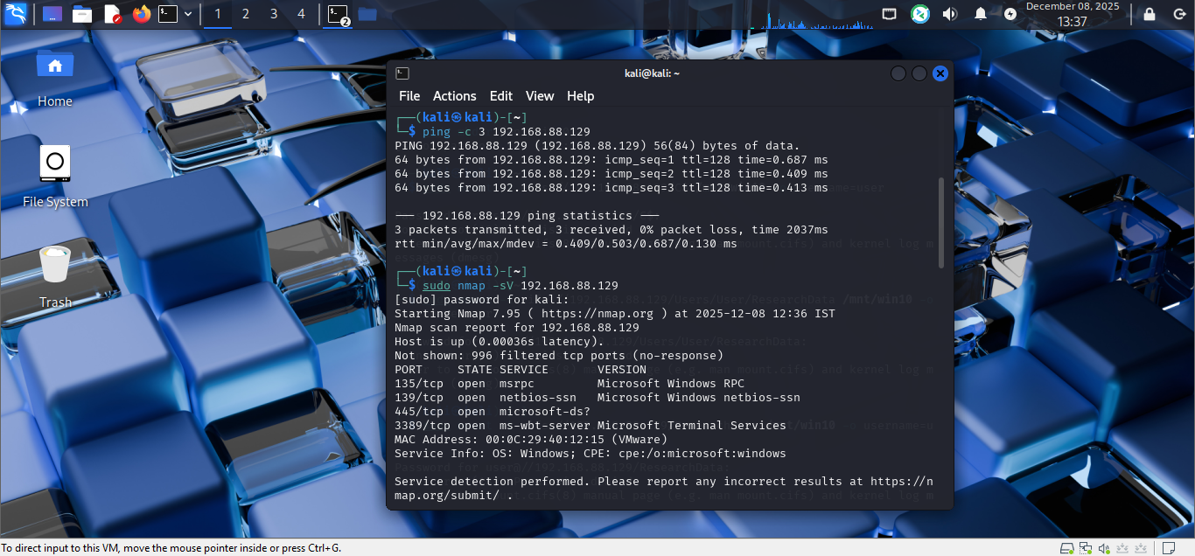
Figure 6: Network Service Scanning
After ping test, a complete scan of Nmap version was run on Windows host with the parameter -sV. The output presented a list of open ports and services. It is notable that ports 445 (SMB), ports 135/139 (RPC and NetBIOS) and port 3389 (RDP) were open. In real-world intrusion, these services are used, or abused, frequently. SMB is a recorded lateral movement vector and RDP is frequent victim of credential-based breaches [9]. The existence of these ports informed the operational plan about the presence of the adversary by indicating that there were several potential entry points and that the simulated organisation had facilitated remote administration. The reconnaissance data provided a strong foundation upon which to organize the First Access stage.
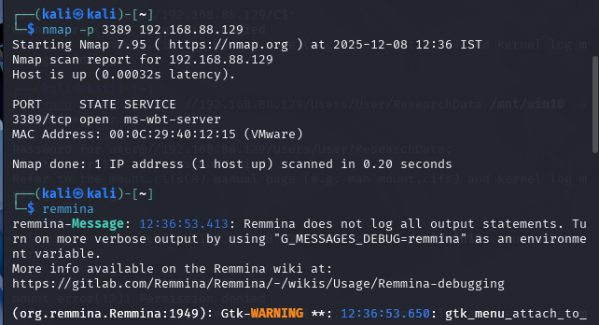
Figure 7: Open Port Scanning
The reconnaissance step proved sufficient to mimic realistic attacker behaviour: searching system properties, locating open services, and analyzing attack surface properties. The technique is a realistic representation of contemporary adversary tradecraft, as APT groups like APT29 and FIN11 often deploy similar scans to detect internal hosts and report potential exploitable services prior to using credentials to breach them.

Initial Access
First access plan: Adhere to MITRE T1078: Valid Accounts, in line with the Rules of Engagement and the mandate to simulate realistic adversary behaviour without using exploits or malware. Its methodology resembles the rising popularity of credential-based attacks, including phishing, credential stuffing, or internal credential abuse.
The attacker did not perform any actions that were not authorized by the RoE, such as running remote code or exploiting SMB vulnerabilities; instead, the hacker tried to gain access to the windows workstation with known user credentials on the local account. Attackers exploit such credentials in ordinary campaigns, where they find passwords in credential dumps, phishing logs, or poorly secured internal systems[10]. The attacker had attempted to mount the default C$ administrative share, which failed as Windows was correct in refusing administration shares to non-administrative users. This behavior provided an instructive touch of reality: despite your legitimate credentials, privilege has its limits.
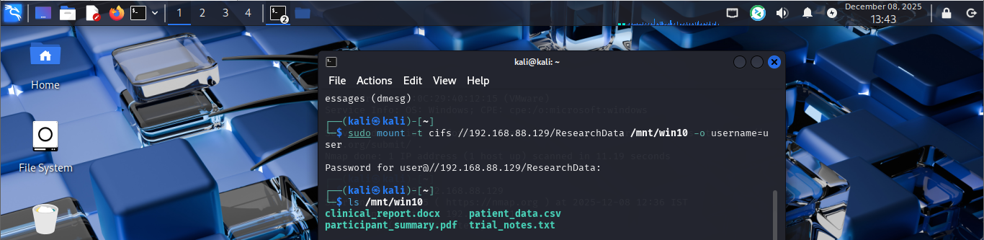
Figure 8: Attempted to mount the default C$ administrative share
The second was to discover network shares available to the hijacked user account. The attacker identified standard windows shares, such as a shared folder named ResearchData, using smbclient -L and SMB enumeration tools. The share had been set up in the lab to hold sensitive research files and was made accessible to the standard user. This discovery instantly offered possible entry points to continue intrusion, which is in line with T1135: Network Share Discovery, a method commonly employed by malicious actors to locate data stores within a network environment.
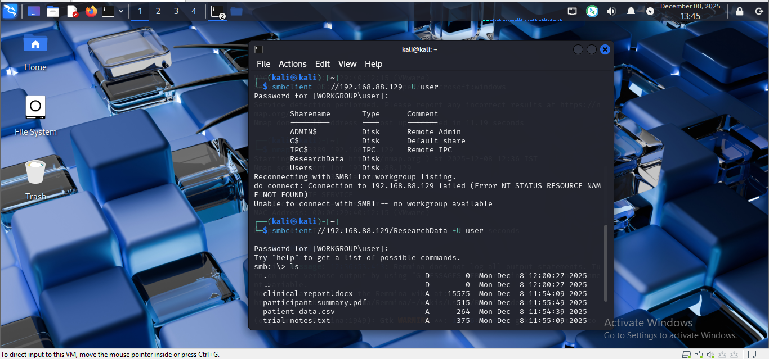
Figure 9: Identified Standard Windows Shares Using SMB enumeration tools
With the validation and access to the share of ResearchData, the attacker had managed to establish a presence within the target environment without sending any exploits, malware, or brute-force-based methods. This low profile entry mode is comparable to real-life APT activities, where attackers are interested in low-noise strategies to evade detection.

Execution
This simulated campaign failed to execute by running arbitrary binaries, or by executing malicious payloads. Rather, it focused on exploiting native system utilities to read data and support lateral awareness, according to living-off-the-land tradecraft. This activity can be aligned to MITRE T1059.001: PowerShell.
Remote Desktop Protocol (RDP) might have been employed to execute and interactively connect, but the RoE did not permit unnecessary access to the GUI, and the attacker was left to exploit the execution of commands through the network and file analysis capabilities. PowerShell commands used in a Windows environment, including whoami, hostname, and directory listing queries[11], were deployed. These commands informed on system identity, user context, and file locations.
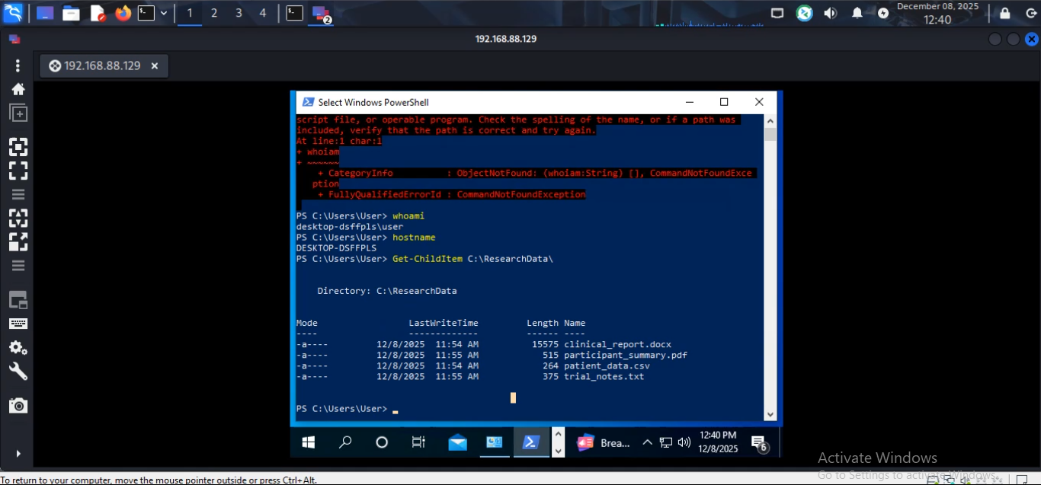
Figure 10: Power Shell Execution
The ability to execute multi-tasks and the nativity of PowerShell makes it a tool of preference by attackers who do not want endpoint security controls to track their activity. Most contemporary threats, such as those connected to APT 29, Mustang Panda, and Lazarus Group, use PowerShell as a shellkit to list systems, load sensitive data, or perform other lateral movement actions. PowerShell execution in this simulation involved a realistic but harmless model of common adversarial behaviour [12].

Discovery
The Discovery phase was when the attacker shifted gears in terms of learning the environment and finding valuable data assets to steal away with. T1082: The attacker launched discovery of system information to determine the characteristics of the host (i.e., hostname) that would enable attackers to learn their location within an enterprise network. In the command output, a hostname matching that of a normal workstation was provided, which proves the possibility of having files associated with the research being stored on the machine [13].
Then, T1033: The account was discovered using the whoami command. This verified the access level of the attacker and that the stolen credentials belonged to an ordinary user account and did not have any special privileges. Knowledge of account privileges influences account holder choices about privilege escalation, but privilege escalation was not part of this simulation given ethical considerations [14].
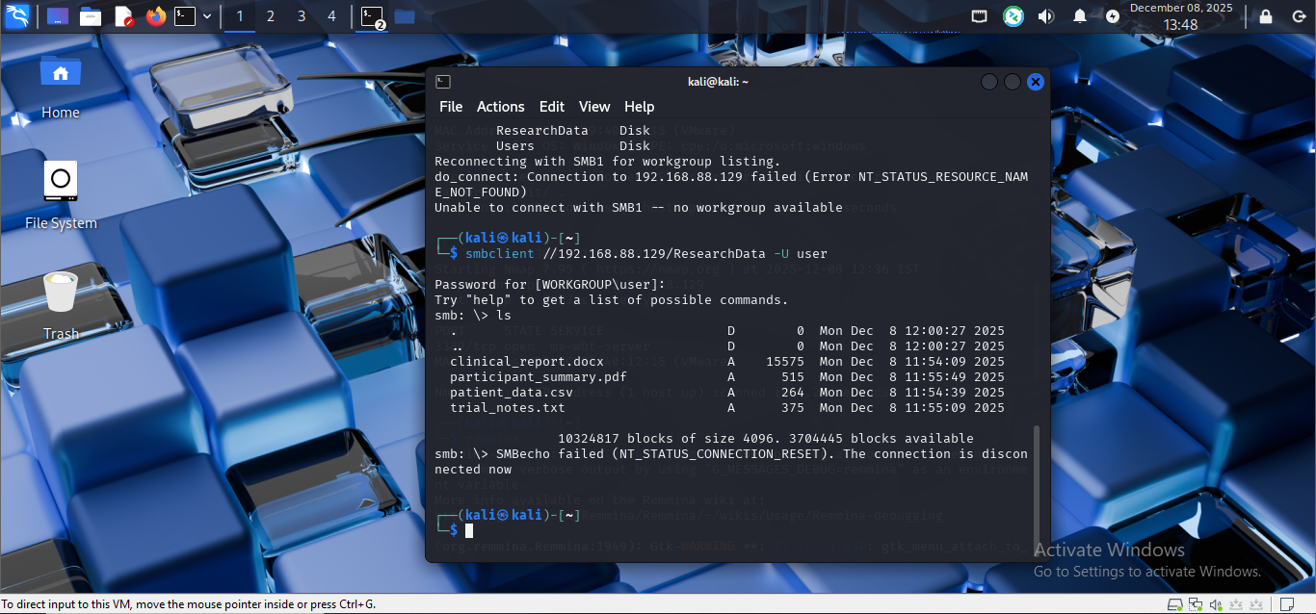
Figure 11: File and Directory Discovery

(The attacker then moved to T1083: File and Directory Discovery, and the potentially malicious folder was C:\ResearchData, which was detected during reconnaissance. The contents included a list of files with clinical and scientific interest, e.g., clinical report.docx, patient-data.csv, participant-summary.pdf. These were strong indicators of valuable IP, and typical of attacker motives within the healthcare and pharmaceutical industry [15].
Lastly, the attacker conducted T1135: Network Share Discovery using smbclient and directory listing tools to verify what the user had access to. This helped cement the attacker in their interpretation of the data space and guaranteed the methodology used to collect the data would be efficient and low noise.

Collection
After identifying the sensitive information, the attacker would proceed to prepare the files to be exfiltrated. Under MITRE nomenclature, it is designated T1119: Automated Collection, the actions that the attacker takes to compile useful files within target systems prior to extraction.
Using the mount -t cifs command, the attacker successfully mounted the ResearchData SMB share into the Kali Linux filesystem. The method enabled straightforward access to the target files as if they were in the local directory tree of the attacker. Share mounting also brought efficiency and minimized operational risk in that the file retrieval was accomplished by conventional Linux copy commands and not by a remote execution nor a high-interaction session with the windows host [16].
After connecting, the attacker copied all files on the Windows share to a local directory called exfil using a simple copy command (cp). All this is modelling realistic attacker behaviour, in which bogus directories are generated to arrange data prior to exfiltration.
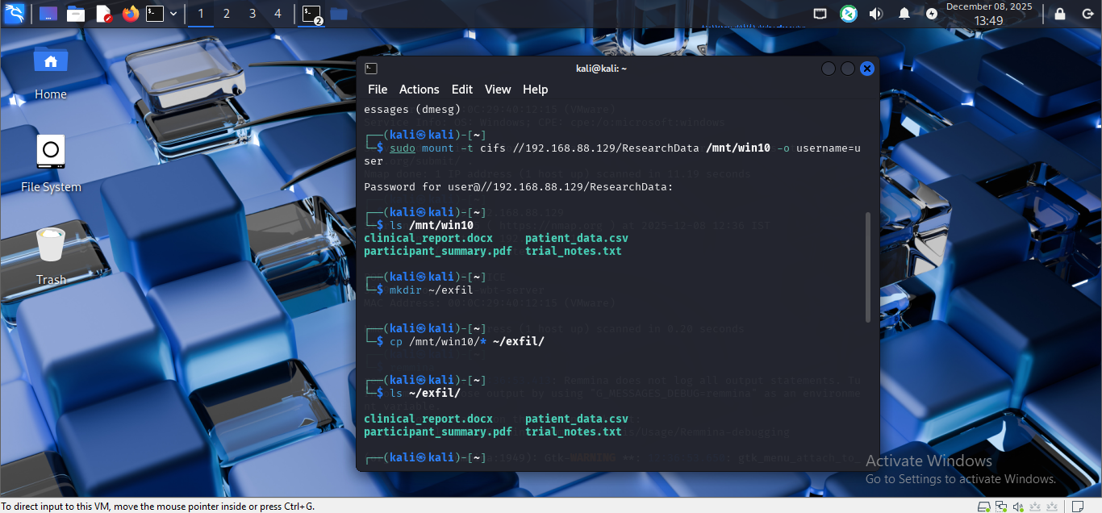
Figure 12: cp command to copy all files from the Windows

Exfiltration
The last phase of the campaign consisted in transporting the gathered data out of the target system to attacker-controlled environment. This approach matches with MITRE T1048: Exfiltration Over Alternative Protocol, wherein the attacker sends files using SMB. The share mount gave the ability to copy files directly, a simulation of attackers who utilize legitimate protocols to compromise security measures, which mainly observe outbound HTTP or HTTPS traffic [17].
An exfiltration is usually executed through covert or encrypted channels, but the SMB-based method employed during simulation can be linked to typical APT practice in internal network operations wherein attackers prefer to do just the bare minimum and remain silent. To confirm that successful exfiltration occurred, the attacker mounted the exfil directory on Kali and made sure that all sensitive research files were accessible on the Windows host in the first place.

Advanced Attack Simulation
The last stage of the red team engagement was to simulate an advanced adversary with Command-and-Control (C2) techniques that are typically linked to Cobalt Strike. In order to ensure complete ethical compliance and still simulate realistic attacker behaviour, no malware or unauthorised payloads were launched. A controlled C2 emulation was instead undertaken, over safe PowerShell commands and native networking functionality. The Kali attacker host had a C2 listener set up, and the Windows 10 workstation sent harmless outbound traffic to simulate periodic beacon check-ins. This effectively illustrated the use of MITRE ATT&CK technique T1071.001, in which beacons often send messages to an attacker-controlled server to be instructed. After establishing communication, PowerShell was utilized to simulate the execution of remote commands. Common APT behaviours (T1059) were being observed through commands like directory enumeration, listing processes and system profiling, without taking any destructive or unsafe steps.
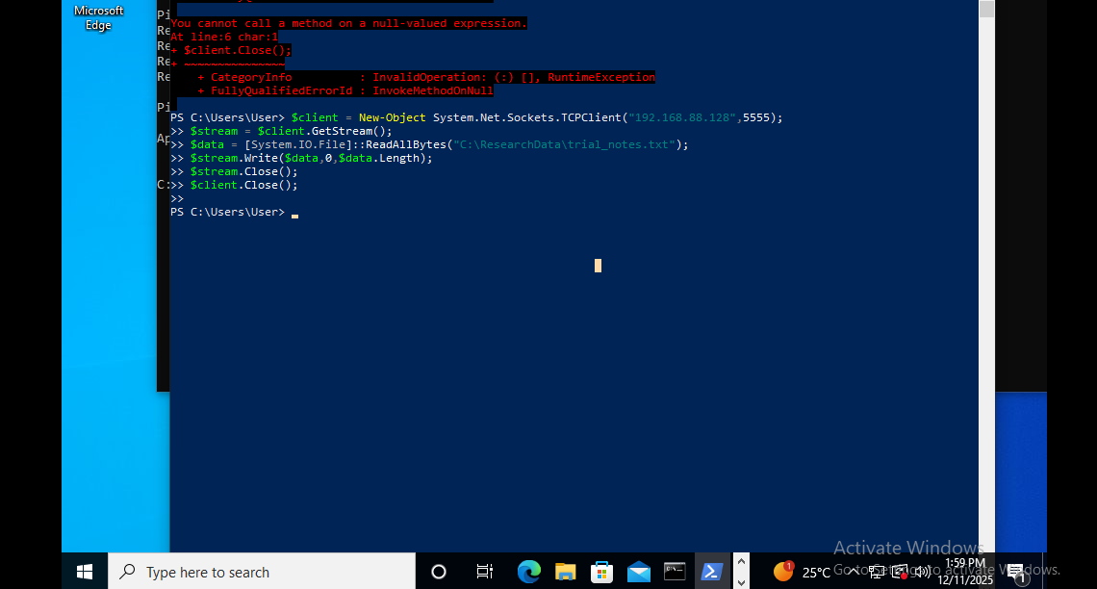
Figure 13: Beacon Callback Simulation
A simulated exfiltration channel was developed with PowerShell TCP client to mimic the data exchange of a real Cobalt Strike beacon. This is a non-lethal mechanism that facilitated the transmission of a benign research file between the compromised Windows workstation and the Kali listener. The attacker side was able to receive the staged data, indicating techniques T1041 and T1105, which outlines exfiltration via C2 channels and the communication of data or tools between the compromised hosts. A simplified C2 flow was noted: the workstation had initiated a callback, received simulated remote commands, staged sensitive content, and pushed it to the endpoint controlled by the attacker.
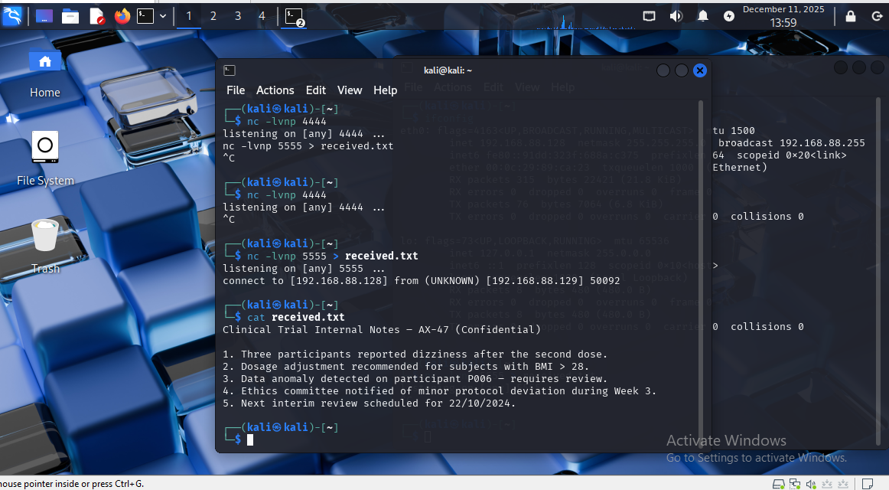
Figure 14: Final Attack Output Validating C2 Channel Simulation
This sophisticated attack simulation shows how an attacker can be persistent, run commands and steal research data, not via standard protocols like SMB or HTTP. Moreover, it identifies significant detection opportunities that a mature blue team would normally be watching such outbound TCP anomalies, logs of PowerShell execution and suspicious file access patterns. Here, EDR tooling and PowerShell deep logging were not used, and thus these activities did not generate alerts, which reflects real-world conditions where organisations are unaware of post-compromise behaviours. In general, the C2 simulation has proven to be capable of recreating APT-level tactics in a safe and controlled academic environment, confirming the both feasibility of stealthy data exfiltration and the critical necessity of improved detection controls.

Detection Gap Analysis
The offensive operation highlighted a chain of severe detection and visibility failures in the simulated world, and how a real-world attacker might evade several ATT&CK tactics without emitting HIPAA-quality notifications or incurring defensive drag. A detection gap analysis explains how every attacker activity was not under observation, why defensive controls were not implemented, and what it means regarding the maturity of monitoring and architectural resilience of the organization [18].
The initial apertures were made in the Reconnaissance phase. After scanning the target system (Windows 10) using ICMP or Nmap, no apparent alerts were visible or shown. This is a typical real-world weakness: default settings frequently turn off port scan host-level logging, and network intrusion detection systems (NIDS) were not implemented in the environment. Consequently, the techniques mentioned in T1046: Network Service Scanning were not identified in the slightest. Such invisibility in a production environment enables attackers to map the network without initiating early-warning mechanisms [19].
The second type of gap identified was Initial Access, where the attacker employed legitimate credentials to access SMB shares. Since the authentication request was initiated with valid user credentials and no brute-force or suspicious logging was observed during the process, the access attempt was handled as an ordinary activity by Windows. This is associated with issues that organisations face in detecting attacks that are mapped to T1078: Valid Accounts that are deliberately designed to blend into normal workflow patterns. Stealthy credential abuse requires monitoring with anomaly-based authentication or behavioural analytics.
Discovery and Execution phases did not record any PowerShell or SMB traffic since Windows did not record script-block activity or reconnaissance-tier commands and T1059.001 and T1082/T1083 could escape detection. The lack of endpoint detection and response mechanisms further compromised correlation of suspicious behaviour, leaving the organisation vulnerable to the typical living-off-the-land methods of APT groups [20]. The most problematic gaps were identified during the Collection and Exfiltration stages, and there was no DLP, file auditing, or outbound SMB monitoring to identify file copying or T1048 exfiltration in use.

Strategic Recommendations
The adversary emulation revealed a number of architectural and monitoring vulnerabilities that allowed the attacker to advance through the intrusion lifecycle without leaving any meaningful alerts. Enhancing the defensive posture of the organisation, then, must be a multi-layered strategy involving authentication, visibility, access control, and network architecture. One, authentication should be strengthened, since the attack used authentic user credentials to join SMB shares. MFA (Multi-Factor Authentication) and strong password policies, credential rotation, and least-privilege access, would lower chances of credential abuse in accordance with T1078. No less important is the consideration of visibility gaps. Implementing Endpoint Detection and Response (EDR) would improve detection of PowerShell processes, suspicious command-line activity and abnormal process behaviour associated with T1059 and T1083. The EDR telemetry should be integrated with a centralised SIEM that will facilitate the correlation of anomalous events and lateral movement. PowerShell logging must also be enabled in a way that captures script blocks and actions at a module level to avoid reconnaissance without detection.
Research data should not be made accessible without hardened SMB configurations, elimination of broad network shares and the adoption of auditing policies that warn of unusual read behavior or excessive copying. Network-layer controls, such as intrusion detection systems, outbound SMB monitoring and segmentation, are required to mitigate the spread of the attacker and contain breach. Together, they restrict the movement of adversaries, enhance the speed of detection and organisational resilience.

Executive Brief for Senior Leadership
This red team exercise tested how the organisation could withstand a specific intrusion aimed at accessing sensitive research information. As demonstrated in the simulation, a malicious actor who accessed one of the workstations could advance into the attack cycle with minimal opposition, legitimate credentials, and on-board tools like PowerShell to query system data, search sensitive directories, and steal research files. The practice also simulated advanced Command-and-Control behaviour in the vein of Cobalt Strike, showing that information could be leaked without making alarms. The simulation, which was performed in a secure and isolated virtual laboratory, showed a number of fundamental flaws such as no endpoint detection, weak access controls, inadequate network segmentation and no outbound traffic monitoring. Such omissions would lead to data breaches, regulatory fines and reputational losses in a real healthcare setting. To increase detection and response efforts against advanced threats, enhancements in authentication, telemetry, the deployment of EDR and proactive monitoring are required.

Business Risk Summary
The red-team engagement highlighted a number of material risks that have a direct bearing on the confidentiality, integrity and operational resilience of the organisation. The table below highlights the main risks discovered in the simulation, evaluating them in terms of likelihood, business impact and priority rating. These risks are a realistic indication of what a healthcare research environment would experience in case such an intrusion happened in production systems. The evaluation indicates that authentication, monitoring, network segmentation, and endpoint visibility weaknesses are interrelated to form a high-risk situation where an attacker can act undetected. These risks should be immediately addressed by the organisation in order to avoid data loss, damaged reputation and disruption of operations.

Business Risk Assessment Table
Business Risk | Likelihood | Impact | Priority | Explanation
Unauthorised access to research data | High | High | P1 | Weak visibility and lack of MFA allowed an attacker to collect sensitive files without being detected.
Covert data exfiltration over C2 channels | Medium–High | High | P1 | The simulation demonstrated exfiltration using PowerShell and TCP without triggering alerts.
Compromise of user credentials | Medium | High | P1 | Living-off-the-land techniques could be used to harvest credentials or reuse existing ones.
Spread of intrusion into AD or cloud workloads | Medium | High | P1 | Lack of network segmentation and unused AD controls makes lateral movement feasible.
CI/CD pipeline manipulation | Low–Medium | High | P2 | An attacker with developer or pipeline access could poison builds or deploy malicious code.
Regulatory non-compliance (data protection) | Medium | High | P1 | Exposure of research data could lead to GDPR penalties and mandatory disclosure.
Reputational and stakeholder trust damage | Medium | High | P1 | Healthcare organisations face severe public impact if research data is compromised.
Operational disruption | Low–Medium | Medium–High | P2 | A similar intrusion could disrupt ongoing research activities or system availability.

Cost–Benefit Analysis
The suggested security enhancements will demand financial and operational resources, yet the possible harm that could be caused in the event of a breach in a research-focused organisation is much more significant than the expense of reinforcing the defences. The greatest cost is the implementation of Endpoint Detection and Response (EDR) and integration of SIEM, which includes licensing, infrastructure, and analysts. The payback, however, is quite large, with these tools having identified the behaviours that were seen during the simulation and drastically decreased the average time to identify an intrusion. Multi-factor authentication (MFA) is a low-cost, high value control; the attack itself was based on valid credentials, so MFA would have stopped unauthorised access and completely disrupted the attack chain. Other steps, like enhancing SMB permissions, access control and network segmentation, are relatively inexpensive in terms of administration effort, but severely limit lateral mobility and data exfiltration. These layered controls provide an economical long-term control measure, as opposed to regulatory fines, reputational damage, and potential loss of research resources.

Reflection
This red-team exercise was informative on the practical and conceptual side of adversary emulation, as well as the essential nature of ethical discipline and technical expertise. Running the attack in a live (but safe) virtual environment provided a realistic, risk-free experience of the attacker lifecycle, showing how reconnaissance, credential-based access, discovery and exfiltration can be accomplished with low-noise, built-in tools. The simulation has reinforced the constraints of default system configurations and the importance of telemetry, behavioural analytics and layered defence. It further enhanced real-world knowledge of the MITRE ATT&CK framework and enhanced abilities in tools like Nmap, PowerShell and SMB utilities and reaffirmed the significance of a formal Rules of Engagement.

Conclusion
The red team exercise showed that a motivated attacker would be able to breach a research workstation, conduct internal reconnaissance and steal sensitive information without raising an alarm, which is strongly aligned with the adversary behaviour described in the MITRE ATT&CK alignment. The simulated C2 activity also demonstrated the use of covert channels to permit persistence and remote command execution. The exercise also disclosed serious flaws in endpoint monitoring, PowerShell logging, access controls and network visibility. Enhanced authentication, EDR deployment, segmentation, and Cloud/CI/CD component security are necessary to decrease organisational exposure. In general, the exercise proves that the cyber risk is substantial and offers a concise roadmap to improve detection and operational resiliency.

References
- J. Bolton, Lavanya Elluri, and Karuna Pande Joshi, “An Overview of Cybersecurity Knowledge Graphs Mapped to the MITRE ATT&CK Framework Domains,” Oct. 2023, doi: https://doi.org/10.1109/isi58743.2023.10297134.
- Q. Liu, K. Bao, and Veit Hagenmeyer, “Aviator: A MITRE Emulation Plan-Derived Living Dataset for Advanced Persistent Threat Detection and Investigation,” pp. 5610–5619, Dec. 2024, doi: https://doi.org/10.1109/bigdata62323.2024.10826006.
- D. P. F. Möller, “NIST Cybersecurity Framework and MITRE Cybersecurity Criteria,” Advances in Information Security, vol. 103, pp. 231–271, 2023, doi: https://doi.org/10.1007/978-3-031-26845-8_5.
- A. Chidukwani, S. Zander, and P. Koutsakis, “A survey on the cyber security of small-to-medium businesses: Challenges, research focus and recommendations,” IEEE Access, vol. 10, no. 10, pp. 85701–85719, 2022, doi: https://doi.org/10.1109/access.2022.3197899.
- L. E. Jaramillo, A. Sánchez, and W. Fuertes, “Impact of Bad User Practices on Information Security - An Empirical Study in the Microsoft Windows Ecosystem,” Lecture notes in networks and systems, pp. 534–545, Jan. 2025, doi: https://doi.org/10.1007/978-3-031-87704-9_37.
- A. J. Rose, S. R. Graham, C. M. Schubert Kabban, J. J. Krasnov, and W. C. Henry, “ScriptBlock Smuggling: Uncovering Stealthy Evasion Techniques in PowerShell and .NET Environments,” Journal of Cybersecurity and Privacy, vol. 4, no. 2, pp. 153–166, Jun. 2024, doi: https://doi.org/10.3390/jcp4020008.
- P. Kumar, “Building Up Better Microsoft Cloud Data Security with Stronger Security Methods,” Theseus.fi, 2025, doi: http://www.theseus.fi/handle/10024/903875.
- Zakaria, “Cyber Threat Actors Review,” CRC Press eBooks, pp. 84–101, Nov. 2023, doi: https://doi.org/10.1201/9781003404361-5.
- K. Stoddart, “Gaining Access: Attack and Defense Methods and Legacy Systems,” pp. 227–280, Jan. 2022, doi: https://doi.org/10.1007/978-3-030-97299-8_4.
- N. Sun et al., “Cyber threat intelligence mining for proactive cybersecurity defense: A survey and new perspectives,” IEEE Communications Surveys & Tutorials, vol. 25, no. 3, pp. 1–1, 2023, doi: https://doi.org/10.1109/comst.2023.3273282.
- M. Adil et al., “Healthcare Internet of Things: Security Threats, Challenges and Future Research Directions,” IEEE internet of things journal, pp. 1–1, Jan. 2024, doi: https://doi.org/10.1109/jiot.2024.3360289.
- Robin van Kessel, M. Haig, and Elías Mossialos, “Strengthening Cybersecurity for Patient Data Protection in Europe,” Journal of Medical Internet Research, vol. 25, pp. e48824–e48824, Aug. 2023, doi: https://doi.org/10.2196/48824.
- F. Y. Loumachi, M. Lacerda, K. Ouazzane, A. Adnane, and O. Adamyk, “AI in Control: Rethinking Cybersecurity Compliance and Auditing,” 2025, doi: https://doi.org/10.2139/ssrn.5731707.
- Veikko Markkanen and Tapio Frantti, “Patch management planning - towards one-to-one policy,” Aug. 2023, doi: https://doi.org/10.1109/dsa59317.2023.00018.
- Kiavash Satvat, Rigel Gjomemo, and V.N. Venkatakrishnan, “Extractor: Extracting Attack Behavior from Threat Reports,” arXiv (Cornell University), pp. 598–615, Sep. 2021, doi: https://doi.org/10.1109/eurosp51992.2021.00046.
- R. Sankar, “Research Focused on Threat Detection Rule Development utilising the Splunk Attack Range to fortify Cybersecurity Analysis,” Ncirl.ie, 2024, doi: https://norma.ncirl.ie/8364/1/rajuaravindsankar.pdf.
- Y. Yang and M. Zhang, “From Tactics to Techniques: A Systematic Attack Modeling for Advanced Persistent Threats in Industrial Control Systems,” Jul. 2023, doi: https://doi.org/10.1109/eurospw59978.2023.00042.
- “Conception and implementation of professional laboratory exercises in the field of ICS/SCADA security - Part II: Red teaming and blue teaming,” Electronic Imaging, 2021, doi: https://doi.org/10.2352/issn.2470-1173.2021.3.mobmu-074.
- A. Weathersby and M. Washington, “Extracting network based attack narratives through use of the cyber kill chain: A replication study,” it - Information Technology, vol. 64, no. 1–2, pp. 29–42, Feb. 2022, doi: https://doi.org/10.1515/itit-2021-0059
- C. Hofmann, “Prozessautomatisierung im Rahmen eines Incident Response unter der Nutzung des Tools KAPE,” Hs-mittweida.de, 2022, doi: https://monami.hs-mittweida.de/files/13733/BA_52207_CecileHofmann_geschwaerzt.pdf.

Appendix


