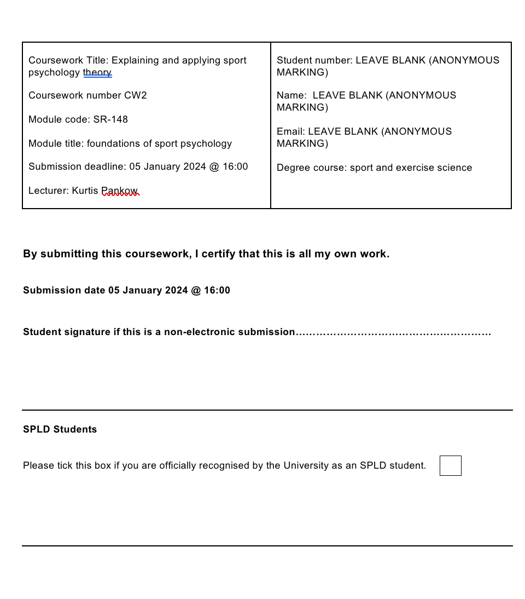
Feedback
- Use more in-text APA referencing.
- My goal was to ensure I included my references during my report as well as doing the referencing at the end.
- Fully explain the theories
- My aim was to ensure I explained the theories to provide a clear understanding to the reader rather than a general overview.

Theory explanation
One theory I will be using for this assignment is significant others. This is because significant others, such as Caleb’s parents, coaches and peers are the key influences on youth sport players. He has good parental support and enjoys playing with his friends. However, Caleb does not think he can speak to anyone about the situation as he is at the ages where his parents are not his first choice of people to speak to about problems.

Another theory is group dynamics. The reason for this is because, from the case we can see that Caleb has been with his local club for three years and is having fun with his friends and he likes the team coach. Whereas when he got selected to join the talent pathway, his first worry was about playing with different people and having new coaches.

The third theory I will be using is achievement goal theory as Caleb’s focus shifts from task oriented to ego oriented after being selected to join the British wheelchair basketball talent pathway. He now has external expectations to meet to make his parents proud instead of just playing for fun with his friends where he is comfortable.

The final theory I will be including is the Individualised Zones of Optimal Functioning (IZOF). This theory assumes every athlete has their own ‘optimal zone’ of arousal/anxiety where their performance levels are at their best.

Scientific report
Whilst reading the case, I have discovered a key issue Caleb is facing is anxiety which may be the reason why the situation has arisen. His anxiety is highlighted from when he got selected into the talent pathway to the session itself. He is overthinking about playing with new people as he is enjoying where he is now. His anxiousness shows during the morning of the session, he seems increasingly withdrawn, can’t eat or talk to his parents. During the competitive session he becomes distracted, loses focus and as a result his performance levels drop. His parents are excited about him being selected, but he does not want to let his parents down by not meeting their expectations which may lead to more anxiety. He has been with his local club for three years and is happy with his friends and coaches, however a shift from familiarity to a new environment triggers anxiety, affecting his performance. Caleb is motivated by the enjoyment of playing with friends and the connection with his team coach, from this I can tell he is more task oriented as his focus is on having fun and personal development. Though, with his selection into the talent pathway and the change from drills into a competitive situation, there are external expectations and pressure to do well which introduce an ego-oriented aspect.

Caleb’s case aligns with anxiety and significant others theory. In sports, parents are the primary contributors for their child’s motivation. Children who view their parents as positive role models develop positive beliefs which leads to an increased enjoyment in their sport. (Ullrich-French & Smith, 2006). Parental behaviours may impact their child’s performance from their high expectations. This is often due to parents urging their child to engage or compete at more advanced levels. These expectations can generate stress and might influence the athletes’ experience resulting in increased anxiety. (Lindstrom Bremer, 2012). While Caleb’s parents are supportive and excited for his success, the change to a new environment and different coaching dynamics triggers anxiety for him. The initial anxiety passes when he sees someone he knows, but the shift into a competitive environment restores anxiety, affecting his performance. Peers also influence each other’s motivation by building confidence, creating rivalry, emotional support, and friendships. Le Bars et al. (2009) discovered that between task and ego motivational climates, the main thing that determined if athletes kept playing their sport was the supportive environment created by peers in a task environment. Studies on coaching indicate that encouragement like providing positive reinforcement create a task environment. These behaviours relate to lowering performance anxiety and boosting self-esteem. (Atkins et al., 2015). Caleb’s perception of achievement goals is strengthened by significant others, whether at home or in his sporting environment.

Caleb’s anxiety also relates to achievement goal theory. This displays the motivations that drive athletes into participating in sports. It includes diverse perspectives regarding both task and outcomes, shaping athletes’ view on their performance. It is possible to predict an individual’s performance depending on their achievement orientation. The two orientations are task, which displays ones ability to improve and their enjoyment, and ego which displays ones ability to outperform others. (Weigand et al., 2001). Caleb’s motivation to play basketball is driven by the enjoyment of being with friends and coaches indicating he is more task oriented. The transition to a competitive environment triggers anxiety, potentially shifting his focus to an ego-orientation. The shift in orientation may contribute to his increased anxiety and decreased performance levels. Athletes’ use of coping strategies correlate with their goal orientations. Studies revealed that individuals with task orientations tended to use problem solving strategies, while those with ego orientations used strategies focused on emotions. (Harwood & Biddle, 2002). Caleb’s achievement orientation is linked to the group dynamics theory as he is in a task environment with a team that share the same goals.

Caleb is in a task environment when he is with his friend which shows good group cohesion. Caleb’s case shows the relationship between anxiety and group dynamics theory. Group dynamics refers to “the actions, processes and changes that occur within and between groups”. The group dynamics principles have aimed to enhance individuals’ self-perceptions and experiences which increases participation. (Eys et al., 2019). In elite youth sports teams, there are connections between team performance, task-related and social aspects of group cohesion. Cohesion is a dynamic social psychological construct which determines a sense of closeness within the team. (Benson et al., 2016). Caleb’s anxiety increases due to concerns about playing with new peers and coaches, affecting the familiarity and comfort of his existing group dynamics. However, when seeing a familiar face, his anxiety reduces. This demonstrates how positive interactions within groups can decrease an individual’s anxiety levels. When the group transitions into a competitive state, Caleb’s anxiety returns, showing how changes in the group dynamics can contribute to anxiety levels. This change negatively affects his performance, suggesting the importance of good group dynamics to decrease anxiety. (Bruner et al., 2014).

The individual’s zone of optimal functioning relates to how an athlete performs based on their arousal levels. In Caleb’s case, when arousal levels increase, anxiety increases and results in a decrease in performance. The IZOF model shows the dynamics of individual emotional experiences connected to performance levels. The connection between arousal and optimal performance attempts to see the standard of upcoming performances, and patterns can be distinguished by the individual to determine if the performance will be successful. (Ruiz et al., 2015). High arousal levels have demonstrated positive effects on simple tasks but affect fine motor tasks negatively. IZOF provides personalised profiling methods to identify intensity levels of arousal for optimal functioning. (Woodcock et al., 2012). Therefore, this situation brings focus to the relationship between anxiety and performance, suggesting a unique threshold among individuals to achieve peak performance.

Caleb has been selected for the talent pathway at 13, he is a very talented athlete, but his anxiety takes over and leaves him with self-doubt. Caleb needs to keep his arousal levels low to perform at his best. A strategy Caleb could use is to practice stressful situations during training, aiming for better performance under pressure. This strategy may help his performance in competitive situations as he has promised in an an ego environment. Team building activities with his new teammates such as an obstacle course requiring communication and teamwork will improve closeness within the group and improve team cohesion in turn developing a comfortable environment and reducing anxiety.

References
- Atkins, M. R., Johnson, D. M., Force, E. C., & Petrie, T. A. (2015). Peers, parents, and coaches, oh my! The relation of the motivational climate to boys’ intention to continue in sport. Psychology of Sport and Exercise, 16, 170–180. https://doi.org/10.1016/j.psychsport.2014.10.008
- Benson, A. J., Šiška, P., Eys, M., Priklerová, S., & Slepička, P. (2016). A prospective multilevel examination of the relationship between cohesion and team performance in elite youth sport. Psychology of Sport and Exercise, 27, 39–46. https://doi.org/10.1016/j.psychsport.2016.07.009
- Bruner, M. W., Eys, M. A., Wilson, K. S., & Côté, J. (2014). Group cohesion and positive youth development in team sport athletes. Sport, Exercise, and Performance Psychology, 3(4), 219–227. https://doi.org/10.1037/spy0000017
- Eys, M., Bruner, M. W., & Martin, L. J. (2019). The dynamic group environment in sport and exercise. Psychology of Sport and Exercise, 42, 40–47. https://doi.org/10.1016/j.psychsport.2018.11.001
- Harwood, C., & Biddle, S. (2002). The application of achievement goal theory in youth sport. Solutions in sport psychology, 2002, 58-73.
- Lindstrom Bremer, K. (2012). Parental Involvement, Pressure, and Support in Youth Sport: A Narrative Literature Review. Journal of Family Theory & Review, 4(3), 235–248. https://doi.org/10.1111/j.1756-2589.2012.00129.x
- Ruiz, M. C., Raglin, J. S., & Hanin, Y. L. (2015). The individual zones of optimal functioning (IZOF) model (1978–2014): Historical overview of its development and use. International Journal of Sport and Exercise Psychology, 15(1), 41–63. https://doi.org/10.1080/1612197x.2015.1041545
- Ullrich-French, S., & Smith, A. L. (2006). Perceptions of relationships with parents and peers in youth sport: Independent and combined prediction of motivational outcomes. Psychology of Sport and Exercise, 7(2), 193–214. https://doi.org/10.1016/j.psychsport.2005.08.006
- Weigand, D., Carr, S., Petherick, C., & Taylor, A. (2001). Motivational climate in sport and physical education: The role of significant others. European Journal of Sport Science, 1(4), 1–13. https://doi.org/10.1080/17461390100071402
- Woodcock, C., Cumming, J., Duda, J. L., & Sharp, L.-A. (2012). Working within an Individual Zone of Optimal Functioning (IZOF) framework: Consultant practice and athlete reflections on refining emotion regulation skills. Psychology of Sport and Exercise, 13(3), 291–302. https://doi.org/10.1016/j.psychsport.2011.11.011

