
Community Engagement Assignment 2 – Reflective report
COMMUNITY ENGAGEMENT (LCBB4002)


uNIVERSITY OF BIRMINGHAM tRINITY SAIN DAVID

Lecturer: DR. OLU ADGEBITE
Student: Sava Daniela
Student Number: 2028792

Introduction

It is generally agreed today that reflection is part of our life. First off all I want to define two main terms from this assignment:
- Reflection - is a cluster of skills and different abilities to indicate a position of critic thinking regarding problem-solving or state of mind (Moon, 2000)

- Reflective Practice – is reflecting about every event that have been through the day, trying to take wisdom from everything, a good reflective practitioner for example will use this thought process to solve problems and find a way to sort out any problems. Being reflective will impact positively also the team cause the outcome of reflecting together will help a lot. Trying to get community implicated in a reflective dialogue will help to sort out the main ideas and subjects and also will bring a more large spectrum of details and ides, plans how to solve some problems.

In this report I want to discus about Gibbs reflection model in the context of community engagement, explaining from my experience how Gibbs reflective model helped me in my community engagement. Also I will reflect about skills that I have accrued during this module and how academic theories helped me creatively to solve problems during the term and at my workplace.

Gibbs reflection model

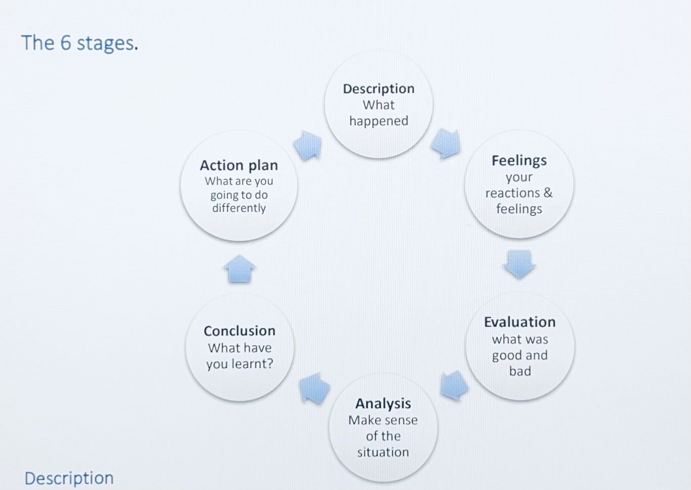
At this stage I want to use Gibbs reflecting model and reflect about one of my community engagement experience. It was a while ago but I can remember it like it if was yesterday. I have engaged in a programme called “ Clean city, clean conscience” this program was in my birth country Republic of Moldova.
- Description- every spring in our country everyone are cleaning our environment. I have been cleaning in a parc near my school with my class and other classes from my school. It was an interesting day through which we have been engaging in cleaning our city and we have spend time together working in a big team. We was listening music cheating and doing a good job.

- Feelings- I was feeling good because above the good impact on environment working with my friends in a team and spending time in such a way was very exciting and sincerely I miss those days a lot. Secondly I was feeling proud of me, feeling that I am doing something important for my community.

- Evaluation- this event had certainly an positive outcome but in the working process was also things about management and because our teacher had two classes to manage it was a bit of uncertain plan of actions, and we sometimes get on a point when we where thinking what
is next and waiting for our teacher to come from other class area and tell to us what is next.

- Analysis- I can say that wark was done brilliant, but management was not the best one so if every class had their own teacher it would be better.

- Conclusion- I can say that I certainly want to participate in such an event again and that such events should be organised time after time because they bound a team together.

Reflective thinking is one of important side in our life not just in a life of practitioner and through reflective thinking we can understand what have been wrong in our communication or behaviour and what have caused an negative reaction of a person. Thinking in a reflective and critic way about yourself can help you to perfectionate yourself.
I have learned from this module a lot of things and the first that come to mind right now is that we should ask right questions in order to solve a problem. But to ask this wright question we should think reflective and criticly about the situation and find that right question.

Reference List

Moon, Jennifer A. (2000)
Reflection in learning & professional development: theory & practice
Published: London; New York: Routledge Falmer, 2000

Benefits of becoming a reflective practitioner (2019)
A joint statement of support from Chief Executives of statutory regulators of health and care professionals
Available at: https://www.hcpc-uk.org/globalassets/news-and-events/benefits-of-becoming-a-reflective-practitioner----joint-statement-2019.pdf Accessed on: 1st of August 2022

- Michigan Journal of Community Service Learning (Spring 2015, pp. 49-63)
Reflective Practice that Persists: Connections Between Reflection in
Service-Learning Programs and in Current Life
Available at: https://files.eric.ed.gov/fulltext/EJ1116316.pdf Accessed on: 03/08/2022

- Gibbs’ reflective cycle
Available at: https://my.cumbria.ac.uk/media/MyCumbria/Documents/ReflectiveCycleGibbs.pdf
Accessed on: 03/08/2022

- Gibbs, G. (1988) Learning by Doing
Available at: https://thoughtsmostlyaboutlearning.files.wordpress.com/2015/12/learning-by-doing-graham-gibbs.pdf Accessed on: 05/08/2022

- Driscoll J (2000) Practising Clinical Supervision. Balliere Tindall, London

