

Eco Bike Hub Case Study

Module: Database Systems
Name: Tong Wu
Student ID: 2106274
Date:2022 .06.14

TABLE OF CONTENTS
1 Abstract 1
2 SQL vs. NoSQL………………………………………………………………………………..1
2.1 Relational Databases and Non-Relational Databases………………………………….….1
2.2 How to choose between SQL and NoSQL?.........................................................2
3 Database Creation……..………………………….…………….…….………………2
3.1 Database Design Principles ………………..………….…………………………….………………………3
3.2 Database Logic Design…………..……………..…………….……………………..………………………..3
3.3 Design of Data Table…………………………………………..……………………………………….…..….4
4 Transaction……………………………….…………………………………………………9
5 Performance Tuning………………………………………………………………………………………9
6 Distributed Database Solution…………………………………………………………11

1 Abstract
Industrialization has brought serious environmental pollution problems, so people finally realize that it is necessary to protect the environment while developing. Therefore, the trend of environmental protection and low carbon is gradually rising, and the cycling culture is becoming more and more popular. More and more people ride bicycles to commute and play, and the bicycle rental industry also develops. We also need to use portable and efficient information technology to complete the management of bicycle rental, sales and maintenance, and keep up with the pace of industrial development.
The content of this design is to design and develop an information management database for bicycle rental, sales and maintenance, which can effectively manage various service conditions of bicycles. An efficient database is conducive to the development of "Eco Bike Hubs" and improves service quality.

2 SQL vs. NoSQL
All subfields of data science are built on the foundation of data. You must collect and evaluate data regardless of the size or use of the building you are constructing. The majority of the time, the data you require is stored in a database management system (DBMS) (Database Management System).
To interact and communicate with a database management system, you must speak its language or one that it knows. SQL is the language that is used to communicate with the database management system (Structured Query Language).
In recent years, a new term in the database world has emerged: NoSQL database. What's the difference between the two, and when should you utilize each? Let us begin at the very beginning. Why are there two ways to access the database? Simply said, SQL and NoSQL interact with databases in different ways. The SQL language is used to connect with relational databases, while NoSQL is used to interact with non-relational databases.

2.1 Relational Databases and Non-Relational Databases
A relational database stores data in several tables, each of which includes multiple records (rows). One or more relationships are used to link these tables together.
Table relationships are defined via keys. Table fields (columns) that contain unique values for each record are referred to as keys. If a field is designated as a table's main key, it can appear in several tables and be used to access multiple tables at the same time. It will be known as a foreign key in the other table once its table is connected to another table using a primary key.
Non-relational databases do not store data in the form of tables and records like relational databases do. Instead, data storage architecture in these databases are created and optimized for specific applications. To communicate with its data, NoSQL databases use Object Relational Mapping (ORM), rather than the SQL used by relational databases. Column store databases, document databases, key-value databases, and graph databases are the four most common types of NoSQL databases. Individually or in combination, these types can be used. The option you choose will be determined by your application and the data you need to keep.
2.2 How to choose between SQL and NoSQL?
So, how do we decide whether to use SQL or NoSQL databases? In order to answer this question, you must consider four factors: flexibility, scalability, consistency, and existing technology.
1. Flexibility is occasionally required, such as when your data has a unique structure and kind. NoSQL databases, by definition, give you more flexibility when it comes to designing schemas and storing diverse data formats in the same database. SQL databases, on the other hand, have a more fixed structure and schema.
2. Scalability: Have you ever seen an elevator in a Japanese parking lot? It permits the parking of automobiles on top of one another. Now I'd like to ask you a question: is it more cost-effective to add floors to an existing elevator or to construct a new elevator? SQL databases are vertically scalable, meaning you can add tiers to them (raise their load), whereas NoSQL databases are horizontally scalable, meaning you can split the work across numerous servers to increase their load.
3. Consistency: SQL databases are designed to be very consistent. However, depending on the DBMS, NoSQL databases might be consistent or inconsistent. MongoDB, for example, is a consistent database, whereas Cassandra is not.
4. Status of the art: One factor to consider is the present state of database technology development. SQL databases are more developed than NoSQL databases because they have been around for a long time. Starting with SQL and then transitioning to NoSQL may be the best option for novices.
SQL is the best choice if you're working with an RDBMS (relational database management system) and want to study the behavior of your data or create bespoke dashboards. SQL is also faster at storing and retrieving data and is better at handling complex queries.
A NoSQL database, on the other hand, is a preferable alternative if you wish to extend an RDBMS' typical structure or construct flexible schemas. When the data you want to store and log originates from multiple sources or you only require temporary storage, NoSQL databases are a better alternative.
Finally, we cannot say that SQL is unquestionably superior to NoSQL, nor that NoSQL is unquestionably superior. They each have their own set of benefits and drawbacks. Your decision should be based on your data, your application, and other aspects that will make the development process go more smoothly. Because the SQL database is older, there is more study to be done, and the fixed schema design and structure are more developed. Because of their flexible schemas, NoSQL databases are easy to scale, adaptable, and relatively simple to use.

3 Database Creation
Database design is more than simply going through the normalization process, it is actually an art that needs to be considered in combination with business issues. Database designs often have multiple possibilities, depending on how the data is actually accessed and modified. Ask questions to determine if the design is as flexible and meaningful as it needs to be. Database design must be combined with actual needs. Database design is a balancing act. Excellent database design is not only flexible enough but also intuitive and easy to understand.

3.1 Database Design Principles
The design of the database in this system should consider and follow the following basic principles of database design to establish a stable, safe and reliable database.
1) Consistency principle: Unify and systematically analyze and design data sources, coordinate various data sources, and ensure data consistency and validity.
2) Integrity principle: The integrity of the database refers to the correctness and compatibility of the data. To prevent legitimate users from adding unsemantic data to the database when using the database. There should be an audit and restraint mechanism for the data entered into the database.
3) Security principle: The security of the database refers to the protection of data to prevent data leakage, alteration or destruction caused by the illegal use of the database by illegal users or the illegal use of the database by legitimate users. There must be authentication and authorization mechanisms.
4) Scalability and extensibility principle: The design of the database structure should fully consider the needs of development and transplantation, and has good extensibility, scalability and moderate redundancy.
5) Normalization: The design of the database should follow the normalization theory. Standardized database design can reduce exceptions and errors during database insertion, deletion, modification and other operations, and reduce data redundancy.

3.2 Database Logic Design
According to the needs of Eco Bike Hubs, through the detailed and in-depth exploration of information management, the design of the data structure and data items has been completed. The entity relationship diagram of the system database is shown in Figure 1.
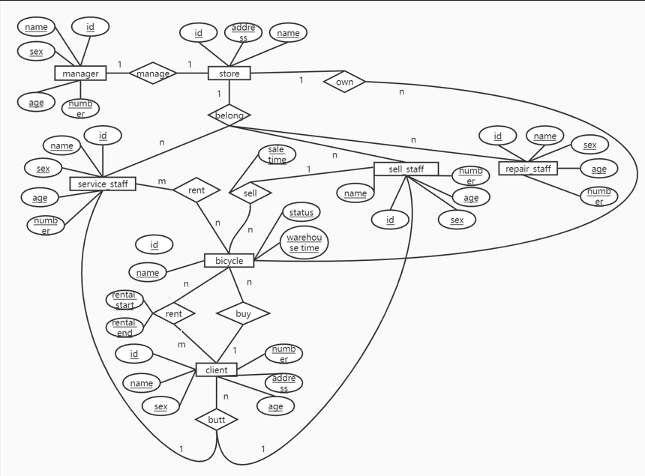
Fig 1 E-R

3.3 Design of Data Table
The following is the design of the database table of the bicycle rental management system, that is, the entity is refined into a specific database table, and the field name, field type, main attribute and field description of the table are described in detail.
The Tables:
Table 1 Table of the bicycle rental management system
Table | Columns
Bicycle | bicycle_id, b_name, b_status, b_warehouse_time, store_id, sell_staff_id, client_id, sale_time
Client | client_id, c_name, c_sex, c_age, c_number, c_address
Manager | manager_id, m_name, m_sex, m_age, m_number
Store | store_id, s_name, s_address, manager_id
Service_staff | service_staff_id, v_name, v_sex, v_age, v_number, store_id
Sell_staff | sell_staff_id, se_name, se_sex, se_age, se_number, store_id
Repair_staff | repair_staff_id, r_name, r_sex, r_age, r_number, store_id
Repair_butt | client_id, repair_staff_id, [content], transaction_time, collection_time
Service_butt | service_staff_id, client_id
Sell_butt | sell_staff_id, client_id
Service_rent_bicycle | service_staff_id, bicycle_id
Client_rent_bicycle | client_id, bicycle_id, rental_start, rental_end

1.Bicycle table: This table is used to store bicycle information in stock. Include the store number to which the bicycle belongs. If a bicycle is sold, this table also includes the salesperson id and customer ID number, and the time of sale.
Table 2 Bicycle table
Column | Attribute Domain Requirements
bicycle_id | Auto increment field use SQL Server’s Identity Property: IDENTITY(1,1), PK
b_name | nvarchar, Size: 50, Required
b_status | nvarchar, Size: 20, Required
b_warehouse_time | nvarchar, Size: 50, Required
store_id | int, Required, FK
sell_staff_id | int, Required, FK
client_id | Int, Required, FK
sale_time | nvarchar, Size: 50, Required

2.Client table: This table is used to store each customer information.
Table3 Client table
Column | Attribute Domain Requirements
client_id | Auto increment field use SQL Server’s Identity Property: IDENTITY(1,1), PK
c_name | nvarchar, Size: 50, Required
c_sex | nchar, Size: 10, Required
c_age | nchar, Size: 10, Required
c_number | int, Required
c_address | nvarchar, Size: 200, Required

3.Manager table: This table is used to store each manager information.
Table4 Manager table
Column | Attribute Domain Requirements
manager_id | Auto increment field use SQL Server’s Identity Property: IDENTITY(1,1), PK
m_name | nvarchar, Size: 50, Required
m_sex | nvarchar, Size: 10, Required
m_age | int, Required
m_number | int, Required

4.Store table: This table is used to store each store information. Include the store manager's number.
Table5 Store table
Column | Attribute Domain Requirements
store_id | Auto increment field use SQL Server’s Identity Property: IDENTITY(1,1), PK
s_name | nvarchar, Size: 50, Required
s_address | nvarchar, Size: 200, Required
manager_id | int, Required, FK

5.Service_staff table: This table is used to store the information of each employee responsible for the service. Include the store id to which the employee belongs.
Table6 Service_staff table
Column | Attribute Domain Requirements
service_staff_id | Auto increment field use SQL Server’s Identity Property: IDENTITY(1,1), PK
v_name | nvarchar, Size: 20, Required
v_sex | nvarchar, Size: 10, Required
v_age | int, Required
v_number | int, Required
store_id | int, Required,FK

6. Sell_staff table: This table is used to store the information of each employee responsible for sales. Include the store id to which the employee belongs.
Table7 Sell_staff table
Column | Attribute Domain Requirements
sell_staff_id | Auto increment field use SQL Server’s Identity Property: IDENTITY(1,1), PK
se_name | nvarchar, Size: 20, Required
se_sex | nvarchar, Size: 10, Required
se_age | int, Required
se_number | int, Required
store_id | int, Required, FK

7. Repair_staff table: This table is used to store the information of each employee responsible for maintenance. Include the store id to which the employee belongs.
Table8 Repair_staff table
Column | Attribute Domain Requirements
repair_staff_id | Auto increment field use SQL Server’s Identity Property: IDENTITY(1,1), PK
r_name | nvarchar, Size: 50, Required
r_sex | nvarchar, Size: 10, Required
r_age | int, Required
r_number | int, Required
store_id | int, Required, FK

8. Repair_butt table: This table is used to store maintenance staff and corresponding customer information. Including the customer number, the number of the employee responsible for maintenance, the content of the maintenance, the storage time of the car, and the time for the customer to pick up the car.
Table9 Repair_butt table
Column | Attribute Domain Requirements
client _id | Auto increment field use SQL Server’s Identity Property: IDENTITY(1,1), PK,FK
repair_staff_id | Auto increment field use SQL Server’s Identity Property: IDENTITY(1,1), PK,FK
[content] | nvarchar, Size: 200, Required
transaction_time | nvarchar, Size: 50, Required
collection_time | nvarchar, Size: 50, Required

9. Service_butt table: This table is used to store service staff and corresponding customer information.
Table10 Service_butt table
Column | Attribute Domain Requirements
service_staff_id | Auto increment field use SQL Server’s Identity Property: IDENTITY(1,1), PK, FK
client_id | Auto increment field use SQL Server’s Identity Property: IDENTITY(1,1), PK,FK

10.Sell_butt table: This table is used to store sales staff and corresponding customer information.
Table11 Sell_butt table
Column | Attribute Domain Requirements
sell_staff_id | Auto increment field use SQL Server’s Identity Property: IDENTITY(1,1), PK, FK
client_id | Auto increment field use SQL Server’s Identity Property: IDENTITY(1,1), PK, FK

11. Service_rent_bicycle table: This table is used to store the information of the employee responsible for the rental car and the corresponding rental car. Include service employee id and car number.
Table12 Service_rent_bicycle table
Column | Attribute Domain Requirements
service_staff_id | Auto increment field use SQL Server’s Identity Property: IDENTITY(1,1), PK, FK
bicycle_id | Auto increment field use SQL Server’s Identity Property: IDENTITY(1,1), PK, FK

12. Client_rent_bicycle table: This table is used to store the information of the customer and the bicycles rented by the customer. Including the customer number, the number of the bicycle rented by the customer, the start time of the rental car, and the return time.
Table13 Client_rent_bicycle table
Column | Attribute Domain Requirements
client_id | Auto increment field use SQL Server’s Identity Property: IDENTITY(1,1), PK, FK
bicycle_id | Auto increment field use SQL Server’s Identity Property: IDENTITY(1,1), PK, FK
rental_start | nvarchar, Size: 50, Required
rental_end | nvarchar, Size: 50, Required

4 Transaction
SQL commands related to transaction control include:
1.BEGIN or START TRANSACTION: start a transaction;
2.COMMIT: commit the transaction;
3.ROLLBACK: rollback transaction;
4.SAVEPOINT: Set a rollback point within the transaction;
4.RELEASE SAVEPOINT: delete the rollback point;
5.ROLLBACK TO: Rolls back the transaction to the point (a variant of the ROLLBACK command).

A transaction either commits (Commit) or rolls back (Rollback), commit means success, rollback means failure. When writing transaction code, start with the BEGIN command, followed by one or more SQL statements, and finally write the COMMIT or ROLLBACK command; COMMIT and ROLLBACK correspond to two transaction states, and only one of them can appear.
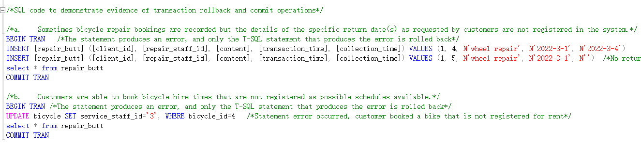
As can be seen from the preceding operation, the database is accessed when the transaction is initiated, and the operation is instantly checked, revealing that the record is in the updated state. The data is rolled back to the state it was in before the transaction commenced as the transaction rollback operation advances. For details, see File 2.

5 Performance Tuning
An index is a method of speeding up the retrieval of data in a table, it is a very useful object in a database, it sorts the values of one or more columns in a data table.
Although the use of indexes can improve the performance of the system and enhance the speed of data retrieval, it needs to occupy a large amount of physical storage space. The general principles of index building are as follows:
(1) Only the owner of the table can create an index on the same table.
(2) Only one clustered index can be created in each table.
(3) Up to 249 non-clustered indexes can be created in each table.
(4) Build indexes on frequently queried fields.
(5) Do not create indexes on columns that define text, image, and bit data types.
(6) Indexing can be established on the outside.
(7) Be sure to build an index on the primary key column.
(8) Do not create indexes on columns with more duplicate values and fewer queries.

The secondary index added to the database is shown in the Figure2-8 (for details, see File 1):
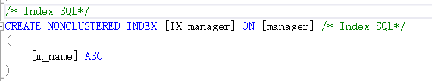
Figure 2
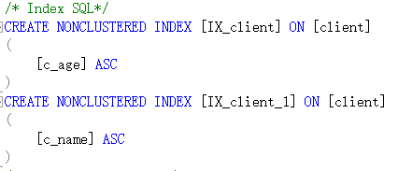
Figure 3
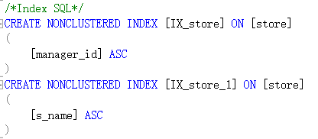
Figure 4
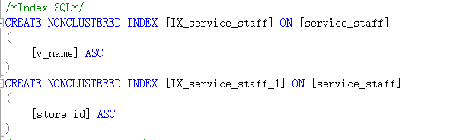
Figure 5
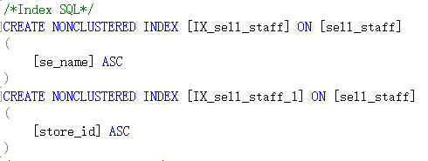
Figure 6
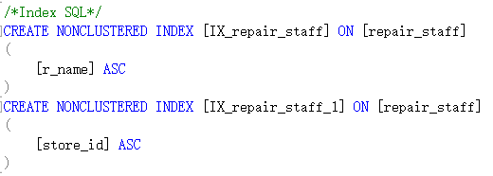
Figure 7
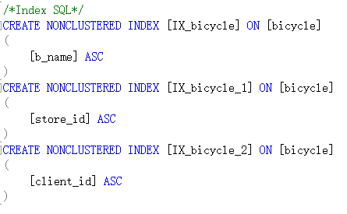
Figure 8

6 Distributed Database Solution
To achieve horizontal sharding with distributed partition view, split a table by dividing it into two or more smaller segments based on the partition key.
According to Antonopoulos et al. (2017), a stored procedure is used to place actions on the vertical sharding table of several sites in a distributed transaction, either all commit or all rollback, which maintains the distributed database system's data consistency.
To achieve vertical sharding, use stored procedures. Create the Customer table to store all of the company's customer information. Two tables are created after vertical sharding. Customer1 (cno, cname, address) is saved in the A server's database DB1, whereas Customer2 (cno, gender, age) is saved in the B server's database. DB2 The stored procedure add customer is created on both A and B, and database linkages are created between them.

References
[1]Elvis C. Foster,and Shripad V. Godbole.Database Systems:A Pragmatic Approach, 3rd edition.CRC Press,2022.
[2]Bronson Gary,and Hsu Jeffrey.Excel 2019 Project Book:Spreadsheets • Databases • Case Studies.Mercury Learning and Information,2021.
[3]Drazen Brdjanin, et al."An experiment in model-driven conceptual database design." Software & Systems Modeling 18.3(2019): doi:10.1007/s10270-018-0672-7.
[4]Vijender Kumar Solanki, et al."Fragmentation in Distributed Database Design Based on Ant Colony Optimization Technique." International Journal of Information Retrieval Research (IJIRR) 9.2(2019): doi:10.4018/IJIRR.2019040103.
[5]XianHui Li, ,and Chun Zhou."A distributed storage method for real-time database System design." IOP Conference Series: Materials Science and Engineering 452.3(2018): doi:10.1088/1757-899X/452/3/032010.

