

Assessment 1
Supporting Paper

Student name: Flor de Maria Galindo Manuel de Killick
Student ID: 2124309

Module name: Mental Disorders and Psychopathology
Module code: BMHP6006
Lecturer name: Bianca Sanfilippo
Date: 22/03/2024

Table of Contents

Introduction..............................................................................................................................3
Depressive episode..................................................................................................................4
Disorder within the ICD-10.......................................................................................................5
Data…………………………………….......................................................................................6
Causes.....................................................................................................................................9 Symptoms/signs.....................................................................................................................10 Diagnosis...............................................................................................................................11
Historical view and treatments ..............................................................................................12
Current treatments………......................................................................................................13
Principles of Care...................................................................................................................14 Recommendations.................................................................................................................15 Conclusion.............................................................................................................................16
References.............................................................................................................................17
Appendix: PowerPoint Presentation.......................................................................................18

Introduction
Depression is a prevalent mental condition that presents symptoms of a persistently depressed mood or a loss of pleasure or interest in activities. This disorder can affect anyone, although women are more likely to suffer from depression than men. Depression affects around 5% of people worldwide (World Health Organisation, 2023). Several factors can contribute to depressive episodes, such as stressful life events that include unpleasant and sometimes painful situations. Romantic breakups, interpersonal disagreements, and the illness or death of close family members are examples of relatively common situations (Bjørndal, 2023).

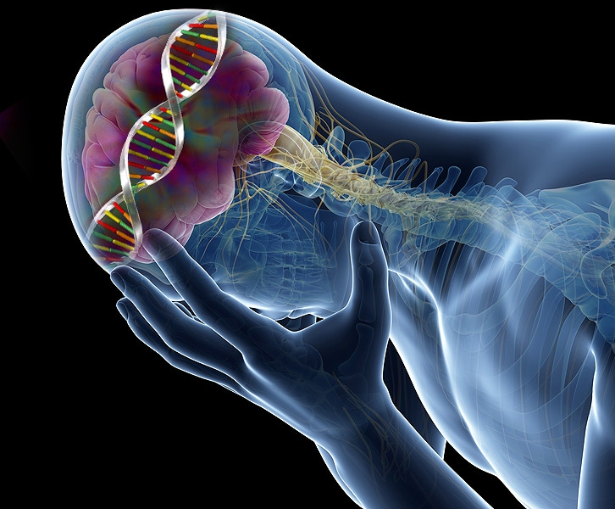

(Medscape, 2024)

Depressive episode
A depressive episode is a state of depression that persists for two weeks, during which the person will feel depressed or lose interest in most activities. The symptoms of depression vary, but the most common are fatigue, changes in appetite, feelings of worthlessness, and repeated thoughts of death. A depressive episode usually lasts six to eight months (Ada’s Medical Knowledge Team, 2022). But a major depressive episode is a chronic condition characterised by the disappearance and recurrence of symptoms. It significantly increases the disease burden. A doctor must diagnose the condition, and the results will confirm the presence of the disorder. The nine symptoms of MDE vary in intensity, duration over time, change in typical state, distress, and impairment (Andrews et al., 2007).

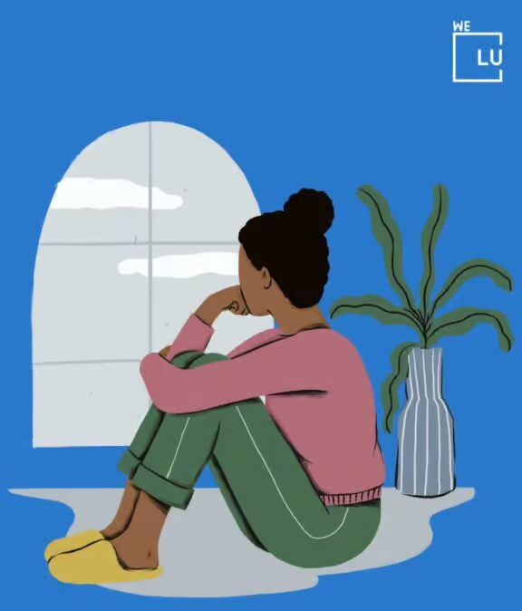

(We Level Up Treatment Centers, 2024)

Disorder within the ICD-10 Manual
According to Depression: ICD-10 Criteria Manual, F32 A depressive episode is defined by three types of episodes: mild, moderate, and severe. The person has a depressed mood, a loss of interest and enjoyment, and decreased energy, leading to increased tiredness and decreased activity (Mental Health Center of America, 2024). It is classified as a mental and behavioural disorder and is part of the group of mood [affective] disorders. (F30-F39).

Data of Depressive episode in the UK
Depression is one of the most common mental health illnesses, impacting almost one out of every six people in the UK. Women are twice as likely as men to suffer from depression, but only 15% of women receive therapy, compared to 9% of men. The Champion Health team set out to discover the health difficulties that employees confront in all aspects of their well-being, from financial to musculoskeletal. They employed clinical measures to assess data from 4,000 employees. The workplace depression figures are as follows: (Pindar, 2024).
- 56% of employees show signs of depression.
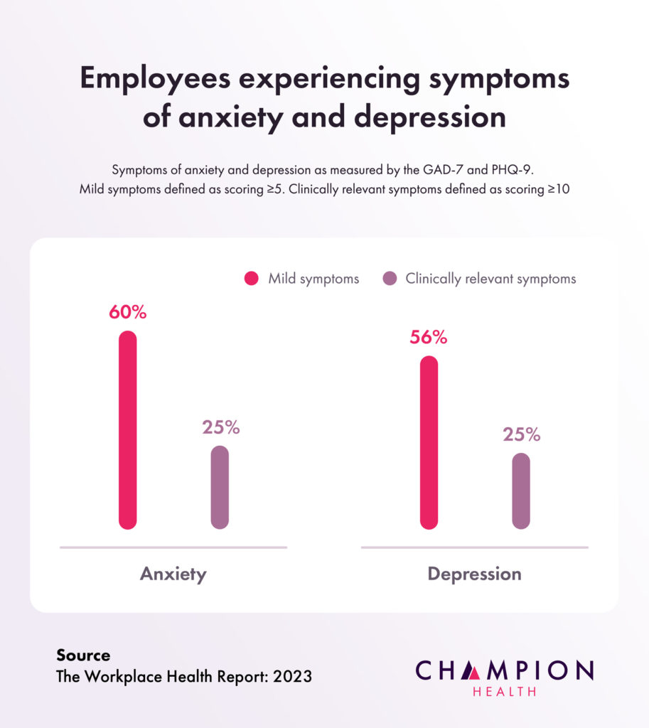

(Pindar, 2024)

2. Female employees are 20% more likely to exhibit symptoms of depression.
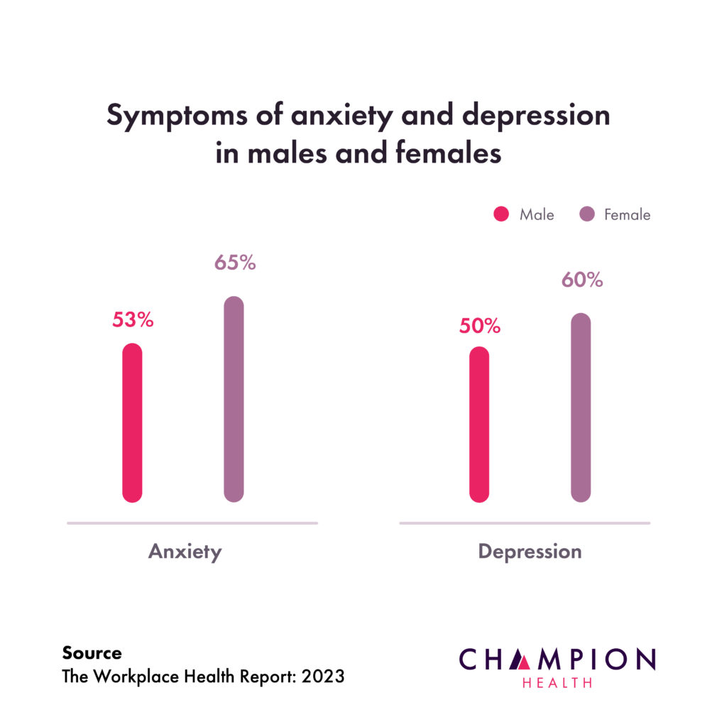

(Pindar, 2024)
3. 61% of employees aged 16 to 24 exhibit depressive symptoms.
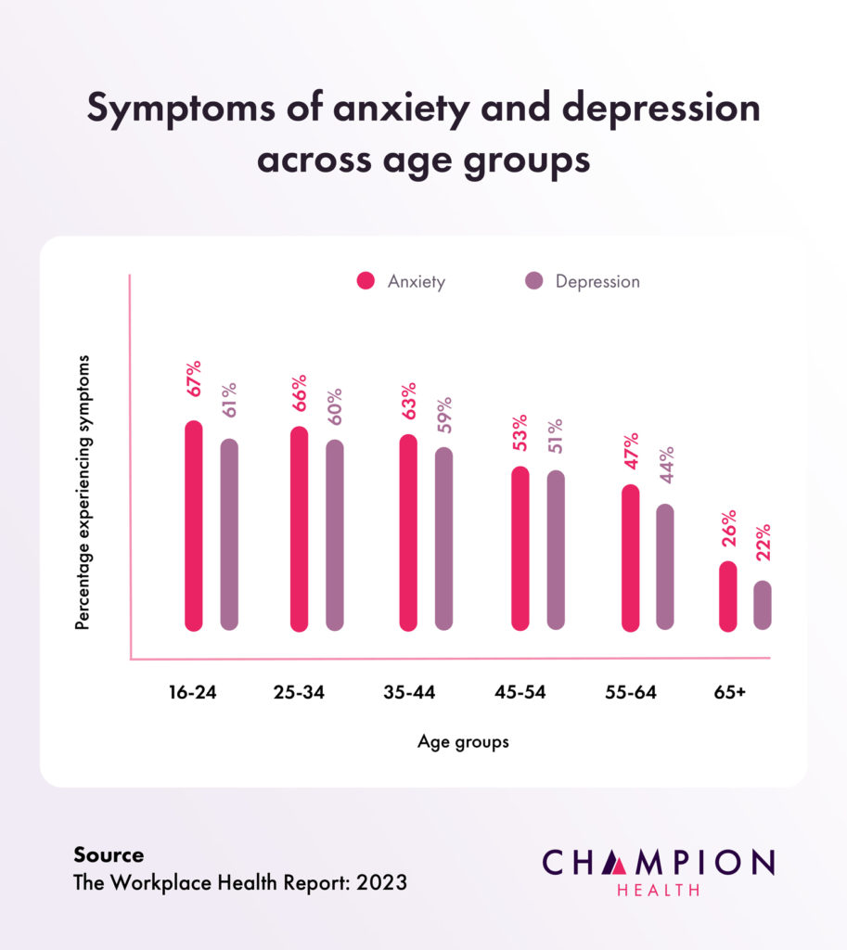

(Pindar, 2024)
4. Currently, just 10% of employees seek mental health help.
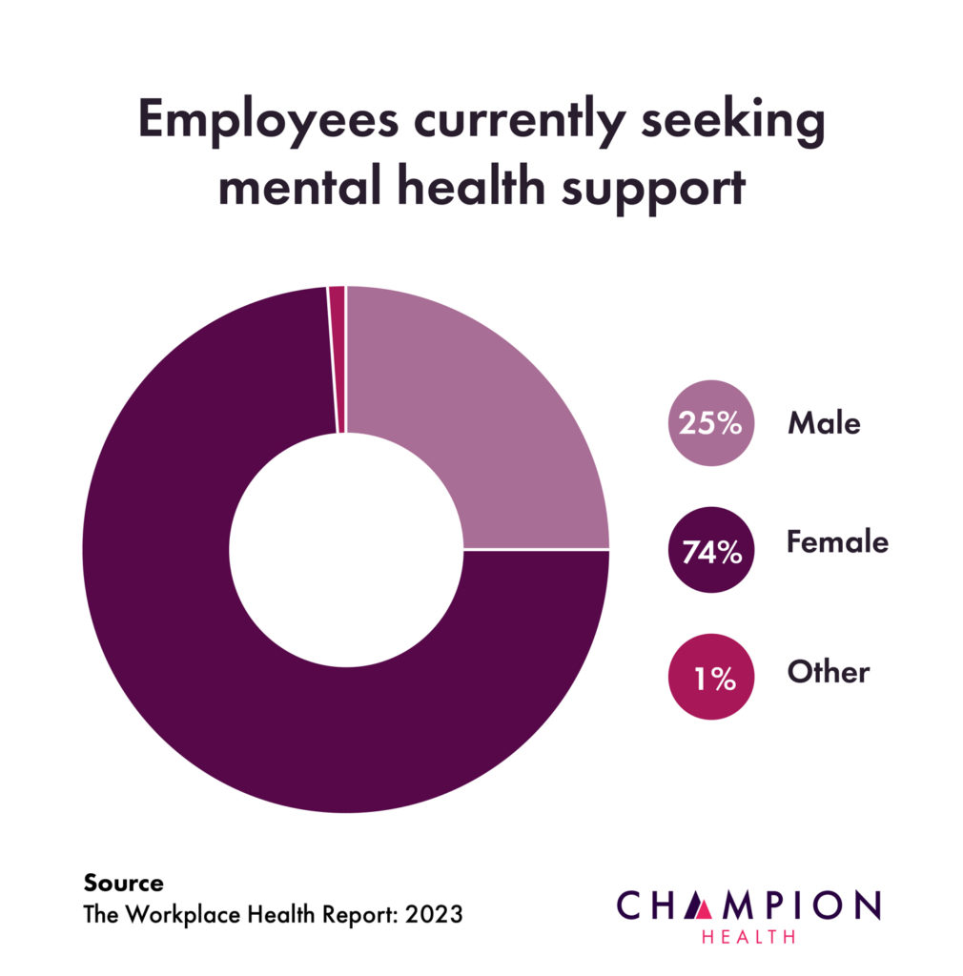

(Pindar, 2024)

Causes
The causes of depressive episodes are complex and involve psychological factors such as past experiences with depression, bipolar disorder, anxiety, attention deficit hyperactive disorder, family history of depression, grief, and childhood trauma. Also, there are biological factors such as insufficient thyroid function, changes in brain function, histories of sleep problems, chronic pain, cancer, and heart disease. And social factors such as drug and alcohol abuse and not being able to obtain or lose employment (Ada’s Medical Knowledge Team, 2022).

Symptoms and signs
The symptoms of a depressive episode are characterised by feelings of sadness, hopelessness, guilt, anxiety, and anger. Additionally, the individual will experience discomfort, tiredness, tension, and changes in appetite or weight. They will lose interest in hobbies and social interactions they once enjoyed. They will not be able to concentrate, which will lead to slower speech. Also, they will gradually adjust their sleeping patterns and lose interest in life, leading to suicidal thoughts or attempts (Washington, and Leonard, 2023).

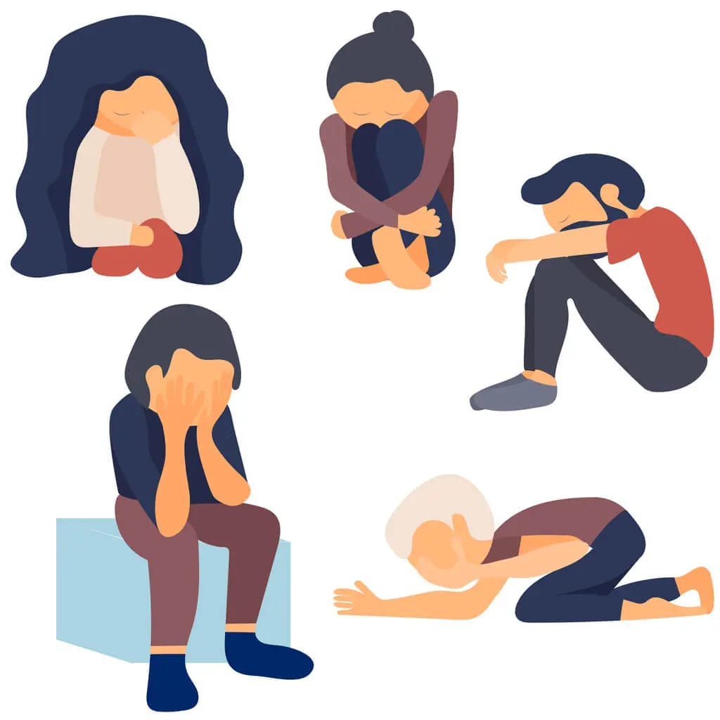

(Epic Health Partners, 2024)

Diagnosis
The mental health clinician is responsible for diagnosing a depressive episode using the criteria outlined in the Diagnostic and Statistical Manual of Mental Disorders, Fifth Edition. To have a major depressive episode, the patient must have five or more depressive symptoms every day for two weeks. However, the doctor may suggest a blood test to rule out hyperthyroidism, and to have a minor depressive episode, the patient must have two or four of the aforementioned symptoms. (Ada’s Medical Knowledge Team, 2022).



(American Psychiatric Association, 2024)

Historical view and treatments
The depression appeared in the second millennium in Mesopotamia. People thought it was a spiritual condition; that is why they had demonic possessions and only priests could treat them. However, Hippocrates proposed that "melancholy" was the result of four unbalanced bodily fluids known as humours: yellow bile, black bile, phlegm, and blood (Schimelpfening, 2023). Advances in neuroscience in the 20th century revealed information about how the mind works, leading psychologists and psychiatrists to develop the American Diagnostic and Statistical Manual of Mental Disorders in 1952 (Brett and McKay, 2023).
Initial treatments included beatings, physical restraints, and starvation. However, Hippocrates' treatments included bloodletting, baths, exercise, and a healthy diet (Schimelpfening, 2023). Already in the 20th century, electroshock therapy and lobotomies were used to treat depression (Brett and McKay, 2023).
 (Ray, 2018)

Current treatments
Depression treatment typically combines self-help techniques, psychotherapy, and medication. After the diagnosis of mild depression, the patient will have to wait a little to see if there is improvement. The GP will see the patient again in 2 to 4 weeks to assess her progress. In addition, the patient will work with a therapist to complete a guided or online self-help book based on cognitive-behavioural therapy principles. There will be 6 to 8 sessions, which can be in person, by phone, or online. Exercise and group conversation therapies will be extremely beneficial in alleviating depressive symptoms. The treatment for moderate-to-severe depression will be a combination of psychotherapy and antidepressants (National Health Service, 2023).

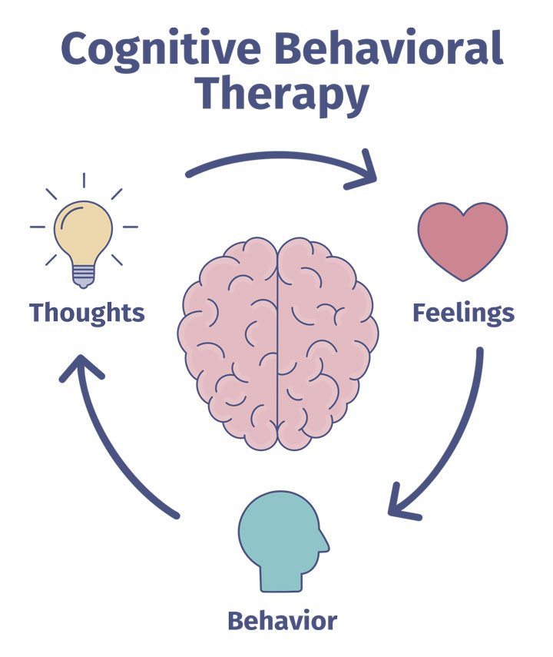

(Golde, 2022)

Principles of care
When working with people who are depressed, we must establish trust and reduce critical attitudes. We should also be compassionate and respectful of any physical or mental illnesses they may have. People must be treated as individuals to receive specialised care. Furthermore, discussions must take place in settings that protect patients' confidentiality, privacy, and dignity. Make people aware of support groups by providing verbal and written information. Support will also be provided to family members and carers, and the Mental Health Act 2007 and Mental Capacity Act 2005 policies will be reviewed on a regular basis (NICE, 2022).
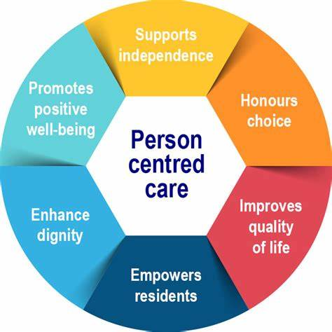

(Manton Heights ABI Unit, 2024)

Recommendations
When you are experiencing depressive symptoms, confront your fears by talking to others about what makes you anxious. This will help you deal with problems and make life easier (National Health Service, 2023). Encourage the individual to consult a mental health expert and support them in adhering to their treatment plan. You should also take care of yourself by sticking to a normal bedtime and wake-up schedule, as well as eating nutritious meals regularly (National Institute of Mental Health, 2024).
On the other hand, maintain contact with friends and family and engage in physical activities such as walking. Avoid alcohol and drugs as much as possible. If you have suicidal thoughts, go to the hospital, and join a support group (World Health Organisation, 2023).



(Sussex Mindfulness Centre, 2024)

Conclusion
Depressive episodes have a negative impact on the emotions, thoughts, and behaviour of the individual. It must be treated immediately to prevent suicides. When comparing previous therapies with contemporary ones, it is possible to conclude that the latter are more successful and safer. Furthermore, simply listening to people who suffer from this mental illness will be the most effective strategy to help in their recovery.

References
Andrews, G., Brugha, T., Thase, M.E., Duffy, F.F., Rucci, P. and Slade, T. (2007) 'Dimensionality and the category of major depressive episode', International Journal of Methods in Psychiatric Research, 16(S1), pp. S41–S51. Available at: https://doi.org/10.1002/mpr.216.
Ada’s Medical Knowledge Team (2022) Depressive Episode. Available at: https://ada.com/conditions/depressive-episode/ (Accessed: 19 March 2024).
Brett and McKay, K. (2023) Leashing the Black Dog: The History of Depression. Available at: https://www.artofmanliness.com/health-fitness/health/the-history-of-depression/ (Accessed: 21 March 2024).
Bjørndal, L.D. (2023) 'The relationship between stressful life events and depression risk'. Nat Rev Psychol 2, 520 (2023). https://doi.org/10.1038/s44159-023-00216-6
Mental Health Center of America (n.d.) Depression: ICD-10 Criteria. Available at: https://mentalhealthcenter.com/depression-icd10-criteria/ (Accessed: 25 March 2024).
National Health Service (2023) Treatment - Depression in adults. Available at: https://www.nhs.uk/mental-health/conditions/depression-in-adults/treatment/ (Accessed: 20 March 2024).
National Health Service (2022) How to cope with depression. Available at: https://www.nhs.uk/mental-health/self-help/tips-and-support/cope-with-depression/ (Accessed: 25 March 2024).
National Institute for Health and Care Excellence (2022) Depression in adults: treatment and management. Available at: https://www.nice.org.uk/guidance/ng222/chapter/recommendations#principles-of-care (Accessed: 22 March 2024).
National Institute of Mental Health (2021) Depression. Available at: https://www.nimh.nih.gov/health/publications/depression (Accessed: 22 March 2024).
Pindar, J. (n.d.) Depression Statistics UK: 2023. Available at: https://championhealth.co.uk/insights/depression-statistics/ (Accessed: 25 March 2024).
Schimelpfening, N. (2023) The History of Depression. Available at: https://www.verywellmind.com/who-discovered-depression-1066770 (Accessed: 19 March 2024).
Washington and Leonar, J. (2023) How to cope with a depressive episode. Available at: https://www.medicalnewstoday.com/articles/322495 (Accessed: 25 March 2024).
World Health Organization (2023) Depressive disorder (depression). Available at: https://www.who.int/news-room/fact-sheets/detail/depression (Accessed: 21 March 2024).

Appendix: Power Point Presentation


