Bridge Construction

Table of Contents
Introduction ………………………………………………………………………………………………. 3
Types of bridges …………………………………………………………………………………………. 4
References ……………………………………………………………………………………………….. 6

Introduction
This research paper explores bridges in detail, examining what they are, how they function, and the engineering principles that guide their design and construction. It looks not only at the basic purpose of bridges but also at the scientific and technical ideas that influence the choices engineers make, from the earliest planning stages through to long-term performance. The paper also considers how different structural systems and materials affect the way bridges behave under load, how efficiently they carry forces, and how well they withstand environmental conditions and ageing over time. By understanding these factors, we gain a clearer picture of why certain bridge types are used in particular locations and how modern engineering continues to refine their safety, durability, and overall effectiveness.
What are bridges?
Bridges are structures designed to span across physical obstacles such as rivers, valleys, roads, railways, or other barriers, allowing people, vehicles, and goods to move safely and efficiently from one side to the other. They form essential links within transport networks, helping to connect communities, support economic activity, and improve access to services and opportunities. Beyond their practical function, bridges often become important landmarks, reflecting the engineering capabilities, materials, and architectural styles of the time in which they were built. Their role in society is therefore both functional and symbolic, representing progress, connection, and the ability to overcome natural and man-made barriers.

Types of Bridges
Bridges can be grouped in many different ways, but one of the most practical and widely used methods is to classify them by their structural system. This approach focuses on how the bridge carries its loads, how forces move through the different components, and how the overall weight is ultimately transferred into the ground. Each structural system behaves in its own distinct way and comes with specific advantages, limitations, and ideal applications. Because of this, engineers select particular bridge forms based on a combination of factors, including the site conditions, the span that needs to be achieved, the materials available, and any construction or logistical challenges associated with the project.
The following section introduces the main structural types used in modern bridge engineering and explains how each system functions in practice, highlighting the principles that guide their design and performance.

Beam Bridge.
A beam bridge is one of the most straightforward and traditional bridge forms, consisting of a horizontal beam supported by piers or abutments at each end. Its simple arrangement makes it particularly suitable for short spans, and it is often chosen because it is economical, quick to build, and requires relatively little specialist construction work. According to Engineering Infinity (2024), beam bridges can be constructed from a range of materials, including timber, reinforced concrete, and steel, allowing them to be adapted to different environments and project requirements. The load on a beam bridge is transferred directly into the supports, making it a practical and reliable option for shorter distances where more complex structural systems are unnecessary. In modern bridge engineering, I-beams and box girders are commonly used, as their shapes provide improved strength, stiffness, and stability, enabling the bridge to carry heavier loads while maintaining an efficient and cost-effective design.
Truss Bridge.
According to History of Bridges (2026), a truss bridge is a type of bridge whose main structural element is the truss a framework made up of connected members arranged to form a series of triangular units. This triangular configuration is used because it creates a highly rigid structure, allowing loads applied at a single point to be distributed across a much wider area. Over time, many different styles of truss bridges have been developed, including the Allan truss, K-truss, and Warren truss, each offering its own balance of strength, efficiency, and ease of construction.
Truss bridges are typically supported by abutments at each end, which anchor the structure firmly and transfer the bridge’s overall load safely into the ground. The truss layout enables forces to move efficiently through the frame: the top chords resist compression, the bottom chords carry tension, and the diagonal members connect the system together to distribute these forces evenly. This well-balanced arrangement allows the bridge to support its own weight as well as the loads that travel across it, ensuring stability, durability, and safe performance throughout its lifespan.

Suspension bridge
According to Britannica, a suspension bridge is a type of bridge in which the roadway is supported by overhead cables that carry the load and transfer it to the towers and anchorages. Modern suspension bridges are lightweight, visually striking, and capable of spanning far greater distances than any other bridge form currently in use. Their ability to cross wide waterways or deep valleys with minimal intermediate supports makes them especially valuable in challenging environments. However, this impressive performance also means they are among the most expensive types of bridge to construct, requiring substantial materials, specialist engineering, and complex installation methods. Although suspension bridges can be designed to carry heavy freight trains, almost all modern examples are built primarily for road traffic, particularly cars, lorries, and other light vehicles, reflecting their typical use in major transport networks.
A suspension bridge carries its vertical loads through curved main cables that act entirely in tension. These forces are then transferred to the towers, which pass them down to the ground through vertical compression, and to the anchorages, which must resist the inward pull and in some cases, the additional vertical pull generated by the cables. Structurally, a suspension bridge can be thought of as an upside-down arch, with the cables forming the tensioned shape while only the towers experience compression. Because the deck is suspended high above the ground, particular care is required to ensure it does not move excessively under traffic, wind, or other dynamic loads. To achieve the necessary stability and comfort for users, the deck must be made sufficiently heavy, sufficiently stiff, or designed as a carefully engineered combination of both, often incorporating aerodynamic shaping to reduce vibration.
There is often some confusion between suspension bridges (Figure 1) and cable stayed bridges (Figure 2). In a suspension bridge, the entire length of the deck is supported by vertical hangers that connect down from long, curved main cables. These main cables run over the tops of the towers and are anchored firmly at both ends of the bridge, creating a continuous suspended system. In contrast, a cable-stayed bridge uses one or more tall towers with diagonal cables that run directly from the tower to the bridge deck. These cables support the deck in a series of straight, angled lines rather than through a continuous suspended cable, giving cable-stayed bridges a distinctly different structural behaviour and visual appearance.
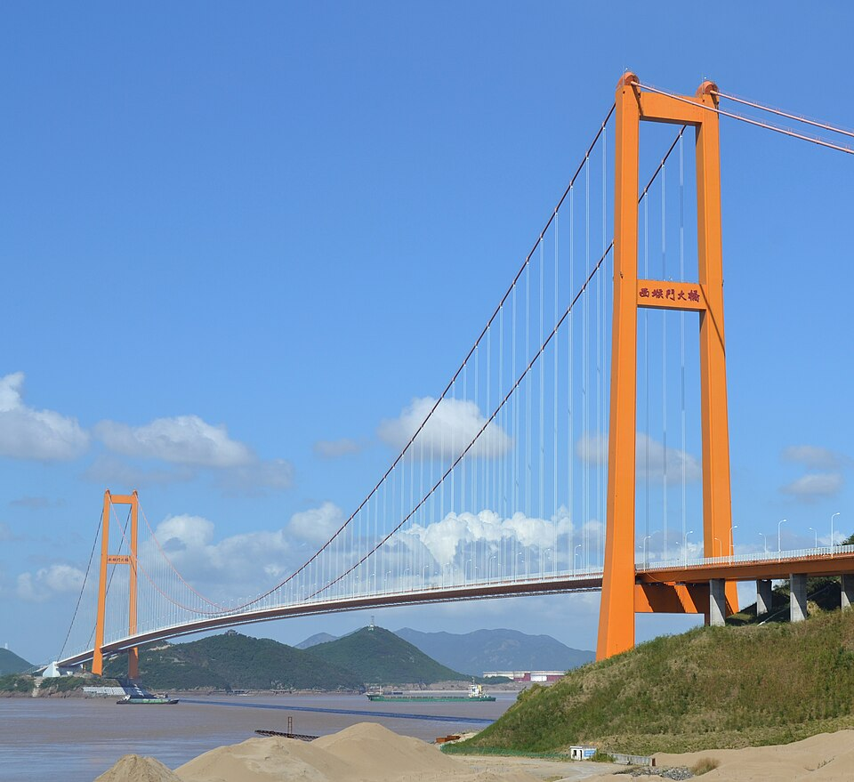
Figure 1: The Xihoumen Bridge in the Zhoushan Archipelago, Zhejiang, China (Glabb 2012)

Figure 2: The Arthur Ravenel Jr. Bridge (newcharleston)

References
Britannica (2026) Suspension Bridge. Available at: Suspension bridge | Definition, Mechanics, History, Examples, & Facts | Britannica (Accessed: 7 May 2026)
Engineering infinity (2024) 7 Main Types of Bridges. Available at: 7 Main Types Of Bridges (Accessed: 22 April 2026)
History of bridges (2026) Truss Bridge - Types, History, Facts and Design. Available at: Truss Bridge - Facts and Types of Truss Bridges (Accessed: 23 April 2026)

