University of Wales Trinity Saint David

ACADEMIC AND EMPLOYABILITY SKILLS REPORT
Module: Academic and Employability Skills
(BMSW 4001)

Name of the lecturer: Lloyd Beharry
Name of the student: Natalia Pinzaru (1906870)

London – 2020
The purpose of this report is to find out the signifiance of the skills we have when we want or we are involved in a job, and how big impact can be when we identify our needs. How can we know our needs? How we improve them? Skill assessments are one of the solution. It helps visualise who knows what and identifies gaps where training may be needed or developing plan, to maximise the growth and potential of the individual.
Also, in this report we will remind about the meaning of the ‘skill’. What are ‘soft skills, ‘transferable’ and ‘hard skills’. I will analyse my own skills and relate my strength and weakness.

What is a ‘skill’?
A skill is the ability to perform out a task with specific results in a given a given amount of time, energy, or both. Competences can o be divided into general and domain-specific competences. Many general skills in the field of work, for example, would include time, communication, teamwork and leadership, self- motivation and others, whereas other skills can only be used for a specific job. Performance usually requires some manipulation of the environment and circumstances to determine the level of skill shown and used.
According to Business Cambridge Dictionary ‘skill’ is a a particular ability that you develop through training and experience and that is useful in a job:
- communication/interpersonal/negotiation skills;
- many young people have never learned the basic skill of good writing;
- business/specialist skills a growing part of the charity's work is providing business skills to developing economies;
- improve/sharpen/upgrade skills improve computer skills and helping to find higher-paid work;
- we are facing a growing skills shortage in sciences;
- leadership/management/organizational skills;
- analytical/practical/technical skills;
- have/possess/lack skills;
- acquire/develop/learn skills;
- apply/use skills.

What are ‘Employability Skills’?
Employability skills are a group of essential abilities that involve the development of a knowledge base, expertise level and mindset that is increasingly necessary for success in the modern workplace. Employabilityskills are typically considered essential qualifications for many job positions and hence have become necessary for an individual’s employment success at just about any level within a business environment.
Essentially, employability abilities is an umbrella term for a lot of exceptionally alluring, transferable aptitudes that transform us into an extremely appealing up-and-comer or representative. It very well may be characterized as a lot of aptitudes bosses need from a potential representative. But employability, is not just about getting a job, it is about a broader set of skills and attributes that will enable a person to be successful throughout the life as well.
Employability skills need to be a school wide focus. They are difficult to teach in a single, discrete lesson, or even in a lesson series. Employability skills are best taught when they are a natural inclusion in everything which goes on in a school. Try listing the employability skills in a framework or checklist, then identifying areas of the curriculum where each skill can be focussed on explicitly for an extended period. For example, the sport and recreation area could focus on teaching interpersonal communication within a large group situation through playing team games, while the English area could focus on encouraging initiative through self guided learning experiences.
The critical component for teaching employability is to make students aware that they are learning skills which will help them become job ready. So if you play a team game, take a moment to make the link between the game, the teamwork skills involved, what has been learnt during the activity, and how it could be applied in the workp

The most important employability skills are:
- Getting along with and working well with other people, such as communication skills and other interpersonal skills;
- Being reliable and dependable: doing what you say you will by the deadline you have agreed, and turning up when you are meant to be there;
- A willingness to learn new skills, whether those are job-specific or more general.

What are soft skills? What are hard skills?
Soft skills are the skills that apply to every job. They are also called ‘transferable skills’ because can be applied to any job. These are your people skills - interpersonal skills, communication skills, and other qualities that enable you to be successful in the workplace. Hard skills are the qualifications required to do the job. They are job-specific and are typically listed in job postings and job descriptions.

Examples of Soft Skills include:
- Communication;
- Flexibility;
- Leadership;
- Motivation;
- Patience;
- Persuasion;
- Problem Solving Abilities;
- Teamwork;
- Time Management;
- Work Ethic.
Soft skills are subjective skills that are much harder to quantify.
Examples of Hard Skills include:
- Proficiency in a foreign language
- A degree or certificate
- Typing speed
- Machine operation
- Computer programming
These hard skills are often listed in our cover letter and on resume, and are easy for an employer or recruiter to recognize.
According with Mind Tools Analysis I have tested my skills and I have got the 51 number which says I need more to build my skills on leadership and management skills.
Therefore, to be a great manager, I must have an extensive set of skills – from planning and delegation to communication and motivation. Because the skill set is so wide, it's tempting to build skills in the areas of management that I’m already comfortable with. But, for long-term success, it's wise to analyze my skills in all areas of management – and then to challenge myself to improve in all of these areas.
About Time Management - 48 score, and it says that I’m managing my time very effectively! Time management is one of the most important career skills areas. Not only does it help me to be more productive, I’ll also be much less stressed.
Swot Analysis and Personal Development Plan
A SWOT analysis is used to identify strengths, weaknesses, opportunities, and threats. This type of analysis may be applied to companies as a whole, separate departments, or individuals within an organization. Strengths and weaknesses are internal while opportunities and threats are external.
A personal SWOT analysis is essential to the creation of a personal development plan because this type of analysis helps an individual to become more self-conscious. SWOT analyses demonstrate individual's strengths, weaknesses, opportunities, and threats as follows:
- Strengths - The interior individual resources that an individual can control, extend, and use furthering their potential benefit, including aptitudes, skills, accomplishments, and training.
- Weaknesses - The interior negative parts of an individual, including absence of training or mastery, absence of center, and useless work propensities.
- Opportunities - External occasions that might be misused by people to further their potential benefit, for example, work opening, innovation classes, and interest for aptitudes.
- Threats - External factors that compromise qualities and openings, for example, work frailty and cutting back.
Using SWOT analysis is a way to understand a business’s position in a market. SWOT is designed to support a developing marketing strategy but is also useful in supporting internal relationships. According to the text Strategic Communications Planning; For Effective Public Relations & Marketing by Joseph D. Ogden and Laurie J. Wilson, SWOT is a useful way to sum up research and focus on any oppertunites present and barriers to overcome.
Generally, SWOT is used in research for a market of a product or service. Once the analysis has been completed the company should have a clear understanding on what areas it excels in and what challenges it will be faced with. Therefore marketing strategies can be adjusted to achieve stategic goals.
Personal Swot Analysis (at workplace)

Strengths  What do you do well? What unique resources can you draw on? What do others see as your strengths? | Weaknesses  What could you improve? Where do you have fewer resources than others? What are others likely to see as weaknesses?
- High specialization;  - Experienced;  - Computer knowledge;  - Logical thinker;  - Hardworking;  - Openminded;  - Disciplined;  - Flexibility;  - Focused;  - Team-oriented. | - Sometimes get bored quickly;  - I focus too much on small details;  - I have trouble saying ‘no’;  - Sometimes lack of confidence;  - Sometimes trouble asking for help;  - I postpone things sometimes;  - Take on too much responsibility;  - Critical of myself;  - Over-sensitive;  - English dilemma.
Opportunities  What opportunities are open to you? What trends could you take advantage of? How can you turn your strengths into opportunities? | Threats  What threats could harm you? What is your competition doing? What threats do your weaknesses expose you to?
- Personal development;  - Building personal network and relationships;  - Decide on an idea I’m;  - Experiencing changes;  - Comfortably adapt to changing;  - Quickly find the solution;  - Good team player;  - Good manner in all workplaces;  - Smart in work I do. | - Discrimination;  - Spoken abuse and bullying;  - Under pressure;  - Distraction;  - Too busy;  - Enough obligations;  - Insecurity;  - Other dialects/accents of English.
www.mindtools.com
While making a self-awareness plan, people should try to improve qualities, limit or dispose of shortcomings, profit by circumstances, and convert dangers into circumstances. For example, a person with a four year certification in IT (quality) could win a further developed accreditation in their field on the off chance that they have not yet acquired such a qualification (shortcoming). This arrangement might be founded on expanding openings for work for people in IT with this accreditation (opportunity) just as the activity uncertainty confronting people inside the IT field who have no instruction past a four year college education (risk).

Personal Development Plan (PDP)

GOALS |  | SKILSS/IMPROVEMENTS (knowledge) and ACTION NEDEED | TARGET | PROGRES/  RESULTS
- Finish University and get knowledge and new skills for the workplace; |  | - Attendance at the University;  - Research of information;  - Collaborations with colleagues and lecturers;  - Finish the assignments well;  - Patience;  - Assiduity. | 2019 – untill Master | - I started to gain more confidence at work;
- Learn English in more specialized terms; |  | - Frequent interactions with people with a more difficult dialect;  - More practice at home;  - Using applications that aim to learn English as quickly as possible. | 2020 - 2021 | !  This section will be completed when I record result.
- Progress in my career; |  | - Succeed English Barierra;  - Avoiding overloading and taking on too many responsibilities;  - Increasing self-pride;  - Realization of things at the moment;  - Asking more for help when I need;  - No taking to the heart some unimportant things;  - Be more confident to talk to people;  - Focusing on small things just on the important things; | 2019 - 2021 | - Attracted the boss’s attention;  - I was chosen as the calmest person in the team;  - I was offered the opportunity to provide training to others.

What are Academic Skills?

Academic Skills are all about helping to become a more effective learner and developing the research and study skills that will help now and in the future.
Developing good academic skills will help to achieve the academic success that reflects our full potential.
Examples of academic skills include:

time management;

reading proficiency;

oral communication;

written communication;

critical thinking;

research abilities;

analytical thinking and problem solving;

organizational and interpersonal skills to excel in an academic setting.

So as to prevail in study hall learning, we as an understudies must have inspiration, devotion, promise to assignments, intercultural understanding, affectability when imparting, adaptability, test readiness procedures, the capacity to organize and systems to manage delaying and uneasiness. Correspondence is an essential case of a scholarly ability. We should have the option to orally speak with companions and teachers, express reflections and musings demonstrating basic deduction during class dialogs and show social affectability while talking with peers.
Composed correspondence is likewise an essential case of a scholarly ability since we should realize how to communicate recorded as a hard copy. For instance, understudies are constantly required to compose papers, addresses, look into papers and diagnostic contextual analyses at pretty much every evaluation level and in about all orders, including English, history, human science, sociologies, brain science, nursing and writing. To improve our scholastic aptitudes, we can demand help from educators and teachers and exploit school assets like guides, social laborers, understudy coaches and pros who work in the scholarly focus.
General Transferable
An exhaustive meaning of transferable abilities was given by the previous Department to Education and Employment (DfEE) in which transferable aptitudes were characterized as those aptitudes that are key to word related capability in all segments and at all levels.
Examples of Transferable Skills include:
- Team work;
- Leadership;
- Personal Motivation, Organisation and Time Management;
- Listening;
- Written Communication;
- Verbal communication;
- Research and Analytical Skills;
- Numeracy Skills;
- Personal Development;
- Information Technology.
Transferable skills are a big deal. Even if we are only at uni to learn, we will develop all manner of abilities and extend our skillset for the better.
In conclusion, there is no doubt that employees who having a good degree will gain an excellent starting point, since a good degree helps employees open the door of finding a job, however, a degree alone is not enough, employers want much more from their graduate employees, they want employees can bring benefits to the company and let the company in an invincible position during the fierce competition. Through extensive research I summed up kinds of employability skills that most needed by companies. And I made a personal SWOT analysis based on employability skills and self assessment test through the internet and actual experience which made me become more aware of myself. After that I made an action plan for myself. I’ll stick to the plan and I hope that it would help me improve my employability skills after I finish it .And get a good job in the competitive job market after I graduate.

REFERENCES

- A. Maund, M. Schriek ‘Skills for the Workplace’, Student Yearbook.
- D. W.G Hind ‘Employability skills’ Stuart Moss 1972.
- P. Morgan ‘Business student’s guide to Study and Employability’
- https://moodle.uwtsd.ac.uk/course/view.php?id=6958.
- https://www.mindtools.com/pages/article/get-started.htm.
- https://www.theguardian.com/careers/careers-blog/changing-your-career-how-to-identify-your-transferable-skills.
- https://www.thebalancecareers.com/hard-skills-vs-soft-skills-2063780.
- https://www.skillsyouneed.com/general/employability-skills.html.

APENDIX

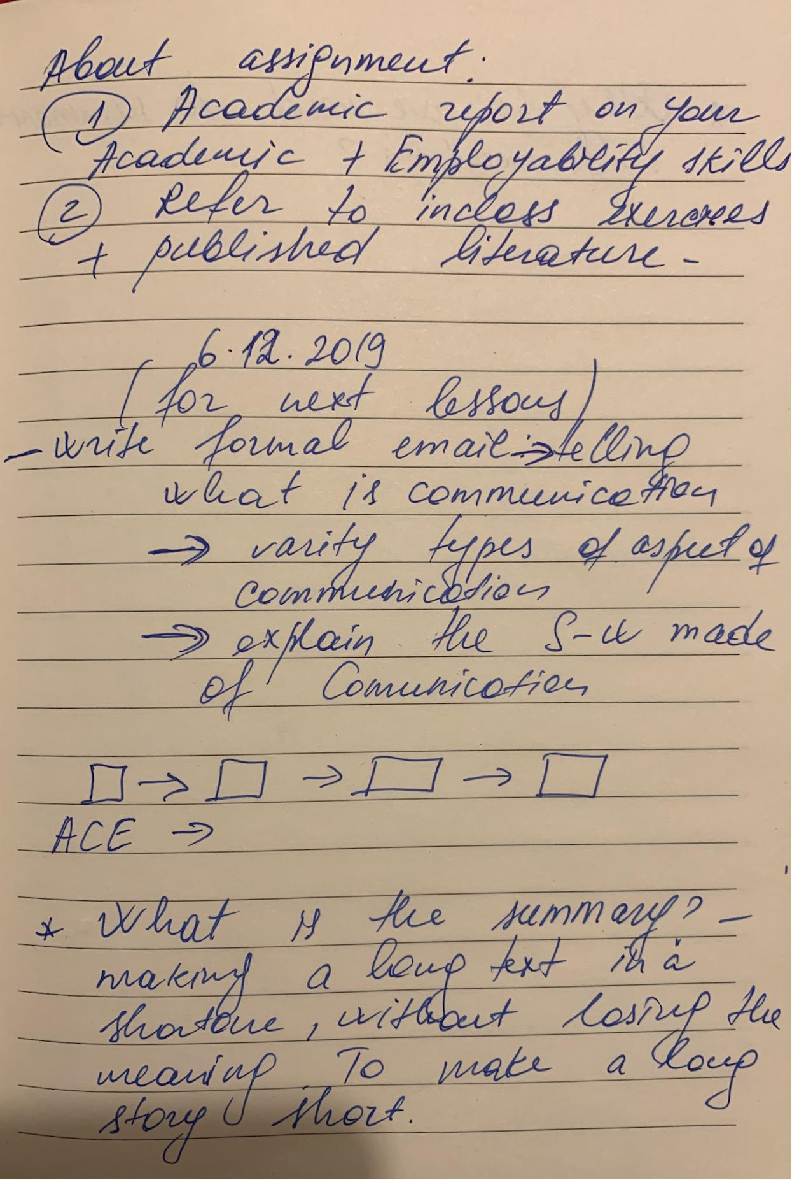

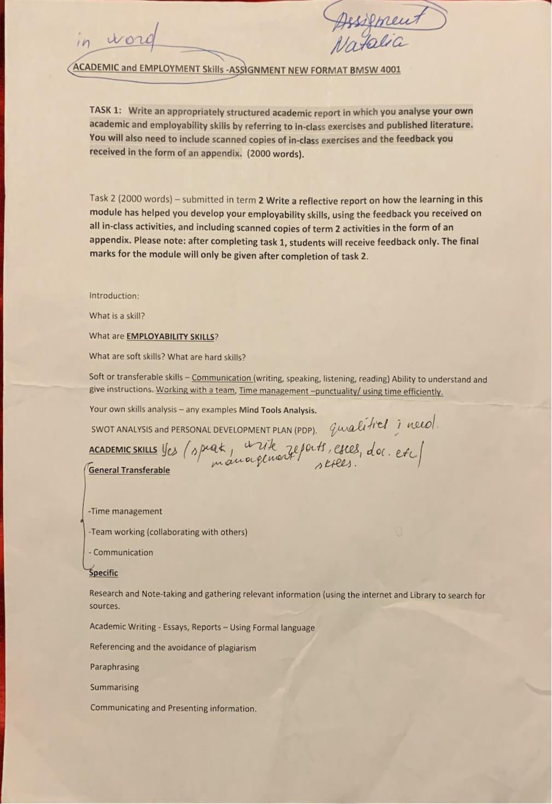
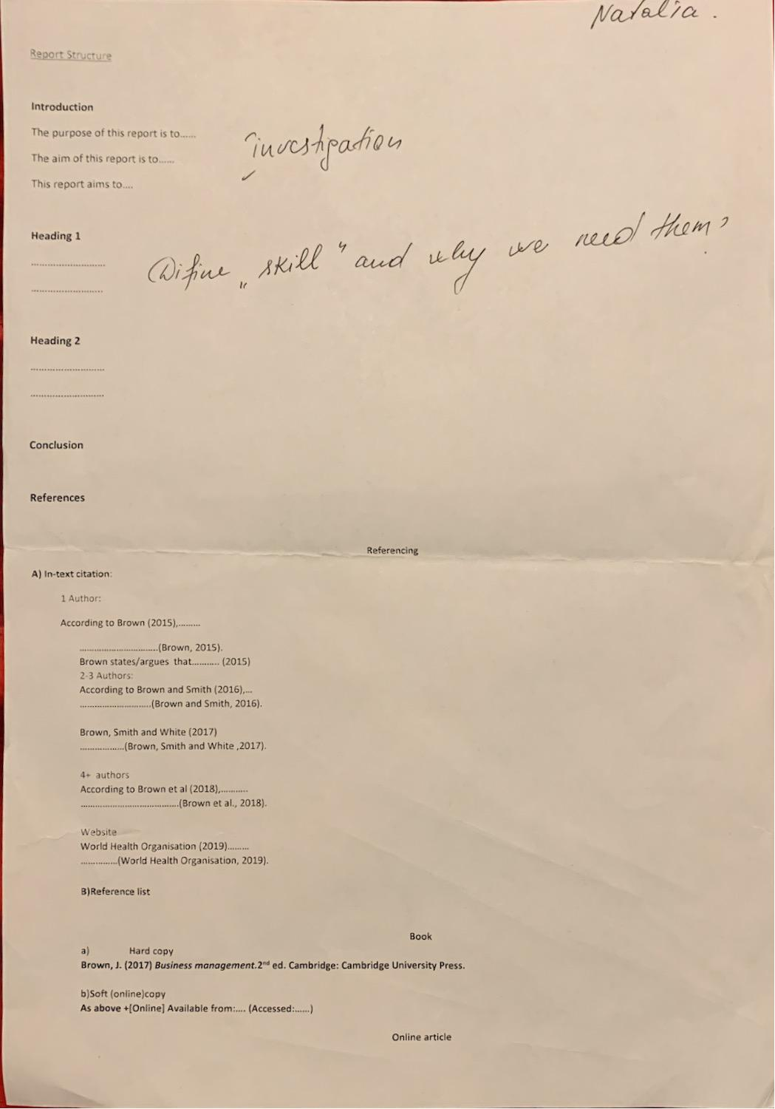

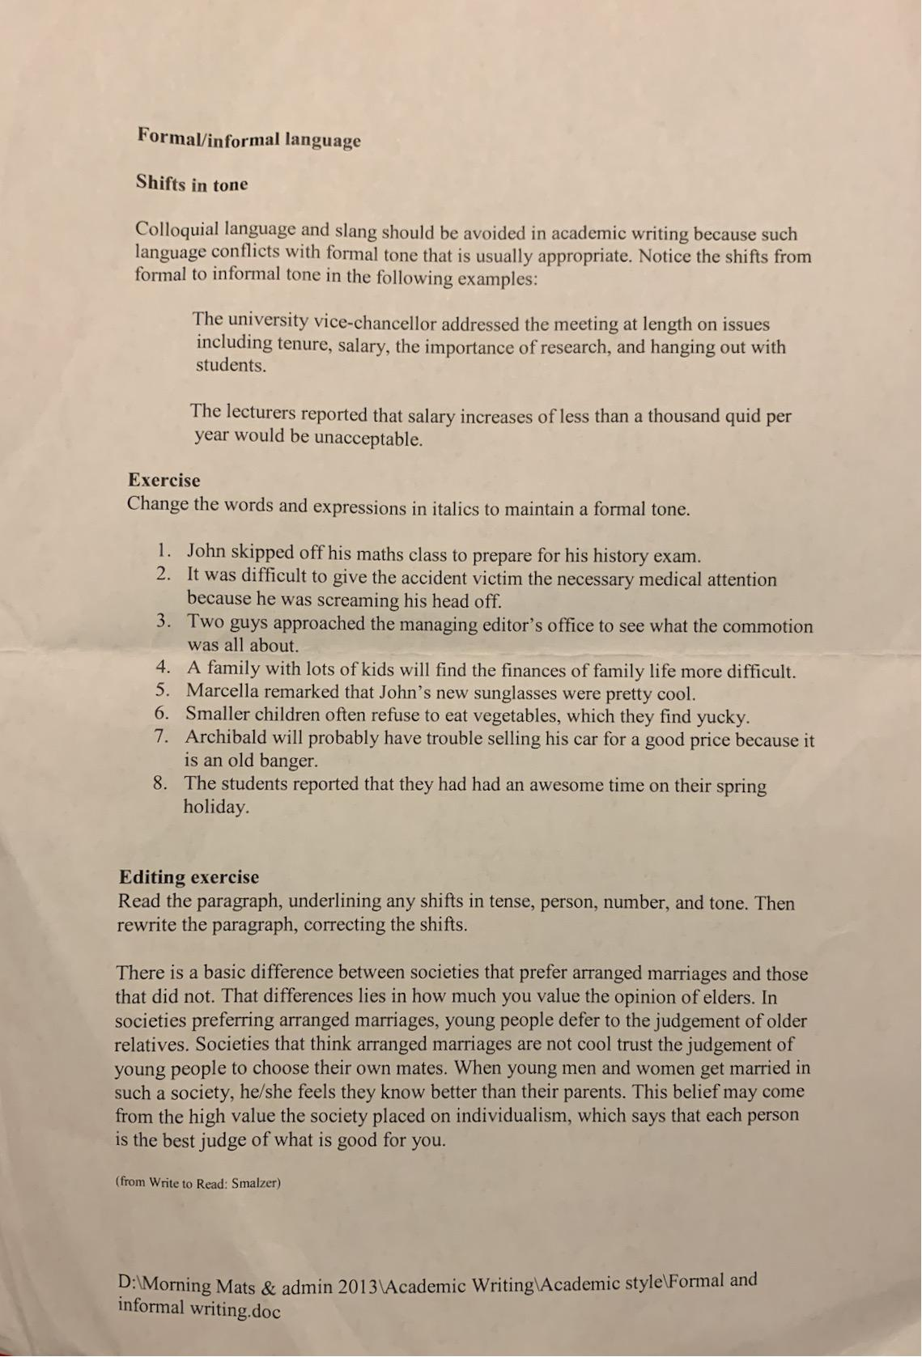

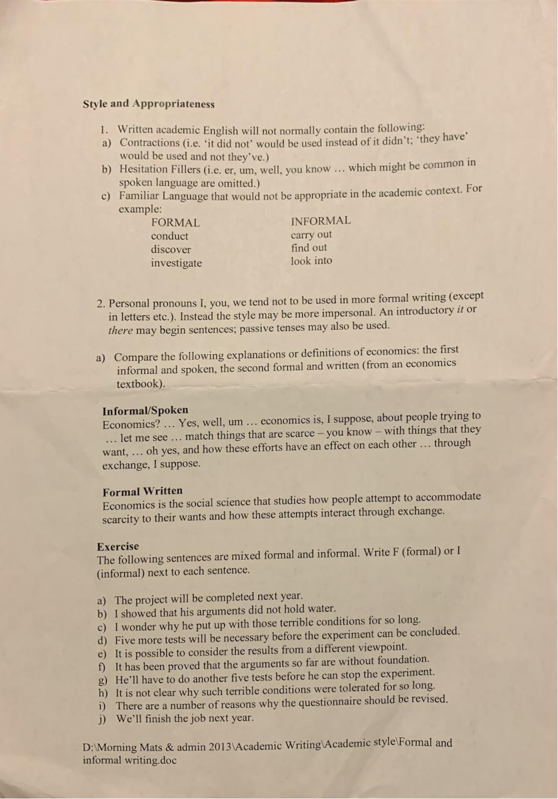

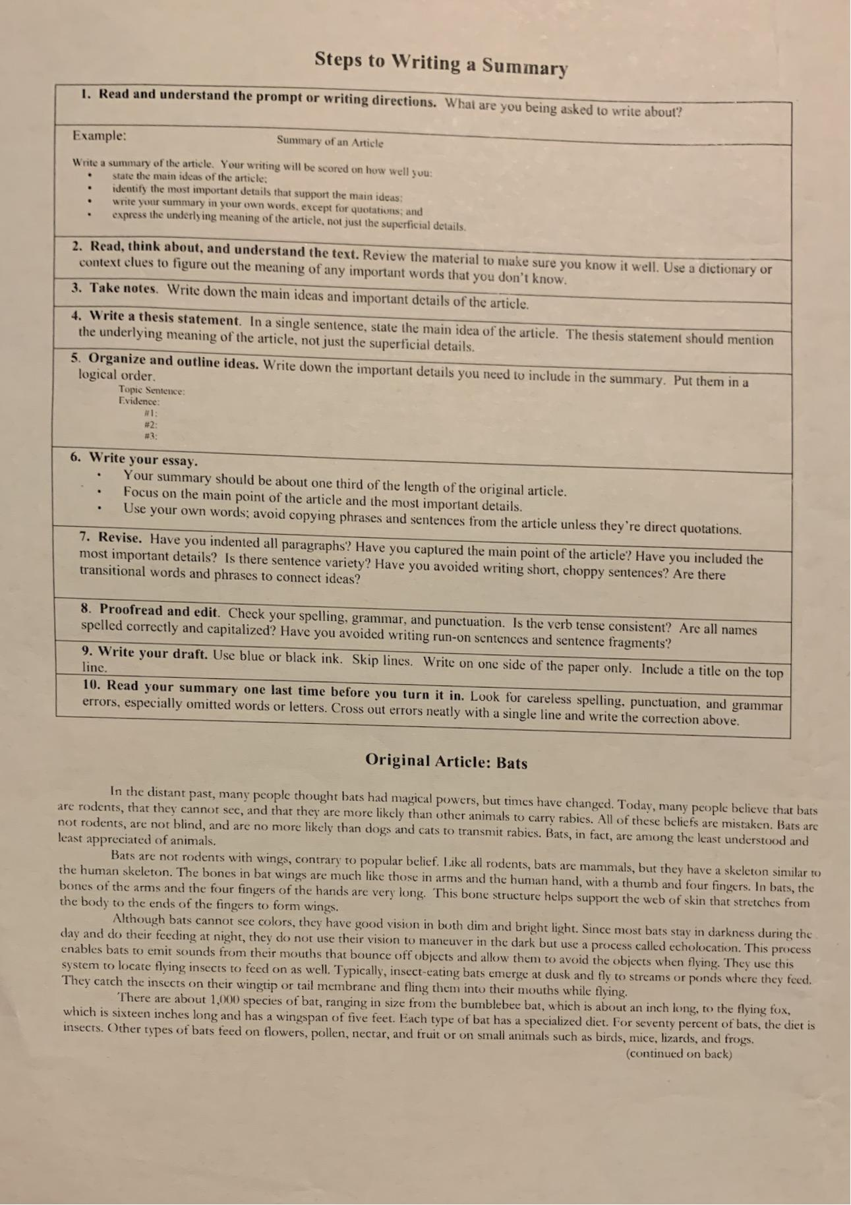

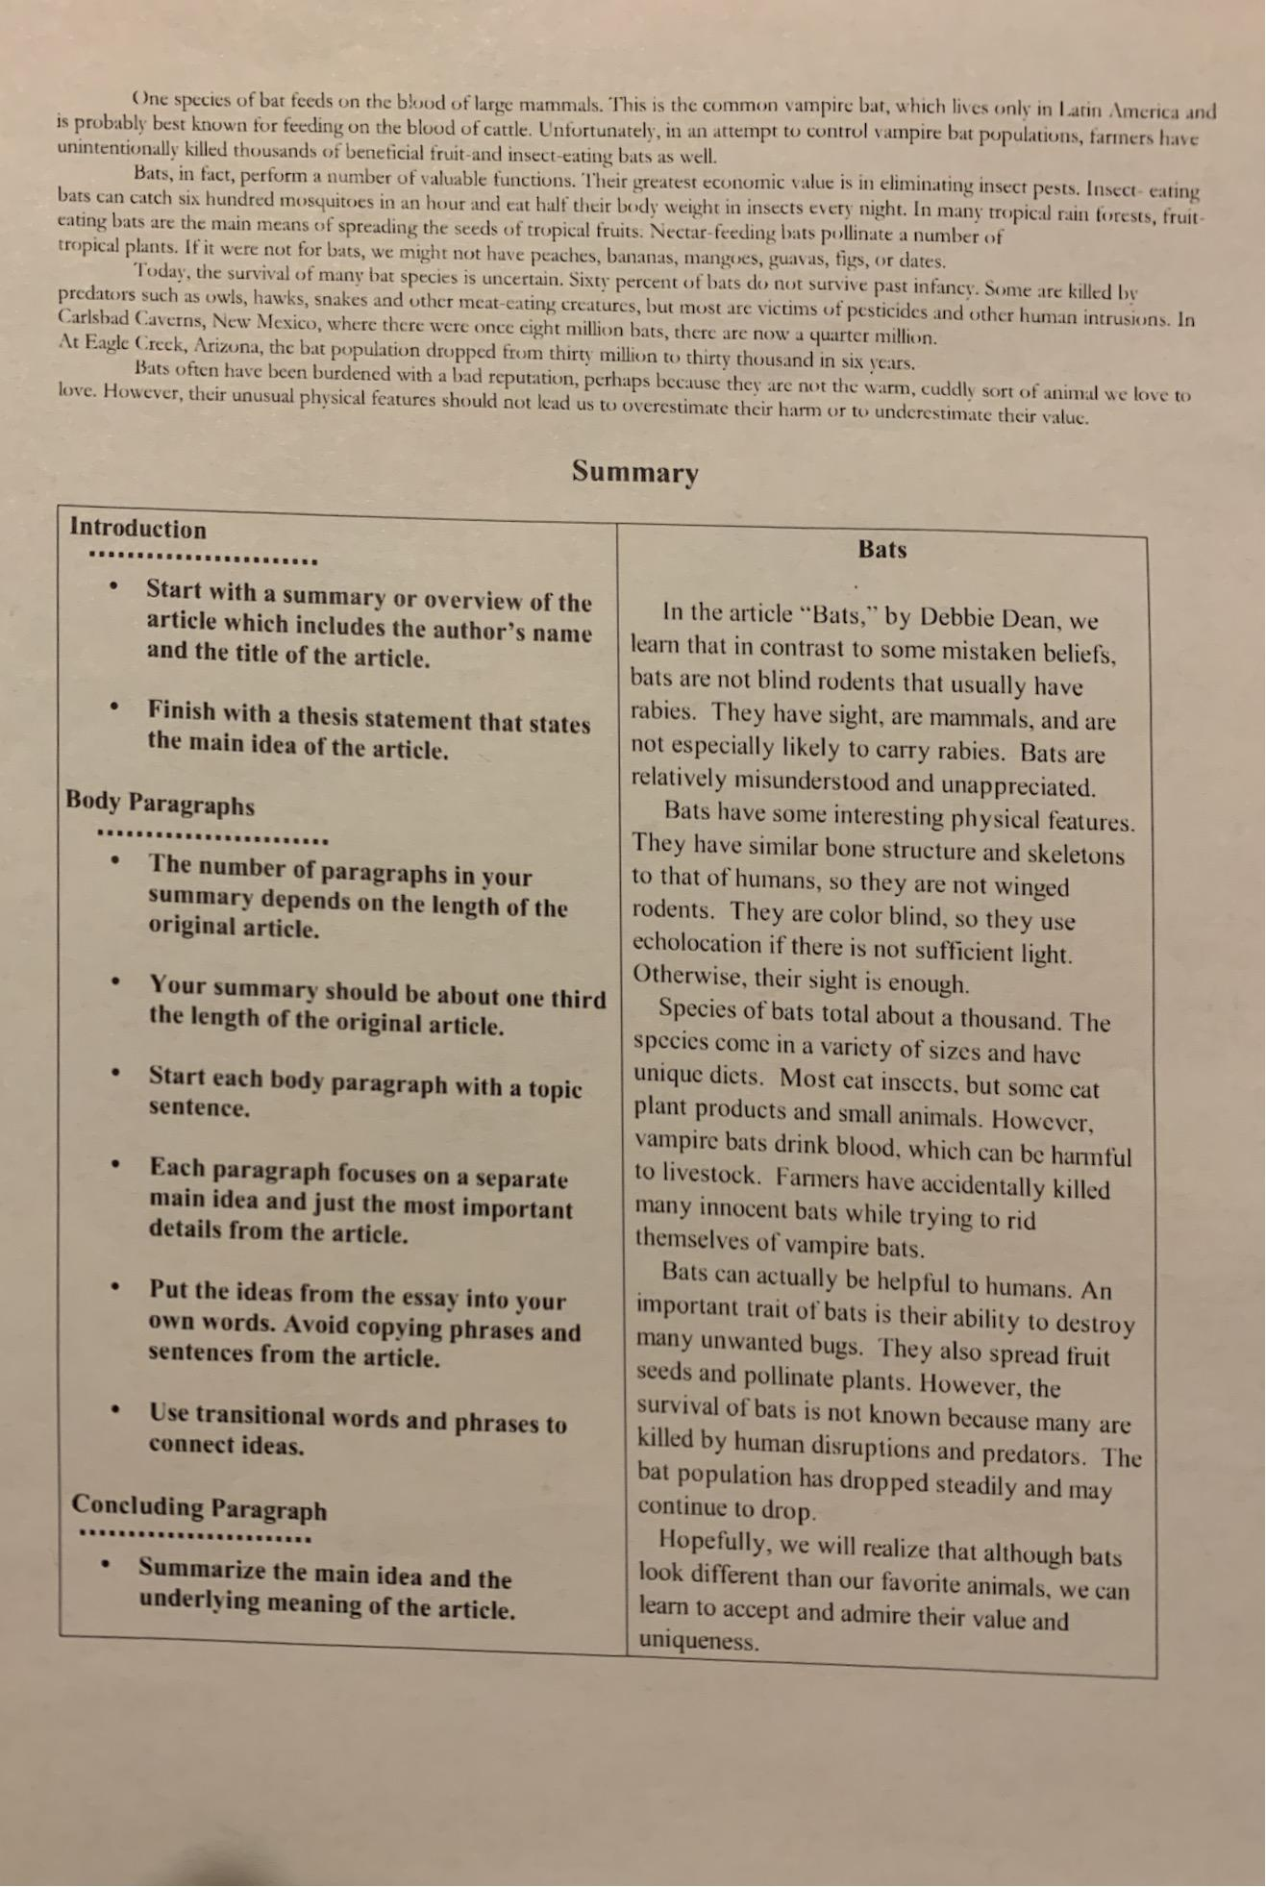

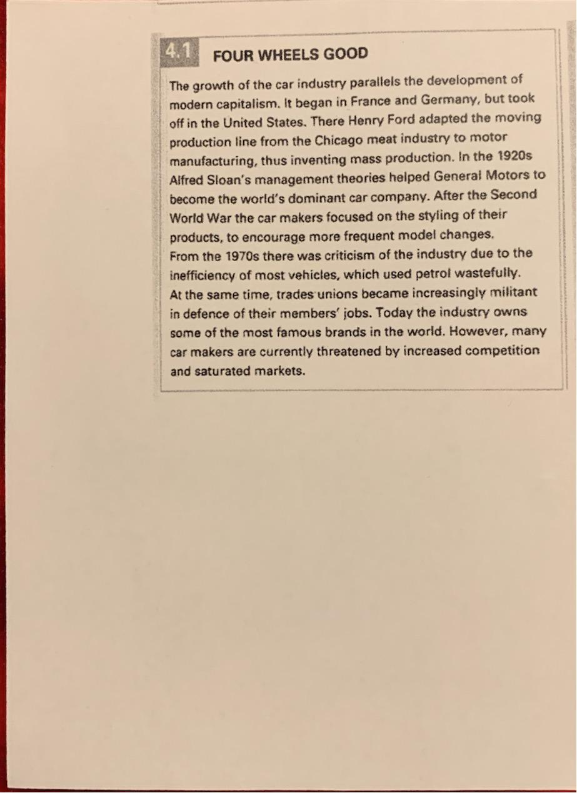

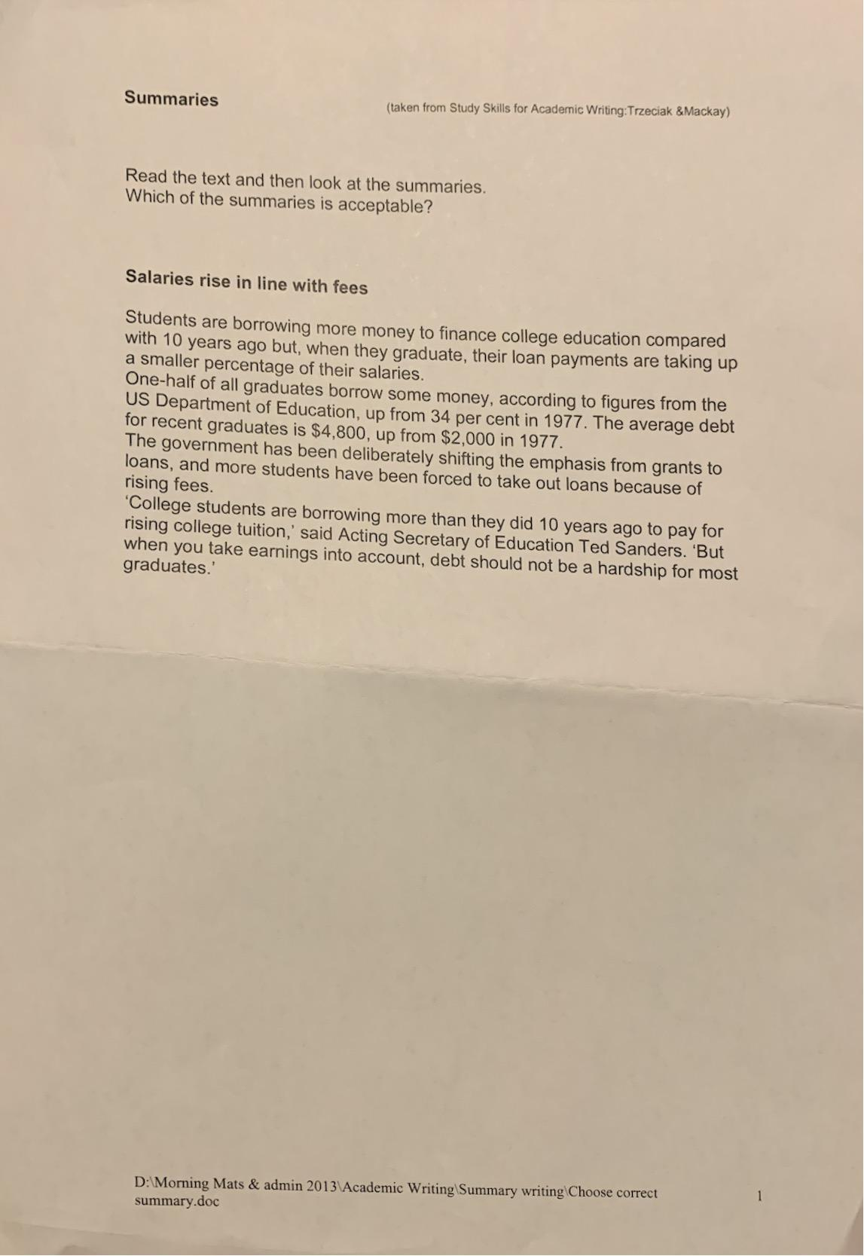

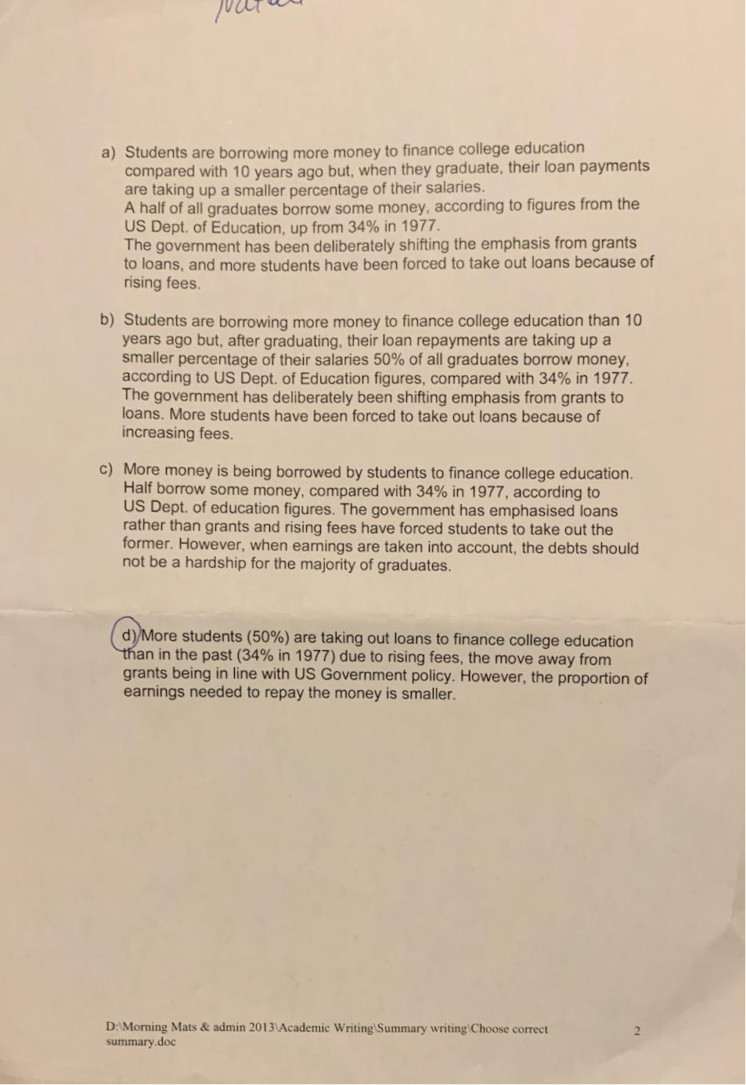


Academic and Employability Skills (ACE) —term 1
BMSW4001
In-class exercise 2: Summarising - RESIT
Student Name: PUStudent ID/Group: 
Please make sure to fill the above correctly to enable us to email you the results.
Time allocated: 1 hour. Please return your paper to the lecturer upon completion. You will need to include a scanned copy of this exercise in the form of an appendix together with your Task 1.

Ex.l
Read the following text and make notes on the main ideas. You can do this on a separate piece of paper which you do not have to hand in.
Personalised learning
At school and university, knowledge is valued in itself, and learners' success is measured purely in terms of test scores. But in corporate language training, the gold standard of mastery is not a final exam, but the learner's use of the target language in real work and life situations. Here, success means something different for each learner. This makes it extra important for the content and activities in corporate language courses to be personalised learning which is tailored to the individual. For this, we need to understand not only each individual learner's training goals, but also their unique learning style.
For a training course to really succeed, both learners and trainers need to take learning style into account. For the last century, discussion around learning styles has mostly focused on the senses. We have been categorised as auditory, visual, reading-based and kinesthetic learners. This notion has been popularised by Dr. Neil Fleming, who developed a 16-question test which learners can use to figure out which category best describes them. On the plus side, this framework has contributed to the diversification of classroom activities in recent decades. Typical classrooms now incorporate audio and video content and task-based learning, in addition to traditional "textbook" material.
However, the theory of sensory learning styles has also been repeatedly "debunked." Current research suggests that tailoring activities and materials to sensory preferences is less important that choosing the sensory mode best suited to the content. As Olga Khazan in The Atlantic Monthly points out, ^{I}'most of the tasks we encounter are only really suited to one type of learning. You can't visualize a perfect French accent, for example." Howard Garner, in his theory of Multiple Intelligences (Ml), argues that the mode of sensing information is less important to learning than the ability or "intelligence" needed to actually process that information once it has been sensed.
Both Khazan and Garner advise that we should drop the notion of sensory learning styles, and instead personalize learning as much as possible. For Gardner, this means to "learn as much as you can about each student, and teach each person in ways that they find comfortable and learn effectively."

Ex2. Summarising Resit
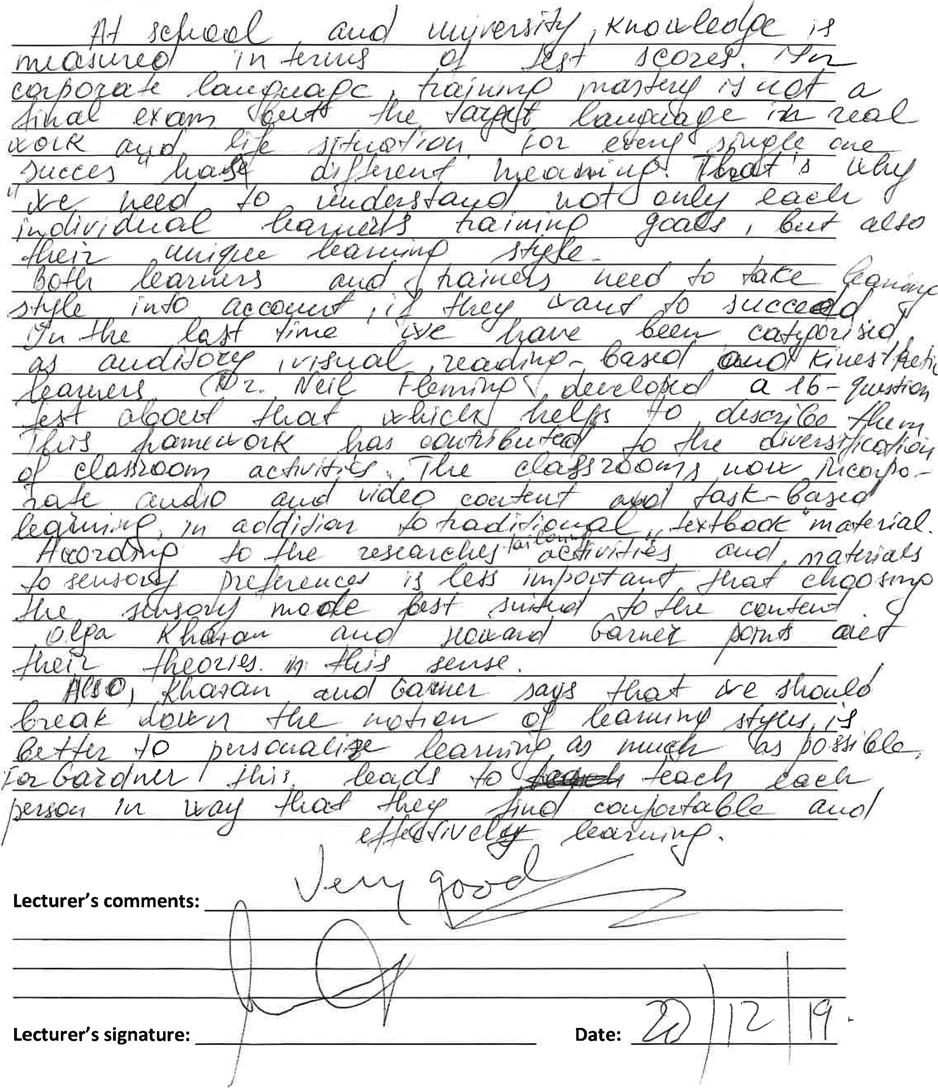
Re-read the text 'Personalised learning' on previous page. Now summarise the text in your own words. Write about 175 words.


